Thought about being a Chef, a Worker in the hospitality trade?

Kai Time

YEAR 11 LEVEL 6 ESSENTIAL LEARNING AREA Languages/Technology/Health

OBJECTIVES  Te Reo : Tuhituhi  - Me hängai, me tika te rere o ngä tuhinga a te äkonga, ä, ka kitea töna auahatanga i roto i ngä momo tuhinga huhua noa.  Tikanga-ä-iwi : Te Wähi me Te Taiao  - Ngä pähekotanga o te tangata ki te wähi me te taiao. | LEARNING OUTCOMES/SKILLS  - Host a group of people  - Write a recipe using healthy Māori foods.

OVERVIEW
Inside the kete is a selection of food that you must use in a meal for foreign dignitaries. Plan the menu and then write instructions for preparing one of the foods.

INSTRUCTIONS
Check the kete for food.

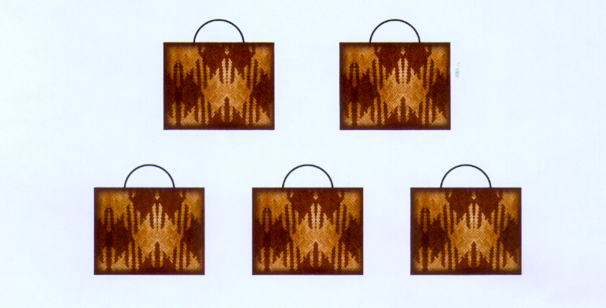
Oysters, crayfish
Kumara, watercress. puha
Mutton birds, wild pork
Root ferns, berries
Eel, tuna, whitefish

MENU
Make up a menu that includes a starter, a main meal, and a dessert. You must use the items from all of the kete as the main ingredients but you can use a selection of spices, herbs, liquids and condiments.

RECIPE
Select one of the dishes and write the recipe for it.

GATHERING
State natural areas in your region where you can get the foods given in the kete.

