Resource sheet 1A: Kei te pēhea koe? (How are you?)

pai
koa

pōuri

riri

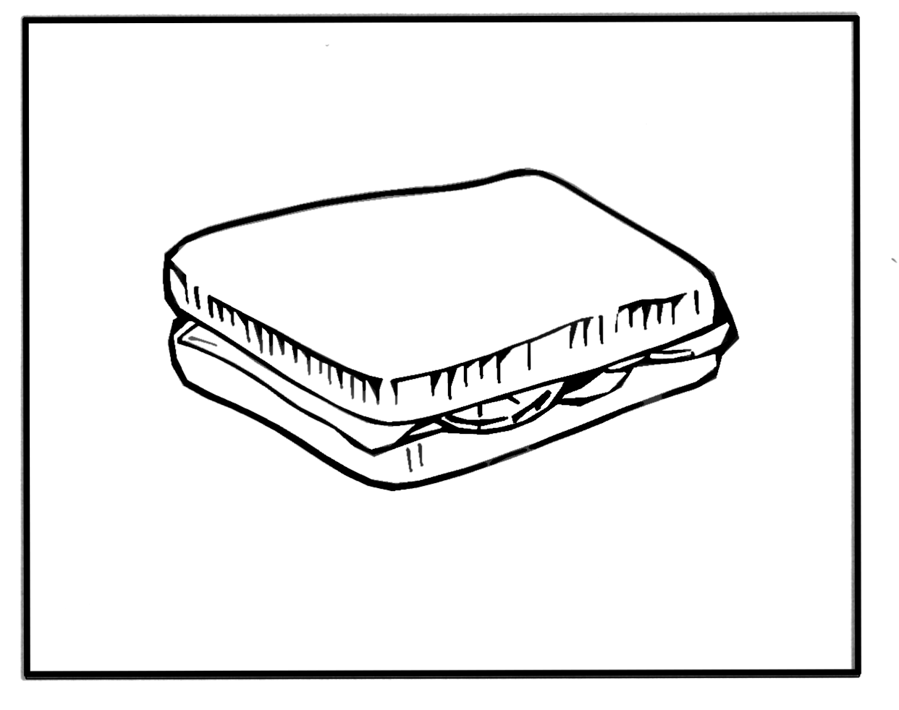
hiakai

hiamoe

