Tohu taka: te reo Pākehā Kao pāua

Pāua fritter recipe

Ingredients:
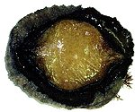
4 pāua
1 medium sized onion
1 egg
1 cup flour
1 cup milk
1 teaspoon baking powder
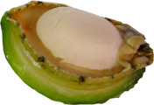
1 teaspoon salt
Pepper
Oil for frying
Several leaves of mint

Method:
Shell the pāua and clean all trimmings.
Wash well and cut into pieces.
Place the pieces in a food processor or mincing machine with the onion.

In a separate bowl, mix the egg, flour, baking powder, salt and pepper and the paua. Add the milk and finely chopped mint. Mix well to make a runny mixture.

Heat some oil in a frypan, then drop in spoonfuls of mixture to make two or three fritters. Cook for a few minutes on one side until brown, and then turn over and cook the other side.

