Resource sheet 3K: Engari kē

Tuhia mai ngā wāhi e haere ana koe, e haere kē ana hoki tō hoa, me whakamahi te kupu ‘engari’ me te kupu ‘kē’.
Write down the names of the places you and your friend are going, using ‘engari’ and ‘kē.’
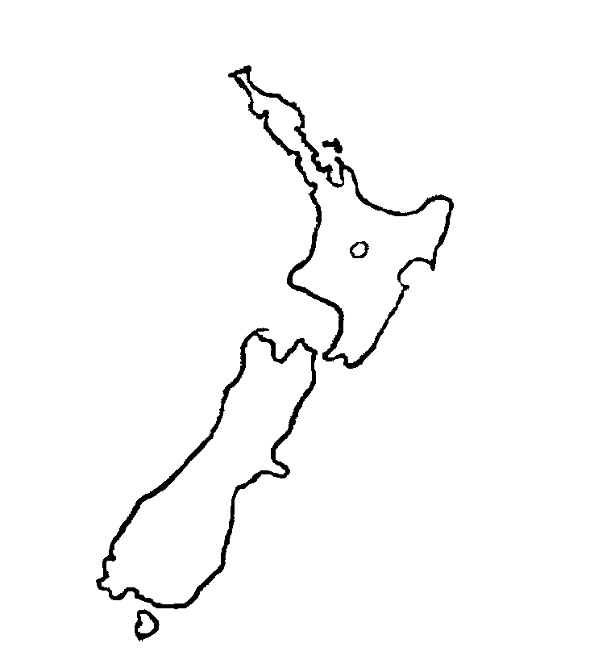
1. ____________________________________________________________
2. ____________________________________________________________
