Resource sheet 3N: Te Ika a Māui
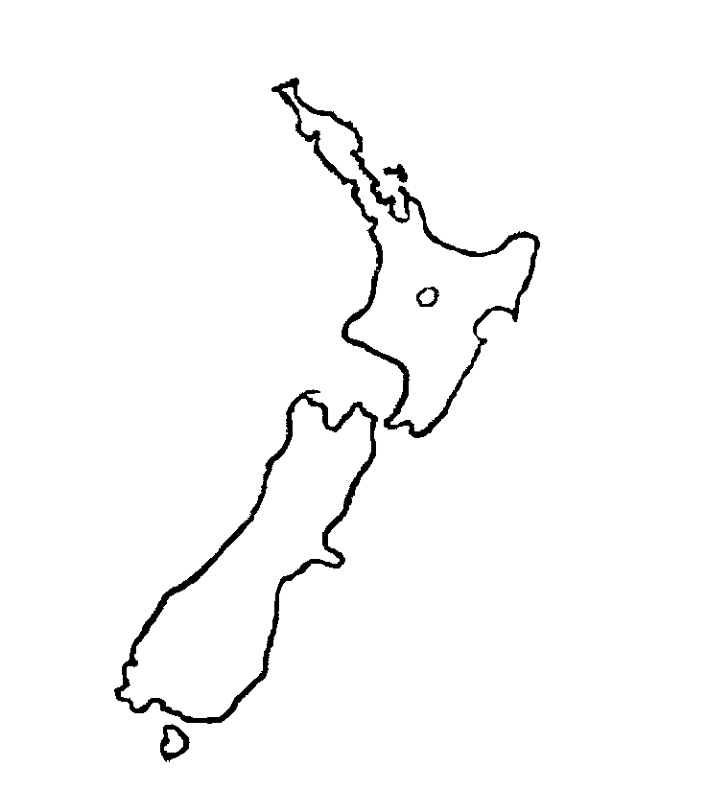

A

B
C

D
E
F
G
H
I

