Resource sheet 3O: Te Waipounamu

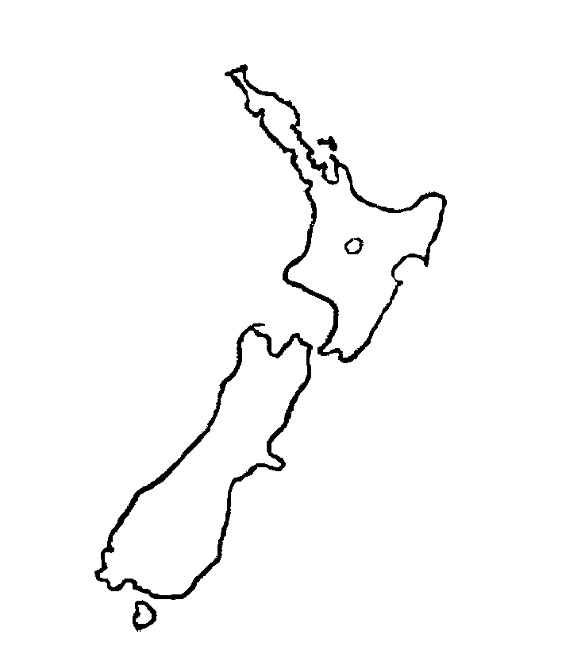
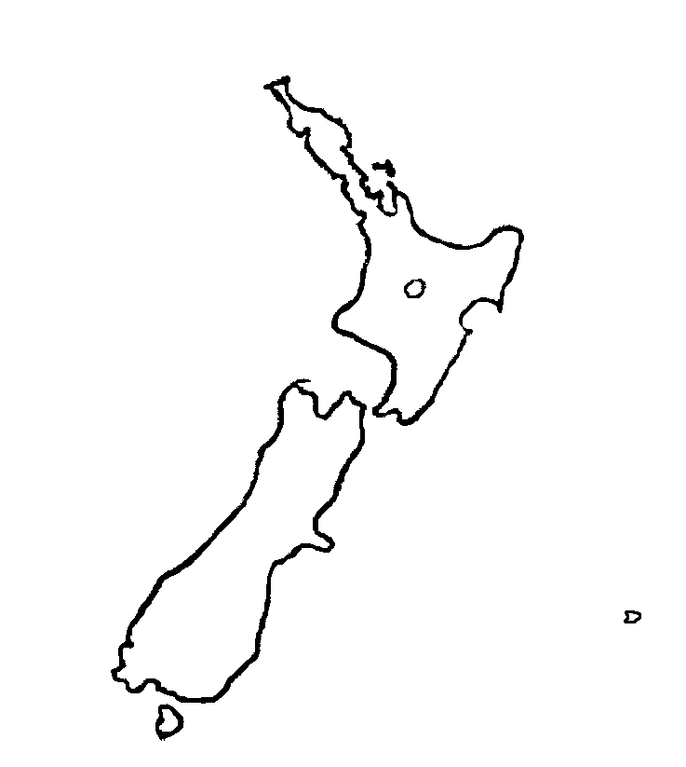
J
K

L
M
N
O
P
Q
R

