Resource sheet 3R: Te Waipounamu

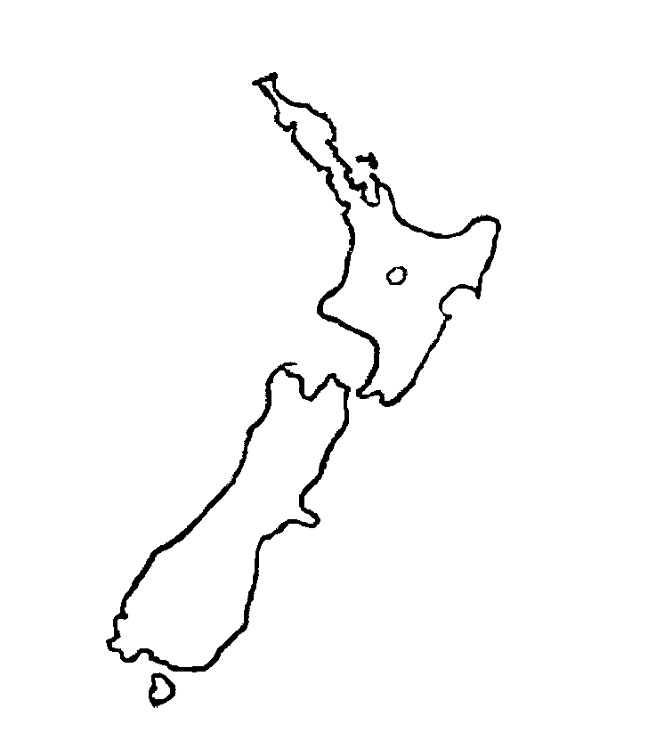
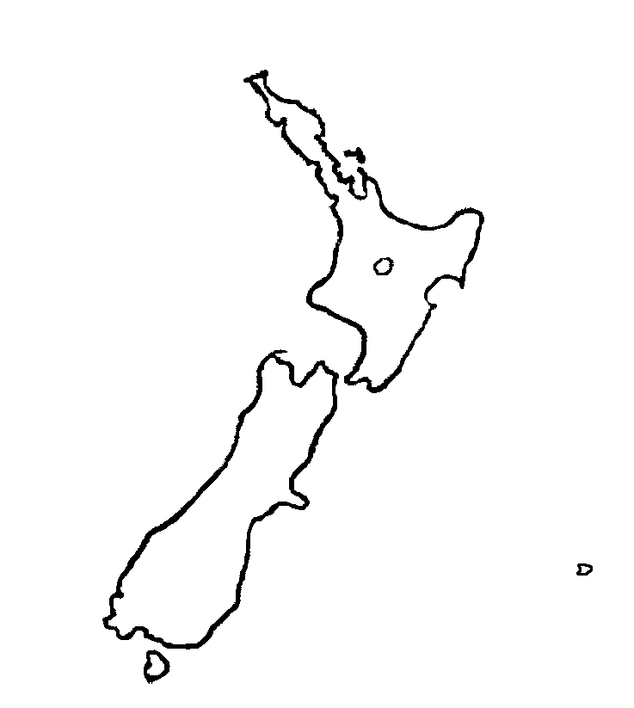
J
K

L
M
N
O
P
Q
R

