Resource sheet 6F: He kōrero nanu

Tuhia ngā kōrero tika kia mārama ai ngā mahi ki roto i ngā pikitia nei.
Unjumble the sentences to describe the activities in the diagrams.

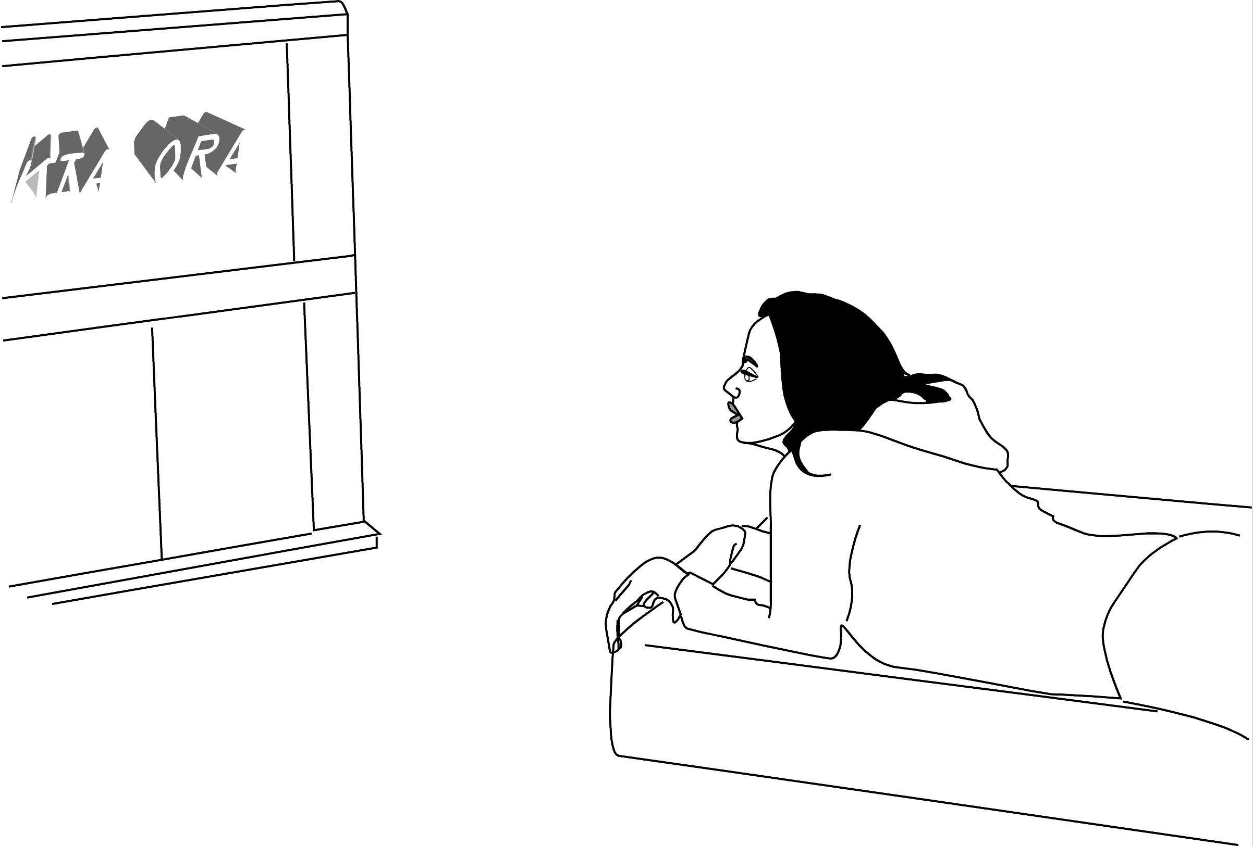
1 _________________________________________________________
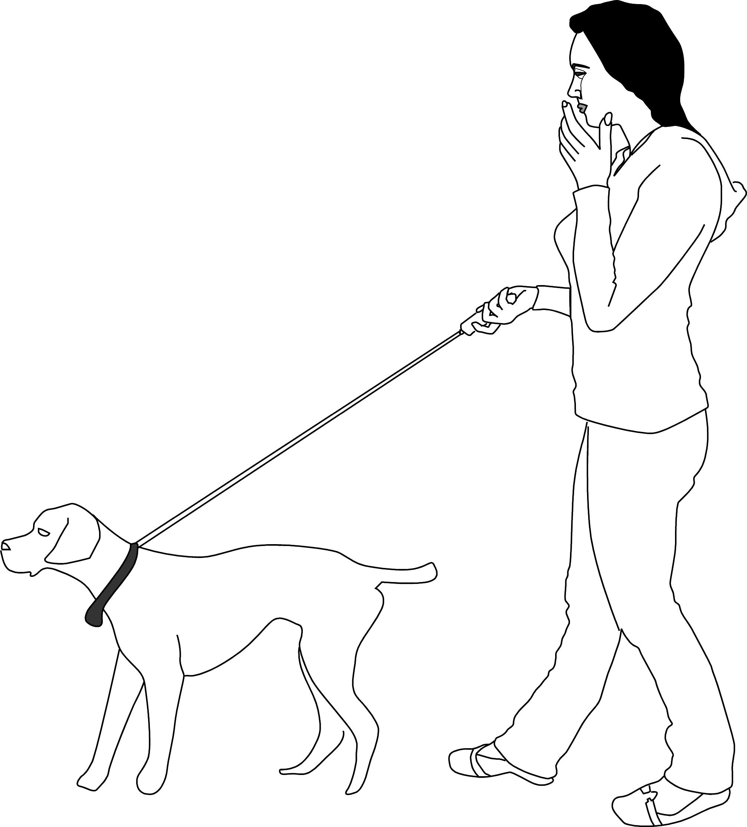
2 _________________________________________________________
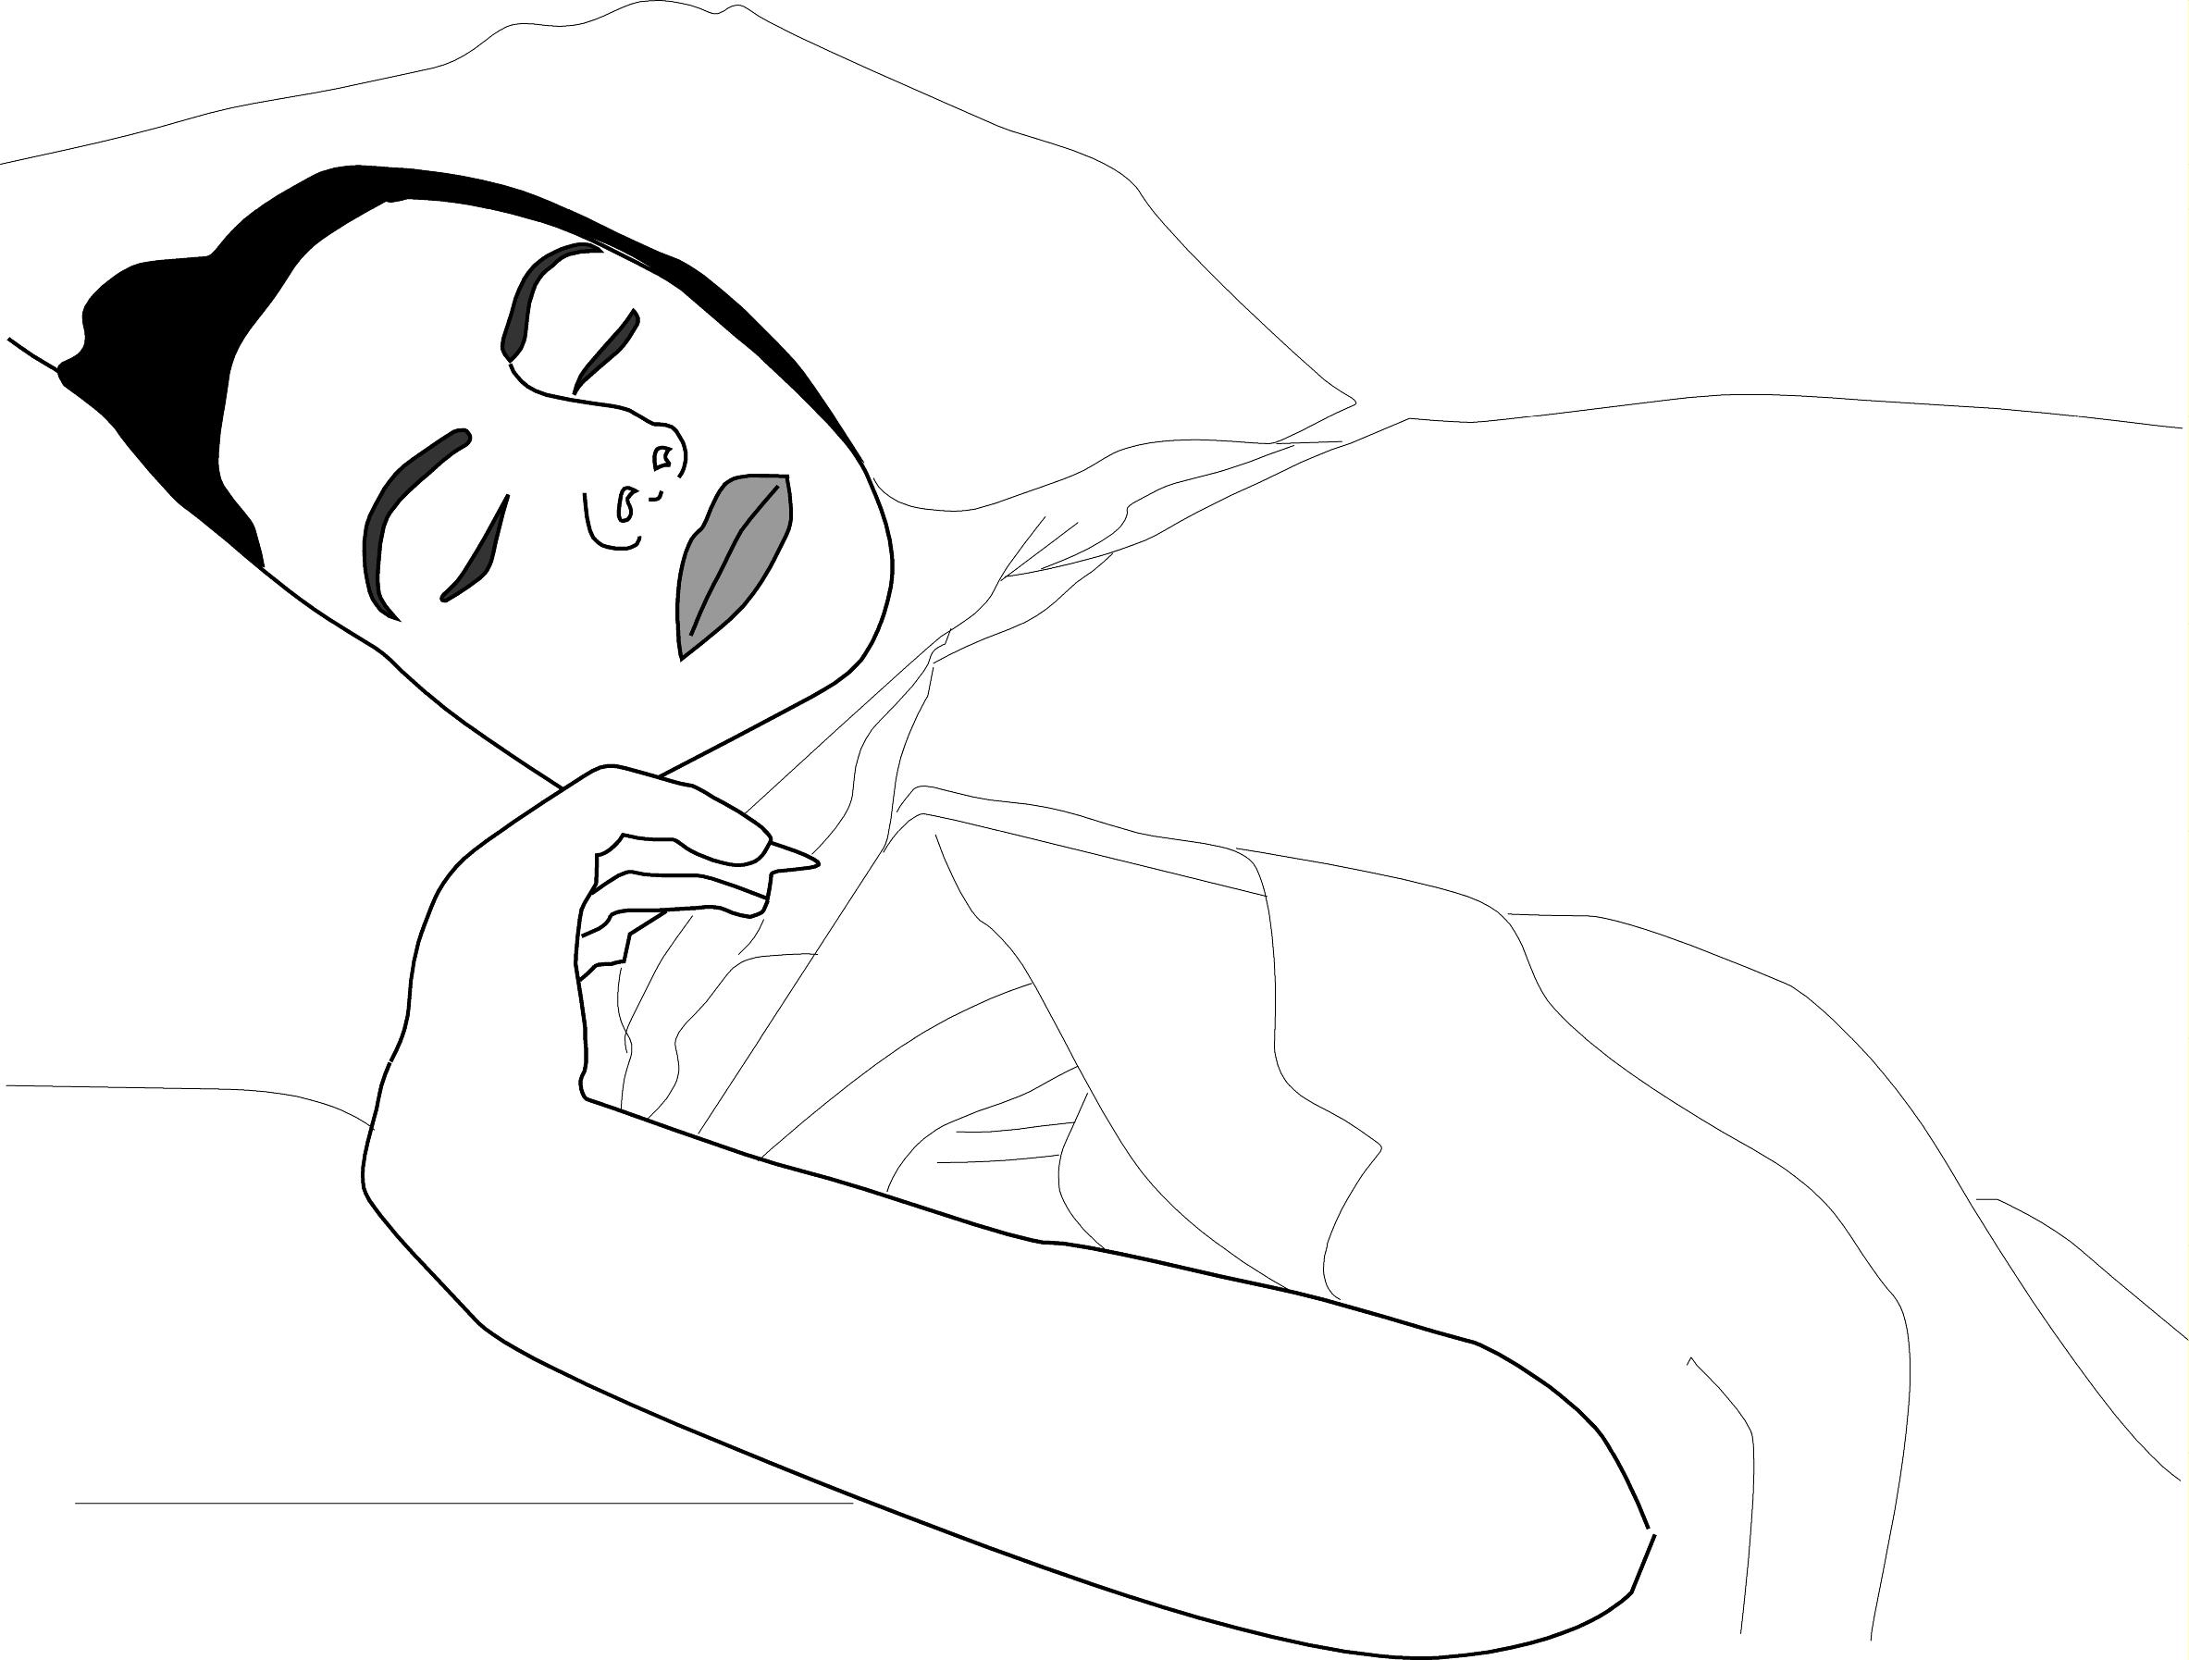

3 _________________________________________________________
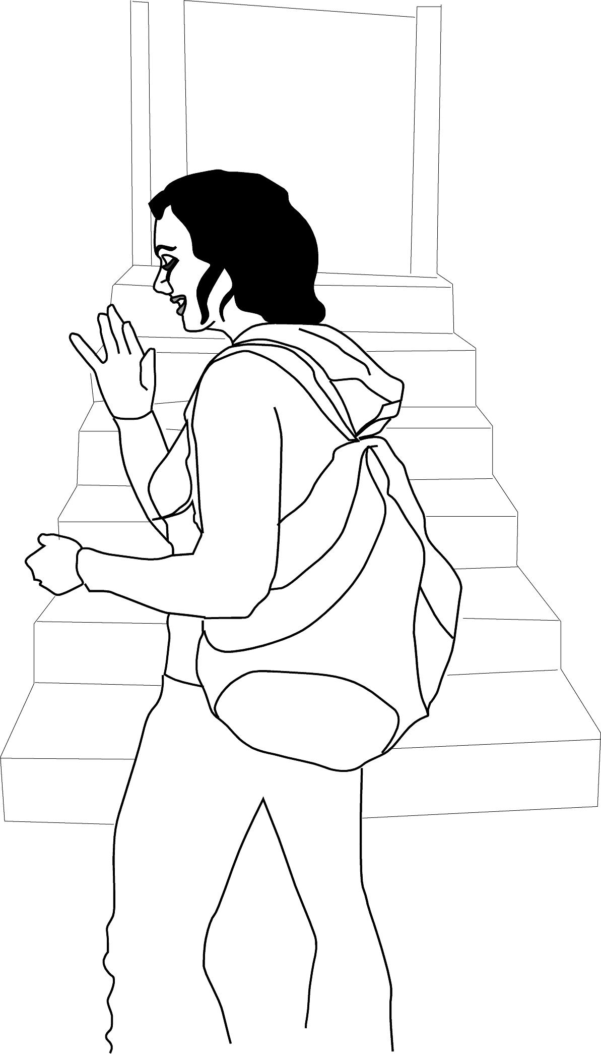

4 _________________________________________________________
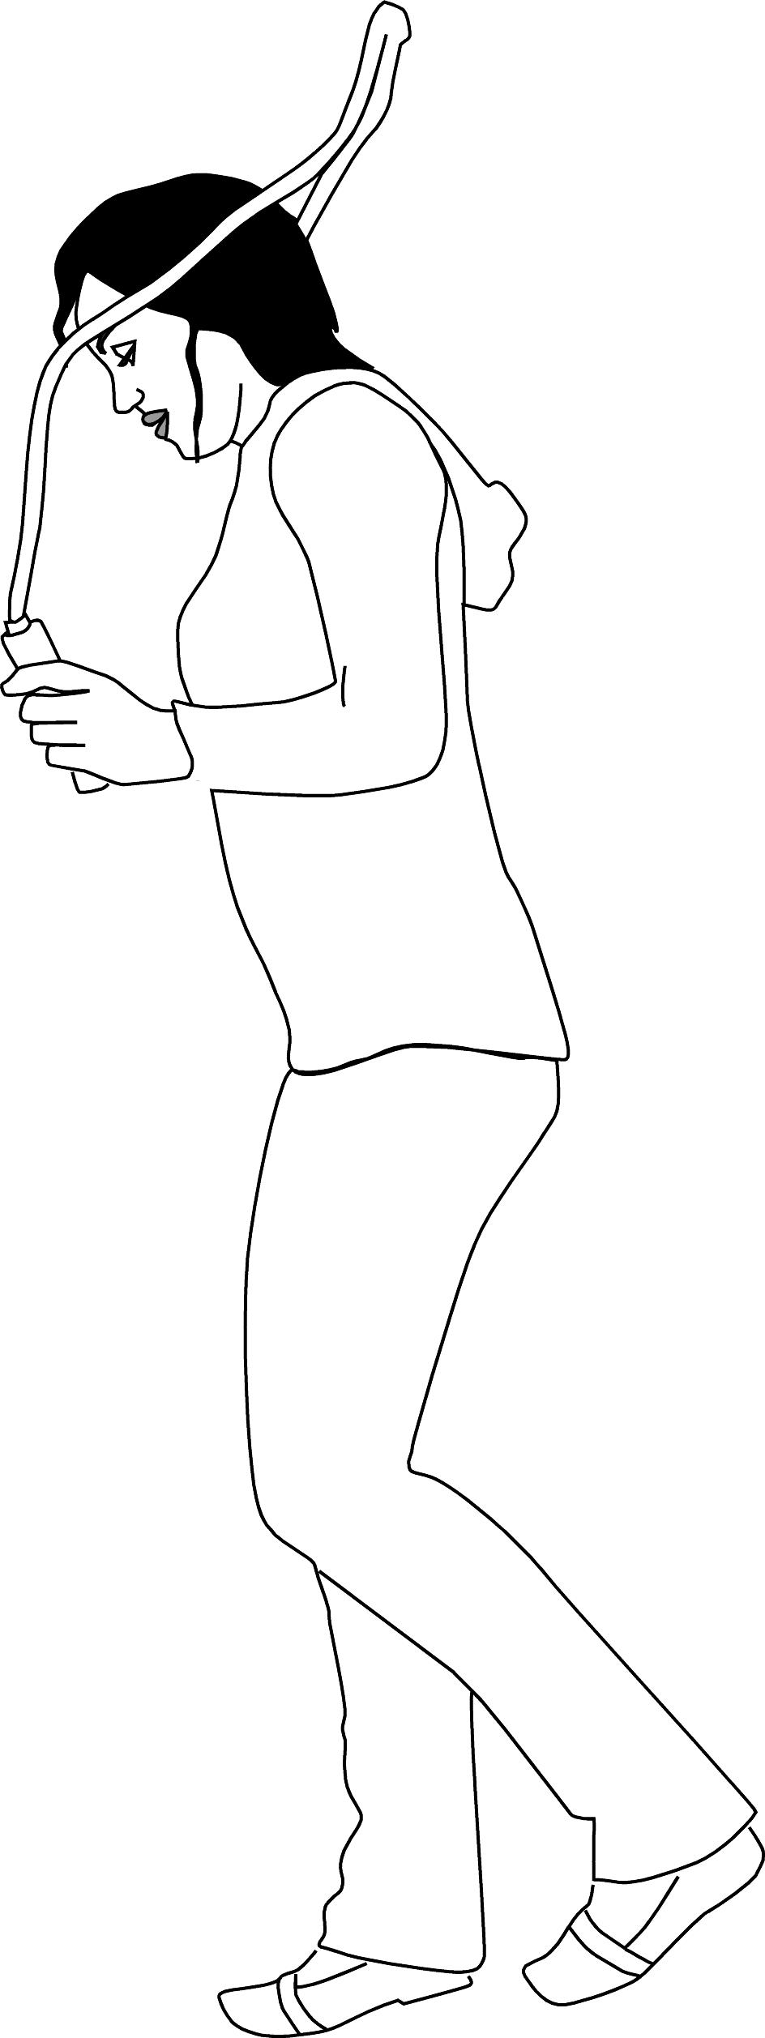

5 _________________________________________________________


6 _________________________________________________________
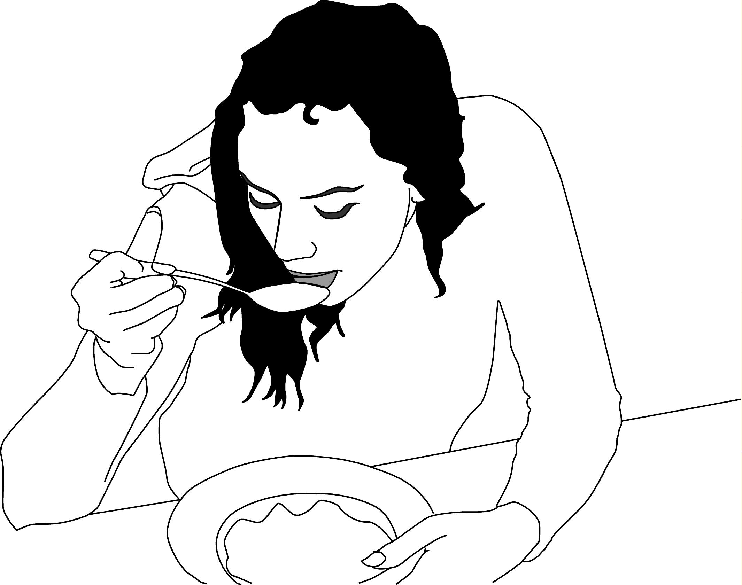

7 _________________________________________________________
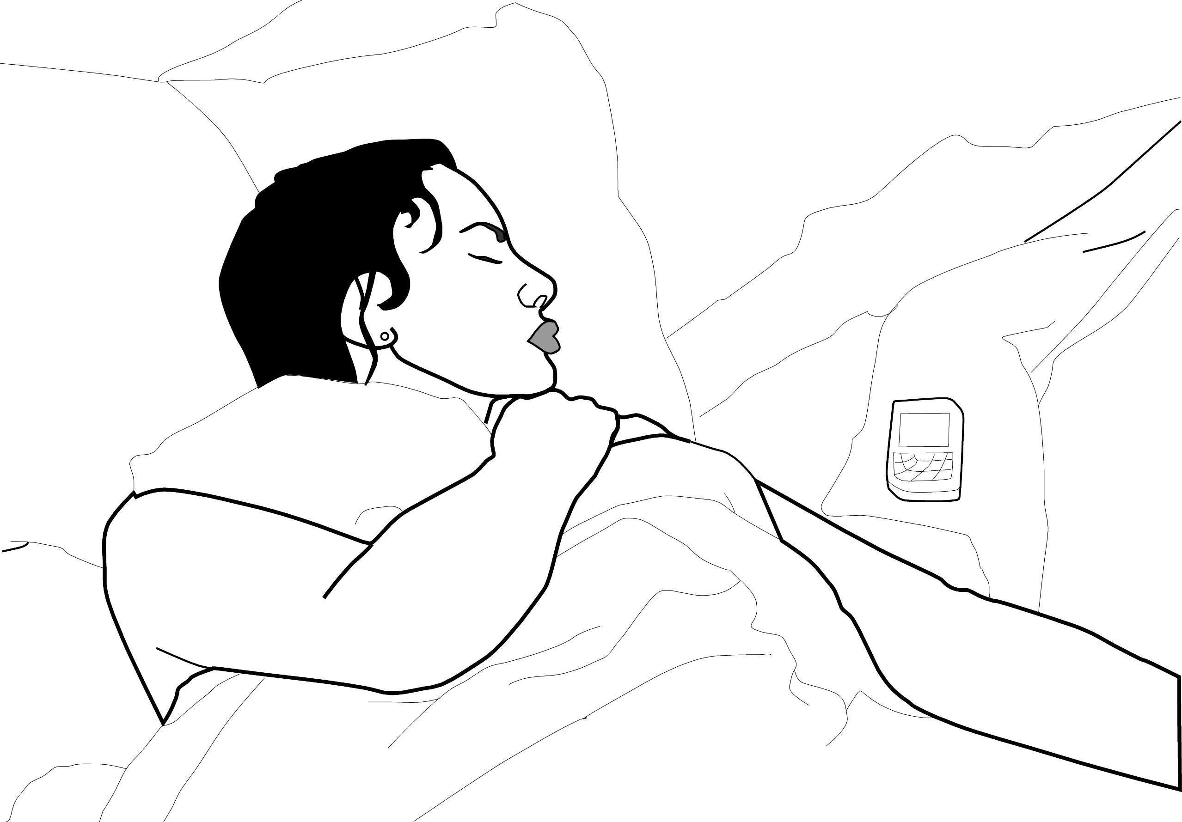

8 _________________________________________________________
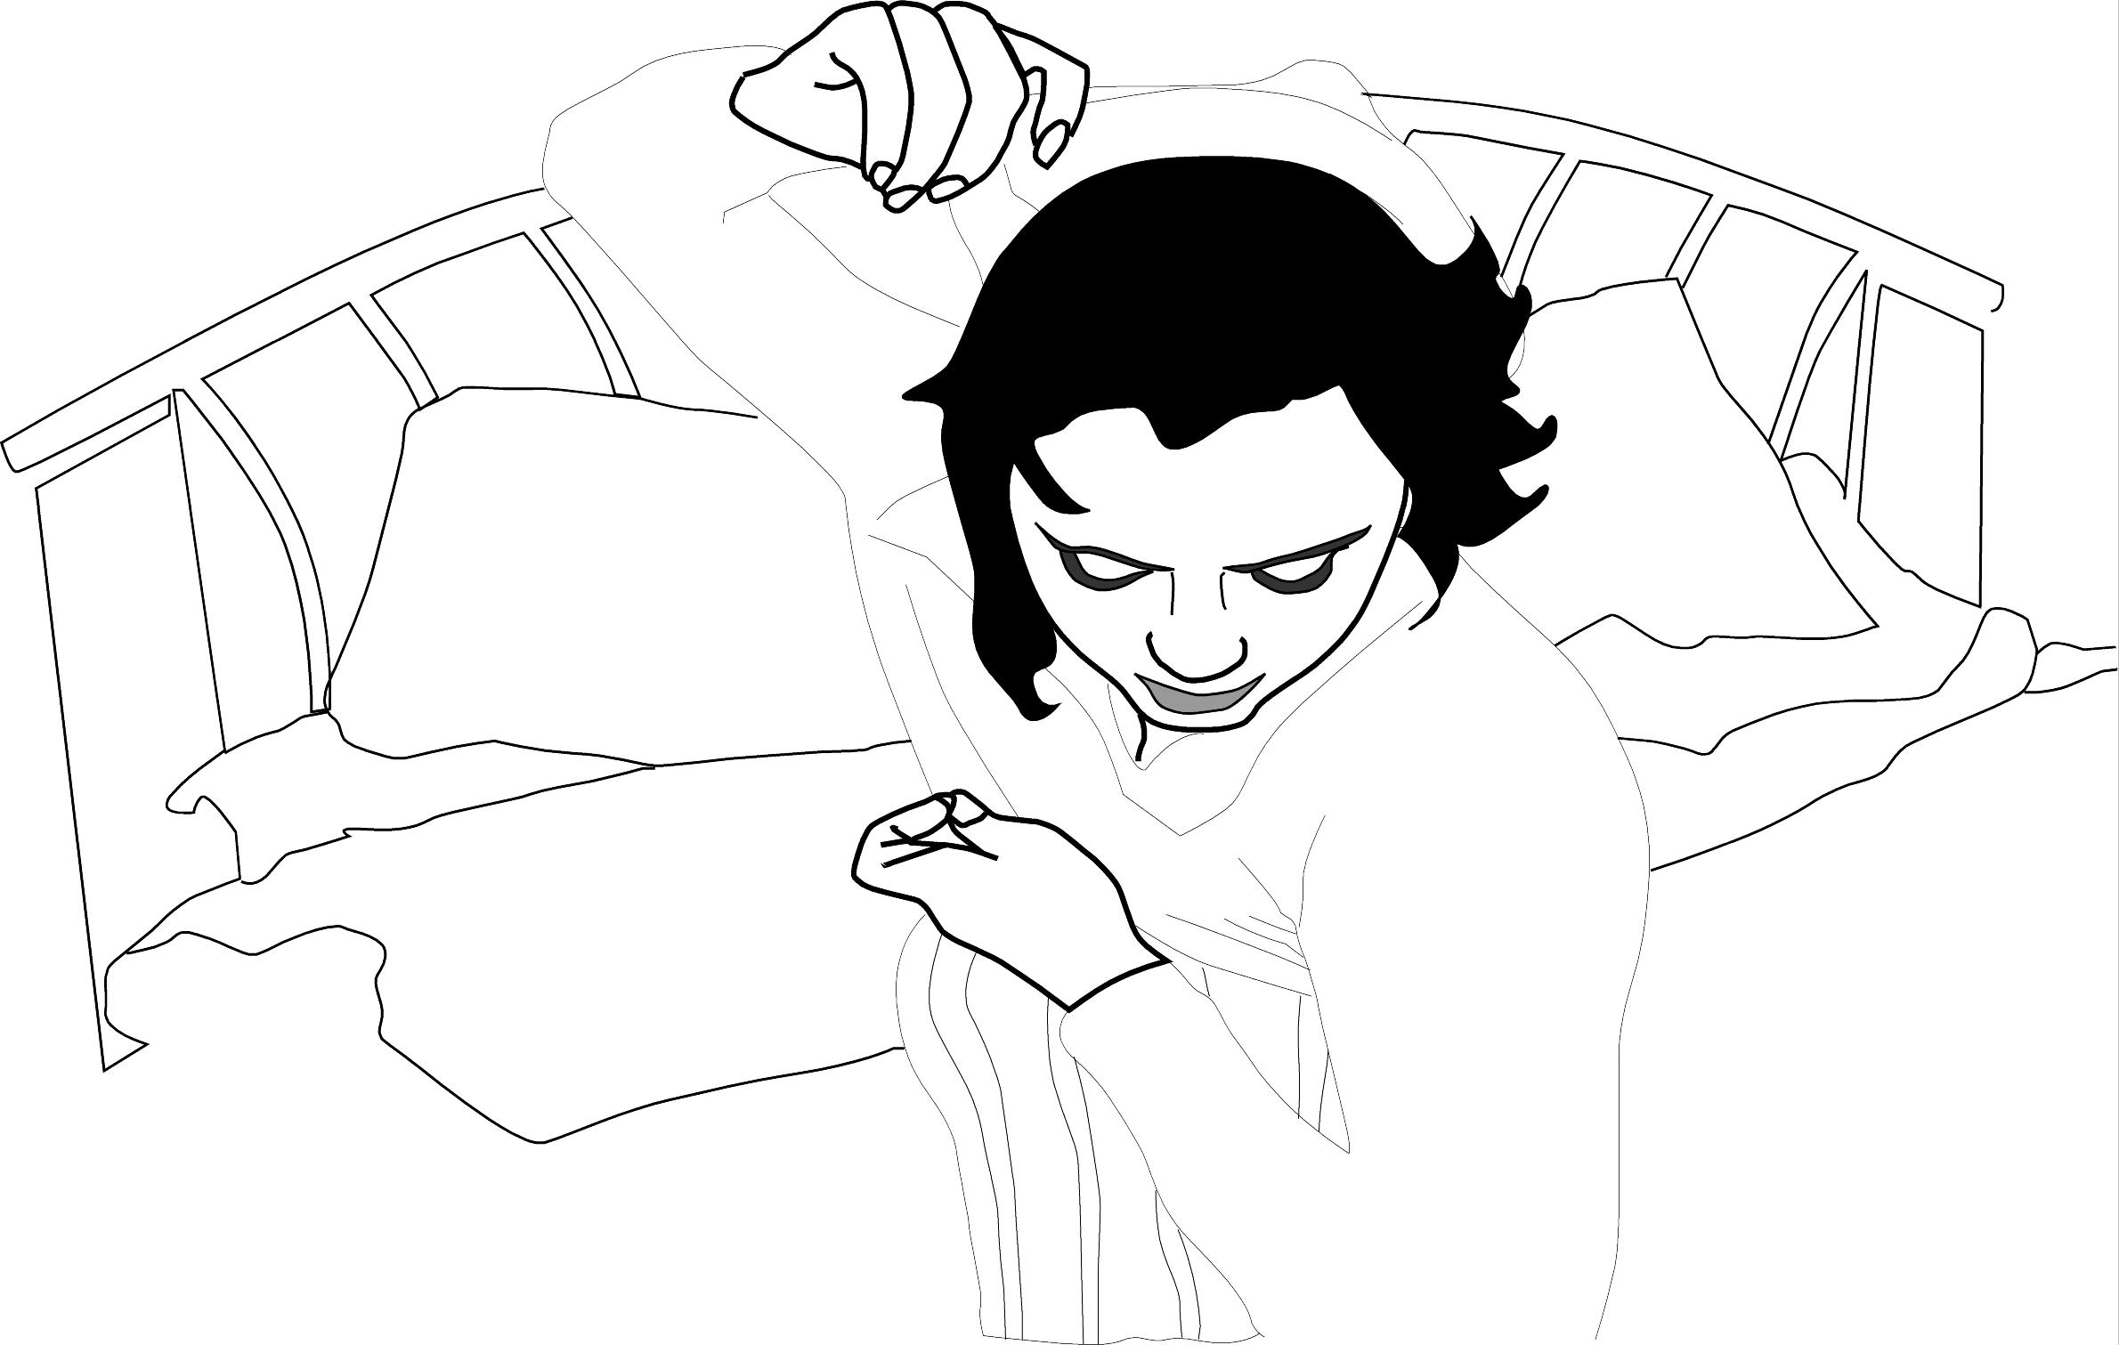

9 _________________________________________________________
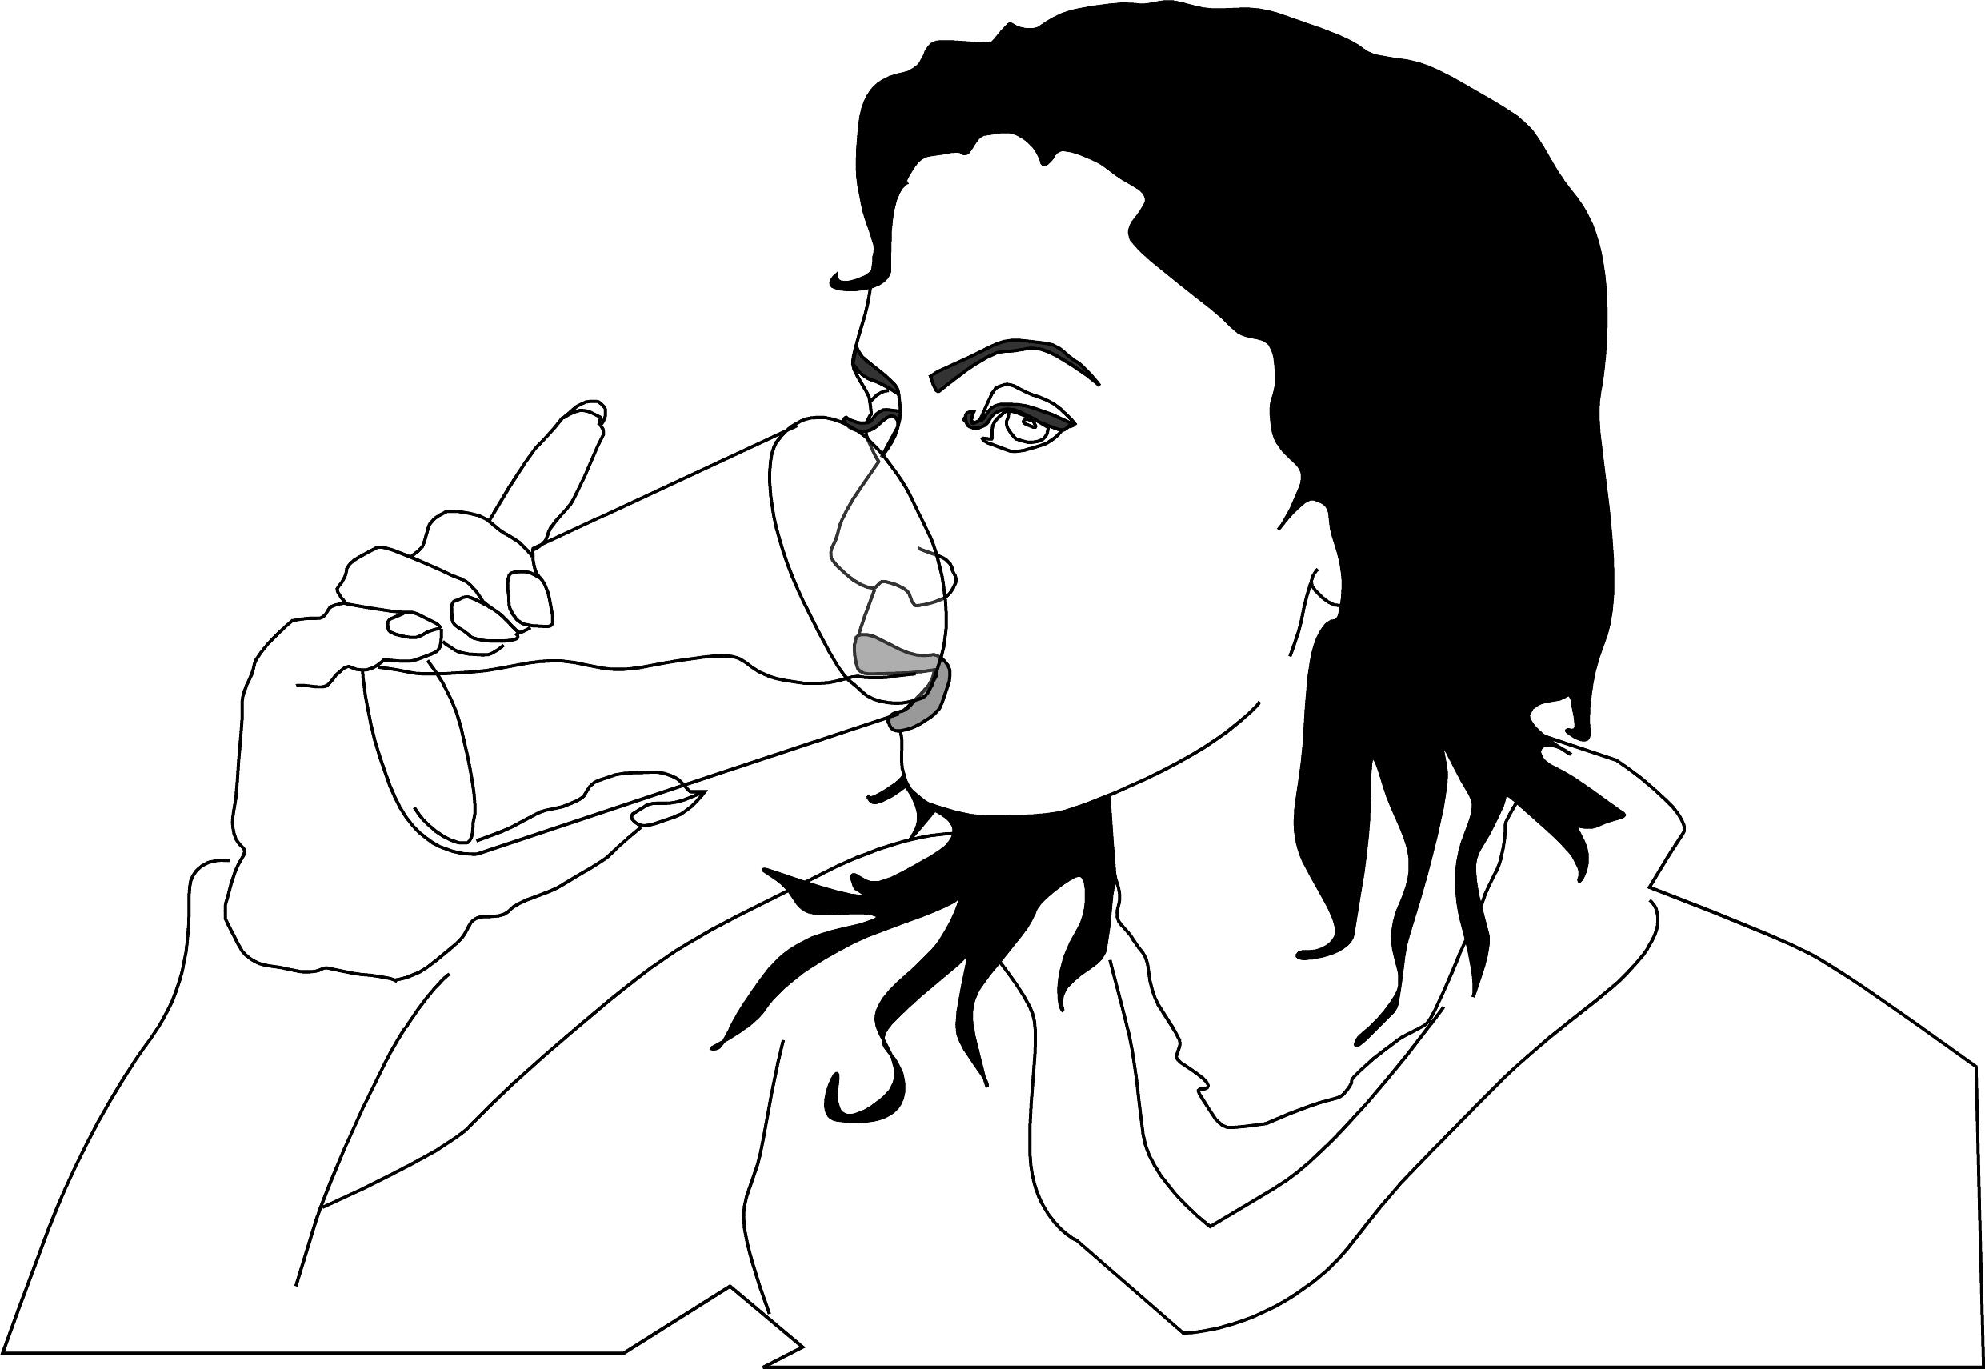

10 _________________________________________________________
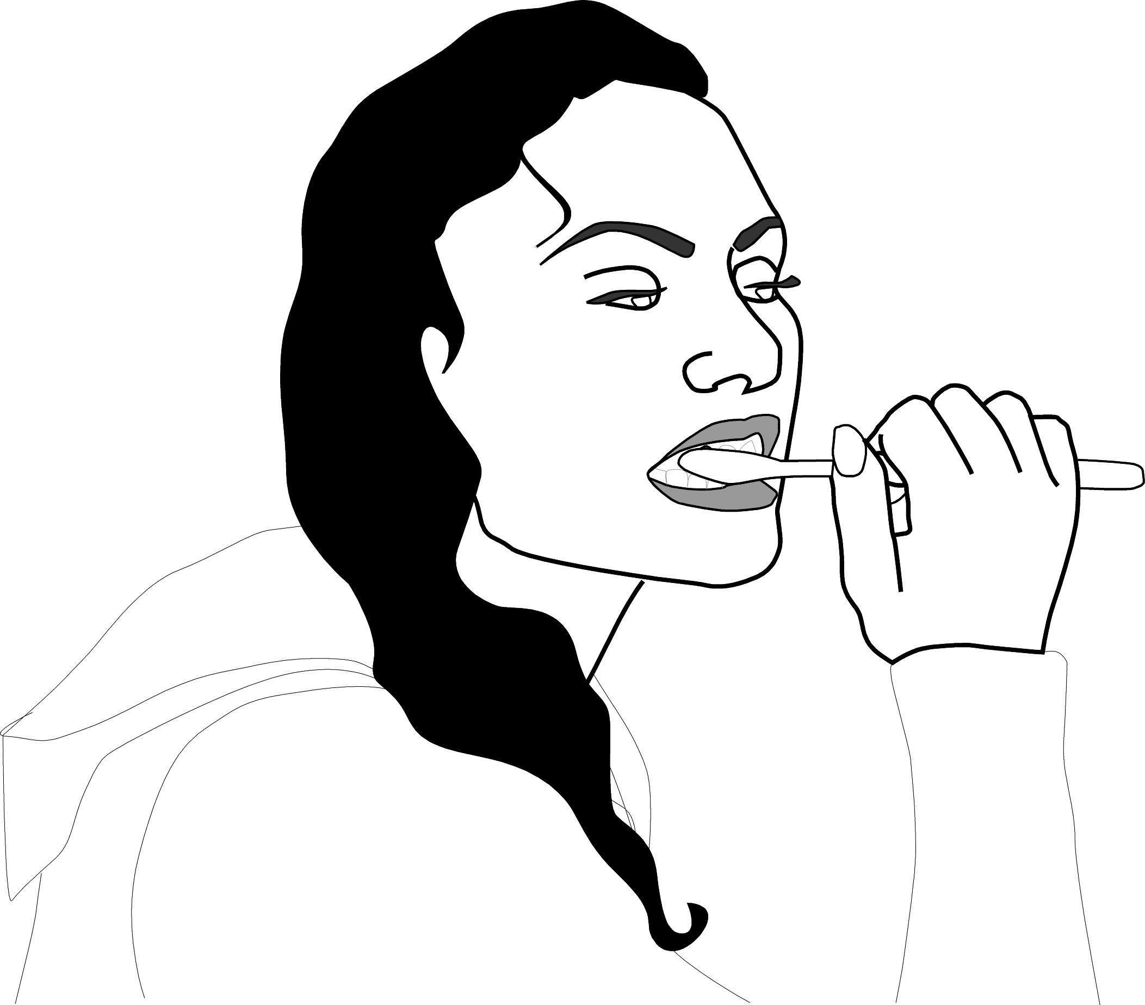

11 _________________________________________________________

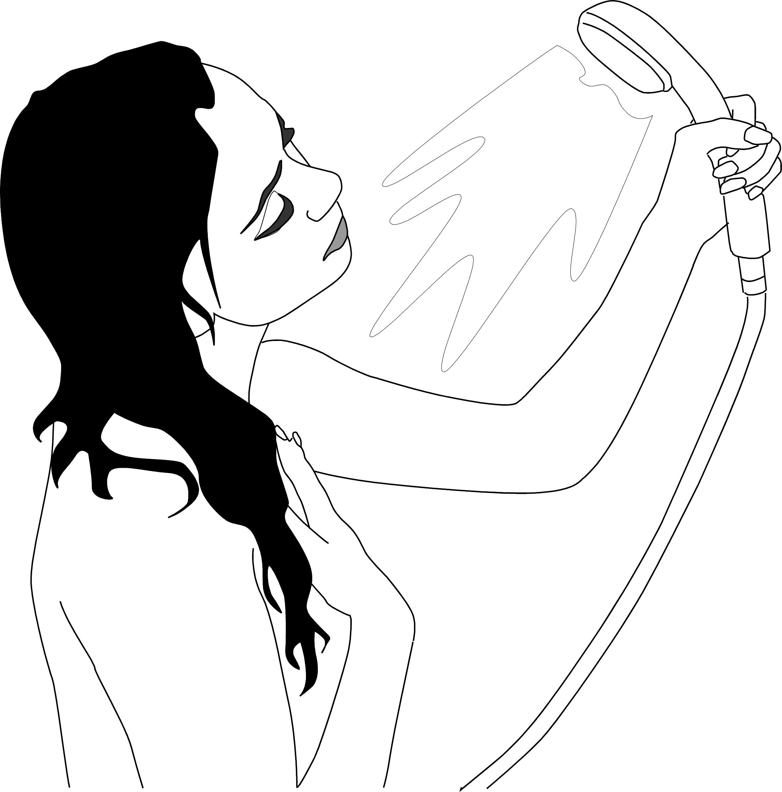
12 _________________________________________________

