Resource sheet 6K: Wharewhare - Ngä mahi a-Rëhia

Whakautua ngā pātai a ō hoa, a tō kaiako hoki mō ngā pikitia nei.
Answer questions from your classmates and teacher about these diagrams.

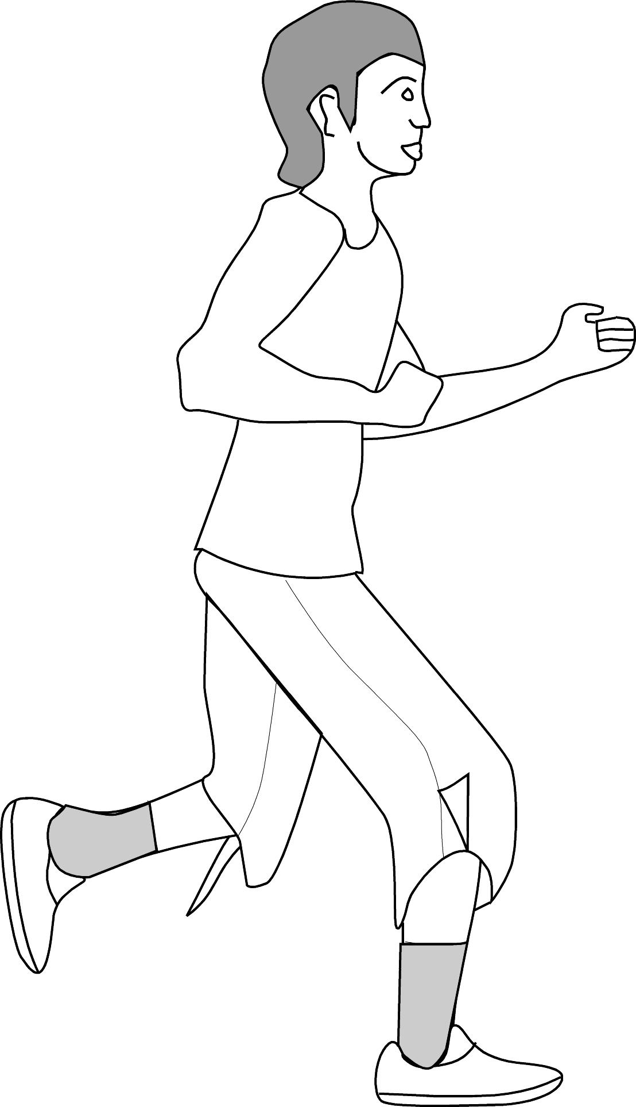  1  2  Ko Te Tapa | 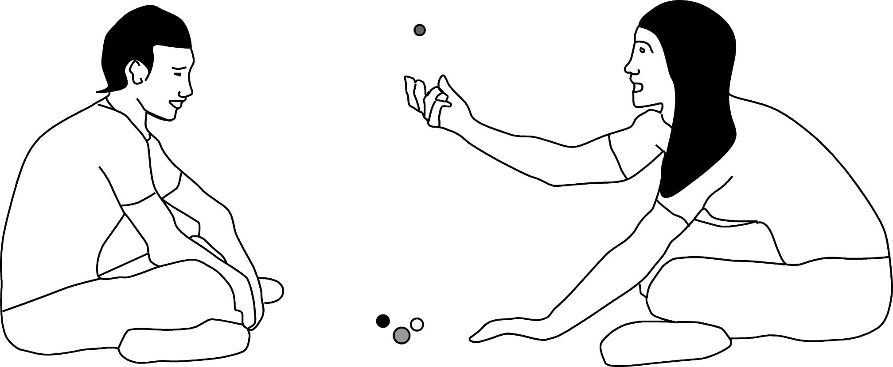  3  Ko Ata rāua ko Pono | 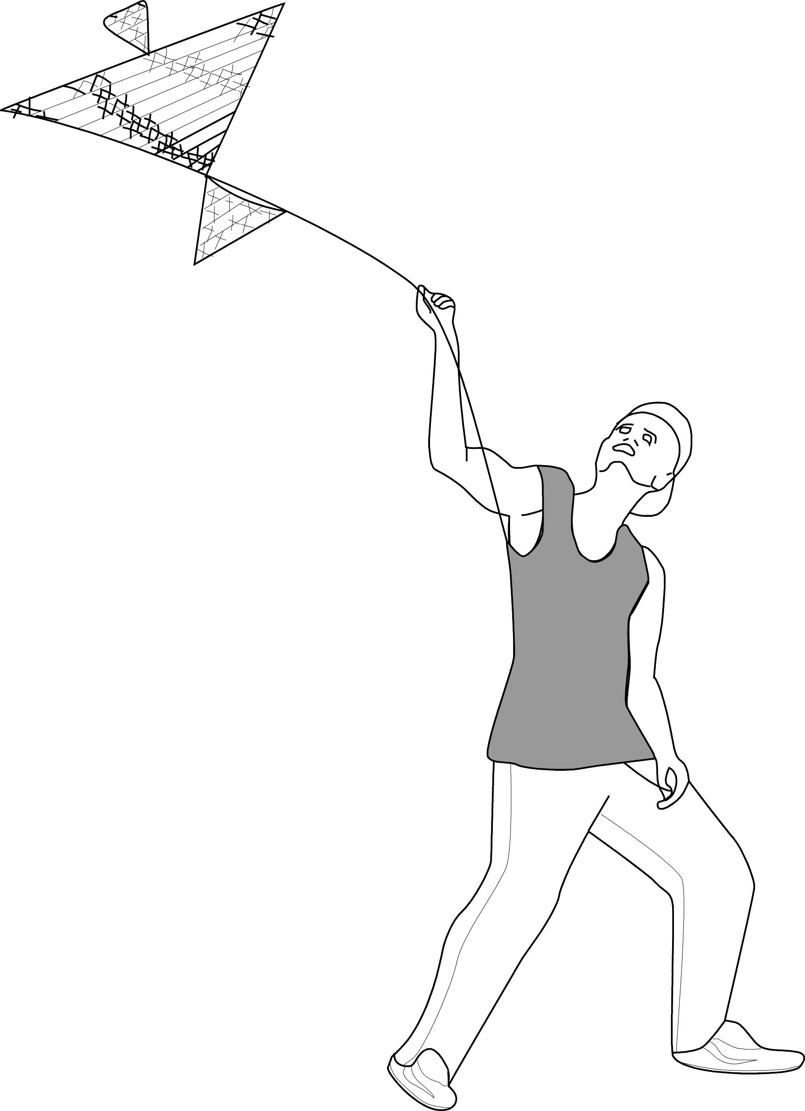  4  Ko Rewa  Ko Māia rāua ko Pīata | 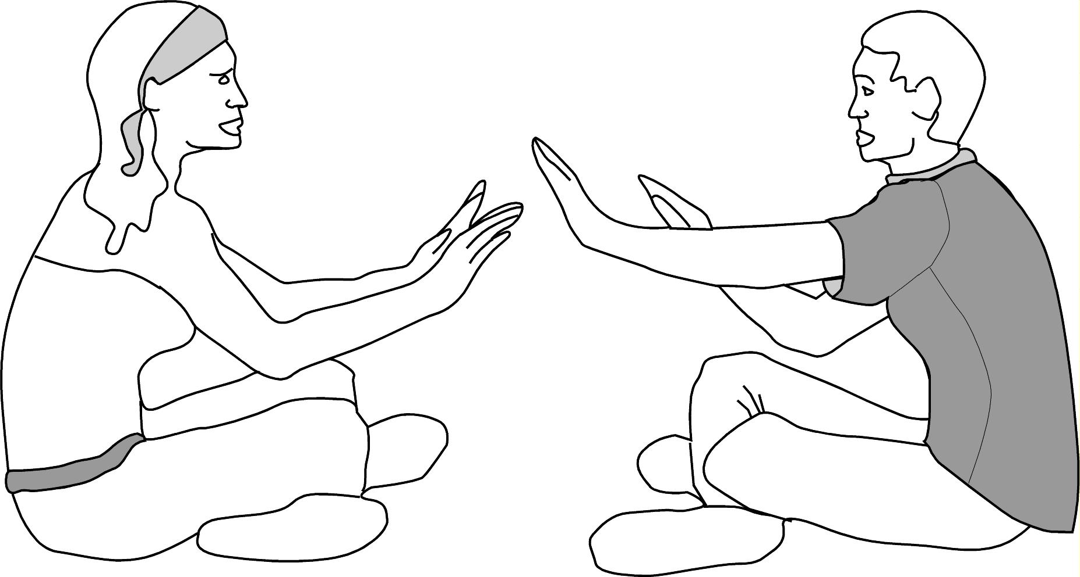  5 | 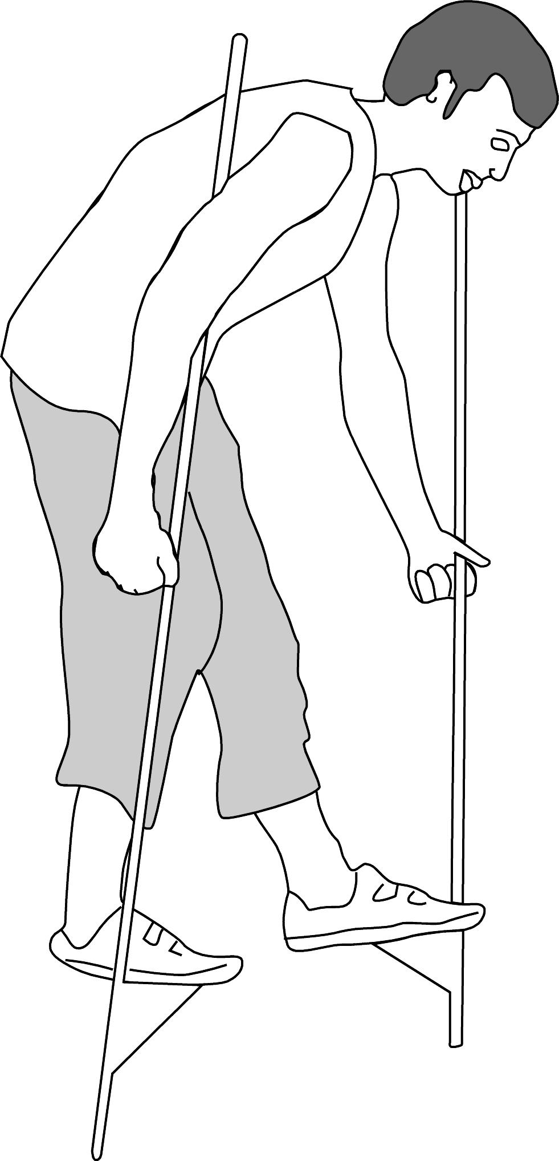  Ko Te Hana
6  7  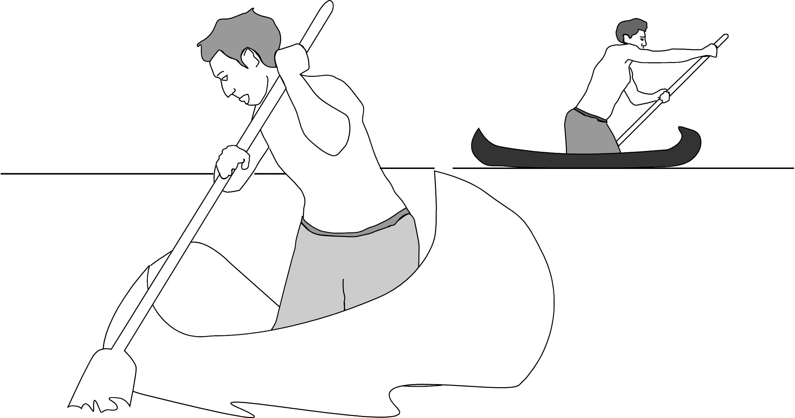  Ko Kiwa rāua ko Pou  11 | 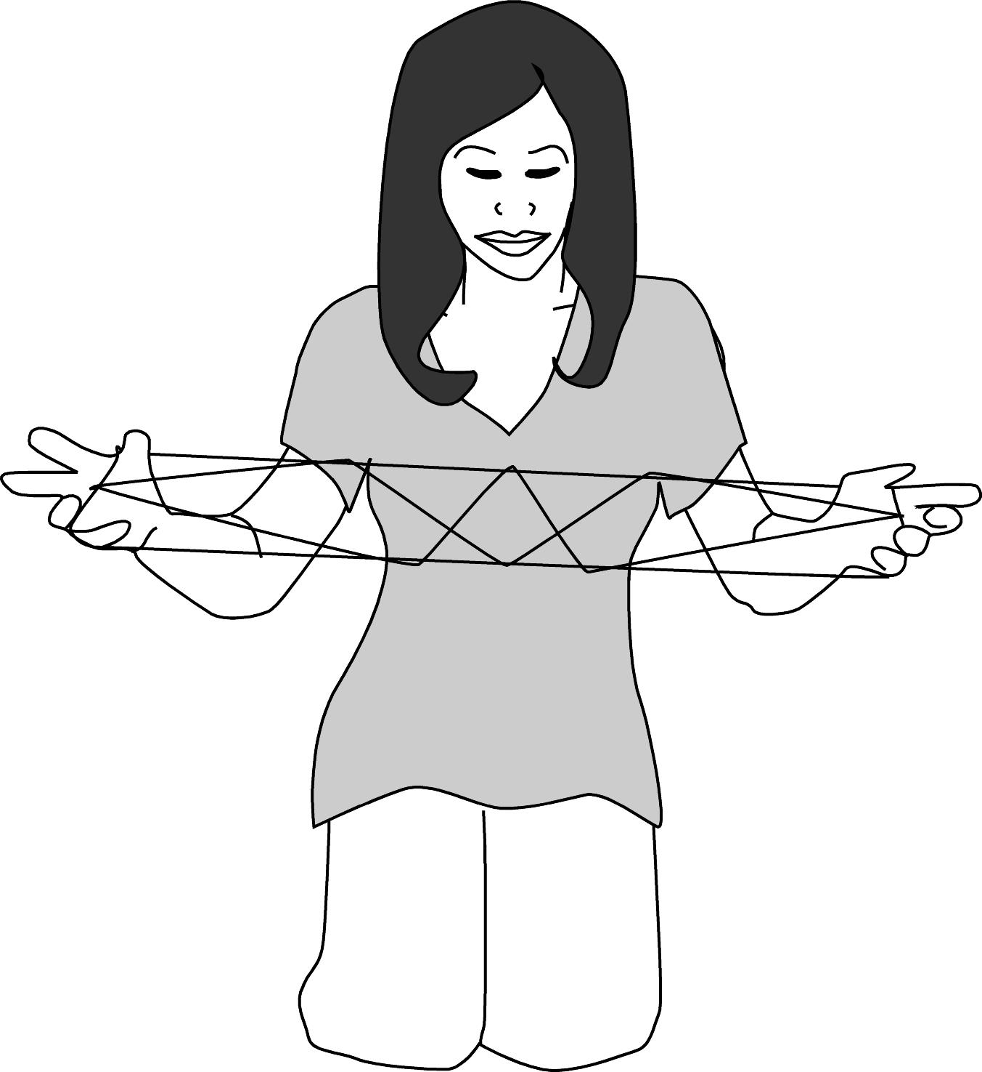  8  Ko Kōtare  Ko Rātū rāua ko Tama | 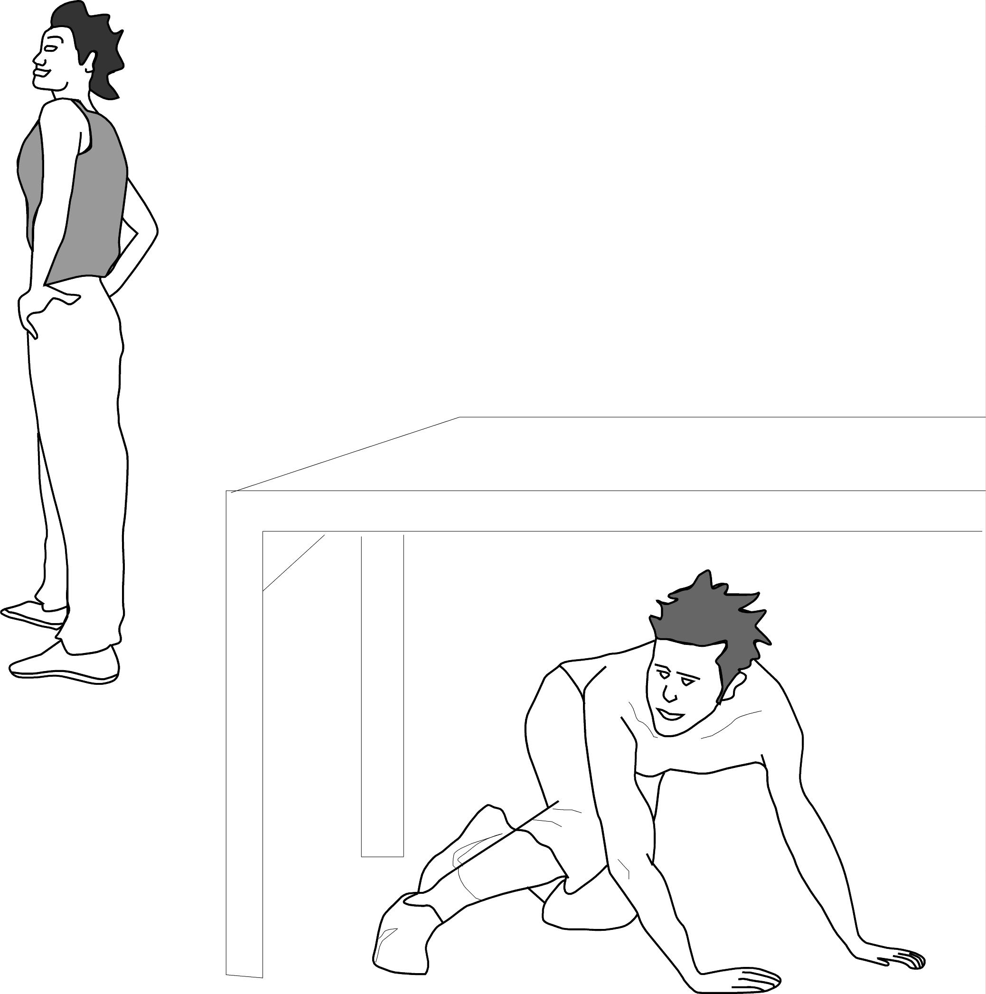 | 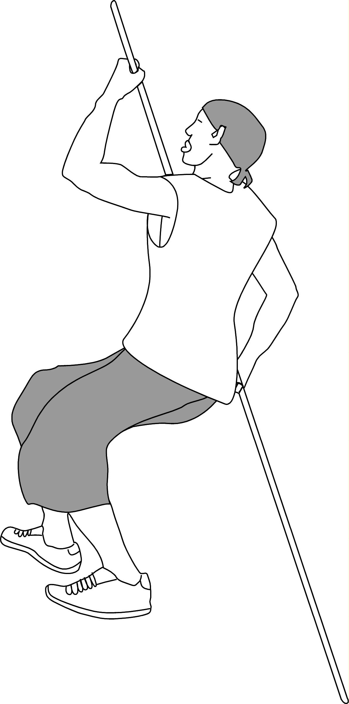  10  9  Ko Takoha | 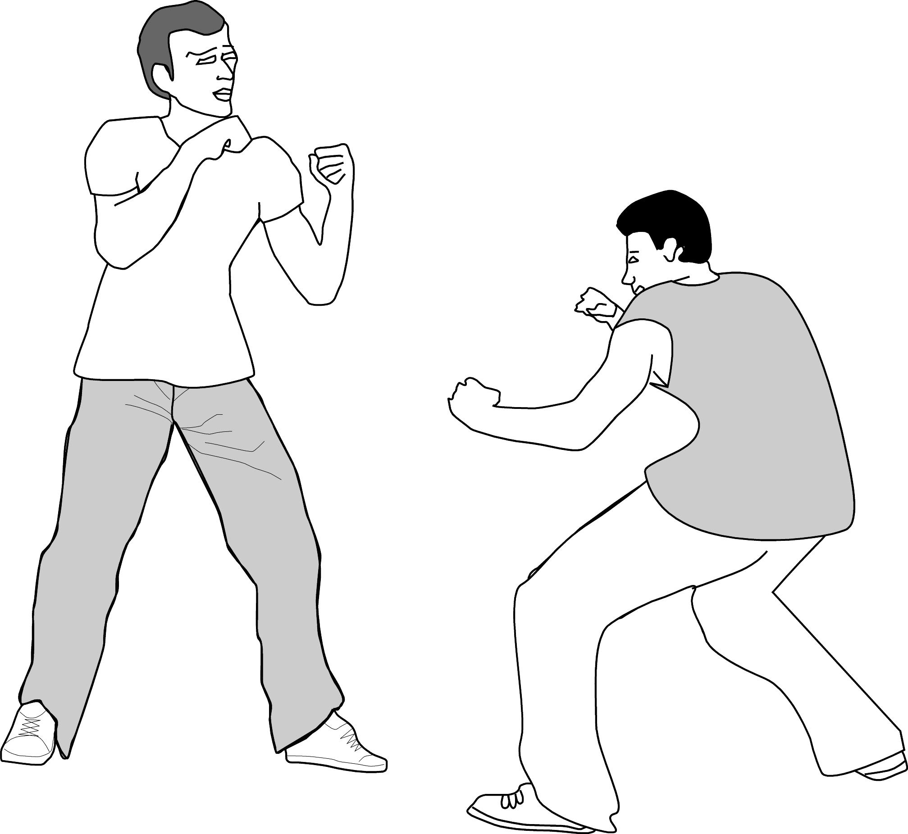  Ko Rota rāua ko Kahu
12  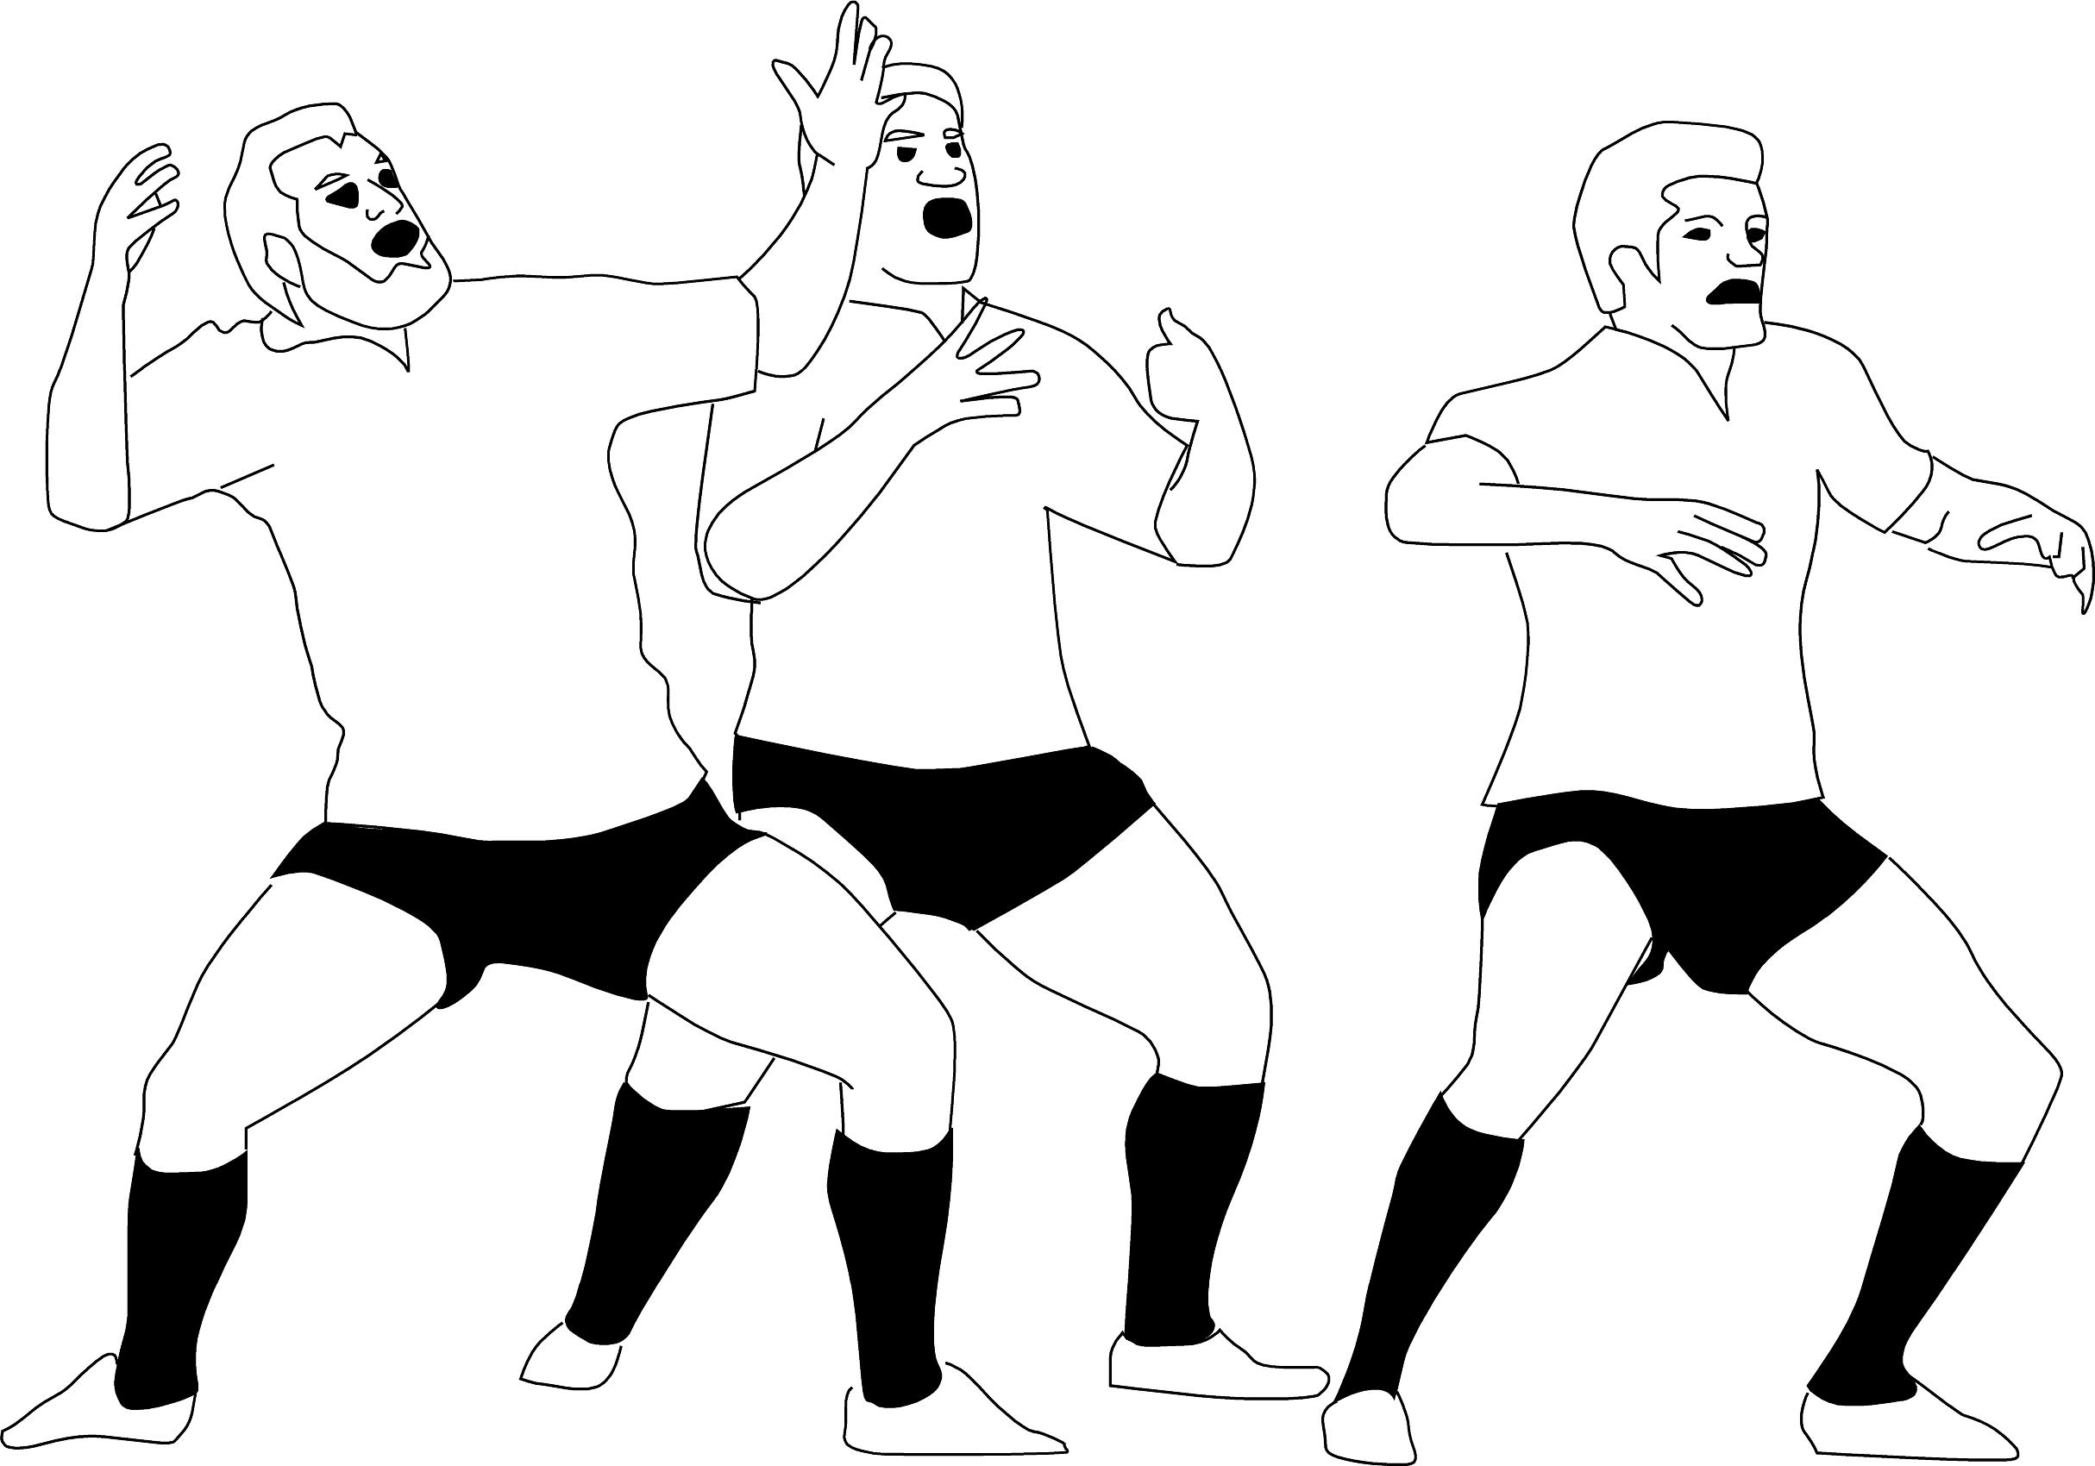  Ko Rā rātou ko Tai ko Mita | 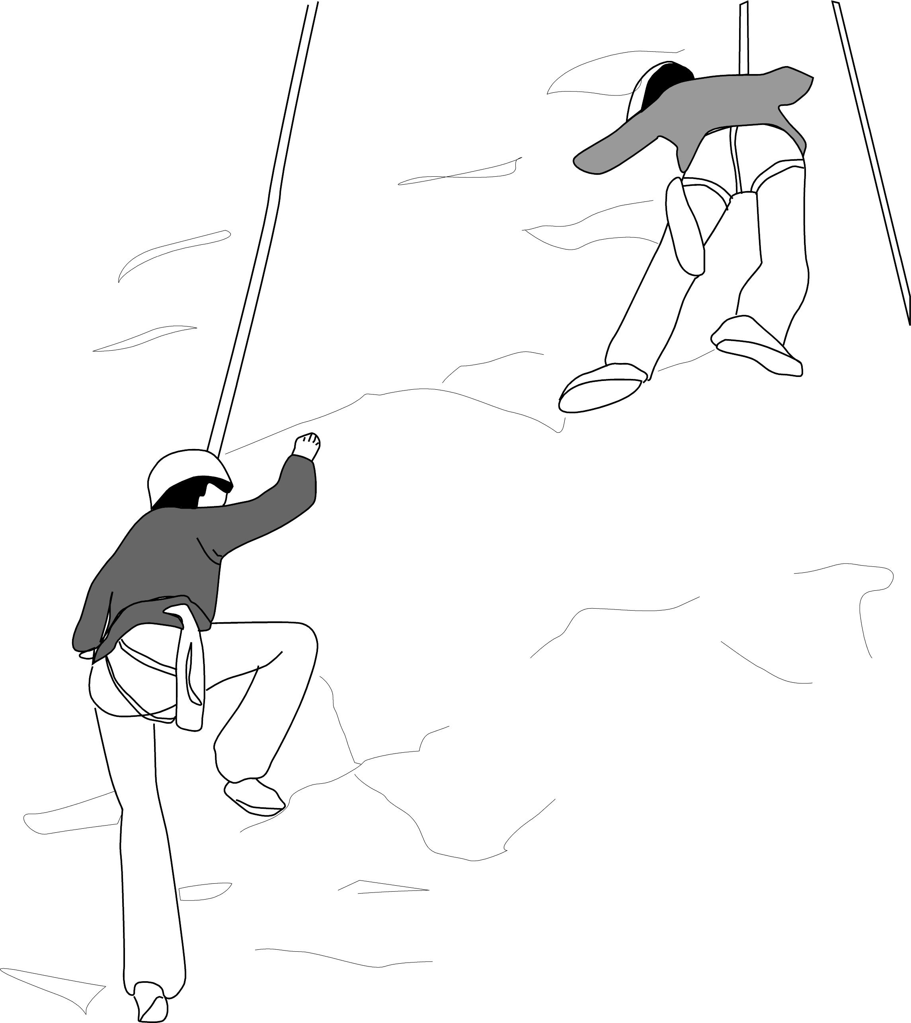  13  Ko Kopa rāua ko Tio | 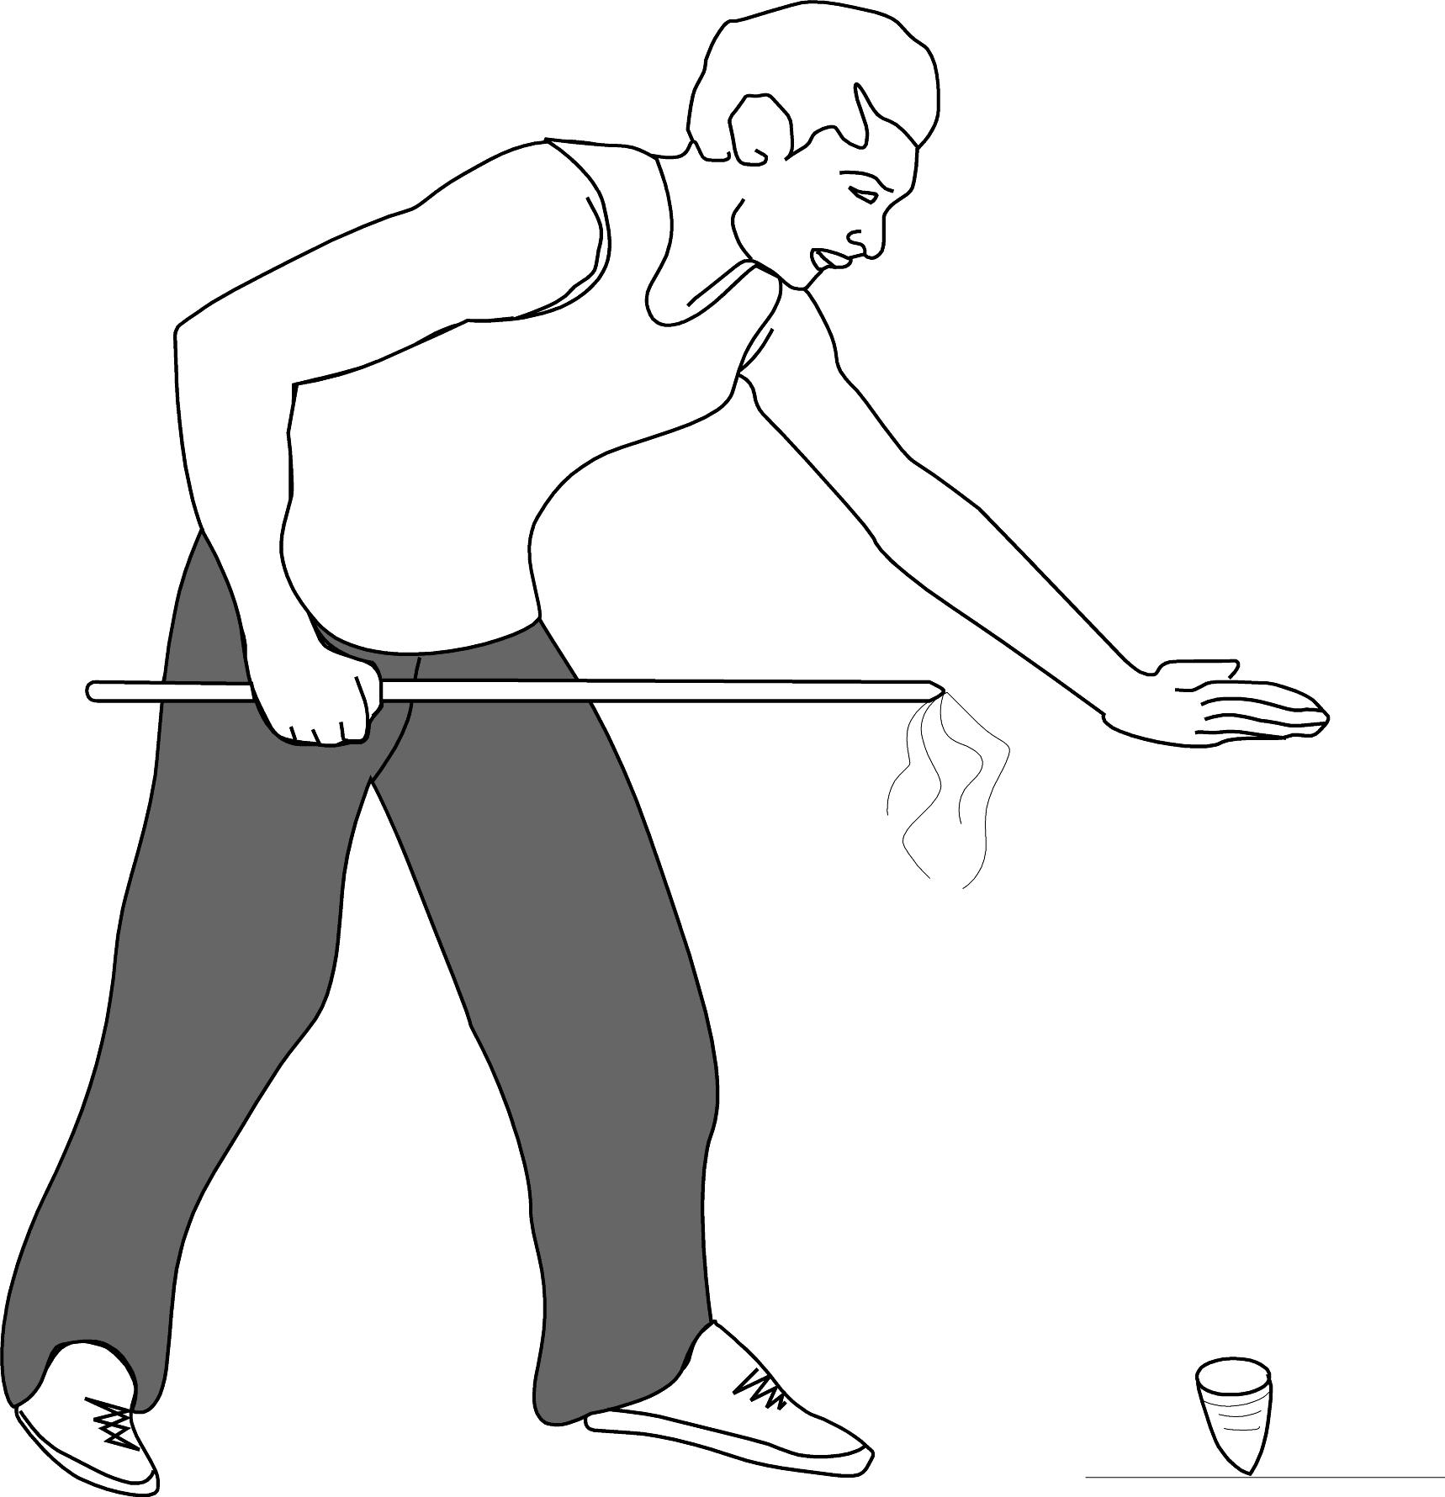  14  Ko Ngoro | 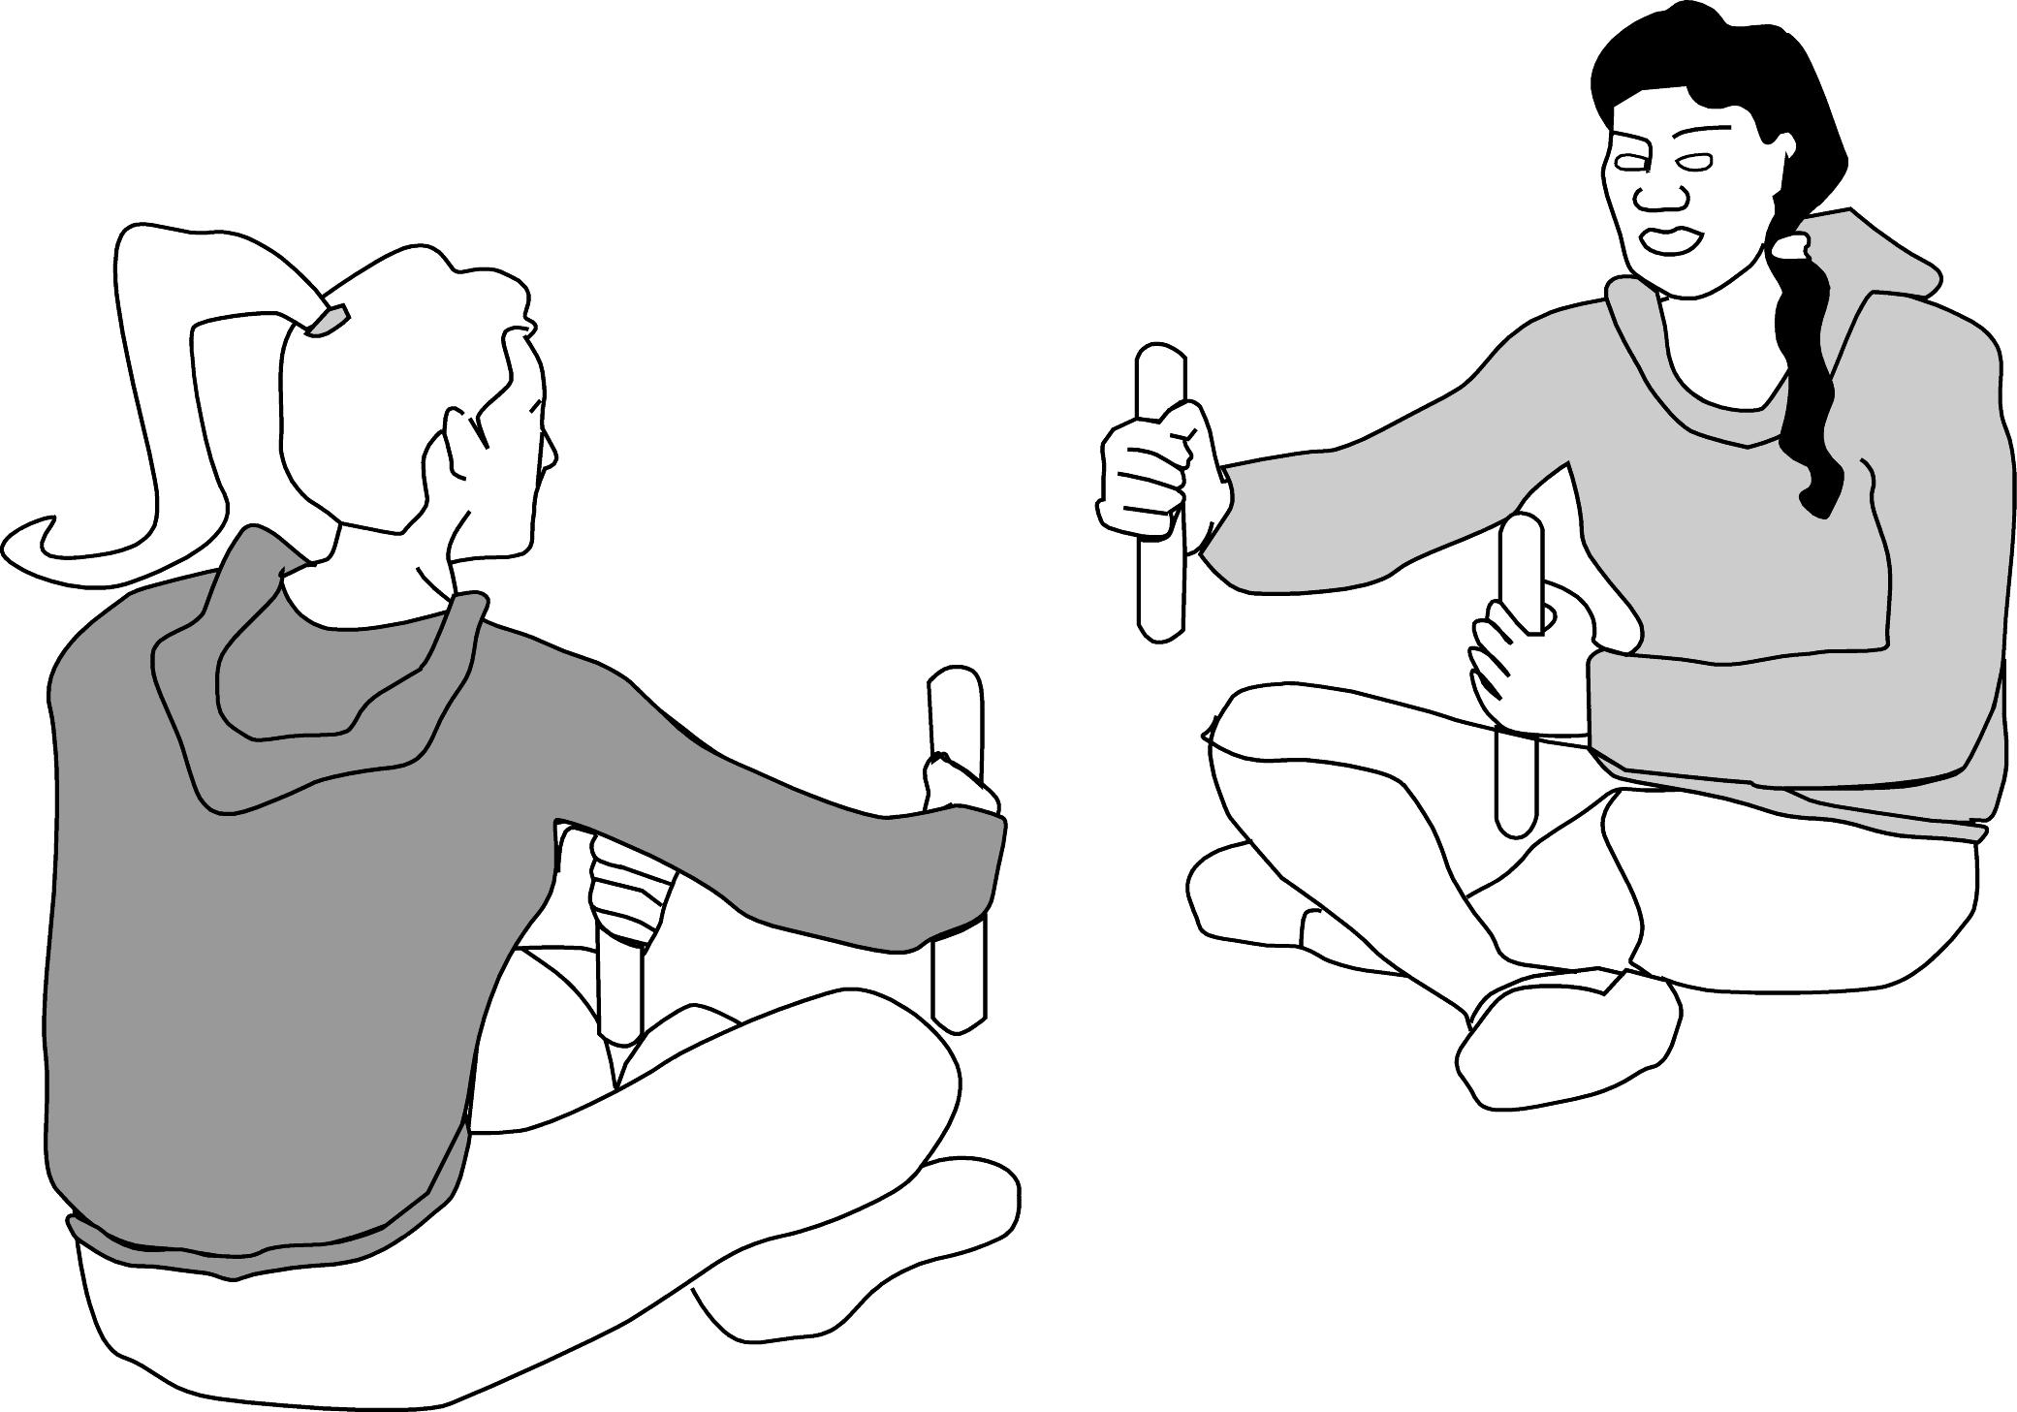  15  Ko Hine rāua ko Pīata | 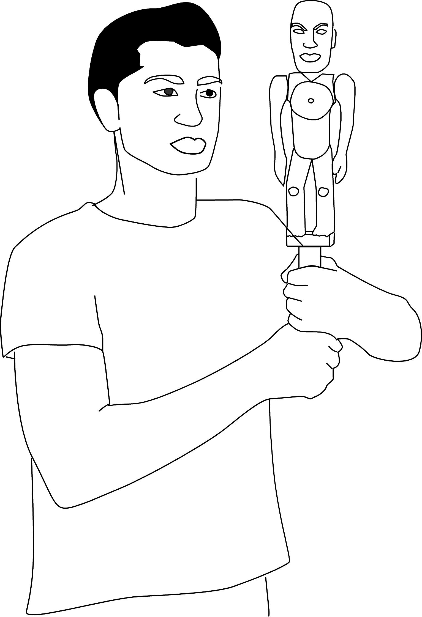  Ko Ariā

