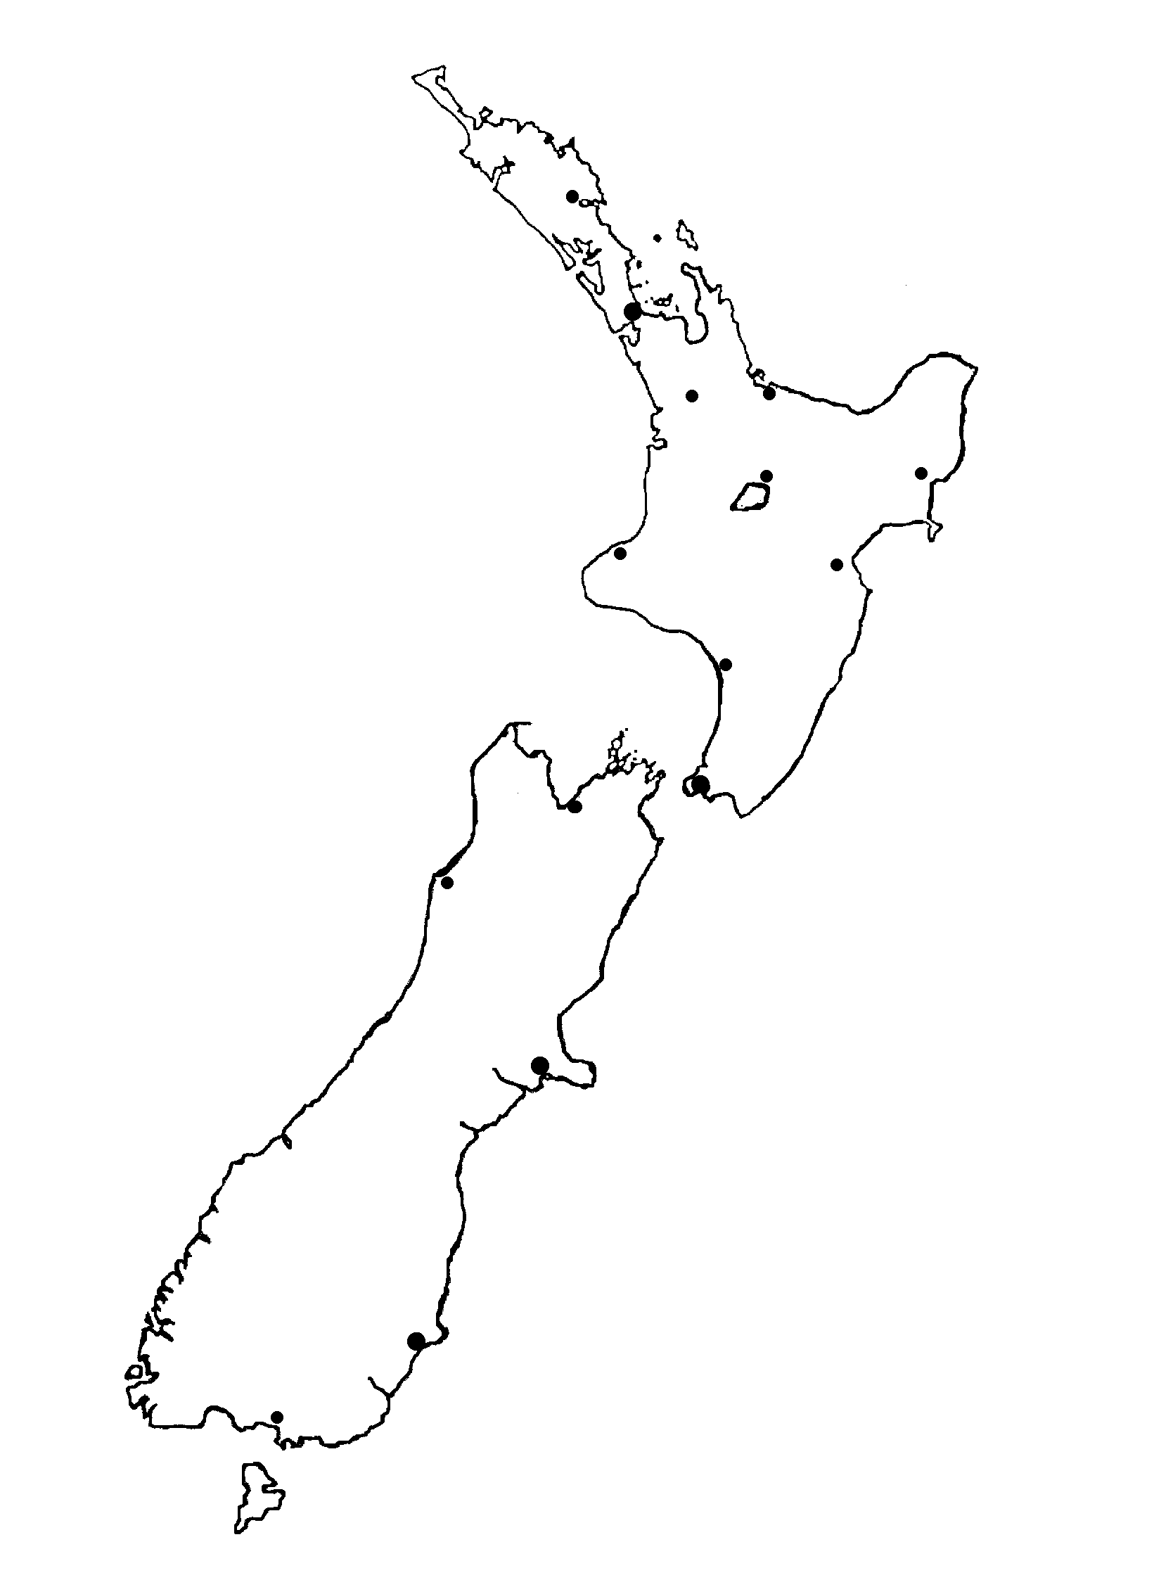
Ngāmotu

Ahuriri

Tūranga
Taupō

Tauranga

Kirikiriroa

Whangārei

Whanganui

Whakatū

Te Whanganui a Tara

Tāmaki makau rau

Ōtautahi

Ōtepoti

Murihiku

Māwhera



23
25
20
23
18
24
18
16
14
14
17
18
Resource sheet 7E: Te āhua o te huarere mō te 6 o Hakihea 2007

