Resource sheet 7G: Pūrongo huarere

Tuhia mai he pūrongo huarere ki raro iho nei. Write a weather report below.

Te Ika a Māui
Rāhina | Rātū | Rāapa | Rāpare | Rāmere
Te ata
 |  |  | 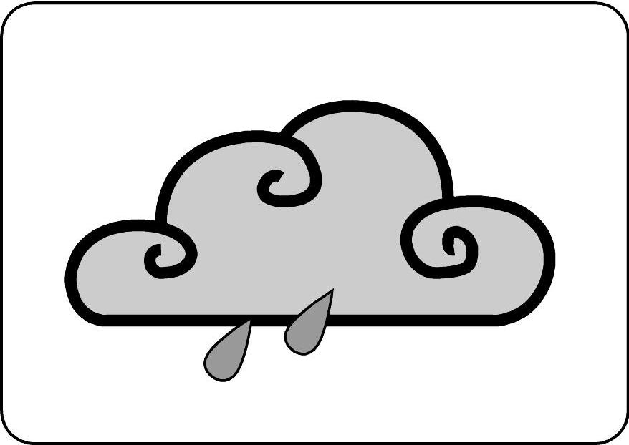 | 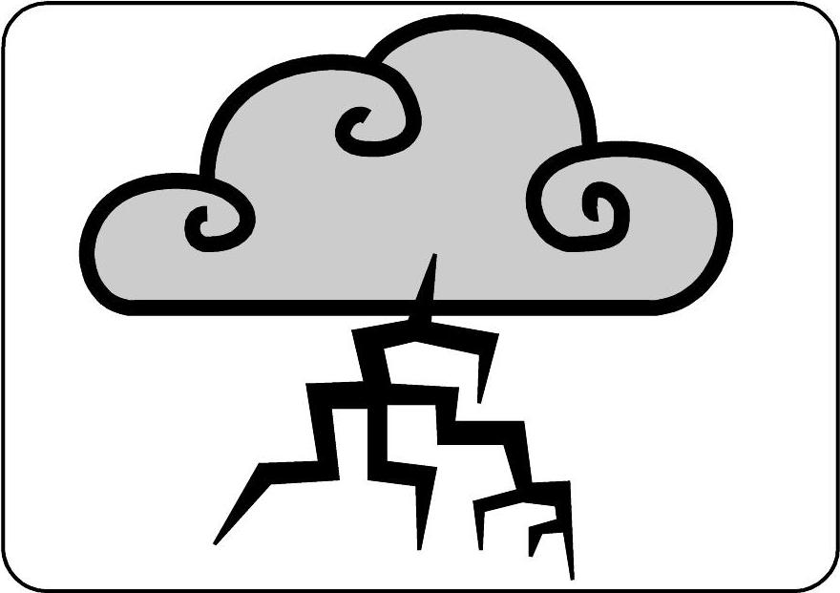
Te ahiahi
 |  | 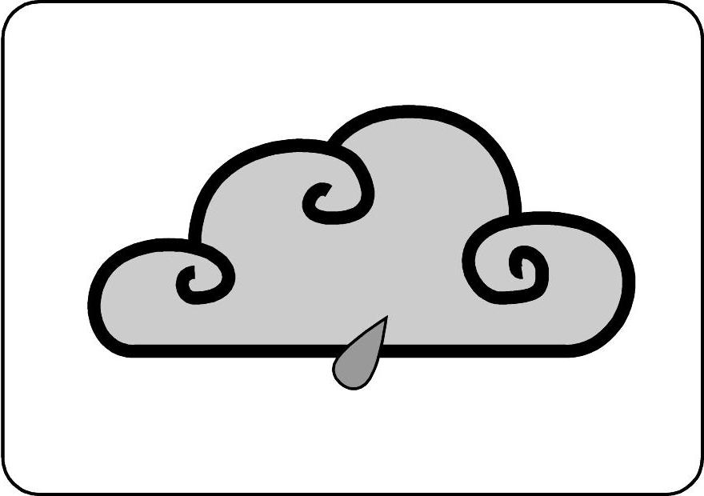 | 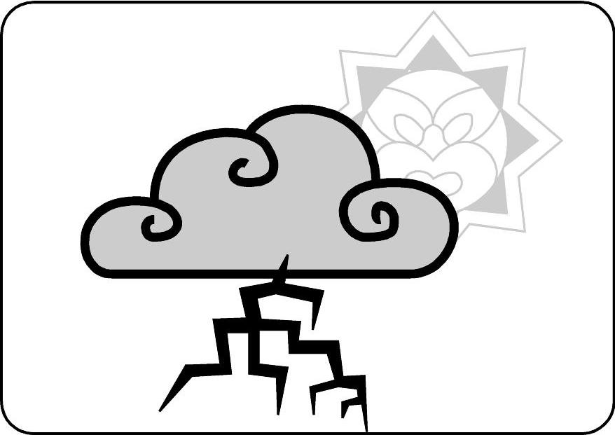 | 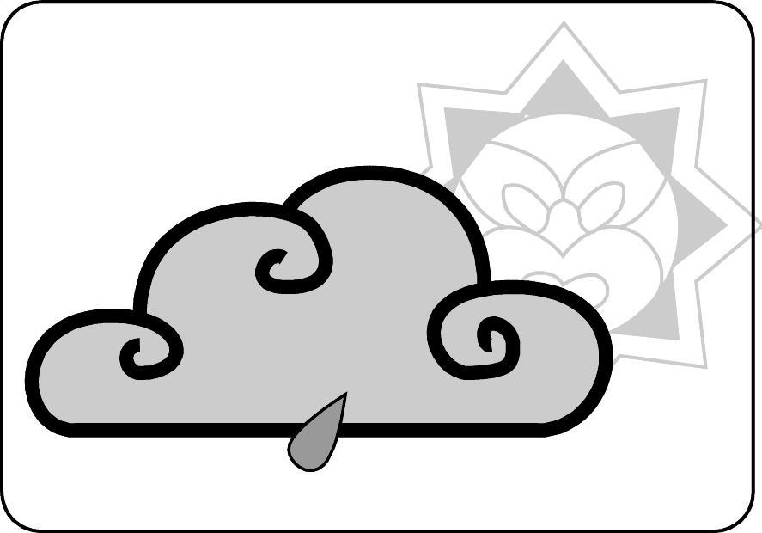

Hau
He kōhengihengi mai i te raki. | He hau pūangi mai i te rāwhiti. | He hau tonga. | He haurokuroku mai i te tonga. | He haupongi mai i te rāwhiti.
Pāmahana
15-18° | 19-21° | 17-19° | 15° | 17-19°

Pūrongo

Kīwaha
He kupu whakatūpato, akiaki rānei ki te whānau

