Complete the map He mahere tāone Ākonga 1

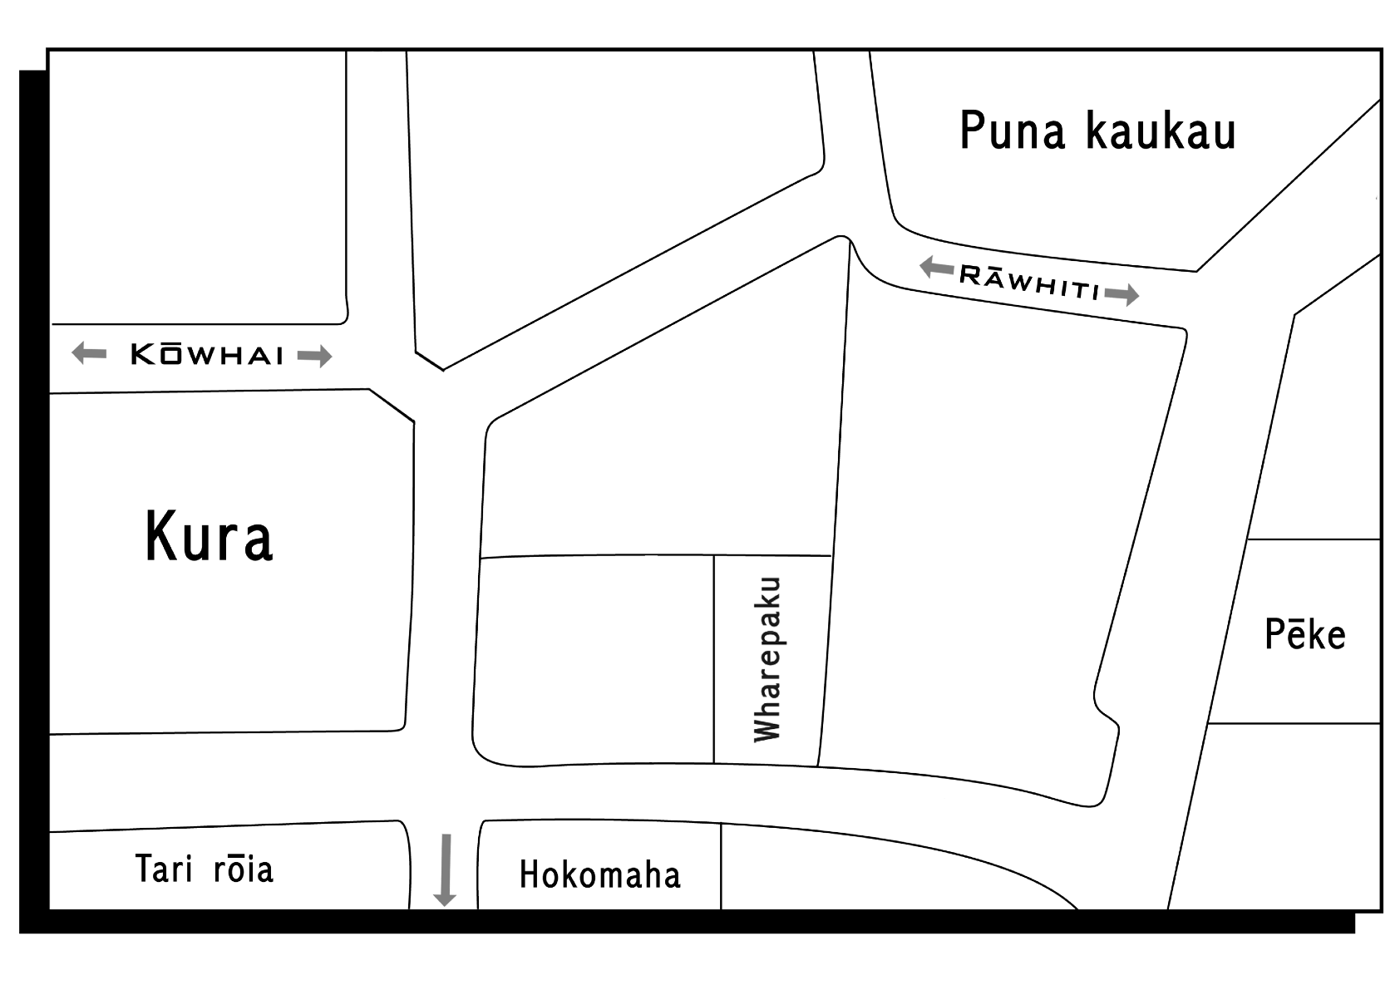
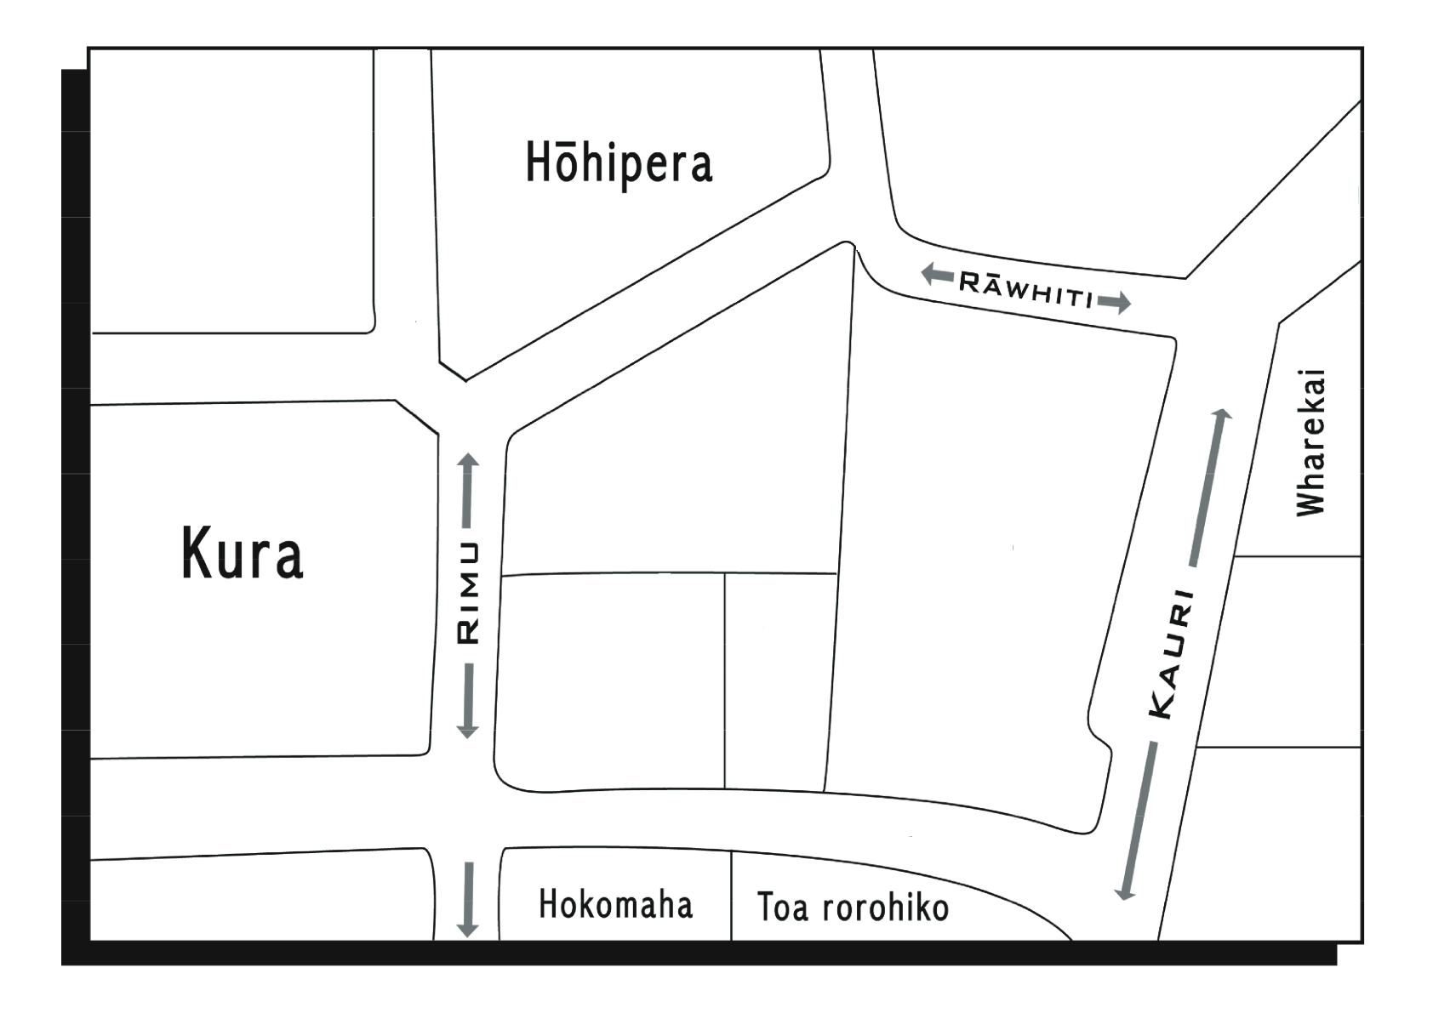
Complete the map He mahere tāone Ākonga 2

Complete the map He mahere tāone Ākonga 3

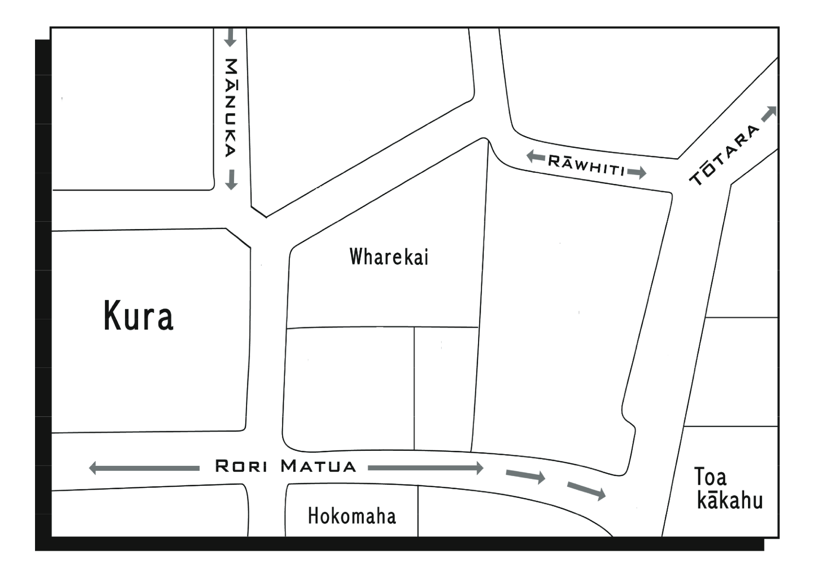
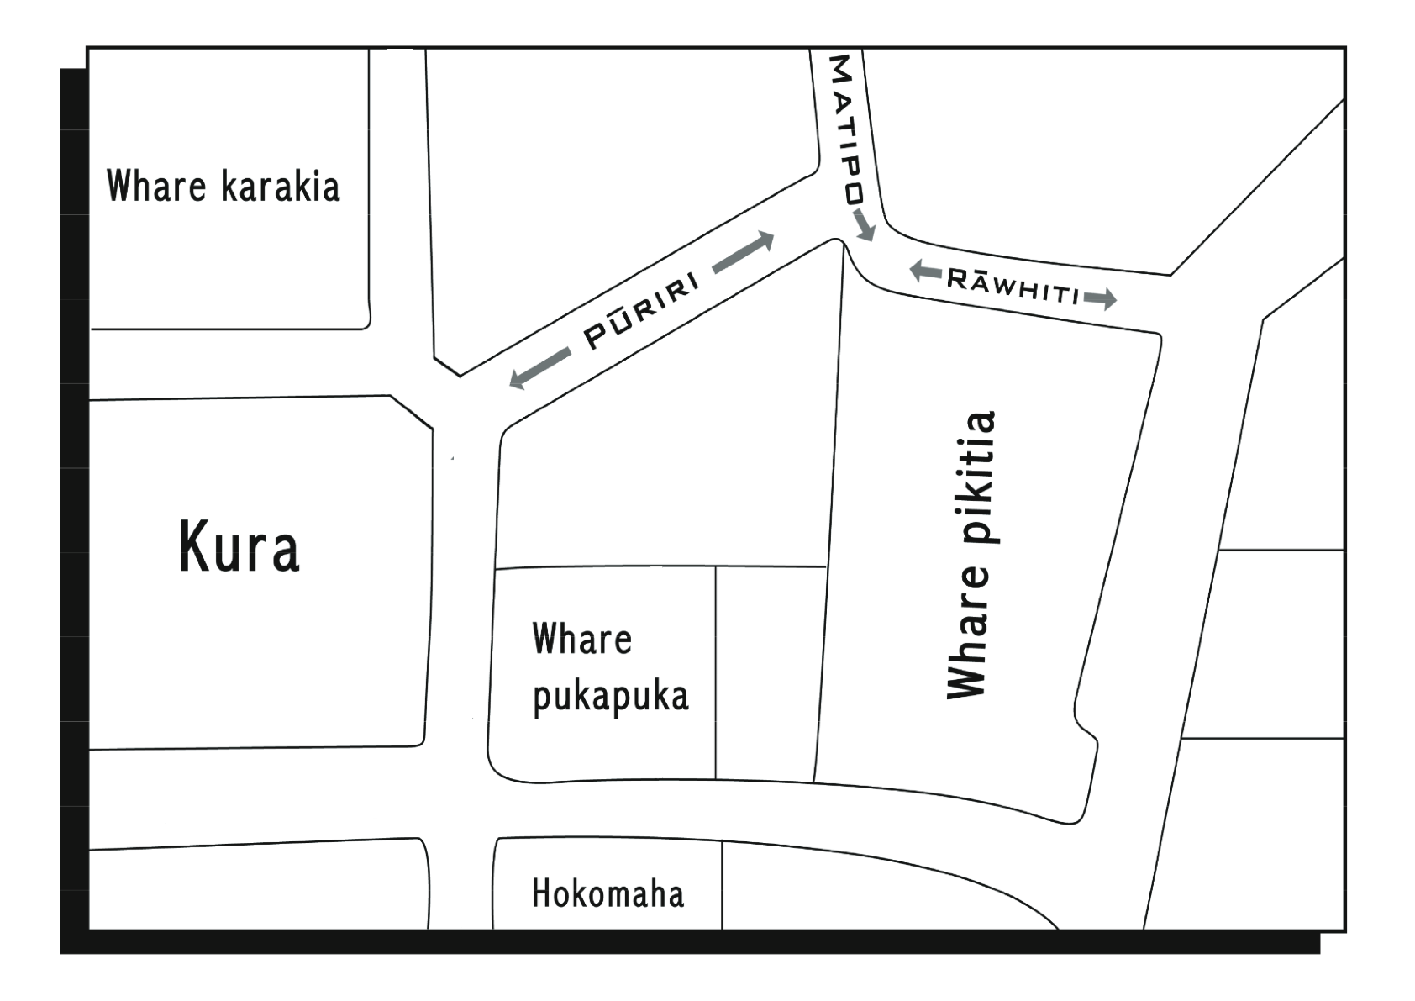
Complete the map He mahere tāone Ākonga 4

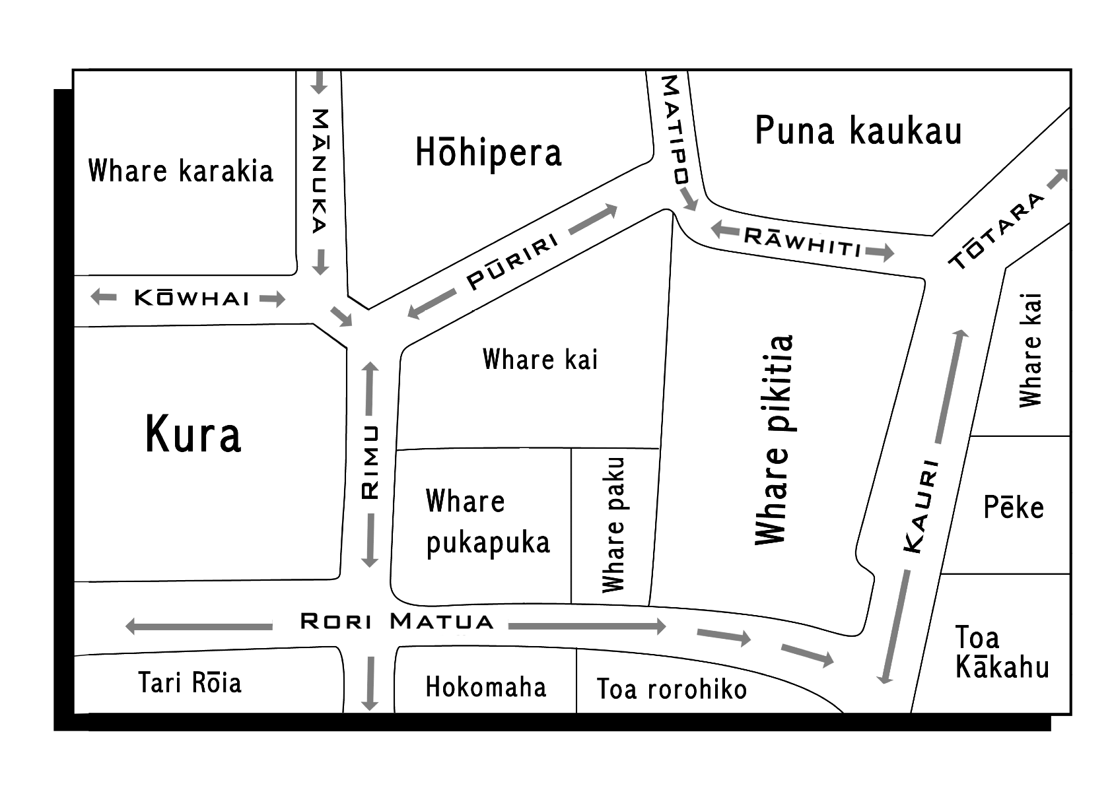
Complete the map He Mahere Tāone Mahere matua

