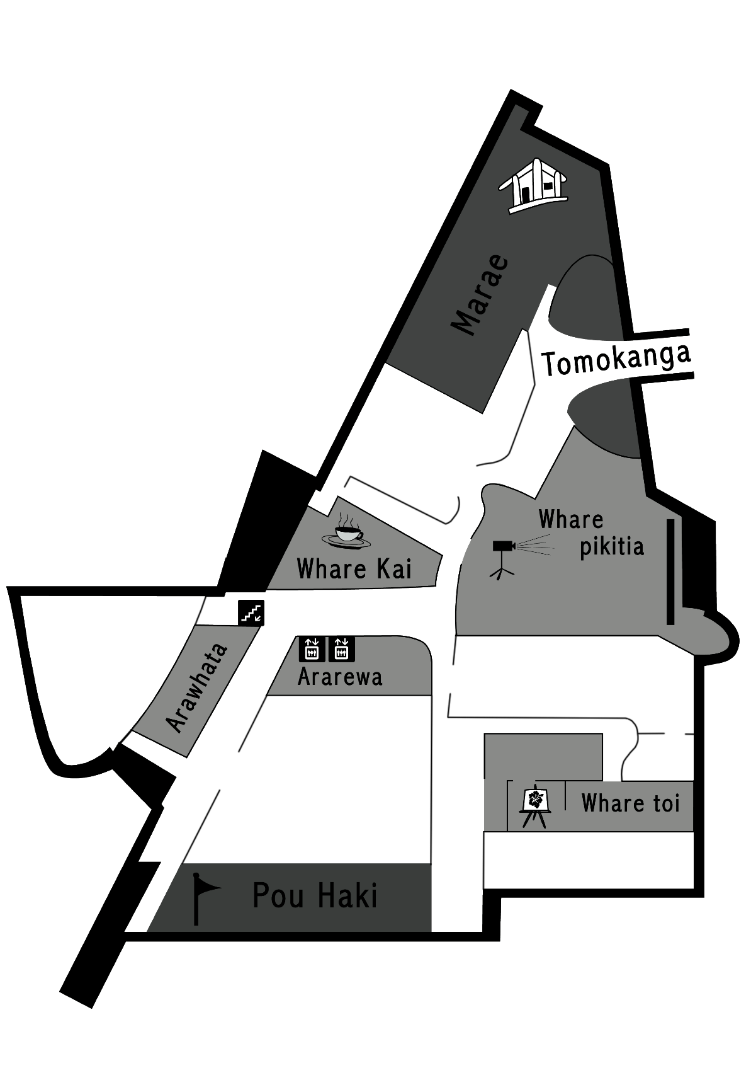
Complete the map He Mahere mō te Whare Pupuri Taonga
Ākonga 1
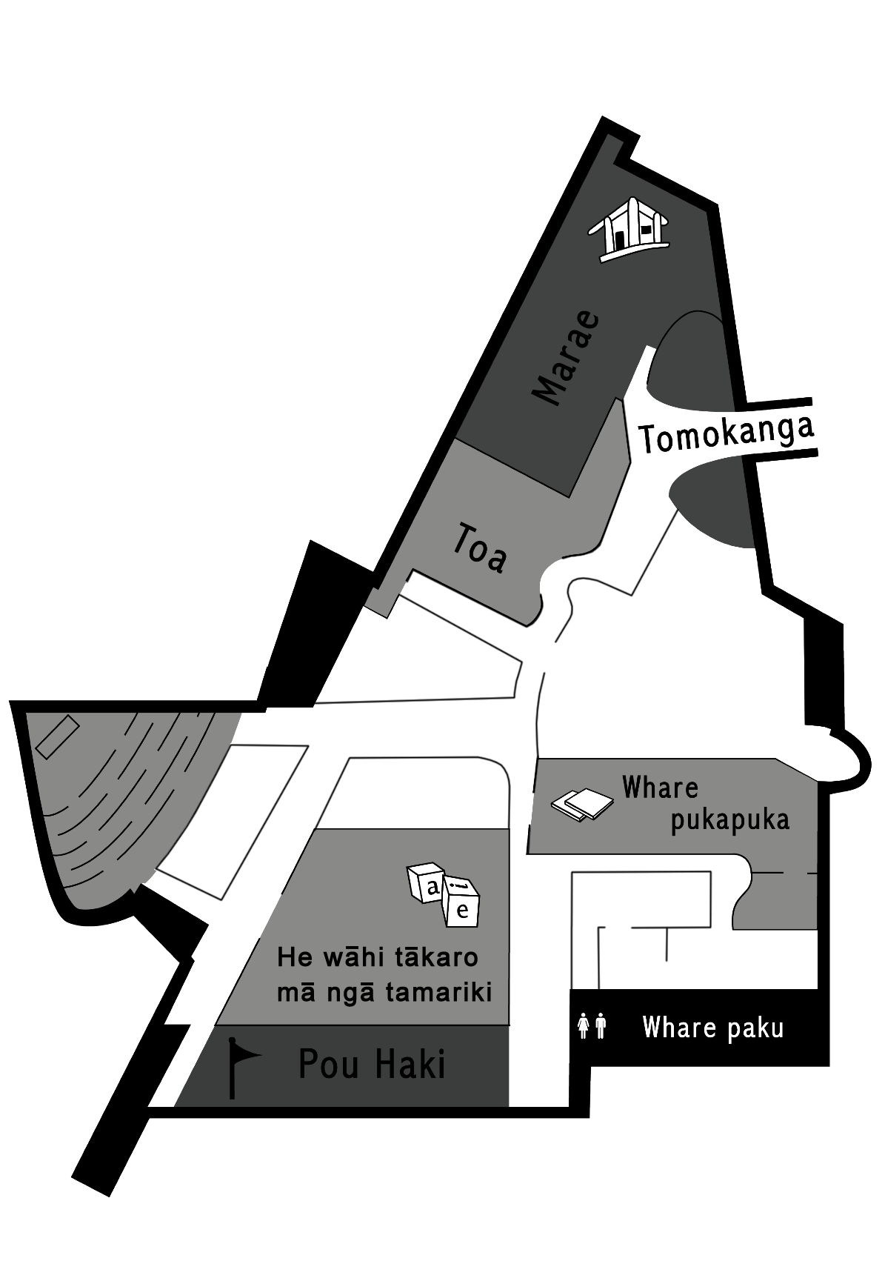
Complete the map He Mahere mō te Whare Pupuri Taonga
Ākonga 2
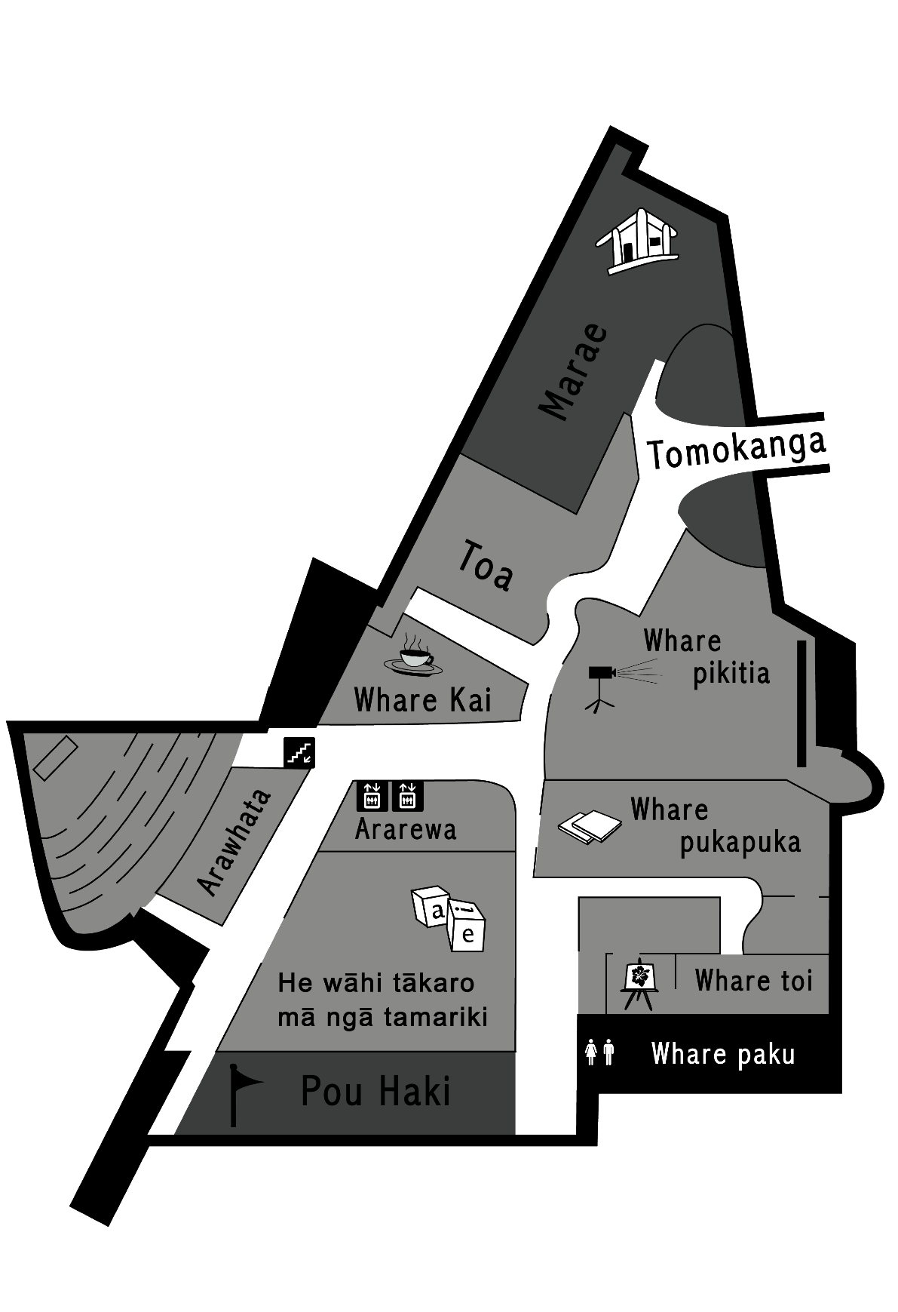
Complete the map He Mahere mō te Whare Pupuri Taonga
Mahere Matua

