Strip Picture He Kōrero i Wāwāhia

Ākonga 1
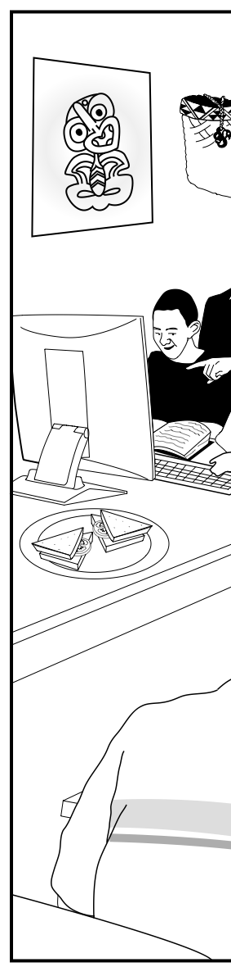
Strip Picture He Kōrero i Wāwāhia

Ākonga 2

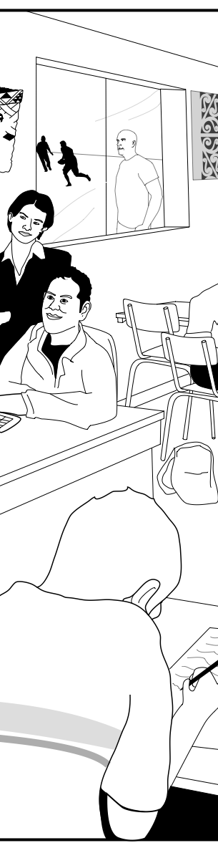

Strip Picture He Kōrero i Wāwāhia

Ākonga 3

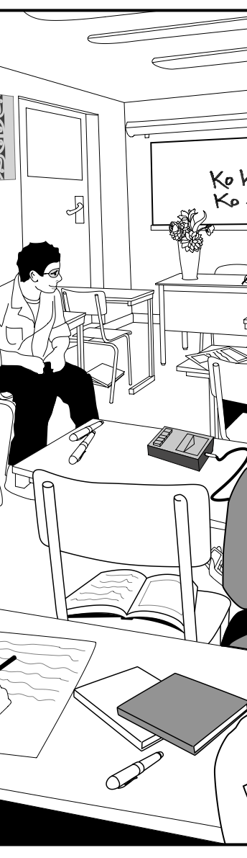

Strip Picture He Kōrero i Wāwāhia

Ākonga 4
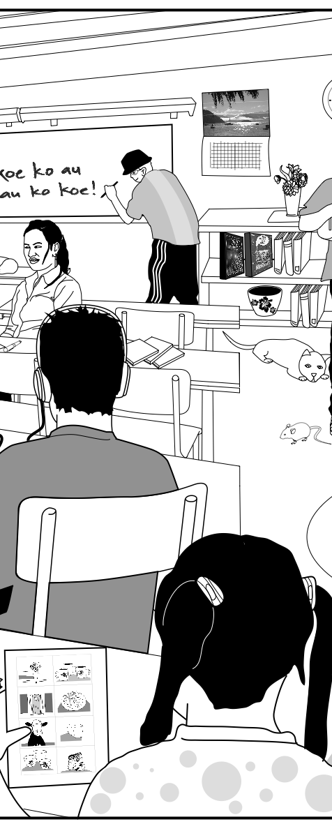

Strip Picture He Kōrero i Wāwāhia

Ākonga 5
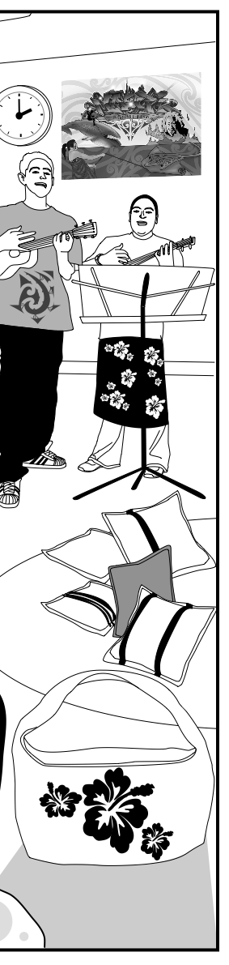
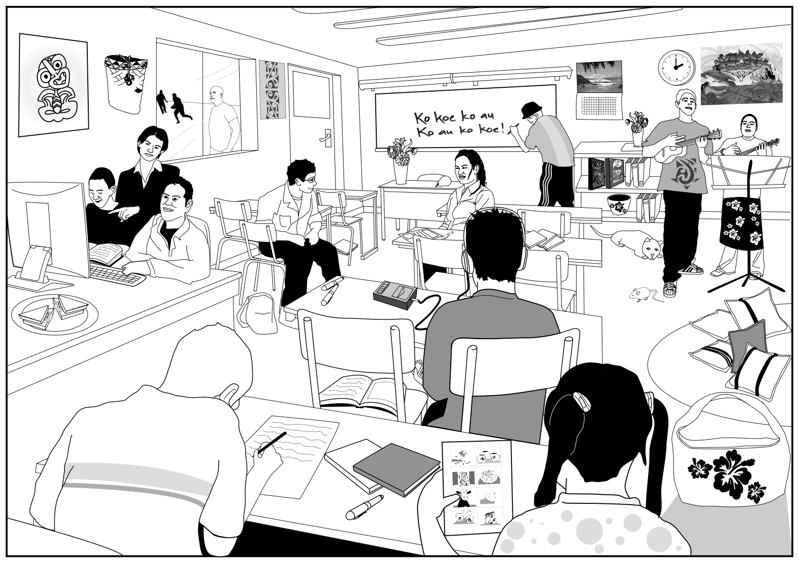
Strip Picture He Kōrero i Wāwāhia Mahere Matua

