Listen and Draw Te Tāone o Awatere Mahere matua
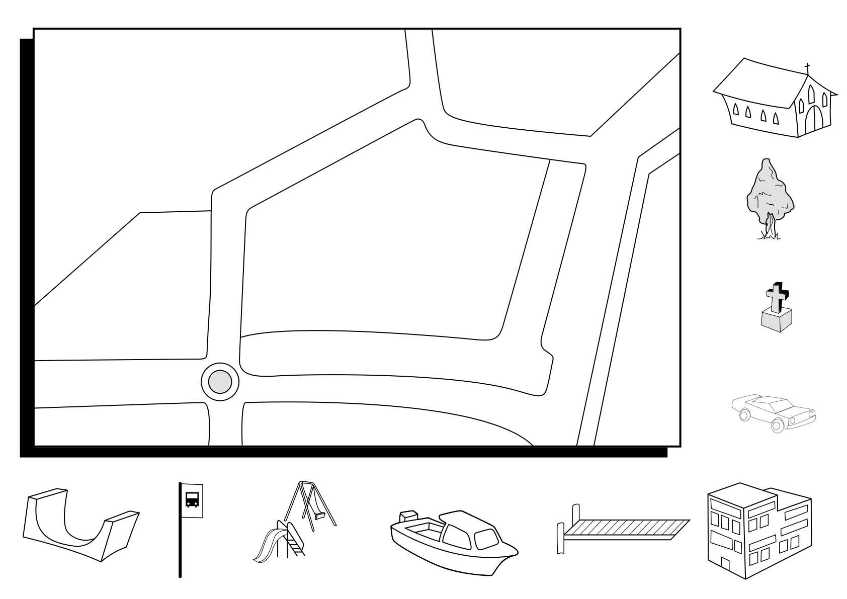
Listen and draw Te Tāone o Awatere Ākonga

