Write from a chart according to text type

Te Mahi Poi Step 1

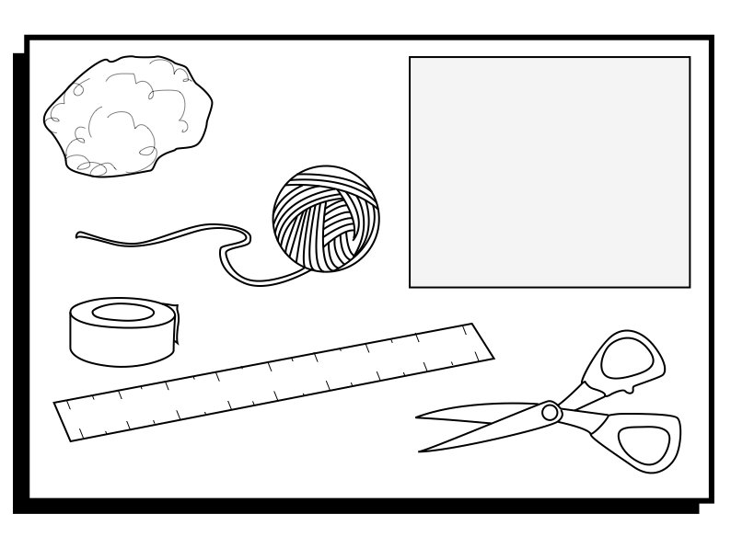

Write from a chart according to text type

Te Mahi Poi Step 2

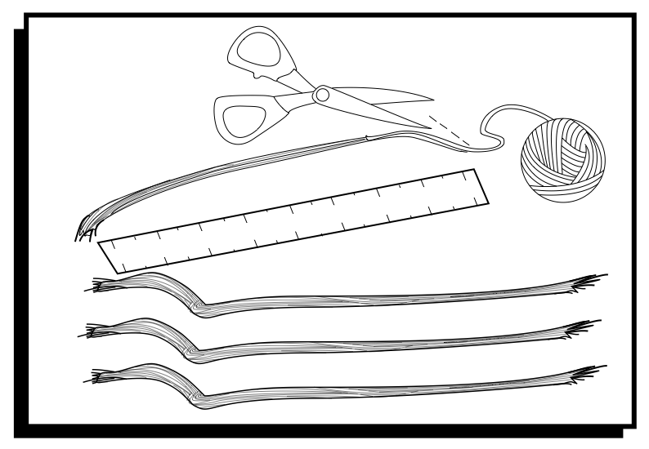

Write from a chart according to text type

Te Mahi Poi Step 3

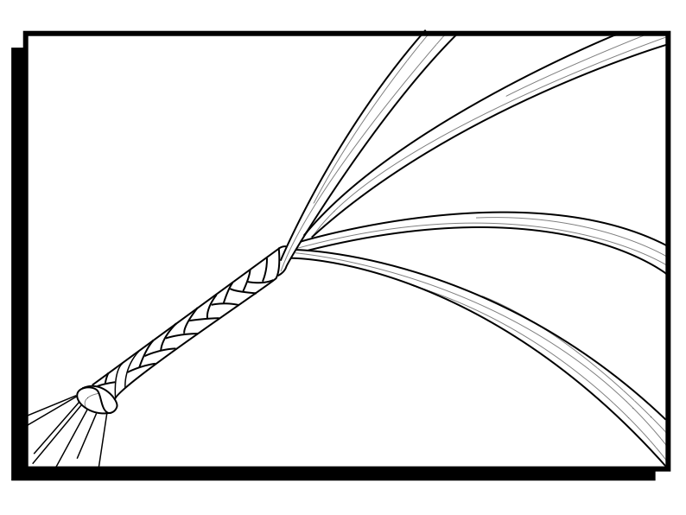
Write from a chart according to text type

Te Mahi Poi Step 4

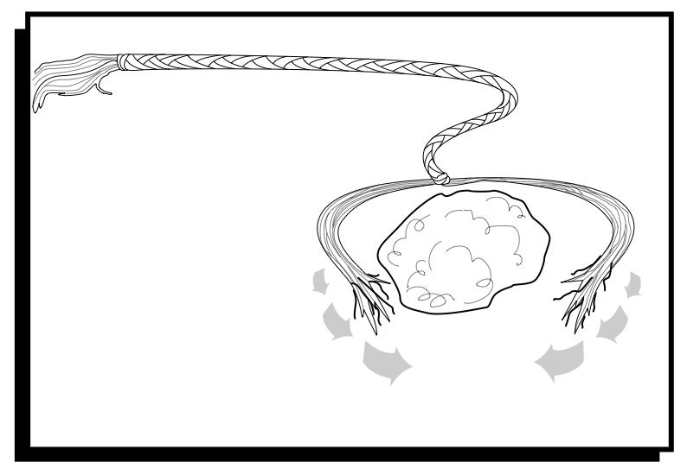

Write from a chart according to text type

Te Mahi Poi Step 5
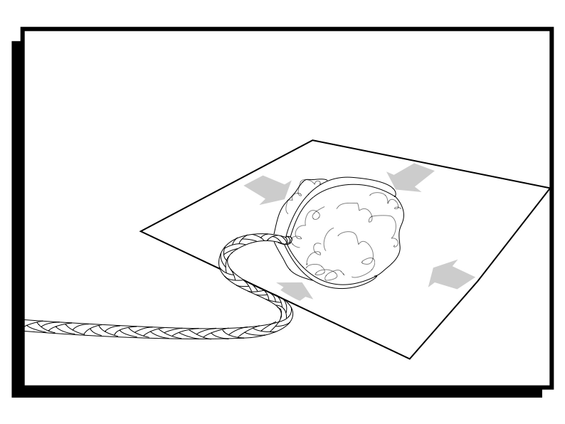

Write from a chart according to text type

Te Mahi Poi Step 6

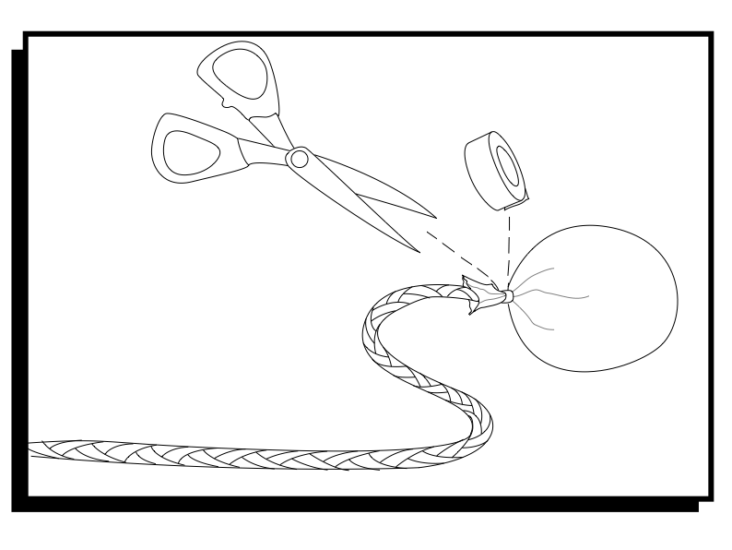

Write from a chart according to text type

Te Mahi Poi Step 7
