Thought about being a Script Writer for Film And Television?

Maori Matrix

YEAR 11 LEVEL 6 ESSENTIAL LEARNING AREA Languages

OBJECTIVES  Te Reo: Mätakitaki  - Ka whai haere, ka märama te äkonga ki ngä wähanga reo ataata ähua roa tonu, ä, ka taea te whakamärama atu te ähua o te hononga atu o ënei ki te reo-ä-waha.  Te Reo: Whakaatu  - Me hängai te reo ataata o te äkonga ki te kaupapa, ki te pütake o te whakaaturanga me te hunga mätakitaki. | LEARNING OUTCOMES/SKILLS  - Writing sentences using pictures as stimulus.  - Expressing opinions.  - Constructing sentences using verbs to describe action.

OVERVIEW
You are trapped in the matrix and are trying to escape from the agents. Can you write your way out?

INSTRUCTIONS
Under each picture, write descriptive sentences saying what you are doing and what the agents are doing.

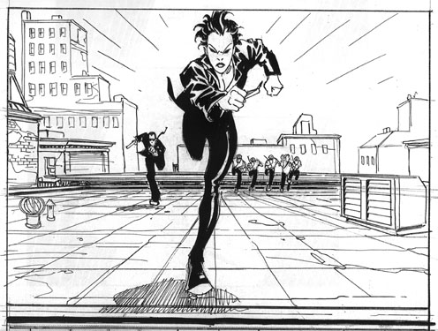
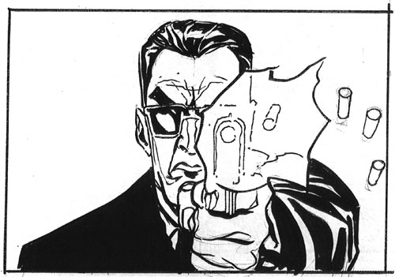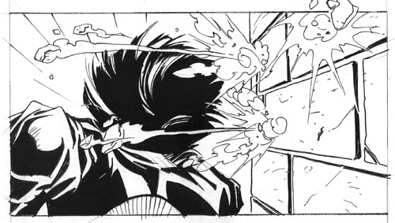

Design a Māori poster for the Matrix . All writing and drawings should reflect Māori culture. Give the title, names of Māori actors and illustrations that are obviously Māori. The Matrix can represent the pākehā world and the real world can represent the Māori world. What obvious differences are there in culture, language, customs, behaviour and beliefs?

Poster | Responses

