Thought about being an Artisan, Jeweller, Craftsperson?

Taonga

YEAR 9-11 LEVEL 4-6 ESSENTIAL LEARNING AREA Arts/Technology

OBJECTIVES  Ngä Toi: Toi Ataata / Mahi  - Ka whakapakari pükenga te äkonga mä te whakamahi rawa tä me ngä taputapu hei whakawhanake ariä.  Tikanga-ä-iwi: Te Ahurea me te Tuku Ihotanga  - Te whai wähitanga o te ahurea me te tuku ihotanga ki te taukiri o te tangata. | LEARNING OUTCOMES/SKILLS  - Design taonga for a special ceremony.  - Use a variety of patterns, designs and symbols on a taonga.

OVERVIEW

Design taonga or pieces of jewellery for a student graduating from University.

INSTRUCTIONS

Design earrings, a neck- piece, a ring and a bracelet for a person in their early 20’s. The pieces should combine traditional and modern materials and look modern and original in design.
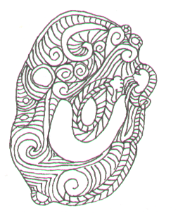
Consider using a mixture of shapes, designs and materials:

- Natural patterns from nature
- Geometric designs
- Paua
- Bone
- Metal
- Stones
- Crystals

Earrings | Neck Piece | Ring | Bracelet
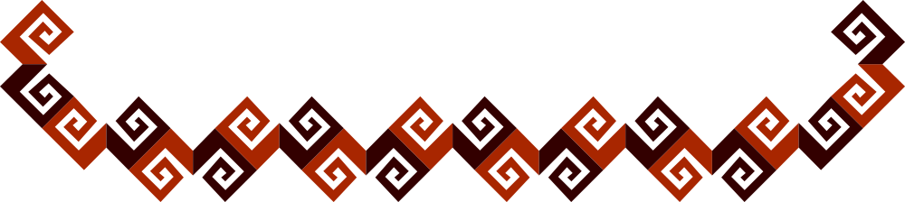

Ideas

 |  |  | 
 |  | 


 | 
 |  |  | 
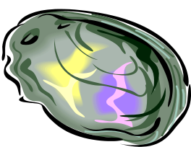 |  | 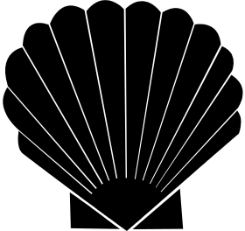 | 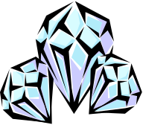
 |  |  | 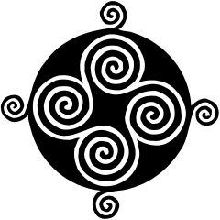
 |  | 

