NGĀ MOMO TOKA  www.science-teachers.com |  | Ingoa: __________________________
Whakapae
2 Ngā toka ka hua mai i te mātaotanga o te tokarewa. (7)
5 He toka kāhuarau ka hua mai i te pākeho. (6)
6 He toka kāhuarau ka hua mai i te tokauku. (5)
8 He toka ‘1’ nei te tohu māro i te ine Moh. (4)
11 He toka ka hua mai inā mātao ai te tokarewa i te mata-ō-nuku. (6)
12 He tikanga whātau i te māro o te toka. (4)
14 He toka ngiha, māeneene, mōhinuhinu, uriuri nei. (8)
16 He toka parataiao e hangaia ana i te whakapiringa o ngā wāhanga kaitā o ētahi toka kē atu. (12)
17 He toka kāhuarau i hua mai i te hōanga. (9)

Whakararo  1 Ngā toka i hua mai i ngā whakaputunga iho a te ngau huarere, a te horonga hoki. (11)  3 He toka waiwera e puta ana i te mata o nuku. (4)  4 He momo toka ngiha urutomo, he tioata nui kei roto. (7)  5 He toka ka hua mai inā pākahatia ai ētahi atu toka e te kaha pēhanga me te wera. (11)  7 He toka parataiao i hua mai ai i ngā putunga kotakota anga i ētahi wā. (9)  9 He toka parataiao i hua mai ai i ngā putunga kirikiri. (9)  10 He toka, ‘10’ te tohu māro i te ine Moh.(7)  13 He toka waiwera. (5)  15 He toka parataiao i hua mai ai i ngā putunga uku. (5) | 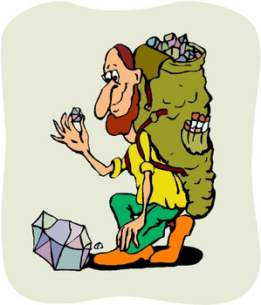

Ngā Momo Toka

Ngā Whakautu

Whakapae Whakararo

2 igneous 1 sedimentary

5 marble 3 lava

6 slate 4 granite

8 talc 5 metamorphic

11 basalt 7 limestone

12 mohs 9 sandstone

14 obsidian 10 diamond

16 conglomerate 13 magma

17 quartzite 15 shale

