TOKA NGIHA  www.science-teachers.com/earth.htm |  | Ingoa __________________________
Whakapae
4 Ngā momo toka ngiha ka hua mai i raro i a Papa.(9)
5 Te kupu Rātini i te reo Pākehā mō ‘ignis’. (4)
11 Te toka ratarata i te kōpū o Papa. (5)
12 Te toka ratarata i te mata-o-nuku. (4)
13 He toka whakaputa māeneene, kanoiti nei. (8)
14 Ngā momo toka ngiha ka hua mai i te mata-o-nuku. 9)

Whakararo  1 Te momo kano tioata ka hua mai inā āta mātao haere ai te toka ratarata. (6)  2 He toka pungapunga māmā nei ka hua mai inā tere mātao haere ai te rangitoto me te kapokapo hau hoki.(6)  3 Te momo kano tioata ka hua mai inā tere mātao ai te toka ratarata. (4)  6 He toka whakaputa, he hinewaiapu te rite engari he paku kē atu ngā tioata. (8)  7 Te momo toka ka hua mai inā mātao ai te rangitoto. (7)  8 He toka urutomo, taratara ana te tioata, he tino toka mō te hanga whare, whakamaharatanga hoki. (7)  9 He toka ngiha whakaputa, mārō nei, māna e hanga ai te puia ārai. (6)  10 He toka ngiha urutomo, uriuri matanui nei, he karā te rite o te hanga kohuke.(6) | 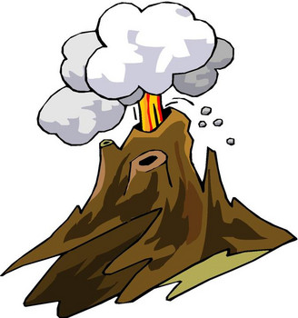

TOKA NGIHA NGĀ WHAKAUTU

Whakapae Wakararo

4 intrusive 1 coarse

5 fire 2 pumice

11 magma 3 fine

12 lava 6 rhyolite

13 obsidian 7 igneous

14 extrusive 8 granite

9 basalt

10 gabbro

