NGĀ TOKA PARATAIAO  www.science-teachers.com/earth.htm |  | Ingoa: __________________________
Whakapae
1 Te kupu mō te whakapiripiringa o ngā para e pēpēhia ana.(10)
6 Te toka parataiao, hangaia ana i te kirikiri kano moroiti nei (te kiripaka me te wherepāra). (9)
7 He toka parataiao tino mārō e hua mai ai i roto i te pākeho. (5)
9 He toka parataiao e hangaia ana i te konupūmā pākawa, te hua o te takere moana kua maroke me te anga koiora. (9)
11 Te whakapiripiringa o ngā para i te kohuke. (11)
12 Papanga. (7)
Whakararo  2 He whakapapa nō te parahua e putu haere ana. Mā konei anō e noho pēpēhi ai. (8)  3 He mea e kitea nuitia ana e ngā tohunga mokoroa i ngā toka parataiao. (7)  4 He toka parataiao i hua mai ai i ngā parahua nui pērā i te toka me ngā pōhatu rikiriki. (12)  5 Ko ngā toka i hua mai ai i ngā mahuetanga parahua. (11)  8 Te kupu mō te tukitukinga o te toka i te hau, i te marangai, i te wera. (7)  10 He toka parataiao i hangaia ai i te uku kua pēpēhia. (5)  11 He hinu anga pōhatu ka hua mai i ngā putunga otaota o hia miriona tau i mua ake. (4) | 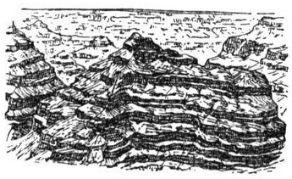

Ngā Toka Parataiao Ngā Whakautu

Whakapae Whakararo

1 compaction 2 pressure

6 sandstone 3 fossils

7 chert 4 conglomerate

9 limestone 5 sedimentary

11 cementatio 8 erosion

12 layered 10 shale

11 coal

