NGĀ TOKA KĀHUARAU  www.science-teachers.com/earth.htm |  | Ingoa: __________________________
Whakapae
6 Ngā momo toka ka hua mai inā pākahatia ai ētahi toka kē atu i te wera me te pēhanga. (11)
7 He toka kāhuarau ka hua mai i te hōanga. (9)
8 He toka tino mārō ka tahuna e te kaha wera, he iti nei te paoa rere. He toka kāhuarau ka ahu mai i te warowaro. (10)
11 He toka kāhuarau ka hua mai i te hinewaiapu. (6)
13 He momo kāhuarautanga inā pā atu te toka ki tētahi āhuatanga wera pērā i te tokarewa, ā, ka wera anō hoki ngā toka noho tata. (7)
Whakararo
1 He toka kāhuarau ngohe hangaia ana i te kohuke paura. (9)
2 He rangi kohuke whakarara kua pākahatia nei e te au ue. (9)
3 He momo tōpana e rangona ai inā tukituki ai tētahi papaneke ki tētahi atu. (8)  4 He kupu anō mō te huri. (5)  5 He toka kāhuarau i hua mai ai i te karā. (6)  6 He toka kāhuarau i hua mai ai i te pākeho. (6)  9 Te momo kāhuarautanga o te whakamaungatanga inā pākia ai te toka e te kaha wera, e te pēhanga. (8)  10 He mea e taea ai te kāhuarau ā-pānga. (4)  12 He toka kāhuarau ka hua mai i te tokauku. (5) | 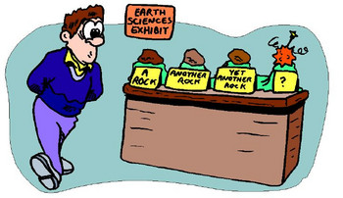

NGĀ TOKA KĀHUARAU NGĀ WHAKAUTU

WHAKAPAE WHAKARARO

6 metamorphic 1 soapstone

7 quartzite 2 foliation

8 anthracite 3 pressure

11 gneiss 4 morph

13 contact 5 schist

6 marble

9 regional

10 heat

12 slate

