SCIENCE UNIT PLAN

YEAR 10

NZ CURRICULUM LEVEL 5 SCIENCE

PHYSICAL WORLD

6 LESSONS & ACTIVITIES

ATMOSPHERE

Plan for Unit of Work – Year 10 Science – Atmosphere
Model: | ALL | Kaupapa Māori:
Teacher knowledge: | Moderate | Low
Essential Learning Area: | Science | Tāne
Curriculum – Subject | Science
Strand: | Planet Earth and Beyond | Ranginui
Process: | Earth Systems  Interacting Systems | Papatūānuku; Ranginui  Papatūānuku
Level: | 5
Title: | Atmosphere | Tāwhirimātea
Achievement Aims & Objective(s): | Students will:  - investigate the composition, structure and features of the geosphere, hydrosphere, and atmosphere (Earth systems); | Tāwhirimātea
 | - investigate how heat from the Sun, the Earth, and human activities is distributed around Earth by the geosphere, hydrosphere and atmosphere. (interacting systems); | Tāwhirimātea
 | - develop and carry out more complex investigations, including using models (investigating in science);
 | - develop an understanding of socio-scientific issues by gathering relevant scientific information in order to draw evidence-based conclusions and to take action where appropriate (participating & contributing);
 | - understand that scientists’ investigations are informed by current scientific theories and aim to collect evidence that will be interpreted through processes of logical argument (understanding about science);
Key Competencies: | All
Perspective: | Atmosphere and its role in distributing heat
Setting: | Aotearoa, global | Aotearoa, global
Lessons: | 6

Activities: | 1. Structure & composition of the atmosphere | Tāhū kōrero
 | 2. Heating of the Earth – a balancing act. | Whakawhenua
 | 3. Investigating factors that influence Earth’s temperature | Rangahau
 | 4. Distributing heat  Reinforcing vocabulary | Reo Māori
 | 5. & 6. Global warming – facts and opinions | Tāhū kōrero
Māori Practice: | Kohinga 2 - Māori practice checklist | Whakairo, reo Māori, whaikōrero, wānanga, waiata
Reo Māori: | Kohinga 3 - Reo Māori checklist | Single words
Resources:  - Kohinga 1 | PM Ryan: The Reed Dictionary of Modern Māori
 | He Taonga Tuku Iho – Ngāti Porou stories from the East Cape, R McConnell, Reed, 1999.
 | http://209.85.173.104/search?q=cache:LbNJiMI2EAYJ:www.gisborneherald.co.nz/features/te_ao_māori_apr04.pdf+Rerekohu+%22flying+mist%22+-school&hl=en&ct=clnk&cd=1&gl=nz
 | http://www.teachersdomain.org/resources/ess05/sci/ess/watcyc/vertical/index.html
 | http://wings.avkids.com/Book/Atmosphere/instructor/heat-01.html
 | http://www.teachersdomain.org/resources/phy03/sci/phys/matter/greenhouse2/index.html
 | http://www.pbs.org/now/classroom/globalwarming.html
 | http://www.pbs.org/now/classroom/globalvenn.pdf
 | http://www.pbs.org/now/classroom/globalproject.pdf
 | http://www.cnn.com/SPECIALS/2005/changing.earth/
 | http://www.weatherquestions.com/What_is_the_greenhouse_effect.htm
 | http://www.weatherquestions.com/What_is_infrared_radiation.htm
UNIT TITLE: ATMOSPHERE

YEAR LEVEL: Year 10

CURRICULUM DETAILS:
KEY COMPETENCIES: All
STRAND: Planet Earth & Beyond Level 5
ACHIEVEMENT OBJECTIVES: Students will:
- investigate the composition, structure and features of the geosphere, hydrosphere, and atmosphere (Earth systems);
- investigate how heat from the Sun, the Earth, and human activities is distributed around Earth by the geosphere, hydrosphere, and atmosphere. (interacting systems).

STRAND: Nature of Science
ACHIEVEMENT OBJECTIVES: Students will:
- develop and carry out more complex investigations, including using models (investigating in science);
- develop an understanding of socio-scientific issues by gathering relevant scientific information in order to draw evidence-based conclusions and to take action where appropriate (participating & contributing);
- understand that scientists’ investigations are informed by current scientific theories and aim to collect evidence that will be interpreted through processes of logical argument (understanding about science).

SPECIFIC LEARNING OUTCOMES:
The students should be able to:
- describe and discuss the components of the atmosphere;
- explain the heating and cooling of the atmosphere;
- discuss the role of ocean currents in the distribution of heat from the atmosphere;
- describe the movement of air as a result of heating and cooling;
- explain the positive and negative aspects of the greenhouse effect;
- compare and contrast different opinions about global warming.

EXPECTED PRIOR KNOWLEDGE:
Planet Earth & Beyond Level 3/4

RESOURCE REQUIREMENTS:
- Lesson 2 (one set for a class demonstration or set per group):
- 2 thermometers
- 2 plastic bags-one large and one small
- 2 twist ties
  - Lesson 3 (set per group of students)
- Six PET bottle experimental chambers (see lesson plan for construction details)
- Three cups of dark soil (garden or potting soil)
- Three cups of white sand or perlite/vermiculite
- Three cups of water
- Six thermometers
- Transparent cellotape
- One 150-watt floodlight bulb
- Portable reflector lamp
- Stand to support lamp set-up
The following are required by technician or teacher setting up the experimental chambers – the amounts are dependent upon number of groups:
- White paint
- Dark soil (garden or potting soil)
- White sand or perlite/vermiculite
- Water

- Lesson 4
- Class set of atlases
- a world globe or access to the on-line ocean atlas at: http://oceanworld.tamu.edu/resources/atlas.htm
- access to a freezer and water
- dark food colouring
- ice cube trays
- glass dish or pneumatic trough, per group

- English-Māori/Māori-English dictionaries.

REFERENCE MATERIAL:
The Reed Dictionary of Modern Māori, PM Ryan, Reed, 1995
http://209.85.173.104/search?q=cache:LbNJiMI2EAYJ:www.gisborneherald.co.nz/features/te_ao_māori_apr04.pdf+Rerekohu+%22flying+mist%22+-school&hl=en&ct=clnk&cd=1&gl=nz
He Taonga Tuku Iho – Ngāti Porou stories from the East Cape, R McConnell, Reed, 1999.
http://www.teachersdomain.org/resources/ess05/sci/ess/watcyc/vertical/index.html
http://wings.avkids.com/Book/Atmosphere/instructor/heat-01.html
http://www.teachersdomain.org/resources/phy03/sci/phys/matter/greenhouse2/index.html
http://www.pbs.org/now/classroom/globalwarming.html
http://www.pbs.org/now/classroom/globalvenn.pdf
http://www.pbs.org/now/classroom/globalproject.pdf
http://www.cnn.com/SPECIALS/2005/changing.earth/
http://www.weatherquestions.com/What_is_the_greenhouse_effect.htm
http://www.weatherquestions.com/What_is_infrared_radiation.htm
LESSON PLAN 1
TIME: 60 minutes
KAUPAPA MĀORI: Tāhū kōrero
TEACHER INSTRUCTIONS:
- A suggested start to this unit and lesson is to read the short extract about Rerekohu in Activity 1, following up with a brainstorm of the science behind his name. if required, point out the key phrases in the sentence: “…….cold winter mornings, you can see a white mist flying across the sea from the river mouth, where the cold water from the land meets the warmer water of the sea.”
Students should have Level 3/4 understanding of the water cycle – evaporation & condensation; and maybe relative heat capacity of land and water (this will be the focus of a practical investigation in Lesson 2.
Discuss the brainstorm in those terms and lead into the topic of the atmosphere and what it provides us with.
- Activity 2 looks closely at the atmosphere, its components (gases and layers), and its importance to life and planet Earth. Students are required to complete a graphing exercise to discover how the atmosphere can be divided into layers based on temperature changes at different heights. Students must read the background material, plot data points, and determine where layers begin and end from their comprehension of the reading material. [35 - 45 mins]
Students should know how to plot data on a graph with negative numbers.
Go over the instructions carefully, reading the information in the boxes aloud. Students may need help understanding that they find the layer divisions based on what they read in the text.
This activity may be assessed: Students should be graded on the correct plotting of the points in the table onto the graph. They should also label eight items on the graph: troposphere, tropopause, stratosphere, stratopause, mesosphere, mesopause, thermosphere and ozone layer.
- Activity 3 is a summary of all of the above in a very clear and concise interactive: http://www.teachersdomain.org/resources/ess05/sci/ess/watcyc/vertical/index.html
[3 min]

STUDENT INSTRUCTIONS:
- You are going to be investigating the atmosphere of the Earth and its close association with water that allows us and all other living things to inhabit this planet.
- In Activity 1, you will brainstorm the link between the name of a great Ngāti Porou chief and the water cycle.
- The structure of the atmosphere is the focus of Activity 2, you will interpret information given in a graphing exercise and come to a group decision on each of the discussion questions.
- Your teacher will show you a short interactive to give you a good visual summary of what you have learned.
ACTIVITY 1
This short account is about Rerekohu, who was a great chief from the area of Kawakawa mai Tawhiti (Te Araroa). It is the first part of a story describing an account of how Rerekohu avoided warfare, showing that the love of war and battle was not a factor enjoyed by all great chiefs.
The kōrero, from the pukapuka, He Taonga Tuku Iho — Ngāti Porou Stories
from the East Cape is told by Te Araroa author Bob McConnell.

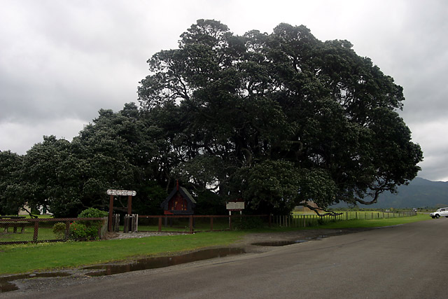
This tree is called Te Waha o Rerekohu — The Mouth of Rerekohu. It’s a strange name to give a tree, but there’s a reason for it.
The old people tell us that there was a food store here to receive food for the mouth of a very important child called Rerekohu. Food from the sea and food from the land.
Why was this boy important? Well, he was the eldest son of Hukarereiti, who was the eldest son of Tūterangiwhiu, who was the eldest son of the great Tūwhakairiora. The great grandmother of Rerekohu was Hinerupe herself. Besides all these important tipuna, his mother was a great woman in the Whaāau a Apanui, so Rerekohu was born to be an important chief in two tribes. And if people were prepared to fill a pātaka with food for him while he was still a baby — that made him more important still.
Why was he called Rerekohu? I can’t tell you that for sure, but on cold winter mornings, you can see a white mist flying across the sea from the river mouth, where the cold water from the land meets the warmer water of the sea. I think Rerekohu was born on such a morning and so was given the name Flying Mist.

In groups, brainstorm what you know about the science behind Rerekohu’s name.

ACTIVITY 2
THE ATMOSPHERE

Earth is surrounded by a blanket of air, which like a blanket keeps the Earth warm.

Air is a mixture of gases.
It is held close to the Earth by gravity but extends hundreds of kilometres from Earth.
The gases in the atmosphere are thicker or denser closest to the ground.
Half of the air in the whole of the atmosphere is found in the 5km closest to the surface of the Earth.
The higher up you go, the thinner the atmosphere becomes. There is no
definite boundary between the atmosphere and outer space. The gases slowly
become thinner and drift into space.

WE NEED THE ATMOSPHERE BECAUSE …..

- It protects us from damaging solar radiation by absorbing ultraviolet (UV) rays from the sun.
- It helps us by reducing temperature increases or decreases between day and night.
- Without the atmosphere, there could not be any life on Earth – animals and plants need oxygen for respiration and plants need carbon dioxide for photosynthesis.
- It plays a major role in water and energy transport.

THE LAYERS OF THE ATMOSPHERE

As you move up through the atmosphere, it changes. It is made up of four main layers based on temperature variations. These temperature variations are due to the way solar energy is absorbed as it moves downward through the atmosphere.

The boxes that follow give information about the Earth’s atmosphere. Use the information to label the graph that you will draw on page 13 to show the four different layers of the atmosphere and the boundaries between them. The data you will use is in the table on the next page.

The upper boundaries between the layers are known as the tropopause, the stratopause, and the mesopause, respectively.

The layer closest to the Earth is called the troposphere. This is where most of the water vapour is. The higher you go up in this layer, the colder the air gets. The troposphere is about 7km at the poles and 17km over the equator.
Most weather takes place in this layer. The average temperature year-round at the surface of the Earth is a very comfortable 15ºC.
The layer above the troposphere, is called the stratosphere. The higher you go up in this layer, the higher the temperature gets. This is because ozone is found here. The ozone (O₃) layer acts like a shield absorbing harmful UV radiation from the sun and changing it into heat. The top of the stratosphere is about 50km above the Earth’s surface. Most commercial jets fly in this layer because there is no weather to disturb the flight but there is a steady wind.
Above the stratosphere is the mesosphere. This middle layer is the coldest layer of the atmosphere. The higher you go up in this layer, the colder the air gets – as cold as -90ºC.
Beyond the mesosphere is the thermosphere. The higher you go, the hotter it gets. The actual temperature in the thermosphere can reach as high as 2000º C! It is so hot here because nitrogen and oxygen in the atmosphere absorb a lot of radiation from space and convert it to heat. This temperature, however, cannot be measured by a conventional thermometer; it would read below 0º C. Special instruments must be used because temperature is a measure of how fast particles move, the faster the particles, the higher the temperature. There are very few particles in the thermosphere, however, so not enough particles would strike a thermometer to heat it. The gases in this layer are very thin. The thermosphere includes a region called the ionosphere. It is special because it makes long distance radio communication possible by reflecting radio waves back to Earth. It is also where the aurora borealis [northern lights] and the aurora australis [southern lights] are generated. These swirling colourful lights are caused by particles from the sun entering Earth’s atmosphere. The space shuttle orbits in the upper part of the thermosphere.
Not really quite a layer because it just becomes thinner and fades away into outer space, is the exosphere. There are no real boundaries between the two; atoms of air are more and more spread out – mostly hydrogen and helium are found there. When astronauts travel back to Earth from space, an altitude of 75km marks the place where atmospheric effects become noticeable on re-entry.

Altitude (km) | Temp (ºC) | Altitude (km) | Temp (ºC)
0 | 15 | 52 | -2
5 | -18 | 55 | -7
10 | -49 | 60 | -17
12 | -56 | 65 | -33
20 | -56 | 70 | -54
25 | -51 | 75 | -65
30 | -46 | 80 | -79
35 | -37 | 84 | -86
40 | -22 | 92 | -86
45 | -8 | 95 | -81
48 | -2 | 100 | -72
The table on the right contains the average temperature readings at various altitudes in the Earth’s atmosphere. Plot this data on the graph grid on the next page, and connect adjacent points with a smooth curve. Be careful to plot the negative temperature numbers correctly.

This profile provides a general picture of temperature at any given time and place; however, the actual temperature may deviate from the average values, particularly in the lower atmosphere.

Label the different layers of the atmosphere and the separating boundaries between each layer.
Mark the general location of the ozone layer.

When you have completed your graph, discuss these questions in your group:
- Why are the four major layers of the atmosphere separated where they are?
- What increases the temperature in the stratosphere?
- Can planes fly in the mesosphere? Why or why not?
- On what does the temperature in the thermosphere depend?

GRAPH OF TEMPERATURE AT VARIOUS ALTITUDES
Altitude (km above sea level) | 100
Altitude (km above sea level) | 95
Altitude (km above sea level) | 90
Altitude (km above sea level) | 85
Altitude (km above sea level) | 80
Altitude (km above sea level) | 75
Altitude (km above sea level) | 70
Altitude (km above sea level) | 65
Altitude (km above sea level) | 60
Altitude (km above sea level) | 55
Altitude (km above sea level) | 50
Altitude (km above sea level) | 45
Altitude (km above sea level) | 40
Altitude (km above sea level) | 35
Altitude (km above sea level) | 30
Altitude (km above sea level) | 25
Altitude (km above sea level) | 20
Altitude (km above sea level) | 15
Altitude (km above sea level) | 10
Altitude (km above sea level) | 5
Altitude (km above sea level) | 0
 |  | -100 | -90 | -80 | -70 | -60 | -50 | -40 | -30 | -20 | -10 | 0 | 10 | 20
 | Temperature (ºC)

You should have eight words labelled on your graph in the correct locations: troposphere, tropopause, stratosphere, stratopause, mesosphere, mesopause, thermosphere and ozone layer.
LESSON PLAN 2
TIME: 60 minutes
KAUPAPA MĀORI: Whakawhenua
TEACHER INSTRUCTIONS:
- The focus for this lesson is the heating of the Earth and its atmosphere. At the start of this lesson, it would be timely to elicit in discussion or to remind students that Earth is the only planet that has the atmosphere and water to support life.
The activities will look at the retention of heat by the atmosphere which makes it habitable by our recognised life-forms.
- Activity 1 should be started as quickly as possible as it will take most of the lesson for completion – it can be conducted as a demonstration or as a group activity.
The students will observe how the Earth heats up during the day and how it slowly cools down at night. This will give them an understanding of how the greenhouse effect works.
The investigation is in two parts with student involvement only at the set-up, between the two parts and at the end, so Activities 2 & 3 may be fitted around it. Writing a paragraph to explain their observations may be done for homework; and using the assessment grid below for marking.
The double layer of air inside the bag acts like a greenhouse, the same way the atmosphere does around the Earth. The bag and Earth allow radiant energy from the sun to enter then heat energy is trapped.
assessment rating | assessment criteria
Excellence  4 | Student is able to communicate clearly that the Earth retains heat by trapping it in Earth's atmosphere resulting in the greenhouse effect.
Merit  3 | Student is able to communicate that the Earth is heated by the sun and loses some of its heat at night.
Achieved  2 | Student is able to communicate that the sun heats the Earth, when a part of Earth is facing the sun.
Not Achieved  1 | Student is able to communicate that the sun heats the Earth.

- For Activity 2, show students the short video (2 min 15sec) on the greenhouse effect to emphasise the importance of this in maintaining the Earth’s temperature at a habitable one of average 15ºC, instead of -18 ºC. The video could be stopped immediately after the brief interview with the scientist, and the remaining part shown in Lesson 4 when the focus is more on the effect of Man’s activities disturbing the balance of heat exchange. http://www.teachersdomain.org/resources/phy03/sci/phys/matter/greenhouse2/index.html
- In introducing Activity 2, extra explanation may be required for the variation in the amount of heat received at the edge of the atmosphere according to location and season.
When the sun's rays are perpendicular (at a 90 degree angle) to a location at the edge of the atmosphere, that area receives the greatest amount of radiation. Shine a flashlight directly at a spot on a wall and see the bright circle it makes. Now move to the left or right and shine the light at the same spot. You will notice that the light from the more oblique angle covers a wider area that is not as bright. This is how the sun's rays strike the earth's atmosphere, and because of the earth's curvature the equator receives a greater amount of solar energy than the poles. The position of the earth relative to the sun (the Earth’s tilt on its axis) also affects the amount of radiation received. When the southern hemisphere experiences summer the South Pole is tilted toward the sun, resulting in a longer period of daylight and more perpendicular rays. Though the earth in its elliptical revolution is actually at its farthest distance from the sun, the amount of energy and the length of daylight overcomes the distance. When the earth is closest to the sun, the South Pole is tilted away and the southern hemisphere experiences winter: short days and oblique rays.
Students will then act out a short drama showing the fate of radiation from the sun.
Prepare role cards and work out numbers of students in each role which will be dependent upon total numbers in the class. Role cards and script as follows:
Radiation coming from sun towards the atmosphere
The transfer of energy from the sun to the earth's atmosphere is accomplished through a process called radiation. Radiation transfers energy in wave motions. The waves can travel through empty space because they do not require an interaction with other molecules.
Teacher narrates: The amount of energy that enters the atmosphere is greatly reduced before it reaches the earth's surface. This is caused by absorption, reflection, and scattering.
2.Absorption of energy
Absorption causes energy to be retained by a substance, and by retaining energy the substance heats up and reradiates.
3Reflection of energy
Reflection occurs when particles and surfaces that are larger than the incoming waves meet and turn back solar energy. Clouds, snow, and light-coloured sand are all reflectors.
4.Scattering of energy
Scattering occurs when particles the same size as the wavelength of the radiation meet. Scattering causes energy to be redirected in all directions, some of which returns to space.

4.Scattering of energy
Scattering occurs when particles the same size as the wavelength of the radiation meet. Scattering causes energy to be redirected in all directions, some of which returns to space.
Teacher narrates:
Due to these three processes, less than half the solar energy that enters the atmosphere reaches the earth's surface and only about one-fifth warms the atmosphere directly.
5.Conduction
Most of the energy that warms our atmosphere comes indirectly from the heated earth. A small amount of the energy absorbed by the earth warms the atmosphere through a process called conduction. Conduction is the transfer of heat within a substance. Gases and liquids are not good conductors, so only the air just above the surface of the Earth is heated by this process.

6.Convection
More heat is transferred from the surface to the atmosphere through a process called convection. Convection is the vertical transfer of energy by the actual movement of the heated substance. Air rises up a chimney, for example, when it is heated by a fire below and becomes less dense (weighs less) than the air surrounding it.

Teacher narrates:
The solar radiation that reaches the earth manages to pass through the atmosphere with little or no interference; yet almost all convected energy is absorbed by the atmosphere. Why? The difference in temperature between the sun and earth changes the wavelength of the convected rays - the lower the temperature, the longer the wavelength.
Shortwave down – Longwave up
The shortwave visible light rays which passed down through the water vapour and carbon dioxide without obstruction return upward as long-wave radiation and most is absorbed by those same clouds. The clouds heat up and re-emit energy back to earth as counter radiation - in effect recycling radiation from the earth.
Teacher narrates:
This process of trapping long-wave radiation has been called the greenhouse effect, and is one of the important ways the atmosphere's temperatures remain within a liveable range.

This could be performed at a later time if necessary and/or in front of an audience. Dressing up, preparing props and costumes could all enhance the enjoyment and learning potential.

STUDENT INSTRUCTIONS:
- You will be carrying out an investigation in Activity 1 to demonstrate the greenhouse effect. You will start it at the beginning of the lesson, check on it and take temperature recordings half way through the lesson and again at the end. The collected data will be used to write a paragraph linking these observations to how the greenhouse effect works.
- In Activity 2, your teacher will show a short video explaining the importance of the greenhouse effect in allowing us to survive on planet Earth.
- You will become an actor in Activity 3, acting in a drama that shows what happens to the energy from the sun.
- ACTIVITY 1
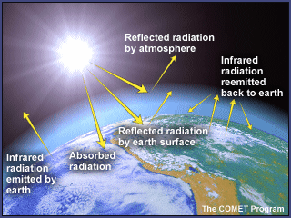
You will conduct an experiment using the sun (or heat lamp), 2 thermometers, 2 twistie-ties, and 2 plastic bags to duplicate the greenhouse effect.
This will allow you to be able to observe and understand how the Earth heats up during the day and cools slightly at night. You will be able to develop your own conclusions for homework from your recorded data.

Method
- Place one of the thermometers inside the small bag.
- Inflate the bag by blowing into it, then securely close it with the twist-tie.
- Put this small inflated bag inside the larger plastic bag.
- Inflate the large bag with air and securely close it with a twist-tie.
- Place the bag in direct sunlight and place the second thermometer next to the bag. If it is an overcast day, it could be set up under a heat lamp.
- Record the temperatures on both thermometers at the beginning of the experiment.
- Record the temperatures after 25 minutes.
- Move the set-up (except the lamp) to a dark cupboard or drawer.
- Observe the temperature reading on both thermometers after 25 minutes.

Data
time (min) | temperature (ºC)
time (min) | inside thermometer | outside thermometer
start
after 25 min in sun
after 25 min in dark

Conclusions

_________________________________________________________________________

_________________________________________________________________________

_________________________________________________________________________

_________________________________________________________________________

_________________________________________________________________________
ACTIVITY 3
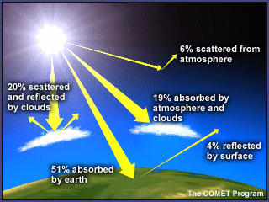
The sun radiates enormous amounts of energy, most of it lost or absorbed before reaching the edge of earth's atmosphere.
Temperature variations in the four layers are due to the way solar energy is absorbed as it moves downward through the atmosphere. The Earth’s surface is the primary absorber of solar energy. Some of this energy is reradiated by the Earth as heat, which warms the overlying troposphere.

The class is going to perform a piece of drama that shows the fate of radiated heat energy from the sun.
Your teacher will give you role cards and will read through the whole script twice.
During the first read-through, listen carefully to the whole piece but identify the part that you have on your role card and make sure you understand how your part fits into the whole.
During the second read-through, again listen carefully but when the teacher gets to your part, put up your hand and look around to identify others in the class who also have the same part.

At the end of the reading, your teacher will:
- direct you to join up with your role group;
- tell you how long you have to learn your lines;
- organise your time for designing how you are going to act out your part of the drama.

LESSON PLAN 3
TIME: 60 minutes
KAUPAPA MĀORI: Rangahau
TEACHER INSTRUCTIONS:
- In this lesson, students will carry out an investigation and form their own conclusions as to how different surface and cover types affect heating using a model bottle system. As a result, they will be able to identify at least three factors affecting the heat-trapping ability of a greenhouse, including the transparency of the greenhouse cover, colour of the surfaces inside the greenhouse, and type of surfaces inside, and then relate these to the atmosphere explaining the importance of the factors in the atmosphere's heat trapping ability. Extension exercises require them to apply their learning to specific examples.
- Gear required for each group:
  - Six PET bottle experimental chambers (see below for construction details)
  - Three cups of dark soil (garden or potting soil)
  - Three cups of white sand or perlite/vermiculite
  - Three cups of water
  - Six thermometers
  - Transparent cellotape
  - One 150-watt floodlight bulb
  - Portable reflector lamp * note comment at end of teacher instructions
  - Stand to support lamp set-up

The following are required by technician or teacher setting up the experimental chambers – the amounts are dependent upon number of groups:
  - White paint
  - Dark soil (garden or potting soil)
  - White sand or perlite/vermiculite
  - Water
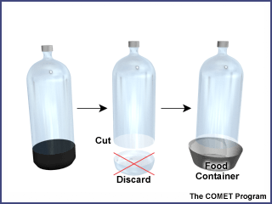
Experimental chamber construction:
- For each chamber, you will need a 2L PET bottle (with cap) and a 2 Cup/½L plastic container for the base – this will need to be at least 12cm in diameter at the top (sour cream, cottage cheese, or deli containers work well)
- Remove the bottle label by soaking it in warm water.
- Cut off the end of the bottle approximately 5cm from the bottom and discard the bottom piece.
- Place the capped bottle in the plastic base and the experimental chamber is ready for use.
NB: If the lamps are not big enough, six bottles may be too many to have under the light at the same time. The ones further from the light may not get the same intensity of heat as the bottles closer to the light thereby compromising the experiment. Students could use a sub-set of the bottles at one time

ACTIVITY
While the earth's temperature is dependent upon the greenhouse-like action of the atmosphere, the amount of heating and cooling is strongly influenced by several factors:
The type of surface that sunlight first encounters is the most important factor:
- Sunlight falling on a white glacier surface strongly reflects back into space, resulting in minimal heating of the surface and lower atmosphere.
- Sunlight falling on a dark desert soil is strongly absorbed, on the other hand, and contributes to significant heating of the surface and lower atmosphere.
- Cloud cover also affects greenhouse warming by both reducing the amount of solar radiation reaching the earth's surface and by reducing the amount of radiation energy emitted into space.
- Water covers 70% of the surface of planet Earth, so the oceans have a great influence on heating and cooling. Water has the capacity to store heat and transport large amounts of heat energy.

In this investigation you will look at how different surface and cover types affect heating using a model bottle system. Your teacher will supply you with the following gear:
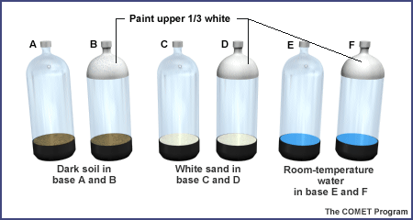
- Six bottle experimental chambers (see picture left)
- Six thermometers
- Transparent cellotape
- One 150-watt floodlight bulb in portable stand
- Stand to support lamp set-up
- Check the labels on the bottles A, B, C, D, E, and F with bottles B, D, and F having the white paint.
- Check the contents of the bases of bottles A and B have dark soil, bottles C and D have white sand, and bottles E and F have room-temperature water.
- Tape a thermometer (using transparent cellotape) to the inside of each bottle (facing out).
- Place the bottle tops in the bases. Make sure the bottles are capped.
- Make sure the bulbs of the thermometers are just above the top of the bases. If the bulbs are below the base, the thermometer may record the heat absorbed directly by the soil or water, complicating the results.

- Predict which bottle will get hotter. Record your predictions and the reasons for them: _____________________________________________________________________
_____________________________________________________________________
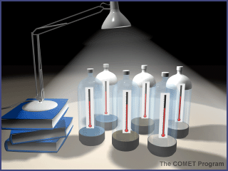
- Within your group organise specific responsibilities during the experiment, e.g. keeping track of the time, reading the temperature for the different bottles, recording temperatures, etc.
- Place the bottles approximately 15cm away from the lamp with the thermometer facing away from the light (as shown in the picture).
- Record the baseline temperatures in the table below.
- Turn on the light and begin recording the temperatures every two minutes. Continue for at least 20 minutes.
- Graph your results. Add a key to explain colour used for each bottle.

Time  (min) | Bottle Temperature (ºC)
Time  (min) | A | B | C | D | E | F
0 (baseline)
2
4
6
8
10
12
14
16
18
20

GRAPH OF TEMPERATURE CHANGE IN DIFFERENT BOTTLES
Temperature (ºC) | 60
Temperature (ºC) | 58
Temperature (ºC) | 56
Temperature (ºC) | 54
Temperature (ºC) | 52
Temperature (ºC) | 50
Temperature (ºC) | 48
Temperature (ºC) | 46
Temperature (ºC) | 44
Temperature (ºC) | 42
Temperature (ºC) | 40
Temperature (ºC) | 38
Temperature (ºC) | 36
Temperature (ºC) | 34
Temperature (ºC) | 32
Temperature (ºC) | 30
Temperature (ºC) | 28
Temperature (ºC) | 26
Temperature (ºC) | 24
Temperature (ºC) | 22
Temperature (ºC) | 20
 |  | 0 | 2 | 4 | 6 | 8 | 10 | 12 | 14 | 16 | 18 | 20
 | Time (min)
KEY:
Observations and Questions
- Compare the graphed information from the different bottles.
- Discuss the results and propose some possible explanations.
- Relate the factors affecting the model greenhouses to the factors affecting the "global greenhouse." Which factors are the same? Which are different?
Using your knowledge
- Sketch and explain how to set up a model greenhouse (with the light on) with the absolutely coolest possible temperatures. Where might such a condition be found on Earth?
- Sketch and explain a greenhouse designed to generate the maximum possible heat. Where might such a condition really exist?
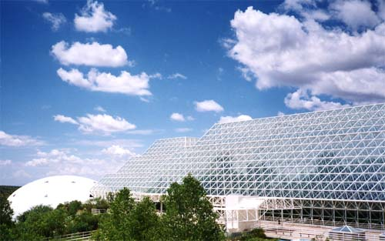

This is Biosphere 2 in the Arizona desert. It looks like a greenhouse, but it is not – it is a glass terrarium.
Find out more about it, including why it is called Biosphere 2 – what is Biosphere 1?

LESSON PLAN 4
TIME: 60 minutes each lesson
KAUPAPA MĀORI: Reo Māori
TEACHER INSTRUCTIONS:
- Activity 1 reinforces vocabulary, and can be modified depending on the level of reo Māori of the students. This has been designed for students with limited knowledge so relevant words have been given in both languages.
Have English-Māori/Māori-English dictionaries available. Guide students according to their literacy, science, and te reo ability.
Encourage students to complete a VOCAB SQUARE for each new ATMOSPHERE term they come across in these activities.

- Activity 2 summarises the investigation from the last lesson and leads into winds (NB: the topic of weather would be a separate unit). Students write paragraphs to demonstrate their understanding. Requirements for this activity are:
  - a class set of atlases

- Winds and ocean currents both play a part in the distribution of the heat energy from the atmosphere. Activity 3 focuses on the role of ocean currents in this. Requirements for this activity are:
  - a world globe or access to the on-line ocean atlas at: http://oceanworld.tamu.edu/resources/atlas.htm
  - access to a freezer and water
  - dark food colouring
  - ice cube trays
  - glass dish or pneumatic trough, per group
Make ice cubes from water with the dark food colouring in it. Each group will need 2 of these coloured ice cubes.
Students will observe that the cold (coloured) water sinks and moves along the bottom of the dish toward the warmer water in the middle; the warmer water moves toward the ends of the baking dish; as the cold water begins to warm, it begins to rise.

- Key concepts for the ocean heat budget are in the file: OceanHeatBudget for teacher reference.
STUDENT INSTRUCTIONS:
- Activity 1 develops your knowledge and understanding and starts a useful literacy glossary of terms for the atmospheric world.
Use the VOCAB SQUARE template after each following lesson to check your understanding of the new terminology that you have used.
- You will review and apply your findings from Lesson 3 and focus on the cause of wind currents in Activity 2.
- For Activity 3, each group will carry out an investigation into ocean currents and the part they play in distributing the heat of the atmosphere.
ACTIVITY 1
You have come across many words about the atmosphere since we started this unit. Use them to create VOCAB SQUARES for words to do with this unit of work.
An example of a completed VOCAB SQUARE is shown below. Use the words listed to create your own VOCAB SQUARES for these words.
Your teacher will guide you in this and provide dictionaries and resources as required.
Example:
WORD  Te Reo Māori: huinga hau  Te Reo Pākehā: air | DEFINITION  To be inserted  Air is a mixture of gases.
EXAMPLE  As you rise higher through the atmosphere, the air gets thinner. We say the air pressure decreases. | DIAGRAM TO HELP REMEMBER  

WORD LIST
Reo Pakeha | Reo Māori | Reo Pakeha | Reo Māori
carbon dioxide | hauha | greenhouse | whare karaihe
oxygen | hā ora | temperature | te wera
nitrogen | hauota | heat energy | pungao wera
atmosphere | hau takiwā | heat | wera
gas | hau | radiation | tokowhiti
ozone | hau ārai | aircraft | wakarererangi
cloud | kapua

GROWING YOUR WORD LIST
As you progress through this unit of work on ATMOSPHERE, create a VOCAB SQUARE for each new word.
ACTIVITY 2
You discovered in the last lesson that:
- water absorbs the same amount of heat without going up in temperature as
quickly, i.e. water heats up much more slowly than land.
- darker colours absorb more wavelengths of light and therefore the dark soil was the hottest (and it cools faster as well).

These results indicate that the Earth, being covered by large bodies of water and land, will heat unevenly. The interior of larger continents will probably get hotter than smaller landmasses.

The uneven heating of the Earth’s surface causes weather:
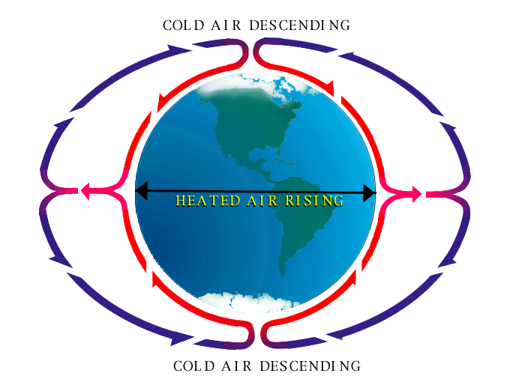
- When you have differences in air temperature, the hot air will rise because it is less dense and the cold air will sink because it is more dense.
- These movements create wind (which also is affected by the rotation of the Earth).
- Hotter air has lower air pressure because the air particles have more energy and so are spread further apart – they are less dense.
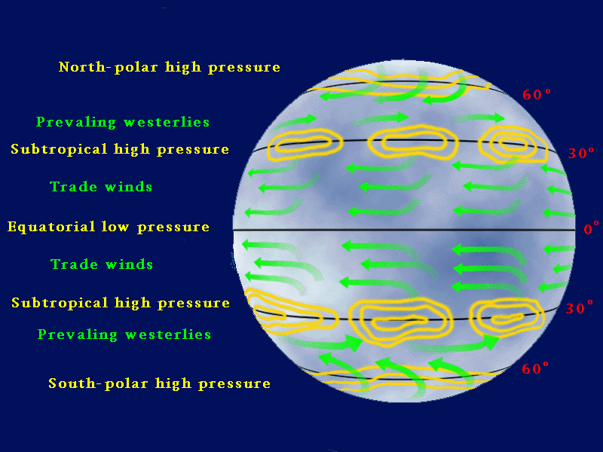
- Higher air pressure will flow into areas of lower air pressure, also creating wind.
- The ability of water to hold more heat means the Earth’s temperature will be much more moderate than if there were a larger percentage of land, making the surface of the Earth more habitable for humans and all life.
- So, continents will be warmer, the air above continents will be warmer and therefore the different temperatures and pressures of the air will lead to wind and weather.

Look at the picture above that shows global wind patterns and use an atlas to answer these questions:
- The latitude of the city closest to you is: ________________
- The prevailing winds for that city are: __________________
What you have learned allows you to explain sea and land breezes, and why there are more moderate temperatures along ocean coasts.
Cities on the coast are milder in winter, cooler in the summer (e.g. Auckland). Inland areas (e.g. Central Otago) can be in the 30’s in the summer, and well below zero in the winter.

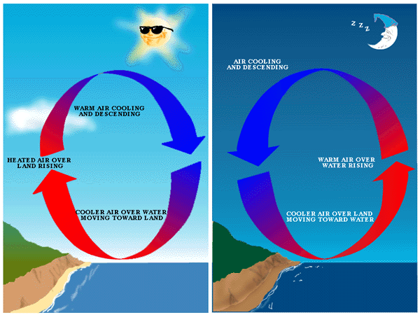
Which picture shows a sea breeze and which one a land breeze?
Identify them and write a paragraph under each of these pictures to explain what is happening (look back at the previous page to include the words: high; low; air pressure; density.

This shows a ________ breeze. This shows a ________ breeze.
__________________________
__________________________
__________________________
__________________________
__________________________
__________________________
__________________________
__________________________
__________________________
__________________________
__________________________
__________________________
__________________________
__________________________
__________________________
__________________________
__________________________
__________________________
__________________________
__________________________
__________________________
__________________________
__________________________
__________________________



ACTIVITY 3
Have a close look at the globe that is in your classroom or the on-line ocean atlas at http://oceanworld.tamu.edu/resources/atlas.htm.

Identify the Pacific Ocean, the Atlantic Ocean, and the Indian Ocean.

Where does each start and finish?

All the oceans on Earth are connected to form one “world ocean.”

Where do you think the water would be warmer — near the equator or near the poles?

The experiment you are going to do now demonstrates how the colder waters nearer the poles and the warmer waters nearer the equator mix together and move to create ocean currents.
- In your group, collect and fill a clear dish or pneumatic trough with warm tap water representing the warm water near the equator.
- Place one ice cube at each end of the dish, representing the cold water near the poles. Predict what will happen as the ice cubes melt.
- Draw and label what you observe in this space:

- Now write an explanation of how differences in water temperature in different parts of the “world ocean” cause ocean currents.
___________________________________________________________________
___________________________________________________________________
___________________________________________________________________
___________________________________________________________________
___________________________________________________________________
LESSON PLAN 5 & 6
TIME: 60 minutes each lesson
KAUPAPA MĀORI: Tāhū kōrero
TEACHER INSTRUCTIONS:
- The next two periods will focus on research of the link between the greenhouse effect and global warming; internet access is required. The research will lead onto exploration of opinions on the global warming debate.
- The outline of the lesson plan is on: http://www.pbs.org/now/classroom/globalwarming.html - selection of tasks from this website depends on time available and student ability to work independently. Read through ‘Backgrounder for Teachers’ and select appropriate parts.
- Other useful websites for basic background information: http://www.weatherquestions.com/What_is_the_greenhouse_effect.htm
http://www.weatherquestions.com/What_is_infrared_radiation.htm
- Use the Venn diagram handout: http://www.pbs.org/now/classroom/globalvenn.pdf
- If extra time is available, the projects would be a great extension: http://www.pbs.org/now/classroom/globalproject.pdf
- Have English-Māori/Māori-English dictionaries available. Guide students according to their literacy, science, and te reo ability.
- Encourage students to complete a VOCAB SQUARE for each new ATMOSPHERE term they come across in their research.

