HE KAUPAPA PŪTAIAO

TAU 10

TE MARAUTANGA O AOTEAROA KAUPAE 5 PŪTAIAO

ŌMATAORA

E 6 NGĀ AKORANGA ME NGĀ MAHI

HARAKEKE

He Mahere Kauapa Mahi – Tau 10 Pūtaiao – Harakeke
Tauira: | TE KATOA | Kaupapa Māori:
Mōhiotanga o te Kaiako: | He āhua mōhio | He iti
Wāhanga Ako: | Pūtaiao | Tāne
Marautanga -Take | Pūtaiao
Whenu: | Te Ao Mataora | Papatūānuku,
Kawa: | He kawa ora; te tāhū ora | Tāne, Papatūānuku.
Kaupae: | 5
Ingoa: | Harakeke | Hineteiwaiwa
Ngā Whāinga Hei Whakatutuki: | Ko tā te tauira:  - he whakamōhio i ngā āhuatanga hanga matua, tūmahi hoki e pā ana ki ngā tukanga ora o te tipu me te kararehe; | Tāne
 | - he tirotiro ki te taupuhipuhinga o te hunga ora (me te tangata) i te nohoanga; | Rongomātāne
 | - he whakawhānui i te whainga kupu, tohu, tikanga pūtaiao hoki.
 | - he whakapakari i te tirohanga kia takimaha te tikanga, kia whai tauira anō hoki.
Ngā Pūkenga Ake: | Te Katoa
Tirohanga: | Te hanga me te mahi, me tōna whakapapa
Wāhi: | Aotearoa; te whenua kura; te marae kāinga | Aotearoa; te marae kāinga
Ngā akoranga: | 6
Ngā mahi: | 1 Te haerenga – te whenua kura, ngā māra huaota, te marae kāinga rānei. Te pā harakeke. | Whakawhenua - whainga tapuwae, mihi
 | 2. Ngā wāhi o te tipu, ngā tūmahi, ngā whakamahinga. Ngā kupu me ngā whakamāramatanga. | Reo Māori

Ngā Mahi: | 3. He āta titiro ki te noho tahitanga. Ētahi tikanga kararehe. (te kai).  Ngā tikanga mataora (MRSGREN) | Rangahau
 | 4. Ngā putiputi, te ruingahae me te kikiritanga | Tāhū kōrero
 | 5. Te noho whanaungatanga | Tāhū kōrero
 | 6. Te whakamahi harakeke | Te Hao
Tikanga Māori | Kohinga 2 – Rārangi Tikanga Māori | Whainga tapuwae, wānanga, kauhau, mihi, waiata
Reo Māori: | Kohinga 3 – Rārangi Reo Māori | He kupu ake, he tapanga.
Ngā rauemi:  - Kohinga 1 | PM Ryan: The Reed Dictionary of Modern Māori
 | http://teaohou.natlib.govt.nz/teaohou/issue/Mao03TeA/c16.html
 | New Growth From Old, J Metge, VUP, 1995
 | Māori Fibre Techniques, M Prendergrast, Reed, 2005
 | New Zealand’s Economic Native Plants, RC Cooper & RC Cambie, OUP, 1991
 | A Field Guide to the Native Edible Plants of New Zealand, A Crowe, Collins, 1983
 | http://www.interlink.org.nz/projects/poles/polesly2.html
 | http://www.alibrown.co.nz/gathering-flax.html
 | http://www.teachersdomain.org/resources/tdc02/sci/life/stru/beakgallery/index.html
 | http://www.teachersdomain.org/resources/tdc02/sci/life/colt/mouths/index.html
 | Kiwi Integrated Science Series, 3 Science Book 1, J Sweeney, D Relph, L DeLacey. New House.
 | Kiwi Integrated Science Series, 4 Science Book 4, J Sweeney, D Relph, S Haigh, L DeLacey. New House.

INGOA KAUPAPA: HARAKEKE

PAETAU: Tau 10

WHIRINGA MARAUTANGA:
NGĀ PŪKENGA AKE: Te katoa
WHENU: Te Ao Mataora Kaupae: 5
NGĀ WHĀINGA HEI WHAKATUTUKI: Ko tā te tauira:
- he whakamōhio i ngā āhuatanga hanga matua, ngā tūmahi hoki e pā ana ki ngā tukanga ora o te tipu me te kararehe (he kawa ora)
- he tirotiro ki te taupuhipuhinga o te hunga ora (me te tangata) i te nohoanga(te tāhū ora)
WHENU: Ōpūtaiao
NGĀ WHĀINGA HEI WHAKATUTUKI: Ko tā te tauira:
- he whakawhānui i te whainga kupu, tohu, tikanga pūtaiao hoki;
- he whakapakari i te tirohanga kia takimaha te tikanga, kia whai tauira anō hoki

NGĀ HUA AKE O TE AKO:
Ka taea e ngā tauira:
- ngā āhuatanga ora te whakamōhio;
- ngā hanga matua me ngā tūmahi hei oranga tipu te whakamōhio, te whakaahua hoki;
- te aitanga o te pua tipu te whakamārama;
- te whakapapa ā-mataora nei te tirotiro, te whakamōhio;
- ētahi whakamahinga o te harakeke te whakamōhio, te wānanga, te whakamārama hoki.

TE MŌHIOTANGA KIA MŌHIOTIA:
Te Ao Mataora Kaupae 3/4

NGĀ RAUEMI HEI WHAI:
- Ko te tīmatanga o te raumati te wā pai hei kawe i tēnei kaupapa, e pua ana te harakeke. Tērā pea e mau tonu ana ētahi pākākano o te tau kua hori ake ki ngā pā, me kohi rānei hei rauemi mō te tau heke.
- Me whai wāhi ki ngā pā harakeke(tī kōuka rānei) me te hunga raranga/pakeke.
- He rau harakeke, he rau tī kōuka rānei e whakaatu ana i ngā wini me ngā pakini a te anuhe nōna te ingoa wini, pakini hoki. (tirohia te whakaahua ki te whārangi Hei Mahi 1 o Akoranga 3).
- He pua harakeke; he pākākano harakeke; he heu matatahi; he papa rākau kotikoti.
- Menā kāore i te tika te kaupeka, he whakaahua o ngā pua harakeke, pākākano hoki.
NGĀ WHAKAPUAKANGA HEI TITIRO:
The Reed Dictionary of Modern Māori, PM Ryan, Reed, 1995
http://teaohou.natlib.govt.nz/teaohou/issue/Mao03TeA/c16.html
New Growth From Old, J Metge, VUP, 1995
Māori Fibre Techniques, M Prendergrast, Reed, 2005
New Zealand’s Economic Native Plants, RC Cooper & RC Cambie, OUP, 1991
A Field Guide to the Native Edible Plants of New Zealand, A Crowe, Collins, 1983
http://www.interlink.org.nz/projects/poles/polesly2.html
http://www.alibrown.co.nz/gathering-flax.html
http://www.teachersdomain.org/resources/tdc02/sci/life/stru/beakgallery/index.html
http://www.teachersdomain.org/resources/tdc02/sci/life/colt/mouths/index.html
Kiwi Integrated Science Series, 3 Science Book 1, J Sweeney, D Relph, L DeLacey. New House.
Kiwi Integrated Science Series, 4 Science Book 4, J Sweeney, D Relph, S Haigh, L DeLacey. New House
TE MAHERE AKORANGA 1
TE WĀ: 60 meneti (kia roa atu mō te haerenga)
KAUPAPA MĀORI: Whakawhenua – whainga tapuwae; mihi
NGĀ TOHUTOHU MĀ TE KAIAKO:
- Mātua tirotiro ki te whenua kura, te māra huaota, te marae kāinga rānei hei whakariterite i te haerenga. Kei te tūranga o te pā harakeke e tika ana, kei te hiahia hoki o te pakeke te tikanga o te wāhi hei take haerenga.
- Menā ka haere ki te māra huaota, tēnā whakaritea te haerenga.
- Whakaotia ngā whakaritenga haerenga ā-kura, hei tauira, te puka Ārai Tiaki Whara; te whakaaetanga a ngā mātua, te aha, te aha.
- Tāruatia te whārangi Hei Mahi.
- Haria ngā kape o Ngā Puka Hātepe Pūtaiao Whātahi o Kiwi, 3 Puka Pūtaiao 1, tirohia te whārangi 38,
- Me kī atu ki ngā tauira kia haria he pukatuhi/pukatā, he pene rākau hoki.
- Tonoa tētahi hei kaikōrero, māna e mihi mō te rōpū.

NGĀ TOHUTOHU MĀ NGĀ TAUIRA:
- Whakaotia, whakahokia ngā puka mō te haerenga ki waho i te kura.
- Me hari pukatuhi, pukatā rānei i te haerenga.
- Me paepae ngā taringa ki te whakarongo, me āta mātakitaki, me whaiwhakaaro ngā pātai.
- Me takirōpūiti te mahi hei whakaoti i ngā tūmahi i te whārangi 38 o te pukapuka mahi i roto i te wā i whakaritea ai.

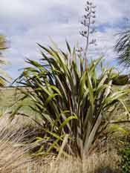
HEI MAHI

Kua tupu tōu pā harakeke,
kua aroha ki te pīpī nei, ki te kākā.

Ka whai oranga katoa te pakeke, te tamariki, te iti, te rahi, me ngā momo hiahia, i te pā harakeke matua.

- Whakarongo, kōrero hoki ki ngā tāngata mō te pā harakeke, me te tiaki kia tipu tonu ai.
- Pānuitia te whārangi mahi ‘Āta tirohia te harakeke’ i tukuna mai e tō kaiako ki a koe.
- Ka noho takirōpū ki te whakaoti i ngā mahi kua whakarārangitia i te whārangi mahi i tukuna mai e tō kaiako, i roto i te wā i whakaritea ai.

Ka tirohia hoki ko ēnei tuhinga me ēnei huahua i ētahi atu o ngā akoranga o tēnei kaupapa mahi.

TE MAHERE AKORANGA 2
TE WĀ: 60 meneti
KAUPAPA MĀORI: Reo Māori
NGĀ TOHUTOHU MĀ TE KAIAKO:
- Mō Hei Mahi 1, me whai whakaahua mō te pā harakeke e pua ana me ētahi pākākano tahito, mō ngā tauira kāore i puta ki te haerenga.
- Mō Hei Mahi 2, whakaritea ngā mahere mō te mahi KIA MĀRAMA TAKIRUA. Menā ka tīkina atu ko ngā kupu i Hei Mahi 1, kei raro ōna mahere, heoi me he kupu kē atu, tēnā whakarerekēhia. Tāruatia ngā mahere kia rite mō ngā tokorua o te karaehe.
Kupu | Whakamāramatanga | Kupu
Puāwai
Kakau
Whā

Kupu | Whakamāramatanga | Kupu
Akaaka
Rito
Pūhui hua

- Mehemea ka whai tāima, ka rata hoki mai ngā tauira, whakaritea te Hei Mahi 3 hei mahi rangahau i roto i te karaehe. Tirohia hoki te whārangi 39 o KIS 3 Pukapuka Pūtaiao. Me whai wāhi ki te rangahau i te kāinga mō ngā akoranga ā muri atu nei.
- Me whai papakupu Reo Pākehā-Reo Māori/Reo Māori-Reo Pākehā mō Hei Mahi 2.
NGĀ TOHUTOHU MĀ NGĀ TAUIRA:
- Ko tā Hei Mahi 1 he whakamōhio mai i ngā wāhi o te tipu, ngā ingoa me ngā tūmahi, arā, te mahi a ia wāhanga kia whai oranga ai te katoa o te tipu.
- Ko tā Hei Mahi 2 he whakahokinga mahara ki ngā mahi o Hei Mahi 1 kia kitea ai he aha ngā kōrero hei whai anō māu, hei mahi anō māu.
- Ko tā Hei Mahi 3, he whakamōmona i tō mōhio kia mārama ai koe ki ngā mahi a te tangata ki te harakeke, o namata, o nāianei hoki.
HEI MAHI 1
Parapara waerea a ururua,
Kia tupu whakaritorito te tupu o te harakeke.

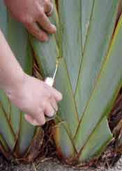
Tipu noa ai te pā harakeke i ngā repo, i te one haumako, haukū hoki, ā, ki te āta tiakina, ka kaha matomato te tipu ahakoa te tapahi mai a te hunga raranga i ngā ngakinga harakeke.
Ko te tipu o te pā harakeke, he rau roa nei he hoari te rite, me he kōwhiuwhiu te tipu ngātahi o te pā. Tuitui tāwhīwhiwhi ana ngā pakiaka o ēnei pā, mā te mata koi tonu o te kaheru e wāwāhi. Tīmata ai te tipu i waenganui pū o te pā, ka hua ko te rito, ka awhitia e ōna mātua i ngā taha.
Mō te kohi harakeke ka tapahia e te kairaranga Māori ko ngā rau anake o waho o te pā, ka waiho noa ko te rito me ōna mātua kia tipu tonu mai.
He whānau tonu te pā harakeke, he tamaiti te rito e tiakina ana e ōna mātua i ngā taha, ā, ko ngā rau o waho he pakeke.
Nō te whānau tonu ngā pā katoa, kotahi te pū e whai oranga katoa ai te pā.

Tirohia te huahua o te pā harakeke i tuhia ai e koe i te akoranga o mua atu, tuhia noatia te āhua o te wāhanga o te tipu kia rite ki tōna ingoa:
Name | Ingoa | Picture/Whakaahua | Function/Mahi
stem | Kakau/kāuru |  | He whakatū i ngā rau kia anga atu ki te hana o te rā hei kai mā rātau, ngā pua hoki kia whakahahaetia.
root | Akaaka/pakiaka |  | He whakatūrangawaewae i te pā kia mau ki te oneone, he kai hoki i te wai i ngā kai ōpapa.
leaf | whā/rau |  | He taka kai mā te pā i te hauhā, i te wai, i te hahana o te rā.
growing tip | rito |  | Tipu ake ai ngā rito hou i konei.
seed pod | puhui hua/pākākano |  | He waka tiaki kākano
flower | puāwai |  | Nō konei anō te aitanga a harakeke.
HEI MAHI 2

KIA MĀRAMA TAKIRUA

Me mahi takirua, kore pukapuka hoki.
Ka tukuna mai e tō kaiako he mahere ki a kōrua, he rerekē tētahi i tētahi. KAUA e whakaatu ki tētahi atu.

E toru ngā rohe tīwae o te mahere:
Kupu | Whakamāramatanga | Kupu
kupu matua
kupu matua
kupu matua
- He ‘Kupu’ te tuatahi, he rarangi kupu matua kei roto;
- He ‘Whakamāramatanga’ te tuarua, kāore he kōrero o roto;
- He ‘Kupu’ te tuatoru, kāore he kōrero o roto.

Ka tuhia e kōrua tetahi whakamāramatanga mō ia kupu o te rohe tīwae tuatahi.
Ka pōkaia te pepa i te rārangi iraira i waenganui i ngā rohe tīwae tuatahi, tuarua hoki kia kitea mai e tō hoa ko ngā kupu engari kāore e kitea mai ngā whakamāramatanga.
Whakawhitihia ngā pepa, pānuitia ngā wakamāramatanga a tō hoa.
Tuhia ki te rohe tīwae tuatoru te kupu, ki tōu nā whakaaro, i whakamāramatia ai e tō hoa.
Kia oti katoa i a kōrua ngā mahere te whakakīkī, tūwheratia kia whakatauriteritehia e kōrua tahi.
- Mehemea e rua ngā kupu rerekē mō te whakamāramatanga kotahi, he rite tonu rānei te tikanga o ngā kupu e rua?
- He mārama rānei ngā whakamāramatanga kia taea ai te kī, kotahi anō tōna whakamāramatanga.
Hei whakakapi, huakina ā kōrua pukapuka, whakatauritehia ngā whakamāramatanga.
HEI MAHI 3
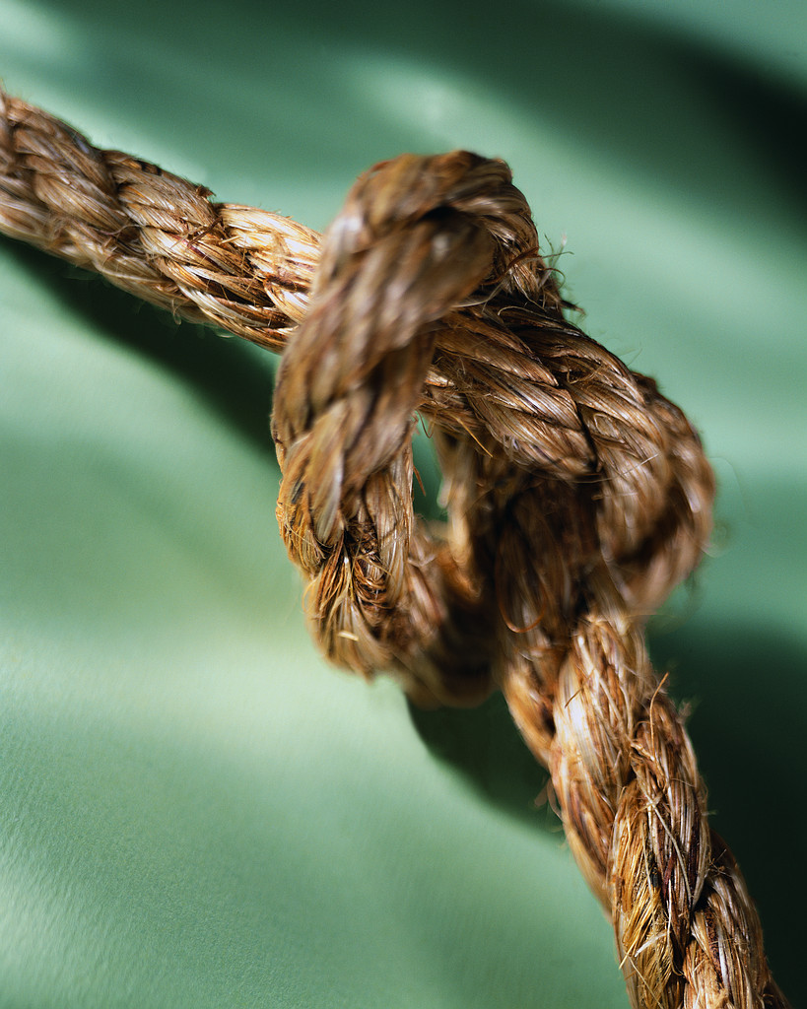
Whakamahia ai te muka harakeke hei whiri momo taura kia maha noa. Ka hārōtia, kātahi ka whiri ai hei whenu mā te taitaka ki te kūhā, ā, kia eke ki te waru ngā whiringa, hei tari karakia, hei whiri tuamaka rānei. Mā te whiri pēnei ka kaha rawa ake te taura – ko ngā taura taumaha hoki hei pupuri waka.

Ki tō whakaaro, he aha te huanga o te muka o te rau harakeke ki te pā harakeke?

Me wānanga ā-rōpūiti nei ētahi atu whakamahinga o te harakeke.
Whriwhiria tētahi o koutou hei whakatakoto i ō koutou whakaaro ki mua i te karaehe.
Ka whakarāpopotohia ō koutou whakaaro ki te papatuhituhi hei wānanga.
He whakaaro anō rānei o ētahi atu o tō whānau mōu?
TE MAHERE AKORANGA 3
TE WĀ: 60 meneti
KAUPAPA MĀORI: Rangahau
NGA TOHUTOHU MĀ TE KAIAKO:
- Me whai rau harakeke, tī kōuka rānei kia 10, kua ngaua e te anuhe tāwhana mō Hei Mahi 1.
- Mō Hei Mahi 2, whakaritea ngā pūataatanga o Te Whare Ngutu Manu me tōna whare kōrero mō ngā ngutu manu hei tauira mō te hanga me ngā tūmahi i http://www.teachersdomain.org/resources/tdc02/sci/life/stru/beakgallery/index.html
Whakaritea ngā whakaahua o Ngā Waha Kararehe me tōna whare kōrero mō ngā wāhanga o te waha hei tauira mō te hanga me ngā tūmahi i http://www.teachersdomain.org/resources/tdc02/sci/life/colt/mouths/index.html
Ka whakawhānuitia atu te Hei Mahi 2 hei akoranga tonu menā e rite ana mo te kaiako, mō ngā tauira hoki.

NGĀ TOHUTOHU MĀ NGĀ TAUIRA:
- Mō Hei mahi 1, ka whakarōpūtia koutou e te kaiako, ā, ka tukuna ki a koutou tētahi, e rua rānei ngā rau harakeke, tī kōuka rānei kua ngaua e te anuhe tāwhana hei tirotiro mā koutou ngā āhuatanga o te ngaungau kai.
Inehia te tawhiti o ia ngau wini, pakini rānei i te karawhā kātahi ka tuhi ai ki tētahi mahere putaputanga. Whakawhāititia katoatia ngā whakataunga a ngā rōpū hei tuhi mahere putaputanga e whakaatu ana i te kore taki whawhai a ngā anuhe tāwhana ki te kai.
- Mō Hei Mahi 2, ka tukuna e te kaiako he whakaahua mō ētahi momo ngutu manu, ngutu kararehe hoki, kia kitea ai te rerekētanga o te huanga mai o te hanga waha hei mahi i te mahi kotahi, arā, ko te horo kai!
Kōrerotia, ā-karaehe nei, ngā ritenga o ngā ngutu me ngā waha ki ngā kai e kaingia nei e rātau.
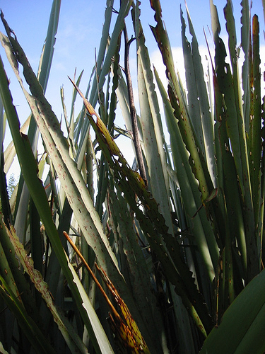
HEI MAHI 1
Tirohia ngā whakaahua e rua nei – e rua ngā momo anuhe e mahi ana, ko tā tētahi he ngau pakini(ko te anuhe pakini), ko tā tetahi he ngau wini (ko te tāwhana). (Tirohia tō mahi i te haerenga o Akoranga 1 me te whārangi 38 o Te Pukapuka Pūtaiao 1 KIS 3)
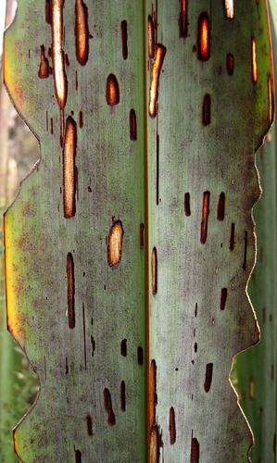
He wāhi anō o te waha o te tāwhana kia taea e ia te kiri o te harakeke te waruwaru, me he kiri āporo e ngaungaua ana e ngā niho o mua. Hāunga anō te anuhe pakini, ko tōna he mea ngaungau i te tapa o te rau, pēnei i te ngaungau a ngā niho o mua i te pihikete. Nā te rerekē o te hanga o te waha o ngā momo anuhe nei e taea ai te kai ngātahi te rau kotahi, engari kāore e tuki tētahi i tētahi.
HEI NGOHE:
Ka tukuna atu ki tō rōpū tētahi rau harakeke, tī kōuka rānei kua ngaungaua e ngā momo anuhe e rua nei. Mā tō karaehe e whakaatu mai te kore tauwhāinga a ngā tokorua nei ki te kai kotahi, mā te ine i te tawhiti o ngā tohu ngau i te karawhā, kātahi ka whakamaheretia ake ngā inehanga. Me ine ā-mirimita mai i te pito tata o te tohu ngau ki te karawhā, e whakaaturia ana i te huahua i raro nei:
karawhā
pakini
wini
Me mirimita te inehanga o ēnei tawhiti

Tuhia ngā inehanga hei rārangi i tētahi mahere putaputanga kia pēnei:
Tawhiti i te karawhā(mm) | Wini | Pakini
0 - 4 | II
5 – 9 | IIII
10 - 14
arā atu anō

Ka whakaritea e tō kaiako tētahi mahere ki te papa hei tuhi mā ia rōpū ngā whakataunga, ā, kia whai tae kē te wini me te pakini, ka whiriwhiria ake he mahere putaputanga e whakaatu ana i te auautanga o ngā tawhiti o ngā wini me ngā pakini i te karawhā o ngā rau harakeke.
TE MAHERE AKORANGA 4
TE WĀ: 60 meneti
KAUPAPA MĀORI: Tāhū kōrero
NGĀ TOHUTOHU MĀ TE KAIAKO:
- Tāruatia ngā whārangi mahi 1, 2, 3.
- Me whai pepa A4 mō Hei Mahi 1.
- Whakaritea kia 7 ngā rau pepa kua tuhia ki ngā āhuatanga e whitu o te ora. (oreore, whakahā, rongo, tipu, whai uri, unga para, kai).
- Me whai papakupu Reo Pākehā-Reo Māori/Reo Māori-Reo Pākehā.
- Me whai pua harakeke, heu matatahi, papa rākau kotikoti hoki.

NGĀ TOHUTOHU MĀ NGĀ TAUIRA:
- Ma tō kaiako koutou e whakarōpū hei whakaoti i ngā ngohe MRS GREN i Hei Mahi 1.
- Pānuitia ngā kōrero mō te ruinga hae me te aitanga a tipu i Hei Mahi 2.
- Mō Hei Mahi 3, ka whāwhātia ā-ringatia ngā kōrero mō te hanga o te harakeke me te tohu i ōna wāhanga.
HEI MAHI 1
He puāwaitanga nō te harakeke;
he rito whakakī i ngā whāruarua.

Mīharo ana te kitenga atu i te puāwaitanga o te pā harakeke, ko te kōrari tonu ka toro ake ki te rangi. E rewa ana ngā pua whero, kōwhai hoki ki runga ake o te pā. Ka whakakī ngā kōrari i ngā tūranga rito, ka tāmate nei te pā, engari nā te puāwaitanga ka whakaritorito anō te tipu ki ngā whāruarua hei pā.

Ehara i te mea ko te whakaritorito anake te hua o te puāwaitanga o te pā harakeke engari mā konei ka taka anō ki te whaihua kia puta mai ai he kākano ka tīnaku hei pā harakeke hou menā tiria atu ki te whenua haumako e rite ana.
Ko te whakaputanga uri TĒTAHI o ngā āhuatanga o te ora e WHITU, arā, e tohua ana ēnei i roto ngā mea ora katoa. Kua tūtaki kē koutou i a MRS GREN, māna e whakamahara mai.
Tīkina atu ngā kupu i raro iho nei hei whakamahara i te mahi a MRS GREN:
unga para (excretion) oreoretanga (movement) tipu (growth) whakahā (respiration)
rongo (sensitivity) whai uri (reproduction) kai (nutrition)
M(O) | R(W) | S(R) | G(T) | R(W) | E(U) | N(K)

Ka whakarōpūtia koutou e tō koutou kaiako kia whitu ngā rōpū, ka tukuna ki ia rōpū, kia 2 ngā whārangi A4, me tētahi o ngā āhuatanga o te ora o MRSGREN. Kei roto tonu i tō rōpū:
- Tuhia ki tētahi o ngā whārangi he porohita ariā (tirohia ki raro iho nei), tuhia hoki tō kupu ki tētahi o ngā hautahi.
tipu

- Mā te rōpū tonu e wānanga ngā kupu whanaunga kia hua mai ai he rerenga kōrero tika ki tērā atu o ngā whārangi pepa.
- Whiriwhiria kia toru ngā kupu i wānangatia ai hei tuhi ki ia hautahi o te porohita.
- Tuhia tētahi rerenga kōrero tika ki muri i te whārangi wānanga kupu, kia whā noa iho ngā kupu matua hei tuhi.
- Tukuna te whārangi porohita ariā ki te rōpū ki te taha maui, tangohia te whārangi porohita ariā i te rōpū i te taha matau.
- Tikina atu ko ā rātau kupu e whā hei tuhi rerenga kōrero tika ki muri i tā koutou whārangi wānanga kupu.
- Tuaruatia te mahi nei kia hoki mai anō ta koutou ake whārangi porohita ariā ki a koutou.
8. Ka tirohia ā koutou rerenga kōrero e tō koutou kaiako i a koutou e mahi ana i te mahi e
whai muri ake nei.
HEI MAHI 2
Tirohia ngā whakaahua nei o te pua harakeke me te tūī.
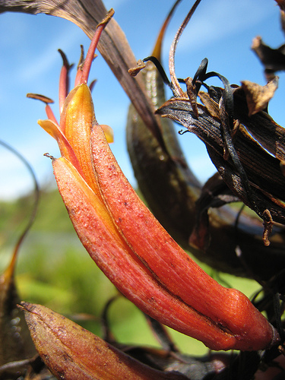
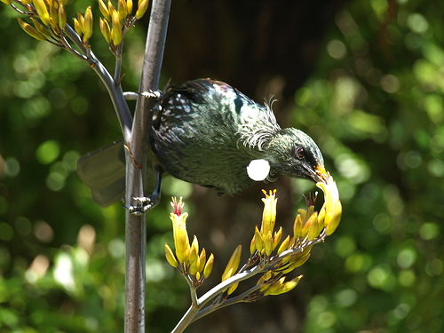
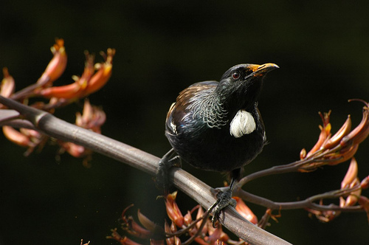

Ka whakahahaetia te pua harakeke e te tūī (ko te tūī te kaiwhakahahae), tirohia te hanga o te ngutu o te tūī. Mā te roa me te āhua ka taea e ia te toro te waihonga o te pua kōrari.
Kei ngā pito pūtawa(te ure) o te pua kōrari te hae(te pūtau tāne). Ka mau i ngā huru tūī i runga ake o te ngutu te hae kōwhai, i mau i reira i te tūpoutanga iho o tōna ngutu ki roto tonu i te pua kia tae atu ki te pā waihonga (ka whakaputa i te waihonga reka hei whakamanea i ngā manu me ngā ngangara ki te kai).
Ka rere atu te tūī ki tētahi pua kōrari anō, ka kawea te hae kia mau ki ngā tauhae tāpiapia (te ūhā) ki waenganui pū o te huinga tauhae.
Ka tipu heke te hae ki raro i te tauhae ki te kura kākano ki reira whakakikiri ai i te pūtau ūhā kia hua mai ai he kākano.
He nui te hae, he nui te whakakikiritanga o te nui pūtau ūhā i te kura kākano, kia hua mai ai te nui o ngā kākano kua mau ki rō pākākano. (Tirohia ngā whakaahua i raro iho nei o ngā pākākano i runga kōrari).
Ka pakeke ngā kākano, ka maroke te pākākano, ka ngawhā ake kia putarere mai ko ngā kākano ka ruiruia(ka marara, ka hariharia hoki) i te matua.
Ka whai hua ngātahi te tūī me te harakeke i tēnei nohoanga. Ka kiia ai he kotahitanga.
- Whakamōhiotia te hua mō te tūī.
- Whakamōhiotia te hua mō te harakeke.
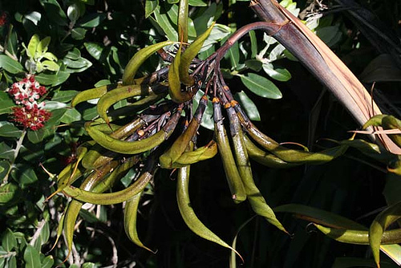
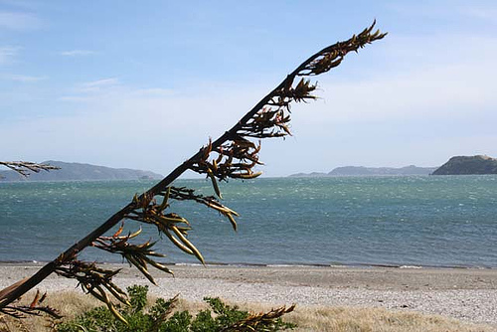

HEI MAHI 3
Ka tukuna mai e tō kaiako he pua kōrari, he heu, he papa rākau hoki.
Ko tāu, he tuaki pua kia mōhiotia ai ngā wāhanga o te pua i whakaahuatia i Hei Mahi 2.
- I mua i te tuakitanga, whakamōhiotia mai ko ēnei wāhanga e kitea ā-wahotia ana o te pua:
  - Raupua (kua whai tae hei whakamanea i te kaiwhakahahae, ka tiaki hoki i ngā wāhanga whai uri);
  - Pārau (kei te take o ngā raupua, i te tiaki i ngā pua i mua i te puāwaitanga mai);
  - Pūtawa e mau pata hae kōwhai ki ngā pito;
  - Tauhae i waenganui pū o te huinga pūtawa.

- Tapahia whāroatia te pua kia haurua.
- Whakamōhiotia ēnei wāhanga:
  - ngā pūtawa (ngā pito e mau hae ana, ngā tā e toko ana i ngā pito ki runga ake);
  - te taupae kei runga ake i tētahi ngongo roa e kiia nei he awahae;
  - te kura kākano kei te take o te awahae;
  - te pā waihonga kei te take o te kura kākano.
- Tuakina te kura kākano kia kitea ai ngā kano tipu.
- Tuhia, huaina hoki te pua kōrari, ō-roto, ō-waho.
- Mā te tirohanga koe e āwhina ki te whakaoti i te mahere i raro nei, mā te whakarārangi i ngā wāhanga kua tohua ā-tau nei kia rite ki te huahua pua kōrari i te taha.
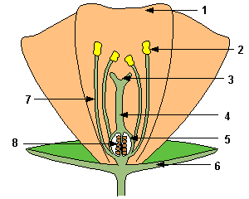
1
2
3
4
5
6
7
8

TE MAHERE AKORANGA 5
TE WĀ: 60 meneti
KAUPAPA MĀORI: Tāhū kōrero
NGĀ TOHUTOHU MĀ TE KAIAKO:
- Haria ngā kape o Ngā Puka Hātepe Pūtaiao Whātahi o Kiwi, 3 Puka Pūtaiao 1, tirohia te whārangi 38 me ngā mahi a ngā tauira i Akoranga 1.
- Me whai papakupu Reo Pākehā-Reo Māori/Reo Māori-Reo Pākehā.

NGĀ TOHUTOHU MĀ NGĀ TAUIRA:
- Tirohia ngā kōrero kua kohia, kua ākona e koe i ngā akoranga o mua atu hei whakaoti i ngā mahi mō te noho whanaunga o ngā momo rerekē o te huinga ora.
HEI MAHI 1
Hutia te rito o te harakeke, kei whea te kōmako e kō?
Ka rere ki uta, ka rere ki tai.
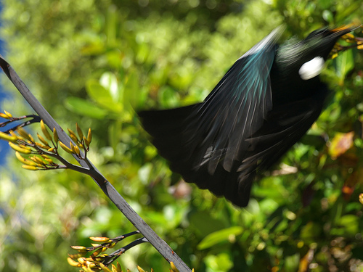
Ki te tāmi koe i te tipu o te pā harakeke, ka kore he pua whai waihonga hei whakamanea i te manu, ka kore hoki he kōrari hei taunga mō te manu. Ka rere kōtiti kē ki te kimi kai, ki te kimi taunga mō rātau.
Ko te tikanga o te whakatauki nei hei tohu i a tātau he whakapapa tonu e here ana i te hunga ora ki a ia anō, kia whai oranga hoki ai.
Kua rarangahia ngā momo o te huinga ora hei kete whakapapa, ka mutu ka kume tēnā, ka tohe tēnā, he kāinga te take, he kai te take.

Ko tā te tāhū kai he whakaatu i te noho whakamauru a tētahi ki tētahi i te huinga ora mō te kai te take. Kei te whainga kai o te hunga oreore te tikanga o te tāhū kai.
Ko ngā momo rōpū:
KAIKIKOKIKO
Ka kai i te kaiotaota kia whai pūngao anō ai.
KAIOTAOTA
Ka kai i te kaiwhakanao kia whai pūngao anō ai.
KAIWHAKANAO
Ka kapohia te pūngao o te rā hei mahi kai i ngā matū pararopi.

Tēra ētahi huinga ora nei, e kai ana te kaikikokiko i tētahi atu anō ōna, hei tauira, ka kai te ngeru i te manu, i kai te manu i te ngangara, i kai te ngangara i te pātītī.
- He kaiwhakanao te pātītī
- He kaiotaota te ngārara ngaungau pātītī
- He kaikikokiko paetahi te manu kai ngarara
- He kaikikokiko paerua te ngeru kai manu

He whakapopo te huakita me te kōpurawhetū e kai ana i ngā tipu me ngā kararehe mate, heoi ka noho ki ngā wāhi katoa o te huinga ora.

Tīkina atu ngā kōrero i kohia e koe i te haerenga i Akoranga 1(tirohia rānei te whārangi 38 o KIS 3 Pupuka Pūtaiao 1), hei āwhina i a koe ki te whakatakoto tāhū kai mō te huinga ora e noho ana i te pā harakeke, ā me tuhi kia whero ki te wāhi i raro iho nei.

Tērā e maha nei ngā tāhū kai i te nuinga o ngā nohoanga. Māu tēnei e whakaatu mai mā te takitaki i ētahi tāhū kai e rua anō mō te pā harakeke, kātahi ka tuhi ai ki raro iho nei: kia kākāriki tētahi, kia kahurangi tētahi.

Ki te noho tahi ngā tāhū kai nei ka hua mai ai he tukutuku kai. Ko ngā tikanga kai katoa o tētahi huinga ora, koinā kē te tukutuku kai.
He uaua kē te tuitui i te katoa o te tukutuku kai i te mea he uaua hoki kia kitea ētahi kararehe, kāore pea i te mōhio ki ngā kai a ētahi.
Whakatōpūhia ngā tāhū kai whai tae hei tukutuku kai, me mau tonu ki ngā tae kia mārama mai ai ko ia tāhū kai.
He tauira tukutuku kai tēnei nō tētahi nohoanga huinga ora, ā, kua whai tae ētahi o ngā tāhū hei whai māu mō tō ake tukutuku kai pā harakeke.
pihareina
ngō
pātītī
paihaurēhi
rō
koropio
ngeru
mānuka
pekerau
pūwere

E 4 ngā tāhū kai o tēnei tukutuku kai. Ka taea e koe tētahi atu te whakamōhio mai?
Hoki atu ki tō whārangi kōrero. Ka taea e koe te tāpiri ētahi atu tāhū kai ki tō tukutuku kai?

HEI MAHI 2
Tirohia te tukutuku kai i Hei Mahi 1:
pihareina
ngō
pātītī
paihaurēhi
rō
koropio
ngeru
mānuka
pekerau
pūwere

Ki te maputia e te kaingaki tōna māra hei patu ngō e kai ana i ana rōhi, ka ahatia te tukutuku kai e noho ana i taua wāhi o te māra?
Āta whakaarohia ngā pānga tata, ngā pānga tawhiti hoki.
Tuhia tētahi whiti kōrero mō ngā pānga mai o te mahi a te kaingaki māra.

_________________________________________________________________________

_________________________________________________________________________

_________________________________________________________________________

_________________________________________________________________________

_________________________________________________________________________

_________________________________________________________________________

_________________________________________________________________________

_________________________________________________________________________

_________________________________________________________________________

_________________________________________________________________________

TE MAHERE AKORANGA 6
TE WĀ: 60 meneti
KAUPAPA MĀORI: Te Hao
NGĀ TOHUTOHU MĀ TE KAIAKO:
- Mātua whakarite i tētahi haerenga tōmua ki te marae, ki te wāhi mahi rānei o te kairaranga hei whakariterite mahi.
- Ētahi tūmahi hei tautoko i ngā akoranga o mua atu, hei whakapakari ake i te mōhio ki ngā tikanga:
  - Te tiaki tipu;
  - Tikanga;
  - Te whakarite i ngā rau/whā;
  - Ngā momo whakamahinga;
  - Te raranga.
- Whakaritea te haerenga.
- Whakaotia ngā whakaritenga haerenga ā-kura, hei tauira, te puka Ārai Tiaki Whara; te whakaaetanga a ngā mātua, te aha, te aha.
- Whiriwhiria ko tētahi hei kaikōrero mō te rōpū.

NGĀ TOHUTOHU MĀ NGĀ TAUIRA:
- Whakaotia, whakahokia ngā puka mō te haerenga ki waho i te kura.
- Me paepae ngā taringa ki te whakarongo, me āta mātakitaki, me whaiwhakaaro ngā pātai.

