HE KAUPAPA PŪTAIAO

TAU 9 & 10

TE MARAUTANGA O AOTEAROA

KAUPAE 3 - 5 PŪTAIAO

TE AO MATŪ

15 NGĀ AKORANGA ME NGĀ MAHI

TE MAHI TAE

He Mahere Kaupapa Mahi –Tau 9 & 10 Pūtaiao – Te Mahi Tae
Tauira: | TE KATOA | Kaupapa Māori:
Mōhiotanga o te kaiako: | Āhua mōhio | He iti
Wāhanga Ako: | Pūtaiao | Tāne
Marautanga -Take | Pūtaiao
Whenu: | Te Ao Matū | Papatūānuku,
Kawa: | Ngā āhuatanga me ngā huringa matū  Te hanga o te matū  Te mātauranga matū me te iwi | Papatūānuku, Ruaumoko
Kaupae: | 3 - 5
Ingoa: | Te Mahi Tae | Hineteiwaiwa
Ngā whāinga hei whakatutuki: | Ko ā ngā tauira:  - he takitaki i te tāhū e here nei i ngā kitenga me ngā āhuatanga matū, āhuatanga ōkiko hoki o ngā momo matū, ki ngā whakaritenga hangarau me ngā kawa māori (Kaupae 3/4 Te mātauranga matū me te iwi); | Papatūānuku
 | - he whai māramatanga ki te āhuatanga ririki o te matū, ā, mā tērā e whakamārama ngā huringa i kitea ai. (Kaupae 4 Te hanga o te matū); | Ruaumoko
- he whakaahua i te hanga o ngā ngota o ētahi momo pūmotu;
- he tohu i te rerekētanga o te pūmotu me te pūhui, arā, te tikanga ririki o te matū horomata me te pūhui matū (Kaupae 5 Te hanga o te matū)
 | - he wānanga i ngā āhuatanga matū, ōkiko hoki o ētahi huinga momo ngaku (Kaupae 5 Ngā āhuatanga me ngā huringa matū);
 | - he mārama ki te tāhū o te whare pūtaiao me tōna ao mārama, he wā nā, ka whai tāhū anō te whare hei wānanga pūtaiao (Kaupae 3/4 Te ao mārama o pūtaiao);
 | - he whakapakari i te pātaka mōhiotanga, he ohu te tikanga e wānanga tahi ai ngā kōrero (Kaupae 3/4 Te pou wānanga o Pūtaiao);
 | - he mārama haere ki ngā tāwhīwhiwhitanga o te wānanga pūtaiao, tae atu ki te tohu i ngā rerekētanga e maha (Kaupae 5 Te pou wānanga o Pūtaiao)
 | - he whakawhānui i te whainga kupu, tohu, tikanga pūtaiao hoki (Kaupae 5 te whare kōrero pūtaiao).
Ngā pūkenga matua: | Te katoa
Tirohanga: | Te tikanga matū o te mahi tae.  Ngā tae me ngā waiwai Māori tuku iho.
Wāhi: | Aotearoa; te ao; marae kāinga | Aotearoa; marae kāinga
Akoranga: | 15
Mahi: | 1 Ngā haerenga (menā ka taea) – ngā rawa mau tae tuku iho o ngā whare. Te whakamōhio noa. | Whakawhenua - whainga tapuwae, mihi
 | 2. Te mātauranga matū matua me te whakamātautau haurehu. | Reo Māori

Mahi: | 3. Te mātauranga matū matua – he tauhohe anō, he tohu, he whārite hoki. | Rangahau
 | 4. Te āhua o te matū. | Tāhū kōrero
 | 5. Te tāpui i ngā kete akoranga, te tūringiringi hoki | Reo Māori
 | 6. Te whakarewatanga | Rangahau
 | 7. Te whai tikanga matū | Rangahau
 | 8. Te kohika/whakatē tae | Whakawhenua
 | 9. Te pātaka kōrero o ngā tae tuku iho o Aotearoa | Te Hao
 | 10. Te waikawa, te kawakore | Tāhū kōrero
 | 11. Te pH/manahauwai me ngā tohu | Tāhū kōrero
 | 12. Ngā pānga:tae/waiwai | Rangahau
 | 13. Te haerenga mahi tae | Whakawhenua
 | 14. Te kaupapa tae | Rangahau
 | 15. Te whakaaturanga | Te Hao
Tikanga Māori: | Kohinga 2 – Rārangi Tikanga Māori | Whainga tapuwae, wānanga, kauhau, mihi, waiata, whakairo.
Reo Māori: | Kohinga 3 – Rārangi Reo Māori | He kupu ake, he mahi tāpuku.
Rauemi:  - Kohinga 1 | PM Ryan: The Reed Dictionary of Modern Māori
 | http://www.aucklandmuseum.com/site_resources/library/Education/Teachers_Guide/Teacher_Resources_Library/Māori_Education_Kits/Māori_-RarangaTuturu_Māori.pdf
 | Kiwi Integrated Science Series, 3 Science Book 1, J Sweeney, D Relph, L DeLacey. New House.
 | Kiwi Integrated Science Series, 4 Science Book 3, J Sweeney, D Relph, S Haigh, L DeLacey. New House. P. 118
 | New Zealand’s Economic Native Plants, RC Cooper & RC Cambie, OUP, 1991
 | http://www.harakeke.info/harakeke.html
 | http://www.aoteamoana.co.nz/native/native.html
 | http://www.doc.govt.nz/templates/page.aspx?id=33571
 | http://www.Māoriart.org.nz/noticeboard/researching_plant_taonga
 | http://www.eske-style.co.nz/Māori_plant_use.asp
 | http://www.nzetc.org/tm/scholarly/tei-BesMaor-c6-6-0.html
 | http://www.nzetc.org/tm/scholarly/tei-Bes02Maor-t1-body-d11.html
 | http://peopleplants.landcareresearch.co.nz/WebForms/default.aspx
 | http://kawhia.Māori.nz/14.html
 | http://www.Māoriauctions.co.nz/myshop/content.php?pageid=57
 | http://uneli.unitec.ac.nz/our_auckland/greylynn/Forest%20Trees.htm
 | http://www.manuka-nz.co.nz/oil-honey-soap/article_info.php/articles_id/40
 | http://www.nzgeothermal.org.nz/geothermal_energy/geothermal_uses.asp
 | http://www.earthues.com/aboutmordants.html
 | http://www.irl.cri.nz/newsandevents/innovate/innovate-sep-2001/stopping-rot-ancient-Māori-textiles.aspx
 | http://www.nzine.co.nz/features/elizarnold.html

INGOA KAUPAPA: TE MAHI TAE

PAETAU: Tau 9/10

WHIRINGA MARAUTANGA:
NGĀ PŪKENGA MATUA: Te katoa
WHENU: Te Ao Rawa Kaupae 3 - 5
NGĀ WHĀINGA HEI WHAKATUTUKI: Ko ā ngā tauira:
- he takitaki i te tāhū e here nei i ngā kitenga me ngā āhuatanga matū, āhuatanga ōkiko hoki o ngā momo matū, ki ngā whakaritenga hangarau me ngā kawa māori (Kaupae 3/4 Te mātauranga matū me te iwi);
- he whai māramatanga ki te āhuatanga ririki o te matū, ā, mā tērā e whakamārama ngā huringa i kitea ai. (Kaupae 4 Te hanga o te matū);
- he whakaahua i te hanga o ngā ngota o ētahi momo pūmotu;
- he tohu i te rerekētanga o te pūmotu me te pūhui, arā, te tikanga ririki o te matū horomata me te pūhui matū (Kaupae 5 Te hanga o te matū)
- he wānanga i ngā āhuatanga matū, ōkiko hoki o ētahi huinga momo ngaku (Kaupae 5 Ngā āhuatanga me ngā huringa matū);
WHENU: Ōpūtaiao
NGĀ WHĀINGA HEI WHAKATUTUKI: Ko ā ngā tauira:
- he mārama ki te tāhū o te whare pūtaiao me tōna ao mārama, he wā nā, ka whai tāhū anō te whare hei wānanga pūtaiao (Kaupae 3/4 Te ao mārama o pūtaiao);
- he whakapakari i te pātaka mōhiotanga, he ohu te tikanga e wānanga tahi ai ngā kōrero (Kaupae 3/4 Te pou wānanga o Pūtaiao);
- he mārama haere ki ngā tāwhīwhiwhitanga o te wānanga pūtaiao, tae atu ki te tohu i ngā rerekētanga e maha (Kaupae 5 Te pou wānanga o Pūtaiao
- he whakawhānui i te whainga kupu, tohu, tikanga pūtaiao hoki (Kaupae 5 te whare kōrero pūtaiao).
NGĀ HUA AKE O TE AKO:
Ka taea e ngā tauira:
- te whakamōhio ngā rerenga ōmatū o te mahi tae;
- te whakamōhio, te whakamārama hoki ngā āhuatanga o te tauhohe matū;
- te whakamōhio, te whakaahua, te whakamārama hoki ngā whakamātautau haurehu matua;
- te whakatauriterite ngā āhuatanga o ngā pūmotu, ngā pūhui, ngā ranunga hoki;
- te whakaahua, te whakamārama hoki ngā āhua e toru o te matū me ngā whakawhitinga;
- te whakamārama te tikanga tūringiringi;
- te whakamōhio, te whakamārama te whakarewatanga o te ngaku;
- te whakatauriterite ētahi o ngā āhuatanga ōkiko o te waikawa me te kawakore.

TE MŌHIOTANGA KIA MŌHIOTIA:
Te Ao Matū Kaupae 1/2

NGĀ RAUEMI HEI WHAI:
- Me mau mōhiti haumaru ngā tauira katoa i ngā mahi ā-ringa katoa.
- Akoranga 1: Me whai kāmera taurua, me whakaahua i ngā rawa mau tae katoa e kitea ana, me mau hoki ki ngā kōrero e rite ana.
- Akoranga 2:
        - Mahi 2: he kuku; he ngaku rīpene Mg 2 hm te roa; he muratahi; he
māti, he pūahi rānei
        - Mahi 3: tirohia te whārangi 53 o KISS 3 Pukapuka Pūtaiao 1 Mirumiru
Hauwai
he māti/pūahi
he papa kiri rākau kua mauherea ki te rūri mita
he ranunga 50% hopiwē/50% nonireka i rō pātara whakatē
he paepae wai nui
he pātara waireka kirihou + he puru kotahi whai puare
he ngongo whakarere
he pata konutea
he waikawameha pūngāwhā
Tā ngā tauira whakaranu, tahu korohū hauwai (ā-rōpū)
he ipuipu
he waikawameha pūmāota (0.1M)
ētahi rau rīpene konupora ½ - 1hm te roa
he papa kiri rākau + he mea hei tahu

Tā ngā tauira hanga, tahu warohau (ā-rōpū)
he ipuipu
he waikawameha pūmāota (0.1M)
he kongakonga māpara
he papa kiri rākau + he mea hei tahu
Tā ngā tauira hanga, tahu hāora (ā-rōpū)
he ipuipu
he hauwai waikuratei (kia 20 vol))
he paura konupora hāorarua
he papa kiri rākau + he mea hei tahu
- Akoranga 3:
  - Hei Mahi 2: he rino, he pūngāwhā(mā ia rōpū)
he ipuipu maroke
he whatanga ipuipu
he paura pūngāwhā
he paura rino matarehu
he rapa
he paekoru, he patu/kuru
he papa ārai ahi, he papa herameke rānei
he kuku
he muratahi + he māti, he pūahi rānei
he kapa, he pūngāwhā (mā ia rōpū)
he rau kapa tapawhā paku
he timo paura pūngāwhā
he rapa
he papa ārai ahi, he papa herameke rānei
he kuku
he muratahi + he māti, he pūahi rānei

he rino, he kapa (mā ia rōpū)
he ipuipu maroke
he whatanga ipuipu
he paura kapa
he paura rino matarehu
he rapa
he paekoru, he patu/kuru
he papa ārai ahi, he papa herameke rānei
he kuku
he muratahi + he māti, he pūahi rānei
- Akoranga 4:
  - Mahi 1: (mā ia rōpū)
he tūnga rawhi
he rawhi
he ine pāmahana
he ipurau karāhe 250mr
he kōrere karāhe (hei mau tika ki runga ipurau)
he hukapapa penupenu 150mr
he whāriki ārai
he waetoru
he muratahi

- Akoranga 5:
  - Mahi 3: he tioata pāhare pāporo
he kuku
kia 3 ngā ipurau karāhe 250mr
he wai wera 200mr
he wai makariri 200mr
he wai tino makariri 200mr
he ngongo karāhe whāiti, he ngongo inu rānei
he kakara kaha, hei tauira, ‘Lynx’
- Akoranga 6:
  - Mahi 1: (mā ia rōpū)
he rapa
he ipuipu
he whatanga ipuipu
he ipu: kapa ngāwhā
kapa pākawa waro
kapa pākawa
konutai pākawa waro
konupūmā pākawa waro
konutai pūhaumāota
konutea pākawa waro
- Mahi 2: (mā ia rōpū)
kia rua ngā paepae ine 100mr
he pīni maroke(pīni karikote, pītiki, pīni rite rānei)
he onepū maroke
he tātari
he paepae aihikirimi 2R
Mō te whakaaturanga a te kaiako:
kia rua ngā paepae ine 100mr
he wai ewaro 50mr
he wai 50mr
- Akoranga 7:
  - Mahi 1: (mā ia rōpu)
he wai
he ipurau
he rākau hei kōrori
he kōrere tātari
he pepa tātari
he paepae whakaeto
he waetoru
he whāriki ārai
he muratahi
he ranunga tote, onepū hoki

- Akoranga 8:
  - Mahi 1: (mā ia rōpū)
he muratahi
he waetoru
he whāriki ārai
he ipurau nui
he rākau kōrori (he pune kirihou, rākau rānei, he toko karāhe)
he pene tohu parewai (hei tohu i te papanga ki te ingoa o te tipu)
ētahi papanga tapawhā mā (he tīhāte papahune, he miro wūru, he pareaku, he aha, he aha)
he tauira tipu (mā te kaiako e tiki) – tirohia ngā whakapuakanga i te whārangi 69 (Mahere akoranga #9) – ka tīkina atu ētahi tipu kē hei mātua whakamātautau, hei tauira, he kiri rīki, he putiputi whai tae.
he kutikuti hei kotikoti tipu
he paekoru, he patu/kuru hei kuoro tipu
he kuku hei rarau hanga/papa wera
he tauera pepa, terei mīti pareaku
he pepa pānui
- Akoranga 10:
  - Mahi 3: (mā ia rōpū)
he pepa tohu waikawa whero
he pepa tohu waikawa kahurangi
he wai māturu
he waikawa pūmāota 0.1mr
he konutai waihā 0.1mr
he miraka
he inu mirumiru
he hopi makawe
he haukini

- Akoranga 11:
  - Mahi 1: (mā ia rōpū)
he Waipūhuitohukonu 1% i rō waiwaihā
he pātara mapu kī i te wai horoi karāhe me te haukini(he haukini kāinga 10% rānei)
he koikoi wūru miro
he pepa A5

  - Mahi 2: he kāpeti whero
he naihi
he papa kotikoti
he ipurau 300ml
he winika
he pēkena houra
he wai whakakōmā
he wai māturu
he haukini
he waikawa pūmāota 0.1mr
he konutai waihā 0.1mr
he miraka
he inu mirumiru
he hopi makawe
- Akoranga 12:
  - Mahi 2: (mā ia rōpū)
he papanga rīnena, pareaku hoki
he kutikuti
kia 3 ngā ipurau karāhe 250mr
he ipu ine
he wai haukini 100mr
he kuku
he wai konumohe 150mr
he toko karāhe
he tae kura 150mr
he whāriki ārai
he waetoru
he muratahi
he ine pāmahana
- Akoranga 14:
  - Mahi: Mā ia rōpu e tono ō rātau hiahia taputapu ā-ringa nei ki te kaiako, ki te kaitiaki taiwhanga pūtaiao rānei.

NGĀ WHAKAPUAKANGA HEI TIROTIRO:
The Reed Dictionary of Modern Māori, PM Ryan, Reed, 1995
http://www.aucklandmuseum.com/site_resources/library/Education/Teachers_Guide/Teacher_Resources_Library/Māori_Education_Kits/Māori_-RarangaTuturu_Māori.pdf
New Zealand’s Economic Native Plants, RC Cooper & RC Cambie, OUP, 1991, pages 133-135, Plate 15
Kiwi Integrated Science Series, 3 Science Book 1, J Sweeney, D Relph, L DeLacey. New House.
Kiwi Integrated Science Series, 4 Science Book 3, J Sweeney, D Relph, S Haigh, L DeLacey. New House. P. 118
http://www.earthues.com/aboutmordants.html
http://www.irl.cri.nz/newsandevents/innovate/innovate-sep-2001/stopping-rot-ancient-Māori-textiles.aspx
http://www.harakeke.info/harakeke.html
http://www.aoteamoana.co.nz/native/native.html
http://www.doc.govt.nz/templates/page.aspx?id=33571
http://www.Māoriart.org.nz/noticeboard/researching_plant_taonga
http://www.eske-style.co.nz/Māori_plant_use.asp
http://www.nzetc.org/tm/scholarly/tei-BesMaor-c6-6-0.html
http://www.nzetc.org/tm/scholarly/tei-Bes02Maor-t1-body-d11.html http://peopleplants.landcareresearch.co.nz/WebForms/default.aspx
Haere ki ‘kimihia’, kimihia ā-rohetia “ngā tae’ i Rohe 1 – 61 urunga
http://kawhia.Māori.nz/14.html
http://www.Māoriauctions.co.nz/myshop/content.php?pageid=57
http://uneli.unitec.ac.nz/our_auckland/greylynn/Forest%20Trees.htm
http://www.manuka-nz.co.nz/oil-honey-soap/article_info.php/articles_id/40
http://www.nzgeothermal.org.nz/geothermal_energy/geothermal_uses.asp
http://www.nzine.co.nz/features/elizarnold.html
MAHERE AKORANGA 1
TE WĀ: 60 meneti (kia roa ake menā ka whakaritea he haerenga)
KAUPAPA MĀORI: Whakawhenua – whainga tapuwae; mihi
NGĀ TOHUTOHU MĀ TE KAIAKO:
- Ko te tae te kaupapa ake o tēnei mahi, arā, te whakamahi i te tae me ngā waiwhakaū, me āna tikanga mahi. Menā e taea, me whakarite haerenga hei tīmata i tēnei mahi, ki te marae, ki te whare taonga, ki tētahi whare rānei kei reira ētahi tae tuku iho e whakaaturia ana, hei tauira – he papa tukutuku, he kete, he kākahu. Tērā pea ka puta tētahi kaumātua, kaitiaki taonga rānei ki te whakamārama i ngā kōrero mō ēnei. Tērā pea ka whakaritea he haerenga anō ā te wā, kia kitea e ngā tauira te mahi tae(o namata, o nāianei rānei) e mahia ana, e whakaritea ana rānei. Hei te mutunga o tēnei kaupapa mahi, kua oti i ngā rōpū tauira te hanga pukapuka mō ngā mahi tae tuku iho o te Māori – ka hao atu ki roto ko ngā tānga whai kōrero me ngā kupu, i tuhia i Akoranga 1.
Menā kua pai mō te haerenga, me whakariterite.
Whakaotia ngā whakaritenga haerenga ā-kura, hei tauira, te puka Ārai Tiaki Whara; te whakaaetanga a ngā mātua, te aha, te aha.
Kīa atu ki ngā tauira kia haria he pukatuhi/pukatā, he pene rākau hoki.
Whakaritea he kaikōrero hei mihi mō te rōpū.
Mehemea kāore he haerenga, whakaritea kia haria mai ētahi papanga whai tae tuku iho hei tirotiro mā ngā tauira i te kura – me whai āwhina i ngā kaumātua.
Ahakoa ko tēhea, whakaritea hoki he kāmera hei mau whakaahua hei whare kōrero whakaahua. Tērā ētahi a ngā tauira hei tāpiri mai i ā rātau ake kete kōrero. Tērā pea ka tuhia kia rerekē ngā tae o ēnei kōrero, whakaahua hoki hei whakaatu.
- Tāruatia ngā whārangi mahi – ka tāia e ngā tauira ā rātau ake whakamāramatanga o te pūrākau o Hinerehia. Ka whai wāhi tēnei ki tētahi pukapuka a te rōpū mō ngā tae tuku iho, me ā rātau tānga whai kōrero o te whakaaturanga, hei whakaoti mā rātau i mua i te paunga o tēnei kaupapa mahi.

NGĀ TOHUTOHU MĀ NGĀ TAUIRA:
- Whakaotia, whakahokia ngā puka haerenga ki waho o te kura.
- Me whai pukatuhi, pukatā hoki hei hari i te haerenga.
- Me paepae ngā taringa ki te whakarongo, me āta mātaki, me whai whakaaro hoki ngā pātai.
- Ka whakawhāititia āu tuhinga, tānga hoki ki te kete pukapuka a te rōpū hei raranga mā koutou i mua i te paunga o tēnei kaupapa mahi.
- Hei mahi kāinga, tāia tāu ake whakamāramatanga mō te pūrākau a Hinerehia – ka raua atu tēnei ki roto i te kete pukapuka a te rōpū.

HEI MAHI

Te Kitenga o Te Raranga – he Pūrākau Māori

E ai ki ngā iwi o Hauraki, nō te wahine patupaiarehe, nō Hinerehia, te whatu me te raranga. Ko ia hoki tērā i moe i te tangata, ko Karangaroa tōna ingoa, he rangatira o Te Maruiwi o te moutere o Motuihe i Te Whanga o Hauraki. I tūtaki rāua i a Hinerehia e kohi rehia ana hei kai. Ka moe, ā, ka whai tamariki.
He tohunga a Hinerehia ki te whakarite me te tae muka harakeke, te whatu kākahu, te raranga kete, whāriki hoki. Ka mahi anake i te pō, i ngā rangi kohu rānei. I te ata ka waiho āna mahi kāore anō kia oti ki tētahi wāhi kāore e taea e ngā hihi o te rā. Koinei te tikanga o te iwi patupaiarehe, i te mea, ka wetewetea ā rātau mahi raranga e te rā, ā, ka riro hoki ō rātau pūkenga ki taua mahi.
Heoi, ka tino hiahia ngā wāhine o Motuihe kia mau i a rātau te mōhio o Hinerehia ki taua mahi engari kaōre e taea i roto i te pōuri. Nā reira ka whakaae tētahi tohunga ki te whakapōraru i ngā whakaaro o Hinerehia kia mahi tonu a ia ahakoa whiti kē te rā. Ka mahi tonu a Hinerehia me te akoako a ngā wāhine e huna tata ana ki a ia i āna tikanga o te whare pora.
Ka ngenge ana, ka whakarērea atu tāna mahi ki rāhaki, kātahi ka mōhio ia kua tinihangatia. Nā reira, ka waiata poroporoaki ki tana tāne me ā rāua tamariki e kore nei e kitea atu anō, ka heke iho tētahi kapua, ka kawea atu ia ki tōna kāinga tawhito, ki Ngā Pae Maunga o Moehau.
I ētahi wā i te pō, inā tau ai rānei te kohu pūrerehu, ka rongo te tangata i te tangi a Hinerehia i te tuanui o te whare. He tohu aituā.
Nā reira i riro ai i ngā wāhine o Hauraki te wānanga o te whare pora, koinei hoki te take e mahia ai tēnei mahi i te awatea, ka tata ki te pō, ka uhia e rātau ā rātau mahi kāore anō kia oti. I te wā i mau anake i a te patupaiarehe te wānanga o te whare pora, ka mau ki te pō.
Kia tūpato te tangata i ēnei rā, kei hoki atu anō tenei wānanga ki te pō, ki te patupaiarehe, ka ngaro, riro. Ka raru a Hinerehia i tana raranga i te awatea. Tērā pea ka raru ngā wāhine o te ao nei menā ka raranga i te pō. Nā reira e whakatūpatohia ana te hanga kōhine ki ēnei tūāhuatanga: “Me mahara ki te raru o Hinerehia”.
- Whakarongo, kōrero hoki ki ngā tāngata mō ngā tae ka riro i ngā whakaritenga mahi tae tuku iho. Otirā ia, whakaarohia ko:
  - te tae o te papanga noa
  - ngā tae o ngā papanga whai tae
  - Menā ka taea, tuhia ngā kōrero mō te rironga o ēnei tae.

- Me mahi takirōpū ki te tā i ngā mea kua whakaaturia mai me te āta tapa i ngā wāhanga tae. Whiriwhiria mā wai tēhea wāhanga hei tā kia pau katoa ngā wāhanga i te rōpū te tā, kaua ki te tauira kotahi. Me āta mahi tēnei mahi i te mea ka noho hei kōrero mō te kete kōrero hei tiki atu mā koutou ā muri atu nei.

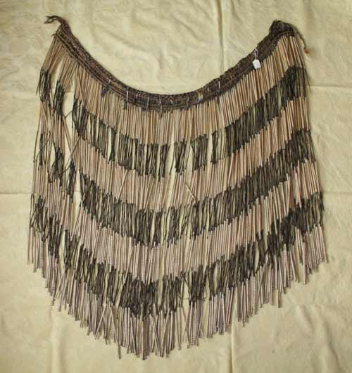

Ko te piupiu he kākahu āhua panekoti nei, kua whatua he whenu harakeke e iri ana i te tātua te hanga. Ka oreore te kaimau, ka piupiu hoki ngā whenu. He tikanga whīwhiwhi te mahi harakeke o Aotearoa nei hei hanga piupiu. Hārōhia ai ngā rau kia muka takirite te āhua, waiho noa he wāhi takoto noa ki waenganui. Kātahi ka whiria ngā wāhi muka. Ka kōhuatia ngā whenu, ka whakamarokehia kia mā te āhua, ā, ka takaia hei ngongo. Kātahi ka mahia ki te tae kia pango. Ko te muka anake ka pango, kia kotikoti ai te āhua ki te pango, ki te mā. Ka mutu ka herea ngā whenu ki te tātua whiri.
Nancy Swarbrick. 'Flax and flax working', Te Ara - the Encyclopedia of New Zealand, updated 21-Sep-2007
URL: http://www.TeAra.govt.nz/TheBush/NativePlantsAndFungi/FlaxAndFlaxWorking/en

MAHERE AKORANGA 2
TE WĀ: 60 meneti
KAUPAPA MĀORI: Reo Māori
NGĀ TOHUTOHU MĀ TE KAIAKO:
- Ka tirohia ētahi kupu matū, Māori, Pākehā hoki mō te mahi tae i tēnei akoranga; heoi kei te mōhio anō o te kaiako te tikanga kia kōrerotia ngā mea e rua, kotahi rānei. Ka wānangatia ā-whakaarotia, ka whakaaturia ā-ringatia, ka mahia ā-rōpūtia hoki ngā tikanga matū o ēnei kupu i ngā akoranga kei te whai mai, ka whai mōhiotanga anō ki ētahi atu kupu matū. Kīa atu ki ngā tauira, me mau mōhiti haumaru i ngā mahi ā-ringa katoa.
- Mā te whakamōhio ki ētahi kupu matū māmā nei i Akoranga 1 e kukume mai te mōhiotanga o te tauira, e whai wāhi hoki ki te wānanga tahi, te whakatau kaupapa hoki. Whakairia ngā kete whakatau poto a ngā rōpū hei tiki atu i te roanga atu o te kaupapa mahi nei; mā te tohu kōrero ki ngā mahere KWL ka oti i te tīmatanga o Akoranga 3 e whai haere atu ai te takahi whakamua a ia tauira.
- Ka tirohia ētahi kupu anō i Hei Mahi 2.
Me whai pātai, me whai tauira mahi anō hei whakatoka i te māramatanga ki ēnei kupu, hei tauira, me whakatau he hau koretae te H me te O hei pūmotu engari ki te huitahi ā-matū, ka hua mai ko te wai tonu, koretae hoki.
Tērā e hanga reka atu ki te tahu a te kaiako i te rīpene konupora i te hau(hāora) i te mutunga o tenei mahi. He tere, he māmā hoki; kīa atu ki ngā tauira kia kaua e titiro pū ki te mura o te ahi, engari ki tua paku atu. Tohua ngā āhuatanga ōkiko o ngā matū hohe: te rīpene konupora, Mg(he mea totoka kiwikiwi te āhua, he maheni); te hāora (he hau koretae, koreami) me te hua anō hoki; te waikura konupora, MgO (he paura mā). Me whai koe i: te rīpene Mg (āhua 2hm te roa),
he kuku,
he muratahi, he māti, he pūahi rānei hei tahu.
Mirimiria te rīpene Mg ki te papa raima, te pepa waru rānei i mua i te tīmatanga o te akoranga hei muku atu i te mata MgO kei kore e tauhohe mai.
- Ko te kaupapa ake o Hei Mahi 3 he whakaatu ā-ringa nei i ētahi tauhohenga matū, he whakamōhio hoki i ētahi whakamātautau hau ngāwari, i runga i te tikanga o ngā pūmotu me ngā pūhui.
Kōrerotia ngā tohu mōrearea e whakaaturia ana i te whārangi mahi – he aha te tikanga, me pēhea te whakamahi matū, me te whakamatāra anō i ngā tauira ki ngā wāhi o te kura e tohua ana(ngā tatau taiwhanga, ngā rūmā whakarite, ngā putunga matū, te aha, te aha), i ā rātau takatakahanga hoki (kei muri i ngā taraka kawe hinu, te aha, te aha). Ngā taputapu hei whai:
  - Tirohia te whārangi 53 KISS 3 Pukapuka Pūtaiao 1 Ngā Mirumiru Hauwai.
he māti, he pūahi
he papa kiri rākau kua mauherea ki te rūri mita
he ranunga 50% hopiwē/50% nonireka i rō pātara whakatē
he paepae wai nui
he pātara waireka kirihou + he puru kotahi whai puare.
he ngongo whakarere
he pata konutea
he waikawameha pūngāwhā
Ka whakaaturia i konei ētahi o ngā āhuatanga ōkiko, ōmatū hoki o te hauwai – he hau koretae, koreami hoki, he māmā ake i te hau, he pūkākā, ka pakū menā ka moe i te hau. Ko te mea whakamutunga nei te whakamātautau ‘pahū’ mō te hauwai ka whakaritea e ngā tauira i tā rātau whakamātautau ā-ringa tuatahi e whai ake nei.
Tā ngā tauira whakaranu, tahu korohū hauwai (ā-rōpū)
he ipuipu
he waikawameha pūmāota (0.1M)
ētahi rau rīpene konupora ½ - 1hm te roa
he papa kiri rākau + he mea hei tahu
Me whakahauhau i ngā tauira kia whānui kē atu te wānanga, kaua ko te titiro anake:
    - he tohu te mahana o te tou o te ipuipu nō te wera o te tauhohenga matū;
    - ki te rongo pēhanga te kōnui, e mau ana i te waha o te ipuipu, he tohu tērā nō te hau e hua mai ana i te tauhohenga matū;
    - ka whakarewahia ki runga o te waikawa te rīpene konupora e ngā mirumiru hau e hua mai ana i te tauhohenga matū(ka rite ki te koti whakarewa);
    - ka hohe haere nā, ā, ka ngaro memeha te rīpene konupora, nā, ka pau ngā matū tauhohe, ka hua mai he matū hou(he hauwai korohū, H₂, he konupora pūhaumāota hoki, MgCl₂).
    - ka mau te hauwai korohū ki rō ipuipu i te mea he māmā ake i te hau o waho.
    - ka whakaaturia ētahi o ngā āhuatanga ōkiko, ōmatū hoki o te hauwai, te pahūtanga me te muranga ahi – hei hau koretae, koreami hoki, he māmā ake i te hau, he pūkākā, ka pakū menā ka moe i te hau.
Tā ngā tauira hanga, tahu warohau (ā-rōpū)
he ipuipu
he waikawameha pūmāota (0.1M)
he kongakonga māpara
he papa kiri rākau + he mea hei tahu
Me whakahauhau i ngā tauira kia whānui kē atu te wānanga, kaua ko te titiro anake:
    - he tohu te mahana o te tou o te ipuipu nō te wera o te tauhohenga matū(kāore i te kaha te tauhohe o te konupūmā pākawa waro pērā i te konupora);
    - ki te hua mirumiru mai, he tohu tērā nō te hau e hua mai ana i te tauhohenga matū;
    - kāore e memeha noa te kongakonga māpara – ka pērā menā ka nui atu te waikawa, heoi kāore i te kaha te tauhohenga pērā i te konupora;
    - kaua e taupoki i te ipuipu hei mau i te warohau, i te mea he taumaha ake te warohau i te hau noa, ā, mā terā e pana ake te hau i te ipuipu. Kīa atu ki ngā tauira te āhua o te warohau totoka CO₂ (he hukapapa maroke) i te atamira o te whare tapere hei kohu – ka noho te warohau ki te papa;
    - ki te tahuna te papa kiri rākau, ka tineia e te hauwaro. He paraikete te rite, ka uhia te muramura o te ahi kia kore e uru atu ai te hau hei kai. Nā reira i noho ai hei matū tinei ahi i ētahi wā.

Tā ngā tauira hanga, tahu hāora (ā-rōpū)
he ipuipu
he hauwai waikuratei (kia 20 vol))
he paura konupora hāorarua
he papa kiri rākau + he mea hei tahu
Me whakahauhau i ngā tauira kia whānui kē atu te wānanga, kaua ko te titiro anake:
    - he tohu te mahana o te tou o te ipuipu nō te wera o te tauhohenga matū(kāore i te kaha te tauhohe o te konupora hāorarua pērā i te konupora, engari kei te kaha me te hou o te hauwai waikuratei te tikanga);
    - ki te hua mirumiru mai, he tohu tērā nō te hau e hua mai ana i te tauhohenga matū;
    - me taupoki te ipuipu kia mau te hāorarua ki roto kei rere ki waho i te mea he rite te taumaha ki te hau o te takiwā;
    - ka mura anō te papa kiri rākau i te hāorarua. Kīa atu ki ngā tauira me whai hāorarua hei tahutahu ahi – te tikanga takitoru o te wera, te kai hei whakakora, me te hau

- Me whai papakupu Reo Pākehā-Reo Māori/Reo Māori-Reo Pākeha.

NGĀ TOHUTOHU MĀ NGĀ TAUIRA:
- Mā te mōhio ki te tāhū o te whare matū e mārama ai ki ngā tikanga o te mahi tae. He reo anō o te ao matū, heoi koinei te mahi a kō ake nei kia mārama mai ko tēnei reo, ko ēnei kupu.
- Ko tā Hei Mahi 1 he tiki atu i tō kete mōhio i te tāhū o te whare matū ka tāpui tahi ai ki ērā o tō rōpū hei kōrero whakatau mā koutou, hei tuhi hoki mā koutou i te mōhiotanga o te rōpū ki tēnei tāhū kōrero ōmatū, kia taea hoki e koutou te whakamātau tā koutou akoako matū i roto i te kaupapa mahi tae nei. Whakamāramatia, whakaahuatia, whakatauiratia rānei ia kupu matū.
- Mō Hei Mahi 2 ka kite koe i ētahi kupu matū anō, me ngā tauira ōmatū o te takiwā. Hei te mutunga o te mahi nei, hei te wā anō kua kiia ai kua whai mōhiotanga koe mō te matū, ka whakaaturia e tō kaiako tētahi tauhohenga matū mā te tahu rino i roto i te hau. Me tika te mau taputapu haumaru, me tino whai hoki i ngā tohutohu a te kaiako, kaua e aro kē, i ngā whakaaturanga me ngā whakamātautau katoa o tēnei kaupapa mahi mō te mahi tae. He kino anō ētahi o ngā matū e whakamahia ana i tēnei kaupapa mahi (he mura, he pūkākā, he paitini) tae atu hoki ki ērā mō te mahi tae. Ki te pā te matū ki tō kiri, kia tere rawa te horoi atu; me he maringitanga rānei whakamōhiotia atu te kaiako.
- Hei te tīmatanga o Hei Mahi 3 ka hanga korohū hauwai tō kaiako, ka whakaaturia hoki ētahi o ngā tikanga. Me kai ō whatu ki te mahi nei kia taea e koe ngā pātai o te whārangi mahi te whakautu.

Te hanga me te whakamātautau mō te korohū hauwai:
- Mātua tirohia ngā āhuatanga ōkiko o te waikawa me te maitai i mua i te tīmatanga, arā, totoka/wai/hau; tae.
- Ringihia te waikawameha pūmāota ki rō ipuipu kia 2hm te mātotoru.
- Hoatu tētahi rau rīpene konupora ki roto kātahi ka taupokina te waha ipuipu ki tō kōnui(hei pupuri i te korohū hauwai ka hua ake).
- Mātakitakina te konupora mō te katoa o te whakamātautau kia kitea e ahatia ana.
- Whāwhātia te tou o te ipuipu.
- Whakamātautauria te hau mā te hoatu i tētahi papa kiri rākau kua tahuna, ki roto tonu i te ipuipu i te tangohanga mai o tō kōnui. E ahatia ana? Menā e koropupū ana, e hua tonu ana te hau.
Te hanga me te whakamātautau hau anō ki te kongakonga māpara me te waikawa pūmāota:
- Mātua tirohia ngā āhuatanga ōkiko o te waikawa me te kongakonga māpara i mua i te tīmatanga, arā, totoka/wai/hau; tae.
- Ringihia te waikawameha pūmāota ki rō ipuipu kia 2hm te mātotoru
- Hoatu tētahi kongakonga māpara paku ki rō ipuipu.
- Mātakitakina te kongakonga māpara mō te katoa o te whakamātautau kia kitea e ahatia ana.
- Whāwhātia te tou o te ipuipu.
- Whakamātautauria te hau mā te hoatu i tētahi papa kiri rākau kua tahuna, ki roto tonu i te ipuipu. E ahatia ana? Kia tuaruatia menā e koropupū tonu ana.
Te hanga me te whakamātautau hau anō ki te konupora hāorarua me te hauwai waikuratei:
- Mātua tirohia ngā āhuatanga ōkiko o te hauwai waikuratei me te paura konupora hāorarua i mua i te tīmatanga, arā, totoka/wai/hau; tae.
- Ringihia te hauwaimeha waikuratei ki rō ipuipu kia 4hm te mātotoru
- Kia paku noa te paura konupora hāorarua hei tāpiri kātahi ka taupokina te waha o te ipuipu ki tō kōnui (hei mau i te hau ka hua mai – kia 20 hekona te roa).
- Mātakitakina kia kitea e ahatia ana.
- Whāwhātia te tou o te ipuipu.
- Tahuna tētahi papa kiri rākau, kia āhua 1 meneti e tahu ana, tineia kia muramura noa iho. Hoatu ki roto i te ipuipu hei whakamātautau i te hau. E ahatia ana? Kia tuaruatia menā e koropūpū tonu ana.
- Kia mutu te whakapaipai atu, tuhia ōu nā kitenga i ngā pupū e hau ana i te takiwā. He tohu te koropupū, te mirumiru rānei nō te putanga mai o te hau, nō te tautohenga matū rawa.
HEI MAHI 1
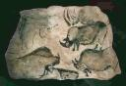
HE TIROHANGA TUATAHI KI TE TAE
He tikanga matū ā tātau mahi katoa, te horokai, te mahi toi, Katoa atu, he matū tonu te hanga. Nā, mā te mārama ki te matū e mārama hoki ai ki te mahi tae.

He aha te tae?
He poapoa noa iho te mahi o ētahi tae, pērā i ērā e hokona ana i ngā toa taputapu o Aotearoa, nā, ka memeha haere te tae i ia horoinga. Ko ngā tae tino pai ka piri tahi me te muingota o te papanga, ka kore e memeha i te horoi.
E ai ki ngā kōrero tawhito, e 5000 tau te roa e whai tikanga ana te mahi tae, i ngā iwi tonu o Inia, o Te Rāwhitiwaenga hoki. I hua mai ngā tae i te kararehe, i te tipu, i te kohuke hoki, ā, kāore i mahia, he paku rānei. Otirā, ko te tipu tonu te huanga nui o te tae, te pakiaka, te hua, te kiri, te rau, te rākau.
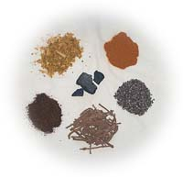
Kua mārama? Me kukume mai he kōrero matū anō.
Te tikanga, he hanga tae te tae e whakapiria ana ā-matū nei ki tētahi papanga anō. Whakaurua noatia te tae hei waimeha(he wairewa), hei ranunga waikawa, papahua rānei; tērā pea mā te hanga waiwai rawa e whakaū te tae ki te papanga. Ka taea tēnei mā te piri o te waiwai ki te tae hei pūhuinga rewakore.

Te mārama ki te ngā kupu matū.
Mātua mahi takitahi ki tāu e taea ai ki te whakaoti i ngā mahere o ngā whārangi e 2 e whai ake nei e whakarārangi ana i ngā kupu matū kua tīpakohia i te wāhanga o runga ake e kīa nei ‘He aha te tae?’.
Kōrerotia te kete kōrero a tēnā, a tēnā o tō rōpū hei whakatau i te koha kōrero a te rōpū.
Mā tō kaiako e tuku mahere ki tō rōpū hei tuhi i te whakatau a te rōpū.
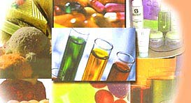
Kātahi ka whakamātautau koutou i ētahi āhuatanga kia mārama ake ai koutou ki te tikanga matū.
Kupu matū | He aha? | He aha te āhua? | Hei tauira …..
solution
wairewa
dissolved
memeha
substance
hanga/matū
insoluble
rewakore
mixture
ranunga

Kupu matū | He aha? | He aha te āhua? | Hei tauira …..
mineral
ōpapa
molecule
muingota
compound
pūhui
acidic
hīmoemoe/kawa
basic
papahua/waiwai

HEI MAHI 2
ENGARI HE AHA TE HUA?
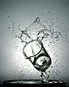
Hangaia ai te ao i ngā momo hanga katoa – he mea hua māori mai, he mea hangahui rānei. Hei tā ngā tohunga pūtaiao mō ngā mea katoa e whakakīkī takiwā ana, he matū, heoi ko ngā wāhanga o te matū, he ngaku, he matū anō hoki. Heoi, he matū katoa, te totoka, te wai, te hau, ahakoa kāore e kitea atu pēnei i te hau e ngāngā nei tātau.
Mōhio tonu te hunga pūtaiao ko te hanga nei, arā, ko te matū, he mea hanga i ngā matūriki moroiti nei, kāore anō kia kitea atu engari e ai ki te whare kōrero pūtaiao, kei reira!
Tōna 10 000 000 000 000 000 000 000 000 ngā matūriki wai i roto i te karāhe wai!
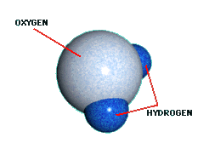
Heoi, hangā ai te wai i ngā matūriki hauwai e rua, me te kotahi o te hāora – e hia kē ngā matūriki i roto i te karāhe wai? Māu e tatau!
He muingota wai tēnei.

Ko te hanga, kotahi te ngota o te te pūmotu hāora, e rua ngota o te pūmotu hauwai, he here matū te kaiwhakapiri.
Ko te ngota te moroiti o te pūmotu.

He ngāwari noa iho!
He rite katoa ngā matūriki hauwai tētahi ki tētahi, he rite katoa ngā matūriki hāora tētahi ki tētahi. Engari he rerekē te rahi o te matūriki hāora ki te matūriki hauwai – tirohia te whakaahua i runga ake nei. Ko te matūriki hauwai te mea moroiti rawa e mōhiotia ana.
Hei tā te hunga pūtaiao he pūmotu te hāora me te hauwai. Hangaia ai te pūmotu i te matūriki ōrite. Ka moe tauhohe ngā pūmotu ka kiia ai he pūhui – kua piri ngā matūriki o ngā pūmotu kia nui atu hei pūhui. He pūhui te Wai(H₂O) i hua mai i te moe ā-matū o ngā pūmotu, te hāora(H) me te hauwai(H).
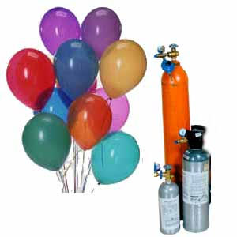
Anei ētahi taputapu i hangaia ai i ētahi o ngā pūmotu e mōhio nei koutou;
haumāmā (He) – he pūmotu hau
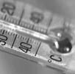
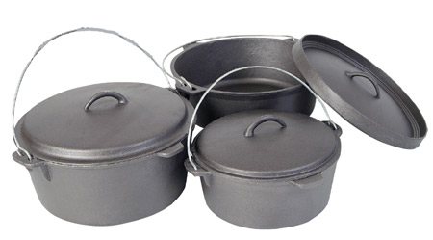
konuoi(Hg) – he pūmotu wai
rino (Fe) – he pūmotu totoka

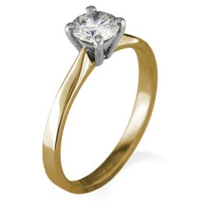
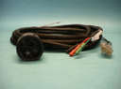

taimana – he momo waro (C) – he pūmotu totoka
koura (Au) – he pūmotu totoka
kapa (Cu) – he pūmotu totoka

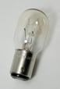

akoni (Ar) – he pūmotu hau
tangitini(W) he pūmotu totoka
konumohe (Al) – he pūmotu totoka
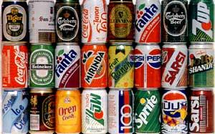
konumohe (Al) – he pūmotu totoka

Anei ētahi pūhui e rua e mōhiotia whānuitia ana:
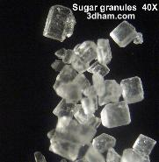
Ko te ingoa matū o te huka e inumia ana i rō waireka, e kaingia ana i rō kaitunutunu i te kāinga ko te huhuka.
Ko tōna rerenga matū ko te C₁₂H₂₂O₁₁.
Nā, ko te hanga pūhui o te huhuka ko ēnei pūmotu e piritahi ana, ko te waro C, ko te hauwai H, me te hāora O.

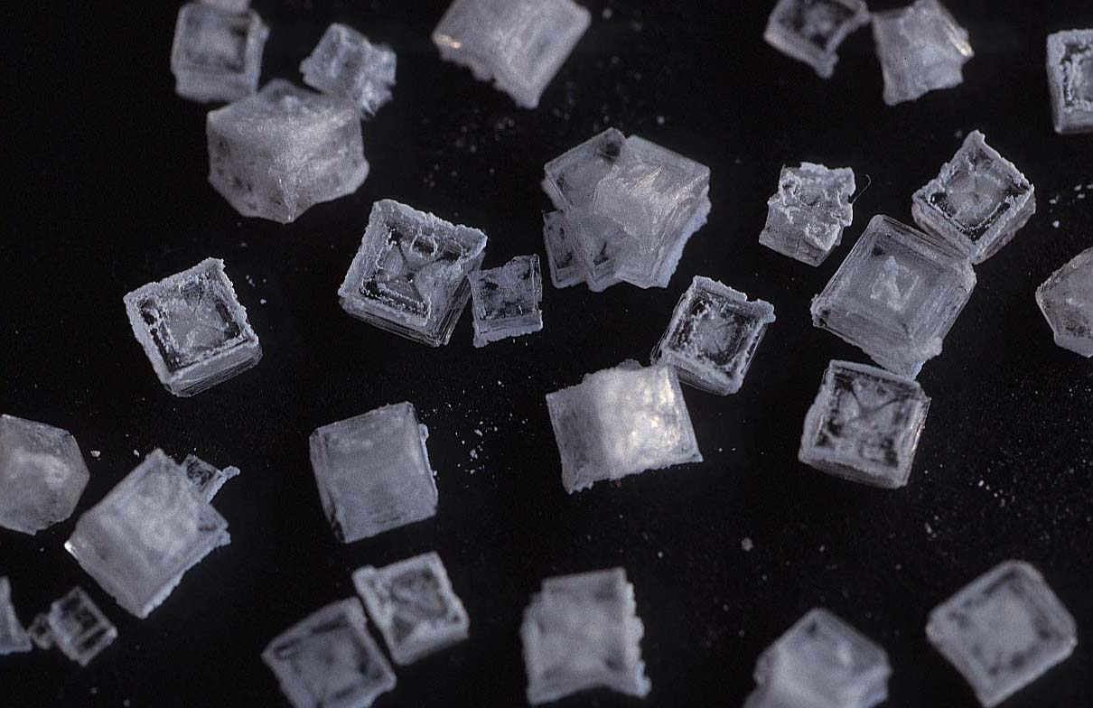
Ko te ingoa matū mō te tote e ruiruia ki te kaitunutunu, ki te ika me te maramara rīwai, ko te konutai pūhaumāota.
Ko tōna rerenga ko te, NaCl.
Nā ko te hanga pūhui o te konutai pūhaumāota, ko ēnei pūmotu e piritahi ana, ko te konutai Na, me te haumāota Cl.

Mā tō kaiako e whakaatu mai te tauhohenga matū. Whiriwhiria he aha ngā pūmotu e hui tahi ana inā tahuna ai te konupora i te hau.
HEI MAHI 3
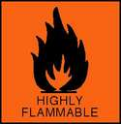
HE PŪMOTU, HE PŪHUI
Ka whakaaturia mai e tō kaiako te hanga hauwai, me āta mātaki atu, kātahi ka whakautu ai i ngā pātai:
- He aha i rewa ai ngā mirumiru ki te hau?
- He aha i ‘pakū’ ai i te pānga atu ki te muraahi?
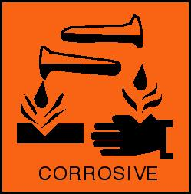
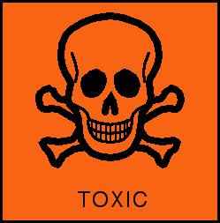
I tīkina atu ai e tō kaiako ko te pūmotu konutea (Zn) me te pūhui waikawameha pūngātara, H₂SO₄, hei hanga korohū hauwai, H₂, me tētahi pūhui anō ko te konutea ngāwhā, (ZnSO₄). I hua mai ngā matū hou i te tauhohenga matū.
He aha ngā pūmotu i whakahuia ai hei hanga i ngā pūhui, ko te waikawameha pūngātara me te konutea ngāwhā?
Ko tāu ināianei he hanga korohū hauwai i te pūmotu konupora, Mg, me te pūhui, waikawameha pūmāota

Mā tō kaiako e whakaatu mai, e tohutohu mai me pēhea. Me āta mātakitaki atu, kātahi ka whakautu ai i ngā pātai nei:
- He aha te āhua o te rīpene konupora i mua i te rironga ki rō ipuipu?
- He aha te āhua o te waikawa pūmāota i mua i te moenga i te konupora?
- Ki tō titiro, i ahatia te rau konupora mai i te tīmatanga ki te mutunga o te whakamātautau?
- He aha te mea i rongo ai koe i te tou o te ipuipu?
- He aha te mea i rangona ai e tō kōnui mau ki te waha o te ipuipu?
- I ahatia, inā tahu ai koe i te hau?
Ko tāu ināianei he hanga hau anō i te pūhui, konupūmā pākawa waro, CaCO₃ (he kongakonga māpara), me tētahi pūhui anō ko te waikawameha pūmāota, HCl.

Mā tō kaiako e whakaatu mai, e tohutohu mai me pēhea. Me āta mātakitaki atu, kātahi ka whakautu ai i ngā pātai nei:
- He aha te āhua o te kongakonga māpara i mua i te rironga atu ki rō ipuipu?
- He aha te āhua o te waikawa pūmāota i mua i te makeretanga atu o te kongakonga māpara ki rō ipuipu?
- Ki tō titiro, i ahatia te kongakonga māpara?
- I ahatia inā tahu ai koe i te hau?

Ko tāu ināinaei he hanga hau anō i te pūhui konupora hāorarua, MnO₂, me tētahi pūhui anō ko te hauwai waikuratei, H₂O₂.

Mā tō kaiako e whakaatu mai, e tohutohu mai me pēhea. Me āta mātakitaki atu, kātahi ka whakautu ai i ngā pātai nei:
- He aha te āhua o te konupora hāorarua i mua i te rironga atu ki rō ipuipu?
- He aha te āhua o te hauwai waikuratei i mua i te rironga atu ki rō ipuipu?
- He aha te mahi i kitea e koe i roto i te ipuipu?
- I ahatia inā tahu ai koe i te hau ki te papa kiri rākau motuahi?

Ka puta mai he hau i ēnei whakamātautau katoa – ko te pupū tonu te tohu.
Whakaarohia ētahi atu wā e kite nei koe i ngā mirumiru e pupū mai ana, ā, tuhia mai ki konei:
_________________________________________________________________________
_________________________________________________________________________
MAHERE AKORANGA 3
TE WĀ: 60 meneti
KAUPAPA MĀORI: Rangahau
NGĀ TOHUTOHU MĀ TE KAIAKO:
- Mō Hei Mahi 1, ka hoki anō ngā whakaaro o ngā tauira ki nga whakamātautau hau me ngā hua o ngā tautohenga matū,ā, ka waihangatia he mahere KWL hei whakairi i ngā kōrero o tērā atu akoranga.
- Ka tirohia i tēnei akoranga ētahi tautohenga matū anō me te whakamōhio mai i ētahi whārite kupu, ā, me te whakaatu hoki i te rerekētanga o te ranunga me te pūhui. Ko tā Hei Mahi 2 he titiro ki ngā pūmotu e toru, e rua ngā maitai(te rino me te kapa), ko tētahi anō ehara i te maitai(he pūngāwhā), me ngā whakaritenga hei whakaranu, hei whakawera anō hoki. Mā te āta mātakitaki me te tiki atu i ngā kete kōrero i whakairia ki te tāhū tautohe matū i Akoranga 1 e taea ai ēnei mahi. Ka whakairia ngā tauhohenga matū hei whārite kupu, hei whārite tohu, ā, hei huihuinga matūriki hoki. Me whakarite mahi kāinga kia mau i ngā tauira ngā tohu.
Hei whakarite mō Hei Mahi 2:
Te rino me te pūngāwhā (mā ia rōpū)
he ipuipu maroke
he whatanga ipuipu
he paura pūngāwhā
he paura rino matarehu
he rapa
he paekoru, he patu/kuru
he papa ārai ahi, he papa herameke rānei
he kuku
he muratahi + he māti, he pūahi rānei
te kapa me te pūngāwhā (mā ia rōpū)
he rau kapa tapawhā paku
he timo paura pūngāwhā
he rapa
he papa ārai ahi, he papa herameke rānei
he kuku
he muratahi + he māti, he pūahi rānei

te rino me te kapa (mā ia rōpū)
he ipuipu maroke
he whatanga ipuipu
he kapa paura
he paura rino matarehu
he rapa
he paekoru, he patu/kuru
he papa ārai ahi, he papa herameke rānei
he kuku
he muratahi + he māti, he pūahi rānei

Tauhohe matū ai ko te maitai me te maitai-kore anake. (Cu, Fe rānei, me S) kāore ko te maitai me te maitai (Cu me Fe) – he ranunga tēnei ka kiia ai he kōranu.
Whakaaturia te mahi a te aukume ki te whakawehe i te paura rino i te paura pūngāwhā kia kitea ai he ranunga tonu, i mua i te whakawerahanga. Whakaaturia hoki kāore e taea tenei mō te hua hou, te pūngāwhā rino.
- Ka oti te whakapaipai i muri mai i te mahi ā-ringa, menā ka whai taima ka mahi takirua ki te Kete Ariā i Hei Mahi 3. Ki te kore e whai taima me mahi i te kāinga.

NGĀ TOHUTOHU MĀ NGĀ TAUIRA:
- Mō Hei Mahi 1, ka hoki anō ō koutou whakaaro ki nga whakamātautau hau me ngā hua o ngā tautohenga matū,ā, ka waihangatia he mahere KWL, he mahere poutoru hei whakairi, i tōu nā mōhiotanga ōmatū o tērā atu akoranga, i tōu nā hia mōhio ki te whare ōmatū, ā, ka whakaoti haere te pou tuatoru i a koe e takahi haere ana i te ara mahi o tēnei kaupapa.
- Mō Hei Mahi 2, ka mahi koe i ngā whakamātautau e toru i runga i te ngā tikanga nei, ko te āta whai i ngā tohutohu, ko te āta mātakitaki me te whakarite i ngā whārite kupu, i ngā whārite tohu, me te whakaahua matūriki.
- Mā te hua o ngā mahi ā-ringa, ngā pānuitanga, ngā pātai hoki i ngā akoranga e rua o mua atu, ka whai wāhi koe ki te mahi takirua i Hei Mahi 3, ki te tuhi i ngā rerenga kōrero e rua, kei roto nei ngā kupu matua e whā.

E mōhiotia ana | E hiahia ana kia mōhiotia | I ākona

HEI MAHI 1

He whakarāpopotonga o ngā whakamātautau hau
Ki te hua mai he hau, ki te hiahia kia mōhiotia, me pēhea te whakamātautau atu?
Kia mōhiotia te hau pūnoa, me _ _ _ _ _ _ _ .

Whakakīa te mahere i raro iho nei:
Ka ahatia inā whakamātautauria ai te hau | He ……… te hau
Ka pahū te hau, ‘pakū’ ana
 | waro hāorarua
Ka mura anō te papa kiri rākau

Ngā tauhohenga matū
Ko te tohu o te tauhohenga matū ko te hua mai o tētahi matū hou, pērā i te hau. Engari ehara i te mea mā te hau anake e tohu mai; tērā ētahi atu hua o te tauhohenga matū.
Koinei ētahi o aua tohu:
- he ehu
- he huringa tae
- he pahūtanga (te oro, ka wera/ka tūrama rānei)
- ka puta te wera
- ka rerekē te hā

te mahere KWL
Mātua whakaotia te mahere KWL i mua i te ahu whakamuatanga ki ētahi atu tauhohenga matū. Mā konei e tohu ai te nui o ngā kōrero i mau i a koe engari kua huakina ake ngā tatau o te whare pātai.
Whakaotia te mahere poutoru hei whakairi, i tōu nā mōhiotanga ōmatū o tērā atu akoranga, i tōu nā hia mōhio ki te whare ōmatū, ā, ka whakaoti haere te pou tuatoru i a koe e takahi haere ana i te ara mahi o tēnei kaupapa.
HEI MAHI 2
HE TAUHOHENGA ANŌ
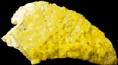
Ka āta tirohia ētahi tauhohenga matū, ā, ka kōrerotia te reo matū, ā-kupu, ā-tohu hoki.
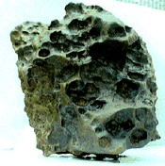
Te rino me te pūngāwhā
Ka ahatia menā ka kaha whakawerahia te ranunga rino, pūngāwhā hoki?

- Tīkina atu te rapa hei koko i te pūngāwhā ki rō ipuipu, kia āhua 2.5hm te mātotoru.
- Me pērā ano mō te paura rino matarehu kia āhua 1hm te mātotoru.
- Ringihia ki roto i te paekoru, ā, kuorotia kia tino ranu ai ngā paura e rua.
- Whakahokia te ranunga ki rō ipuipu.
- Hoatu ki runga i te muratahi, āta whakawerahia te ranunga rino/pūngāwhā ki roto tonu i te mura o te ahi, kātahi ka kaha kē atu te wera. Kia mura mai te ranunga kua rewa nei, me tū. Kaua e hongi i te auahi e puta mai ana i te pūngāwhā.
- Waiho te ipuipu kia mātao ki roto i te whatanga, ki runga rānei i te papa ārai ahi; kātahi ka tirohia te matū hou kua hangaia e koe.

Ōu kitenga me āu whārite:
- Whakamāramatia ngā mea i kite ai koe:_______________________________________
_______________________________________________________________________
_______________________________________________________________________

- Tuhia te whārite ā-kupu mō ngā ingoa o ngā matū me ngā whakamāramatanga:
paura kiwikiwi + paura kōwhai(kua wera) ka hurihia hei totoka parauri rawa
rino pūngāwhā pūngāwhā rino

Nā, tuhia ko ngā tohu:
Fe + S (kua wera) FeS

Kātahi ka tuhia ko ngā whakaahua matūriki (pērā i te whakaahua wai i Akoranga 2, Hei Mahi 2):
Fe
Fe
(kua wera)
S
S

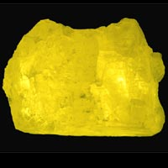
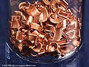
Te kapa me te pūngāwhā
Ka ahatia menā ka kaha whakawerahia te ranunga kapa maitai me te pūngāwhā maitai kore?
- Tīkina atu tētahi rau kapa tapawhā paku.
- Maringihia he timonga pūngāwhā ki runga i te rau, ā, me pani mā te rapa kia paparite, kia rahirahi.
- Puritia mā te kuku, whakawerahia ō-raro mā te muratahi.
- Waiho te rau kia mātao ki runga i te papa ārai ahi; kātahi ka tirohia e koe te matū hou kua waihangatia nei.

Ōu kitenga me āu whārite:
- Whakamāramatia ngā mea i kite ai koe:_______________________________________
_______________________________________________________________________
_______________________________________________________________________

- Tuhia te whārite ā-kupu mō ngā ingoa o ngā matū me ngā whakamāramatanga:

……………. + …………….. (kua wera) ………………..
……… ……….. ……………..

Nā, tuhia ko ngā tohu:
….. + ….. (kua wera) ……….

Kātahi ka tuhia ko ngā whakaahua matūriki
(kua wera)

Cu
Cu
S
……… …………
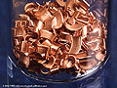
Te rino me te kapa
Ka ahatia menā ka kaha whakawerahia te ranunga maitai rino me te kapa?

- Tīkina te rapa hei koko i te paura kapa ki roto i te ipuipu maroke, kia 0.5hm te mātotoru.
- Me pērā hoki mō te paura rino matarehu kia 0.5hm hoki.
- Ringihia ngā kai o te ipuipu ki roto i te paekoru, ā, kuorotia kia ranutahi ai.
- Whakahokia te ranunga ki roto i te ipuipu.
- Hoatu ki runga i te muratahi, āta whakawerahia te ranunga rino/kapa ki roto tonu i te mura o te ahi, kātahi ka kaha kē atu te wera.
- Waiho te ipuipu kia mātao ki roto i te whatanga, ki runga rānei i te papa ārai ahi; kātahi ka kimi ai i ngā tohu tauhohe matū.
Ōu kitenga me āu whārite:
- Whakamāramatia ngā mea i kite ai koe:_______________________________________
_______________________________________________________________________
_______________________________________________________________________

- Whakamāramatia ki ōu nā whakaaro te mahi i kite ai koe:_______________________
_______________________________________________________________________
_______________________________________________________________________

Hei whakamārama:
E ai ki ngā kōrero a te whakaahua matūriki me te whārite ā-tohu, kotahi anō te ngota rino e tauhohe ana ki te ngota pūngāwhā kotahi, kia hua mai ai he matūriki pūngāwhā rino kotahi tonu nei.
Ehara. Ko te tohu ngāwari noa tēnei. Ko te mea tika kē, kei tua atu i te piriona piriona ngā matūriki e tauhohehohe ana. Ahakoa te paku o ngā matū e whakarawekengia nei e tātau, e hia kē piriona ngā matūriki e whakaoreorehia ana.
He pūmotu te pūngāwhā, nāna tēnei whakamātautau i tīmata. He ngota pūngāwhā anake kei roto. He matū/pūmotu horomata tēnei.
He pērā hoki te rino, he pūmotu horomata anō nā te mea ko te ngota rino anake kei roto.
I whakaranumia ngā ngota rino, pūngāwhā hoki ki roto i te paekoru. Ka kīa ai he ranunga. Kāore ngā ngota o te rino me te pūngāwhā e huri rerekē, heoi menā e hiahiatia ana, ka taea te whakawehe, arā, nā te āhuatanga ōkiko o te rino – tōna tikanga aukume – ka kumea kia wehe i te pūngāwhā. Mā tō kaiako e whakaatu mai.
Engari ka wera ngā ngota, ka rerekē.
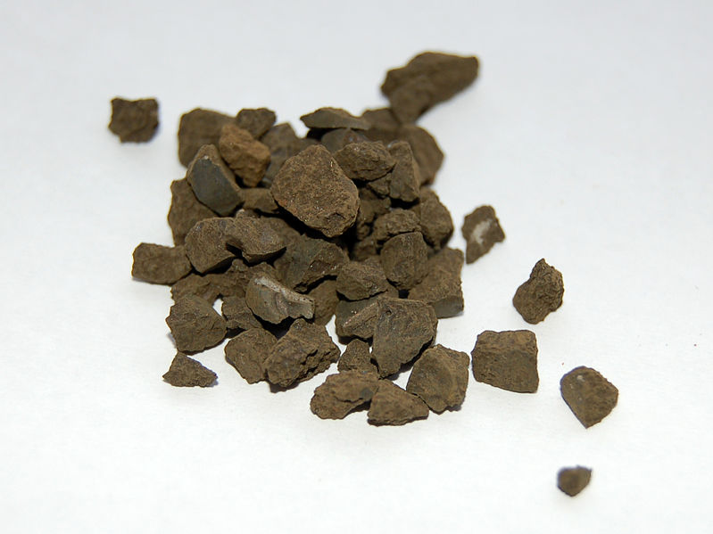
Ka huitahi ngā ngota rino me ngā ngota pūngāwhā ka hua mai he matū hou, ko te pūngāwhā rino.
Nā te hou rawa o tēnei matū, ka rerekē hoki ōna āhuatanga i ērā o ōna mātua ngota, te rino me te pūngāwhā.
Ka kīa ai he pūhui, i te mea, nui atu i te kotahi momo ngota te hanga o ia matūriki FeS.

HEI MAHI 3

TE KETE ARIĀ

chemical reaction
chemical reaction
chemical reaction
chemical reaction
tauhohenga matū

matū
pūmotu

compound
pūhui

Me mahi takirua ki te wānanga i ngā kupu i roto i te kete ariā hei whakamārama i te pānga o tētahi ki tētahi.
Tuhia kia RUA ngā rerenga kōrero, kei roto katoa ngā kupu matua nei i ia rerenga.

_________________________________________________________________________
_________________________________________________________________________
_________________________________________________________________________
_________________________________________________________________________

_________________________________________________________________________
_________________________________________________________________________
_________________________________________________________________________
_________________________________________________________________________

MAHERE AKORANGA 4
TE WĀ: 60 meneti
KAUPAPA MĀORI: Tahu kōrero
NGĀ TOHUTOHU MĀ TE KAIAKO:
- Ko te kaupapa o te akoranga nei ko te noho o te matū me ngā whakaritenga kia hurihia hei matū kē atu. Kia mahara: kāore te whāhau e wānangatia ana i tēnei akoranga. Kia whai wāhi ngā tauira i Hei Mahi 1 ki te whakaaro, ki te kōrero hoki mō ō rātau nā mōhiotanga.
- Tīkina atu ēnei taputapu mō te whakamātautau ā-ringa i Hei Mahi 2:
he tūnga rawhi
he rawhi
he ine pāmahana
he ipurau karāhe 250mr
he kōrere karāhe (hei mau tika ki runga ipurau)
he hukapapa penupenu 150mr
he whāriki ārai
he waetoru
he muratahi

Ka tuhia, ka whakamaheretia ngā hua o ngā mahi, ā, ka whai whakataunga ngā kitenga a ngā tauira. Tēra pea ka pānuitia ā-wahatia e te karaehe tētahi kōrero hei tohu i ngā whakaritenga. Ka mutu, ka tuhia he huahua hei whakakao i ngā whakaritenga nei e huri rerekē ana me te tīpakotanga hoki o ngā kupu matua.

NGĀ TOHUTOHU MĀ NGĀ TAUIRA:
- Mā tō kaiako koutou e whakarōpū ki te whakaoti i te whakamātautau ā-ringa i Hei Mahi 1.
- Pānuitia ngā kōrero mō ngā huringa rerekētanga i Hei Mahi 2, kātahi ka whakaoti ai i te huahua whakarāpopototanga.
HEI MAHI 1
TE ĀHUA O TE MATŪ
He totoka, he wai, he hau rānei te matū, ki tā te hunga pūtaiao.
Tuhia ōu whakaaro:
- E mea ana te kupu ‘totoka’ ko ēnei whakaaro e rua:
________________________________________________________________
________________________________________________________________
- E mea ana te kupu ‘wai’ ko ēnei whakaaro e rua:
________________________________________________________________
________________________________________________________________
- E mea ana te kupu ‘hau’ ko ēnei whakaaro e rua:
________________________________________________________________
________________________________________________________________

Mā tō kaiako e whakarāpopoto ngā whakaaro o te karaehe mō te totoka, mō te wai, mō te hau anō hoki.
Mā te kōrero tahi a te rōpū e whakatau ko ēhea ngā whakaaro pai ake.
Ka huri rerekē te āhua o te matū, heoi ka āta tirohia e tātau tēnei āhuatanga i ngā mahi e whai ake nei.
hau
wai
totoka

Titiro ki ngā whakaahua o te whārangi e whai ake nei. Mō ia whakaahua, whakaingoatia ngā momo matū e whakaaturia ana, ā, whakaahuatia hoki ngā huringa o ngā āhua matū e rite ana mō te tūāhua e whakaaturia ana i ia whakaahua.
He motutio

Te/Ngā momo matū: ___________________

Te huringa āhua: ______________________

_____________________________________

_____________________________________
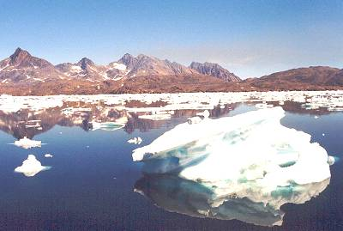

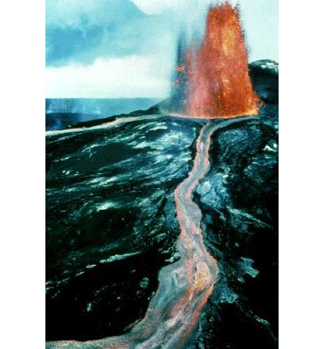
Te rangitoto i Hawaii

Te/Ngā momo matū: ___________________

Te huringa āhua: ______________________

_____________________________________

_____________________________________

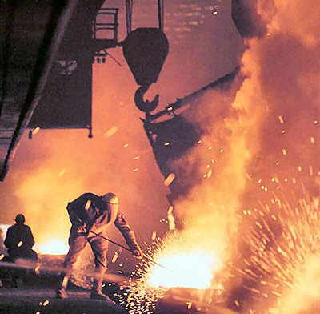
He ‘tāhorotanga’ i te mira maitai

Te/Ngā momo matū: ____________________

Te huringa āhua: ______________________

_____________________________________

_____________________________________

He kapu kawhe e korohū ana

Te/Ngā momo matū: ____________________

Te huringa āhua: ______________________

_____________________________________

_____________________________________

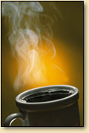

HEI MAHI 2
TE HURINGA ĀHUA
Ko tāu mahi, he whai haere i ngā huringa āhua o te pāmahana o te wai e whakawerahia ana.
- Tīkina atu ngā taputapu, whakatūria kia rite ki tā tō kaiako i whakaaturia mai.
- tūnga rawhi | - ipurau karāhe 250mr | - waetoru
- rawhi | - hukapapa penupenu 150mr | - muratahi
- ine pāmahana | - whāriki ārai | - kōrere karāhe
- Ka whātaua, ka tuhia hoki e koe i ia 2 meneti te pāmahana me te tohu anō e noho tonu ana te hukapapa, e paera ana rānei te wai (tirohia i raro iho nei mō tētahi tauira mahere hei tuhi i ngā hua).
- Me toru whātau i ia 2 meneti i mua i te tahunga o te muraahi; inā tahuna ai te muraahi, kaua e tīni te ritenga puarehau, te tū i raro i te waetoru, te nui rānei o te hau.
- Me whakawera tonu, me whātau tonu, kia 6 meneti rānō te paeratanga o te wai.
- Ka mutu te whātau whakamutunga, huripokia te kōrere i runga i te ipurau.
- Kimihia he matū ka hua mai o roto o te kōrere.
NGĀ HUA
Tuhia he mahere kia pēnei (me whārangi kotahi te rahi):
Te wā (men) | Pāmahana (ºC) | Hukapapa? | E paera ana?
 |  | * | **

* Tohua ki te ✓ menā e noho tonu ana te hukapapa.
** Tohua ki te ✓ menā e paera ana te wai.

Tuhia he kauwhata toro – me whārangi kauwhata kotahi te rahi.
Ko ngā raraunga e whaimana ai tātau(ngā wā hei whātau) me tuhi ki te tuaka x (e whakapae ana).
Kia mahara, me whakaingoa; me tapa ingoa hoki ki ngā tuaka, me tohu hoki i ngā inehanga.
NGĀ WHAKATAUNGA:
Whakaahuatia mai te huringa o te pāmahana wai i te rerenga o te wā:
- (e noho tonu ana te hukapapa) ____________________________________________________________________________
____________________________________________________________________
- (e paera ana te wai) _______________________________________________________________________________
____________________________________________________________________
- (i waenganui i ēnei e rua) ______________________________________________________________________________
____________________________________________________________________
Whakamāramatia te pānga o te wera ki te āhua(totoka, wai, hau) o te wai, ā, kōrerotia mai te āhua inā mātao haere ai:
_________________________________________________________________________
_________________________________________________________________________
_________________________________________________________________________

E toru ngā āhua matua o te matū: he totoka, he wai, he hau. He hanga rangitahi ēnei – kei te tikanga o te noho te ritenga o te āhua o te matū, kia totoka, kia wai, kia hau rānei, ka taea e te matū ngā āhua katoa. Ka totoka te hau. Ka waiwai te maitai. Heoi i te nuinga o te wā kāore i te tika te noho kia huri totoka te hau, kia rere wai rānei te maitai. Otirā ka whakarewahia te maitai hei wai i ia rā i ngā mira maitai, hei hanga taputapu, hei hanga aha rānei hei whakamahi. Ka whakarewahia te maitai, ka hurihia hei wai, engari he maitai tonu.
Ki te noho TOTOKA tētahi mea pērā i te kapa, i te maitai, i te toka, i te hukapapa, he māro tonu. E kore e ngāwari te huri āhua, e kore te rahi e rerekē. Koinei te whakamāramatanga mō te totoka: he matū, tau ana te rōrahi, tau ana te āhua.
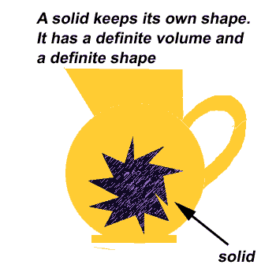
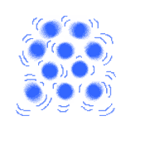
He aha i noho pēnei ai te totoka? Ahakoa wiri ai ngā muingota o te totoka, kāore e tawhiti te oreore. Inā wiri ai, ka wiri tū. Ka piritahi me he rangi kapa.
Menā e noho totoka ana te matū, kāore i te tino nui te wāhi hei whakakī, menā kua wai, kua hau rānei. He tika hoki. Huipiri ai ngā muingota, kāore e tū wehe. Nā reira ka tāmia atu ki te wāhi pakupaku.
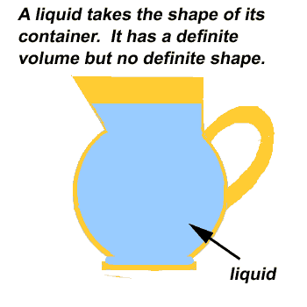
Ka rere, ka oreore te WAI pērā i te miere, i te hinu tunu kai. He ngāwari noa iho te huri o tōna āhua, kia rite hoki ki tōna paepae, engari tōna rahi ka mau tonu. Ko te whakamāramatanga mō te wai ko tēnei, he matū, tau ana te rōrahi, engari tōna hanga ka huri kē.
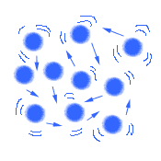
He pēnei nā te wai i te mea e oreore ana ōna muingota, reti ana, neke ana.
Ka nui atu te wāhi mau i te wai i tērā o te totoka. He oreore nō ngā muingota, ka rērere haere engari kāore e tino tawhiti atu tētahi i tētahi.

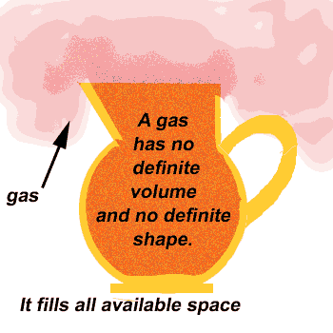
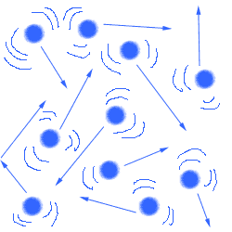
Ka whānui kē atu te rere a te HAU kia kī te wāhi e mau ana i taua hau, pērā i te hāora, i te waro hāorarua, i te haumāmā, i te korohū hoki. Menā ka huakina e koe te poro haumāmā, ka puta te hau ki ngā wāhi katoa o te rūma. Kāore i te tau te rōrahi o te hau, kāore hoki e tau te hanga o te hau.
Rerepēpeke ana ngā muingota o te hau. Kāore e piri.
He nui rawa te wāhi e whakakīa ana e te hau, nui atu i te wai me te totoka. Pau te takiwā i te hau te whakakī! Engari, ka taea te pēpēhi, te whakakōpeke, kāore i te pērā te wai me te totoka. Koirā te take e taea ai e te kairukumoana te kawe hāora kia roa rawa te ruku, koirā hoki te take e taea e te paepae haumāmā paku ngā porohau e maha te pupuhi.

Kei te kite mai koe, kei te oreorenga o ngā muingota te tikanga o te āhua o te matū. Nui rawa te oreore a ngā muingota o te hau. He iti rawa kē te oreore a ngā muingota o te totoka. Nui te pūngao o te hau, he iti kē nō te wai, he iti rawa nō te totoka.
Ko te pūngao nei he pūngao wera. Ko te wera te pūngao o ngā muingota e oreore ana. Ki te wera rawa tētahi mea, kei te nui te pūngao o ngā muingota, ā, terā tonu pea he hau.
Me pēhea te whakatere ake i te oreore a te muingota? He ngāwari noa iho. Kia mahara ko te wera te pūngao o ngā muingota oreore. Mā te wera e whakatere ake te oreore a te muingota.
Me pēhea te whakapōturi i te oreore a te muingota? Hei whakapōturi i te oreore a te muingota, me heke, me tango rānei te wera.
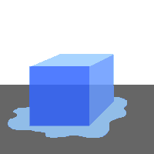
Ki te tangohia e koe te porotio i te pouaka kōpaka ka hoatu ki rō paepae, ka karawhiua e ngā muingota hau o te rūmā e tere ana te rērere. Tāwhanawhana ana i te porotio me ōna muingota anō. Nā reira ka tere ake te wiri a ngā muingota nei, Ka rere paheke ētahi. Nā te tō ā-papa, ka heke ki raro ki te paepae. Kei te hurihia te porotio hei wai. Kāore e roa kua rewa hei wai i te paepae. Ko te rewanga nei te huringa i te totoka ki te wai. E noho H₂O tonu ana ngā muingota. Kua rerekē ko tōna āhua. Ko te pae rewa te pāmahana e huri wai ai te totoka.
Ka taea hoki te āhua o te wai te whakahuri. Ki te hoatu i te paepae ki runga tō, ka whakaterehia ake te oreore a ngā muingota. Ki te tere rawa, ka tarapeke i te paepae, ka puta ki te takiwā, marara atu ana. Koinei te āhua hau o te wai, he korohū, he mamaoa rānei. Kua hurihia te āhua o te wai. Ko te whakaetonga te huringa i te wai ki te hau. Ko taua matū tonu. He H₂O tonu ngā muingota. Engari kua rerekē te āhua. Ko te pae paera te pāmahana e huri hau ai te wai.
Kāore e kitea atu te korohū. Ko ngā āhua kapua nei e kitea ana i runga i te paepae wai e koropupū ana, ko te tōtā. Ka rere atu ngā muingota wai hei mamaoa ki te hau mātao, ka heke te wera, ka hurihia hei wai anō. Ko te Tōtātanga te huringa i te hau ki te wai.
Waihoki, ka whakahurihia te wai hei tio menā ka hoatu ki roto i te pouaka tio. Ka heke te wera, ka pōturi te oreore a ngā muingota, ā, ka tio, ka toka. Ko te Whakatio te huringa i te wai ki te totoka.

Tēnā, ka whakawerahia tētahi poro maitai nei, pēnei i te umu hiko. Tuatahi, ahakoa kua tere ake te wiri a ngā muingota, ka mau tonu hei kapa. Ka kaha ake te wera, ka tere ake te wiri, engari ka mau tonu hei kapa. Otirā, ka whakawerahia rawatia kia tino tere ake te wiri a ngā muingota, kia tūrama mai te umu, ka noho totoka tonu.
He wera kē atu te pae rewa o te umu i tērā o te tio. Kia mahara, kei tēnā matū, kei tēnā matū anō ōna ake āhuatanga, te tae, te māro, te maheni, te apiapi. Huri āhua hoki ai ngā matū katoa ki ngā pae wera e rite ana ki tēnā, ki tēnā.

Tapaina ia pere o te mahere i raro nei ki ngā kupu kua tīpakohia i runga ake.

hau
wai
totoka
MAHERE AKORANGA 5
TE WĀ: 60 meneti
KAUPAPA MĀORI: Reo Māori
NGĀ TOHUTOHU MĀ TE KAIAKO:
- Hei Mahi 1 – Ngā pātai e rua hei whakamātautau i te mārama o te tauira ki ngā āhua o te matū. “He wai, he wai!”
Ngā whakautu
He awa | Kua utua
Te moana | L
He huka | S
He ua | L
He kapua | L, G * rānei
He awakeo | S
Kei roto i a tātau | L
He ua whatu | S
He kohu | L, G * rānei
Kei roto i te tipu | L
I te hau o te rūmā e noho nā koe ināianei | G

* he kapua, he kohu
Ko te hanga o te kapua, he tākohu wai, he wai tonu, he tioata i ētahi wā. Hei tā Erik Brenstrum, kaimatapae huarere o Aotearoa, tīmata mai ai te nuinga o te ua i Aotearoa nei hei whā hukarere. Kei ngā hua o te rangi ngā rahinga o ngā momo āhua o te wai, ā, nā reira i hua rerekē mai ai ngā momo kapua. Ka hurihia te tākohu wai hei wai, kātahi anō ka kitea atu. Tērā pea ko te whakautu i āta whakaarohia ko te ‘kāore i te mōhio’.

Ko te kohu ko te kapua i te papa, ā, he ranunga nō te tākohu wai me te wai. Ka mātao haere te hau ka rere mai te kohu, ka tōtātia te tākohu wai. He apiapi ake te kohu i te nehu, nā, he nui atu ōna pata ua.

“Te rohe wai mō ngā matū pūnoa”
Māka: | Ngā whakautu:
1 māka | a) | rino
1 māka | b) | tote
1 māka | c) | rino
1 māka(e rua kia tika) | d) | konumohe + rino
1 māka | e) | hau

- Mō Hei Mahi 2, whakaritea he mahere mō te mahi MĀRAMA TAKIRUA. Menā nō ngā akoranga o mua atu ngā kupu, kua oti kē te mahere te whakarite i raro nei, me tīni menā he kupu atu anō. Tāruatia kia nui mō ngā tokorua i te karaehe.
kupu | whakamāramatanga | kupu
Horomatanga
Matanga
Ranunga

kupu | whakamāramatanga | kupu
Ngota
Muingota
Matū

- Me whai papakupu Reo Pākehā-Reo Māori/Reo Māori-Reo Pākehā.
- Ko tā Hei Mahi 3 he whakaatu nō te kaiako i te tūringiringi matūriki. Me tīmata te whakamātautau pāhare pāporo i te tīmatanga o te akoranga, kia haere noa, ā, kitea noatia ngā hua i te mutunga o te akoranga. Me hāngai ngā kōrero ki ngā whakaaro o ngā tauira mō te tūringiringi.
Ngā taputapu hei whai: he tioata pāhare pāporo
he kuku
kia 3 ngā ipurau karāhe 250mr
he wai wera 200mr
he wai makariri 200mr
he wai tino makariri 200mr
he ngongo karāhe whāiti, he ngongo inu rānei
he kakara kaha, hei tauira, ‘Lynx’

NGĀ TOHUTOHU MĀ NGĀ TAUIRA:
- Mō Hei Mahi 1, ka whakamātautauria i roto i ngā tūmahi tō māramatanga ki ngā whakaaro nei.
- Ka whai wāhi koe i Hei Mahi 2 ki te hoki anō ki ngā kōrero o ngā akoranga o mua atu kia mōhio ai koe he aha ngā āhuatanga hei akoako anō māu.
- Ko tā ngā whakaaturanga a te kaiako i Hei Mahi 3, he tohu i te rerenga matūriki – te tūringiringi. Me āta mātakitaki kia tika ai te mau, te wānanga hoki i ngā kōrero.
HEI MAHI 1

He wai, he wai!

Ko te mahi nei he whakamōhio i ngā momo āhua o te wai i ngā momo wahi o te ao.

Ka noho te wai hei totoka, hei wai, hei hau anō hoki. He āhua ēnei. He rerekē te āhua o te wai i ngā wāhi rerekē. Hei tauira, he wai rere te wai i te awa. Engari ki te hukapapa te awa ka huri totoka kē etahi wāhi o te wai.
Kua whakarārangihia i raro iho nei ētahi wāhi e kitea ana te wai.
Whakataungia te āhua o te wai i te nuinga o te wā, kātahi ka porohita ai i te reta e tika ana.
(Kua tohua kētia te mea tuatahi). Menā kāore koe i te mōhio, porohitatia te DK.

Ngā wāhi e kitea ana te wai | Te āhua o te wai (porohitatia tētahi mō ia wāhi)
Ngā wāhi e kitea ana te wai | totoka | wai | hau | kāore i te mōhio
He awa | S | L | G | KM
Te moana | S | L | G | KM
Huka | S | L | G | KM
Ua | S | L | G | KM
Kapua | S | L | G | KM
He awakeo | S | L | G | KM
Kei roto i a tātau | S | L | G | KM
Ua whatu | S | L | G | KM
Kohu | S | L | G | KM
Kei roto i te tipu | S | L | G | KM
Kei roto i te hau o te rūma e noho nei koe ināianei | S | L | G | KM

Te Rohe Wai mō Ngā Matū Pūnoa

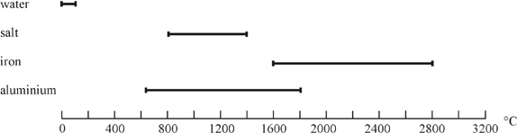

Ka whakaaturia mai e ia paekōrero te rohe o te pāmahana e noho wai ana te matū.
Tirohia te mahere nei hei whakautu i ngā pātai.

a) Nō tēhea matū te paerewa teitei ake? ____________________

b) Paera ai ko tēhea matū i te 1400°C? ____________________

c) Ko tēhea te matū e noho wai tonu ai i te rohe nui atu o te pāmahana?
____________________

d) Huri wai ai ko tēhea matū i te 1600°C? ____________________

HEI MAHI 2
MĀRAMA TAKIRUA

Mō te mahi nei me mahi takirua, kore pukapuka.
Ka tukuna mai e tō kaiako he mahere ki ia tauira, i ia tokorua. Kāore i te rite. KAUA e whakaatu tō mahere ki tētahi atu!
E toru ngā pou o ia mahere:
kupu | whakamāramatanga | kupu
kupu matua
kupu matua
kupu matua
- Ko te pou tuatahi ko ‘kupu’, he rārangi kupu matua kei roto;
- Ko te pou tuarua ko “whakamāramatanga”, kāore he kōrero o roto;
- Ko te pou tuatoru ko “kupu”, kāore he kōrero o roto.

Mā koutou katoa e tuhi whakamāramatanga mō ia kupu i te pou tuatahi.
Pokaia te pepa i te rārangi kēhua i waenganui i te pou tuatahi me te tuarua, kia kitea e tō hoa ngā whakamāramatanga, engari kāore e kitea ana ngā kupu.
Whakawhitia ngā pepa, ā, pānuitia ngā whakamāramatanga o tō hoa.
Nā, tuhia ki te pou tuatoru te kupu, ki tōu nā whakaaro, e whakamāramatia ana e tō hoa.
Kia oti i a kōrua ngā mahere te whakakī, huakina kia whakatauriteritehia e kōrua ko tō hoa.
Menā e rua ngā kupu rerekē mō te whakamāramatanga kotahi, he rite rānei te tikanga o ngā kupu e rua?
He mārama ngā whakamāramatanga kia kīa ai kotahi anō te tikanga o te kupu?

Ka mutu, huakina ā koutou pukapuka kia kitea ai ngā whakamāramatanga.
HEI MAHI 3
Kua mau i a tātau te whakaaro, hangaia ai ngā matū katoa i te matūriki, te ngota rānei, te muingota rānei.
Hei tēnei o ngā mahi, ka whai koe i ētahi o ngā tikanga wānanga a te hunga pūtaiao i te takiwā e noho nei rātau, ā, ka whakatauritea ki ō rātau whakaaro mō ‘Te Kaupapa Matūriki o te Matū’.
Me pēhea e rongo ai tātau i te whare mahi parāoa ahakoa kotahi poraka te tawhiti atu?
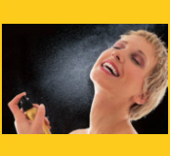
Me pēhea e mōhio ai he pēkena kei te tunua i te kīhini ahakoa kei tētahi moka kē noa atu tātau o te whare?

Ka hui tahi ngā matūriki hau(rehu) ki ngā matūriki hau e oreore ana, e tukituki ana, ā, ka wehe kē atu i te wāhi i hangaia ai.
Ko te huihuinga, ko te nekehanga nei o ngā matūriki ko te TŪRINGIRINGI.
Ka tūringiringi anō ki rō wai.

Mā tō kaiako tēnei e whakaatu mai: ka tīmata i te tīmatanga o te akoranga kia kitea ai ngā hua i te mutunga.
He ipurau waiwera 250mR
He ipurau wai mātao 250mR
He ipurau tino makariri 250mR
He tioata pāhare pāporo
He ngongo karāhe

Kia āta whakatakotoria tētahi tioata ki raro o ia ipurau, kia āta tangohia hoki te ngongo karāhe kia kore e raru ai ngā tioata, ka waiho noa ngā ipurau kia mutu rānō te karaehe.
Waituhia ko ia ipurau i runga ake nei kia kitea ai ngā hua i te mutunga o te akoranga.
Whakamāramatia te take i pēnei ai ngā hua, ā-nekehanga matūriki nei, ā-pāmahana, ā-tūringiringi hoki:
_________________________________________________________________________
_________________________________________________________________________
_________________________________________________________________________
Kia kitea ai te tere o te tūringiringi o te hau i te rūma, ka maputia e tō kaiako te kakara Lynx, tētahi atu kakara rānei, i mua i te karaehe i a rātau e noho ana.
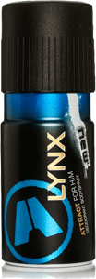
Ka rongo haere ngā tauira i te kakara, ka whakatūria ō rātau ringa, ā, ka tuhia
ko te wā mai i te maputanga. Mā te tātai i te wā i rere ai i tētahi tawhiti e mōhiotia ana, e mōhiotia ai te wā i tūringiringi ai te hau kakara i te karaehe.

Te tawhiti i te maputanga (m) | Te wā i rongo kakara ai (men)

Whakaarohia ētahi atu tauira o te turingiringi i ā tātau takatūranga.
MAHERE AKORANGA 6
TE WĀ: 60 meneti
KAUPAPA MĀORI: Rangahau
NGĀ TOHUTOHU MĀ TE KAIAKO:
- He whakawhāititanga i ngā mokamoka kōrero te take o tēnei akoranga hei whakapakari ake i te mōhiotanga o ngā tauira. Ka tīkina atu he kupu anō, ka reo Māori, ka reo Pākehā hoki te whakatakotoranga mai hei tautoko i te mahi akoako.
- Mō Hei Mahi 1, ka whakamāramatia, ka whakamātautauria hoki te whakarewatanga, ā, ka waiho mā ngā tauira kē e whakaatu ā-ringa mai, ā-tuhi mai. Me whiwhi ia rōpū ko ēnei taputapu:
he rapa
he ipuipu
he whatanga ipuipu
he ipu: kapa ngāwhā
kapa pākawa waro
kapa pākawa
konutai pākawa waro
konupūmā pākawa waro
konutai pūhaumāota
konutea pākawa waro
- Ka tīkina atu hei tāhū tauira i Hei Mahi 2, hei whaiwhakaaro mā ngā tauira, hei tautoko hoki kia mārama ake ai rātau. Me whai ko ēnei taputapu mā ia rōpū:
kia rua ngā paepae ine 100mr
he pīni maroke(pīni karikote, pītiki, pīni rite rānei)
he onepū maroke
he tātari
he paepae aihikirimi 2R
Mō te whakaaturanga a te kaiako:
kia rua ngā paepae ine 100mr
he wai ewaro 50mr
he wai 50mr

NGĀ TOHUTOHU MĀ NGĀ TAUIRA:
- Ko tā Hei Mahi 1 he whakamōhio mai i ētahi kupu matū anō, ā, ka kōrerotia, ka mārama hoki i roto i ngā whakamātautau ā-ringa.
- Mō Hei Mahi 2 ka tirohia anō e koe te tikanga whkarewa, memeha rānei mā te whakatū tauira, ā, ka kitea ngā hua o te tauira i te whakaaturanga ranunga wai a tō kaiako.
HEI MAHI 1
TE WHAKAREWANGA
Inā horoi ai tātau i ō tātau tinana, ō tatau kākahu, ā tātau rīhi, kei te whakamemeha, kei te whakarewa i te paru.
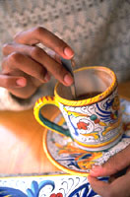
Inā kōrori ai tātau i te huka, i te kawhe rānei ki rō waiwera, he tikanga whakamemeha, whakarewa anō.
Kia mahara tātau ki ēnei mea inā wānangatia ai te memehatanga:
- Kotahi anō te momo matū i roto i te matū horomata (he pūmotu rānei, he pūhui rānei)
- E rua kē nuku atu ngā momo matū o te ranunga.

Ki te hoatu te huka(he pūhui) ki roto i te wai(he pūhui anō) , ā, ka kōroritia, ka āhua ngaro haere te huka. Engari kei reira tonu, kua memeha i roto i te wai – kua marara atu ngā matūriki huka i te wai, ā, kua kore e kitea nā te moroiti. Nā te mea kāore he tae o te huka, mā te rongo ārero kē e mōhio ai he matūriki huka kei roto. I kitea i tērā o ngā akoranga o mua tata atu tēnei āhuatanga mō te pāhare pāporo. Nā te tae anō o te tioata pāhare pāporo i mōhiotia ai he matūriki kei roto i te wai.
Anei ētahi kupu matū anō:
- Ko te wai whakamemeha totoka ka kīa ai he whakarewa.
- Ko te totoka e memehatia ana ka kīa ai he rewanga.
- Ko te ranunga o te rewanga me te whakarewa ka kīa ai he wairewa.
- Ko te matū ka memeha nei he mea rewa.
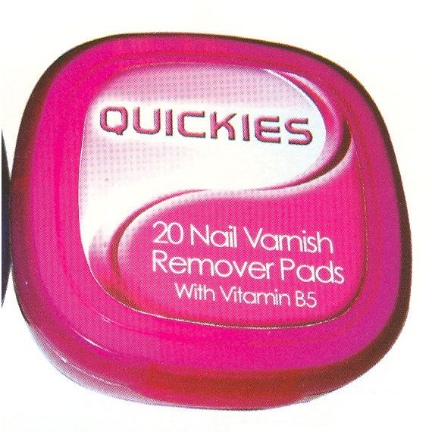
- Ko te matū kore memeha he rewa-kore.
- Ka inehia te tikanga rewa o te matū mā te ngāwari o te memeha ki rō whakarewa.
Ko te wai te tino whakarewa, heoi ko ngā matū kāore e rewa i rō wai ka memeha kē i rō wai ewaro mā, wai ewaro, hinu paina, hauwaiwaro hoki.
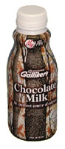
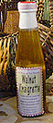
- Ka marara te matū rewa-kore i te wai kia ehu te wai, ā, ka kīa ai te ranunga nei he waitārewa.

- Memeha āi ētahi wai ki rō wai anō – he tairewa ēnei.
- Ko ētahi wai kāore e rata ki ētahi wai kē atu, ā, ka kīa ai ēnei he tairewa-kore, ka noho whakapapa tetahi wai ki runga i tētahi. Ki te rūrūtia ka marara pata iti atu tētahi i te ranunga kia ehu noa te wai. Koinei te whakaehunga.
Mā tō kaiako e tuku ētahi momo matū hei whakamātautau mā koutou i te tikanga whakarewa o ia matū.
- Whakakīa te ipuipu ki te wai noa kia hautoru, ā, hoatu ki roto mā te rapa tētahi wāhi o tētahi o aua matū.
- Hei whakaranu, puritia te kakī o te ipuipu mā te kōnui me te kōroa, ā, mā tētahi matikara o ringa kē e āta pere te tou o te ipuipu. Mā tēnei e takahuri ai ngā matū o roto.
- Tirohia ngā matū o roto, tuhia ngā mea e kitea ana i te mahere i raro nei.
Te matū i whakaranumia ki rō wai | tae | E mahea ana? | E ehu ana? | REWA/REWA-KORE
pāhare kura ngāwhā
kapa pākawa waro
kapa pākawa
konutai pākawa waro
konupūmā pākawa waro
konutai pūhaumāota
konutea pākawa waro

Te tohu i ngā tauira
Mā ngā whakaahua o te whārangi o mua atu koe e āwhina ki te whai tauira mō ngā kupu i raro iho nei:
- rewanga _______________________________________
- whakarewa _______________________________________
- wairewa _______________________________________
- matū rewa _______________________________________
- matū rewa-kore _______________________________________
- waitārewa _______________________________________
- wai tairewa _______________________________________
- wai tairewa-kore _______________________________________
- whakaehunga _______________________________________
HEI MAHI 2
He aha e kore e pūrena ai te kapu kī i te kawhe mehemea ka hoatu anō he pune huka e hia nei ki roto?
Kia mōhiotia ai me pēhea e nohonoho ai ngā matūriki, me hanga tauira whakamemehatanga.
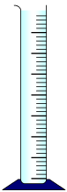
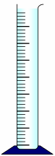
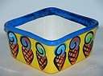
Me tiki ko ia rōpū ngā taputapu nei:
Kia rua ngā ipurau ine 100mR
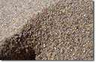
He pīni maroke (pīni harikote, he pītiki, he pīni rite rānei)
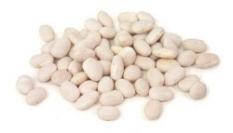
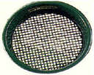
he onepū maroke
he tātari
he paepae aihikirīmi 2R
- Ringihia te onepū ki roto i tētahi o ngā ipurau ki te tohu 50mR.
- Ringihia ngā pīni maroke ki roto i tētahi atu ipurau ki te tohu 50mR.
- Ringihia te onepū ki roto i te ipurau e mau pīni ana, ā, āta rūrūtia.
- Pānuitia te pae ine e tohu ana i te kīnga o te ranunga pīni, onepū hoki i te ipurau.
- Kōrerotia i tō rōpū menā ko taua pae ine te pae ine i matapaetia, ā, kōrerotia hoki te take i heke kē taua pē ine i tērā i matapaetia ai.
- Tātarihia te ranunga ki roto i te paepae aihikirīmi 2R kia wehe te onepū i ngā pīni.
- Matapaetia te pae ine menā ka ringihia anō ki rō ipurau, tēnā ki tāna, tēnā ki tāna.
- Whakahokia ki roto i ngā ipurau – tēnā anō ki tāna, tēnā anō ki tāna.
- Kōrerotia i tō rōpū tō koutou i matapaetia ai, te hua tonu o ngā mahi. Me whai take mō ngā whakataunga nei.
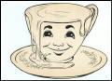
- He pakupaku noa iho ngā matūriki o te wai, he nui kē nga matūriki o te huka(tirohia anō te Akoranga 2 mō te rerenga matū, ka kitea te take i rahi ake i tētahi). Whakamāramatia te take e kore e pūrena ai te kapu kī i te kawhe menā ka hoatu he pune huka e hia nei ki roto.
_______________________________________________________________________
_______________________________________________________________________
_______________________________________________________________________
Mā tō kaiako e whakaatu tauira mai, he wai ewaro me te wai ngā kai.
I mua i te whakaaturanga, matapaetia te pae ine o te ranunga o ngā wai e rua. He pakupaku noa iho ngā matūriki o te wai, he nui atu ērā o te wai ewaro.
Mutu ana te whakaaturanga, tuhia tētahi huahua o te ranunga wai ewaro me te wai e whakaatu ana i ngā matūriki wai hei ira paku, ko ngā matūriki wai ewaro hei ira nui.
MAHERE AKORANGA 7
TE WĀ: 60 meneti
KAUPAPA MĀORI: Rangahau
NGĀ TOHUTOHU MĀ TE KAIAKO:
- He mahi ā-ringa te Hei Mahi 1 o ngā tikanga matua o te mātauranga matū o te akoranga o mua atu. Pai kē atu kia waiho mā ngā tauira e whiriwhiri, e whakatau, i te ārahi noa i a rātau. Menā ka kore e taea e ngā tauira, hoatu te kāri whakamōhio hei whakakipakipa anō i a rātau:
KĀRI WHAKAMŌHIO:
- Kāore e rewa te onepū i rō wai.
- Ka rewa te tote i rō wai.
- Ka mau te onepū i te pepa tātari.
- Ka rere tonu te tote.
- Kia whiwhi tote ai, me paera te wai ki rō paepae whakaeto.
- Waiho noa ngā pata wai e toe ana kia whakaeto.

Menā e hia āwhina ana ngā tauira ki te whakatau me pēhea te whakahoki mai i te wai, me whakamahara i a rātau ki ngā mahi o Hei Mahi 2 i Akoranga 4 – te whakawera i te hukapapa penupenu kia paera, ā, ka taupokina ki te kōrere.
- Ka whai wāhi ngā tauira i Hei Mahi 2 ki te whakatau i ō rātau mōhiotanga ōmatū i mau i a rātau i tēnei kaupapa mahi. Ka whakamaua kia tina ngā kupu e te WHARE KUPU, ā, ka mirimiria kia rite ki te matatau o te tauira ki te reo Māori. I whakaritea tēnei mō ngā tauira paku nei te matatau, nā reira i reo rua mai ai.
Tērā pea ka tīkina atu hoki ko ngā kupu mō ngā taputapu o te taiwhanga pūtaiao hei whakawhānui atu i te pātaka kupu.
Me whai papakupu reo Pākehā-Reo Māori/Reo Māori-Reo Pākehā. Aratakina atu ngā tauira i runga i ō rātau mōhio ki te tākupu, ki te pūtaiao, ki te reo Māori anō hoki.
Me whakahauhau atu i ngā tauira kia whakaoti rātau i ngā WHARE KUPU mō ia kupu hou ka kitea e rātau i ngā akoranga kei te heke mai, arā, te waikawa me te kawa-kore, te wai māro me te wai ngohe hoki.
NGĀ TOHUTOHU MĀ NGĀ TAUIRA:
- Ka whai wāhi ngā rōpū i Hei Mahi 1 ki te rarau atu i ā rātau kete mātauranga mō ngā āhuatanga ōkiko matū, ki te whakatau i tētahi take.
- Ko tā Hei Mahi 2 he tautoko i te akoako mātauranga matū, ā, he tīmata hoki ki te whakakī i te kete kupu ki ngā kupu mō ngā tikanga matua o te mātauranga matū.
Whakairohia he WHARE KUPU i muri mai i ia akoranga hei whakamātautau māu i ngā kupu hou kua kōrerotia e koe.
HEI MAHI 1
TE WHAKAWEHE RANUNGA
Inā whakaranumia ai ētahi matū, kāore e tauhohe ake,ā, kāore hoki e hua mai he matū hou. Ka hanumi noa iho ngā matūriki engari ka noho taketake tonu ngā matū, kia taea te ranunga te whakawehewehe i runga anō i ngā āhuatanga ōkiko o tēnā, o tēnā matū, kia noho motuhake ngā matū ake o te ranunga.
He whakarāpopototanga tēnei o ngā āhuatanga ōkiko:
pae rewa
pae paera
tikanga rewa

Ngā āhuatanga ōkiko

rongo
kahakawe iahiko

apiapi
kakano

tae
aukume
rahi matūriki

Ngā whakaritenga Whakawehe
Mā ngā matū i roto i te ranunga e tohu mai te whakaritenga hei whakawehe:
- Tātari
- Whakaeto
- Āta tāhorotanga
- Huri whakawaho
- Whakatioata
- Māturu
- hīeweewe

Mā tō kaiako e whakarāpopoto i ia whakaritenga, engari ko tāu he mahi i te tuatahi, tuarua hoki.

TĀTARITANGA
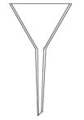
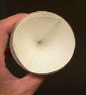
Mā te tātari e whakawehe te totoka rewa-kore i te wai. He pepa tātari, he kōrere tātari ngā taputapu mō te tātaritanga ki rō taiwhanga pūtaiao.
Ko te wai rere i te pepa ka kīa ai he wai tātari.
Ko ngā totoka ka mau i te pepa tātari ko te parahua.
TE WHAKAETOTANGA
Mā te whakaetonga o te whakarewa e wehe ai ngā totoka rewa i te whakarewa.

Mahia atu!
Ka hoatu ki a koe ko te ranunga tote, onepū hoki, ā, ko tāu, he whakawehe.
Koinei ngā taputapu hei whakamahi māu:
- wai | - kōrere tātari | - waetoru
- he ipurau | - pepa tātari | - whāriki ārai
- toko kōrori | - paepae whakaeto | - muratahi

Tuhia, whakamāramatia rānei te whakaritenga(whakatūnga) me te take i pērā ai:
(Ki te kore rawa e aro i a koe, tonoa atu ki tō kaiako kia hōmai he KĀRI WHAKAMŌHIO)

Ki te whakaae mai tō kaiako, tēnā mahia!

Mutu ana te mahi, wānangatia ā-rōpūtia me pēhea te whakarite kia whakahokia mai anō ko te wai.
HEI MAHI 2
He nui ngā kupu mātauranga matū kua kitea e koe i tēnei kaupapa mahi. Tīkina atu hei take whakairo WHARE KUPU.
Kei raro nei tētahi tauira o te WHARE KUPU kua oti kē te whakairo. Whakairohia he WHARE KUPU mō ngā kupu kua whakarārangihia mai.
Mā tō kaiako koe e ārahi, e tuku papakupu, rauemi mai.
Hei tauira:
KUPU  Te Reo Māori: wai  Te Reo Pākehā: water | WHAKAMĀRAMATANGA  He pūhui wai, he hāora, he hauwai ngā kai. Kāore he tae, pūrotu ana, e kore e rangona e te ihu, e te ārero.
TAUIRA  He whakarewa pūnoa nei te wai, kore te wai, kore te ora. | HUAHUA HEI WHAKAMAHARA  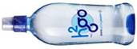

RĀRANGI KUPU
Reo Pākehā | Reo Māori | Reo Pākehā | Reo Māori
atom | ngota | particle | matūriki
oxygen | hā ora | molecule | muingota
hydrogen | hauwai | dissolve | memeha
element | horomatanga | soluble | rewa
compound | matanga | solvent | whakarewa
mixture | ranunga | insoluble | rewa-kore
substance | matū | solution | wairewa
salt | tote | solute | rewanga
sugar | huka | diffusion | tūringiringi

TE WHAKAMŌMONA I TŌ RĀRANGI KUPU
I a koe e pakari haere ana i tēnei kaupapa mahi, whakairohia he WHARE KUPU mō ia kupu hou.
MAHERE AKORANGA 8
TE WĀ: 60 meneti
KAUPAPA MĀORI: Whakawhenua
NGĀ TOHUTOHU MĀ TE KAIAKO:
- Ka tīkina atu ngā akoranga mātauranga matū o ngā akoranga o mua atu hei whakamahi i tēnei akoranga mō ngā kai o te tipu, mō te kohika tae hoki. Arā atu anō ngā maunga o te mātauranga matū hei piki, heoi me whakatā ki konei kia tahuri ngā whakaaro ki te mahi tae! He pai tonu menā ka pātaihia ngā pātai i te wā anō o te akoako, hei tauira, te whakamōhio i ngā pūmotu, i ngā pūhui, i ngā wairewa, i te tūringiringi, te aha, te aha. E rua ngā reo, Pākehā, Māori, hei poutoko ake i ngā kupu.
- Nā te mea ka whakatā i te wā e whaowhia ana, he pai rawa a Hei Mahi 2 hei whakangahau i ngā kupu me ngā ariā mātauranga matū kua kitea kētia i roto i ngā akoranga, ā, ka whakaaritia ki te taha o te whakaaturanga o ngā papanga tae o ngā tauira.
- Mō tēnei whakaritenga kohika tae, me tuku atu ngā hua tipu mō Hei Mahi 1. Me whakamātautau ia rōpū ētahi momo papanga ki tētahi hua tipu, kia rerekē te hua tipu a tēnā rōpū, a tēnā rōpū; me rite rānei te hua tipu, ka rerekē ko ngā papanga o ia rōpū. Mā tēnei mahi e kai atu ai te ngākau ki ngā momo tae ka hua mai i ngā momo tipu me te rerekē o ngā pānga ki ngā papanga rerekē, ā, ka rangahaua tēnei āhuatanga i te akoranga e whai muri atu nei. Ka whai wāhi ngā akoranga ā muri atu (#10) ki te waikawa me te kawa-kore, te wai māro me te wai ngohengohe, ka whai take anō ēnei ki te tae o te huanga whakamutunga me te āhua hoki o te wai whakaū, menā ka whakamahia mai.
Kia mahara ngā tauira ki ngā tikanga haumaru (te mau mōhiti haumaru, ngā tikanga mahi, te mau maro, kākahu haumaru hoki kia kore e kino ai ngā hū i ngā paratī matū).
Whakaaturia me pēhea te kōrori kore maringi, ā, me pēhea hoki te mau papanga wera ki te kuku.
Me tohutohu i a rātau mō te tapa tauira papanga, mō te whakapaipai hoki.
- Ngā taputapu hei whai (mā ia rōpū):
he muratahi
he waetoru
he whāriki ārai
he ipurau nui
he rākau kōrori (he pune kirihou, rākau rānei, he toko karāhe)
he pene tohu parewai (hei tohu i te papanga ki te ingoa o te tipu)
ētahi papanga tapawhā mā (he tīhāte papahune, he miro wūru, he pareaku, he aha, he aha)
he tauira tipu (mā te kaiako e tiki) – tirohia ngā whakapuakanga i te whārangi 69 (Mahere akoranga #9) – ka tīkina atu ētahi tipu kē hei mātua whakamātautau, hei tauira, he kiri rīki, he putiputi whai tae.
he kutikuti hei kotikoti tipu
he paekoru, he patu/kuru hei kuoro tipu
he kuku hei rarau hanga/papa wera
he tauera pepa, terei mīti pareaku
he pepa pānui
- Whakaritea he wāhi hei whakairi i ngā papanga kia maroke, hei tauira, he whatanga kākahu pōkai e mau nei i te nui i te wāhi iti, he kini pepa piko hei waea whakairi, he niupepa i raro hei papa māturuturu. Ko te niupepa hoki hei wāhi takoto mō ngā papanga.
- Tirohia te Whakaahua 15 o New Zealand’s Economic Native Plants, RC Cooper & RC Cambie, OUP, 1991 kia kitea ko ngā tae ka hua mai i ngā tipu māori o Aotearoa hei tae kore wai whakaū mō ngā papanga.
- Hoatu ki ia rōpū he pepa pānui kia taea e rātau te whakarite ki te pakitara o te rūmā hei whakaatu mai i ngā papanga whai nama i te tīmatanga o te akoranga e whai muri atu nei. Me whakamahara i a rātau kia whai tohu kōrero kia mārama ki ngā tikanga o ngā nama.

NGĀ TOHUTOHU MĀ NGĀ TAUIRA
- Mō Hei Mahi 1, ka whakamātautau ia rōpū i tētahi mea paku rerekē i ētahi atu (mā te kaiako tēnei e whakamārama – he papanga rānei, he tipu rānei).
- He mahi anō hei whakaoti mā koutou i Hei Mahi 2 i a koutou e tatari ana kia mau te tae.
- Tīkina atu te pene tīpako hei tapa i ngā tauira papanga ki te ingoa o te hua tipu i whakamahia ai hei tae, ki te nama 1, 2, 3…
- Horoia ngā papanga i te wairere mātao i mua i te tīmatanga.
- Kutikutia te hua tipu kia rauiti, kātahi ka kuoro ai ki rō paekoru.
- Paeratia te wai i rō ipurau karāhe i runga i te muratahi, ā, hoatu te hua tipu kua kuorotia ki roto.
- Me tino kōrori, ā, tukuna atu ngā mokamoka papanga ki roto.
- Waiho kia tōpuni mō te 10 meneti.
- Kia hipa atu i te tekau meneti, tangohia ngā papanga mā te kuku, whakatakotoria ki runga terei whai pepa tauera.
- Whakairia tetahi hāwhe o ngā papanga ki runga whatanga kia maroke. Tuhia he nama ki ēnei papanga.
- Opeopea tērā atu hāwhe o ngā papanga ki te wairere mātao, ā, whakairia ki runga whatanga kia maroke. Me whai nama hoki ēnei papanga.
- Whakapaipaihia te taiwhanga i te mutunga, whāia ngā tohutohu a te kaiako.
- Whakaritea te pepa pānui hei whakaatu i ngā papanga whai nama, kua maroke nei, ā te tīmatanga o te akoranga whai muri nei. Kia mahara, me whai tohu kōrero kia rite ai ngā nama o ia papanga ki te tikanga tae.
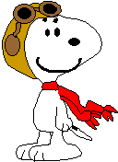
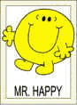
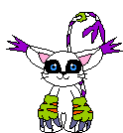


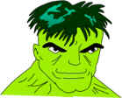
HEI MAHI 2
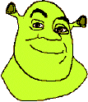

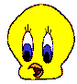
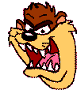
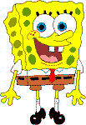

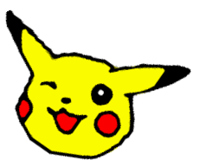
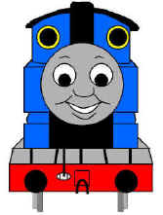

KO WAIREWA

Titoa he pakiwaitara hei haka, hei waiata, hei
whakaari, hei aha rānei kia noho ai ko ngā kupu
pūtaiao i ākona e koutou hei kaiwhakaari, kia pēnei
nā; ko Rangi Wai, ko Hine Huka, ko Tāne Ngota, ko
wai ake rānei.

Whakatūria he kapa whakaari. Tirohia anō te Hei
Mahi 1 i Akoranga 6 hei āwhina i a koe ki te whai
ingoa.

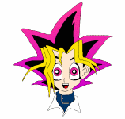
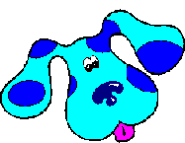
Me noho te pakiwaitara nei hei kanohi mō te pātaka
pūtaiao i tomokia ai e koe i tēnei kaupapa mahi, arā,
ko ngā tikanga whakarewa, ranunga, ngota,
muingota, pūhui, pūmotu anō hoki.

Tukuna te wairua o te kōrero kia rere, kia
ngahau!

Tērā pea ka whakaaria mai i te mutunga o te
kaupapa mahi nei.
MAHERE AKORANGA 9
TIME: 60 meneti
KAUPAPA MĀORI: Te Hao
NGĀ TOHUTOHU MĀ TE KAIAKO:
- Me whai taima ngā tauira, kia āhua 10 meneti, ki te whakarite i ā rātau papanga tae o terā atu akoranga ki runga pepa pānui.
- Ko te kaupapa o tēnei akoranga he rangahau mā ngā tauira ko ngā momo hua tipu i whakamahia hei tae, me ngā tikanga tae tuku iho. Ka whai wāhi anō rātau ki te whiriwhiri, ki te kohikohi hoki i ngā tipu e hiahia ana rātau hei tae mā rātau ake. Me kōrero ki ngā tauira mō ngā tikanga tiaki i ēnei kōrero, kia wawe ai, kia māmā ai te tiki atu. Tērā pea he kōnae rau wherawhera, he pukatuhi, he kete hiko, he aha atu rānei e rite ana mā te tauira.
Me kōrero hoki ki ngā tauira mō ngā puna kōrero, rauemi anō hoki hei whāwhā mā rātau.
Kua tuhia ki te whārangi mahi ētahi pā ipurangi hei tirotiro mā rātau, ā, mā te tono ki Te Puna Mātauranga o Aotearoa, mā te kimikimi hoki i te whare pukapuka o te kāinga, e nui atu ai te pātaka rauemi hei ketuketu mā ngā tauira.

NGĀ TOHUTOHU MĀ NGĀ TAUIRA:
- Me kimi kōrero koe kia whānui te māramatanga ki ngā tae me ngā tikanga tae tuku iho hei āwhina i a koe ki te whakarite, ki te tae hoki i tētahi papanga tae ki tōu nā e hiahia ai.
Puritia, tiakina hoki āu kōrero kia māmā, kia wawe anō te tiki atu menā e hiahia ana. Me whakatau tahi ko tō kaiako me pēhea.
Kua tuhia ētahi pā ipurangi ki te whārangi mahi engari kaua e noho here anake ki ērā mō te rangahau kōrero. Kia mahara ki te mōhio o ngā tāngata mātau o tōu nā kāinga. Mā rātau pea e tino mōhio ai koe ki ngā wāhi e putu ana ngā hua tipu e hiahiatia ana.
HEI MAHI
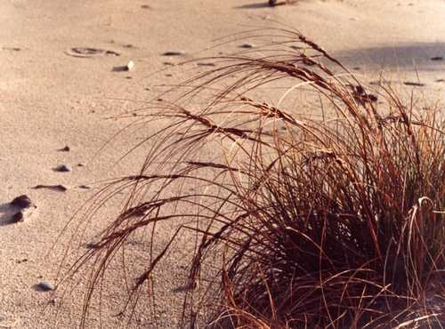
TE KETE TAE O TE MĀORI
He pākākano harakeke
He pua kōwhai
He hīako pūriri
He pīngao
He hīako tānekaha
He hīako hīnau
He paru

He horoi, he muku ngā mahi nui o te tikanga tae tuku iho. Ko ngā tae matua hei tae kākahu ko ngā tae māori tonu o te harakeke, te pango, te parauri, te kōwhai hoki.
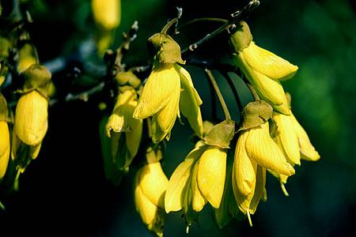
I ēnei rā kua maha atu ngā momo tae hei whakamahi, kua moe tahi ngā tae tuku iho ki ngā waiwhakaū o nāianei, kua tīkina atu rānei he tipu kē atu ka whāngaia ki ngā waiwhakaū matū.
Ko tāu, he rangahau i ngā momo hua tipu i tīkina atu ai hei tae me ngā tikanga tae tuku iho. Ka whai wāhi anō koe ki te whiriwhiri, ki te kimi, ki te kohikohi hoki i ngā tipu me ngā papanga e hiahia ana koe hei mahi tae māu ake.
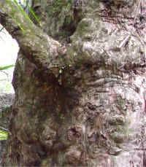
Mā tō kaiako koe e ārahi, ā, kei raro nei ētahi pā ipurangi hei tīmatanga rangahau māu:
http://www.harakeke.info/harakeke.html
http://www.aoteamoana.co.nz/native/native.html
http://www.doc.govt.nz/templates/page.aspx?id=33571
http://www.Māoriart.org.nz/noticeboard/researching_plant_taonga
http://www.eske-style.co.nz/Māori_plant_use.asp
http://www.nzetc.org/tm/scholarly/tei-BesMaor-c6-6-0.html
http://www.nzetc.org/tm/scholarly/tei-Bes02Maor-t1-body-d11.html http://peopleplants.landcareresearch.co.nz/WebForms/default.aspx
Haere ki kimihia, kimihia ā-rohetia “ngā tae’ i ngā Rohe 1 – 61 raraunga
http://kawhia.Māori.nz/14.html
http://www.Māoriauctions.co.nz/myshop/content.php?pageid=57
http://uneli.unitec.ac.nz/our_auckland/greylynn/Forest%20Trees.htm
http://www.manuka-nz.co.nz/oil-honey-soap/article_info.php/articles_id/40
http://www.nzgeothermal.org.nz/geothermal_energy/geothermal_uses.asp
http://www.nzine.co.nz/features/elizarnold.html
MAHERE AKORANGA 10
TE WĀ: 60 meneti
KAUPAPA MĀORI: Tahu kōrero
NGĀ TOHUTOHU MĀ TE KAIAKO:
- Mō Hei Mahi 1, ka mahi takitahi ngā tauira, kātahi ka hui ā-rōpū ki te wānanga i ō rātau mōhiotanga ki ngā waikawa me ngā kawakore. Tērā ka mau tēnei take ki ētahi o ngā āhuatanga whāngote me ētahi atu momo. Ko te take o tēnei akoranga he tautoko, he whakawhānui hoki i te mōhiotanga o ngā tauira ki ngā tikanga matua o te mātauranga matū me te whakapakari i a rātau kia mārama ki ngā ōritenga i roto i ngā whānau matū. Kei te mōhiotanga anō o ngā tauira te tikanga menā ka tīnihia rānei te akoranga.
- Ka whakahaeretia te Hei Mahi 2 hei wānanga takitoru, hei whakanui i te pānui ā-whai whakaaro nei kia mārama ki ngā kōrero, tēnā i tōna kaupae, tēnā i tōna, kia tikarohia hoki te marama i te kōrero. Mātua pānuitia te kōrero ki ngā tauira kia rongo ai rātau ki te tika o te whakahuahua kupu. He mea nui hoki ki tēnei kaupapa te wānanga o te karaehe i muri i te whakaotinga a ngā tauira i te tohuārahi, ā, māna e whakapakari ngā pūkenga ohu.
- Mō Hei Mahi 3 ka whakamātautauria e ngā tauira ētahi momo matū ki te pepa tohu waikawa hei whakatau mā rātau ngā huringa tae o te whakamātautau waikawa. Ko ngā taputapu hei whai mā ia rōpū:
he pepa tohu waikawa whero
he pepa tohu waikawa kahurangi
he wai māturu
he waikawa pūmāota 0.1mr
he konutai waihā 0.1mr
he miraka
he inu koropupū
he hopi makawe
he haukini

NGĀ TOHUTOHU MĀ NGĀ TAUIRA:
- Me mahi takitahi mō Hei Mahi 1 ki te wānanga mōu anō tō mōhiotanga ki ngā waikawa me ngā kawakore, kātahi ka kōrero tahi me te rōpū. Ko tā koutou kete kōrero hei koha anō ki te wānanga o te karaehe.
- Kia mutu te pānuitanga a tō kaiako i te tuhinga i Hei Mahi 2, ka whai koe i tētahi tikanga pānui kaupae, māu anō e kimi kōrero i te tuhinga hei āwhina i a koe mō ia rerenga kōrero. Me takirōpūiti te mahi, kōrerotia, wānangatia ā koutou whakautu.
- He whakamātautau ngāwari te mahi māu i Hei Mahi 3 kia tere kitea ai te āhua o te matū, he waikawa rānei, he kawakore rānei, kāore noa iho rānei.
HEI MAHI 1

HE AHA TŌ TĀTAU MŌHIOTANGA MŌ TE WAIKAWA ME TE KAWAKORE?
Wānangatia katoatia tōu e mōhio ai mō te waikawa me te kawakore i mua i te kōrerotanga atu ki tō rōpū.
He aha te waikawa? He aha te kawakore? He paitini rānei te waikawa? He paitini rānei te kawakore
How can you tell if a solution is acidic or basic?

Ka ahatia menā ka hoatu te putiputi ki rō waikawa? Ka ahatia menā ka hoatu te putiputi ki rō kawakore? Me pēhea e rerekē ai ngā momo waikawa? Me pēhea e rerekē ai ngā momo kawakore?

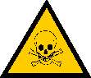

Rarangahia he kete whakaaro ki runga i te whārangi i tukuna mai ai e tō kaiako.
HEI MAHI 2

TE WAIKAWA, TE KAWAKORE, TE TANGATA

He whānau pūhui whānui ngā waikawa me ngā kawakore, e whai tikanga ana i roto i te mātauranga matū, matū mataora hoki. Whakamahia tauhohea ai ngā waikawa me ngā kawakore i roto i ngā umanga hanga nui.
Ko tētahi o ngā waikawa e hira ana ki ngā umanga hanga ko te waikawa pūngāwhā, ka whakaritea hei mahi maniua ahuwhenua, hei hanga miro, peita, tae hoki, me te whakahoromata i ngā hua o te hinu. Ka whakamahia te kawakore, te konutai waihā hei hanga papanga, pepa, waihoroi hoki.
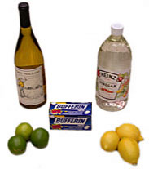
He hīmoemoe te waikawa: winika, wai rēmana, wai ārani, waina, ahipirini.
Kai ai te tangata i te waikawa, i te kawakore hoki. He kawa te waikawa, ā, he nui ā tātau kai pērā, he hīmoemoe te āhua. Arā te winika, he waikawameha ahetiki (he wairewa 3% o te waikawameha ahetiki te winika o te kāinga), nāna, ka matakawa te wai huamata, te huapīkara hoki. Nō te waikawa hoki te matakawa o ētahi atu kai e mōhiotia noatia ana: ko te waikawa hitiki o te ārani me te rēmana, ko te waikawa tātariki o te waina, ko te waikawa anō o te ahipirini.
Ko te matakawa o te waikawa he āhuareka i ētahi momo kai, engari ko tō te kawakore he pāhare kē, ā, kāore i te tino kaingia e te tangata. Heoi he nui ngā tāngata kua waia kē ki te kai kawhene, kai nikotini hoki, he pāhare tahi ēnei, he momo kawakore mau hauota. He pāhare anō te kuinihi, te kai e pāhare ai te wai toniki. He kawakore ngā kaipatukawa pērā i te konutai pākawa warorua (houra pekana) me te konupūmā pākawa waro (Terewhakaeaea), ā, he whakatau te mahi, i ngā waikawa o te puku kia waiwai, kia warohau noa. He mania nei te kawakore, i te mea he hopi te hanga, nā reira i whakamahia ai hei waihoroi. Memeha ai te hinu me te pūmua i te kawakore kaha nei, te Rāi (konutai waihā), e whakamahia ana hei horoi umu, hei whakatahe manga kia kore ai e pāpuni, ā, hei pani huti huruhuru hoki.
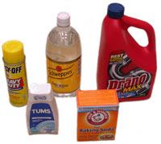
He pāhare ngā kawakore: kawhe, hikareti, wai toniki, houra pekana, pire patuwaikawa, hopi.
Me kore ake te waikawa me te kawakore e ora ai te ao. Arā te waikawa i roto i ō tātau puku hei ngaungau kai. He mea nui anō kia taea e te kaiao te whakarite te nui o te waikawa i roto i a ia hei oranga anō mōna. E whai oranga ana ngā moana o te ao, i te mea kei te mahi tahi te waikawa me te kawakore kia rite ai te nui o te waikawa i roto i te waitai. Waihoki, e tino tiakina ana te waikawa o ngā pūtau ora kia mau i a rātau ō rātau nā hanga, kia ora anō i runga i ngā kawa pūtau.
TE TOHU TAKITORU – Te Waikawa, Te Kawakore, Te Tangata
Kaupae 1: Tuhia ko te tika(T) ko te hē (F) rānei ki te taha o ia rerenga kōrero. Menā e tika ana, kei roto ngā kōrero i te tuhinga, ka rerekē pea ngā kupu engari kei reira. Me whai whakaaro ki te kōrero mai mō ngā take i whakatau ai koutou ko te tika, ko te hē rānei.
- Kei ngā wāhi katoa te waikawa me te kawakore.
- Nā te ngao ka kore e kaingia e tātau te waikawa me te kawakore.
- He pāhare te waikawa.
- Ko te waikawa tātariki te ingoa mō te rāi.
- Hangaia ai te hopi i te kawakore.
- Ko te ingoa matū o te winika ko te waikawa ahipirini.

Kaupae 2: Tuhia ko te tika(T) ko te hē (F) rānei ki te taha o ia rerenga kōrero. Māu anō e whiriwhiri, e kume mai te whakautu i te tuhinga. Me whai whakaaro ki te kōrero mai mō ngā take i whakatau ai koutou ko te tika, ko te hē rānei.
- Nā te rōrahi rawa o te waitai i noho memeha ai te waikawa.
- Ki te ngaua koe e te tokopā, mā tētahi kai pūnoa o te kihini e pai ake ai.
- He waikawa te raima.
- He waikawa te pāhare.

Kaupae 3: Tuhia ko te tika(T) ko te hē (F) rānei ki te taha o ia rerenga kōrero. Māu anō e whakatau menā ka whakaae te kaituhi kōrero ki te 1 me te 2. Me whai whakaaro ki te kōrero mai mō ngā take i whakatau ai koutou ko te tika, ko te hē rānei.
- He matū mōrearea/kino te waikawa me te kawakore.
- He whaipainga kē atu te waikawa i te kawakore.
HEI MAHI 3
KIA MŌHIO KI TE WHĀNAU WAIKAWA, KI TE WHĀNAU KAWAKORE HOKI
Kua whakamōhio mai te pānuitanga o Hei Mahi 2 i a koe ki ngā āhuatanga ōkiko o te waikawa me te kawakore, pērā i te ngao, i te rongo. I kitea hoki e koe ngā āhuatanga matū o te waikawa i ngā akoranga o mua atu, pērā i te tauhohenga ki te maitai.
Ka āta tirohia ētahi atu āhuatanga o ēnei whānau i tētahi kaupapa mahi kē atu. Mō te rangi nei, ka hāngai ngā whakaaro ki te whakamātautau tae kia kitea menā he waikawa, he kawa kore, he kore noa (ehara i te waikawa, ehara hoki i te kawakore) rānei te matū. He mea hira anō tēnei, ka aua atu e mōhio ana te hunga tākuta, ngā tohunga ōmataora, ōmatū hoki ki ngā āhuatanga kino o te kaha waikawa, kawakore hoki ki te kiri tangata, ki ngā whēkau, ki ngā tauhohenga matū tonu o te tinana, kāore i pērā ki te wai māori.
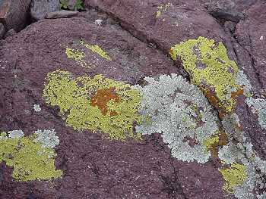
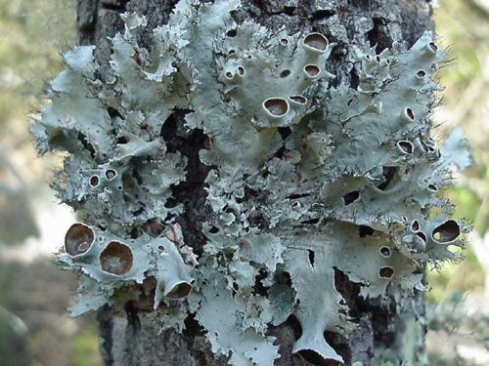
Ka mahia mai te tae e kīa nei ko te tohu waikawa i te pukoko (he momo kaiako rerekē i hua mai i te kōpurawhetū me te pūkohu); ka ngotea e te pepa, ka whakamarokengia (hei pepa tohu waikawa), ā, ka whakaputua mō ngā tau e hia nei, kia tīkina atu anō inā hiahiatia ana. E rua ngā tae o te tohu waikawa – he kahurangi, he whero/māwhero.
Tēnā, kia tirohia e tātau ka ahatia te tohu waikawa whero, kahurangi hoki i roto i ngā momo wai.
Tīkina atu ko ēnei taputapu hei hoatu ki ia rōpū:
- pepa tohu waikawa whero | - waikawa pūmāota 0.1mr | - inu koropupū
- pepa tohu waikawa kahurangi | - konutai waihā 0.1mr | - hopi makawe
- wai māturu | - miraka | - haukini
Whakamātautauria ia wai mā te māturu ki runga i te pepa tohu waikawa whero ka tahi, ki te pepa kahurangi ka rua, kātahi ka tuhi ai i ngā hua o te whakamātautau ki te mahere i raro nei:
matū | tohu waikawa whero | tohu waikawa kahurangi | waikawa/kore/kawakore
wai māturu
waikawa pūmāota 0.1mr
konutai waihā 0.1mr
miraka
inu koropupū
hopi makawe
haukini

Tuhia he rerenga kōrero mō te pānga o te waikawa ki ia tae o te tohu waikawa:
_________________________________________________________________________
Tuhia he rerenga kōrero mō te pānga o te kawakore ki ia tae o te tohu waikawa:
_________________________________________________________________________
Tuhia tētahi rerenga kōrero hei whakamārama i te hua mō te wai māturu:
_________________________________________________________________________

He tohu pH te tohu waikawa. He whero te tohu waikawa i rō waikawa, he kahurangi ki rō kawakore. He māmā, he tere te whakamātautau nei engari kāore i te tino tika i te mea:
1. Ka tino memeha te tae, he uaua te kite i ētahi wā. He koretake noa iho mō te
whakamātautau toto me ētahu atu wairewa tae.
2. Ko te raru nui o te tohu waikawa, ko te wāhi e huri ai te tae, ehara pea i te wāhi hira i
tētahi whakamātautau pūtaiao e noho taurite ai te waikawa/kawakore. Nā reira me whai
ētahi atu tohu pH kia nui rawa.

Ko te pH te inekaha o te waikawa, o te kawakore rānei.
- 1 ki te 14 ngā pae o te tauine pH.
- Kei raro i te 7 ngā tohu pH o te waikawa, ko te 1 te tohu o te waikawa kaha ake.
- Kei runga i te 7 ngā tohu pH o te kawakore, ko te 14 te tohu o te kawakore kaha ake.
- Ko ngā matū noho waenga, ehara i te waikawa, i te kawakore hoki, ko te 7 te tohu pH.
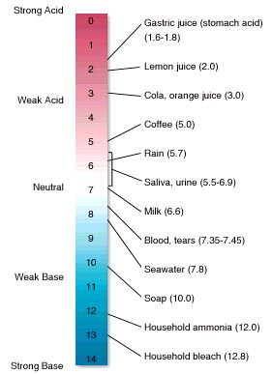
- Ka inehia te pH ki ētahi tohu.

MAHERE AKORANGA 11
TE WĀ: 60 meneti
KAUPAPA MĀORI: Tahu kōrero
NGĀ TOHUTOHU MĀ TE KAIAKO:
- He ngahau te Hei Mahi 1 mā ngā tauira, ka tīkina atu ko te waipūhuitohukonu hei waituhi kēhua, ka mapuhia ki te waihoroi karāhe(he haukini kei roto) ka mārama mai ngā tuhituhinga – menā kāore he waihoroi karāhe, mā te haukini noa. Ngā taputapu hei tiki:
he Waipūhuitohukonu 1% i rō waiwaihā
he pātara mapu kī i te wai horoi karāhe me te haukini(he haukini kāinga 10% rānei)
he koikoi wūru miro
he pepa A5

- Mō Hei Mahi 2, ka hangaia e ngā tauira ā rātau ake tohu pH i te kāpeti whero, ā, ka whakamātautauria te whānui o ngā momo waikawa, kawakore hoki kia kitea ai ngā tikanga huringa tae. Ngā taputapu hei tiki:
he kāpeti whero
he naihi
he papa kotikoti
he ipurau 300ml
he winika
he pēkena houra
he wai whakakōmā
he wai māturu
he haukini
he waikawa pūmāota 0.1mr
he konutai waihā 0.1mr
he miraka
he inu koropupū
he hopi makawe

NGĀ TOHUTOHU MĀ NGĀ TAUIRA:
- Me ngahau te Hei Mahi 1, he tuhi kēhua te tikanga, ā, mā te mana o te tohu pH e whakamārama mai ngā kōrero.
- Mō Hei Mahi 2, ka waihangatia e koe ko tāu ake tohu pH i te hua tipu, ā, ka whakataua ko ngā huringa tae o ngā momo waikawa, kawakore hoki.
HEI MAHI 1
TE TUHI KĒHUA
Ko tāu mahi he hanga kāri whakamahara, kia whakamahia anō. Anei ngā tohutohu:
- Tirohia tō WHARE KUPU, kōwhiria tētahi o ngā kupu me tōna whakamāramatanga. Kaua e whāki atu i te mea ka whakamātautau kē koe i ētahi atu o tō rōpū.
- Whiriwhiria menā kia whakamātautauria te mōhio ki te kupu, ki te whakamāramatanga RĀNEI. Ka tuhia e koe ko tētahi mā te pene, ko tētahi he tuhinga kēhua kē. Ki te tuhia e koe te kupu matua mā te pene, ka waiho te whakamāramatanga hei whakaaro mā tētahi, heoi ki te tuhia e koe te whakamāramatanga mā te pene, ka noho ko te kupu kē hei take whiriwhiri mā tētahi.
- Tīkina atu te pepa A5, tuhia mā te pene te kupu matua, tōna whakamāramatanga rānei, ki runga ake.
- Tuhia ki raro ki te ‘waituhi kēhua’ te whakamāramatanga, te kupu matua rānei. Me tautau te koi wūru miro ki roto i te waipūhuitohukonu 1% te kaha, ā, ka tuhituhi. Maroke ana, ngaro ana ngā tohu o te tuhituhi.
- Tēnā whakamātautauria ērā atu o tō rōpū mā te tono atu ki a rātau kia whakautua mai (te kupu matua rānei, te whakamāramatanga rānei).
- Hei hura i te whakautu tika, mapuhia te wāhi o te pepa i tuhikēhuatia ai, ki te waihoroi karāhe whai haukini, kia nehu noa te maputanga, kia 30hm neke atu te mamao. Me aro atu te mapu i ngā kanohi tangata.
- Waiho te pepa ki rāhaki kia maroke.
- Kia oti katoa i ia tauira o te rōpū te whakamātautau atu, ka tukuna e tō kaiako he nama ki ia tauira o te rōpū, hei whakarōpū ā-nama anō i a koutou.
- Tuaruatia te 5 me te 6.
Tōna tikanga mahi:
He ‘tohu’ te waipūhuitohukonu, kāore he tae menā e noho māori ana, waikawa ana rānei. Ki te tuhia te kōrero kēhua ki te pepa, ka whakaetohia te waipiro o roto, ka ngaro te kōrero.
Ki te pāngia e te kawakore, pērā i te haukini i roto i te waihoroi karāhe, ka tino māwhero, tōna āhua tūturu. Nā te mea ka whakaeto ake te haukini i te pepa, ka hoki anō ki tōna tīmatanga, ā, ka noho kore tae anō te waipūhuitohukonu.
Ka mapuhia te pepa, ka paku tīrama mai te tuhinga, māwhero rawa. Ka maroke haere te pepa, ka ngaro haere hoki te tuhinga. Mā te mapu anō ki te waihoroikarāhe, ka hoki mai anō te kōrero.
HEI MAHI 2
Ka huri te tae o ētahi momo tipu menā ka rerekē te pH, hei tauira, ka huri te tae waiporoporo o te puti panihi kia ngangana i roto i te waikawa kaha, ka otaraima kē i roto i te kawakore kaha.
Ka waihangatia e koe ko tāu ake tohu pH i te hua tipu. Ka whakamahia tēnei hei tohu pH i te whānui o ngā matū.
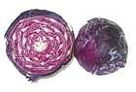
Mā te kāpeti whero tēnei e taea ai. Inā kōhuatia ai te hua whenua, ka tukitukihia te kiriuhi wē o ngā pūtau ka rere ngā matū wairewa ki roto i te wai kōhua.
Ngā Whakaritenga mō Te Tohu Kāpeti Whero:
- Kotikotia te kāpeti whero.
- Kōhuatia te kāpeti ki rō wairere. Kia rere mai te tae whero ki roto i te wai kōhua, kua pai. Koinei te wai hei pupuri mō ngā whakamātautau tohu.
- Kia paku noa iho te wai kāpeti hei mahi mō ia whakamātautau.
- Mutu ana ia whakamātautau, horoia te ipuipu ki te wairere.
- Puritia te ipuipu ki mua i te papa mā, i te matapihi rānei kia pai ai te kite i te tae. Ki te kore tonu e kitea atu, meatia te pune kirihou mā.
- Ringihia kia 1 – 2 pata winika ki roto i te wai kāpeti whero.
Ka hurihia rānei te tae? Tuhia te kōrero ki te mahere i te whārangi whai muri atu nei.
- Hōatu te houra pekana kia paku kini nei ki roto.
Ka hurihia rānei te tae? Tuhia te kōrero ki te mahere.
- Kia 1 – 2 pata wai whakakōmā.
He pānga anō ki te tae? Taihoa, me tatari tonu – tēnā he aha te tae ināianei? Tuhia te kōrero ki te mahere.
- Kāti, whakamātautauria atu ngā mea e whakarārangihia ana i raro nei (ko aua mea anō i whakamātautauria ai i tērā atu akoranga).
matū | huringa tae | matū | huringa tae
winika |  | 0.1mR waikawa pūmāota
houra pekana |  | 0.1mR konutai waihā
wai whakakōmā |  | miraka
wai māturu |  | inu koropupū
haukini |  | hopi makawe
He rite anō te tae o te wai kāpeti whero i te katoa o ngā waikawa? Menā āe, he aha te tae _________
He rite anō te tae i ngā kawakore katoa? _______________
Ka meingatia e koe te houra pekana me te winika kia hua ai rānei te tae o waenganui pū?
MAHERE AKORANGA 12
TE WĀ: 60 meneti
KAUPAPA MĀORI: Rangahau
NGĀ TOHUTOHU MĀ TE KAIAKO:
- Mō Hei Mahi 1, ka ākona e ngā tauira me pēhea e ū ai te tae ki te papanga me ngā tikanga hoki o te waiwhakaū, nā ka whakatauritea e rātau i Hei Mahi 2 ngā mahi a te wai whakaū me ērā kāore i whai wai whakaū.
- Ngā taputapu hei whai mō Hei Mahi 2 mā ia rōpū:
he papanga rīnena, pareaku hoki
he kutikuti
kia 3 ngā ipurau karāhe 250mr
he ipu ine
he wai haukini 100mr
he kuku
he wai konumohe 150mr
he toko karāhe
he tae kura 150mr
he whāriki ārai
he waetoru
he muratahi
he ine pāmahana

- Kōrerotia me ngā tauira ngā take e whai ake nei hei whakaaro mō ā rātau whakaritenga kaupapa mō Mahere Akoranga #14. Menā kei te nui ngā papanga kua mahia e ngā tauira ki te tae, ā, e whakamātautauria ana hoki e rātau, ka rata hoki pea rātau ki ngā whakamātautau kaurangamuri. Me whakamahara i a rātau ki te mau mōhiti haumaru, kākahu haumaru hoki, ā, me tūpato ki te raweke matū. Mutu ana te mahi tae, ringihia atu ngā matū waikawa, kawakore rānei ki te waiopeope whakamutunga. He mea mahara pea mā ngā tauira ki te waiopeope makawe.
- Me winika mā, me wairēmana rānei te waiopeope waikawa.
- Me haukini(kore hukahopi), me houra pekana te waiopeope kawakore. Whero haere ai te kahurangi me te waiporoporo i rō winika; whero haere hoki ai te karaka i rō haukini; ka kaha ake rānei, ka whai kauruku kē rānei ētahi tae i rō kaurangamuri.

NGĀ TOHUTOHU MĀ NGĀ TAUIRA:
- Ka whai tikanga anō te tauhohenga matū o te waiwhakaū ki te tae tonu i hua mai i te papanga me te ū tonu o taua tae ki te papanga – arā, e kore e memeha noa i te horoitanga. Ko tā Hei Mahi 1 he whakamārama i te mahi a te tauhohenga matū kia tutuki ai ko tēnei.
- Mō Hei Mahi 2, ka kitea atu te pānga o te waiwhakaū ki ngā papanga māori, papanga hanga hoki.
HEI MAHI 1
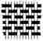
TE Ū O TE TAE KI TE KAKA

He mea hanga te kaka i ngā miro kua whatuwhatua. Whiria ai te miro i ngā rau weu e hia nei.
Tirohia i raro i te karu whakarahi wāwāhi.
He matūriki tae
He weu wūru hangaia ai i ngā matūriki nui

He kaka, he matūriki, he kaka, he matūriki, koia te hanga. Whakamanea atu ai ngā matūriki kaka i ērā o te tae.

He kaha te aro o te matūriki wūru ki te matūriki tae kia
tata. Heoi ka piri te tae ki te mata o te wūru.

Ka uhia te weu e te kahu tae.

Mā te here matū e mau ai te matūriki tae ki te matūriki
wūru.

Tērā ētahi kaka, ētahi tae hoki, kāore tētahi e piri ki tētahi.

He uaua te tae i ngā kaka i hangā e te tangata, pērā i te pareaku. Ka tīkina atū ko ētahi matū motuhake nei hei whakaū i te tae. Koinei tēnei mea te wai whakaū.

Ko te tikanga o te kupu wai whakaū, ko te ngau.
He weu rīnena
He matūriki nō te wairewa haukini wawairewwahaukini

Mō te whakamātautau i Hei Mahi 2, ka
tōpunitia te kaka ki rō wairewa haukini.

He matūriki waihā kei roto.

Kātahi ka waiwaitia te kaka ki rō waikonumohe.
He weu rīnena
He matūriki nō te waikonumohe
He matūriki konumohe kei roto.

Ka tata ngā matūriki o ia wairewa, tētahi ki tētahi.

He weu rīnena
Ngā matūriki konumohe waihā – te waiwhakaū

Ka piri tahi ngā matūriki o ia wairewa hei konumohe waihā.

Koinei te waiwhakaū e piri nei ki ngā weu o te kaka.

He weu rīnena
Ngā matūriki tae kura

Ka rere ko ngā matūriki tae kura ki te waiwhakaū.

Ka piri te tae kura ki ngā matūriki waiwhakaū hei kahu tae mō te weu.

HEI MAHI 2
TE MAHI WAIWHAKAŪ

Ka tirohia e koe ngā hua o te mahi waiwhakaū kia ū ai te tae ki te papangā.

- Tapahia ngā papanga(rīnena, pareaku) kia wāhi toru. Tapahia atu tētahi kokonga o ia papanga pareaku.
- Whakapiria tētahi wāhi o ia momo papanga kāore anō kia mahia, ki te pou tuarua o te mahere o te whārangi whai muri i tēnei.
- Ringihia te haukini 100mR ki roto i te ipurau 250mR te rahi. Tīkina mā te kuku tētahi wāhi o ia momo papanga, ka hoatu ki roto i te ipurau.
- Tīkina atu te toko karāhe hei kōrori i ngā papanga mō te 2 meneti te roa, kātahi ka tangohia anō mā te kuku. Waiho kia rere te nuinga o te wairewa haukini o ngā papanga ki roto anō i te ipurau.
- Ringihia te waikonumohe 150mR ki roto i tētahi ipurau 250 mR mā. Hoatu ngā papanga e rua i waiwaitia i te haukini, ki roto. Kōroritia mō te 2 meneti.
- Ringhia te tae kura 150mR ki roto i tētahi ipurau 250 mR mā, hei kauranga tae.
- Tangohia ngā papanga i te waikonumohe mā te kuku. Hoatu ki roto i te kauranga tae, ā, whakawerahia kia 50ºC, me whātau te wera mā te ine pāmahana.
- Waiho kia 50ºC (kia iti te mura) te pāmahana o te kauranga tae. Kōrorita mā te toko karāhe. Kia pau te 10 meneti, tangohia ake ngā papanga mā te kuku.
- Horoia rawatia ngā wāhi papanga ki rō wai mātao. Waiho kia maroke.
- Hoatu ngā toenga papanga kāore i mahia ki roto i te kauranga tae. Tuaruatia te 8 me te 9.
- Kia maroke katoa ngā papanga, whakapiria ki te mahere.

NGĀ PĀTAI:
- He aha te hua o te waiwai rīnena ki rō haukini, ki rō konumohe hoki i mua i te whakamaroketanga? ________________________________________________________________
- Whakaū ai te waiwhakaū i te tae ki ngā weu i hangaia e te tangata?
_______________________________________________________________
- Ko ēhea ngā papanga whai tae kano kē atu, te kai whakaū, te kore rānei?
________________________________________________________________
- I ētahi wā, ka hurihia e te waiwhakaū te tae o te papanga. I pēneitia tētahi o āu papanga?
________________________________________________________________
Mahere hua:
Ingoa papanga | Whakaritenga
Ingoa papanga | Kāore i mahia | I kai matū, i mahia ki te tae, i horoia | I mahia ki te tae, i horoia
Rīnena
Pareaku

MAHERE AKORANGA 13
TE WĀ: 60 meneti
KAUPAPA MĀORI: Whakawhenua
NGĀ TOHUTOHU MĀ TE KAIAKO:
- Mātua whakaritea tētahi haerenga moata ki te marae, ki te wāhi mahi rānei o te kairaranga hei whakariterite i ngā mahi.
- Whakaritea ngā waka hei kawe tauira.
- Whakaotia ngā whakaritenga haerenga ā-kura, hei tauira, Te Puka Ārai Tiaki Whara; te whakaaetanga a ngā mātua, te aha, te aha.
- Whiriwhiria tētahi kaikōrero hei mihi mō te rōpū.
- Ko te kaupapa o te haerenga nei, kia kitea ā-kanohitia e ngā tauira te mahi tae tuku iho. Me raupā ngā ringa tauira i tēnei haerenga, mā reira e pai ai, e mātau ai te whāwhātanga atu ki ā rātau ake mahi tae.

NGĀ TOHUTOHU MĀ NGĀ TAUIRA:
- Whakaotia, whakahokia ngā puka whakamana haerenga ki waho o te kura.
- Me hari pukatuhi, pukatā rānei i te haerenga.
- Me paepae ngā taringa ki te whakarongo, me āta mātakitaki, me uru tika atu ki ngā mahi, me whai whakaaro ngā pātai.
MAHERE AKORANGA 14
TE WĀ: 60 meneti
KAUPAPA MĀORI: Rangahau
NGĀ TOHUTOHU MĀ TE KAIAKO:
- Ka whai wāhi ngā tauira ki te whakarite i ā rātau ake kaupapa mahi tae ā-rōpū nei, i runga anō i ō rātau nā mōhio ki ngā āhuatanga matū, ki ngā tirohanga matū ā-ringa me ngā haerenga.
- Me moata tā rātau tono taputapu, matū hoki ki te kaitiaki taiwhanga pūtaiao kia whakaritea tikatia mai.
- Tērā kua whakataua kētia e te rōpū te aronga o te kaupapa, kua whakaritea hoki ngā tūmahi mā ia tauira mō te tiki, mō te kohi hua tipu, papanga hoki hei tae.
- Kia tirohia ngā whakaritenga e te kaiako i mua i te tīmatanga o te mahi.

MAHERE AKORANGA 15
TE WĀ: 60 meneti
KAUPAPA MĀORI: Te Hao
NGĀ TOHUTOHU MĀ TE KAIAKO:
- Ka whai wāhi ngā tauira ki te whakaatu mai i ngā kaupapa kua oti kē i a rātau te mahi me te āta whakamārama hoki i ngā kawa, i ngā ritenga matū o ngā hua i puta mai.
- Tērā pea ka whakaaria mai te whakaaturanga o Wairewa i tēnei akoranga.
- Me tono manuhiri kia haramai.

pH – mana + hauwai(potential of hydogen)

