KAUPAPA MAHI

TE MAHI WHAKAĀHUA

-

Aotearoa Festival

(REO MĀORI).

KAUPAPA: Te Reo Māori TAUMATA 10-12

WHENU: Tuhituhi/Pānui

TE HOROPAKI: Whakaāhua

ACHIEVEMENT OBJECTIVES.

- Ko te āta matawai whakaāhua me ōna kaupapa.

- Ko te whakatakoto kōrero mai i taua whakaāhua

ESSENTIAL SKILLS  - Analysis and reasoning  - Picture interpretation  - Communication of messages/information through writing and speaking. | RESOURCES  - Task sheet  - Writing and poster equipment  - Māori Dictionary.

EXPECTED LEARNING OUTCOMES  - To enhance fluency in Te reo Māori  - To develop an understanding of picture interpretation.  - To articulate through writing and speaking messages contained within a picture.  - To convey messages effectively through poster form. | ASSESSMENT TASKS  - Oral work – discussion of picture and messages contained within  - Answer questions.  - Design a poster containing specific messages.

KAUPAPA HĀNGAI: Te Mahi Titiro Whakaāhua

NGĀ MAHI.

NGOHE 1 Kōrerorero
Āta tirohia te pikitia i raro iho nei, korua ko tētahi hoa.
Kōrerorerotia ngā āhuatanga kei roto i te pikitia.

ANEI ĒTAHI PĀTAI HEI WERO WHAKAARO
- He aha ngā mea kei te whakaatuhia mai?
- Ki te kite te tangata tauiwi i tēnei whakaāhua he aha ētahi mea ka akona e ia?
- Ka matua kite koe I te whakaāhua nei, he aha ōu whakaaro tuatahi?
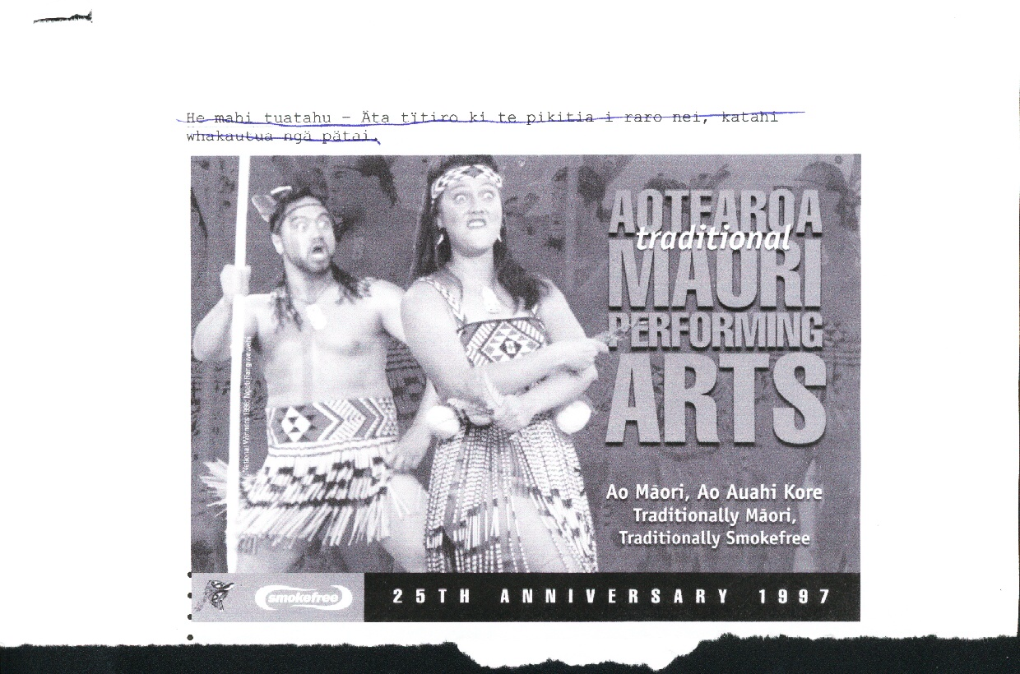
- He aha ngā mahi i te “Aotearoa Traditional Māori Performing Arts”

NGOHE 2
- Whakautua ngā pātai i raro iho nei. E hāngai ana ngā pātai ki te pikitia.
- Tuhia o whakahoki ki roto I ngā wāhi wātea.
- Kia mārama te whakaputa I ōu whakaaro.

NGĀ PĀTAI
- He aha te tino kaupapa o tēnei whakaāhua?

- He aha te kaupapa tuarua o te whakaāhua nei?

- Ki tōu whakaaro mā wai tēnei kaupapa, tēnei whakaāhua?

- Nā wai i tuku pūtea tautoko mo te whakaāhua nei? Na te aha koe i mohio ai?
- Ki tōu whakaaro hoki, he aha te take ka tautoko mai te rōpū nei?
- He aha te hui kei te pānuitia mai e te whakaāhua nei? He aha ngā mahi kei te mahia i taua hui? He aha ōu whakaaro mo te hui nā? He pai? Kāhore rānei?
- Nō tēhea rōpū ngā tokorua nei? Nō tēhea rohe? Ki tōu whakaaro, he aha te take i whakaurua atu ai tēnei rōpū ki roto i te whakaāhua nei?
- Titiro ki te tauira i runga i te pari o te wahine, te tātua o te tāne. Ki a koe, he aha ētahi whakamārama mo ngā tauira nā?
- He aha ōu whakaaro mo ngā kākahu haka o ēnei rā? He mea tūturu ērā? he aha rānei? Whakaingoatia mai ngā momo mea kei te mauria e te tokorua nei. He aha ētahi pitopito kōrero mo aua ranga?
- Ki ōu whakaaro anō hoki, he pai, kāhore rānei te whakaāhua nei? Kei te mārama ōna kaupapa? Whakawhānuitia mai o whakaaro.

NGOHE 3
- He tangata rongonui mahi toi koe. Kua riro i a koe te mahi hoahoa i tētahi whakaāhua mo te hui nei, arā te hui taumahekeheke haka o te motu ka tū ki Manawatu ā te ‘Labour Weekend’ 2004
- Ko tāu mahi he whakaoti i te mahi nei (Ko te rerekētanga mai i te whakaāhua i runga nei, me tuhi āu kōrero i roto i te reo Māori).

TAKU PĀNUI WHAKAĀHUA

TEACHERS COPY Answers to the questions.
- What is the main message of this poster?
Aotearoa Traditional Performing Arts Festival.
- What is the secondary message of this poster?
Ao Māori, ao auahi kore – Traditionally Māori; Traditionally Smokefree.
- Who do you think this poster is aimed at? Why do you think that?
All Māori, anyone interested in Kapa Haka and tourists.
Because it is demonstrating Kapa Haka ….
Because it is mainly Māori people who follow Kapa Haka to this level….
Tourists are interested in learning about ‘things’ Māori (etc. etc.)
- Who has helped to finance this poster?
Smoke free. How do you know this?
– indicated on poster.
- Reason for support by this organisation?
To express the smoke free (healthy) message to rangatahi Māori

- What is the actual event being advertised in this poster about?
National Kapa Haka Festival/competition where teams from all regions in Aotearoa are represented…..etc. etc.
This event is really good for te iwi Māori because (teacher explain reasons).
- What group are these two people from?
Ngāti Rangiwewehi – Rotorua.
Why were they selected? They won the competition in 1996 and were national champions in 1997 when the poster was produced. Furthermore, they have continued to make the competition finals since 1996.
- Patterns on items of clothing
Tāne / male Tātua/Whitiki //Pattern.
- Patikitiki pattern- indicates abundance, progress.
- Niho taniwha – indicates strength, strong direction specific pathways, direction.
9. Thoughts about modern Haka gear? Traditional? Origin? Names of different parts of clothing?
- Bodice; piupiu; whitiki; have now become “traditional gear”-
- Not purely “traditional” ---- the pari, tāpeka whitiki are adaptations of ancient clothing, taken from tāniko border work on traditional korowai (cloaks) and kākahu….etc. etc. etc.

PARTS OF THE COSTUME.

Feathers / ---- Huruhuru manu; parehuia

Headband/Headtie ----- Tipare

Earrings/Pendants -----Hei taringa

Neck pendant -----Hei kaki

Bodice -----Pari

Belt -----Tātua / Whitiki; Piupiu
10. Thoughts about effectiveness of poster?
(Students will express their own whakaaro –

