KAUPAPA MAHI

TE MAHI WHAI
(Māori version)

Reo Māori.

Kori tinana (P.E.) / Hauora

Tikanga-a-iwi

KAUPAPA : Hauora; Kori Tinana; Te Reo Māori

WHENU: Hakinakina
TE HOROPAKI: Te Mahi Whai

Taumata: Yrs. 10 - 12

ACHIEVEMENT OBJECTIVES

- Strand B
- Acquire and apply complex motor skills by using basic principles of motor learning.
- To develop an understanding of complex instructional structures.
- To learn to follow those instructions

ESSENTIAL SKILLS  Physical Co-ordination  - Problem solving - Self management  - Social and Co-operative Learning  - Communication | RESOURCES  - Writing Equipment  - Paper and Task sheet  - Māori Dictionary

EXPECTED LEARNING OUTCOMES

- Enhance Te Reo Māori
- To develop an understanding of complex instructions in Māori
- To increase vocabulary acquisition
- To acquire the skill of Whai through specific instructional language.
- To enhance learning of language through illustrations and instructions.

ASSESSMENT TASKS

- Vocabulary development – Pairs reading out loud – comprehension development
- Identifying new vocabulary – List, write explanation in Māori; similarity; opposites.
- Draw hand and label parts
- Drawings on how to perform string game with each instruction.

NGĀ MAHI WHAI
Ko ēnei kōrero he mea whakamārama me pēhea te hanga i te tauira RUA TAIMANA mā te mahi Whai.
Me pēnei te whakahaere i au mahi.

NGOHE 1
- Pānuitia ngā kōrero ki a koe ake. I a koe e pānui ana, tohua mai ngā kupu hou ki a koe.
- Rapua he hoa mahi tahi ka pānui-a-waha kōrua ki a kōrua.

NGOHE 2 (a) Te Mahi Whai

- Titiro ki ngā kupu kua whakarārangitia i raro nei.
(Ko te nuinga o aua kupu, he kupu hou).
- Tuhia te whakamāramatanga mo aua kupu.

TAUIRA Te Rua Taimana.
NGĀ TOHUTOHU

- Tikina atu he tūaina kia 120 mitarau te roa. Honoa ngā pito e rua.
- Whakairia tō tūaina ki runga i ō kōnui me ō koiti kia noho whakapae i ō kapunga.
- Me whakawhiti atu tō koroa matau ki tō koroa mauī ka tiki atu i te tūaina whakapae I tērā taha. Kumea mai kia āhua kikī tō tūaina.
- Me mahi pērā mo tēra atu taha.
- Ināianei, tukua atu te tūaina mai i ō kōnui.
- Hikina ake ma ō kōnui (i te wā kōtahi) te tūaina whakapae ki raro.
- Me whakawhiti atu tō kōnui me tō kōroa o tō ringa matau ki te pū o tēra atu kōroa. Hikina ake te tūaina i reira ki runga i tō kōnui. Me mahi pērā hoki mō tērā taha.
- Me huri roto ō kōnui, ā, ka takahuri ake.
- Whakaurua ō kōroa e rua ki roto i ngā tapatoru o te tūaina whakapae tuarua
- Whakamakerehia atu te tūaina mai i o koiti. Kia āhua kikī te pupuri.
- Ko te tūmanako kua oti i a koe he RUA TAIMANA
Tihei mauri ora!!!!!!

NGOHE 3 KUPU HOU LIST
Ināianei, me mahi tahi kōrua ko tō hoa ki te hanga i te tauira RUA TAIMANA.
Āta pānuitia, āta mahia, ā, puta pai noa mai tō tauira. Mahi tonu, mahi tonu kia tino pakari koe!
(Whakataetae pea ki tō hoa.)

NGĀ KUPU HOU
1 | Tuaina
2 | Mitarau
3 | Hono
4 | Whakairi
5 | Noho whakapae
6 | Whakawhiti
7 | Kikī
8 | Hiki
9 | Pu
10 | Takahuri
11 | Whakauru
12 | Tapatoru
13 | Āhua
14 | Tūmanako
15 | Oti

HE MAHI KUPU ANŌ.

Titiro ki ēnei kupu e rārangi nei.

Tuhia he kupu ōrite, te tikanga, he kupu apitihana

 | TE KUPU | TE TIKANGA | ŌRITE | ĀPITIHANA
1 | Tūaina
2 | Mitarau
3 | Hono
4 | Whakairi
5 | Kikī
6 | Pu
7 | Whakauru
8 | Tūmanako
9 | Oti
10 | Hiki

NGOHE 4 Tāhia tō ringa, ka tuhia ngā ingoa Māori mo ia matimati.

Tuhia te kupu Ingarihi ki te taha o ngā kupu kua rārangitia iho nei.

- Ringa 2. Matimati

3. Kōiti/Tōiti 4. Manawa

5. Kōroa 6. Mapere

7. Monamona 8. Kōnui

9. whatianga/pona- ringa 10 maikuku

NGOHE 5.

Tūhia ia tohutohu, ka tāhia he pikita e hāngai ana ki aua tohutohu.

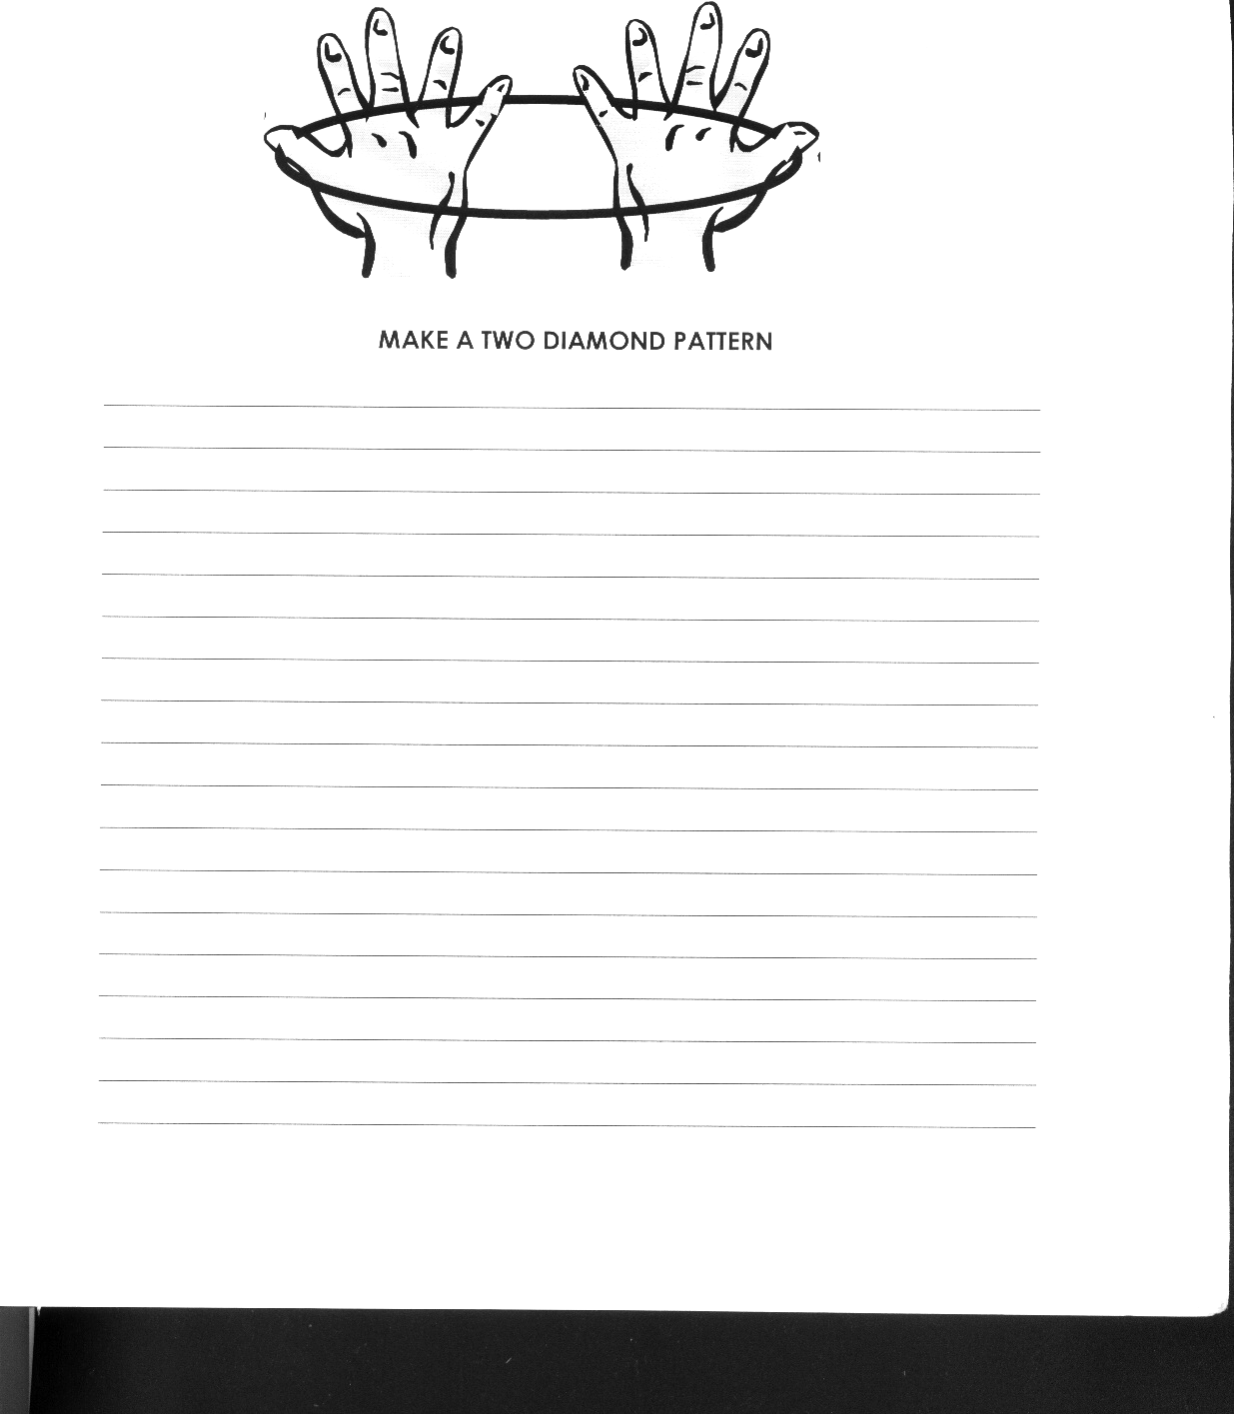
Kua otia te mea tuatahi.

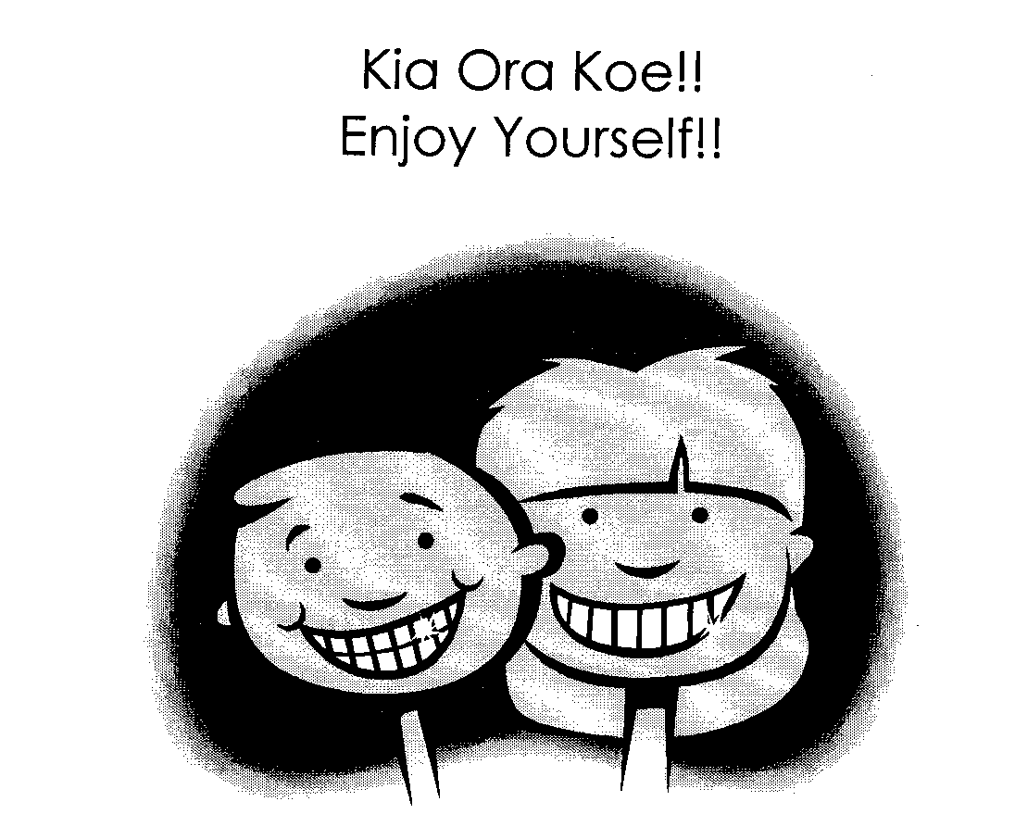

TEACHER’S COPY – Mahi Whai Pātiki Tokorua

Mo te ngohe 2 (For Activity 2)

- Thumb Kōnui / Koromatua
- Index Finger Kōroa
- Middle Finger Māpere
- Ring Finger Manawa
- Little Finger Kōiti / Tōiti
- Knuckle Monamona
- Fingernail Maikuku
- Palm Kapunga
- Wrist Whatīanga Ringa / Ponga Ringa

