TASK SHEET

PICTURE ANALYSIS

(Aotearoa Festival)

English version

REO MĀORI, SOCIAL STUDIES.

SUBJECT: Māori Social Studies

STRAND: Writing; Reading

CONTEXT: Picture Interpretation

ACHIEVEMENT OBJECTIVES.

- Picture analysis and interpretation

- Articulating messages from a picture.

ESSENTIAL SKILLS  - Analysis and reasoning  - Picture interpretation  - Communication of messages/information through writing and speaking. | RESOURCES  - Task sheet  - Writing and poster equipment  - Māori Dictionary.

EXPECTED LEARNING OUTCOMES  - To enhance fluency in Te reo Māori  - To develop an understanding of picture interpretation.  - To articulate through writing and speaking messages contained within a picture.  - To convey messages effectively through poster form. | ASSESSMENT TASKS  - Oral work – discussion of picture and messages contained within  - Answer questions.  - Design a poster containing specific messages.

SPECIAL FOCUS: Picture Interpretation.

TASK 1 Oral Discussion

In pairs, look in detail at the photo below.
Discuss all the aspects you can observe within the photo.

USE THE FOLLOWING QUESTIONS TO PROVOKE YOUR THINKING.
What things are actually being displayed in this photo?
What things about the Māori could a foreign person learn when viewing this photograph?
When you first saw this photo what were your immediate thoughts?
What actually is the ‘Aotearoa Traditional Māori Performing Arts’ – what is the point of that long name?

ACTIVITY 2
Answer the following questions pertaining to the picture.
Write your responses in the spaces provided.
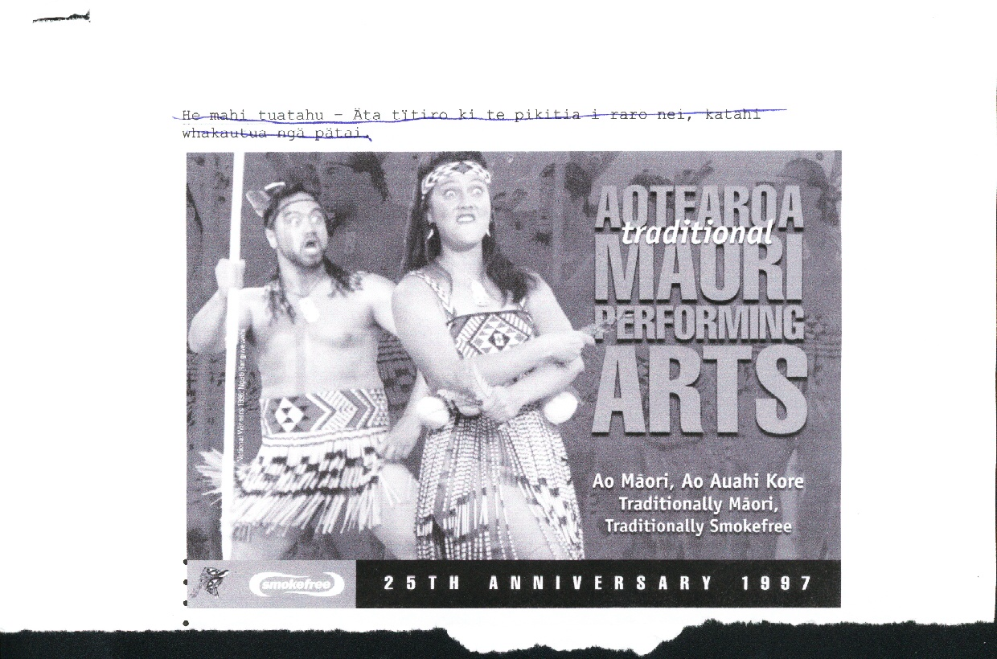
Be clear and concise with your responses.

THE QUESTIONS

- What is the main message of this picture?

- What is the secondary message of this poster?

- Who do you think this poster is aimed at? Why do you think that?

- Who has helped to finance this poster? How do you know this?

- What would the reason be for this organisation to support this initiative?

- What is the actual event being advertised in this poster ‘about’?
What actually happens at those events?
What do you think of this event/hui? Are they good/bad? …
Do you enjoy this event?

- What group are these two people from? From what region? Why do you think this particular group was selected for this picture?

- Carefully examine the patterns on the bodice of the woman and the belt of the tāne. What is the significance of these items of ‘clothing’?
What do you think an interpretation of the pattern could be?

- What do you think of Haka gear/clothes worn these days? Are they ‘traditional’ clothing? What is their source/origin?
Name the different parts of costume being worn by these performers. Write some thoughts pertaining to these questions.

- What are your thoughts about this poster? Are the messages clear? effective? Can it be improved? How?
Expand your thoughts here.
10. Thoughts about effectiveness of poster?
(Students will express their own whakaaro)

ACTIVITY 3
You are a famous Māori graphic Artist.
You have won the contract to design a poster advertising this event, i.e. the Aotearoa Traditional Māori Performing Arts Festival which will be staged in Palmerston North – Manawatu on Labour Weekend 2004
Your task is to design and complete this poster. (The difference from the previous poster is that this one must be Te Reo Māori).

POSTER RE AOTEAROA FESTIVAL.

TEACHERS COPY Answers to the questions.

- What is the main message of this poster?
Aotearoa Traditional Performing Arts Festival.
- What is the secondary message of this poster?
Ao Māori, ao auahi kore – Traditionally Māori; Traditionally Smoke free.
- Who do you think this poster is aimed at? Why do you think that?
All Māori, anyone interested in Kapa Haka and tourists.
Because it is demonstrating Kapa Haka ….
Because it is mainly Māori people who follow Kapa Haka to this level….
Tourists are interested in learning about ‘things’ Māori (etc. etc.)
- Who has helped to finance this poster?
Smoke free. How do you know this?
– indicated on poster.
- Reason for support by this organisation?
To express the smoke free (healthy) message to rangatahi Māori.
- What is the actual event being advertised in this poster about?
National Kapa Haka Festival/competition where teams from all regions in Aotearoa are represented.
This event is really good for te iwi Māori because…..(Teacher to discuss reasons).
- What group are these two people from?
Ngāti Rangiwewehi – Rotorua.
Why have they been selected?
They won the competition in 1996 and were national champions in 1997 when the poster was produced. Furthermore, they have continued to make the competition finals since 1996.
- Patterns on items of clothing
Tāne / male Tātua/Whitiki //Pattern.
- Patikitiki pattern- indicates abundance, progress.
- Niho taniwha – indicates strength, strong direction specific pathways, direction.
9. Thoughts about modern Haka gear? Traditional? Origin? Names of different parts of clothing?
- Bodice; piupiu; whitiki; have now become “traditional gear”-
- Not purely “traditional” ---- the pari, tāpeka whitiki are adaptations of ancient clothing, taken from tāniko border work on traditional korowai (cloaks) and kākahu etc.

PARTS OF THE COSTUME.

Feathers / ---- Huruhuru manu; parehuia

Headband/Headtie ----- Tipare

Earrings/Pendants -----Hei taringa

Neck pendant -----Hei kaki

Bodice -----Pari

Belt -----Tātua / Whitiki; Piupiu

