YEAR 10 UNIT PLAN 1

KARAWHIUA

TE AHUA O TE MAHERE

Akoranga 1 Tohutohu haere 5

Mahere
Ngā Ngohe

Akoranga 2 Kei hea koe e noho ana? 11

Mahere
Ngā Ngohe

Akoranga 3 Kōrero huna 16

Mahere
Ngā Ngohe

Akoranga 4 Te kēmu nui 1 21

Mahere
Ngā Ngohe

Akoranga 5 Te kēmu nui 2 27

Mahere
Ngā Ngohe

Akoranga 6 Mā hea koe haere ai? 34

Mahere
Ngā Ngohe

Akoranga 7 Tukua kia rere 39

Mahere
Ngā Ngohe

Akoranga 8 Te kitenga nui 43

Mahere
Ngā Ngohe

Kaupapa Mahi 1  Tau 10 | KARAWHIUA
KAUPAPA TEINA
KOEKE | 3
TE ROA | 8 X 45 meneti
WHĀINGA PAETAE | 3.1 Communicate, including comparing and contrasting about habits and routines  3.3 Give and follow directions  3.4 Communicate, including comparing, contrasting about how people travel
This Unit Plan includes kaupapa Māori references from He Aratohu 2007 Integrating Kaupapa Māori into Mainstream Secondary School Teaching and Learning Programmes-Practical Guidelines for teachers of all subjects. See www.thm.ac.nz/
TE KAUPAPA AKO ME ONA WHEUE |  | Mainstream |  |  | He Aratohu
 |  | Language and Languages - Te Reo Māori  Whenu Torohū: Whakarongo, Pānui, Mātakitaki  Whenu Whakaputa: Kōrero, Tuhituhi, Whakaari |  |  | Reo Māori Integration Model  Reo Māori vocab, word puzzles, phrases, mihi.
TE REO MĀORI |  | Ngā ariā o te reo | Te wetewete i te reo  Mā hea ..., Tokohia ...,  Ko te ...,  he….,  me…,  tūmahi/ingoa/āhua |  | Kupu hou  kupu mō ngā momo waka | Kīwaha  Kāore e kore  Engari mō tēnā  Auare ake te taea e rātou  Nāwai i hē, kātahi ka hē tonu atu  Te mutunga kē mai o te heahea  Kia ahatia!  Kua takoto te mānuka  E hika!  Kaua e aro atu  Aue, taukuri e!
NGĀ PŪKENGA HEI WHAI |  | Hei te mutunga o te kaupapa mahi nei, ka āhei te ākonga ki te:  - whakamahi i ngā kupu hou me te tuhituhi i ngā rerenga kōrero kua waia nei te whakarongo atu  - pānui i ngā kupu, i ngā rerenga kōrero mārama nei te whai  - whakahoki kōrero i te reo Māori ki ngā kōrero, tohutohu, pātai āhua uaua hoki
KAWENGA  Ngā tikanga hei whakahauhau atu i ngā ākonga kia mārama ai ngā mahi ki a rātou e tutuki ai ngā whāinga pūkenga |  | - Me whakanui atu i ngā kupu hou kia mau i te ākonga. Me whakauru mai ko ngā kupu pēnei i te; ngā tohutohu haere ... Mā hea ..., Tokohia ..., Ko te ..., he…., me…, kupu mō ngā momo waka, kīwaha, kupu taurite, Kupu –tūmahi/ingoa/āhua
MAHI I IA RĀ
NGOHE  Activities/Ngohe  K = Katoa  TR = Takirōpū  T = Takirua  tt = Takitahi |  | Akoranga 1  - Whakaari ā-Tinana  - Whakatohungia  - Mahi whakamāori  Akoranga 2  - Kaua e takahi i te pēpi  - Whakarite tohutohu  - Kei hea tō kāinga?  Akoranga 3  - He tohutohu haere  - Kimi kōrero huna  Akoranga 4  - Pānuihia, whakarāpopotohia  - Whakarārangi kupu  Akoranga 5  - Ngā momo taumahi  - He whakaari  Akoranga 6  - Mā runga poaka?  - He uiuitanga  - He aha ngā kitenga?  Akoranga 7  - Tū kupu  - He whakarite uiuitanga  Akoranga 8  - Wā whakarite tonu  - Wā whakamārama |  | He Aratohu  Māori Practice  Me rongo ngā ākonga ki te reo Māori e kōrerotia ana. Tōna tikanga mā tēnei e mau i a rātou ētahi āhuatanga o te reo, mā tēnei anō e kaupapa Māori ai te ako.  Me mataara te kaiako ki te kōrero reo Māori ki ngā ākonga ahakoa te matatau, te kore matatau rānei o te ākonga. Ko te tikanga kia rongo ngā ākonga ki te reo Māori pai, tika hoki e kōrerotia ana.
AROMATAWAI  Ngā whakaritenga e tika ana hei aromatawai i te whai a ngā ākonga kia tutuki i ā rātou ngā whāinga, kia mau i a rātou ngā pūkenga |  | 1. Te mātakitaki, te whakarongo  2. Te whakahoki kōrero mai a te ākonga  3. Te kōrero ki/a ngā hoa ākonga  4. Te tuhituhi
RAUEMI |  | 1. Papa Kupu  2. Rauemi mō ngā akoranga 1, 2, 3, 4, 5, 6, 7, 8  3. See resources on Te Hiringa i te Mahara http://www.thm.ac.nz/resources/

Tau Mahere Ako |  | 1
Ingoa Mahere Ako |  | Karawhiua!
Tau Akoranga |  | 1 o 8
Ingoa Akoranga |  | Tohutohu haere
Paetau |  | Tau 10
Te whāinga hei whakatutuki |  | 3.3 Give and follow directions
Te wā hei whakatutuki |  | 50 meneti
Ngā rauemi |  | Rauemi 1
Te raupapa ngohe | Te Roa  15  20  15 | - Whakaari ā-Tinana  - Tohungia  - Mahi whakamāori
Ngā mahi aromatawai |  | Ngohe 3 – Mahi whakamāori (Tā te kaiako)

Ngohe 1: Whakaari ā-tinana

Mahi: He kēmu

Whāinga: Kia mau i ngā ākonga ngā kupu hou mō ngā tohutohu

Kia whiwhi: Rauemi 1 – Ngā kupu hou
Te roa: 15 meneti
Te mahi: Rōpū

- Whakarōpūhia ngā ākonga.
- Tohatohaina te Rauemi 1 ki ia rōpū.
- Kia rima mēneti te roa kia mau i ō rātou hinengaro ngā kupu hou mō te tohutohu.
- Ka pau te rima mēneti, hōatu tētahi kupu hou ki tētahi ākonga o ia rōpū. Ko tā rātou mahi he whakaatu i te tikanga o aua kupu ki ō rātou ake rōpū arā, ko te ‘charades’ te āhua.
- Ka whiwhi māka te rōpu tuatahi ka mau i a rātou te kupu e whakaaturia ana.

Ngohe 2: Tohungia

Mahi: He tuhi pikitia, he tapa ingoa

Whāinga: Kia taea e te ākonga ngā kupu hou o te pikitia te whakaingoa

Kia whiwhi: Pepa nui, pene hinu tāe
Te roa: 20 meneti
Te mahi: Rōpū

- Me noho takirōpū ngā ākonga.
- Tohatohaina ngā pepa nui me ngā pene hinu tāe ki ia rōpū.
- Ko te mahi he tuhi i tētahi pikitia o ngā tiriti o tētahi taone nui.
- Tuhia hoki ngā ingoa o ngā tiriti.
- Whiriwhiria tētahi pito tīmatanga, tētahi pito whakamutunga hoki ki runga i te pikitia.
- Whakarārangihia ngā tohutohu kia haere atu i te tīmatanga ki te mutunga.
- Me whakaatu mai ngā kōrero/tohutohu ki te katoa.

Ngohe 3: He whakamāori

Mahi: He tuhituhi, he mahi whakamāori/whakapākeha

Whāinga: Kia mārama ngā ākonga ki ngā tohutohu

Kia whiwhi: Rauemi 2: He whakamāori

Te roa: 15 meneti
Te mahi: Takitahi

- Hōatu te Rauemi 2 ki ngā ākonga.
- Mā rātou e whakaoti.
- Mā te kaiako e whakamātautau.
Rauemi 1 - He Tohutohu Haere

He Kupu Hou

ahu(tia) | move in a certain direction
kapiti | gorge
ara | pathway, path, road
ara rīpeka | cross roads, intersection
ara tereina | railway track
auheke | slope
haere tōtika | go straight ahead
hāngai | be opposite, in line with
huarahi | road
tiriti | street
huarahi matua | main road
huri whakamatau | turn right
huri whakamaui | turn left
kokonga | corner
huringa | round about
piriti | bridge
pito | end
taha matau | right side
taha maui | left side
tapuae/tapuwae | foot steps
whakawhiti(hia) | to cross
hauāuru | west
raki | north
rāwhiti | east
tonga | south
kia tae atu koe | till you arrive
me peka atu i te piriti | you should turn off at the bridge
whāia te huarahi | follow the road
e tū ki ngā rama | stop at the lights
ka puta atu koe | you will come out
kaua e peka atu | don’t turn off
whakawhiti i te huarahi | cross the road
haere torotika | go straight ahead

Rauemi 2 – Mahi whakamāori (Tohutohu haere)

Whakamāoritia ēnei rerenga kōrero e whai ake nei.
Translate the following sentences into Māori

- Turn right at the intersection.

________________________________________________________

- Go straight ahead and turn left at the lights.

________________________________________________________

- Follow the main road till you arrive at the bridge.

________________________________________________________

- Turn left at the second roundabout.

________________________________________________________

- Stop at the corner, turn right and go straight to the end.

________________________________________________________
.

Whakapākehātia ēnei rerenga kōrero i raro iho nei:
Translate the following sentences into English

- Whakawhitihia te huarahi o Kōwhai.

________________________________________________________

- Me haere tōtika kia tae atu koe ki te kokonga o Rata me Rimu.

________________________________________________________

- Me huri whakamaui, ā, kaua e peka atu.

________________________________________________________

- Me huri whakamatau i te huringa, ā, me haere tōtika ki te ara tereina.

________________________________________________________

Rauemi 2 – Mahi whakamāori: Tohutohu haere (Tā te kaiako ngā whakautu)

Whakamāoritia ēnei rerenga kōrero e whai ake nei. Translate the following sentences into Māori

- Turn right at the intersection. Huri whakamatau i te ara rīpeka

- Go straight ahead and turn left at the lights. Me haere tōtika, ā, huri whakamaui i ngā rama.

- Follow the main road till you arrive at the bridge. Whāia atu te huarahi matua kia tae atu koe ki te piriti.

- Turn left at the second roundabout. Huri whakamaui i te huringa tuarua

- Stop at the corner, turn right and go straight to the end. E tū ki te kokonga, huri whakamatau, kātahi me haere tōtika

Whakapākehātia ēnei rerenga kōrero i raro iho nei:
Translate the following sentences into English

- Whakawhitihia te huarahi o Kōwhai. Cross Kōwhai Road.

- Me haere totika kia tae atu koe ki te kokonga o Rata me Rimu. Go straight ahead until you get to the corner of Rimu and Rata.

- Me huri whakamaui, ā, kaua e peka atu. Turn left and don’t branch off.

- Me huri whakamatau i te huringa, ā, me haere tōtika ki te ara tereina. Turn right at the roundabout and go straight ahead to the railway crossing

Tau Mahere Ako |  | 1
Ingoa Mahere Ako |  | Karawhiua!
Tau Akoranga |  | 2 o 8
Ingoa Akoranga |  | Kei hea koe e noho ana?
Paetau |  | Tau 10
Te whāinga hei whakatutuki |  | 3.1 Communicate, including comparing and contrasting about habits and routines  3.3 Give and follow directions  3.4 Communicate, including comparing, contrasting about how people travel
Te wā hei whakatutuki |  | 50 meneti
Ngā rauemi |  | Rauemi 3  Pānui 1, 2  Ārai kāpō x 6
Te raupapa ngohe | Te Roa  15  20  15 | - Kaua e takahi i te pēpi  - Whakarite tohutohu.  - Kei hea tō kāinga?
Ngā mahi aromatawai

Ngohe 1: Kaua e takahi i te pēpi!

Mahi: He kēmu whakarongo

Whāinga: Kia taea e te ākonga ngā tohutohu te whai kāpō

Kia whiwhi: Rauemi 3 – Ngā pikitia o ngā pēpi
Ārai kāpō (mā ngā ākonga)
Te roa: 15 meneti
Te mahi: Takirōpū

- Whakaritea tētahi wāhi wātea i roto i te rūma ako, i waho rānei.
- Kutikutihia ngā pikitia o ngā pēpi, horahia ki te papa (Pai ake kia whakaritea i mua tonu i tēnei akoranga.)
- Whakarōpūhia ngā ākonga. Mā ia rōpū e whiriwhiri te tangata tuatahi hei mau ārai kāpō.
- Ko te mahi a ia rōpū he ārahi i ngā kāpō kia kore e takahia ngā whakaahua pēpi.
- Mā te kōrero anake e ārahi, kaua e pāpā atu ki te kāpō.
- Kia mutu tētahi me mau ārai kāpō tētahi atu.

Rauemi 3 – Ngā Pikitia o ngā pēpi

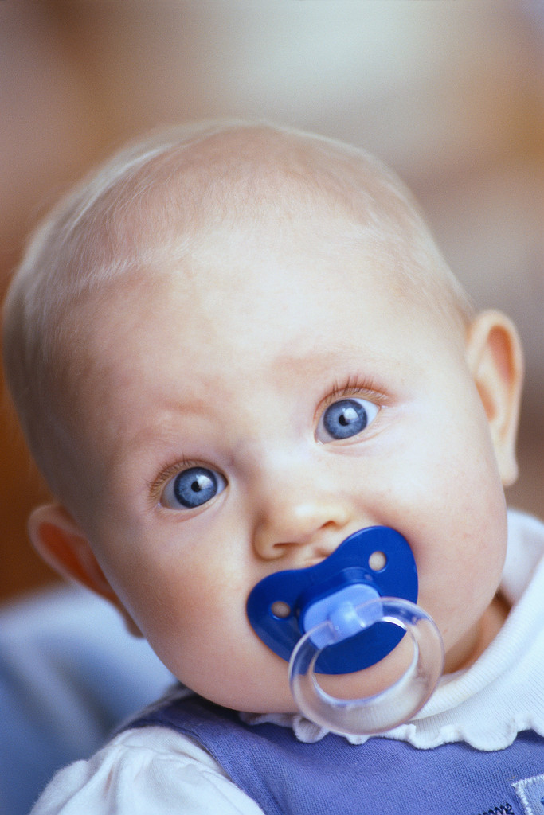
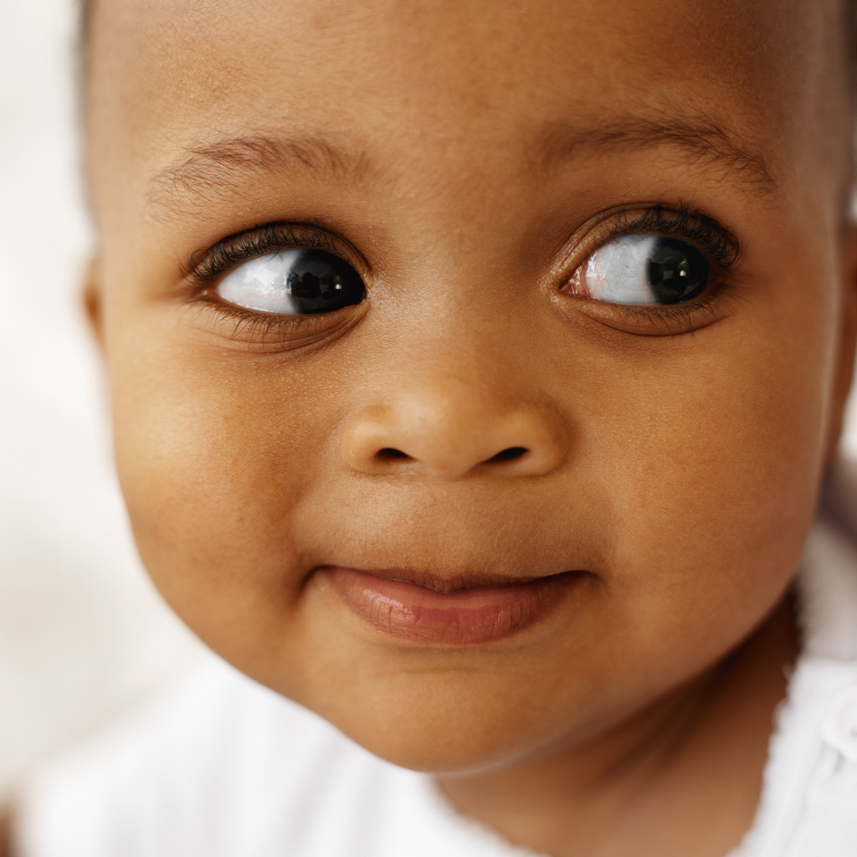

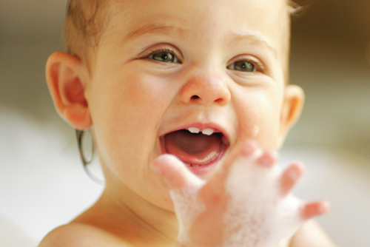

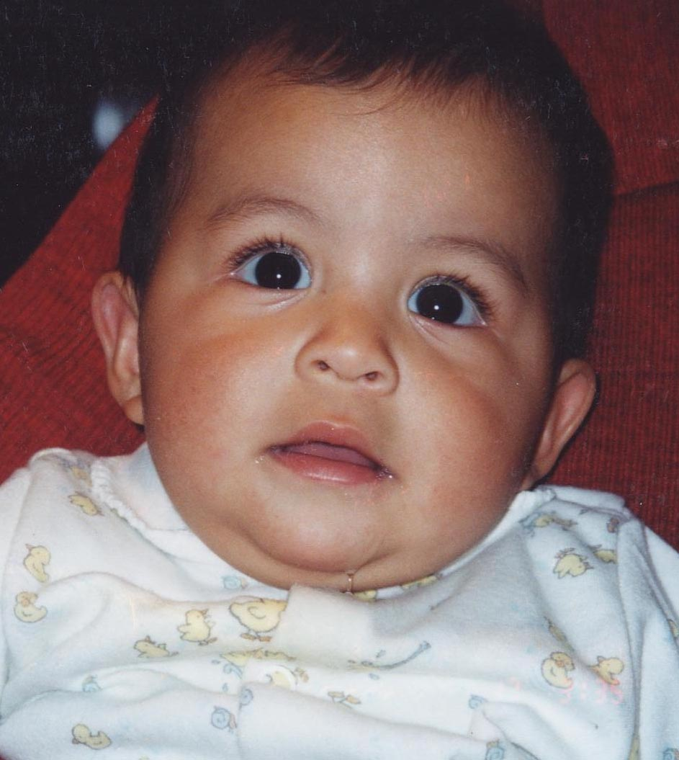

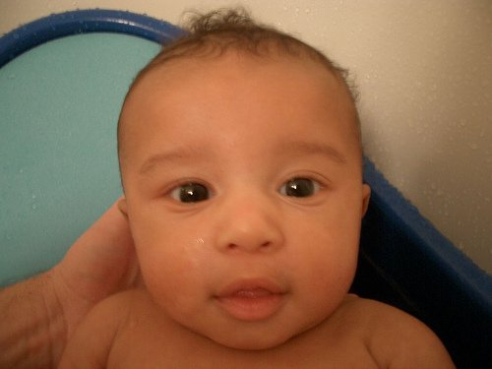

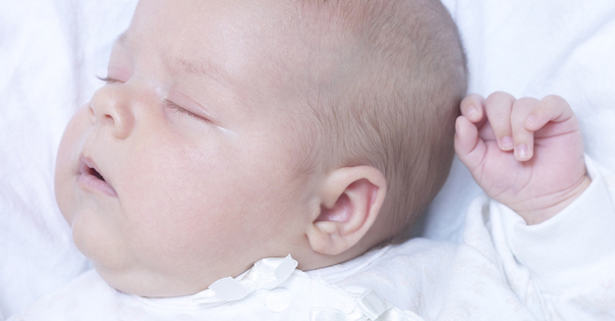
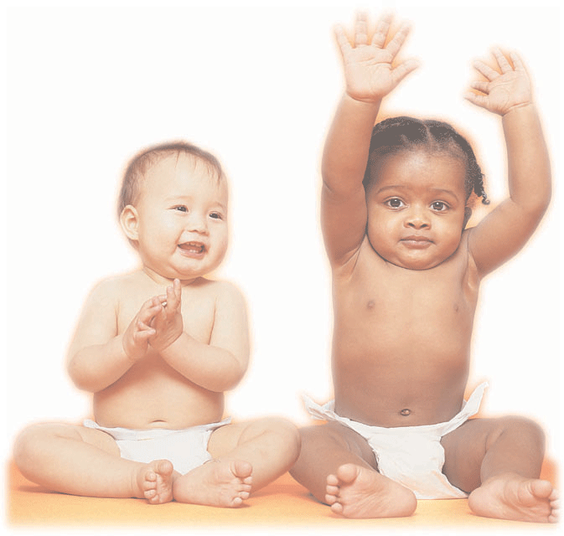

Ngohe 2: Whakarite tohutohu

Mahi: He tuhi kōrero

Whāinga: Kia oti i ngā ākonga ngā tohutohu te tuhi mai i tō rātou rūma ako ki ētahi wāhi o te kura, kia mārama hoki ngā tohutohu ki te hunga whai.

Kia whiwhi: Pānui 2 (Ngā ingoa o ngā momo wāhi o te kura)

Te roa: 20 meneti
Te mahi: Katoa/Rōpū

- Me noho takirōpū ngā ākonga.
- Hōatu ki ia rōpū te ingoa o tētahi wāhi o te kura. Kaua e whāki atu ki ērā atu rōpū.
- Ko te mahi a ia rōpū he tuhituhi i ngā tohutohu haere (mā raro) mai i tō rātou rūma ako ki tētahi wāhi o te kura. Ko te tikanga kia āhua uaua ngā tohutohu.
- Mutu ana taua mahi mā te kaiako e whiriwhiri me pēhea te tohutohu a tētahi rōpū i tētahi atu. Tēnā pea mā tētahi rōpū e kōrero ā rātou tohutohu kia mau i ngā hinengaro o tētahi rōpū kē atu kātahi ka haere ki taua wāhi. Hei te hokinga mai ka whāki mai ko hea taua wāhi o te kura.

Pānui 1 – Ngā ingoa wāhi o te kura (hei tauira)

Whare  pukapuka | Whare whakaminenga | Whare  Tākaro | Whare  hoko kai
Tūnga  waka | Te tari o te  tumuaki | Te rūma o te  nēhi | Tētahi rūma  rorohiko
Tētahi wāhi o te  papa tākaro | Tētahi rūma  ako | Tētahi  kīhini | Te tari o  tētahi kaiako

Ngohe 3: Kei hea tō kāinga?

Mahi: He tuhi kōrero

Whāinga: Kia oti i ngā ākonga ngā tohutohu te tuhi mai i ō rātou kāinga ki te kura, kia mārama hoki ngā tohutohu ki te hunga whai.

Kia whiwhi: Rauemi 1 (Hei ārahi)

Te roa: 15 meneti
Te mahi: Katoa/Rōpū

- Whakamāramatia atu ki te katoa tā rātou mahi mō tēnei ngohe.
- Tuhia kia 6-8 ngā tohutohu haere mai i ō rātou ake kāinga ki te kura.
- Mena ka pau te wā mō tēnei mahi, me whakaoti i te kāinga.

Tau Mahere Ako |  | 1
Ingoa Mahere Ako |  | Karawhiua!
Tau Akoranga |  | 3 o 8
Ingoa Akoranga |  | Kōrero huna
Paetau |  | Tau 10
Te whāinga hei whakatutuki |  | 3.3 Give and follow directions  3.4 Communicate, including comparing, contrasting about how people travel
Te wā hei whakatutuki |  | 45 meneti
Ngā rauemi |  | Rauemi 4  Pānui 2 – tā te kaiako
Te raupapa ngohe | Te Roa  10  35 | 1. He tohutohu haere  2. Kimi kōrero huna. (Me whakarite tēnei ngohe i mua tonu i te akoranga)
Ngā mahi aromatawai

Ngohe 1: He aha āu tohutohu?

Mahi: He tuhituhi, he kōrero

Whāinga: Kia mārama ngā ākonga ki ngā kōrero e whāia ana e ia.

Kia whiwhi: Ngā mahi kāinga a ngā ākonga

Te roa: 10 meneti
Te mahi: Takitahi

- Whiriwhiria ngā ākonga kia tū ki te whakahuahua i ā rātou tohutohu haere mai i ō rātou ake kāinga ki te kura.

Ngohe 2: Kimi kōrero huna

WHAKARITEA TĒNEI NGOHE I MUA TONU I TE AKORANGA

Mahi: He kimi taonga (Treasure hunt)

Whāinga: Kia tutuki i ngā ākonga:
- ngā tīwhiri te tātari
- ngā tohutohu o ngā tīwhiri te whai
ka kitea hoki ngā kupu/kōrero huna
ka mahi ngātahi
ka whakatakoto kōrero kia tika ai

Kia whiwhi: Pānui 2 – Ngā tīwhiri/ngā kōrero huna
Tēpa whakamau
Te roa: 35 meneti
Te mahi: Takirōpū

- Anei ngā whakaritenga mā te kaiako i mua tonu i tēnei akoranga:
  - Whakairia ngā tīwhiri tekau ki ngā momo wāhi o te kura. Ko te tikanga me āhua huna aua tīwhiri.
  - Kei raro tonu i ngā tīwhiri he kupu huna hei kape mā ngā ākonga, nā reira me whai kupu huna ia tīwhiri. Te tikanga ka huia katoatia ngā kupu huna hei rerenga kōrero.

- Anei ngā tohutohu ki ngā ākonga:
  - Whakarōpūtia!
  - He ‘kimi taonga’ te āhua o te kēmu nei.
  - Mā ia rōpū e whai ngā tīwhiri tekau huri noa i te kura.
  - Kaua e tango i ngā tīwhiri engari tuhia te kupu huna e iri ana i raro i ia tīwhiri.
  - Mutu ana tēnei ko te mahi nui mā ia rōpū he whakarārangi i ngā kupu huna katoa kia tika te takoto o te kōrero huna.
  - Ka tika te kōrero ka toa te rōpū.

- Mā te kaiako e pānui te tīwhiri tuatahi mō ngā rōpū katoa. Mā te tīwhiri tuatahi e ārahi i ngā ākonga ki te tīwhiri e whai ake, e whai ake.

Pānui 2 – He Kōrero Huna
1. | HIKOHIKO ANA TE RORO, PATOPATO ANA TE RINGA  KO TĒHEA RŪMA AKO TĒNEI? KIA TERE! KAUA E HINGA! | takitini
2. | NGUNGURU ANA TE PUKU, KEI TE HIA WAI?  ME HAERE TŌTIKA KI TE WĀHI MŌ TE HOKO KAI | he
3. | HE WAHI TĒNEI MĀ KOUTOU KATOA HEI RANGAHAU  HEI AHA, HEI AHA  KEI REIRA ANŌ HOKI NGĀ PUKAPUKA E MAHA | engari
4. | HUIHUI ANA TE TANGATA, WHAKAMINEMINE MAI  HE WHARE TĒNEI MĀ TE TINI ME TE MANO,  MĀ KOUTOU ANŌ E WHAI | taku
5. | KO TĀNE MAHUTA TE KAITIAKI O TE WAO, HE NUI ŌNA URI, KIMIHIA TE RĀKAU NUI, HE TĪWHIRI KI MURI | i te
6. | KORIKORI ANA, PEKEPEKE MAI, ME HAERE TOROTIKA KI TE WHARE HĀKINAKINA  HE WHARE NUI, HE WHARE PAI | ehara
7. | MŌ TE TANGATA TAUHOU KI TŌ KOUTOU KURA,  KEI HEA TE TOHU WHAKAAHUA, HE AHA TĒNĀ KI MUA? | toa
8. | WHIUA ANA TE PŌRO, HOPUKINA MAI  KEI HEA TE KOTI NETIPŌRO, POITŪKOHU RĀNEI,  MĀ KOUTOU E WHAI | takitahi
9. | TĀKARO MAI RĀ KI Ō KOUTOU HOA,  KEI REIRA HE TĪWIHIRI ANŌ  KEI ROTO I TE PAPA TĀKARO NUI MŌ KOUTOU KATOA | toa
10. | KO WAI TE KAIHAUTŪ O TŌ TĀTOU NEI KURA,  ME PEKA ATU KOUTOU KI TŌNA TARI,  KAUA E HIPA, KAUA E PĀHI | toa

Pānui 2 – He Kōrero Huna (Mā te kaiako anakē)

1. | HIKOHIKO ANA TE RORO, PATOPATO ANA TE RINGA  KO TĒHEA RŪMA AKO TĒNEI? KIA TERE! KAUA E HINGA!  (Pānuihia tēnei tīwhiri ki ngā ākonga) | takitini
2. | HARURU ANA TE PUKU, KEI TE HIA WAI?  ME HAERE TŌTIKA KI TE WĀHI MŌ TE HOKO KAI  (Whakairia tēnei tīwhiri ki tētahi rūma rorohiko – computer suite) | he
3. | HE WAHI TĒNEI MĀ KOUTOU KATOA HEI RANGAHAU HEI AHA, HEI AHA  KEI REIRA ANŌ HOKI NGĀ PUKAPUKA E MAHA  (Whakairia tēnei tīwhiri ki te wāhi hoko kai - cafeteria) | engari
4. | HUIHUI ANA TE TANGATA, WHAKAMINEMINE MAI  HE WHARE TĒNEI MĀ TE TINI ME TE MANO, MĀ KOUTOU ANŌ E WHAI  (Whakairia tēnei tīwhiri ki te whare pukapuka) | taku
5. | KO TĀNE MAHUTA TE KAITIAKI O TE WAO, HE NUI ŌNA URI, KIMIHIA TE RĀKAU NUI, HE TĪWHIRI KI MURI  (Whakairia tēnei tīwhiri ki whare huihui – assembly hall) | i te
6. | KORIKORI ANA, PEKEPEKE MAI, ME HAERE TOROTIKA KI TE WHARE HĀKINAKINA  HE WHARE NUI, HE WHARE PAI  (Whakairia tēnei tīwhiri ki muri i tētahi rākau nui) | ehara
7. | MŌ TE TANGATA TAUHOU KI TŌ KOUTOU KURA,  KEI HEA TE TOHU WHAKAAHUA, HE AHA TĒNĀ KI MUA?  (Whakairia tēnei tīwhiri ki te whare taka porepore – gym) | toa
8. | WHIUA ANA TE PŌRO, HOPUKINA MAI  KEI HEA TE KOTI NETIPŌRO, POITŪKOHU RĀNEI, MĀ KOUTOU E WHAI  (Whakairia tēnei tīwhiri ki te tohu whakaatu o te kura – school sign) | takitahi
9. | TĀKARO MAI RĀ KI Ō KOUTOU HOA, KEI REIRA HE TĪWIHIRI ANŌ  KEI ROTO I TE PAPA TĀKARO NUI MŌ KOUTOU KATOA  (Whakairia tēnei tīwhiri ki tētahi kōti netipōro – netball court) | toa
10. | KO WAI TE KAIHAUTŪ O TŌ TĀTOU NEI KURA  ME PEKA ATU KOUTOU KI TŌNA TARI, KAUA E HIPA, KAUA E PĀHI  (Whakairia tēnei tīwhiri ki tētahi wāhi o te papa tākaro – playground area) | toa

Ko te kōrero huna tēnei: Ehara taku toa i te toa takitahi engari he toa takitini.

Tau Mahere Ako |  | 1
Ingoa Mahere Ako |  | Karawhiua!
Tau Akoranga |  | 4 o 8
Ingoa Akoranga |  | Te Kēmu Nui
Paetau |  | Tau 10
Te whāinga hei whakatutuki |  | 3.1 Communicate, including comparing and contrasting about habits and routines  3.3 Give and follow directions  3.4 Communicate, including comparing, contrasting about how people travel
Te wā hei whakatutuki |  | 45 meneti
Ngā rauemi |  | Rauemi 4, 5  Pānui 3
Te raupapa ngohe | Te Roa  20  25 | - Pānuihia, whakarāpopotohia  - Whakarārangi kupu
Ngā mahi aromatawai

Ngohe 1: Pānuihia, whakarāpopotohia

Mahi: He pānui

Whāinga: Kia mārama ngā ākonga ki te ia o ngā kōrero

Kia whiwhi: Rauemi 4: Te Kēmu nui

Te roa: 20 meneti
Te mahi: Katoa/Rōpū

- Takirōpūhia ngā ākonga. Kia whā ngā ākonga ki ia rōpū.
- Tohatohaina te Rauemi 4 ki ia rōpū.
- Mā ngā ākonga e pānui ā waha te kōrerorero.
- Mutu ana te mahi pānui ka tuhia e nga rōpū tētahi paku whakarāpopototanga mō te kōrerorero.
- Mā ia rōpū e whakamārama atu ki te karaehe ō rātou whakaaro.

Rauemi 4 - Te Kēmu nui

TE KĒMU NUI

Ko te Rāhoroi tēnei. Ko te rā 18 o Whiringa ā Nuku. Kei te whakarite a Tame mā ki te haere ki te taiwhanga hākinakina ki te mātakitaki i te kēmu whutupōro i waenganui i te tīma o ngā Hurricanes me te tīma o ngā Blues.

Tame: E hoa, kei te haramai tonu koe ki te kēmu?

Eru: Kāore e kore e hoa! Otirā e mōhio tonu ana koe he pai ake ngā Hurricanes i ngā Blues. Ka toa te tīma o ngā Hurricanes!

Tame: Engari mō tēna! Auare ake tē taea e rātou! I hinga kē rātou i te whiringa tuatahi o te whakataetae nei nō reira nāwai i hē, kātahi ka hē tonu atu!

Eru: Engari, ehara nō rātou te hē. Te mutunga kē mai o te heahea o tō rātou kaiwawao!

Tame: Kia ahatia! I hinga rātou i te tīmatanga ā, ka hinga anō rātou i te rā nei.

Eru: Tēnā, kua takoto te mānuka e hoa. Heoi anō, ākuni tāua ka mōhio ko wai e pai ake.

Mīria: E hika! Kia tau kōrua. He kēmu noa iho tēnei.

Tame: Hei aha tāu e hine. Ehara tēnei i te kēmu noa iho.

Eru: Āe! E whakaae ana au ki tō kōrero e hoa.

Tame: Kia ora e Eru. Me haere tātou ki te kēmu e hoa. Mā hea tātou haere ai? Mā runga pahi, mā runga tereina rānei?

Mīria: Mā runga hoiho, mā raro rānei?

Eru: Kaua e aro atu e Tame. Mā runga i tōku waka tere tātou haere
ai.

Mīria: Auē taukuri e!

Tame & Eru: E hine, e mōhio ana koe he aha ngā tohutohu haere ki te
taiwhanga hākinakina?

Mīria: Auē! He koretake kōrua. Me haere koe mā runga i te huarahi matua, kia tae atu koe ki ngā rama tuatahi, me huri whakamaui, ā, me haere tōtika kia tae atu koe ki te pito. Kei reira te taiwhanga hākinakina ki tō taha matau.

Kua tae atu a Tame rātou ko Eru, ko Mīria ki te kēmu nui i te taiwhanga hākinakina mā runga i te waka tere o Eru. Ko ngā Hurricanes te tīma toa. Te mutunga kē o te pai!

Ngohe 2: Whakarārangi kupu

Mahi: He tuhituhi

Whāinga: Te whai kupu hou

Kia whiwhi: Rauemi 4, 5
Pānui 3

Te roa: 25 meneti
Te mahi: Takitahi

- Me noho takitahi ngā ākonga.
- Hōatu te Rauemi 5 ki te karaehe.
- Ko tā rātou mahi ka pānuihia anō te Rauemi 4 kātahi ka kimihia e ngā ākonga ngā momo kupu hei whakakī atu i te Rauemi 5.
- Tuhia ngā momo kupu ki runga i te papa tuhi.
- Whiria ētahi ākonga hei whakapuaki i ngā kupu kua whakarārangitia e rātou.
- Mā te kaiako e āwhina atu (Tirohia te Pānui 3 hei ārahi i a koe)
- Me whakamātautau te kaiako i ngā mōhiotanga me ngā whakamāramatanga o ngā ākonga mō ngā kīwaha, ngā tohutohu haere me ngā momo waka.

Rauemi 5 – Whakarārangihia

Pānuihia te kōrerorero mō te kēmu nui kātahi kimihia ēnei momo kupu, kōrero rānei e whai ake nei: Read the dialogue of the ‘big game’ again and then look for the following categories of words:

Kīwaha | Tohutohu Haere | Momo Waka

Pānui 3 – Whakarārangi Kupu (Tā te kaiako)

Kīwaha |  | Tohutohu Haere |  | Momo Waka
Kāore e kore | Without a doubt | huarahi matua | main road | pahi | bus
Engari mō tēnā | I doubt it! Not a chance | ngā rama | lights | tereina | train
Auare ake te taea e rātou | They haven’t got a chance/hope | huri whakamaui | turn left | hoiho | horse
Nāwai i hē, kātahi ka hē tonu atu | Going from bad to worse | haere tōtika | go straight ahead | waka tere | fast car
Te mutunga kē mai o te heahea | Couldn’t have been more stupid | kia tae atu koe | till you get to | mā raro | walking (by foot)
Kia ahatia! | So what! | te pito | the end
Kua takoto te mānuka | The challenge has been set | taha matau | right side
E hika! | Gee, far out
Kaua e aro atu | Don’t take any notice
Aue, taukuri e! | oh dear/good gracious

Tau Mahere Ako |  | 1
Ingoa Mahere Ako |  | Karawhiua!
Tau Akoranga |  | 5 o 8
Ingoa Akoranga |  | Te Kemu nui 2
Paetau |  | Tau 10
Te whāinga hei whakatutuki |  | 3.1 Communicate, including comparing and contrasting about habits and routines
Te wā hei whakatutuki |  | 45 meneti
Ngā rauemi |  | Rauemi 4, 6
Te raupapa ngohe | Te Roa  20  25 | - Ngā momo taumahi  - He whakaari
Ngā mahi aromatawai

Ngohe 1: Ngā momo taumahi

Mahi: He pānui, he tuhituhi

Whāinga: Kia whai māramatanga hei whakautu pātai hei whakataurite hoki

Kia whiwhi: Rauemi 4: Te Kēmu nui
Rauemi 6: Te Kēmu nui – Ngā momo taumahi

Te roa: 20 meneti
Te mahi: Takirua

- Whakahokia te Rauemi 4 ki ngā ākonga.
- Kei te pai te mahi takirua.
- Ko te mahi a ia tokorua he pānui, he whakaoti hoki i ngā momo taumahi arā te whakautu pātai, te mahi whakamāori me te mahi whakataurite i roto tonu i te kōrerorero, Te Kēmu Nui.

Rauemi 6 – Te Kēmu Nui: Ngā Momo Taumahi

Mutu ana te pānuitanga o Te Kēmu Nui, whakaotia ēnei mahi e toru i raro iho nei: When you have finished reading Te Kēmu Nui you should complete the 3 tasks below:

Taumahi 1: Whakautu pātai ki te reo Māori

1. Mā hea rātou haere ai ki te kēmu nui?
2. Tokohia rātou i haere ki te kēmu?
3. Hei tā Tame whakaaro, ko wai te tīma pai ake?
4. He aha te kupu Pākeha mō te ‘taiwhanga hākinakina’?
5. Ko wai i toa?

Taumahi 2: Whakamāoritia mai ngā kīwaha

Without a doubt
I doubt it! Not a chance
They haven’t got a chance/hope
Going from bad to worse
Couldn’t have been more stupid
So what!
The challenge has been set
Gee, far out
Don’t take any notice
oh dear/good gracious

Taumahi 3: Kupu Taurite - Kimihia ngā kupu e rite ana ki ēnei e whai ake nei:
Look for the words in the story with the same meaning as these.

1. moka
2. raiti
3. Hātarei
4. ākuanei
5. Oketopa
6. torotika
7. kapa
8. kaiwhakawā

Rauemi 6 – Te Kēmu nui: Ngā Momo Taumahi (Tā te kaiako)

Mutu ana te pānuitanga o Te Kēmu Nui, me whakaoti koe i ēnei mahi e toru kei raro iho nei: When you have finished reading Te Kēmu Nui you should complete the 3 tasks below:

Taumahi 1: Whakautu pātai ki te reo Māori

1. Mā hea rātou haere ai ki te kēmu nui? | Mā runga i te waka tere o Eru
2. Tokohia rātou i haere ki te kēmu? | Tokotoru
3. Hei tā Tame whakaaro, ko wai te tīma pai ake? | Ko te tīma Blues
4. He aha te kupu Pākehā mō te ‘taiwhanga hākinakina’? | Sports stadium
5. Ko wai i toa? | Ko te tima Hurricanes

Taumahi 2: Whakamāoritia mai ngā kīwaha

Kāore e kore Without a doubt
Engari mō tēnā I doubt it! Not a chance
Auare ake te taea e rātou They haven’t got a chance/hope
Nāwai i hē, kātahi ka hē tonu atu Going from bad to worse
Te mutunga kē mai o te heahea Couldn’t have been more stupid
Kia ahatia! So what!
Kua takoto te mānuka The challenge has been set
E hika! Gee, far out
Kaua e aro atu Don’t take any notice
Aue, taukuri e! oh dear/good gracious

Taumahi 3: Kupu Taurite - Kimihia ngā kupu e rite ana ki ēnei e whai ake nei:
Look for the words in the story with the same meaning as these.

1. moka | pito
2. raiti | rama
3. Hātarei | Rāhoroi
4. ākuanei | ākuni
5. Oketopa | Whiringa ā Nuku
6. torotika | tōtika
7. kapa | tīma
8. kaiwhakawā | kaiwawao

Ngohe 2: He whakaari

Mahi: He whakarite whakaari

Whāinga: Kia mārama ki ngā momo kīwaha

Kia whiwhi: Pānui 4

Te roa: 25 meneti
Te mahi: Takirōpū

- Whakarōpūtia ngā ākonga.
- Hōatu kia rua ngā momo kīwaha ki ia rōpū.
- Mā ngā rōpū e whakarite tētahi whakaari ki te karaehe hei whakaatu i te tikanga o aua kīwaha.
- Mā ia rōpū e whakaari ki te katoa.

Pānui 4 – He kīwaha

Kāore e kore | Without a doubt | Kia ahatia! | So what!
Engari mō tēnā | I doubt it! Not a chance | Kua takoto te manuka | The challenge has been set
Auare ake te taea e rātou | They haven’t got a chance/hope | E hika! | Gee, far out
Nāwai i hē, kātahi ka hē atu | Going from bad to worse | Kaua e aro atu | Don’t take any notice
Te mutunga kē mai o te heahea | Couldn’t have been more stupid | Aue, taukuri e! | oh dear/good gracious

Tau Mahere Ako |  | 1
Ingoa Mahere Ako |  | Karawhiua!
Tau Akoranga |  | 6 o 8
Ingoa Akoranga |  | Ma hea koe haere ai?
Paetau |  | Tau 10
Te whāinga hei whakatutuki |  | 3.4 Communicate, including comparing, contrasting about how people travel
Te wā hei whakatutuki |  | 45 meneti
Ngā rauemi |  | Rauemi 7  Pānui 5
Te raupapa ngohe | Te Roa  15  20  10 | - Mā runga poaka  - He uiuitanga  - He aha ngā kitenga?
Ngā mahi aromatawai

Ngohe 1: Mā runga poaka?

Mahi: He kōrero

Whāinga: Kia mau i ngā ākonga tētahi rerenga hou

Kia whiwhi: Pānui 5

Te roa: 15 meneti
Te mahi: Katoa

- Me noho hāngai ngā ākonga ki a rātou anō. (sitting opposite)
- Mā te kaiako e tuhi tētahi momo waka ki runga i tētahi pepa hei hōatu ki ia ākonga; he motokā, he hoiho, he waka rererangi, he waka ama, he taraka, he kaipuke, he waka kawe tūroro, he aha, he aha.
- Mā te kaiako e pānui ā-waha tētahi rerenga kōrero pēnei, ‘Mā hea a Timoti (ingoa o tētahi ākonga) haere ai?’ Nā reira me whiriwhiri tētahi ākonga hei whakapuaki i te tangi o taua momo waka. (Poaka, oink, oink)
- Ko tā te ākonga e noho hāngai tonu ana ki taua tangi, he kōrero atu i te katoa o te rerenga kōrero ki tā te tangi tohu mai ai, arā, ‘Mā runga poaka a Tīmoti haere ai.’

Pānui 5 – Ngā momo waka

Anei ētahi tauira

Mā hea a Hēni haere ai? Mā runga i te poaka a Hēni haere ai!
Mā hea a Heta haere ai? Mā runga wakarererangi a Heta haere ai.
Mā hea a Ngārimu haere ai? Mā runga i te kaihe a ia haere ai. Eeoeeo!!
Mā hea a Rena haere ai? Mā runga taraka a Rena haere ai.
Mā hea a Raiha haere ai? Mā runga i te kaipuke a Raiha haere ai.
Mā hea a Heta haere ai? Mā runga wakarererangi a Heta haere ai.
Mā hea a Mātānuku haere ai? Mā runga i te waka ruku a ia haere ai.
Mā hea a Hera haere ai? Mā runga motopaika a Hera haere ai.
Mā hea a Temi haere ai? Mā runga taraka a Temi haere ai.

Nō Te Hiringa i te Mahara tēnei kēmu: www.thm.ac.nz/

Ngohe 2: He uiuitanga

Mahi: He kōrero, he tuhituhi

Whāinga: He pātai, he whakautu

Kia whiwhi: Rauemi 7 – He Uiuitanga

Te roa: 20 meneti
Te mahi: Katoa

- Hōatu te Rauemi 7 ki ia ākonga.
- Ko tā rātou mahi me huri rauna i te rūma ki te kohikohi kōrero mō tētahi uiuitanga.
- He uiuitanga tēnei mā ngā ākonga kia mōhio mai mā hea rātou haere ai.
- Ko te mahi a ngā ākonga mā rātou e tukuna atu ngā pātai e rua ki ō rātou hoamahi kātahi me tuhi te nama o ngā ākonga katoa e haere ana ki te kura aha atu rānei mā runga i ngā momo waka. (Rauemi 7)

Rauemi 7 – Mā hea koe haere ai ki hea, ki hea?

He uiuitanga tēnei mā ngā tauira kia mōhio mai mā hea rātou haere ai. Ko tāu mahi he pātai atu i ēnei pātai e rua ki ō hoa, kātahi ka tuhi ai te nama o ngā ākonga e haere ana ki te kura, ki hea rānei, mā runga i ēnei momo waka. This is a survey for the students to find out how they travel. Ask the following 2 questions and write down the number of students who use these various modes of transport.

MĀ HEA KOE HAERE AI KI TE KURA?
Mā runga  pahi | Mā runga  waka | Mā runga  pāhikara | Mā runga motopaika | Mā runga  papa wīra | Mā raro

MĀ HEA KOE HAERE AI KI NGĀ MAHI RĒHIA?
(Hākinakina, kapa haka, mahi whakaari, tautohetohe, te aha, te aha)
Mā runga  pahi | Mā runga  waka | Mā runga  pāhikara | Mā runga motopaika | Mā runga  papa wīra | Mā raro

Ngohe 3: He aha ngā kitenga?

Mahi: He kōrero

Whāinga: Kia whakaraupapahia ngā kitenga o tētahi uiuitanga

Kia whiwhi: Rauemi 7 – He Uiuitanga (kua oti kē)

Te roa: 10 meneti
Te mahi: Katoa

- Mutu ana te mahi uiui (Ngohe 2) mā ngā ākonga e whakamārama atu i ō rātou kitenga (findings) o te uiuitanga.
- Ko ētahi o ngā kitenga e pēnei ana:
  - Ko tēhea momo waka e pai ana ki ngā ākonga?
  - Ko tēhea momo waka kāore i te tino pai ki ngā ākonga?
  - Tokohia ngā ākonga mō ia momo waka?
  - He kitenga anō.

Tau Mahere Ako |  | 1
Ingoa Mahere Ako |  | Karawhiua!
Tau Akoranga |  | 7 o 8
Ingoa Akoranga |  | Tukua kia rere
Paetau |  | Tau 10
Te whāinga hei whakatutuki |  | 3.1 Communicate, including comparing and contrasting about habits and routines  3.3 Give and follow directions  3.4 Communicate, including comparing, contrasting about how people travel
Te wā hei whakatutuki |  | 45 meneti
Ngā rauemi |  | Rauemi 7, 8  Pepa nui, pene hinu tae  Rorohiko
Te raupapa ngohe | Te Roa  15  35 | - Tū Kupu  - He whakarite uiuitanga whānui
Ngā mahi aromatawai

Ngohe 1: Tū Kupu

Mahi: He tuhituhi

Whāinga: Kia whai kupu, kia pakari ake i te mōhiotanga o ngā kupu (vocabulary) o ia ākonga

Kia whiwhi: Rauemi 8 – Tū Kupu

Te roa: 10 meneti
Te mahi: Takirua

- Whakamārama atu ki ngā ākonga he kēmu tēnei hei whakapakari ake i ō rātou mōhiotanga o ngā kupu.
- Tohatohatia te Rauemi 8 ki ia takirua.
- Mā tētahi ākonga e whiriwhiri i tētahi reta Māori.
- Kia rite te karaehe ka timata te whakakīkī o te Rauemi 8.
- Me timata ia kupu ki te reta nā te ākonga i whiriwhiri.
- He rēhi tēnei. Ka oti te takirua tuatahi ka karanga atu rāua ‘kua oti’ kātahi ka mutu te mahi tuhituhi mō te katoa.
- Mā ia takirōpū e whāki atu i ā rāua kupu mō ia wāhanga.
- Tekau ngā piro mō te takirua kua tuhia tētahi kupu motuhake (unique). E rima ngā piro mō te kupu e ōrite ana ki tētahi atu.
- Hei te mutunga o te kēmu me kaute i ngā piro katoa.
- Ko wai te tīma toa?
Rauemi 8 – Tū Kupu

INGOA  WAHINE | INGOA  TĀNE | WĀHI  TAONE | HĀKINAKINA  TĀKARO | TOHUTOHU  HAERE | MOMO  WAKA | KAUTE

Ngohe 2: He Uiuitanga Whānui

Mahi: He tuhituhi, he kōrero, he whakarongo

Whāinga: Kia oti i ngā ākonga te uiuitanga te whakarite

Kia whiwhi: Rauemi 7 hei ārahi
Pepa Nui/Pene hinu tae/kara
Rorohiko

Te roa: 20 meneti
Te mahi: Takirua/Takirōpū

- Me noho takirua ngā ākonga, takirōpū rānei.
- Hōatu tētahi pepa nui ki ia rōpū/tokorua.
- Ko te mahi a ngā ākonga, he whakarite i ā rātou ake uiuitanga.
- Kaua e kape noa iho te Rauemi 7 engari me whakawhānui ake i ngā momo pātai. Anei ētahi tauira hei āwhina:
  - Mā hea koe haere ai ki te kura?
  - He aha te momo waka pai ki a koe?
  - Mā hea koe haere ai ki te tākaro whutupōro?
  - He aha te momo tākaro pai ki a koe?
  - Ngā momo pātai. He nui ngā momo pātai pai?
  - Me te whakaaro anō, he aha i pērā ai?

- Mā ngā ākonga e tuhi ō rātou whakaaro ki runga i te pepa nui i te tuatahi. Kia rite tēnā mahi me whakamahi i te rorohiko kia tika ai te āhua o te uiuitanga.
- Me whakarite he wā hei uiuitanga mā ngā ākonga i ētahi tāngata i waho atu i te karaehe.
Tau Mahere Ako |  | 1
Ingoa Mahere Ako |  | Karawhiua!
Tau Akoranga |  | 8 o 8
Ingoa Akoranga |  | Te kitenga nui
Paetau |  | Tau 10
Te whāinga hei whakatutuki |  | 3.1 Communicate, including comparing and contrasting about habits and routines  3.4 Communicate, including comparing, contrasting about how people travel
Te wā hei whakatutuki |  | 45 meneti
Ngā rauemi |  | Ngā uiuitanga a ngā ākonga  Rorohiko
Te raupapa ngohe | Te Roa  20  25-30 | - Wā whakarite tonu  - Wā whakamārama
Ngā mahi aromatawai

Ngohe 1: Wā whakarite

Mahi: He tuhituhi, he whakawhāiti kōrero

Whāinga: Te whakahoki kōrero mai i ngā uiuitanga

Kia whiwhi: Ngā uiuitanga a ngā ākonga

Te roa: 20 meneti
Te mahi: Takirua/katoa

- Ko te mahi mā ngā ākonga he whakawhāiti i āna kōrero i kohikohia ai i ngā uiuitanga hei whakamārama atu ki te karaehe.
- Mā te kaiako e ārahi, e āwhina ngā ākonga kia oti i a rātou tēnei tūmahi.
- Anei ētahi whakaaro hei whakaatu atu i ngā whakamāramatanga ki te karaehe.
  - Mā te pūwhiti (data projector)
  - Mā te pānui (charts)
  - Mā runga papa tuhi

Ngohe 2: Wā whakamārama

Mahi: He tuhituhi, he kōrero

Whāinga: Kia taea e ngā ākonga te kōrero te whakamārama.

Kia whiwhi: Ngā uiuitanga a ngā ākonga
He rorohiko
He pūwhiti (data projector)

Te roa: 20 meneti
Te mahi: Takirua

- Mā ia rōpū/takirua e whakamārama atu ki te karaehe ngā kitenga nui o te uiuitanga.
- Ka taea tonutia e te hunga whakarongo te tuku pātai ki ngā kaikōrero i te wā e kōrero ana rātou.

