YEAR 12 UNIT PLAN 3

HE AHA TE MEA NUI O TE TĀKARO?

He aha te mea nui o te tākaro?

Unit Plan Overview 3

Lesson 1 He pūkenga

Plan 5
Tasks and Activities 6

Lesson 2 Nō hea mai te tākaro?

Plan 10
Tasks and Activities 11

Lesson 3 Ngā taputapu

Plan 13
Tasks and Activities 14

Lesson 4 He kaitākaro

Plan 18
Tasks and Activities 19

Lesson 5 He kōrero whakanui

Plan 23
Tasks and Activities 24

Lesson 6 He tākaro motuhake

Plan 30
Tasks and Activities 31

Lesson 7 He whiringa nui

Plan 32
Tasks and Activities 33

Lesson 8 He whakaari

Plan 35
Tasks and Activities 36

Māori Curriculum in the Mainstream

UNIT 3 | He aha te mea nui o te tākaro?
Year 12 | 8 lessons
KAUPAPA TEINA
KOEKE – Level | 6 – 7
TE ROA – Duration | 8 x 50 meneti
WHAINGA PAETAE | 6.3 Communicate about immediate plans, hopes, wishes and intentions  6.4 Communicate in formal situations  7.2 Offer and respond to advice, warnings and suggestions  7.4 Offer and respond to information and opinions giving reasons
This Unit Plan includes kaupapa Māori references from He Aratohu 2007 Integrating Kaupapa Māori into Mainstream Secondary School Teaching and Learning Programmes-Practical Guidelines for teachers of all subjects. This will be released in 2008 – see www.thm.ac.nz

 | Mainstream |  | He Aratohu  Kaupapa Māori Te Hao model  Teacher knowledge: Moderate - High
ESSENTIAL LEARNING AREA AND STRAND | Language and Languages: Te Reo Māori  Whenu Torohū – Strand receptive  Whakarongo, Pānui, Mātakitaki  Whenu Whakaputa – Strand expressive  Kōrero, Tuhituhi, Whakaari |  | Papatūānuku  Oral – Listening, speaking  Tūmatauenga, Rongomātāne  Written – Reading, writing  Tangaroa, Ruaumoko  Visual – Viewing, presenting  Hineraumati, Tānerore, Tangaroa, Ruaumoko
TE REO MĀORI | Ngā Aria o te reo  Te āhua  Te wāhi | Te Wetewete i te reo  Tokohia  Ko wai…  Nō hea  Ko te  Kupu tūmahi/ ingoa/ āhua  Nā wai, Nō wai |  | Kupu hou  Tāwhanawhana  Whakarewa waka  Kiato  Tatā  Tauwhāinga | Kīwaha  Pakē ana te haere!
PŪKENGA  Learning outcomes Specific outcomes for fellow students to achieve by the end of the Unit. | By the end of this Unit students will be able to:  1. Make use of context and familiar language to understand instructions and information in formal  and informal contexts.  2. Understand specific details on context that may contain unfamiliar language.  3. Distinguish between past and present actions and states.  4. Discuss projects and tasks in pairs / groups.  5. Give short talks on familiar topics in familiar contexts, past and present.
KAWENGA  Teaching points  Points emphasised to help students understand the task and achieve the learning outcomes. | 1. Increasing and maintain new vocabulary and sentence structures as per above  2. Constructing questions and recording responses  3. Reading and identifying particular language features of a text  4. Giving and receiving concise and precise instructions  5. State a reason for a particular viewpoint  6. How to act out charade / mime
MAHI IA RA - Daily routine | Karakia, te wā, te āhua o te rangi, ngā ngohe, te mahi kāinga, karakia whakakapi
NGOHE  Activities  Learning activities the students will be required to do  C=Class  G=Group  P=Pair  I-Individual, independently  - - - - - - - - - - - - - - - - - - -  G=Group  - Sports teams roles and responsibilities  - Describing sports equipment, develop and present running commentary  I=Individual / Independent  - Rangahau kōrero, kohikohi kōrero, investigative questions | Lesson 1 He pūkenga  - Hei whakahikohiko (C).  - Explain to the class that this lesson is about sporting terms (C).  - He whakahou kupu. Activity 1(G).  - He whakaari. Activity 1(G).  - Karakia (C).  Lesson 2 Nō hea mai te tākaro?  - Explain to the class that this lesson is about origins of sport (C).  - Rangahau kōrero. Activity 2(I).  - Whakawhāiti kōrero (G).  - Karakia (C).  Lesson 3 Ngā taputapu  - Hei Whakahikohiko  - Explain to the class that this lesson is about sports equipment (C).  - Ngā taputapu. Activity 3 (G).  - Whakarārangitia. Activity 3 (G).  - Karakia (C).  Lesson 4 He kaitākaro  - Hei Whakahikohiko(C).  - Explain to the class that this lesson is about roles and responsibilities in sport (C).  - Nō wai te tūranga? Activity 4 (G).  - Ko wai te kaitākaro? Activity 4 (C).  - Karakia (C).  Lesson 5 He kōrero whakanui  - Explain to the class that this lesson is about promoting your sport (C).  - Tohua ngā kōrero matua. Activity 5 (G).  - Te whakawhānuitanga. Activity 5 (I).  - Karakia (C).  Lesson 6 He tākaro motuhake  - Explain to the class that this lesson is about creating a promotional resource for their sport (C).  - He mahere whakaratarata. Activity 6 (G).  - Karakia (C).  Lesson 7 He whiringa nui  - Explain to the class that this lesson is about presenting each groups recruitment strategy (C).  - Pāohotia Mai. Activity 7 (G).  - Karakia (C).  Lesson 8 He whakaari  - Explain to the class that this lesson is about pomoting and presenting their sport (C).  - He whakaari (G/C).  - Karakia (C). |  |  | Māori practice  Kauhau – information is sought, collated and presented to encourage a response.  Mihi – sporting personalities and sporting attributes are acknowledged.
AROMATAWAI  Assessment  Most appropriate method for measuring how well the students have achieved the Learning Outcomes | 1. Observational and formative  2. Oral – in response to teacher and peer questions  3. Peer  4. Written  5. Formative  6. Summative  7. Reference to AS 90132 Kōrero i te reo o tōna ao
RAUEMI  Resources  Teaching and learning resources used e.g. equipment, texts etc | 1. Karakia  2. Papa Kupu  3. Language activity sheets  4. Haumie magazine, Huia Education, Te Tāhuhu o Te Mātauranga 2007  5. Charts, A3 paper, assorted stationery, cardboard  6. TVNZ (2007), Henare back in the picture: From http://tvnz.co.nz/view/page/488120/1410461 on 9 November, 2007

Unit Plan Number |  | 3
Unit Plan Name |  | HE AHA TE MEA NUI O TE TĀKARO?
Lesson Number |  | 1 of 8
Lesson Title |  | He pūkenga
Year Level |  | Y12
Learning Intention/Outcome Statements |  | 6.3 Communicate about immediate plans, hopes, wishes and intentions
Teacher and student instructions
Estimated time for completion |  | 55 Minutes
Resource requirements |  | Activity 1
Tasks in sequence  Some of these tasks are self-explanatory hence are not described in detail below. | Duration  (mins)  5  3  20  20  2 | - Hei whakahikohiko (C).  - Explain to the class that this lesson is about sporting terms (C).  - He whakahou kupu. Activity 1(G).  - He whakaari. Activity 1(G).  - Karakia (C).
Reference material |  | Activity 1
Answer/marking schedule/criteria

Task 1 Hei whakahikohiko

You need: List of sports personalities.
Duration: 5 minutes
Participation: Class
Objective: To associate names with sports – IN MĀORI.

1. Think of a number of sporting personalities.
2. Say the word, ‘tūranga!’ and then a name.
3. Students have to race to say in Māori, the position that player plays in their particular sport.
4. As well as ‘tūranga’, you can also simply use the ‘tākaro’ and then a name, and students have
to guess IN MĀORI, what the sport is.
5. Other words to use could include; nama/tau, iwi, whenua.

Task 3 He whakahou kupu

You need: Activity 1
Duration: 20 minutes
Participation: Groups
Objective: To elicit vocabulary about particular sports.

- Divide class into 3 Groups, allocate and name each of the groups with one of the following sports:
  - Waka Ama
  - Pahikete Pōro
  - Whakarewa Waka
- Handout Activity 1.
- Each group is to discuss and understand the action of each term, then construct a new Māori word for each of the English terms

Task 4 He whakaari

You need: Completed Activity 1 , Paper, Markers
Duration: 15 Minutes
Participation: Same Groups as Task 1
Objective: To identify words that correspond to actions.

- Instruct groups to transfer their Māori sport terms onto the whiteboard or a large chart for the rest of the class to see.
- Instruct groups to create clear actions to role play each of the terms they have translated.
- Each group will then take turns to move to the front of the class and role play each action while the remaining groups must guess which term they are portraying.

Activity 1A

WAKA AMA
Ingoa Pākehā | TōnaTikanga | Ingoa Māori
Bailer | e.g. He tangata te Bailer. Mā te Bailer e tatā te waka | e.g. Kaitatā
Powerhouse
Steerer
Pulling Water
Safety Boat
Outrigger
Pace Setter
Lashing
Sprint
Life Jacket

Activity 1B

PAHIKETE PŌRO
Ingoa Pākehā | TōnaTikanga | Ingoa Māori
Dribble | e.g. He mahi tēnei nā te kaitākaro pahiketepōro me tana pōro . Ka patupatua kia tāwhanawhana iti nei. | e.g. Ārahirahi
Foul
Substitution
Lay Up
Point Guard
Three Pointer
Ally-Oop
Fast Break
Slam Dunk
Trash Talk

Activity 1C

WHAKAREWA WAKA
Ingoa Pākehā | TōnaTikanga | Ingoa Māori
Drift | e.g. He mahi tēnei nā te waka. Ki te tika te rewa a te waka/motokā ka āhua rere tītaha nei. | e.g. rewa waka
Donut
Pit Stop
Road train
Stall it
Rarky
Gas it
Tail gate
Smokey
Rally

Unit Plan Number |  | 3
Unit Plan Name |  | HE AHA TE MEA NUI O TE TĀKARO?
Lesson Number |  | 2 of 8
Lesson Title |  | Nō hea mai te tākaro?
Year Level |  | Y12
Learning Intention/Outcome Statements |  | 7.4 Offer and respond to information and opinions giving reasons
Teacher and student instructions
Estimated time for completion |  | 50 Minutes
Resource requirements |  | Activity 2, Internet or Library access
Tasks in sequence  Some of these tasks are self-explanatory hence are not described in detail below. | Duration  (mins)  3  20  25  2 | - Explain to the class that this lesson is about  origins of sport (C).  2. Rangahau kōrero. Activity 2(I).  3. Whakawhāiti kōrero (G).  4. Karakia (C).
Reference material |  | Activity 2
Answer/marking schedule/criteria

Task 2 Rangahau kōrero

You need: Access to information – Library, Internet , Activity 2
Duration: 20 Minutes
Participation: Individuals
Objective: To identify origins of selected sports (from Lesson 1).

- Organise a time when students can carry out some research in the library or use the schools computer suite.
- Give students instructions to research origins of the sport they worked with in Lesson 1, using Activity 2.
- Discuss Activity 2 questions to clarify understanding before setting students on task
- Allow students to independently research using the Activity 2 to guide them

Task 3 Kohikohi kōrero

You need: Newsprint, Markers, Crayons
Duration: 20 Minutes
Participation: Sports Groups from Lesson 1
Objective: To produce and present an explanation chart about the origins of sport.

- Instruct students to rejoin their sports team and compare research notes.
- Students must then condense the information they have collectively gathered.
- Each group is to design a chart about their sport and its origins.
- Each group is to present and explain their chart to the other 2 groups.

Activity 2

Te Momo Tākaro

- Nōnahea tēnei tākaro i tīmata mai ai?
- Ko wai te/ngā tīma /rōpū/tangata tuatahi i puta rongonui ai i tēnei tākaro?
- I takea mai te tākaro nei i tēhea whenua?
- Nā wai tēnei tākaro i tīmata?
- He aha tētahi whakataetae i tino mōhiotia ai tēnei momo tākaro?

Unit Plan Number |  | 3
Unit Plan Name |  | HE AHA TE MEA NUI O TE TĀKARO?
Lesson Number |  | 3 of 8
Lesson Title |  | Ngā taputapu
Year Level |  | Y12
Learning Intention/Outcome Statements |  | 7.2 Offer and respond to advice, warnings and suggestions
Teacher and student instructions
Estimated time for completion |  | 50 Minutes
Resource requirements |  | Activity 3
Tasks in sequence  Some of these tasks are self-explanatory hence are not described in detail below. | Duration  (mins)  5  3  20  20  2 | 1. Hei Whakahikohiko (C).  2. Explain to the class that this lesson is about  sports equipment (C).  3. Ngā taputapu. Activity 3 (G).  4. Whakarārangitia. Activity 3 (G).  5. Karakia (C).
Reference material |  | Activity 3
Answer/marking schedule/criteria

Task 1 Hei whakahikohiko

You need: Space
Duration: 5 Minutes
Participation: Class
Objective: To form groups according to the number called.

- Clear a space in the classroom or even do this exercise outside.
- On the word – ‘Haere’ students are to simply walk around the space aimlessly not making a noise.
- Call out any number between 2 and 5 in Māori.
- Students have to immediately group together in that number. Anyone left out has to sit down.
- You can use numbers, colours, house names etc.

Task 3 Ngā taputapu

You need: Activity 3
Duration: 20 Minutes
Participation: Sports Groups from Lesson 1
Objective: To write lists of the various types of Sports Equipment used in sports.

1. Handout Activity 3A, 3B or 3C to corresponding Sports Groups.
2. Students are to describe each of their groups’ sports equipment, explaining its function and
how it is used.
3. Encourage the use of the following sentence patterns.

  - He __________ tēnei nō/nā te kaihoe

  - Ko tōna tikanga/ko tāna mahi hei _____________ i te waka

Task 4 Whakarārangitia

You need: Newsprint, Markers
Duration: 20 Minutes
Participation: Sports Groups from Lesson 1
Objective: To listen for meaning.

- Each group is to select three pieces of sports equipment they have described in Task 1.
- Three speakers from each group must then stand and speak about their item, describing what it is and how it is used, TO THE OTHER 2 SPORTS GROUPS.
- Pick one of the listening groups to then rank the 3 items that have been described, from most important item to the least important. Validate why you have ranked these in this order and explain this to the class.
- Encourage students to use these language patterns:

  - Ko te mea tuatahi he _____________

  - Nā te mea ko tōna tikanga ____________

Activity 3A
WAKA AMA
Ngā Taputapu | He Whakamārama | Tōna Tikanga | Ingoa Māori
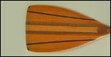
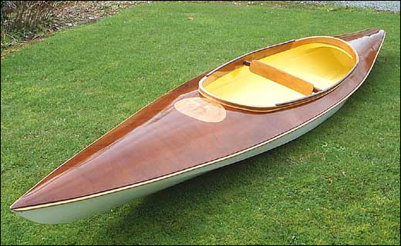
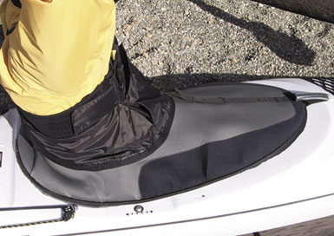
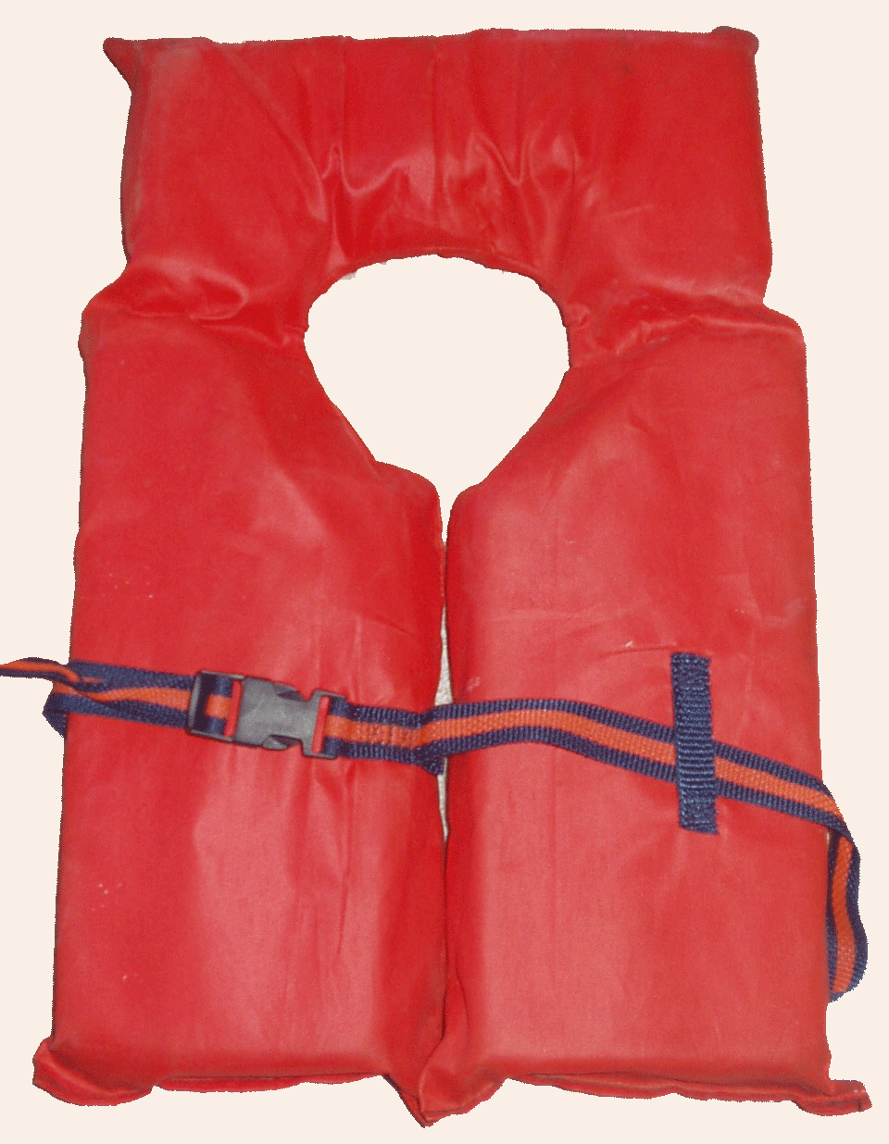
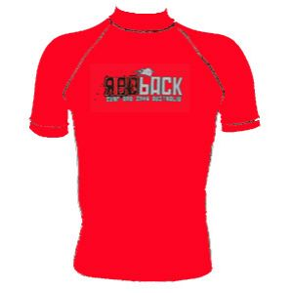

Activity 3B
PAHIKETE PŌRO
Ngā Taputapu | He Whakamārama | Tōna Tikanga | Ingoa Māori
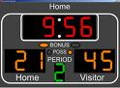



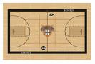

Activity 3C
WHAKAREWA WAKA
Ngā Taputapu | He Whakamārama | Tōna Tikanga | Ingoa Māori

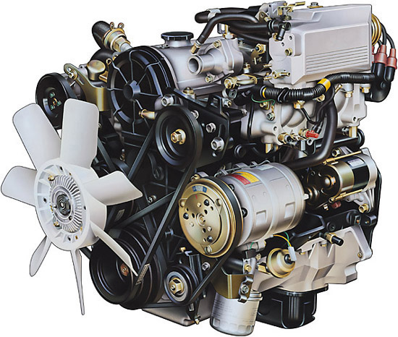
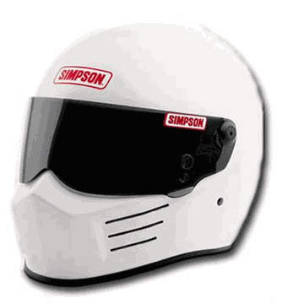



Unit Plan Number |  | 3
Unit Plan Name |  | HE AHA TE MEA NUI O TE TĀKARO?
Lesson Number |  | 4 of 8
Lesson Title |  | He Kaitākaro
Year Level |  | Y12
Learning Intention/Outcome Statements |  | 7.4 Offer and respond to information and opinions giving reasons
Teacher and student instructions
Estimated time for completion |  | 50 Minutes
Resource requirements |  | Activity 4, Role Cards
Tasks in sequence  Some of these tasks are self-explanatory hence are not described in detail below. | Duration  (mins)  7  2  20  20  1 | 1. Hei Whakahikohiko(C).  2. Explain to the class that this lesson is about roles  and responsibilities in sport (C).  3. Nō wai te tūranga? Activity 4 (G).  4. Ko wai te kaitākaro? Activity 4 (C).  5. Karakia (C).
Reference material |  | Activity 4
Answer/marking schedule/criteria |  | Comments are grammatically correct.

Task 1 Hei whakahikohiko

You need: Pen, Paper for students, Resource 1
Duration: 7 minutes
Participation: Class
Objective: Listening for meaning

1. Read the text in Resource 1 to the class
2. Students are to follow the instructions and draw what is being described.

Resource 1

Tērā tētahi maunga e tū ana i te kōraha. He maunga teitei te maunga nei, ā, e titi ake ana ki ngā kapua i te rangi. He pōtae hoki tōna, mā ana i te huka. Kei tōna taha maui ko tētahi waka rererangi e rere atu ana i a ia. Nō Aotearoa te waka nei, mau koru ana i te taha. Kei tōna taha matau, kei tōna take ko te ngahere paina e tipu ake ana. Kei reira hoki tētahi taraka mau kaimahi ki te ngahere. Heoi, kei mua tonu i te maunga ko koe e mihi atu ana ki a koe anō.

Task 3 Nō wai te tūranga?

You need: Activity 4
Duration: 20 Minutes
Participation: Sports Groups.
Objective: To identify and describe roles and responsibilities in sport.

- Hand out Activity 4 to students.
- Students are to describe in Māori the roles and responsibilities of each person in Activity 4.

Task 4 Ko wai te kaitākaro?

You need: Activity 4 – Cardboard (for Role Cards, with a headband preferably)
Duration: 20 Minutes
Participation: Class
Objective: To elicit responses to questions.

- Explain to class that this activity is like “Guess Who”
- Ask each of the Sports Groups to write the Māori names of the people you identified in Activity 4 on a piece of cardboard and hand it in to the Kaiako
- One student will be asked to stand and the Kaiako will place a Role Card on the top of his/her head. The student must then ask questions about his/her possible identity, students can only ask questions that can be answered with Ae or Kāo.
- Encourage question patterns such as:

  - He kaihoe au?
  - He kaitākaro au?
  - He hoe tētahi o āku taputapu tākaro?

Activity 4A
WAKA AMA
INGOA TŪRANGA | mĀori | TĀna Mahi
Pace Setter  Determines the pace for the waka team | e.g  Te Amorangi | e.g.  Ko tāna mahi hei tohu i te tere o te waka
Steerer
Steers the waka

Manager
Manages the teams administration
Safety Coordinator Ensures safety practices of all paddlers
Skipper
Team Captain

Activity 4B
PAHIKETE PŌRO
INGOA TŪRANGA | mĀori | TĀna Mahi
Point Guard
Play Maker of the team
Coach
Teacher of the game
Centre Forward
Power player of the team
Statician
Maintains game statistics
Umpire
Makes sure everyone plays by the rules

Activity 4C
WHAKAREWA WAKA
INGOA TŪRANGA | mĀori | TĀna Mahi
Race Driver
Person who drives the race car
Mechanic
Person who maintains car motor
Car Owner
Person who owns the car
Pit Crew
Team who service the car
Sponsors
Team Funders

Unit Plan Number |  | 3
Unit Plan Name |  | HE AHA TE MEA NUI O TE TĀKARO?
Lesson Number |  | 5 of 8
Lesson Title |  | He kōrero whakanui
Year Level |  | Y12
Learning Intention/Outcome Statements |  | 7.4 Offer and respond to information and opinions giving reasons
Teacher and student instructions
Estimated time for completion |  | 50 Minutes
Resource requirements |  | Activity 5
Tasks in sequence  Some of these tasks are self-explanatory hence are not described in detail below. | Duration  (mins)  3  20  25  2 | - Explain to the class that this lesson is about  promoting your sport (C).  2. Tohua ngā kōrero matua. Activity 5 (G).  3. Te whakawhānuitanga. Activity 5 (I).  4. Karakia (C).
Reference material |  | Activity 5  AS 90132 Kōrero i te reo o tōna ao
Answer/marking schedule/criteria |  | Complete both sections in Activity 5a, 5b. and 5c.

Task 2 Tohua ngā kōrero matua

You need: Activity 5
Duration: 20 minutes.
Participation: Sports Groups.
Objective: To read for meaning and to extract main points or ideas from text.

- Hand out Activity 5 to Sports Groups
- Explain to groups that this piece of work will be assessed.
- This activity can be adapted for formal assessment against achievement standard
AS90132 Kōrero i te reo o tōna ao.
- Allow groups time to read through the article.
- Students must then list the main points of their chosen articles in Activity 5.

Task 3 Te whakawhānuitanga

You need: Activity 5
Duration: 25 minutes
Participation: Individuals
Objective: To present main points of text.

- Using their notes from Activity 5 in Task 1, students are to choose 2 alternative forms of communication as listed below, and present that information IN MĀORI in their chosen styles.

  - Radio Announcement
  - Text Message to a friend
  - Email to whānau in Australia
  - Sports Report on CODE (Māori Television)

2. This is to be written in the Te Whakawhānuitanga column of Activity 5.
3. Students are to present these to their particular group or to the whole class.

Activity 5A

WAKA AMA

2007 Tauwhāinga Kopere Ā-Waka Ama Mō Ngā Wharekura

I tu tēnei tauwhāinga nui ki Rotoiti i te rohe o Te Arawa, i te mutunga o Paenga-whāwhā. E hia kē ngā kura tuarua i hoe atu ki Rotoiti!

Ahakoa te ua kāore i ngoikore ngā kaihoe. Tata ki te 1000 o rātou i te whakataetae waka ama o ngā wharekura huri noa i te motu, i tae atu ki te whakatūwheratanga o te whakataetae. Ko tēnei te tauwhāinga nui rawa atu. Neke atu i te 80 ngā kura mai i tētahi moka ki tētahi moka o te motu. Me mihi kau atu ki ngā kaihoe i tutuki pai i a ratou ngā momo tauwhāinga e whā i roto tonu i ngā rā e toru noa.

 | Ngā Kaupapa Matua | Te Whakawhānuitanga
1
2
3
4

Activity 5B

PAHIKETE PŌRO

KEI RUNGA NOA ATU ANŌ A PAUL HENARE
Ahakoa i whara te kaitākaro whetū i tērā marama arā, a Paul Henare, kei te puta tōmua anō a ia ki te kēmu o te ANBL.
Kāore ia i haere ki tāwāhi mō te tākaro tuatahi i te wāhanga tākaro tuatahi mō te tau ki te tīma Slingers ki Singapore, engari ka hono atu ia ki ōna hoa tīma ā tērā Tūrei ki Poipiripi, Ahitereiria, ki te whakarite mō te kēmu tuarua mō te rā whakatā e heke mai nei.
Ka mea mai a Richard Clarke o te tīma kaiwhakahaere, tēnā pea ka pakari tonu a Henare ki tērā kēmu i te mea, katahi anō ka kaha mai ōna waewae i tana pokanga i tērā marama, nā reira kei te pai te whakaaro.
Heoi anō, he tautākaro kaikaha tō tana tīma, ka hiki tonu te ngākau, menā ka tākaro rānei ia, kāore rānei. Mā tana putanga noa ki reira ki Ahitereiria e kaha ai ōna hoa tīma, i runga i tōna mana tākaro i roto i te kapa.
Ko te ope tākaro ki tāwāhi mō te kēmu nei ko ēnei; ko Wayne Turner rātou ko Ryan Kersten, ko Brent Charleton, ko Phill Jones, ko Kirk Penney, ko Oscar Forman, ko Mika Vukona, ko Tony Ronaldson, ko Rick Rickert, ko Tim Behrendorff. Ka tūtaki rātou tahi ki a Paul ki Melbourne i muri i tā rātou kēmu ki Singapore.

 | Ngā Kaupapa Matua | Te Whakawhānuitanga
1
2
3
4
Activity 5C

WHAKAREWA WAKA

TE AO WHAKAREWA WAKA

Ko Jairus Tamati Wharerau tētahi ingoa e mōhiotia whānuitia ana ki te ao whakapaipai waka, ki te ao whakarewa waka hoki. Ko te whakarewa waka he tikanga taraiwa waka, he momo taraiwa waka ki tōna taha haukoki me te ahu whakamua tonu. Kua rima tau noa tēnei uri o Ngāpuhi e whai wāhi nei ki tēnei hākinakina. E whitu ngā whakataetae nui i toa a ia, heoti ko te D1NZ Whakataetae Hautū Waka ā-Motu 2003 te whakataetae tino nui i waimarie a ia.

Āra atu anō tētahi ko te rapu pūtea kia āhei te tangata ki te whakataetae. E ai ki a Jairus, he waimarie te kite i tētahi kaitautoko whai rawa, i te mea i te nuinga o te wā, nā te pāpaku o ngā pūkoro, ka whakawhiwhia te kaiwhakataetae ki ngā taputapu anahe, kāhore ki te pūtea. Heoi, ehara ko ngā pūkenga kē o te tangata. Nā te hihiko o te wairua me tōna ngākaunui ki ngā tini āhua o te whakataetae, e kaha mīharo nei a ia ki tēnei hākinakina.

Hei ngā marama tata nei, ka whakatū a Jairus i tētahi whakataetae ki te Whanganui-a-Tara, heoi ka tūwhera noa ki te hunga pāpāho, ki te hunga hoki ka whiwhi pōwhiri motuhake.

 | Ngā Kaupapa Matua | Te Whakawhānuitanga
1
2
3
4

Unit Plan Number |  | 3
Unit Plan Name |  | HE AHA TE MEA NUI O TE TĀKARO?
Lesson Number |  | 6 of 8
Lesson Title |  | He tākaro motuhake
Year Level |  | Y12
Learning Intention/Outcome Statements |  | 6.3 Communicate about immediate plans, hopes,  wishes and intentions  6.4 Communicate in formal situations
Teacher and student instructions
Estimated time for completion |  | 50 Minutes
Resource requirements |  | Activity 6
Tasks in sequence  Some of these tasks are self-explanatory hence are not described in detail below. | Duration  (mins)  4  45  1 | - Explain to the class that this lesson is about  creating a promotional resource for their sport (C).  2. He mahere whakaratarata. Activity 6 (G).  3. Karakia (C).
Reference material |  | Activity 6
Answer/marking schedule/criteria

Task 2 He mahere whakaratarata

You need: Activity 6
Duration: 45 Minutes
Participation: Sports Groups
Objective: To create a recruitment plan.

- Instruct students to create a resource, aid or item that will promote their sport and entice others to want to play or participate in their sport.
- Guide students to think about what positive aspects of their sport they can use as attractive selling points for recruiting new team members.
- Students can select one or two of the suggestions listed below

  - Poster / Slogan
  - TV Advert
  - Radio Jingle
  - Newspaper Advert
  - Promotional Speech

4. Use Activity 6 to form the recruitment plan. This must be completed this lesson and presented
in Lesson 7.

Activity 6

Hei pātai
He aha ngā mea pai o te tākaro nei hei whakapatipati i te tangata?

Me whakahāngai ngā kōrero nei ki a wai?

Me pēhea te whakaatu?

Mā wai e mahi?

He aha te wā e oti ai te mahi nei?

He aha te whakapaunga pūtea e tutuki ai te mahi nei?

Unit Plan Number |  | 3
Unit Plan Name |  | HE AHA TE MEA NUI O TE TĀKARO?
Lesson Number |  | 7 of 8
Lesson Title |  | He whiringa nui
Year Level |  | Y12
Learning Intention/Outcome Statements |  | 6.3 Communicate about immediate plans, hopes, wishes and intentions
Teacher and student instructions
Estimated time for completion |  | 50 Minutes
Resource requirements |  | Activity 7
Tasks in sequence  Some of these tasks are self-explanatory hence are not described in detail below. | Duration  (mins)  3  45  2 | 1. Explain to the class that this lesson is about  presenting each groups recruitment strategy (C).  2. Pāohotia Mai. Activity 7 (G).  3. Karakia (C).
Reference material |  | Activity 7
Answer/marking schedule/criteria

Task 2 Pāohotia mai

You need: Activity 7
Duration: 45 Minutes
Participation: Sports Groups
Objective: To listen for meaning and to respond with questions.

- Hand out Activity 7.
- Instruct groups to present their recruitment strategy to the other 2 groups
- Using Activity 7 below, observing groups are to list aspects of the other groups report, that they may not agree with, and formulate questions about these.
- When a group has completed presenting their strategies, observing groups have the opportunity to ask them the questions they have constructed in Activity 7.

Activity 7

INGOA TĀKARO

HE ĀHUATANGA HEI WHAKAARO | TE PĀTAI

Unit Plan Number |  | 3
Unit Plan Name |  | HE AHA TE MEA NUI O TE TĀKARO?
Lesson Number |  | 8 of 8
Lesson Title |  | He whakaari
Year Level |  | Y12
Learning Intention/Outcome Statements |  | 7.4 Offer and respond to information and opinions giving reasons
Teacher and student instructions
Estimated time for completion |  | 50 Minutes
Resource requirements |  | List of Terms, Card, Markers
Tasks in sequence  Some of these tasks are self-explanatory hence are not described in detail below. | Duration  (mins)  3  45  2 | 1. Explain to the class that this lesson is about  pomoting and presenting their sport (C).  2. He whakaari (G/C).  3. Karakia (C).
Reference material
Answer/marking schedule/criteria

Task 2 He whakaari

You need: Paper, Pens, Cardboard, Markers
Duration: 45 minutes
Participation: Sports Groups
Objective: To prepare and present skit.

- Groups have 15 minutes to prepare 10 word cards which best describe their sport.
- These words must be large enough to be seen at a glance.
- Each word will need to be explained or acted out to the rest of the class.
- Therefore each group needs to prepare a sequenced, running commentary for the words.
- When 15 minutes is up, organise groups to present their ‘Whakaari’ – ‘Show and Tell’.
- All of the words must be spoken about or acted upon – IN MĀORI.

