Māori Curriculum in the Mainstream

Year 9

Unit Plan 3

8 Lessons

He aha te wa Mr Wolf?

Table of Contents
Unit Plan 3 – He aha te wa Mr Wolf? 4
Lesson 1 – He aha te taima? 8
Task 3 Wharewhare 9
Resource 1 – Wharewhare: Kāri Matua 10
Activity Sheet 1 11
Task 4 He aha te taima? 14
Resource 1 (OHP) – He aha te wā? 15
Activity Sheet 1 16
Task 5 He rārangi wā 18
Resource 2 – Timetable example (Tā te kaiako) 19
Lesson Two – Make a Match 21
Task 3 Make a match 22
Activity 1 – Draw a line from the time to the correct picture 23
Task 4 Questionnaire 24
Activity Sheet 2 25
Task 5 Ko te rātaka a Hēmi Tutu! 26
Resource 1 27
Activity Sheet 3 29
Answer Sheet – Tā te kaiako 31
Lesson 3 – Ko te aha tenei ra? 33
Task 3 Ngā rā o te wiki 34
Resource 1 35
Task 4 Rātapu, Rāhina 36
Task 5 Ko te aha tēnei rā? 37
Activity Sheet 1 38
Answer Sheet – Tā te kaiako 39
Task 6 Ngā marama o te tau 40
Resource 2 41
Lesson 4 – He Maramataka 42
Task 3 What’s the date? 43
Activity Sheet 1 43
Task 4 Quiz 44
Resource 1 – Tā te kaiako 45
Task 5 He Maramataka 46
Lesson 5 – Te ahua o te rangi 47
Task 3 Charades 48
Resource 1 49
Resource 2 – Tā te kaiako 50
Task 4 Weather and season 51
Resource 3 - Page 1 52
Resource 3 - Page 2 53
Resource 3 – Page 3 54
Resource 3 – Page 4 55
Resource 3 – Page 5 56
Task 5 He kimi kupu 57
Activity Sheet 1 58
Activity Sheet 1 – Tā te Kaiako (Answer Sheet) 60
Lesson 6 – Kei te whiti mai te ra! 62
Task 2 Maranga ake e Hēmi! 63
Resource 1 64
Task 3 Ngā tū kupu 65
Activity Sheet 1 65
Task 4 He whakaari 66
Task 5 Kei te whiti te rā 67
Activity Sheet 2 68
Lesson 7 - Pehea te ahua o te rangi ki to whare? 69
Task 3 Whakautu pātai 71
Task 4 Kei te whiti te rā 72
Activity Sheet 2 73
Task 5 Pēhea te āhua o te rangi ki Te Ika a Māui? 74
Activity Sheet 3 75
Task 6 He kauhau mō te āhua o te rangi 77
Activity Sheet 3 78
Lesson 8 – Weather Report 79
Task 3 He kauhau mō te āhua o te rangi/Mahi whakarongo 80
Activity Sheet 1 – Mahi Whakarongo 81

Unit Plan 3 – He aha te wa Mr Wolf?

Year 9 Learners
Unit Plan |  |  |  |  |  |  | 3
KAUPAPA AKO  Unit Plan Name |  |  |  |  |  |  | He aha te wā Mr Wolf?
KOEKE:  Level |  |  |  |  |  |  | 2
TE ROA  Duration |  |  |  |  |  |  | 8 x 45 minutes
WHAINGA PAETAE |  |  |  |  |  |  | 2.4 Communicate about time, weather and seasons
Whenu Torohū (Strand Receptive) |  |  |  |  |  |  | Whenu Whakaputa (Strand Expressive)
Whakarongo |  | Pānui |  |  | Mātakitaki |  | Kōrero |  |  | Tuhituhi |  | Whakaari
Ngā ariā o te reo |  |  |  | Te wetewete i te reo |  |  |  |  | Kupu hou |  |  | Kīwaha
Te āhua  Te wā  Te wāhi |  |  |  | Ko …  Kei te…  Kupu mō ngā āhua o te rangi  Kupu hou mō te taima  He…..  He aha te taima?  E ono karaka  I te iwa karka  Ko te aha tēnei rā, marama, tau  Ko Rātū tēnei rā  Kupu tūmahi/ingoa/āhua |  |  |  |  | Karaka  taima  Ngā rā o te wiki  Ngā marama o te tau  Ngā kupu mō te āhua o te rangi  - Ua  - Hukapapa  - Hukarere  - Paki  - Whiti  - Āwhā  - Āwhiowhio  - Whaitiri  - Waipuke  - Tīaho  - Hau pūkeri  - Hau maiangi  - Hau  - Mao |  |  | Kātahi te rangi ataahua!  Ka tau kē!  Auē!  Ka rawe hoki!  Te reka hoki o ā tātou kai!
Mahi ia rā: (Daily Routine) Karakia, te wā, te āhua o te rangi, ngā ngohe, te mahi kāinga, karakia whakakapi.

Specific Outcomes for fellow students to achieve by end of Unit. | Points emphasised to help students understand the task and achieve the learning outcomes. |  |  |  |  | Learning activities the students will be required to do. |  | Most appropriate method for measuring how well the students have achieved the Learning Outcomes. |  |  |  | Teaching/Learning resources used e.g. equipment, texts.
PUKENGA  LEARNING OUTCOMES | KAWENGA  TEACHING POINTS |  |  |  |  | NGOHE ACTIVITIES  C=Class  G=Group  P=Pair  I=Individual independently |  | AROMATAWAI |  |  |  | RAUEMI  RESOURCES
By the end of this Unit students will be able to:
1. Use new vocabulary and sentence structure to tell the time.  2. Use new words and sentences to tell the date.  3. Describe weather patterns.  4. Construct questions to gain information, and give a response.  5. Provide information for another source.  6. Use an appropriate kīwaha to support position.  7. Relate/recount information provided by another source.  8. Write and present about a weather report. |  |  | 1. Increasing and retaining new vocab is critical to speaking well.  Introducing;  He aha?  Ko wai …  Ko te aha?  Ko te…  He…  Kei te…  Kupu -tūmahi/ingoa/āhua  2. constructing questions and recording responses  4. Purpose of and kīwaha model ideal.  5. State a reason for a particular viewpoint |  |  | Lesson 1  3.Wharewhare. (C) Numbers game. Activity Sheet 1  4.He aha te wā? (P) Telling the time. Activity Sheet 2  5.He rārangi wā: (G)  Lesson 2  3.Make a match (C) Activity Sheet 1  4.He aha te taima? (P) Questionnaire: Activity Sheet 2  5.Ko te rātaka a Hēmi Tutu : Resource 1. Activity Sheet 3. Answer Sheet – Tā te kaiako  Lesson 3  3.Revising days of the week (C) Resource 1  4.Rātapu, Rāhina (C) He kēmu.  5.Ko te aha tēnei rā. (C) Activity Sheet 1  Lesson 4  3.What’s the date? (P)  4.Quiz. (C) Resource 1  5.Creating a Māramataka (G)  Lesson 5  3.Kupu hou (P) Charades. Resource 1  Resource 2: Tā te kaiako  4.Weather & seasons. (C) Weather flashcards  5.He kimi kupu: (C) Activity 1  Lesson 6  3.Ngā tū kupu (C) Activity Sheet 1. Resource 1  4.He whakaari (C) Resource 1 from Lesson 2  5.Tuhi rerenga. (C) Activity Sheet 2  Lesson 7  3.Whakautu pātai (C) –Resource 1 from Lesson 6, Activity Sheet 1.  4.Kei te whiti te rā. (P) Activity Sheet 2  5.Pēhea te āhua te rangi ki Te Ika a Māui. (C) Activity Sheet 3  6.He rīpoata mō Tāwhirimātea. (C)  Lesson 8.  3.He kauhau mō te āhua o te rangi. He mahi whakarongo (C) Activity Sheet 1 |  |  |  |  | Observational & formative  Oral-in response to teacher and peer questions  Peer  Written  Formative  Summative | Karakia whakamārōrō, whakatere tangata  Papa Kupu  Lesson 1  - Resource 1  - Resource 2  - OHP  - Large Newsprint/Bold pens  Lesson 2:  - Activity Sheet 1  - Activity Sheet 2  - Activity Sheet 3  - (Answer Sheet)  - Resource 1  Lesson 3:  - Resource 1  - Activity Sheet 1  - (Answer Sheet)  - Resource 2  Lesson 4:  - Resource 1  - A3 paper/Bold pens  Lesson 5:  - Resource 1  - Resource 2  - Weather Cards x 4 sets  - Activity Sheet 1  - Activity Sheet 1 – Answer Sheet  Lesson 6  - Resource 1  - Activity Sheet 1  - Activity Sheet 2  Lesson 7:  - Resource 1 from Lesson 6  - Activity Sheet 1  - Activity Sheet 2  - Activity Sheet 3  Lesson 8:  - Activity Sheet 1  - Weather Cards from Lesson 5

Lesson 1 – He aha te taima?

Unit Plan Number |  | 3
Unit Plan Name |  | He aha te wā Mr Wolf?
Lesson Number |  | 1 of 8
Lesson Title |  | He aha te taima?
Year Level |  | Y9
Learning Intention/Outcome Statements |  | 2.4 Communicate about time, weather and seasons
Teacher and student instructions |  | Teacher: Resource 1 to be cut up.  Resource 2 to be copied on to OHP
Estimated time for completion |  | 45 minutes
Resource requirements |  | Ignition Karakia  Copies of Activity Sheet 1 & 2  Resource 1 – OHP  Resource 2 – tā te kaiako  Large Newsprint  Bold pens
Tasks in sequence | Duration  (mins)  2  3  15  8  10-12  3 | - Karakia whakatau i te tangata (C).  - Hei whakamārama: Explain to students that the lesson is about counting, numbers & telling the time. (C).  - Wharewhare. (C) Numbers game. Activity Sheet 1  - He aha te wā? (P) Telling the time. Activity Sheet 2  - He rārangi wā: (G)  - Karakia whakamutunga.
Reference material
Answer/marking schedule/criteria |  | Activity Sheet 1 He aha te taima? Is completed and correct

Task 3 Wharewhare

You need: Copy of Resource 1 – Kāri Matua (Tā te kaiako)
Activity Sheet 1 – Wharewhare
Duration: 10-12 mins
Participation: Class
Objective: To learn and retain numbers in Māori

- Explain to the class that the kaupapa of the lesson is about numbers.
- Ask students how well versed they are with counting consequently you may need to introduce large numbers to students. (100, 1000 etc)
- Cut up and hand out Activity Sheet 1 – Wharewhare cards to the students and explain that this game is like bingo.
- One card per student.
- Ask the students in Māori to collect 12 small stones from outside or provide counters for them to use.
- The teacher will call out the numbers slowly on the kāri matua in English. The numbers on the student cards are written in Māori.
- The students must place a stone on the corresponding number.
- Once a student’s card is full they call out ‘Wharewhare’.
- The student then calls out all his numbers in Māori and they are checked by the teacher.
- Swap the cards around and play the game again to give another student an opportunity to win.
- You may like to offer a small prize to the winner.

Resource 1 – Wharewhare: Kāri Matua

0 | 1 | 2 | 3 | 4 | 5 | 6 | 7 | 8 | 9 | 10
11 | 12 | 13 | 14 | 15 | 16 | 17 | 18 | 19 | 20 | 21
22 | 23 | 24 | 25 | 26 | 27 | 28 | 29 | 30 | 31 | 32
33 | 34 | 35 | 36 | 37 | 38 | 39 | 40 | 41 | 42 | 43
44 | 45 | 46 | 47 | 48 | 49 | 50 | 51 | 52 | 53 | 54
55 | 56 | 57 | 58 | 59 | 60 | 61 | 62 | 63 | 64 | 65
66 | 67 | 68 | 69 | 70 | 71 | 72 | 73 | 74 | 75 | 76
77 | 78 | 79 | 80 | 81 | 82 | 83 | 84 | 85 | 86 | 87
88 | 89 | 90 | 91 | 92 | 93 | 94 | 95 | 96 | 97 | 98
99 | 100 | 1000

Note:
- The shaded numbers above are the actual numbers on the student cards
- Vary the numbers to ensure a wide range is used

Activity Sheet 1 ……………………………………………………

e rua tekau mā rua | tekau mā toru | e rima  tekau | kore
e rima tekau mā  waru | e toru tekau mā rima | tekau mā rua | e ono tekau mā rima
tekau  mā tahi | e iwa  tekau | e rua  tekau | e whitu

e rua tekau mā rua | tekau mā toru | e rima  tekau | kore
e rima tekau mā  waru | e toru tekau mā rima | tekau mā rua | e ono tekau mā rima
tekau  mā tahi | e iwa  tekau | e rua  tekau | e whitu

e waru tekau | tekau mā iwa | e rua | kotahi mano
e whitu tekau mā waru | e whitu tekau mā waru | e waru tēkau mā tahi | e ono tekau mā rima
e rima tekau | e whā tekau mā tahi | e rua  tekau | tekau

e whā  tekau | tekau mā toru | e whā tekau mā whitu | kotahi  rau
e toru tekau mā waru | e toru tekau mā rima | tekau mā rua | e whā tekau mā rima
tekau  mā tahi | e rua tekau mā iwa | e rua  tekau | e whitu

e whā | tekau mā whā | e rima | kore
e whitu tekau mā whitu | e rima tekau mā rima | e waru tekau mā tahi | e whitu tekau mā ono
e waru tekau | e iwa  tekau mā tahi | e ono  tekau | e whitu

kore | e rima tekau mā toru | kotahi | e rua
e whitu tekau | e toru tekau mā rima | tekau mā rua | e ono tekau mā rima
tekau  mā waru | e toru  tekau | e ono tekau mā ono | e whitu

Task 4 He aha te taima?

You need: Activity Sheet 2
Resource Sheet 1 – OHP
Duration: 8 mins
Participation: Class/group
Objective: To ask and answer the question ‘He aha te wā?’

- Write the question ‘He aha te taima?’ on the white/blackboard.
- Introduce kupu hou relating to telling the time by using the OHP - Resource 1.
- Put the students into pairs.
- Hand out the Activity Sheet 1.
- Students must write the precise time according to the pictures and draw in the hands of the times stated.
- Students to peer check their answers.

Resource 1 (OHP) – He aha te wā?

Haurua mai i te half past
Ki te
to the hour
Hauwhā ki te quarter to
Mai i te
past the hour
Hauwhā mai i te quarter past
Karaka
o’clock

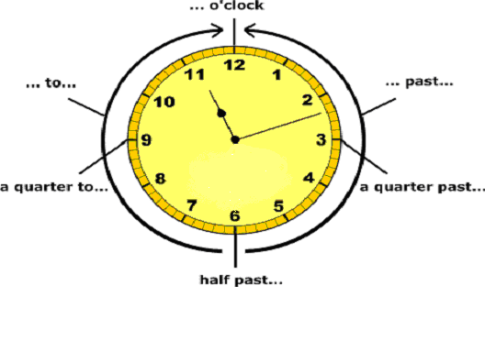

Five o’clock | E rima karaka.
Half past 5 | Haurua mai i te rima karaka.
Half past 5 | or
Half past 5 | Hāwhe pāhi i te rima karaka.
Quarter past 5 | Hauwhā mai i te rima karaka.
Quarter past 5 | or
Quarter past 5 | Tekau mā rima mēneti mai i te rima karaka.
Quarter to 5 | Hauwhā ki te rima karaka.
Quarter to 5 | or
Quarter to 5 | Kōata ki te rima karaka / Tekau mā rima mēneti ki te rima karaka.

Activity Sheet 1

12
11
1
2
10
8
7
5
4
3
9
6

12
11
1
2
10
8
7
5
4
3
9
6

He aha te taima?
_________________________________

_________________________________
He aha te taima?
_________________________________

_________________________________

12
11
1
2
10
8
7
5
4
3
9
6

12
11
1
2
10
8
7
5
4
3
9
6

He aha te taima?
_________________________________

_________________________________
He aha te taima?
_________________________________

_________________________________

Draw the hands in the clock faces

12
11
1
2
10
8
7
5
4
3
9
6

12
11
1
2
10
8
7
5
4
3
9
6

Haurua mai i te tekau mā rua karaka

12
11
1
2
10
8
7
5
4
3
9
6

12
11
1
2
10
8
7
5
4
3
9
6

Tekau meneti ki te whitu karaka

Hauwhā mai i te toru karaka

E rua tekau mā rima meneti
i te waru karaka

Task 5 He rārangi wā

You need: Large Newsprint
Bold pens
Resource Sheet 2 – Timetable example (Tā te
kaiako)
Duration: 10 mins
Participation: Small groups
Objective: To recognise corresponding times for specific
activities of the day.

- Arrange class into small groups.
- Give each group a large piece of newsprint and bold pens.

- The students must draw up a daily timetable scheduling specific activities for the day.

- Explain to the students that you would like them to draw the activities and they must write the corresponding times in Māori only.

- An example is included for the teacher’s convenience. (Resource Sheet 2)

- Each group must feedback their timetables to the class.

Resource 2 – Timetable example (Tā te kaiako)

Daily Schedule

Whitu karaka | Wake up
Haurua mai i te whitu karaka | Breakfast
Haurua mai i te waru karaka | School Starts
Tekau karaka | Interval
Hauwhā mai i te tekau karaka | P.E
Hauwhā mai i te tekau mā tahi karaka | Maths
Tekau mā rua karaka | Lunch
Tahi karaka | Te Reo Māori
Rua karaka | English
Tekau mā rima meneti i te toru karaka | School ends
Haurua mai i te toru karaka | Band Practice

Lesson Two – Make a Match

Unit Plan Number |  | 3
Unit Plan Name |  | He aha te wā Mr Wolf?
Lesson Number |  | 2 of 8
Lesson Title |  | Make a match
Year Level |  | Y9
Learning Intention/Outcome Statements |  | 2.4 Communicate about time, weather and seasons
Teacher and student instructions |  | Teacher:
Estimated time for completion |  | 45 minutes
Resource requirements |  | Ignition Karakia  Activity Sheet 1, Activity Sheet 2, Activity Sheet 3, (Answer Sheet), Resource 1
Tasks in sequence | Duration  (mins)  2  3  5-7  15  10-12  3 | - Karakia whakatau i te tangata (C).  - Hei whakamārama: Explain to students that the lesson is about time references. (C).  - Make a match (C) Activity Sheet 1  - He aha te taima? (P) Questionnaire: Activity Sheet 2  - Ko te rātaka a Hēmi Tutu : Resource 1. Activity Sheet 3. Answer Sheet – Tā te kaiako  - Karakia whakamutunga.
Reference material
Answer/marking schedule/criteria |  | Activity Sheet 2 completed and correct  Teacher has answer sheet for Activity Sheet 3

Task 3 Make a match

You need: Activity sheet 1
Student Timetables from Lesson 1
Duration: 5-7 mins
Participation: Class
Objective: Choosing the correct times for certain activities

- Explain to the class that this task is about revisiting how to tell the time.
- Hand out Activity Sheet 1.
- Students must match the activities with the appropriate time by drawing a line between the two.
- Students may use their own student timetables from Lesson 1 as a prompt.

Activity 1 – Draw a line from the time to the correct picture

Daily Schedule

Whitu karaka |  |   School ends
Haurua mai i te whitu karaka |  | 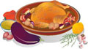  Dinner
Waru karaka |  |   morning tea
Tekau karaka |  | Go to school
Tekau mā rua karaka |  | Wake up
Tekau mā rima meneti i te toru karaka |  | Breakfast
Rima karaka |  | 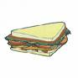  Lunch
Ono karaka i te pō |  | 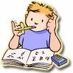  Homework

Task 4 Questionnaire

You need: Copies of Activity Sheet 2
Duration: 15 mins
Participation: Class
Objective: To elicit responses to questions relating to time

- Hand out Activity Sheet 2 to the students.
- Students must walk around to their class mates asking the questions on the questionnaire.
- At this stage the student is only required to put in the actual time in Māori. The remainder of the answer has been given. (Note the use of past and future tense markers)
- The teacher may need to re-visit Resource 2 (OHP from Lesson 1) if the class is having difficulty remembering the structure for telling the time.

Activity Sheet 2
Ngā pātai

What time did you go to bed last night?

I te ______________________________ i haere au ki te moe inapō..

What time did you have breakfast this morning?

I te ______________________________ i kai i taku parakuihi i tēnei ata.

What time did you arrive at school today?

I te ______________________________ i tae au ki te kura i tēnei ata.

What time did you have dinner last night?

I te ______________________________ i kai au inapō.

What time will you finish school today?

Ā te ____________________________ mutu ai te kura i te rā nei..

What time is Home and Away on each night?

I te _________________________ ka whakaatu te hōtaka a Home and Away ia pō.

What time will you go to bed tonight?

Ā te ____________________________ haere ai au ki te moe i te pō nei.

What time does the first bell ring for school?

Ā te ____________________________ tangi ai te pere tuatahi mō te kura.

Task 5 Ko te rātaka a Hēmi Tutu!

You need: Copies of Resource 1
Copies of Activity Sheet 3
Answer Sheet – Tā te kaiako
Duration: 10 mins
Participation: Small groups
Objective: To recognise times used in a specific context

- Handout Resource 1 to the students.
- Students may read through Hēmi’s timetable and then answer the questions on Activity Sheet 3
- The students can work in pairs for this task.

Resource 1
Ko te Rātaka
a Hēmi Tutu



Ko te raumati tēnei wā. Koinei te ‘Action Week’ mō te kura tuarua o Hēmi Tutu. Kei te haere a Hēmi rātou ko tōna karaehe ki Te Whanganui a Tara. I ētahi wā he tama hīanga a Hēmi Tutu nō reira kua whakaritea e tōna kaiako tētahi rātaka māna kia kore ai a Hēmi e wareware i āna mahi ia rā, mō te ‘Action Week’.

Te Wā | Ko te Rāhina  Ko te tuawaru o Mahuru | Ko te Rātū  Ko te tuaiwa o Mahuru | Ko te Raapa  Ko te tekau o Mahuru | Ko te Rāpare  Ko te tekau mā tahi o Mahuru | Ko te Rāmere  Ko te tekau mā rua o Mahuru
Haurua mai i te whitu karaka | Oho ake! | Oho ake! | Oho ake! | Oho ake! | Oho ake!
Waru karaka | Parakuihi | Haere ki Te Whanganui a Tara | Parakuihi | Parakuihi | Parakuihi
Iwa karaka | Haere ki Ahuriri |  | Te whare taonga o  Te Papa | Haere ki Te Whare Pāremata | Hoki atu ki te wā kāinga
Tekau karaka |  |  |  |  | Hoki atu ki te wā kāinga
Tekau mā tahi karaka |  |  |  |  | Hoki atu ki te wā kāinga
Tekau mā rua karaka | Tina |  | Tina | Tina | Tina
Tahi karaka | Haere ki te ‘Whetū Ao Pōrutu – (Splash Planet) | Tina | Whare Kaukau | Hokohoko | Tū ki Ahuriri kite kohi pipi
Toru karaka |  | Wā wātea | Wā wātea
Ono karaka | Hapa o te pō ki ‘Valentines | Hapa o te pō | Hapa o te pō | Hapa o te pō | Tae ki te kāinga
Whitu karaka | Wā wātea | Whare Pikitia | Pīrori Tekau  (Ten Pin bowling) | Wā wātea | Whakatā!

Activity Sheet 3
Answer the following questions. The first one has been done for you.
Ngā pātai | Ngā whakautu
1. He aha te taima i oho ai a Hēmi? | I te haurua mai i te whitu karaka.
2. He aha te taima i haere ai a Hēmi ki Ahuriri? | ______________________________________
3. He aha te taima i haere ai a Hēmi mā ki Te  Whanganui a Tara? | ______________________________________
4. He aha te taima i haere ai a Hēmi ki Whetū Ao  Pōrutu? | ______________________________________
5. He aha te taima i kai parakuihi ai a Hēmi? | ______________________________________
6. Ko te aha te rā i haere ai rātou ki Te Papa? | ______________________________________
7. He aha te taima i haere ai rātou ki Valentines? | ______________________________________
8. He aha te taima i haere ai rātou ki te Whare  Pāremata? | ______________________________________
9. Ko te aha te rā i haere rātou ki te Pīrori Tekau? | ______________________________________
10. He aha te taima i haere ai rātou ki te whare  pikitia? | ______________________________________
11. He aha te taima i haere ai rātou ki te whare  kaukau? | ______________________________________
12. He aha te taima i haere ai rātou ki te  hokohoko? | ______________________________________
13. He aha te taima i hoki atu ai rātou ki te wā  kāinga? | ______________________________________
14. He aha te taima i tū ai rātou ki Ahuriri ki te kohi pipi? | ______________________________________
15. Ko te aha te rā i tae mai ai rātou ki te kāinga? | ______________________________________

Answer Sheet – Tā te kaiako

Ngā pātai | Ngā whakautu
1. He aha te taima i oho ai Hēmi? | I te haurua mai i te whitu karaka.
2. He aha te taima i haere ai a Hēmi ki Ahuriri? | I te iwa karaka
3. He aha te taima i haere ai a Hēmi mā ki Te  Whanganui a Tara? | I te waru karaka
4. He aha te taima i haere ai a Hēmi ki Whetū Ao Pōrutu? | I te tahi karaka
5. He aha te taima i kai parakuihi ai a Hēmi? | I te haurua mai i te whitu karaka
6. Ko te aha te rā i haere ai rātou ki Te Papa? | Ko te Rāapa
7. He aha te taima i haere ai rātou ki Valentines? | I te ono karaka
8. He aha te taima i haere ai rātou ki te Whare Pāremata? | I te iwa karaka
9. Ko te aha te rā i haere ai rātou ki te Pīrori  Tekau? | Ko te Rāapa
10. He aha te taima i haere ai rātou ki te whare  pikitia? | I te whitu karaka
11. He aha te taima i haere ai rātou ki te whare  kaukau? | I te tahi karaka
12. He aha te taima i haere rātou ki te hokohoko? | I te tahi karaka
13. He aha te taima i hoki atu ai rātou ki te wā  kāinga? | I te iwa karaka
14. He aha te taima i tū ai rātou ki Ahuriri ki te kohi  pipi? | I te tahi karaka
15. Ko te aha te rā i tae mai ai rātou ki te kāinga? | Ko te Rāmere

Lesson 3 – Ko te aha tenei ra?
Unit Plan Number |  | 3
Unit Plan Name |  | He aha te wā Mr Wolf?
Lesson Number |  | 3 of 8
Lesson Title |  | Ko te aha tēnei rā?
Year Level |  | Y9
Learning Intention/Outcome Statements |  | 2.4 Communicate about time, weather and seasons
Teacher and student instructions |  | Teacher:
Estimated time for completion |  | 45 minutes
Resource requirements |  | Ignition Karakia  Resource 1  Activity Sheet 1  Activity Sheet 1 - Answer Sheet  Resource 2
Tasks in sequence | Duration  (mins)  2  2  5  10-12  8  10-12  2 | - Karakia whakatau i te tangata (C).  - Hei whakamārama: Explain to students that the lesson is about learning the days of the week. (C).  - Revising days of the week (C) Resource 1  - Rātapu, Rāhina (C) He kēmu.  - Ko te aha tēnei rā. (C) Activity Sheet 1  - Ngā marama o te tau. Tito waiata (G) Resource 2  - Karakia whakamutunga.
Reference material
Answer/marking schedule/criteria |  | Activity Sheet 1 Ko te aha tēnei rā? is completed and correct.

Task 3 Ngā rā o te wiki

You need: Copies of Resource 1
Duration: 5 mins
Participation: Class
Objective: To retain and use the Māori names for the days of the week

- Explain to the class that the kaupapa of the lesson is about revising the days of the week.
- Re-introduce the days of the week by writing them up on the board.
- Give the students 3 minutes to memorise the days of the week using any technique they are familiar with.
- Put the students into pairs and give each pair Resource 1 (days of the weeks cut into strips)
- The pair must arrange the days in the correct order.
- This is a race. The first pair to complete this exercise wins.
Resource 1 (Cut into individual strips)
RĀHINA
RĀTŪ
RĀAPA
RĀPARE
RĀMERE
RĀHOROI
RĀTAPU

Task 4 Rātapu, Rāhina

You need: Outside Space
Student to take his/her own chair outside.
Duration: 10 - 12 mins
Participation: Class
Objective: Retain and use the days of the week in Māori.

- Explain to the students that this game is both a physical and mental challenge and also a lot of fun.
- Make seven rows of four chairs, depending on how many chairs you have.
- Each row represents a day of the week, therefore the first row represents Rātapu (Sunday)
- Ask the class to choose a row to sit in and settle them quickly.
- Spread the students evenly throughout the rows if you need to.
- The students must remember the day that their row represents and must remain as that particular day for the entire game.
- The teacher will then call out a day of the week in Māori. For example if Rāapa is called out then the first row automatically becomes Rāapa therefore the other rows must follow the sequence, Rāpare, Rāmere, Rāhoroi, Rātapu, Rāhina and Rātū.
- All students must then run and sit in their allocated day as fast as they can.
- The teacher continues to call out different days of the week in Māori and watches for the last person to sit down. Consequently the last person to sit down is out.
- The game continues until you have a winner.
- The students are required to not only be fast but remember the correct order of the days of the week.

Task 5 Ko te aha tēnei rā?

You need: Copies of Activity Sheet 1
Resource 1 from Lesson 2
Duration: 10 mins
Participation: Class
Objective: To elicit responses to ‘ko te aha tēnei rā?’

- Introduce the question by writing it up on the white board. ‘Ko te aha tēnei rā? And give the correct response. ‘Ko Rāhina tēnei rā.
- Hand out Resource 1 from Lesson 2 to the students.
- Students must complete Activity Sheet 1
- Peer check the answers.

Activity Sheet 1

Ngā pātai | Ngā whakautu
1. Ko te aha te rā i haere ai a Hēmi ki Ahuriri? | Ko te Rāhina.
2. Ko te aha te rā i haere ai a Hēmi ki Te  Whanganui a Tara? | ______________________________________
3. Ko te aha te rā i haere ai a Hēmi ki Te Papa? | ______________________________________
4. Ko te aha te rā i haere ai a Hēmi ki Whetū Ao  Pōrutu? | ______________________________________
5. Ko te aha te rā i haere ai a Hēmi ki te whare  pikitia? | ______________________________________
6. Ko te aha te rā i haere ai a Hēmi ki Valentines? | ______________________________________
7. Ko te aha te rā i haere ai a Hēmi ki te Whare Pāremata? | ______________________________________
8. Ko te aha te rā i hoki atu ai a Hēmi ki te wā kāinga? | ______________________________________
9. Ko te aha te rā i haere ai rātou ki te Pīrori  Tekau? | ______________________________________
10. Ko te aha te marama i haere ai a Hēmi ki Te  Whanganui a Tara? | ______________________________________

Answer Sheet – Tā te kaiako

Ngā pātai | Ngā whakautu
1. Ko te aha te rā i haere ai a Hēmi ki Ahuriri? | Ko te Rāhina.
2. Ko te aha te rā i haere ai a Hēmi ki Te  Whanganui a Tara? | Ko te Rātū.
3. Ko te aha te rā i haere ai a Hēmi ki Te Papa? | Ko te Rāapa.
4. Ko te aha te rā i haere ai a Hēmi ki Whetū Ao  Pōrutu? | Ko te Rāhina.
5. Ko te aha te rā i haere ai a Hēmi ki te whare  pikitia? | Ko te Rātū.
6. Ko te aha te rā i haere ai a Hēmi ki Valentines? | Ko te Rāhina.
7. Ko te aha te rā i haere ai a Hēmi ki te Whare  Pāremata? | Ko te Rāpare
8. Ko te aha te rā i hoki atu ai a Hēmi ki te wā  kāinga? | Ko te Rāmere.
9. Ko te aha te rā i haere ai rātou ki te Pīrori  Tekau? | Ko te Rāapa
10. Ko te aha te marama i haere ai a Hēmi ki Te  Whanganui a Tara? | Ko te Mahuru.

Task 6 Ngā marama o te tau

You need: Paper and pen per group
Duration: 10 mins
Participation: Small groups
Objective: To learn the months of the year

- Group the students according to which month they were born. Try and aim for at least 5 groups of 4-5, depending on how many students.
- Hand out Resource 1 to the students
- Give the students 2-3 minutes to look over the months of the year. Note that these words may be very new to some.
- The groups must use a well known tune to make up a song using the months of the year.
- Here are a few suggestions for tunes.
  - Nursery Rhymes
  - Make up a rap.
- Each group must perform their song to the class
- Groups may also add actions.

Resource 2
Ngā marama o te tau

Kohitātea | January | Hōngongoi | July
Hui tanguru | February | Here-turi-kōkā | August
Poutū te rangi | March | Mahuru | September
Paenga whāwhā | April | Whiringa-ā-nuku | October
Haratua | May | Whiringa-ā-rangi | November
Pipiri | June | Hakihea | December

Lesson 4 – He Maramataka
Unit Plan Number |  | 3
Unit Plan Name |  | He aha te wā Mr Wolf?
Lesson Number |  | 4 of 8
Lesson Title |  | He Maramataka?
Year Level |  | Y9
Learning Intention/Outcome Statements |  | 2.4 Communicate about time, weather and seasons
Teacher and student instructions |  | Teacher:
Estimated time for completion |  | 45 minutes
Resource requirements |  | Ignition Karakia  Resource 1 – Tā te kaiako  A3 Paper  Bold Pens
Tasks in sequence | Duration  (mins)  2  2  5  10  25  2 | - Karakia whakatau i te tangata (C).  - Hei whakamārama: Explain to students that the lesson is about talking about time creating a Maramataka.(C).  - What’s the date? (P)  - Quiz. (C) Resource 1 – Tā te kaiako  - Creating a Maramataka (G)  - Karakia whakamutunga.
Reference material
Answer/marking schedule/criteria |  | Teacher to correct student Maramataka

Task 3 What’s the date?

You need: Whiteboard markers
Activity Sheet 1
Duration: 5 mins
Participation: Class
Objective: To learn how to say the date in Māori

- Explain to the students that the lesson is about learning how to say the date in Māori

- The teacher will write today’s date (in full) on the board in English.

- Give the class an opportunity to write the date themselves in Māori.

- Hand out Activity Sheet 1.

- The teacher will write a number of different dates on the whiteboard and the students will write the corresponding times in Māori using the graph below as a guide.

- Teacher may also ask different students to come up the front and write dates on the board to add variation to this exercise.

Activity Sheet 1

Ko te rā | Ko te nama | Ko te marama | Ko te tau
 |  |  | 1000 |  | 100 | 10
He tauira
Ko te Rāhina | Ko te tuatahi | o Whiringa ā Rangi | (te tau) rua mano |  |  | mā ono

Task 4 Quiz

You need: Resource 1
Duration: 10 mins
Participation: Class/Group
Objective: To elicit correct responses to questions about times and dates

- Explain to the students that this is a quiz.
- All the questions will relate to times and dates for specific events.
- Although the questions will be in English the answers must be in Māori. Students may follow the format from the previous task.
- Assemble the students in to 4-5 even teams.
- Each group must give themselves a name.
- Write up the score board with each group name.
- Allocate each group with a vowel sound i.e. a, e, i, o, u. This will act as the buzzer; therefore if a group knows the answer they must use their vowel sound to hum the song ‘What’s the time Mr Wolf’. The first group to buzz in may answer the question.
- If the first group answers correctly they are awarded a point. If it is incorrect the next group to buzz in may answer the question.
- The quiz may begin once the teacher and all the teams are ready.
- The team with the most points at the end of the quiz wins the game.

Resource 1 – Tā te kaiako

The Quiz
1. What date does Christmas Day fall on? | Ko te rua tekau mā rima o Hakihea.
2. Which month do we celebrate Matariki ? | Ko te marama o Pipiri
3. What time does the school break for lunch? | As per your own school
4. What is today’s date? | As per today’s date
5. Which day do people normally attend church? | Ko te Rātapu
6. Which month do we celebrate Mothers Day? | Ko te Haratua
7. What time is Shortland Street on TV? | Te whitu karaka
8. Which month do we celebrate Easter? | Ko te marama o Poutū te rangi
9. What date were you born? | As per their birthday
10. What will be the date tomorrow? | As per tomorrow’s date
11. Which year marked the turn of the century? | Ko te tau rua mano
12. What time does school end today? | As per your own school?
13. Which month is Valentines Day? | Ko Hui Tanguru
14. What year did the All Blacks win the world Cup? (This question is worth 2 points) | Ko te tau kotahi mano e iwa rau e waru tekau mā whitu.
15. When was the Treaty of Waitangi signed?  (This question is worth 4 points) | Ko te tuaono o Hui tanguru, ko te tau kotahi mano, e waru rau e whā tekau.

Task 5 He Maramataka

You need: A3 paper/Bold pens
Duration: 25 mins
Participation: Class
Objective: To create a weekly timetable for the class using the Māori terms for time, days and months of the year.

- Explain to the class that this task requires them to put together a class weekly timetable like that of Hēmi Tutu in Lesson 2.
- Times and days must be written in Māori only.
- The class may like to pretend that they too are going on a trip to a destination of their choice.
- You may group the students in their teams from the previous task.
- Appoint one person to be the scribe and stress the importance of full participation of each group member.
- Appoint another student from each group to feedback to the rest of the class.
- Teacher assistance may be required for this task.

Lesson 5 – Te ahua o te rangi
Unit Plan Number |  | 3
Unit Plan Name |  | He aha te wā Mr Wolf?
Lesson Number |  | 5 of 8
Lesson Title |  | Te āhua o te rangi
Year Level |  | Y9
Learning Intention/Outcome Statements |  | 2.4 Communicate about time, weather and seasons
Teacher and student instructions |  | Activity Sheet 1 – Answer Sheet:  Resource 2: Teacher only  Cut out and laminate Weather Flash Cards: 4 sets required
Estimated time for completion |  | 45 minutes
Resource requirements |  | Ignition Karakia  Resource 1 & 2  Weather Flash Cards x 4 sets
Tasks in sequence | Duration  (mins)  2  2  15-18  8  10  3 | - Karakia whakatau i te tangata (C).  - Hei whakamārama: Explain to students that the lesson is about describing weather(C).  - Kupu hou (P) Charades. Resource 1  - Resource 2: Tā te kaiako  - Weather & seasons. (C) Weather flashcards  - He kimi kupu: (C) Activity 1  - Answer Sheet – Tā te kaiako  - Karakia whakamutunga.
Reference material
Answer/marking schedule/criteria

Task 3 Charades

You need: Copies of Resource 1 for students
Resource 2 (cut up) – tā te kaiako
Duration: 15-20 mins
Participation: Pairs/group/class
Objective: To reinforce learning of kupu hou

- Explain to the students that the lesson is about learning new words about weather and seasons.
- Hand out Resource 1.
- Students may work in pairs to test each other and memorise the words. (2 mins)
- Take Resource Sheet 1 away.
- Split the class into 2 teams.
- Cut up Resource 2 – Kupu hou sheet into individual words. (tā te kaiako)
- One person from each must come to the front of the classroom where the teacher will give them the first new word (from Resource 2).
- Student must act out their word to the class.
- The first person from either group to call out the correct answer in Māori receives a point for his/her team.
- You may repeat the process so that each student has had a turn or until you have gone through your new word list.
- The team with the most points at the end of the game wins.
- Have fun!

Resource 1

Kupu mō te āhua o te rangi
āwhā | storm
āwhiowhio | tornado
hau | wind
hau maiangi | lightwind
hau pūkeri | strong wind
hau raki | northerly wind
hau tonga | southerly wind
hiko | lightning
huka | snow
hukapapa | frost
hukarere | to snow
kapua | cloud
kohu | mist, fog
kōpatapata | light rain (falling in drops which can be heard hitting the ground)
mao | to stop raining
marangai | bad weather
paki | fine weather
tīaho | to shine (of the moon)
tūpuhi | storm, gale
ua | rain
uira | lightning, electricity
waipuke | flood
whaitiri | thunder
whiti | to shine (of the sun)
Ngā wāhanga o te tau - Seasons
Hōtoke/Takurua | Winter
Raumati | Summer
Kōanga | Spring
Ngahuru | Autumn

Resource 2 – Tā te kaiako ----------------------------------

āwhā | hukarere
āwhiowhio | kapua
hau | kohu
hau maiangi | kōpatapata
hau pūkeri | mao
hau raki | marangai
hau tonga | paki
hiko | tīaho
huka | tūpuhi
hukapapa | ua
whaitiri | whiti
Raumati | waipuke
Hōtoke | Ngahuru
Kōanga

Task 4 Weather and season

You need: Weather flash cards – 4 sets (Cut out and laminate if possible)
Duration: 8 mins
Participation: Pairs/group/class
Objective: To successfully sort weather into groups relating todifferent seasons

- Separate the class into 4 groups. Each group represents a season. i.e. Hōtoke, Raumati, Ngahuru and Kōanga.
- Give each group a set of Weather Flash Cards.
- Each group or season must sort through the weather flash cards and discard the ones that do not belong to their season.
- Explain to the class that there will be weather words that can be used in more than one season.
- You can make this task a race if you wish. Therefore the first group to complete this task wins.
- The teacher must check that the weather conditions do indeed match the seasons.

Resource 3 - Page 1

awha

awhiowhio

hau

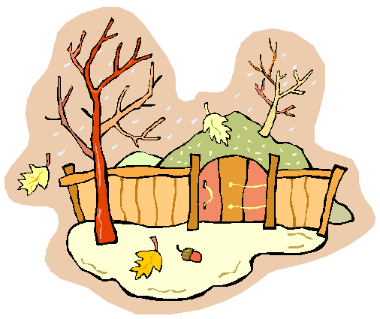
hau maiangi


hau pukeri

Resource 3 - Page 2
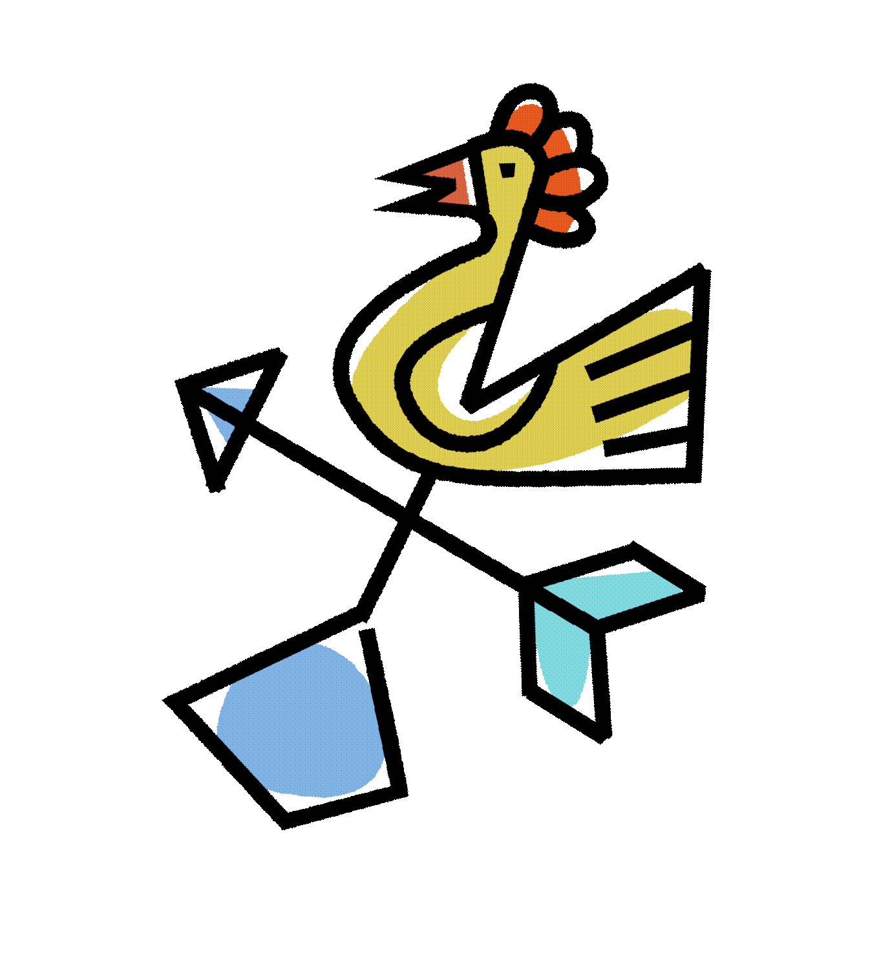
hau raki

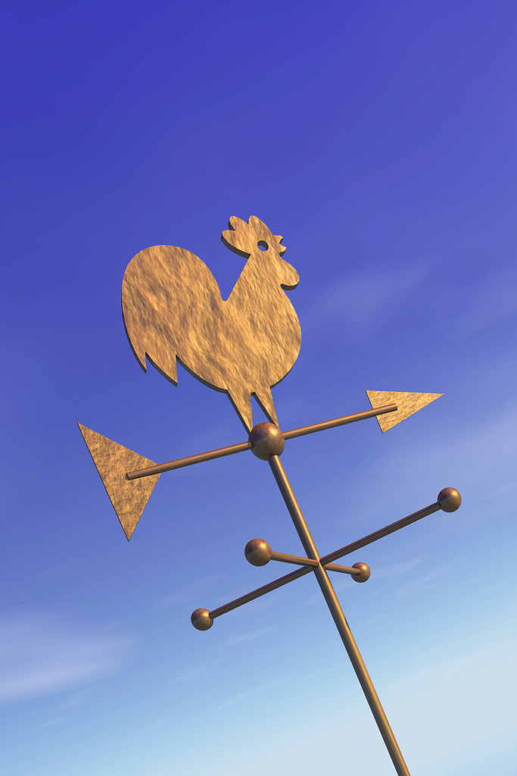
Hau tonga

hiko

huka


kapua

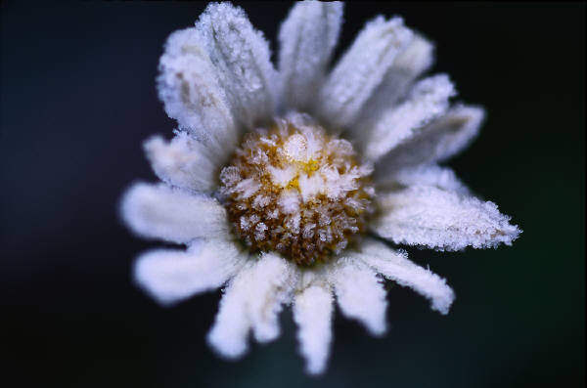


Resource 3 – Page 3


hukarere

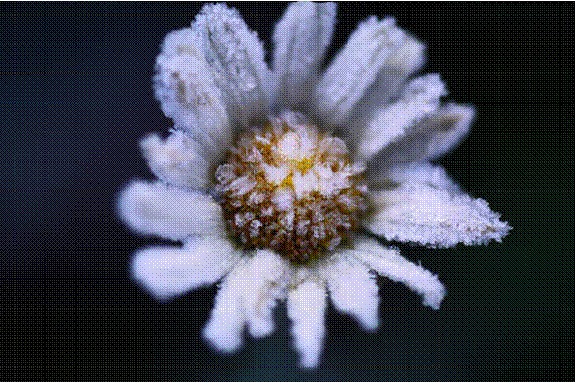
hukapapa

ua


kopatapata


kohu

Resource 3 – Page 4


mao

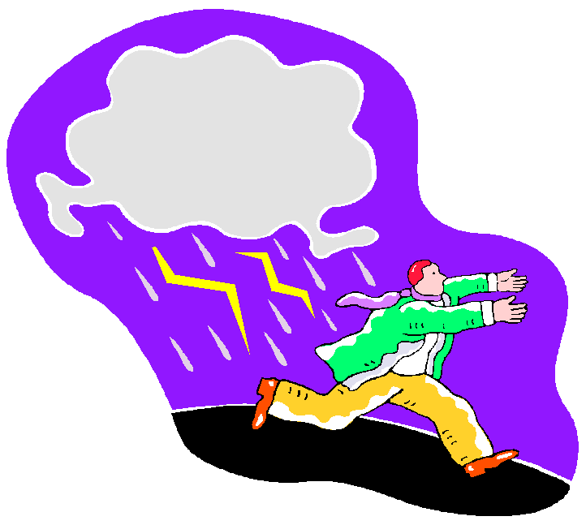
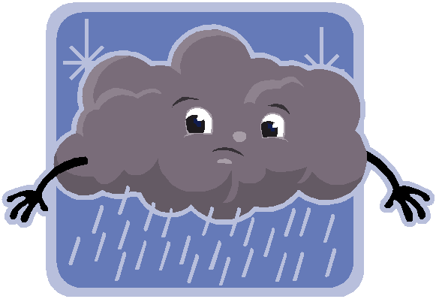
marangai


paki


tiaho

Resource 3 – Page 5


whiti


uira

waipuke

whaitiri

Task 5 He kimi kupu

You need: Copies of Activity Sheet 1
Activity Sheet 1 Answer Sheet: tā te kaiako
Duration: 10 mins
Participation: Class/Group
Objective: Re familiarise the students with kupu for ‘te āhua o te rangi’

- Explain to the students that this is a task to re familiarise themselves with kupu for ‘te āhua o te rangi’.

- You may want to offer a small prize for the first person finished as an incentive.

Activity Sheet 1
He Kimi Kupu – Word Finder
a | u | a | e | Ū | s | j | s | H | i | k | o | q | u | n | g | a | h | b | u
n | i | o | k | k | Ā | w | h | Ā | z | o | y | u | t | o | z | p | u | i | o
i | g | l | o | i | k | Ō | p | u | e | Ō | i | g | Ū | i | P | a | k | i | k
p | o | a | m | o | l | h | o | o | a | l | i | n | p | e | c | i | a | c | e
i | t | u | h | Ā | m | k | e | h | r | o | a | u | p | a | k | y | v | t | g
j | z | i | k | u | i | o | Ā | t | u | a | l | a | m | c | o | t | a | o | t
b | i | h | a | Ō | r | h | v | a | s | k | a | r | a | u | K | s | t | T | Ū
y | a | p | d | l | a | u | x | i | r | e | a | Ō | k | t | o | u | y | Ē | w
i | g | e | c | p | g | e | t | i | l | a | b | p | a | u | A | t | e | u | i
Ū | n | u | u | m | n | p | t | o | i | y | y | r | a | v | n | y | a | h | s
r | a | t | g | k | m | a | e | k | s | x | c | i | Ī | p | G | Ē | u | e | o
r | r | a | t | w | m | g | w | h | i | u | c | w | Ī | u | a | p | a | Ē | p
u | a | e | W | u | i | Ō | q | n | t | r | s | h | o | e | Ū | n | z | n | w
y | m | Ū | a | h | m | o | H | Ō | t | o | k | e | t | t | w | Ē | n | g | h
h | v | R | i | a | e | t | n | o | a | b | e | t | v | p | g | u | i | r | a
w | k | k | P | i | M | a | o | t | q | d | d | t | q | i | n | h | i | n | i
h | t | i | U | o | a | o | o | t | a | i | o | Ī | e | r | u | i | o | i | t
i | r | i | k | c | i | h | Ā | g | e | l | p | a | k | i | l | c | t | e | i
t | e | o | e | o | h | w | i | s | a | e | p | h | i | h | z | a | f | a | r
i | f | w | h | Ā | w | h | i | o | w | h | i | o | j | y | k | b | a | s | i

āwha | kapua | tūpuhi | Hōtoke
āwhiowhio | kohu | ua | Raumati
hau | mao | uira | Kōanga
hiko | marangai | waipuke | Ngahuru
huka | paki | whaitiri
hukapapa | tīaho | whiti

Activity Sheet 1 – Tā te Kaiako (Answer Sheet)

He Kimi Kupu – Word Finder
a | u | a | e | Ū | s | j | s | H | i | k | o | q | u | n | g | a | h | b | u
n | i | o | k | k | Ā | w | h | Ā | z | o | y | u | t | o | z | p | u | i | o
i | g | l | o | i | k | Ō | p | u | e | Ō | i | g | Ū | i | P | a | k | i | k
p | o | a | m | o | l | h | o | o | a | l | i | n | p | e | c | i | a | c | e
i | t | u | h | Ā | m | k | e | h | r | o | a | u | p | a | k | y | v | t | g
j | z | i | k | u | i | o | Ā | t | u | a | l | a | m | c | o | t | a | o | t
b | i | h | a | Ō | r | h | v | a | s | k | a | r | a | u | K | s | t | T | Ū
y | a | p | d | l | a | u | x | i | r | e | a | Ō | k | t | o | u | y | Ē | w
i | g | e | c | p | g | e | t | i | l | a | b | p | a | u | A | t | e | u | i
Ū | n | u | u | m | n | p | t | o | i | y | y | r | a | v | n | y | a | h | s
r | a | t | g | k | m | a | e | k | s | x | c | i | Ī | p | G | Ē | u | e | o
r | r | a | t | w | m | g | w | h | i | u | c | w | Ī | u | a | p | a | Ē | p
u | a | e | W | u | i | Ō | q | n | t | r | s | h | o | e | Ū | n | z | n | w
y | m | Ū | a | h | m | o | H | Ō | t | o | k | e | t | t | w | Ē | n | g | h
h | v | R | i | a | e | t | n | o | a | b | e | t | v | p | g | u | i | r | a
w | k | k | P | i | M | a | o | t | q | d | d | t | q | i | n | h | i | n | i
h | t | i | U | o | a | o | o | t | a | i | o | Ī | e | r | u | i | o | i | t
i | r | i | k | c | i | h | Ā | g | e | l | p | a | k | i | l | c | t | e | i
t | e | o | e | o | h | w | i | s | a | e | p | h | i | h | z | a | f | a | r
i | f | w | h | Ā | w | h | i | o | w | h | i | o | j | y | k | b | a | s | i

āwha | kapua | tūpuhi | Hōtoke
āwhiowhio | kohu | ua | Raumati
hau | mao | uira | Kōanga
hiko | marangai | waipuke | Ngahuru
huka | paki | whaitiri
hukapapa | tīaho | whiti

Lesson 6 – Kei te whiti mai te ra!

Unit Plan Number |  | 3
Unit Plan Name |  | He aha te wā Mr Wolf?
Lesson Number |  | 6 of 8
Lesson Title |  | Kei te whiti mai te rā!
Year Level |  | Y9
Learning Intention/Outcome Statements |  | 2.4 Communicate about time, weather and seasons
Teacher and student instructions |  | Teacher:
Estimated time for completion |  | 45 minutes
Resource requirements |  | Ignition Karakia  Resource 1  Activity Sheet 1  Activity Sheet 2
Tasks in sequence | Duration  (mins)  2  2  8  20  10-12  3 | - Karakia whakatau i te tangata (C).  - Hei whakamārama: Explain to students that the lesson is learning more about the weather(C).  - Ngā tū kupu (C) Activity Sheet 1. Resource 1  - He whakaari (C) Resource 1  - Tuhi rerenga. (C) Activity Sheet 2  - He karakia whakamutunga
Reference material
Answer/marking schedule/criteria |  | Activity Sheet 2 completed and correct

Task 2 Maranga ake e Hēmi!

You need: Resource 1
Duration: 8 mins
Participation: Pairs/group/class
Objective: Identify key words in story

- Explain to the students that this lesson is about identifying kupu for the weather in a controlled context.
- Hand out Resource 1 to students.
- Students are to read again in pairs and identify three types of words from the story; ko te taima, ngā kupu mō te āhua o te rangi me ngā wāhanga o te tau.
- Each pair must complete the table below.

Resource 1

He Kōrerorero: Maranga ake e Hēmi!


Ko te kaipānui: Kua hipa atu te kōanga ā, kua tae mai te raumati.
Kei te moe tonu a Hēmi i roto i tōna moenga. E haere ana tōna pāpā, a Whare, ki te whakaoho i a ia. Ko Ana tōna māmā. Ko Tio rāua ko Rangi ōna teina.

Ko Whare: Maranga ake e tama! Kua ngaro te hukapapa i waho. Kāre he kapua i te rangi. Kei te whiti mai te rā! Kei te waiata ngā manu. Kātahi te rangi ataahua!


Ko Ana: E tama! Maranga ake! Kei te haere kōrua ko tō pāpā
ki te hī ika. Ahakoa he rangi paki kua rongo ake au kei te haramai tētahi hau pūkeri. Auē!


Ko Tāmati: E Hēmi, maranga ake! Kei te haere mātou ki ōku hoa ki Ruapehu ki te rere huka. Ka taea e au te rere huka pērā ki tētahi āwhiowhio. Ka tau kē nē rā Hēmi?

Ko Tio: Maranga ake e Hēmi! Kei te haere au ki Taupō i tēnei ata mō te whakataetae poikiri. Heoi anō, kei te heke te ua i reira. Tērā pea he waipuke kei te haere. Otirā ko te tumanako ka mao!


Ko Ana: Haramai e te whānau. Kua reri te parakuihi. He nui ngā mahi mā tātou i te rangi nei nō reira he nui ngā kai mā tātou. Te reka hoki o ā tātou kai! Kua maranga ake a Hēmi?


Ko Whare: Hei aha māna! Mā te whaitiri kei roto i tōna puku
e whakaoho.
Ko Ana: Āe. He kai mā Hēmi kei roto kē i ōna moemoeā!
Ko te whānau: Ha ha ha ha ha!

Task 3 Ngā tū kupu

You need: Copies of Activity Sheet 1
Resource 1
Duration: 8 mins
Participation: Pairs/group/class
Objective: Identify key words in story

- Hand out Activity Sheet 1 to students.
- Students are to read through the dialogue (Resource 1 from Lesson 2) again in pairs and identify three types of words from the story; He kīwaha, ngā kupu mō te āhua o te rangi me ngā wāhanga o te tau.
- Each pair must complete the table below.

Activity Sheet 1

He kīwaha  (idioms) | Ko ngā kupu mō te āhua o te rangi  (Words for the weather) | Ngā wāhanga o te tau  (seasons)

Task 4 He whakaari

You need: Resource 1 (Dialogue from previous task)
Duration: 20
Participation: Class
Objective: To cement learning of how to say the time and how to describe the weather

- Assemble the students in to groups of 6.
- Give each group a copy of the dialogue.
- Each member of the group must select a part or character to play.
- The students must learn their individual parts and present the play to the class however there is a twist.
- The teacher will give each group a certain emotion in which the play can be presented. For example:
  - Happy
  - Sad
  - Angry
  - Scared
  - Present as a rap
  - Present as a song
  - Any other emotions or situations that you can think of.
- Each group will present their play to the class.
- This can be a lot of fun and it will cement the learning of times and weather for students.

Task 5 Kei te whiti te rā

You need: Copies of Activity Sheet 2
Duration: 10-12 mins
Participation: Class
Objective: To elicit responses to the question ‘Pēhea te āhua o te rangi?’

- Hand out Activity Sheet 2 to students.
- Students are to follow the examples in Activity Sheet 2 and come up with the appropriate responses that correspond to each picture.
- Revision may be required with structure and appropriate sentence starters such as ‘kei te.. he….’ etc.
- Teacher may assist as necessary with this exercise

Activity Sheet 2

According to the pictures below, write a sentence to describe the weather. The first two have been done for you.

Pēhea te āhua o te rangi?

Kei te whiti mai te rā. | He āwhā tēnei.

Lesson 7 - Pehea te ahua o te rangi ki to whare?
Unit Plan Number |  | 3
Unit Plan Name |  | He aha te wā Mr Wolf?
Lesson Number |  | 7 of 8
Lesson Title |  | Pēhea te āhua o te rangi ki tō whare?
Year Level |  | Y9
Learning Intention/Outcome Statements |  | 2.4 Communicate about time, weather and seasons
Teacher and student instructions |  | Teacher:
Estimated time for completion |  | 45 minutes
Resource requirements |  | Ignition Karakia  Resource 1 from Lesson 6  Activity Sheet 1  Activity Sheet 2  Activity Sheet 3
Tasks in sequence | Duration  (mins)  2  2  10  12  10  5  3 | - Karakia whakatau i te tangata (C).  - Hei whakamārama: Explain to students that the lesson is learning more about the weather.  - Whakautu pātai (C) –Resource 1 from Lesson 6, Activity Sheet 1.  - Kei te whiti te rā. (P) Activity Sheet 2  - Pēhea te āhua o te rangi ki Te Ika a Māui. (C) Activity Sheet 3  - He whakamārama: He rīpoata mō ngā āhua o te rangi. (C)  - He karakia whakamutunga.
Reference material
Answer/marking schedule/criteria |  | Activity Sheet 1 & 2 completed and correct

Task 3 Whakautu pātai

You need: Copies of Activity Sheet 1
Resource 1 from Lesson 6 (Maranga ake e Hēmi)
Duration: 10 mins
Participation: Class
Objective: Respond appropriately to the question, ‘Pēhea te āhua o te rangi?’

- Using Resource 1 from Lesson 6, the students must answer the following questions using words from Activity Sheet 1

- Teacher may check answers.

Activity Sheet 1

- Ko tēhea wāhanga o te tau tēnei?

______________________________________________________________

- Pēhea te āhua o te rangi ki tō Hēmi whare?

______________________________________________________________

- Kei te haere a Hēmi rāua ko tōna pāpā ki hea?

______________________________________________________________

4. Pēhea te āhua o te rangi ki Ruapehu?

______________________________________________________________

5. Pēhea te āhua o te rangi ki Taupō?

______________________________________________________________

Task 4 Kei te whiti te rā

You need: Copies of Activity Sheet 2
Duration: 10-12 mins
Participation: Class/pairs
Objective: To elicit responses to the question ‘Pēhea te āhua o te rangi?’

- Hand out Activity Sheet 2 to students.
- Students are to follow the examples in Activity Sheet 2 and come up with the appropriate responses that correspond to each picture.
- Students may work in pairs.
- Revision may be required with structure and appropriate sentence starters such as ‘kei te.. he….’ etc.
- Teacher may assist as necessary with this exercise

Activity Sheet 2

According to the pictures below, write a sentence to describe the weather. The first two have been done for you.

Pēhea te āhua o te rangi?

Kei te whiti mai te rā. | He āwhā tēnei.

Task 5 Pēhea te āhua o te rangi ki Te Ika a Māui?

You need: Activity Sheet 3
Māori/English dictionaries
Duration: 8 mins
Participation: Class/pairs
Objective: To describe the weather in different places

- Hand out Activity Sheet 2 to the students.
- Students must complete the Activity Sheet 2
- Students are expected to answer the questions in full.

Activity Sheet 3
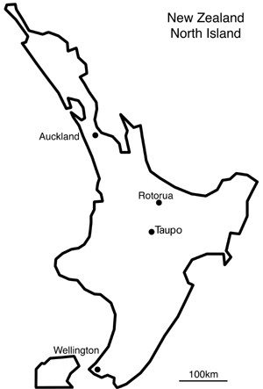
Te Ika a Māui


Tāmaki Makaurau

Tauranga

Kirikiriroa



Tūranganui a Kiwa
Taupō



Whanganui
Heretaunga


Te Whanganui a Tara


Look at the weather forecast and answer the following questions. Write your answers in Māori. The first one has been done for you.

Pēhea te āhua o te rangi ki Te Whanganui a Tara?
Kei te hukarere(rere te huka) ki Te Whanganui a Tara.

- Pēhea te āhua o te rangi ki Taupō?
______________________________________________________________
- Pēhea te āhua o te rangi ki Tāmaki Makaurau?
______________________________________________________________
- Pēhea te āhua o te rangi ki Tūranganui a Kiwa?
______________________________________________________________
- Pēhea te āhua o te rangi ki Whanganui?
______________________________________________________________
- He rangi paki ki Heretaunga? ĀE KĀO (Circle the correct answer)

Task 6 He kauhau mō te āhua o te rangi

You need: Activity Sheet 3
Duration: 5 mins
Participation: Class/pairs/groups
Objective: To describe the weather in different places

- Explain to the students that they must prepare a weather report to give to the class.
- Hand out Activity Sheet 4 to the students.
- Read through the instructions with the students to ensure they understand what is expected.
- Students may work in pairs or groups
- The class may begin preparation for their reports as mahi kāinga and present to the class in Lesson 8
- Teacher may assist with the preparation of this task.

Activity Sheet 3

Ngā tohutohu (Instructions)

You are a weather reporter for the 6.00 o’clock evening news. Create your own weather report to be televised. Your presentation must include the following detail;

Begin with an opening introduction of yourself and your segment of this programme for the evening | Tēnā koutou katoa. Ko Hēmi tōku ingoa mō Te Kaea e whakapāho ana i ngā āhua o te rangi mō Te Ika a Māui
Give a weather forecast for a two day period i.e. today and tomorrow | He rangi paki ki Taupō.  Apōpō ka puta te hau āwhiowhio ki reira
Give the forecast for 3 towns in the North Island. One sentence pertaining to each town is sufficient | Kei te heke te ua ki Ahuriri  He hau pūkeri ki Heretaunga  Kei te hukarere ki Tūrangi
You must draw a Map of the North Island on to the white board.
You may use the weather flash cards from Lesson 5 to illustrate the weather conditions of each town you have chosen to speak about. Alternately you may draw your own
You must demonstrate appropriate pronunciation, body language and expression within your presentation
Clearly conclude your presentation with appropriate poroporoaki | Kua mutu aku kōrero mō ngā āhua o te rangi. Ko Hēmi Tutu tēnei mō Te Kaea.

Lesson 8 – Weather Report

Unit Plan Number |  | 3
Unit Plan Name |  | He aha te wā Mr Wolf?
Lesson Number |  | 8 of 8
Lesson Title |  | Weather report
Year Level |  | Y9
Learning Intention/Outcome Statements |  | 2.4 Communicate about time, weather and seasons
Teacher and student instructions |  | Teacher:
Estimated time for completion |  | 45 minutes
Resource requirements |  | Ignition Karakia  Weather Cards from Lesson 5  Activity Sheet 1
Tasks in sequence | Duration  (mins)  2  2  38  3 | - Karakia whakatau i te tangata (C).  - Hei whakamārama: Explain to students that this lesson will be about presenting weather reports to the class.  - He kauhau mō te āhua o te rangi. He mahi whakarongo (C) Activity Sheet 1  - Karakia whakamutunga.
Reference material
Answer/marking schedule/criteria |  | Teacher to assess individuals for correctness in structuring kōrero for weather reports and mahi whakarongo

Task 3 He kauhau mō te āhua o te rangi/Mahi whakarongo

You need: Copies of Activity Sheet 1 from Lesson 7
Weather flashcards (Lesson 5)
Whiteboard markers
Draw or find a large map of NZ to attach to the whiteboard
Duration: 38mins
Participation: Pairs/groups/class
Objective: Present a weather report
Listen and record information about a weather forecast

- During the first part of the lesson please allow the class time to work on and finalise their kauhau to be presented.
- Once the students are ready they may present their weather reports either in pairs or groups to the class (As decided by the teacher)
- Explain to the class that while the presentations are taking place the must listen careful and record the information required on Activity Sheet 1 – Mahi Whakarongo

Activity Sheet 1 – Mahi Whakarongo
Record the following information about 3 different weather reports presented to the class.

Ingoa o te/ngā kaikōrero  Name of the reporter(s) | Ngā taone  Towns | Āhua o te rangi  Weather forecast

