Māori Curriculum in the Mainstream

Unit Plan 3

Year 9

6 Lessons & Activities

Te whakatakoto rerenga korero

Constructing Sentences

Table of Contents

Unit Plan Overview 3
Lesson 1 – Te hanga pukapuka 5
Hei Mahi 1 6
Lesson Two – Te kupu huna # 1 10
Lesson Two – Te kupu huna # 1 10
Hei Mahi 1 11
Lesson Three – Te kupu huna #2 14
Hei Mahi 1 15
Lesson Four – He Mahere Wāhanga Kupu 17
Hei Mahi 1 He Mahere Wāhanga Kupu 18
Lesson Five – He hanga kōrero 19
Hei Mahi 1 20
Lesson Six – Kei te harikoa ahau! 22
Hei Mahi 1 23

Unit Plan Overview

Unit Plan Number |  |  |  |  |  | Three for Year Nine
Unit Plan Name |  |  |  |  |  | Te whakatakoto rerenga kōrero  TOPIC: Exploring Grammar in Te Reo Māori
KOEKE:  Level |  |  |  |  |  | 1 2 3 4 5
TE ROA  Duration |  |  |  |  |  | 6 x 50 meneti
WHAINGA PAETAE |  |  |  |  |  | Students will learn to construct and write simple sentences in te reo Māori.
Whenu Torohū (Strand Receptive) |  |  |  |  |  | Whenu Whakaputa (Strand Expressive)
Whakarongo |  | Pānui |  | Mātakitaki |  | Kōrero |  | Tuhituhi |  |  | Whakaari
Ngā ariā o te reo |  |  | Te wetewete i te reo |  |  | Kupu hou |  |  | Kīwaha
Te āhua  Wāhi |  |  | Kei te  E … ana  Ka …  Kua …  I …  I te … |  |  | Hanga  Tuku  Kaiwhakawā |  |  | Ka mau te wehi!
Mahi ia rā (Daily Routine): Karakia, te wā, te āhua o te rangi, Lesson, mahi kāinga, karakia whakamutunga, whakataukī, Kīwaha.

Specific Outcomes for fellow students to achieve by end of Unit. | Points emphasised to help students understand the task and achieve the learning outcomes. |  |  |  | Learning activities the students will be required to do. |  | Most appropriate method for measuring how well the students have achieved the Learning Outcomes. |  |  | Teaching/Learning resources used e.g. equipment, texts.
PŪKENGA  learning outcomes | KAWENGA  Teaching points |  |  |  | NGOHE  activities  C=Class, G=Group  P=Pair  I=Individual independently |  | AROMATAWAI  assessments |  |  | RAUEMI  resources
By the end of this unit, students will be able to:
- Identify nouns, verbs and adjectives  - Use the English Māori dictionary  - Construct simple sentences in Māori  - Communicate about events, and where they take place. | English words can be translated into Māori (or any language)  Introduce sentence construction beginning:  Kei te …  Kei te + verb + noun + adjective = rerenga korero (sentence)  E … ana …  E + verb + ana + noun + adjective  Ka …  Ka + verb + noun + adjective + ki te + wāhi.  Kua …  Kua + Verb + noun + ki te + wāhi.  I …  I + verb + noun + ki te + wāhi  I te…  I te + verb + noun + ki te + wāhi. |  |  |  | Model the activity by using examples and getting students to provide words in English  Get students to look up the Māori translation for the sample words.  In pairs, complete the worksheet to identify 6 (3 each) nouns, adjectives and verbs, in Māori |  | Observation of completion of worksheet  (at least 3 of each)  Peer assessment  Show and tell (to the class) at least one correct meaningful sentence.  Self assessment  Written  Teacher assessment of completed worksheets  Formative |  |  | - Colourful pictures  - English to Māori dictionaries  - Worksheets

Lesson 1 – Te hanga pukapuka

Lesson Number | 1 of 6
Lesson Title | Te hanga pukapuka
Year Level | Year 9
Learning Intention/Outcome Statements | Students will learn to identify verbs and nouns and to construct and write simple sentences in te reo Māori.
Teacher and student instructions | Copy Hei Mahi 1 for students
Estimated time for completion | 50 minutes
Resource requirements | Hei Mahi 1  Scissors  Glue  Two-page booklets, stapled.
Activity/Tasks in sequence | - Divide class into groups of six  - Give Hei Mahi 1 to students  - Students arrange pictures in a sequence which they think make sense. Then they write a simple story about the pictures. Sentences can begin with one of the verbal markers.  - When each group has finished their stories, (and they have been checked), they prepare good copies in the form of booklets.
Reference material
Answer/marking schedule/criteria | Sentences are grammatically correct.

Hei Mahi 1

a Kei te______a Hēmi 
Kei te kai a Hemi i te āporo



e Ka
Ka rere te poaka ki Ahireireiria!




i I a Hēni
I tuku a Hēni i te reta

1 I te a Mere


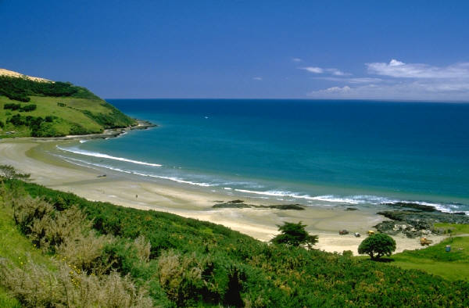
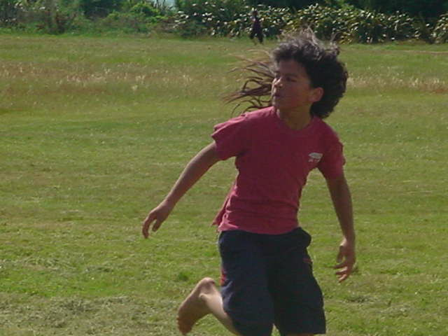
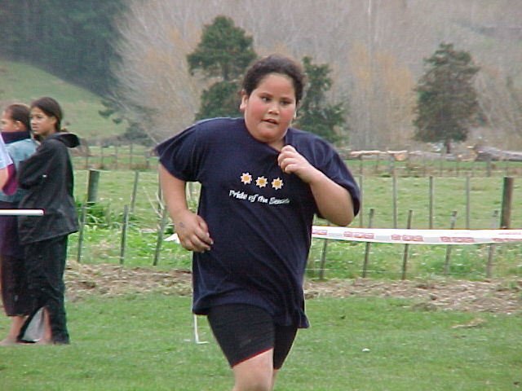

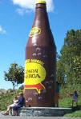
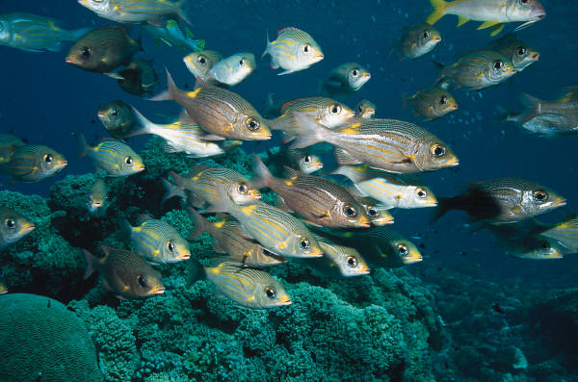
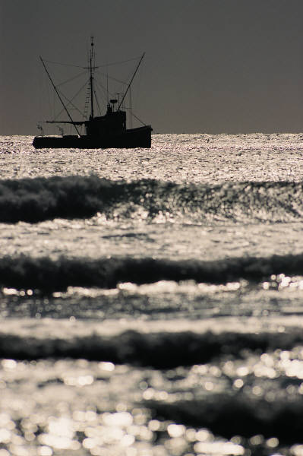
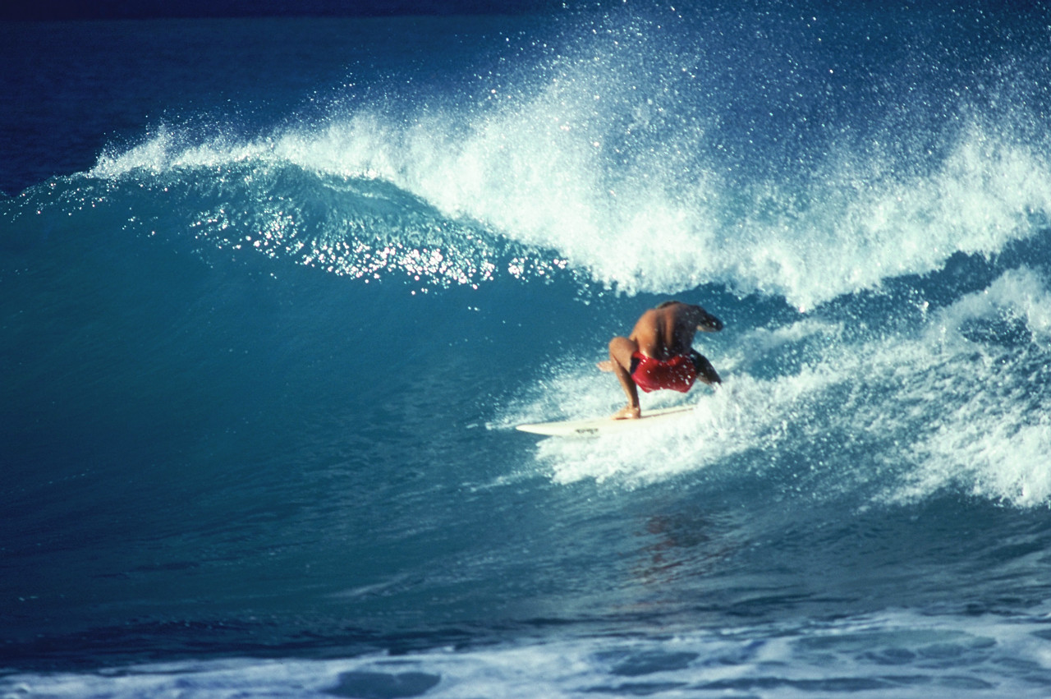



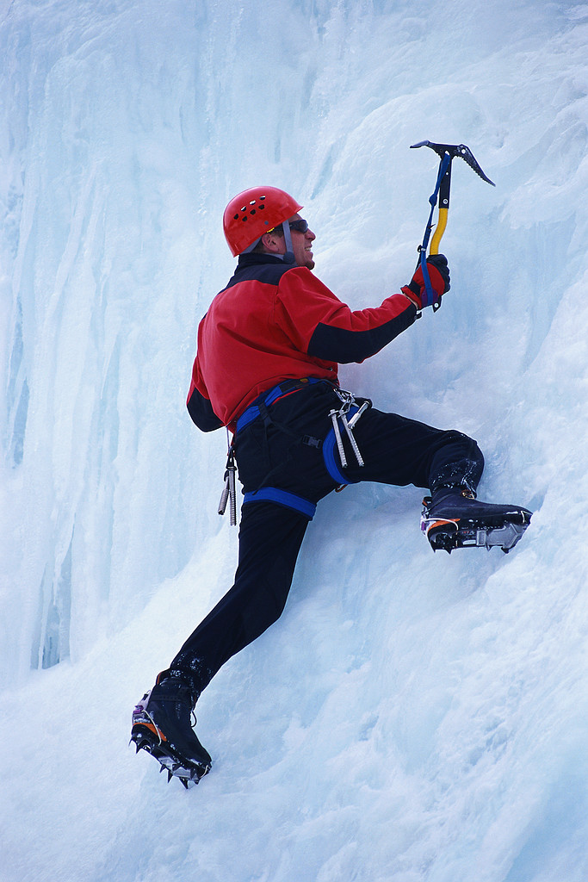
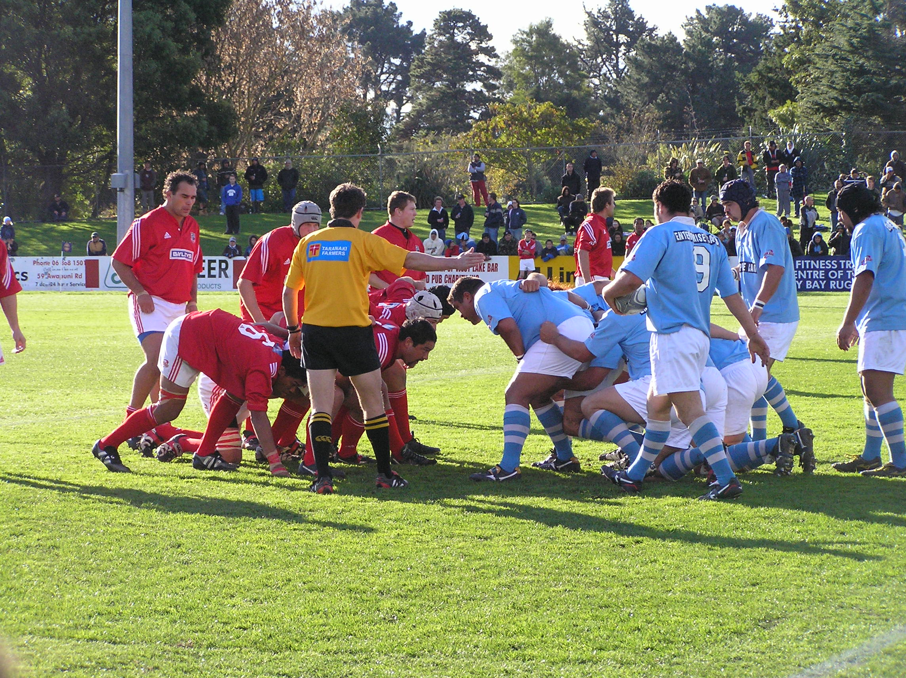


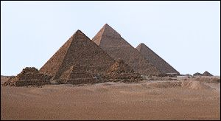
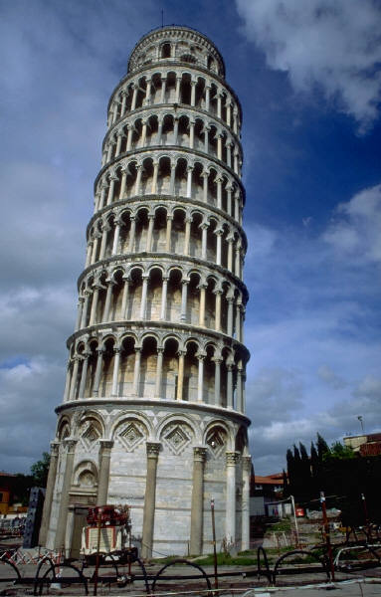






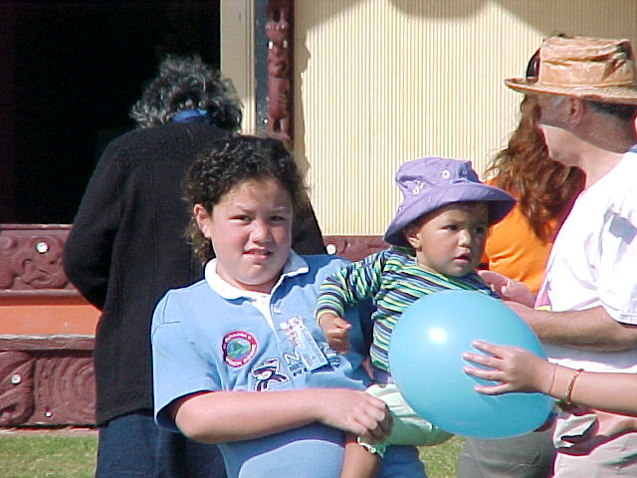
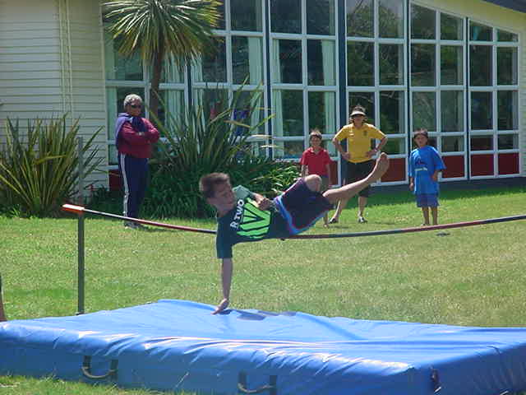
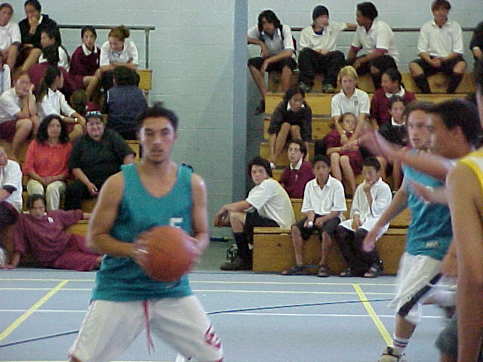
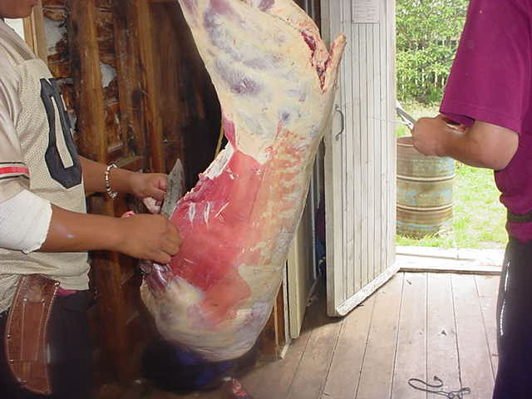
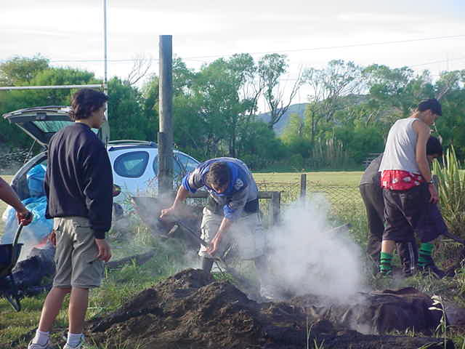
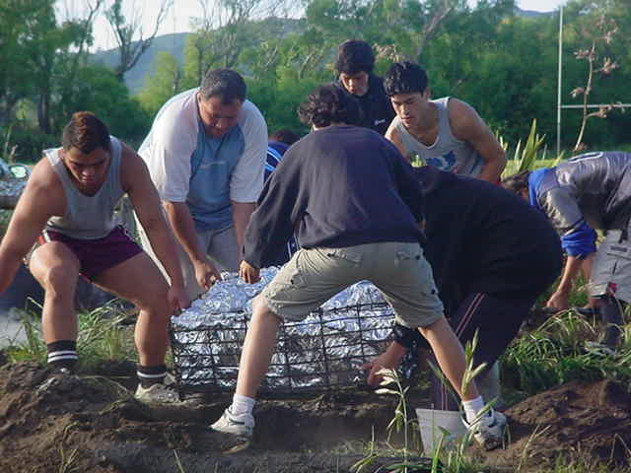

Lesson Two – Te kupu huna # 1

Lesson Number | 2 of 6
Lesson Title | Te kupu huna #1
Year | Year 9
Learning Intention/Outcome Statements | Students will learn to construct and write simple sentences in te reo Māori using verbs and nouns.
Teacher and student instructions | This activity will reinforce new words (kupu hou) which students can use to help form simple sentences in Māori.
Estimated time for completion | 50 minutes
Resource requirements | Over head projector or laptop and projector.  Hei Mahi 1 is an example of the sentences and pictures that can be used. There is no limit to the sentences or pictures that may be selected.
Activity/Tasks in sequence | - Divide students into groups of five.  - One student is the Kaiwhakawā. The remaining four work in pairs.  - Kaiwhakawā gives students #1 of Hei Mahi 1. Sentences are best projected onto a large screen or wall.  The first pair to guess the sentence, win.  Each group plays kupu huna, X10 pictures for each group. Winners play each other.
Reference material
Answer/marking schedule/criteria | Answers must be correct.

Hei Mahi 1
Tirohia ngā rārangi. Ko te tikanga o te pikitia te kupu huna.
Look at the sentences. The meaning of the picture is the missing word.
The kupu huna is in brackets.
(1) Kei te rātou. (mahi hāngi)

(2) I haere rātou ki te (kaukau)
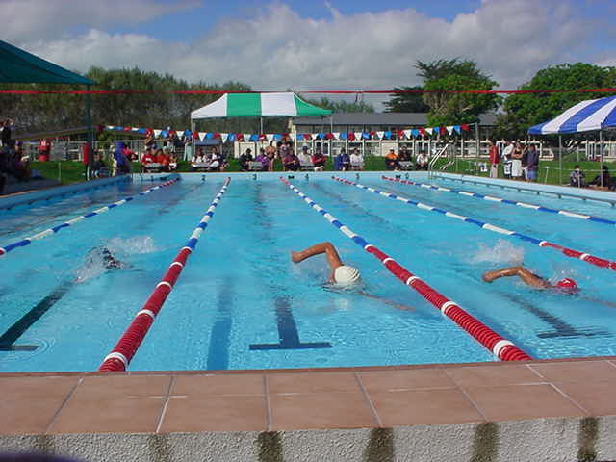

(3) Ka a Buckaroo. (eke hoiho)
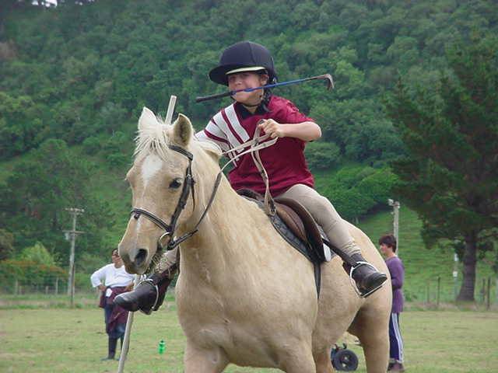

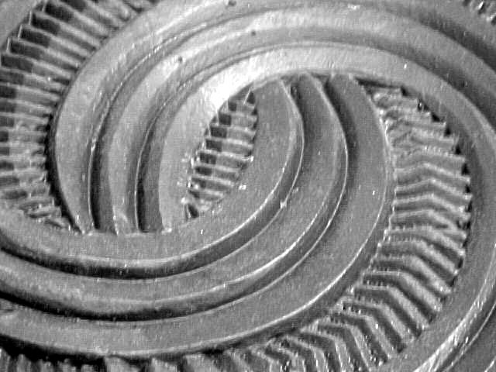
(4) E ana a ia. (whakairo)

(5) Kua ngā kurī. (moe)
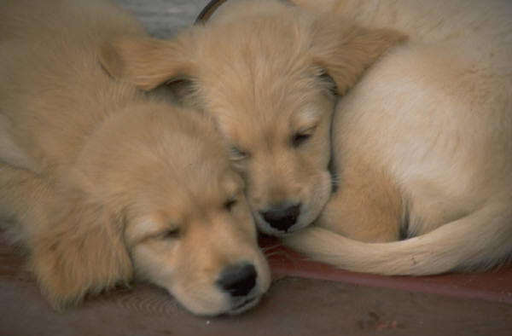

(6) I te a ia (tangi)

(7) Kei te a ia. (mamae)

(8) E ana rātou. (kimi)

(9) Ka te tamaiti. (Kaute)

(10) Kei te te whānau. (hīkoi)


(11) Kua atu rātou ki


Lesson Three – Te kupu huna #2

Lesson Number | 3 of 6
Lesson Title | Te kupu huna #2
Year Level | Year 9
Learning Intention/Outcome Statements | Students will learn to construct and write simple sentences in te reo Māori, using verbs and nouns.
Teacher and student instructions | This exercise is an extension of Lesson Two. Students have to guess the verb, the noun, and destination from the pictures they are given.  Copy Hei Mahi 1 for students.  Organise students as for Lesson #2
Estimated time for completion | 50 minutes
Resource requirements | Over head projector or laptop and projector.  Hei Mahi 1 is an example of the sentences and pictures that can be used. There is no limit to the sentences or pictures that may be selected.
Activity/Tasks in sequence | - Divide students into groups of five.  - One student is the Kaiwhakawā. The remaining four work in pairs.  - Kaiwhakawā gives students #1 of Hei Mahi 1. Sentences are best projected onto large screen or wall.  The first pair to complete the sentences correctly and guess the kupu huna wins. Each group plays kupu huna, X8 pictures for each group. Winners play each other.
Reference material
Answer/marking schedule/criteria | Sentences are grammatically correct.

Hei Mahi 1

(1) E ana ngā taitama. (tākaro whutupōro)
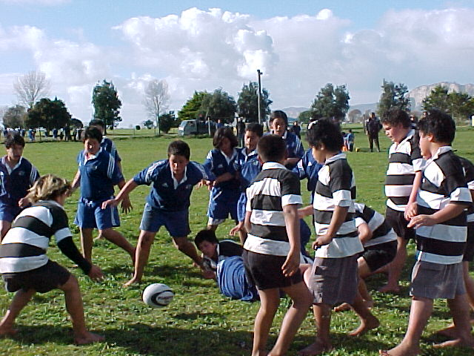

(2) Kua a ia i ngā

(3) Kei te a ia

(4) E ana a ia i te tamaiti.

(5) Kua te waka rererangi ki
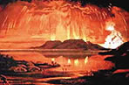

(6) I te a ia ki

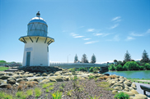

(7) Ka te tumuaki ki



(8) I te ki
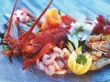

Lesson Four – He Mahere Wāhanga Kupu

Lesson Number | 4 of 6
Lesson Title | He Mahere Wāhanga Kupu
Year Level | Year 9
Learning Intention/Outcome Statements | Students will learn to construct and write simple sentences in te reo Māori. Joining syllables together to form words.
Teacher and student instructions | Copy Hei Mahi 1 for students
Estimated time for completion | 50 minutes
Resource requirements | Hei Mahi 1
Activity/Tasks in sequence | - Copy Hei Mahi 1 ‘He Mahere Wāhanga Kupu’ for students.  - Students use Hei Mahi 1 to construct sentences.  - Each student chooses a wāhanga kupu (syllable). Students add syllables until a whole word is formed. eg. Ma/hi/ta/hi.  - Once the word is formed, the next student must construct a sentence using mahitahi, i.e. Kei te mahitahi ngā tamariki.  - Students sit in a circle. One student leaves the room. Class chooses a word. Students are given a wāhanga (syllable) of the word.  - The student returns to class.  - Each student sings their syllable.  - The student who has come back into the class must join the wāhanga kupu together to form the word. The student must construct a sentence using the word, e.g. Kei te waiata rātou.  - One of the students starts a beat ‘pātukitahi’, or clicking fingers ‘pekēke’, or knocking ‘pātōtō’, or clapping ‘pakipaki’. Everyone closes their eyes. Whatever the beat the students pick up, they must use a wāhanga kupu to construct a word. Start with short two syllable words.  - If a word has more than three syllables, students can ‘whiu’ with a hand signal to a classmate who completes the word. Requires pretty good concentration!
Reference material
Answer/marking schedule/criteria | Sentences must be grammatically correct.

Hei Mahi 1 He Mahere Wāhanga Kupu

 | Aa | Ee | Ii | Oo | Uu
Hh | ha | he | hi | ho | hu
Kk | ka | ke | ki | ko | ku
Mm | ma | me | mi | mo | mu
Nn | na | ne | ni | no | nu
Pp | pa | pe | pi | po | pu
Rr | ra | re | ri | ro | ru
Tt | ta | te | ti | to | tu
Ww | wa | we | wi | wo | wu
NG ng | nga | nge | ngi | ngo | ngu
WH wh | wha | whe | whi | who | whu

Lesson Five – He hanga kōrero

Lesson Number | 5 of 6
Lesson Title | He hanga kōrero
Year Level | Year 9
Learning Intention/Outcome Statements | Students will learn to construct and write simple sentences in te reo Māori, using a verb and a noun.
Teacher and student instructions | Group exercise. Prepare work stations for groups. Provide Hei Mahi for workstation similar to Hei Mahi 1. Number of Hei Mahi will be dependent on class numbers.
Estimated time for completion | 50 minutes
Resource requirements | A Porotiti or pointer that can be spun.
Activity/Tasks in sequence | - Students work in groups of four for this exercise.  - Place porotiti and Hei Mahi 1 in centre of group.  - Students take turns being the Tīmata which means starting the sentence with a verbal maker – Kei te etc.  - Tīmata determines the tense. Spin the porotiti. The student that the porotiti is pointing to, must add a verb to the sentence. Verb must be taken from any of the pictures on Hei Mahi 1, but can only be used once. Spin the porotiti again. This time, the student adds the noun. The noun is also taken from the pictures on Hei Mahi 1 and can only be used once. Spin the porotiti. This time the student adds the object of the sentence of destination (if able to!). The object/destination is also to be taken from Hei Mahi 1. Students write down the sentence they have composed.  - Students move around to the next station.
Reference material
Answer/marking schedule/criteria | Exercise must be carried out in an orderly fashion.  Sentences must be grammatically correct.

Hei Mahi 1

Nama | Kupu mahi (verb) | Kupu ingoa (Noun) | Te Wāhi (Destination) or The object of the sentence.
1 |  |   Te Pinki Panatara
2 |  | 
3 |  |  | 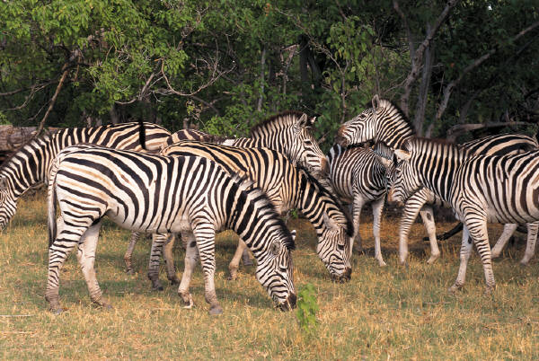
4 |  |   
5
6
7 |  | 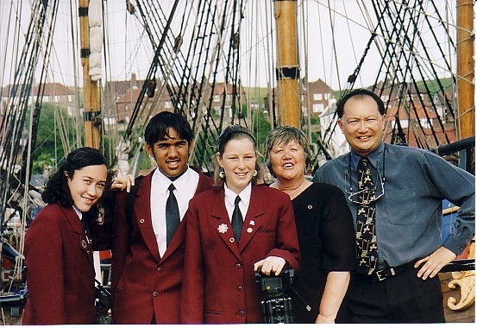

8 |  |  | 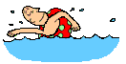
9
10

Lesson Six – Kei te harikoa ahau!

Lesson Number | 6 of 6
Lesson Title | Kei te harikoa ahau!
Year Level | Year 9
Learning Intention/Outcome Statements | Students will learn to construct and write simple sentences in te reo Māori, to communicate about events and where they take place.
Teacher and student instructions | Copy Hei Mahi 1 for students.
Estimated time for completion | 50 minutes
Resource requirements | Hei Mahi 1  Magazines  Scissors/glue/A3 sheets of paper.
Activity/Tasks in sequence | - Give students Hei Mahi 1.  - Teacher asks students questions about pictures.  Hei tauira: (Kaiako) E aha ana a ia?  Tauira: E haere ana ia ki te moana.  3. Students look at picture and answer questions.  4. Students cut out pictures from magazines to present to class. Students ask four questions about pictures.  5. Students ask classmates about their pictures.
Reference material
Answer/marking schedule/criteria | Student questions and answers must be grammatically correct.  Questions must begin with verbal markers.

Hei Mahi 1
Pātai 1 | E aha ana rātou?
Pikitia
Pātai 2 | I te aha te koroua?
Pikitia
Pātai 3 | Kei te haere rāua ki hea?
Pikitia
Pātai 4 | Kua tae atu a Raiha rāua ko Wai ki hea?
Pikitia | 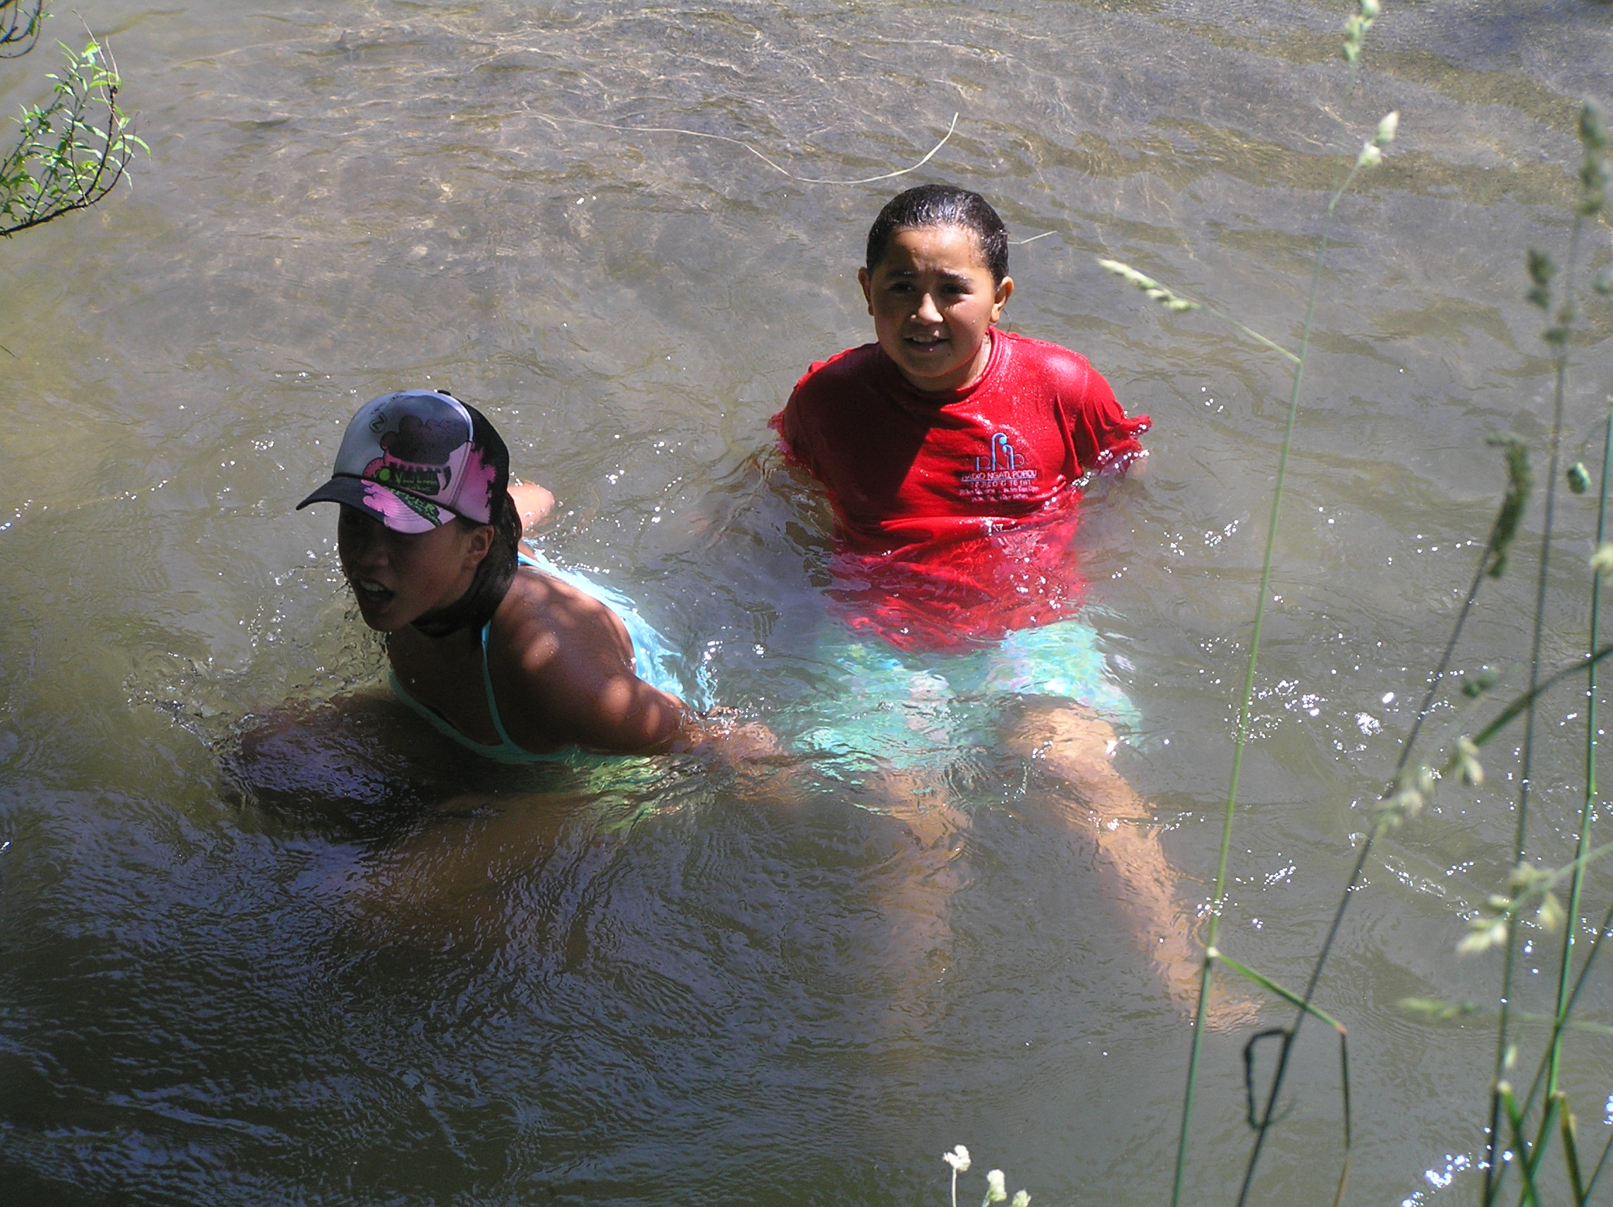

Pātai 5 | I hea te whānau?
Pikitia
Pātai 6 | E rere ana te ika ki hea?
Pikitia | 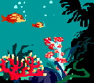
Pātai 7 | Ka kite ngā tamariki i a wai?
Pikitia
Pātai 8 | I haere te whānau ki hea?
Pikitia

Pātai 9 | E aha ana te Pirihimana?
Pikitia
Pātai 10 | Kua tuku a Haami i te reta ki hea?
Pikitia

