Activity 1

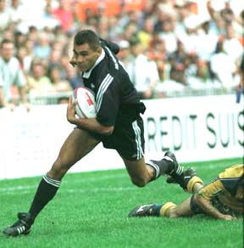
Identify the person in the photo and create your own facts box.

- Ko tenei tangata i tipu ake ki roto o Tamaki Makaurau I te taone o Otahuhu. Ko te kura tuarua I haere ia ko Tangaroa. E toru ana tamariki ko Natalie, ko blair, ko Martyn. Ko ia te kapene I toa I whiwhi koura hoki ki te takaro whitu whutupaoro o Aotearoa, I te whakataetae o te Commonwealth. I whanau mai ia i te tau 1965.
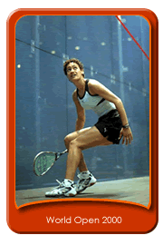

- He toa tenei wahine ki te takaro poipatu. Ko nga kura I akonga ia, ko Melville Primary me Church College. E toru ona tuahine, kotahi te tungane, otira rua tekau ma whitu nga tau o tenei wahine. I te tau kotahi mano iwa rau iwa tekau ma iwa, I riro I aia te taitara British Open. Koia te nama rua mo te takaro poitpatu wahine o te ao. I tipu ake tenei wahine toa ki Kirikiriroa.

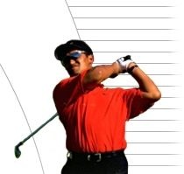

- Ko tenei tahae I pakeke mai ki Titahi Bay, I roto I te Whanganui a Tara. No te tau kotahi mano, iwa rau whitu tekau ia I whanau ai. Kotahi tona tamaiti. He rongonuitia ia mo te hakinakina hauhauporo. I toa ia ki nga whakataetae hauhauporo I Taiwan, I Aoatearoa, me Ahitereiria.

Activity 2

Circle the correct answer, using the information provided from the facts box.

- Ko tehea te tau i toa ai a Leilani ki te whakataetae British Open?

- 1998
(b) 1997
(c) 2000
(d) 1999

- Ko tehea te kura tuarua o Leilani?

- Melville
- Church
- St Mary
- Fairfield

- He rongonuitia a Leilani mo tehea takaro?

- Poitarawhiti
- Poipatu
- Poiuka
- Poirewa

- I tipu mai a Michael Campbell I hea?

- Timaru
- Te Atatu
- Tithai Bay
- Te Araroa

- He toa a Michael Campbell ki tehea hakinakina?

- Hikihiki
- Hoki
- Hahauporo
- Hutuporo

- Kei tehea rohe o Aotearoa a Titahi Bay?

- Te Whanganui a Tara
- Tamaki Makaurau
- Ngai Tahu
- Taranaki

7. Ko wai te kapene o te tima Whitu whutupaoro o Aotearoa I whiwhi koura?

- Dallas Seymour
- Christian Cullen
- Eric Rush
- Karl Te Nana

- Tokohia nga tamariki a Eric Rush, a ko wai nga ingoa?

- E rua
- E toru
- E wha
- E rima

- I pakeke ake a Eric I hea?

- Onehunga
- Otahuhu
- Otara
- Orewa

- E hea na tau o Eric Rush?

- Toru tekau ma rima
- Rua tekau ma ono
- Toru tekau ma waru
- Toru tekau ma ono

- Activity 3

Complete the following crossword.

 |  |  |  |  |  |  |  | 1
 |  |  |  | 1
 |  |  |  |  |  |  |  |  |  |  | 2
 |  | 2 |  | 3
 |  |  |  |  |  | 3
4 |  |  |  |  | 4
 |  |  |  | 5

Whakapae Whakararo

- oycej 1) anilei
- lehicam 2) taouhuh
- richecrs 3) hacmlepb
- milonath 4) hitati
- aby

ANSWERS

- Activity 1
Name: Eric Rush
Born: 1965
Grew up: Otahuhu, Auckland
Education: Tangaroa College
Family: Married 3 children,
Natalie, Blair, Martyn
Claim to Fame: Captain NZ Sevens

Name: Leilani Joyce
Born: 1974
Grew up: Hamilton
Education: Melville Primary, Church College
Family: 3 sisters, 1 brother
Claim to Fame:1999 British Open Champion,
World No2 Squash Player

Name: Michael Campbell
Born: 1970
Grew up: Titahi Bay, Wellington
Family: Married, 1 child
Claim to Fame: Professional Golfer.
Won Taiwan, Australia, NZ
Open

Answers

Activity 2

- d
- b
- b
- c
- c
- a
- c
- b
- b
- d

- Activity 3

 |  |  |  |  |  |  |  | L
 |  |  |  | J | O | Y | C | E
 |  |  |  |  |  |  |  | I |  |  | O
 |  | M | I | C | H | A | E | L |  |  | T
 |  |  |  | A |  |  |  | A |  |  | A
 |  |  |  | M |  |  |  | N |  |  | H
 |  |  |  | P |  | E | R | I | C | R | U | S | H
 |  |  |  | B |  |  |  |  |  |  | H
 |  |  |  | E |  |  |  |  |  |  | U
 |  |  |  | L
H | A | M | I | L | T | O | N
 |  |  |  |  | I
 |  |  |  |  | T
 |  |  |  | B | A | Y
 |  |  |  |  | H
 |  |  |  |  | I

Your score is: Activity 1_______(3)

Activity 2_______(10)

Activity 3_______(9)

Total ________(22)

