Born: 5:11:74
Grew up: Hastings
Schools: Lindisfarne/ Otago
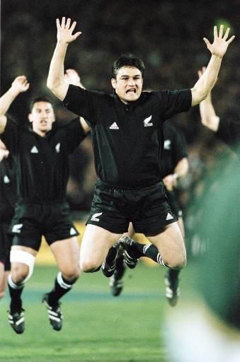
Claim to fame: All Black Captain

Rauemi – Resource (a useful reference for completing this task is contained in Te Tauira Whiri I te Reo “Nga Kupu Hou 2 – Hakinakina 2”)

- Activity 1

Complete the following passage in Maroi using the information in the box above.

- I whanau mau a __________ I te tau__________. I tipu ake ia

ki__________. I haere ia ki te kura tuarua o___________ me te Whare

Wananga o___________. Kei te rongonuitia a Taine mo te

turanga__________ ki roto I te tima hutupaoro o___________.

- Activity 2

Complete the following crossword puzzle. Answers are in Maori.

1 |  |  |  |  |  | 2 |  |  |  |  |  |  |  |  |  | 4
 |  |  |  |  |  | 2 |  |  |  |  | 3
 |  |  |  |  |  |  |  |  |  |  |  |  | 3
 |  |  |  |  |  |  |  |  |  |  | 4

Whakapae | Whakararo
- number eight | - back row
- halfback | 2. 2nd five eighth
- centre | 3. hooker
- prop | 4. left wing

- Activity 3

Join the Maori words to their English equivalent. The first one has been done for you.

- Whakawai (a) try

- tikape (b) scrum

- kakari (c) collapsed

- rutu (d) bind

- takahuri (e) screw

- kaiwhana (f) poach

- hinga (g) tackle

- piro (h) draw

- here (I) hook

- urutomo (j) kicker

- Activity 4

Find the Maori words and mark them in the wordfind puzzle.

W | H | A | N | A | T | E | R | U | P | O | T
H | A | N | A | G | O | E | A | A | I | R | W
A | N | A | H | W | I | A | K | I | R | O | H
K | A | E | I | U | O | T | A | W | O | I | A
A | P | N | M | H | E | O | R | T | A | M | K
R | T | E | I | R | A | K | A | K | I | H | A
A | W | E | O | A | R | O | K | T | W | U | P
R | H | I | R | A | P | E | A | P | E | I | I
A | K | O | T | A | H | A | N | G | A | U | P
N | G | O | R | O | R | A | E | W | P | H | I
G | O | A | A | R | E | T | A | W | E | K | O
I | O | U | T | E | K | U | T | E | K | K | U

kakari | rakaraka
kaiwhara | taweko
ketuketu | whana
kotaha | whakapipi
piro | whakararangi

ANSWERS

- Activity 1

- Taine Randell

- 5:11:74

- Heretaunga

- Lindisfarne

- Otago

- Kapene

- Aotearoa

- Activity 2

K | A | U | A | R | O | T | A | K | A | T | A | H | I |  |  | P
A |  |  |  |  |  | O |  |  |  |  |  |  |  |  |  | A
P |  |  |  |  |  | P | O | U | T | O | K | O |  |  |  | E
A |  |  |  |  |  | A |  |  |  |  | A |  |  |  |  | H
M |  |  |  |  |  | R |  |  |  |  | I |  | T | O | P | A | P | U
U |  |  |  |  |  | U |  |  |  |  | K |  |  |  |  | U
R |  |  |  |  |  | A |  |  |  |  | A |  |  |  |  | M
I |  |  |  |  |  |  |  |  |  |  | P | O | U | M | U | A
 |  |  |  |  |  |  |  |  |  |  | E |  |  |  |  | U
 |  |  |  |  |  |  |  |  |  |  |  |  |  |  |  | I

- Activity 3

- H

- I

- B

- G

- E

- J

- C

- A

- D

- F

- Activity 4

W | H | A | N | A | T | E | R | U | P | O | T
H | A | N | A | G | O | E | A | A | I | R | W
A | N | A | H | W | I | A | K | I | R | O | H
K | A | E | I | U | O | T | A | W | O | I | A
A | P | N | M | H | E | O | R | T | A | M | K
R | T | E | I | R | A | K | A | K | I | H | A
A | W | E | O | A | R | O | K | T | W | U | P
R | H | I | R | A | P | E | A | P | E | I | I
A | K | O | T | A | H | A | N | G | A | U | P
N | G | O | R | O | R | A | E | W | P | H | I
G | O | A | A | R | E | T | A | W | E | K | O
I | O | U | T | E | K | U | T | E | K | K | U

Your score is: Activity 1 _________ (7)

Activity 2 _________ (8)

Activity 3 _________ (10)

Activity 4 _________ (5)

Total _________ (30)

