KAUPAPA MAHI

(Te Wero)

HUIHUINGA TANGATA

HE MAHI WHAKAAHUA
(REO MĀORI).

Reo Māori
Tikanga-a-iwi
Mahi Toi

KAUPAPA: Te Reo Māori TAUMATA 10-12
Tikanga – a – iwi.
WHENU: Mātakitaki, Tuhituhi, Mahi Toi

TE HOROPAKI: He huihuinga tangata – Te Wero

ACHIEVEMENT OBJECTIVES.

- Kia taea te āta matawai pikitia me ōna kaupapa.

- Kia whakatakoto kōrero mai i taua pikitia
- Kia whakawhānuitia ngā mātauranga tikanga me Te Reo Māori.

ESSENTIAL SKILLS  Picture analysis and interpretation  Communication of information through writing.  To gain information on this specific Māori art form | RESOURCES  Task sheet  Writing and drawing equipment  Māori Dictionary.

EXPECTED LEARNING OUTCOMES  To further develop Te Reo and Tikanga Māori skills and knowledge.  To develop skills in picture interpretation and message communication through writing.  To articulate through writing and speaking messages contained within a picture.  To practise drawing of this specific art form. | ASSESSMENT TASKS  Discussion – information processing.  Picture interpretation -- answer questions.  Writing practice – Report writing.  Mini Research  Practise Drawing  Pūhoro forms  Discussion – Report back.

KAUPAPA HĀNGAI: Te Mahi Titiro Pikitia.

NGĀ MAHI.

NGOHE 1

He mahi takirua tēnei. Me mahi tahi kōrua ko tō hoa.
Āta tirohia te pikitia, ka whakawhitiwhiti whakaaro kōrua mo te pikitia nei
(e rima miniti noa iho te roa).

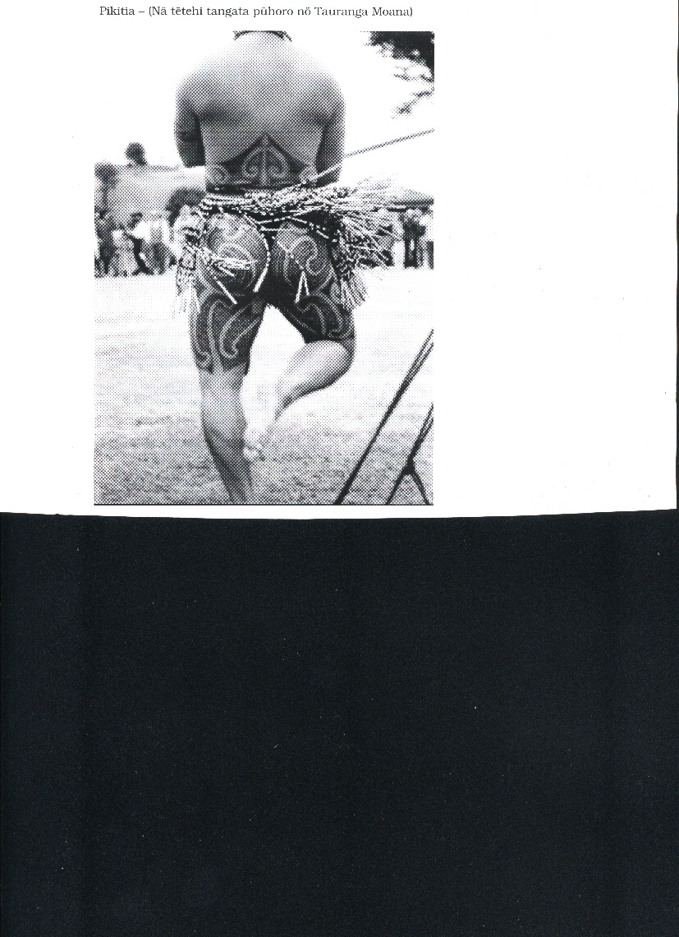

MĀ ĒNEI PĀTAI O KŌRUA WHAKAARO E ARATAKI.

He aha te mahi a te tangata nei?
Kei hea ia? He aha te kaupapa?
He aha ngā whakapaipaitanga i runga i tōna tinana?

NGOHE 2:
Whakahokia ngā pātai i raro iho nei.
Tuhia ō whakahoki ki roto i ngā wāhi wātea.
E hāngai ana ngā pātai ki te pikitia.

- He aha te mahi a te tangata nei?

- He aha te tikanga o tēnei mahi ki tōu mōhio?
- Ki tōu whakaaro, he aha te tino take e mahia ai te mahi nei i ēnei rā?
- He aha ōu whakaaro mo ngā mahi whakapaipai i runga i tōna tinana?
- Ka mahia te mahi nei e wai?
NGOHE 3: Tuhituhi
He Kairipoata koe mo tētahi niu-pepa –a- rohe. I haere koe ki tētahi hui Māori kei te rapu kōrero. Koinei te whakaahua kei te hiahia tō tumuaki ki te whakauru ki roto i te niupepa.
Ko tāu mahi he tuhituhi i ētahi kōrero e hāngai ana ki te whakaahua nei.
(Māu tonu e whakarite i tāu ake kaupapa).
Tuhia o kōrero i raro iho nei – Kia 2-3 pea ngā kōwae.

HE HUI WHAKAHIRAHIRA.

NGOHE 4: HE RANGAHAU ITI
Rapua he kōrero e hāngai ana ki te Tā Moko – ngā Ātanga tangata. Tirohia ngā kōrero e hāngai ana ki te PŪHORO tāne. Tuhia mai he kōrero mo tēna rite. Mā ngā pātai i raro iho nei ō whakaaro e arataki.

He aha te tikanga o te mahi nei?
He aha ngā tino tauira o te pūhoro?
Ko wai ngā tāngata mau pūhoro?
Aha atu….aha atu…..
TUHIA Ō KŌRERO KI RARO NEI

NGOHE 5 HE MAHI TĀ PIKITIA
Whiriwhiria ngā tino tauira o tēnei pūhoro.
Tāhia ki runga pepa, whakaingoatia aua tauira.

HE TAUIRA PŪHORO.

NGOHE 6: Whakawhitiwhiti Korero
Me kōrero tahi kōrua ko tō hoa mo ngā mea hou e pā ana ki te mahi pūhoro.
Kua kitea ake e kōrua i roto i a kōrua rangahau.
(E rima miniti noa iho te roa mo tēnei mahi)

