Lesson Number: 4

Social Studies in the New Zealand Curriculum

Lesson Title: Hikurangi

Level: 4

Strand: Culture and Heritage

Achievement Objective:
Students will demonstrate knowledge and understandings of;
- Why and how individuals and groups pass on and sustain their culture and heritage;
Students could demonstrate such knowledge and understandings when they;
  - Explain why people attach importance to their culture and heritage;
  - Describe various ways in which cultural practices and heritage are recorded and passed on to others (e.g., through myths, legends, stories, carvings, paintings, songs, schooling);
  - Give examples of ways in which people can retain their culture and heritage when they move to a new community.

Learning Outcome Statement:

Students will be able to;
- Relate one traditional narrative associated with Hikurangi Maunga

Teacher and Student Instructions:
Teacher
Copy photo of Hikurangi Maunga to OHP or data show

Resources:

Resource 1 Photo of Hikurangi Maunga

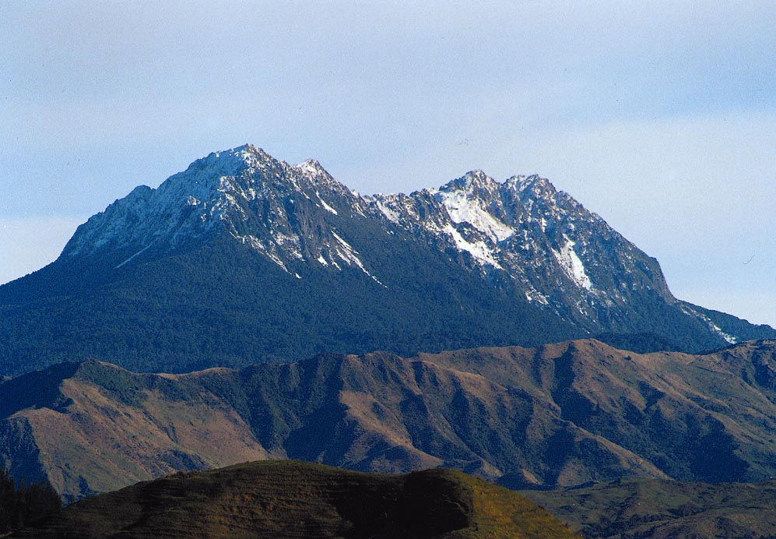

Resource 2

Words from “Ka hoki nei au ki te Tairāwhiti”
nā Peta Awatere

Ko te iwi tena Ngati-Porou
Tatare e maru ana Maunga
Hikurangi te iringa waka o Maui
Tikitiki, te maunga pupu o te
tangata i te tai whakamate a
Ruatapu whakatauki ai
Te Kani a Takirau he maunga
Tu tonu mai onamata tona mana
Tuku iho no Tuawhakarere

Resource 3

Traditional narrative 1
Hikurangi maunga is the sacred mountain of the Ngāti Porou people. The maunga is mentioned in the traditional waiata by Peta Awatere that supports local tradition that Hikurangi is the last resting place of the waka that belonged to Maui-Tikitiki-a-Taranga. The name of the waka is Nukutaimemeha.
The two major peaks on Hikurangi are “Te Tipi o Taikehu” and “Te Tone a Hauku”. The waka Nukutaimemeha is said to lie in a lake between the two peaks called “Te Roto o Hinetakawhiti”.

Traditional narrative 2
Hikurangi Maunga was sanctuary for the people when Ruatapu sent a massive tidal wave to destroy the people of Paikea. The only place that was safe was on Hikurangi Maunga. Ruatapu was the one responsible for the maritime disaster known as “Te Huripureita”. In a cunning plan to become the paramount son of Uenuku in far off Hawaiki, Ruatapu organised a fishing expedition for the mataamua – the first born of Hawaiki, seventy in all. He gathered them together and in a waka built by his uncle Haeora and called “Tutepewa-a-rangi, set sail for the fishing grounds. Once out at sea he capsized the waka and set about killing all his brothers. Paikea however escaped and Ruatapu drowned. But he was still about to send as part of his revenge the great flood called “Te Tai-a-Ruatapu”.

Traditional narrative 3
In 1856 Te Kani-a-Takirau was asked to be the first Māori King. A delegation from Tūwharetoa, Tainui, Te Arawa and Kahungunu arrived in Ūawa with the request. He politely accepted his manuhiri but declined the offer quoting what has now become a Ngāti Porou banner standard for self determination, pride and unity. He said,
“Ehara taku maunga a Hikurangi i te maunga nekeneke, he maunga tū tonu mai onamata. Ko tōku mana tuku iho nō Tuawhakarere, he ihu tō mai nō Te Pō.”
“My mountain Hikurangi is a mountain that does not move, it is a mountain that has stood steadfast from time immemorial. My lineage is an ancient one a legacy from the time of the great night.”
Te Kani-a-Takirau was one of the last great ariki of Ngāti Porou.

Resource 4
References
References:

Mahuika, A.T. 1973 Nga Wahine Kai-Hautu o Ngati Porou
M.A. Thesis Sydney University, Australia.

Mahuika, A.T. 1973 He Pitopito Korero mo Hikurangi Maunga

Ngata,A.T. 1941 Rauru-nui-a-Toi Lectures. Te Whanau
Ngata. Sir Henare Ngata Gisborne.

Activity Tasks in Sequence:

(1) Show photo of Hikurangi Maunga on OHP or Data Show.
(2) Organise students into three groups
(3) Give each group one of the narratives.
(4) Groups report back – explaining their particular narrative.
(5) Teacher asks students questions relating to narratives.

Assessment Tasks:

Students answer questions relating to narratives
Marking Schedule:
(1) Hikurangi is the sacred of which people?
Ngāti Porou
(2) Name the two peaks of Hikurangi maunga
Te Tipi o Taikehu and Te Tone o Hauku
(3) What is the name of the lake that lies between the two peaks?
Te Roto o Hinetakawhiti
(4) What is the name of the waka belonging to Maui?
Nukutaimemeha
(5) What was Ruatapu’s cunning plan?
To kill all the mātaamua of Hawaiki
(6) What was the name of the waka built by his uncle Haeora?
Tūtepewa-a-Rangi
(7) What was the name of his brother who escaped his evil plan?
Paikea
(8) The tragedy at sea was known as …
Te Huripureiata
(9) What was the name of the wave that Ruatapu sent as revenge against Paikea?
Te Tai-a-Ruatapu
(10) Who was Te Kani-a-Takirau?
Paramount chief-Ariki of Ngāti Porou
(11) He was approached to be the …
The first Māori King
(12) What did he say …
Ehara taku maunga a Hikurangi i te maunga nekeneke. He maunga tū tonu mai onamata.

