Lesson Number: 10

Social Studies in the New Zealand Curriculum

Lesson Title: Paikea

Level: 4

Strand: Culture and Heritage

Achievement Objective:

Students will demonstrate knowledge and understandings of;
- Why and how individuals and groups pass on and sustain their culture and heritage;
Students could demonstrate such knowledge and understandings when they;
  - Explain why people attach importance to their culture and heritage;
  - Describe various ways in which cultural practices and heritage are recorded and passed on to others (e.g., through myths, legends, stories, carvings, paintings, songs, schooling);
  - Give examples of ways in which people can retain their culture and heritage when they move to a new community.

Learning Outcome Statement:
Students will be able to;
(1) Give the versions of Te Rāwheoro and Whitireia Whare Wānanga as to who the parents of Paikea were.
(2) Whakapapa from Paikea to Porourangi
(3) Say where Paikea landed in Aotearoa
(4) Say who was the son who came to see him at Whangarā-mai-tawhiti
(5) Tell class the name of at least one of his wives
(6) Give the name of the wharenui at Whangarā-mai-tawhiti

Teacher and Student Instructions:

Copy photo of Whitireia Wharenui onto OHP or Data Show

Resources:
Resource 1 Photo of Whitireia Wharenui

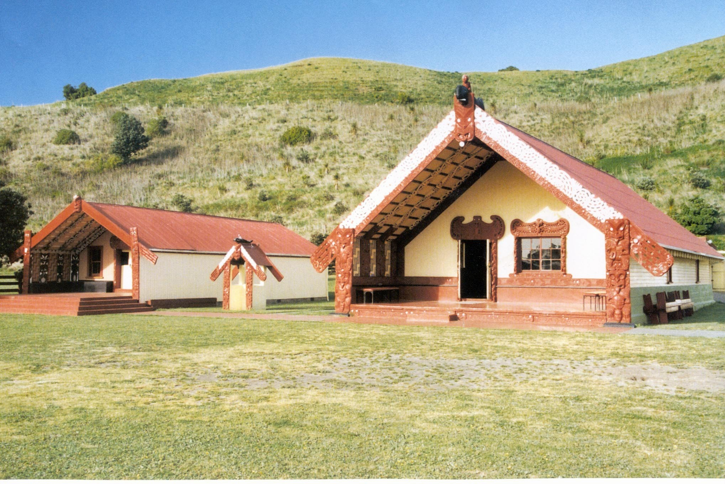

Resource 2
Traditional narrative 1

Paikea
According to the Te Rāwheoro Whare Wānanga, Rongomaitahanui and Taneuarangi were the parents of Paikea. According to the Whitireia Whare Wānanga, Uenuku and Rangatoro were his parents.
Paikea was the sole survivor of the maritime disaster known as “Te Huripureiata”. Where his brother Ruatapu attempted to murder all the first born of Hawaiki so that he would be the heir to the mana-prestige of Uenuku. Paikea was able to call upon his ancestor, the whale to come to his rescue. He came ashore at Ahuahu (Great Mercury Island) and made his way south in search of a home which resembled his Whangarā, in Hawaiki. He married Huturangi at Te Kautuku near Rangitukia on the East Coast. They moved further south finally settling at a place which he called Whangarā-mai-tawhiti, Whangarā from afar.
Rongomaituaho travelled from Hawaiki in search of his father. Rongomaituaho was a son by the marriage of Paikea to a woman in Hawaiki called Hauwhakaturia. Father and son were reunited in Whangarā-mai-tawhiti where their descendants live today.
Whitireia is the name of the Wharenui at Whangarā-mai-tawhiti. Paikea is the tekoteko on top of the wharenui. He can been seen astride his whale.

Resource 3

Paikea Whakapapa

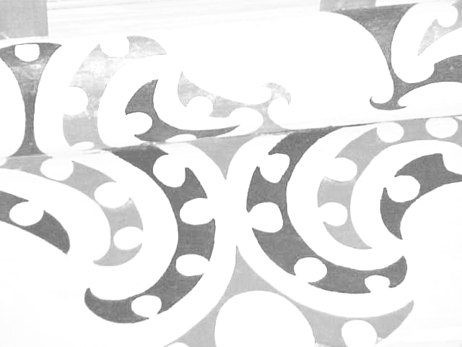
Paikea

Pouheni

Tarawhakatu
Nanaia
Porourangi

Activity Tasks in Sequence:
(1) Tell class story of Paikea
(2) Show photo of Whitireia Wharenui (and Wahoterangi) which stand at Whangarā-mai-tawhiti.
(3) Give students whakapapa from Paikea to Porourangi. Students memorise names.
(4) Students write down names of the Whare-Wānanga. Te Rāwheoro and Whitireia.
Write names of parents under each whare wānanga.

Assessment Tasks:
Answer questionnaire

Marking Schedule:

(1) According to the Te Rāwheoro Whare Wānanga who were the parent’s of Paikea?
Rongomaitahanui(Mummy) and Taneuarangi(Daddy)
According to the Whitireia Whare Wānanga who were the parents of Paikea?
Uenuku(Daddy) and Rangatoro(Mummy)
(2) Please write the whakapapa from Paikea to Porourangi
Paikea
Pouheni
Tarawhakatu
Nanaia
Porourangi
(3) Where did Paikea land in Aotearoa?
Ahuahu (Great Mercury Island-Bay of Islands)
(4) Who was the son who came to see him at Whangarā-mai-tawhiti?
Rongomaituaho
(5) Name one of the wives of Paikea
Hauwhakaturia or
Huturangi
(6) What is the name of the wharenui at Whangarā-mai-tawhiti?
Whitireia

