Lesson Number: 11

Social Studies in the New Zealand Curriculum

Lesson Title: Porourangi

Level: 4

Strand: Culture and heritage

Achievement Objective:

Students will demonstrate knowledge and understandings of;
- Why and how individuals and groups pass on and sustain their culture and heritage;
Students could demonstrate such knowledge and understandings when they;
  - Explain why people attach importance to their culture and heritage;
  - Describe various ways in which cultural practices and heritage are recorded and passed on to others (e.g., through myths, legends, stories, carvings, paintings, songs, schooling);
  - Give examples of ways in which people can retain their culture and heritage when they move to a new community.

Learning Outcome Statement:
Students will be able to;
(1) Say where Porourangi was born
(2) Give his full title or name
(3) Recite the whakapapa from Paikea to Porourangi
(4) Tell the class who he married
(5) Identify Porourangi Wharenui
(6) Say where Porourangi was born
(7) Recount the circumstances of his death
(8) Say who led the building of Porourangi wharenui

Teacher and Student Instructions:
Copy the photo of Porourangi Wharenui to OHP or Data Show
Copy the photo of Rapata Wahawaha to OHP or Data Show
Copy whakapapa from Paikea to Porourangi to distribute to class.

Resources:

Resource 1 Photo of Porourangi Wharenui

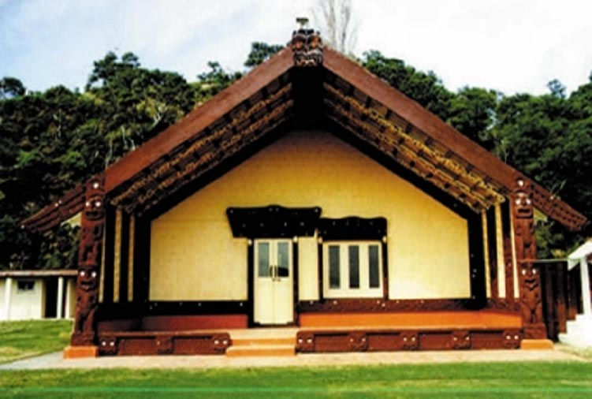

Resource 2 Photo of Rapata Wahawaha

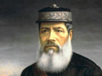

Resource 3 Whakapapa from Paikea to Porourangi

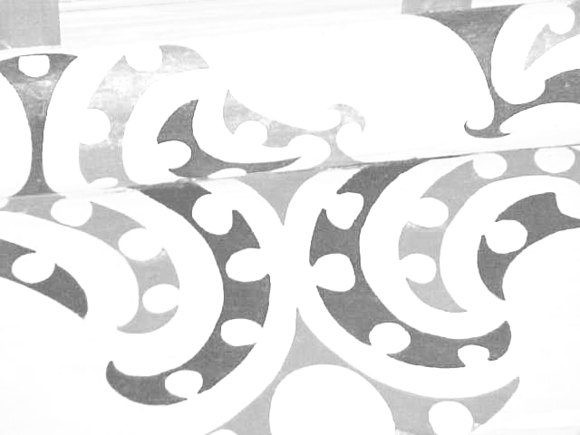

Paikea Whakapapa

Paikea

Pouheni

Tarawhakatu
Nanaia
Porourangi

Resource 4
Traditional narrative 1
Porourangi was born at Whangarā-mai-tawhiti. His parents were Nanaia and Niwaniwa. The tribal group Ngāti Porou are named after this very important ancestor.
His full name was, Porouariki-te matatara-a-whare-te-tuhi-mareikura-a-Rauru. He was the first born son of an extremely important genealogical whakapapa line. Porourangi was the converging point for many of the most senior whakapapa lines in Aotearoa and the Pacific. He married Hamoterangi and their first child was a son called Hau.
He had a number of Pā or homes. One was at Whangarā called Te Wharemapou and another was at Ūawa called Te Rāroa.
In old age Porourangi wanted to go fishing which would have meant that he violated his very tapu status. He was stung by a “moho” fish and died upon returning to shore.
Porourangi is commemorated in the Porourangi Wharenui which stands at Waiomatatini in Ruatoria. The wharenui was commissioned by Rapata Wahawaha and is testimony to the significance of the ancestor today.

Activity Tasks in Sequence:
(1) Show students photo of Porourangi Wharenui
(2) Read traditional narrative 1 to students. Then give them a copy of narrative. Or they can copy it from the OHP or Data Show.
(3) Organise students into groups of 3
(4) Give each group a copy of the whakapapa
(5) Groups have 5 minutes to memorise whakapapa
(6) Each group then recounts the story of Porourangi including the whakapapa from Paikea

Assessment Tasks:
Students recount story of Porourangi including giving whakapapa from Paikea.

Marking Schedule:
Account of Porourangi must include;
(1) Where Porourangi was born
Whangarā-mai-tawhiti
(2) His full title or name
Porouariki-te matatara-a-whare-te tuhi mareikura-a-Rauru
(3) A recitation of the whakapapa from Paikea to Porourangi
Paikea
Pouheni
Tarawhakatū
Nanaia
Porourangi
(4) The name of his wife
Hamoterangi
(5) Where Porourangi wharenui is situated
Waiomatatini, Ruatoria
(6) An account of the circumstances of his death
Stung by a moho while out fishing
(7) The name of the man who instigated the building of Porourangi Wharenui.
Rapata Wahawaha
(8) When shown the photo of Porourangi wharenui students are able to identify it accurately.

