Lesson Number: 13

Social Studies in the New Zealand Curriculum

Lesson Title: Ngā Wharenui o Ngāti Porou

Level: 4

Strand: Culture and Heritage

Achievement Objective:

Students will demonstrate knowledge and understandings of;
- Why and how individuals and groups pass on and sustain their culture and heritage;
Students could demonstrate such knowledge and understandings when they;
  - Explain why people attach importance to their culture and heritage;
  - Describe various ways in which cultural practices and heritage are recorded and passed on to others (e.g., through myths, legends, stories, carvings, paintings, songs, schooling);
  - Give examples of ways in which people can retain their culture and heritage when they move to a new community.

Learning Outcome Statement:

Students will be able to
(1) identify 6 Ngāti Porou Wharenui
(2) understand the significance of Wharenui as repositories of tribal histories
(3) Identify one ancestor with each wharenui

Teacher and Student Instructions:

Copy Ngāti Porou Wharenui to OHP or Data Show

Resources:

Resource 1 Ngā Wharenui o Ngāti Porou x 6
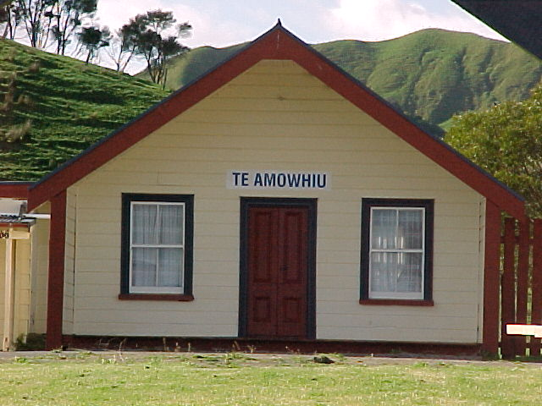
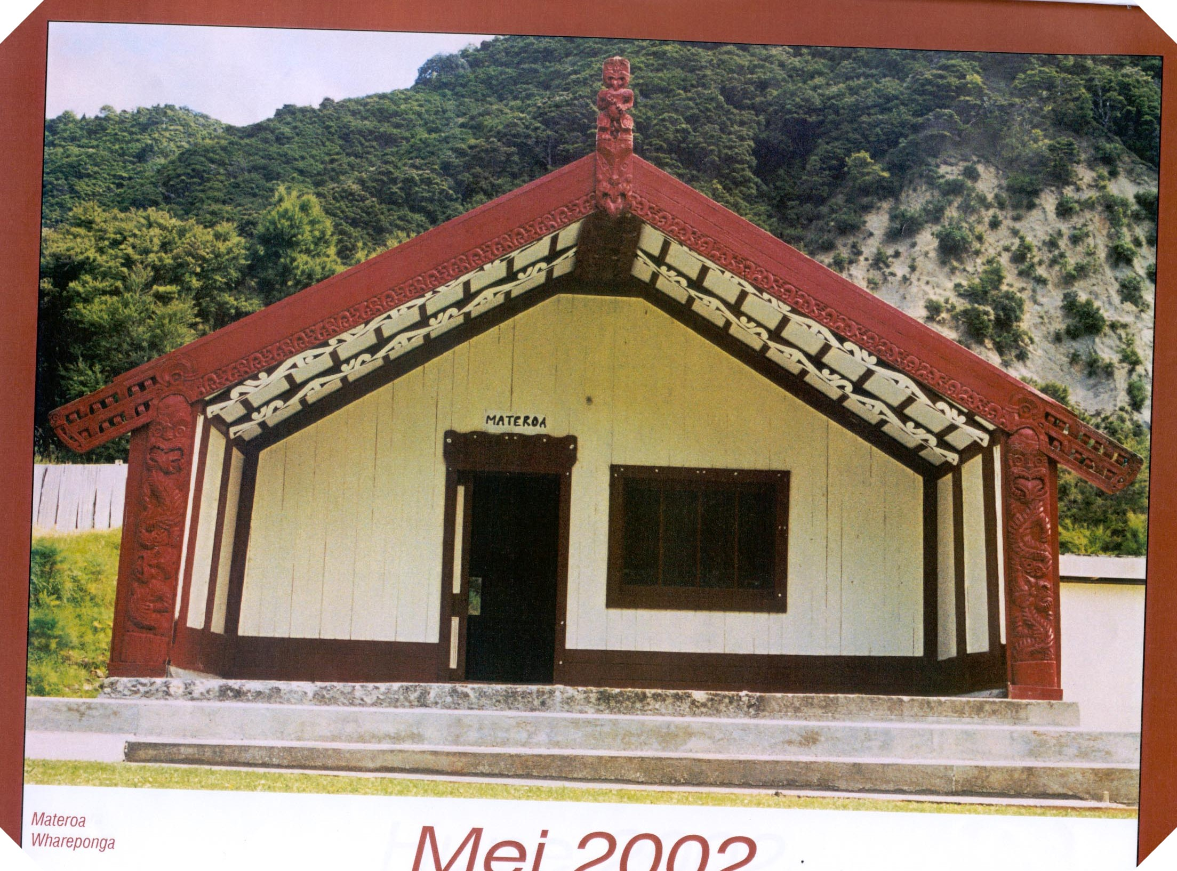

Te Amowhiu Wharenui Materoa Wharenui

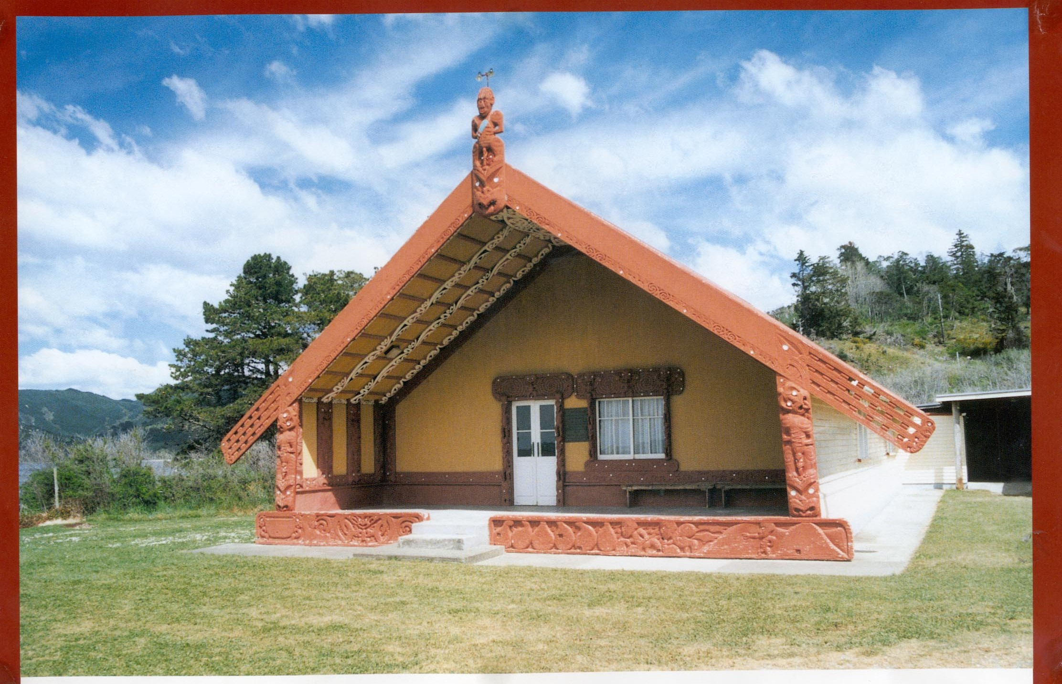
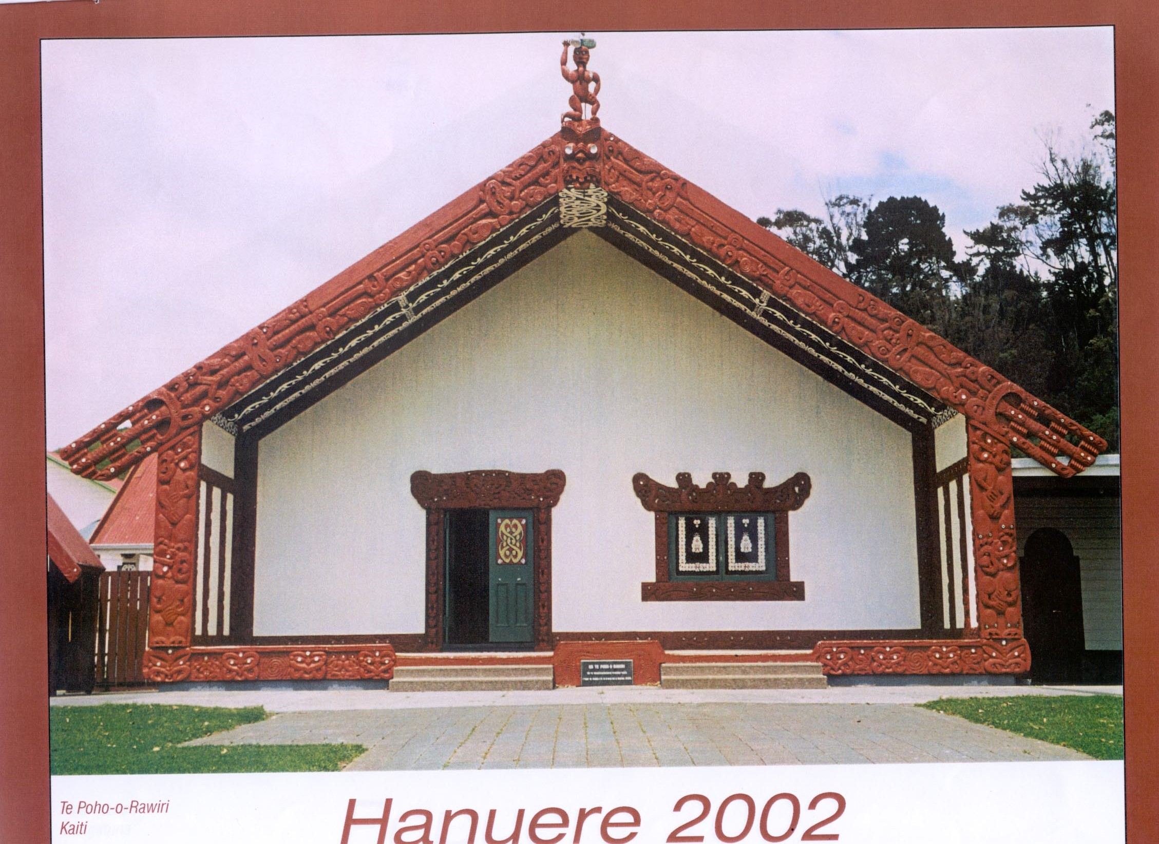

Te Poho o Rāwiri Iritekura Wharenui

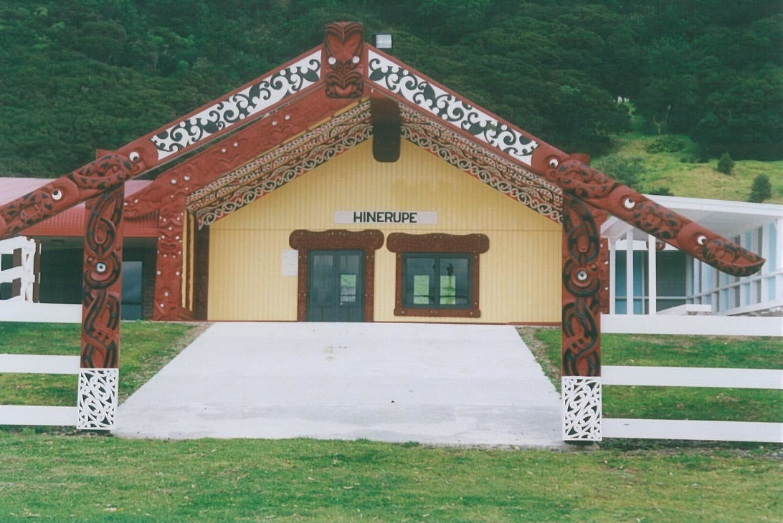
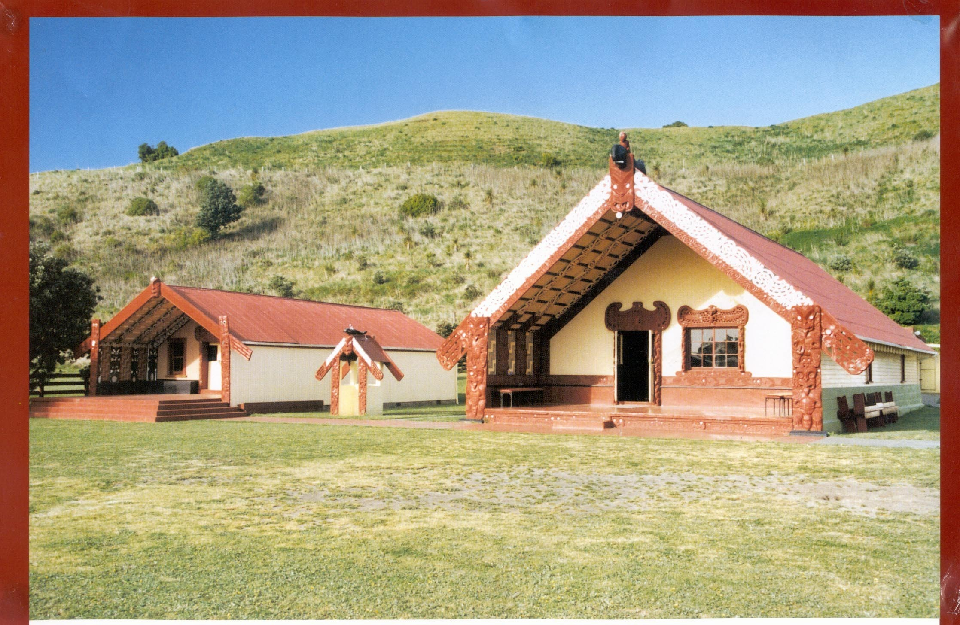

Whitireia Wharenui Hinerupe Wharenui

Activity Tasks in Sequence:
(1) Discuss significance of Wharenui as repositories of tribal histories and a gather place for the whānau and hapū and iwi events and activities.
(2) Show Photographs of Ngāti Porou Wharenui.

Te Amowhiu | Materoa | Te Poho-o-Rāwiri | Iritekura | Whitireia | Hinerupe
Rangipureora  Kuranui | Te Aitanga-a-Mate | Oneone | Iritekura | Konohi | Hinerupe
Uawa | Whareponga | Kaiti-Tūranga | Waipiro | Whangarā | Te Araroa

(3) Discuss hapū associated with wharenui. Identify wharenui with rohe (district).

Assessment Tasks:

Students identify photographs of wharenui correctly

Students identify Wharenui with tipuna and rohe.

Marking Schedule:

Wharenui | Hapū | Rohe
Te Amowhiu | Te Whānau-a-Rangipureora  Ngāti Kuranui | Ūawa
Materoa | Te Aitanga-a-Mate | Whareponga
Te Poho o Rāwiri | Ngāti Oneone | Kaiti/Tūranga
Iritekura | Te Whānau-a-Iritekura | Waipiro
Whitireia | Ngāti Konohi | Whangarā
Hinerupe | Te Whānau-a-Hinerupe | Te Araroa

