Lesson Number: 16

Social Studies in the New Zealand Curriculum

Lesson Title: Te Kani-a-Takirau #2

Level: 3

Strand: Time, Continuity, and Change

Achievement Objective:
Students will demonstrate knowledge and understandings of;
- How the ideas and actions of people in the past changed the lives of others;
Students could demonstrate such knowledge and understandings when they:
- Give examples of why particular women, men and children in the past are remembered
- Describe peoples ideas and actions that changed the lives of other people in particular times and places;
- Explain consequences of ideas and actions of people in the past;
- Explain the likely future significance of these ideas and actions.

Learning Outcome Statement:

Students can;
- Give three (3) reasons why Te Kani-a-Takirau was of ariki status.
- Say who his parents were
- Say who his grandparents were
- Identify at least three (3) things that he did to assist his people

Teacher and Student Instructions:
Teacher
Copy Resources 1-4 for data show or to be used on OHP

Resources:

Resource 1 Photo of Te Kani-a-Takirau

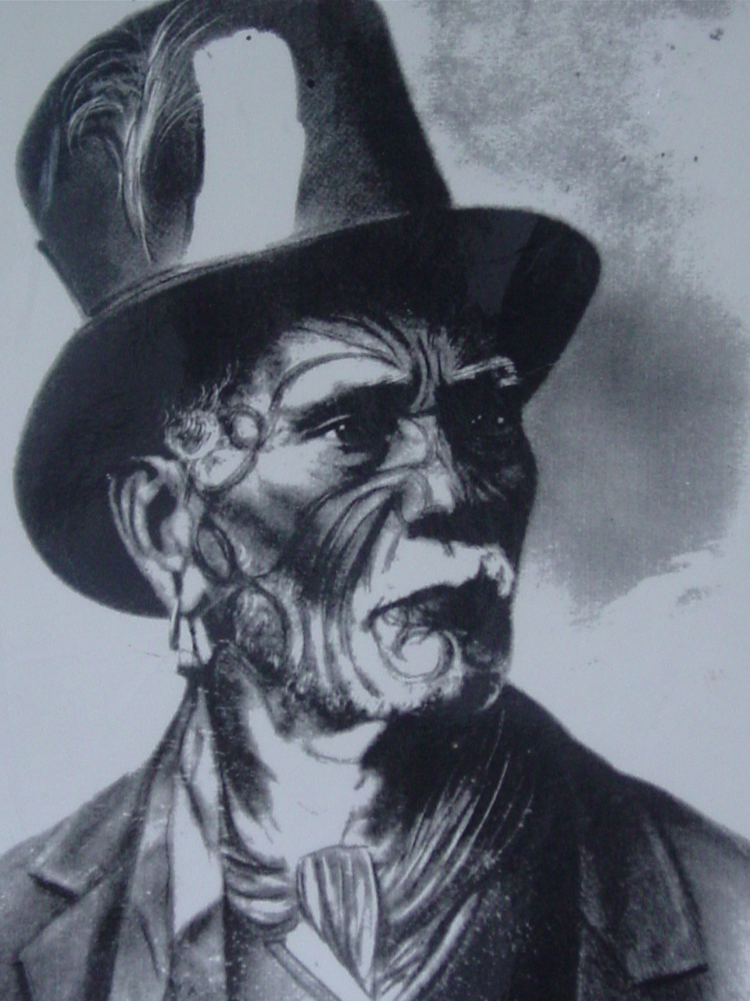

Te Kani-a-Takirau 1799?-1856

Resource 2 Biography of Te Kani-a-Takirau

Te Kani-a-Takirau: Ngāti Porou Ariki (paramount chief).
The leadership of Te Kani-a-Takirau, paramount chief of Ngāti Porou, spanned the period of transition in the early 19th century from a society based on traditional leadership to one shaped by attitudes towards Pakeha colonisation. He was the son of Te Rongotumamao and Ngarangikahiwa.
Born into a time of fractionalised tribal warfare and burgeoning settler presence, Te Kani-a-Takirau stood between a traditional tribal society and a competitive market driven world. He achieved eminence in both, encouraging his people to maintain the relevant and appropriate tenants of cultural precepts and principles while adapting to the technologies and theologies introduced by the new settlers.
For the people of the East Coast he was the converging point of some of the most illustrious descent lines of Ngāti Porou and neighbouring tribes. He was not only a significant figure in the political environment of Māoridom but was also a repository of tribal knowledge and lore.
He succeeded to the prestige and authority of his maternal grandmother, Hinematioro and his paternal grandfather, Te Whakatatare-o-te-rangi. He lived in Ūawa (Tolaga Bay) but also had residence in Whangarā and Tūranga.
Te Kani-a-Takirau was considered to be extremely sacred and as a young person always travelled under the protection of complex and powerful karakia (incantations) and a retinue of the finest warriors. If a pa, which he was visiting, was attacked he would be borne away by a small force dedicated to ensuring his safety.
Involved in a number of inter-tribal battles where he saw many close family members perish, Te Kani-a-Takirau became a strong advocate of negotiation and mediation as a means of resolving disputes and conflict rather than war.
He was greatly respected by the early traders and missionaries to the area and excelled in creating industry and commerce from which his people derived much benefit. At the height of his entrepreneurial and business powers he had at least 200 people employed in growing crops and preparing flax-flax rope for sale. He was one of the first Māori in the country to own a schooner which traded flax between Ūawa and Auckland and Auckland and Sydney, Australia.
Māori and Pakeha alike were struck by his physical bearing with the trader Polack recording the following;
“He approached the vessel in a small canoe, undistinguished from his people, either in dress or style; his person was noble, in height somewhat above six feet, and by his dignified walk, commonly assumed by superior men in rank, he shone pre-eminent above his companions; his age about thirty six years, his countenance handsome but little marked with the moko…”
In 1844 the Reverend Stack described Te Kani-a-Takirau as;
“An extremely handsome man with very regular features every part of his face being beautifully tattooed. His voice was pleasant and the whole appearance of the man was so singularly dignified that our interview made an indelible impression on my mind. He was clad in native garments and remained seated during our short visit. There was nothing about our surroundings to impress one; … But the man himself was quite different from anyone else I had ever seen. He possessed such an indescribable air of distinction that I felt quite awestruck in his presence”. And Baker similarly records Te Kani-a-Takirau as being a “man of
Princely appearance, tall, fair and handsome with curly auburn hair and possessing all the qualities of one of nature’s gentlemen. Being a man of extra high birth he was looked upon as sacred by his people who he could sway in any direction by a word or wave of his hand”.
He married a number of woman as was the tradition for men of his rank and by Hine-i-tieri-i-te-rangi he had a son called Te Waikari. Unfortunately Te Waikari was stricken with a fatal illness while a young man and he died leaving no issue and no heir for his father Te Kani-a-Takirau.
In later life Te Kani-a-Takirau was approached to be the first Māori King which he declined with the now ‘oft quoted phrase, “Ehara taku maunga a Hikurangi i te maunga haere, he maunga tū tonu mai onamata ko tōku mana tuku iho nō Tuawhakarere. He ihu tō mai nō Te Pō”.
“My mountain Hikurangi is a mountain which does not move, it has stood resolute since time immemorial, my prestige is a lineage from an ancient time. The prow of which comes from The (time of) Great Night.
The Treaty of Waitangi was signed in his house called “Te Kani” but he did not sign. And while he supported the work of the missionaries he never converted to Christianity.
Te Kani-a-Takirau also married Te Amotawa who was with him when he died in 1856.
Today, Te Kani-a-Takirau continues to personify tribal identity, authority and unity. A shining example of maintaining relevant cultural beliefs and practices while adapting to and mastering the new technologies and information of the time for the benefit of the people.

Resource 3 Whakapapa of Te Kani-a-Takirau

Paikea
Pouheni
Tarawhakatu
Nanaia
Porourangi
Hau
Rakaipo
Manutangirua
Hingangaroa
Hauiti
Hinetera
Tutekohi
Tamatanui
Hurawaikato
Te Whakapiuarangi
Te Whakahioterangi
Ponui
Konohi
Marukawiti === Te Umupapa
Hineturaha = Te Kaingakiore Tanetokorangi = Ngunguruterangi
Te Whakatatare-o-te-rangi = Hineirahirahiaiterangi Hinematioro = Te Hoatiki
Te Rongotumamao =========== Ngarangikahiwa
Te Kani-a-Takirau
Te Waikari

According to traditional narratives the mana of Te Kani-a-Takirau to lead the people passed to Hirini Tuahine Te Kani-a-Takirau, the son of the Tūranga chief, Rāwiri Te Eketuoterangi. Te Kani-a-Takirau had taken Hirini as a whāngai when Te Waikari died. The authority to protect the people passed to Karauria Pahura.

Resource 4 Photographs of :

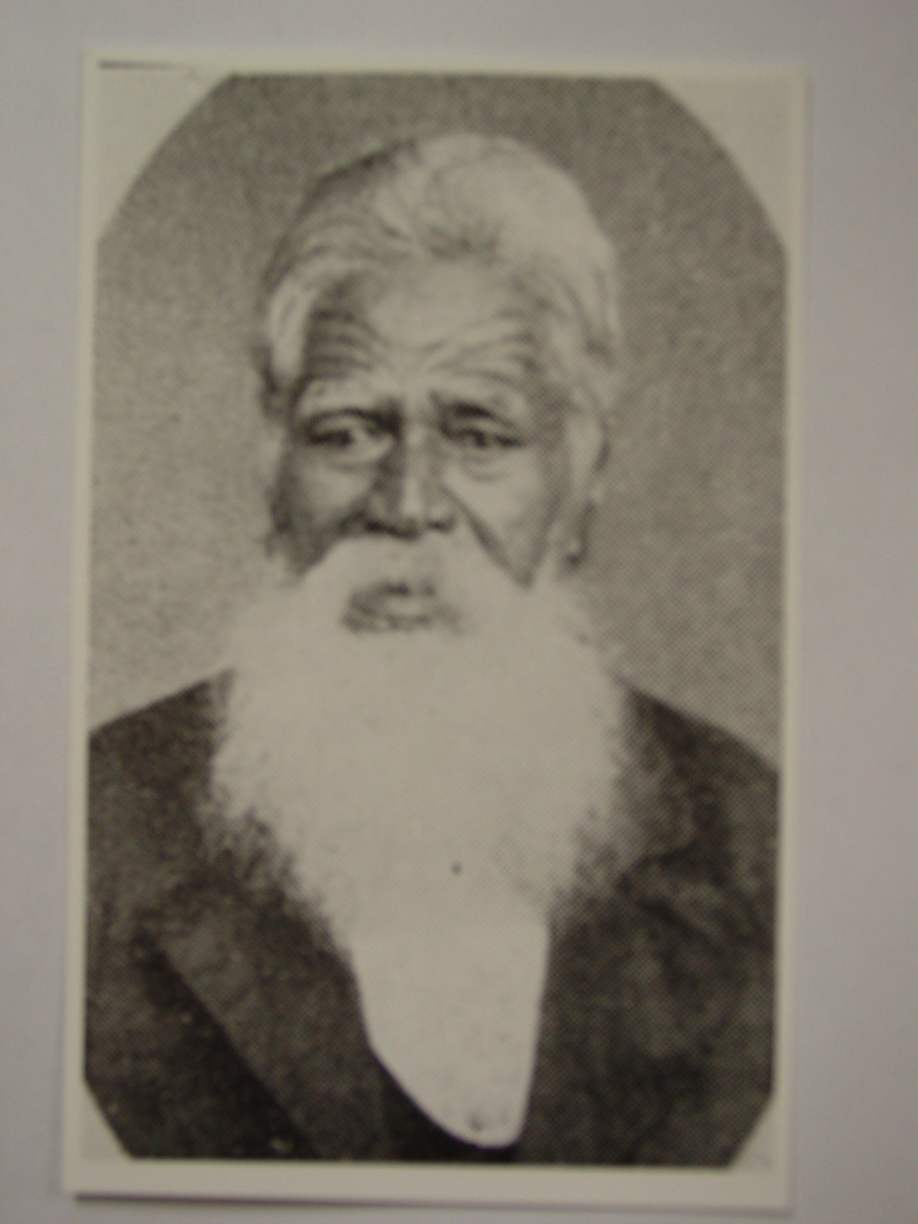
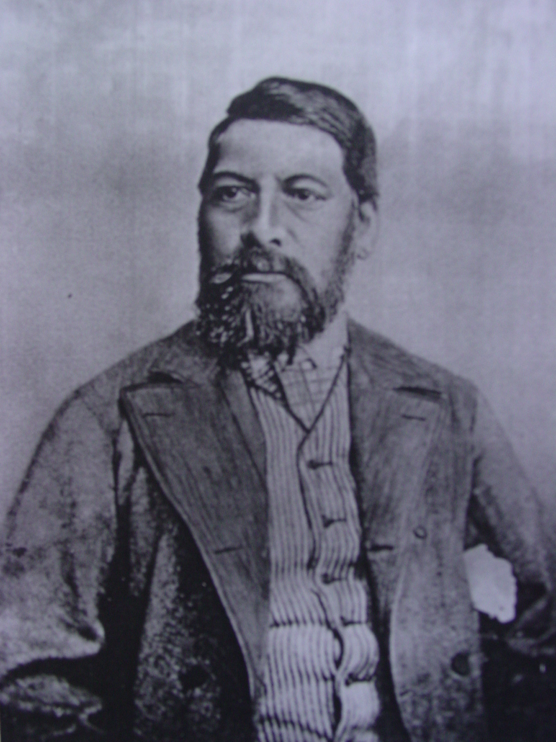

Karauria Pahura Hirini Te Kani
Resource 5 OHP
Resource 6 Data show projecter
Resource 7 A3 sheets of paper and black vivid markers
Resource 8 Koauau music

Activity Tasks in Sequence:

1 Introduction
Play Koauau music 1-2 minutes
Show class photograph of Te Kani-a-Takirau on OHP or Data Show.
Discuss life in Aotearoa New Zealand in the 1800’s

2 Let’s Begin
(a) Put students into groups with 1 piece of paper and vivid marker.
(b) Show Resource 2 on OHP or Data show.
(c) Get class to read out loud biography. Explain new vocabulary.
(d) Students write ‘Te Kani-a-Takirau’ Ariki on their paper.
(e) Discuss in group why Te Kani-a-Takirau was an Ariki.
(f) Write three reasons on paper.
(g) Write down who his parents and grandparents were.
(h) Identify three (3) things that the students think he did to help his people. Write these down on the paper.
Assessment Tasks:
Students select a reporter from each group who reads out their three (3) reasons why Te Kani-a-Takirau was an ariki. The reporter also reads outs who his parents and grandparents were concluding with at least three things he did to help his people.

Marking Schedule:

Three (3) reasons why Te Kani-a- Takirau was an ariki;
(1) Whakapapa; Heaps of senior lines of descent converged on him.
(2) What his tipuna did, mainly the good things! They helped protect the interests of the people against outside invasion.
(3) What he did to help the people, the people admired and respected him because he acted in their best interest and was always looking for ways to benefit the collective of whānau and hapū who he acted as supreme administrator for.
Parents: (Daddy) Te Rongotumamao and (Mummy) Ngarangikahiwa.
Paternal Grandfather: Te Whakatatare-o-te-rangi
Maternal Grandmother: Hinematioro.
The three things he did to help his people;
(a) Maintained the relevant traditions of his tipuna
(b) Used new technology and education for the benefit of the people.
(c) Saw negotiation and mediation as better ways of resolving conflict than war.
(feel free to include other activities with equal validity)

