Lesson Number: 17

Social Studies in the New Zealand Curriculum

Lesson Title: Puketawai Marae

Level: 3

Strand: Time, Continuity, and Change

Achievement Objective:
Students will demonstrate knowledge and understandings of;
- How the past is recorded and remembered in different ways.
Students could demonstrate such knowledge and understandings when they:
- Identify ways people can find out about their past;
- Explain how people’s experiences and activities have been recorded in different time and place settings
- Explain what people in the present can learn about people in the past though records.

Learning Outcome Statement:
Students will be able to;
- Identify a photograph of Puketawai Marae
- Say the name of the Wharenui and Wharekai
- Name the Kohanga Reo
- Name two tipuna photographs inside the wharenui
- Name two tipuna photographs (W.W2 soldiers) inside the Wharekai.
- Pronounce correctly the whakapapa from Hauiti to Te Amowhiu.

Teacher and Student Instructions:
Teacher
Copy photo of Puketawai Marae- Wharenui and Wharekai and Kohanga Reo
With permission of Marae-whānau copy tipuna photographs to OHP or Data Show.
Copy whakapapa from Hauiti to Te Amowhiu on Whiteboard or to OHP or Data Show
Students
Copy outline of marae onto paper

Resources:

Resource 1 Photographs of Puketawai Marae

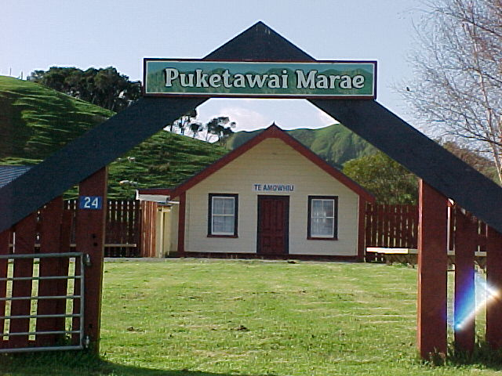

Puketawai Marae

Resource 2 Photographs of Tipuna

Resource 3 Whakapapa from Hauiti to Te Amowhiu

Hauiti
Tamateapaia
Angiangiterangi
Tutekaniwha
Te Rangitetakoria
Te Amowhiu

Resource 4
Large sheets of white paper and crayons

Activity Tasks in Sequence:
Introduction
(a) Show class a photograph of Puketawai Marae.
(b) Explain how marae in Ūawa help keep the history of Te Aitanga-a- Hauiti tipuna alive. Puketawai is one of the marae.
(c) Share information about marae students know of or belong to.

Lets Begin
(a) Say the name of the Wharenui and Wharekai
(b) Students repeat
(c) distribute sheets to students
(d) Students draw outline of marae and name buildings
(e) Students draw outline of Kohanga Reo and name Kohanga building.
(f) Show students photographs of tipuna from inside wharenui.
(g) Discuss tipuna, when they lived and who they are related to (if possible).
(h) Show students photographs of C company soldiers.
(i) Discuss Soldiers from Ūawa who went off to war.
(j) Students recite whakapapa from Hauiti down to Te Amowhiu.

Assessment Tasks:

(a) Students draw outline of marae and name buildings. They are asked to name the buildings.

(b) Students draw outline of Kohanga Reo and name Kohanga building.

(c) Students are asked what is the Kohanga Reo about.

(d) Students can say why photographs are kept in the wharenui.

(e) Why are photographs of the soldiers kept in the Wharekai?

(f) Why did they go to war?

(g) Recite the names in the whakapapa from Hauiti to Te Amowhiu..

Marking Schedule:

(a) Wharenui Te Amowhiu
Wharekai Ngā Tūngane Rere ki te Pakanga
(b) Kohanga Reo E Tipu
(c) The Kohanga is about keeping the Māori Language alive.
(d) To remind the whānau who has passed on.
(e) A memorial to remind the whānau that they fought to save us all.
(f) To fight against those who wanted to take over the world.
(g) Hauiti
Tamateapaia
Angiangiterangi
Tutekaniwha
Te Rangitetakoria
Te Amowhiu

