Lesson Number: 22

Social Studies in the New Zealand Curriculum

Lesson Title: Ruakapanga #2 The Play

Level: 4

Strand: Culture and Heritage

Achievement Objective:
Students will demonstrate knowledge and understandings of;
- Why and how individuals and groups pass on and sustain their culture and heritage;
Students could demonstrate such knowledge and understandings when they;
  - Explain why people attach importance to their culture and heritage;
  - Describe various ways in which cultural practices and heritage are recorded and passed on to others (e.g., through myths, legends, stories, carvings, paintings, songs, schooling);
  - Give examples of ways in which people can retain their culture and heritage when they move to a new community.

Learning Outcome Statement:
Students can;
Make up a skit about the Ruakapanga story.

Teacher and Student Instructions:
Teacher
Copy photo of Ruakapanga wharenui onto OHP or on file to show via projector.
Copy story of Ruakapanga for students

Resources:

Resource 1
Photo of Ruakapanga wharenui

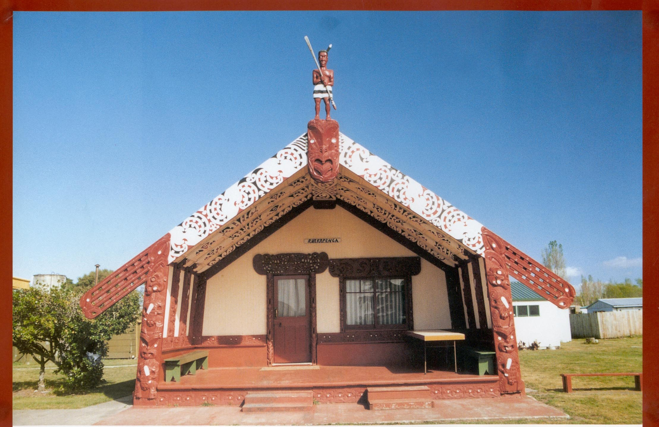

Resource 2
Story of Ruakapanga

Ruakapanga

The story of how the kumara came to this land

Characters Ruakapanga, Pourangahua, Tiungarangi, Harongarangi, Kanioro, Tamaiwaho, Mokowhiti, Anuhe and Mokoroa.
Ku and Mara, two twin kumara.
Narrator

Narrator Our story begins outside a wharenui in Hawaiki, the ancient homeland. Pourangahua has gone to visit the great chief Ruakapanga. Pourangahua would like to borrow the fabulous birds of Ruakapanga, Tiungarangi and Harongarangi.

Scene One (knock, knock, knock)

Ruakapanga (singing) who’s that knocking at my door? Come on in.
Haramai, kuhu mai. Enter, enter.

Pourangahua (Enters) Kia ora koro.

Ruakapanga Kia ora Pou! Kei te aha koe?

Pourangahua Kei te pai, kei te pai!

(Both men hongi)

Ruakapanga Sit down my good friend. I don’t see enough of you.

Pourangahua And I you. You are looking well.

Ruakapanga Ae, ae, Kia ora. Thank you. What have you been up to?

Pourangahua I’ve just returned from Uawa in Aotearoa. We had to come back to get some kumara. My wife, Kanioro, stayed behind to prepare the land for planting.

Ruakapanga Don’t they have any kumara over there in the land of Kupe?

Pourangahua No. They’ve got some aruhe but it’s rather tasteless.

Ruakapanga Were you able to get some kumara?

Pourangahua Yes. But our waka is in the garage and I have to find another way to get our kumara back to Aotearoa. I was wondering if I could borrow your great birds to take me and the kumara back.

Narrator. Ruakapanga hesitates because he has great affection for his birds. After a great deal of thought he agrees but cautions Pourangahua.

Ruakapanga Yes you may borrow my birds, Tiungarangi and Harongarangi. I love my pet birds dearly. But remember this. As soon as you arrive in Uawa you must release my birds before the sun rises.
Ruakapanga calls out to Tiungarangi and Harongarangi. He says a karakia to guide them safely on their journey. Pourangahua places the kumara on Harongarangi and gets on board Tiungarangi.
Porangahua thanked Ruakapanga and told him not to worry. He would look after the birds and let them go before the sun rose.
With a great beating of wings, the merry trio and the precious cargo of kumara flew off. Bound for Aotearoa.

Pourangahua Up my beauties and away!!!

Ku Wow! This is the highest I’ve ever been.

Mara Me too. Where are we going?

Ku To the Great fish of Maui. To the land of Kupe, Aotearoa. Estimated time of arrival, apopo.

Ku Wow!

Narrator After a few hours flying, Pourangahua sees Aotearoa in the distance.

Pourangahua Yippeee! Land ahoy!

Tiungarangi We’re on time Haro.

Harongarangi Ae. I’ve only been here once before. It’s quite a nice place.

Narrator The great birds flew over the Turanganui-a-Kiwa river and turned north to Uawa. Within minutes they were alighting outside the home of Pourangahua.
Pourangahua jumps down, ties up the birds and runs to his house where Kanioro has appeared at the door.

Kanioro Pouey! My Pouey!

Pourangahua Kani my Kanioro. Am I glad to see you!
I’ve missed you so!
Kanioro And I you. Tell me all about Hawaiki. What’s it like? Are the people friendly? What’s your apartment like?

Pourangahua It’s a wonderful place my dear. Come let me make you a cup of tea and I’ll tell you all about it. I brought some kumara for you to have a look at. Look …

Narrator Pou and Kanioro go inside. Pourangahua is so caught up with seeing Kanioro again that he forgets what Ruakapanga said. Release the birds once you get to Aotearoa and certainly before the sun rises.
Day turns to night and the first brushes of dawn streak the horizon. Tiu and Haro have become agitated and are now growing quite fearful.

Tiungarangi He’s not going to release us! I don’t believe it he’s forgotten about us! Screech louder Haro, louder!

Harongarangi Pou wake up Pou let us go. Together my friend ..
Tiungarangi Pou, Pou let us go. Pou, Pou let us go! Purari paka! Release us the son is rising!

Harongarangi The fool! We are doomed! Aue Taukuri e! Pou please…. wake up.
Narrator Tiungarangi begins to cry. The Roimata Toroa, the tears of the great albatross are forever immortalised in the tukutuku panels in marae around the country from that day forth.
Dawn breaks and a stumbling half asleep Pourangahua bursts from his house.

Pourangahua I’m sooo sorry, please forgive me.

Harongarangi Hurry up, you have endangered us you selfish fool!

Tiungarangi Quickly, hurry up let us us, go untie us. Is this how you repay Ruakapanga favor? He’ll be angry if anything happens to us.

Pourangahua finishes untying the birds

Pourangahua Goodbye, thank you, pass my regards onto Ruakapanga!

Narrator The birds give him a stern look and quickly take flight.
The sun bursts clear of the horizon just as the birds are flying over Hikurangi Mountain. Tamaiwaho the tipua, the dreaded demon rises up and savages the birds. He catches hold of Tiungarangi and almost devours the great bird but Harongarangi fly’s fearlessly towards Tamaiwaho and he releases Tiungarangi.
Both birds return wounded, bleeding and barely alive back to Hawaiki to the home of Ruakapanga.

Ruakapanga No! My dear friends who has done this to you? They will pay! Oh Tiu what happened? Haro you are hurt, I am so sorry. So so sorry. Whoever did this to you will pay dearly.

Tiungarangi It was Pourangahua, he let us go too late.

Harongarangi It was Tamaiwaho. He attacked us over Hikurangi Mountain.

Ruakapanga Rest my pets rest. There will be time enough for revenge. Come let me take you to Dr Pat.

Tiungarangi
Harongarangi We feel better already!

Narrator Ruakapanga sent his forces against Tamaiwaho destroying the dreaded demon of Hikurangi Maunga and driving him away. He then sent three huge pests to Aotearoa to attack the kumara plants of Pourangahua and his people.
The pests were the Mokoroa the Anuhe and the Mokowhiti.
They chased Ku and Mara and their descendants all over the place never giving them peace or letting them rest.
Even today if you hear a loud knocking on the window it might be a huge green bug looking for those kumara you brought from Pak’n Save!
And so ends the story of how the kumara was brought to Aotearoa by the great birds of Ruakapanga, Tiungarangi and Harongarangi. And how the forgetfulness of Pourangahua caused the kumara to be attacked and infested with bugs right up to today.

Resource 3
Pictures of the pests that attacked Pourangahua’s kumara crop.

Mokowhiti Mokoroa Anuhe

Activity Tasks in Sequence:
(1) Show students photo of Ruakapanga wharenui which stands in Ūawa.
The wharenui is named after the ancestor Ruakapanga who owned the great birds, Tiungarangi and Harongarangi. The birds were borrowed by Pourangahua and is one of the traditions of how the kumara was brought to Aotearoa.
(2) Organise students into two groups
(3) Students read story in groups.

Assessment Tasks:
(1) Students remain on task
(2) Students make up a short skit about the Ruakapanga story
(3) Students act out skit
Marking Schedule:

Skit is short and humourous

