KAUPAPA MAHI

Mahi Whai

(English Version)

- P.E. / Health
- Reo Māori
- Social Studies

SUBJECT: PE / Health

STRAND: Physical Education

CONTEXT: String Game LEVELS: Years 4 – 12

ACHIEVEMENT OBJECTIVES:

- Strand B.
- Acquire and apply complex motor skills by using basic principals of motor learning
- Following instructions

ESSENTIAL SKILLS  - Physical  - Communication  - Work and safety  - Problem solving  - Information  - Social and cooperative learning  - Self management and competitive | RESOURCES  - Pen  - Paper  - Task sheets  - String  - Māori Dictionary.

EXPECTED LEARNING OUTCOMES:  - To acquire the skill of Whai – string- games through specific instructional language.  - To learn how to learn through following explicit instructions.  - To develop specific motor skills – flexibility, dexterity, through string games.  - To gain insight into Māori culture | ASSESSMENT TASKS:  - Pair work. Reading of instructions to develop comprehension and understanding.  - Interpret and follow instructions.  - Write 10 sentences on the use of, and cultural function of, MAHI WHAI.’  - Draw the hand and label parts in Māori  - Write out instructions and draw diagrams on how to perform this string game.
AN OVERVIEW

Following are instructions for a Māori String Game—Mahi Whai, explaining how to form the two (2) diamond pattern.
To help you in your learning, some tasks are outlined:
- You will learn how to make the two diamond figure, plus learn some history pertaining to Māori String Games – Te Mahi Whai
- Follow the directions in the lay out.

ACTIVITY 1: Pair work

- With a friend, read through the instructions, make sure you have a clear understanding of these instructions.
- When finished, you must both now interpret and follow the instructions.
- Your goal is to make the two diamond pattern

HERE ARE THE INSTRUCTIONS Mahi Whai – String Games.
Figure: Two Diamonds
- Procure a length of string of about `120` centimetres. Join ends together and knot.
- Place string over thumbs and little fingers of both hands to cross over palms. Pull taut.
- Your right index finger crosses over to the index finger of your left hand, goes under the string and pulls across.
- Do the same with your left index finger.
- Let go of the string around thumbs
- Both thumbs at the same time go down over the first crossing of the string to lift up the bottom string.
- With the index finger and thumb of one hand, reach over to the other and grab hold of the string at the base of the index finger, pull back over thumb
- Turn thumbs into the middle to each other then turn up
- Place the two index fingers into the small diamond holes formed by the lower second crossover string
- Release string from little fingers, face your palms out, make your string taut
- Hopefully you have completed the two diamond figure.

ACTIVITY 2:

Seek out some references on Mahi Whai. Quickly read up on the history and functions of Whai / Māori String Games.(“Māori Leisure Activities”)

In the gaps provided below, write 10 sentences about the history, the use of and the cultural functions of Mahi Whai.

Ten Sentences About Whai.

ACTIVITY 3
Copy your hand here in the space provided, then find the Māori name for each finger and each part of your hand. List below by the corresponding number.

My Hand. – Māori Words

- Hand 2. Fingers

- Small finger 4. Ring finger

5. Index finger 6. Middle finger
7. Thumb 8. Palm
9. Knuckles 10. Nails
ACTIVITY 4
- Your task is to draw up some pictures to enable a person to learn to do the two diamonds figure by following your instructions and diagrams.
- On the attached paper, copy out the instructions and draw a picture to go with the instructions.
- Make out your instructions in comic strip form. The first one has been done for you.

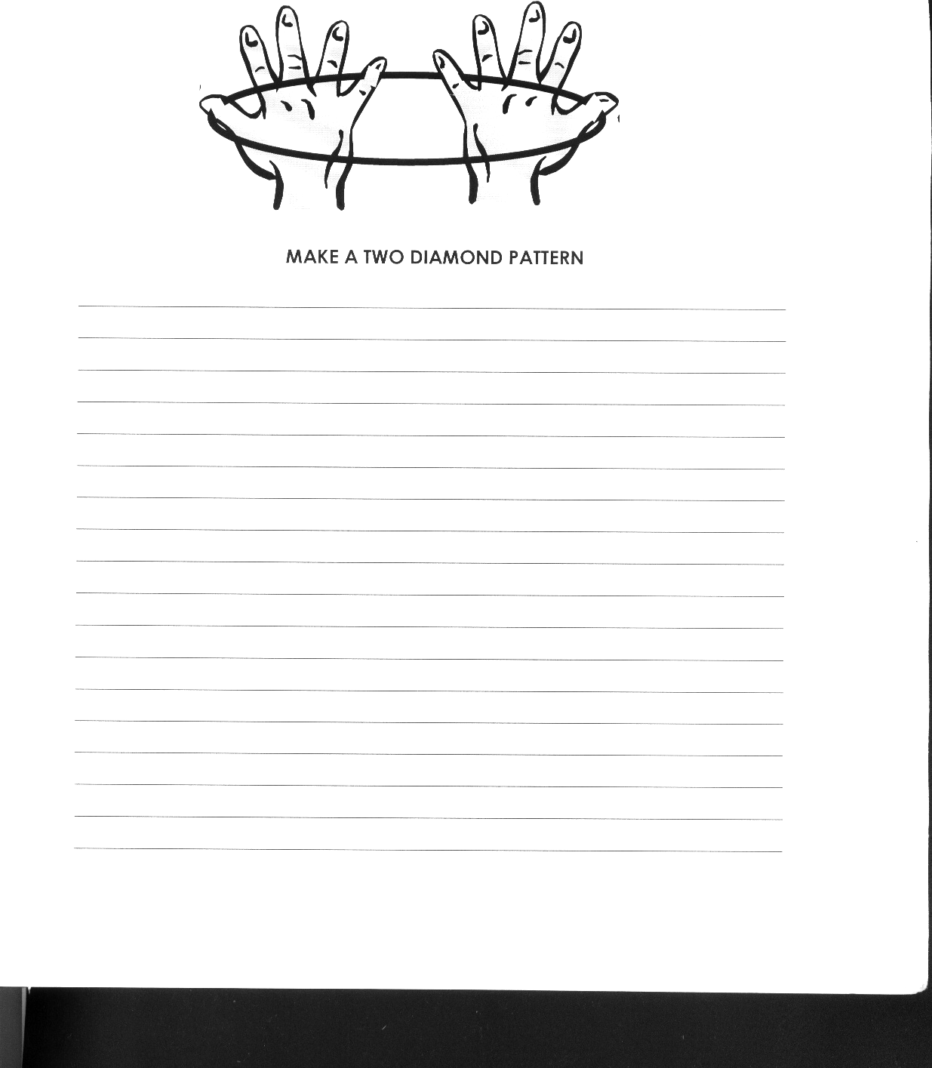

MAKE A TWO DIAMOND PATTERN.

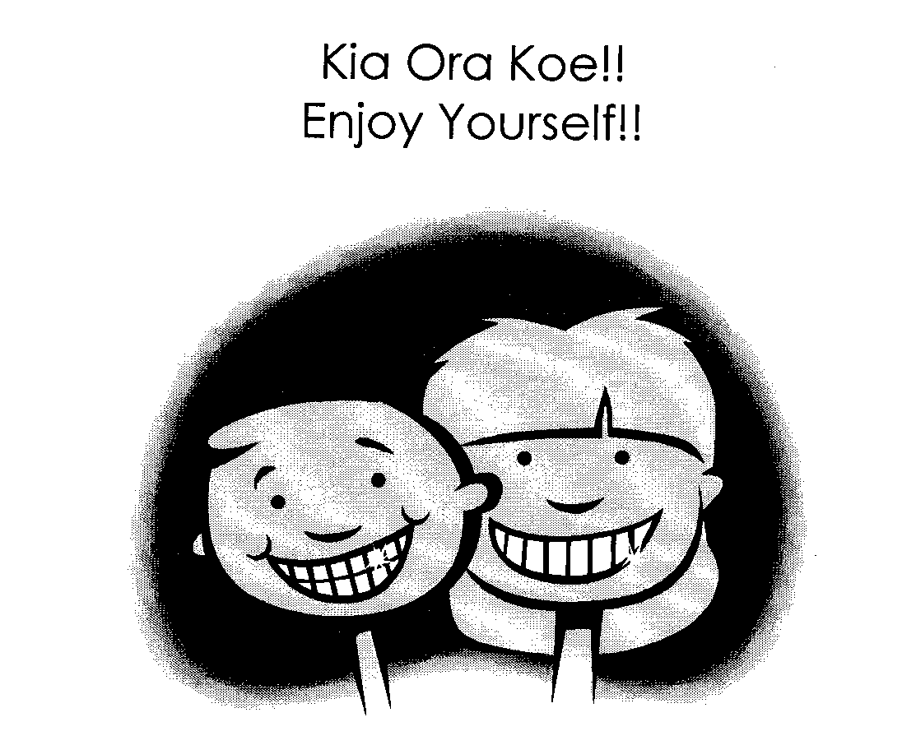

TEACHER’S COPY – Mahi Whai Patiki Tokorua

Mo te ngome 2 (For Activity 2)

- Thumb Konui / Poromata
- Index Finger Koroa
- Middle Finger Mapere
- Ring Finger Manawa
- Little Finger Toiti
- Knuckle Monamona
- Fingernail Matimati/Maikuku
- Palm Kapunga
- Wrist Kawiti-ringa/Whatianga-ringa/Pona-ringa

