“TREASURED PETS”

The Kaitiaki concept
(English version)

Social Studies, Māori, Art.

- Picture analysis
- Writing
- Display
- Speaking

SUBJECT: Social Studies, Māori, Art TAUMATA 10-12

STRANDS: Writing, Speaking, Picture, Analysis, Display.

CONTEXT: The concept of Kaitiaki Māori – Māori guardians.

ACHIEVEMENT OBJECTIVES.

- Understanding visual art in context – purposes of objects/ images of the past.
- To enhance understanding of Kaitiakitanga Māori – Māori Guardianship.
- To enhance basic Reo Māori and Tikanga.

ESSENTIAL SKILLS  Observation and analysis  Research  Communication of messages through medium of art.  Self Management. | RESOURCES  Task sheet  Writing and drawing equipment  Māori Dictionary.  Research materials  Art Resources

EXPECTED LEARNING OUTCOMES  Increase Reo Māori and knowledge base.  To develop understanding of Māori symbolism.  Develop understanding of Kaitiaki concept. | ASSESSMENT TASKS  Questions regarding Mōkaikai Kahurangi.  Mini Research  Find out 5 tribal Kaitiaki.  Seek out information on own Tribal Kaitiaki.  Picture of Kaitiaki.  Oral presentation.

STUDY TOPIC: TREASURED ‘PETS OF THE MĀORI-

The concept of Kaitiakitanga.

In ancient times the thinking, the beliefs of the ancient Māori with regard to the world they lived in were very different to those of many Māori of today. Everything in this world was special.
Every thing, every animal had its own mana, its own life essence and needed to be treated with respect, with reverence.
They believed they were specially placed here on earth by the Gods in that these animals had inhabited the earth well before people lived here. Because of this, some animals needed to be held in the highest esteem and were carefully treated and cared for. Eventually those animals took on an almost atua status and became regarded as the guardians of the people.

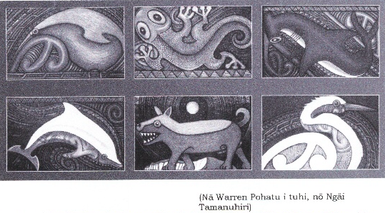
BELOW ARE SOME EXAMPLES OF KAITIAKI MĀORI.

From the left (top) Kiwi Lizard Shark.
(bottom) Dolphin Dog White Heron.

ACTIVITY 1: SOME QUESTIONS.
Answer the questions in the spaces provided

- In your opinion, why is the thinking of the Māori of ancient times different to many Māori of today?

- What do you think is the difference in thinking illustrated in this example?

- Name the animals used as examples.
- What is your understanding of “Kaitiaki Māori”?
- In your opinion, do you think the relationship between an owner and his/her pet these days is a modern alternative to the ancient mōkai kahurangi(treasured pets) of the past? Expand on your response.
ACTIVITY 2: MINI RESEARCH TASK.

- Find out (by reading, talking to people) about the Kaitiaki concept and write down 5 (five) points.
- What sorts of animals were used? Were other things used?
- What tended to be the function of a Kaitiaki?

1
2
3
4
5

ACTIVITY 3 TRIBAL KAITIAKI.

Find out five iwi Kaitiaki --- list here.
 | TRIBE | MOKAI | REASON | NAME

ACTIVITY 4
Seek out some information about your tribal/hapu Kaitiaki.
Write here some stories about your Kaitiaki…where did/does it dwell?

MY IWI’s MŌKAIKAI KAITIAKI

ACTIVITY 5.

Draw a picture of your Kaitiaki (use the style as outlined in the illustrations to assist you if you like it).

ACTIVITY 6 HE MAHI KŌRERO

XX00 7e

Your task now is to show your picture to your group/class and present a talk about your Kaitiaki.
Your presentation will be marked out of 20, you will need to speak for up to 3- 4 minutes.
At the end of your presentation there will be time for 5 questions from your ”audience.”

YOU WILL BE MARKED ON THE FOLLOWING CRITERIA (SUGGESTED ONLY TEACHER TO MODIFY)

No. | CRITERIA | MARK | MARK AWARDED | ASSESSORS COMMENT
1. | Clarity | 5
2. | Content is interesting and informative, You demonstrate that you have conducted some research | 5
3. | You express opinions with logical reasons | 5
4. | Language is appropriate | 5
 | TOTAL MARKS | 20

