TASK SHEET
(English version).

MĀORI TOOLS AND IMPLEMENTS.

- Māori
- Social Studies
- Technology.

SUBJECT: Technology, Reo Māori, Social Studies

STRAND: Reading, Writing

CONTEXT: Māori Tools and Implements

ACHIEVEMENT OBJECTIVES:
- To broaden knowledge base of Technology of Māori in the past.
- To broaden knowledge of Te Ao Māori.

ESSENTIAL SKILLS:  - Research and analysis  - Self management  - Lateral thinking and reasoning. | RESOURCES:  - Task sheets  - Writing equipment  - Māori Dictionary
EXPECTED LEARNING OUTCOMES  - To enhance Te Reo Māori  - To increase knowledge in a specific area i.e. Māori technology.  - To build on comprehension skills. | ASSESSMENT TASKS  - Reading to comprehend.  - Vocabulary work  - Responding to questions.

FOCUS TOPIC: Māori Tools and Implements
INFORMATION.

Māori had no knowledge of metals. Tools were made from wood, bone and stone. They experimented with the new stones they found in New Zealand and set up quarries and tool-making places, using stones such as argyllite, andesite and basalt to make knives, chisels adzes and hammers. On the West Coast of the South Island, they found a special stone. This was greenstone (pounamu) and was very tough and strong but it could be cut with other stones such as sandstone and greywacke.

Methods of tool making.

Flaking or chipping. Sometimes the sharp edge flake might be the tool needed or the core itself might be chipped.

Battering or picking. This is the breaking down of the stone by hitting it lightly and constantly with a hammer.

Grinding is when the stone is ground smooth on a piece of Sandstone.

Cutting or sawing. This is done by a mānia which is a blunt stone tied onto a stick or held in the hand and often used with wet, fine sand. The stone to be cut is ground down and a deep cut made on each side, then the break is made.

Using a stone age technology, the tribes made every kind of tool, weapon and implement necessary for their survival.

ACTIVITY 1: Comprehension questions.
Answer the following questions in the spaces provided.

- To your knowledge what is a quarry?
- To a “Stone-age” people, things like a quarry would be very important. In your opinion
why would this be so? What important things would be happening there?
- Why do you think the pounamu became such an important tāonga to the Māori people?

- Who do you think would be responsible for producing and manufacturing tools for the iwi?
Why do you think this is so?

- List 5 implements/tools that would be essential for survival in a Stone-age society.
State your reasons for your thinking.

a.
b.
c.
d.
e.
f.

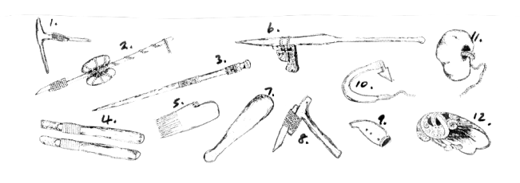

ACTIVITY 2:

Look at each individual object in the picture.

Listed below are the Māori names for those objects.
In your Māori Dictionary, look up the English names and write them in the space provided. Also, fill in the number of the relevant object in the picture.

MĀORI TOOLS AND IMPLEMENTS
 | MĀORI NAME | ENGLISH EQUIPMENT | WHICH ITEM?
1 | Uhi
2 | Whao
3 | Nguru
4 | Turuturu
5 | Heru
6 | Punga
7 | Tata / kāheru
8 | Tūwiri
9 | Kō
10 | Matau
11 | Toki
12 | Patu.

ACTIVITY 3:

Now read the following descriptions of the tāonga / implements. Select which description goes with which tool, write in the appropriate letter.

MĀORI TOOLS AND IMPLEMENTS.

Descriptions.

- A tattooing comb made like a tiny adze with a bone blade tied to it
- A pounder. When used for pounding fern root on a stone, it is usually made from wood. Stone pounders are used for flax fibres.
- Fish-hooks are made from bone, wood, shell, stone and are often made of two pieces joined together.
- Adze. Made from a stone blade tied to a wooden handle. The stones used are basalt., greywacke, argyllite, andesite and greenstone. The adze is the main wood working tool.
- A digging tool used in the kumara beds. The footrest tied to the bottom is sometimes carved.
- Weaving sticks are about 44 – 56 cms long. Some have a lot of carving on them. They have a knob at one end and a sharp point for putting into the ground, at the other end.
- Chisels and gouges are between 2 – 20 cms long and are made from basalt and nephrite. Chisels have the straight cutting edge, gouges have the rounded edge.
- An anchor is a large stone with a hole drilled through it for the anchor rope.
- The cord drill is used to drill holes in stone, bone, and shell. The shaft is from 30 – 60 cms. long and is balanced with stones tied to it. A stone flame is tied to it for the point.
- A whistle is made from wood or stone with the inside bored by a drill. It is shaped so there is a fat and slim end. Several holes are drilled from the outside to the inside. It is used for sending signals.
- Combs are used to dress hair and for decoration. The most valuable sort is made from whalebone, in one piece with a small human head carved on the side.
- Bailers have a wide rim which is carved and has a handle jutting out from it. If a bailer belongs to an important canoe it is given a personal name.

NOW FILL IN WHICH DESCRIPTION YOU HAVE SELECTED (in the grid below).

No. | MĀORI NAME | DESCRIPTION SELECTED | APPROPRIATE LETTER
1 | Uhi Matarau
2 | Tūwiri
3 | Turuturu
4 | Whāo
5 | Heru
6 | Kō
7 | Patu pao
8 | Toki
9 | Nguru
10 | Matau
11 | Punga
12 | Tata; Tīheru

Teacher’s Copy.

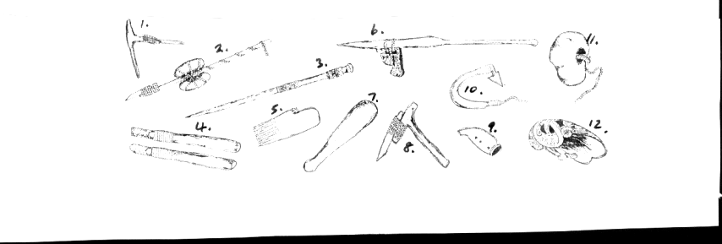
Names: Uhi, Whao, Nguru, Turuturu, Heru, Punga, Tata/Tīheru, Tūwiri, Kō, Matau, Toki, Patu

Letter | Description | Number
A | A tattooing comb made like a tiny adze with a bone blade tied to it  Uhi Matarau / Tattoo Chisel – top left corner | 1
B | A Pounder. When used for pounding fern root on a stone, it is usually made from wood. Stone pounders are used for flax fibre.  Patu Pao/ Pounder – looks like a patu middle bottom left. | 7
C | Fish hooks are made from bone, wood, shell, stone and are often made of two pieces joined together.  Matau / Fish hook – middle right | 10
D | Adze. Made from a stone blade tied to a wooden handle. The stones used are basalt, greywacke, argyllite, andesite and greenstone. The adze is the maid wood working tool.  Toki / Adze. – middle bottom | 8
E | A digging tool used in the Kumara beds. The footrest, tied to the bottom is sometimes carved.  Kō / Digging tool – top middle | 6
F | Weaving sticks are about 44 – 56 cms long. Some have a lot of carving on them. They have a knob at one end and a sharp point for putting into the ground, at the other end.  Turuturu / Weaving stick – left section 3rd implement from top left | 3
G | Chisels and gouges are between 2-20 cms long and are made from basalt and nephrite. Chisels have the straight cutting edge, gouges have the rounded edge.  Whāo / Chisel – bottom left hand corner | 4
H | An anchor is a large stone with a hole drilled through it for the anchor rope.  Punga / Anchor – top right hand corner | 11
I | The cord drill is used to drill holes in stone, bone and shell. The shaft is from 30 – 60 cms long and is balanced with stones tied to it. A stone flake is tied to it for the point.  Tūwiri / Cordless Drill – second implement from the top left | 2
J | A whistle is made from wood or stone with the inside bored by a drill. It is shaped so there is a fat and slim end. Several holes are drilled from the outside to the inside. It is used for sending signals.  Nguru / Flute – Bottom right, second implement in from end | 9
K | Combs are used to dress hair and for decoration. The most valuable sort is made from whalebone in one piece with a small head carved on the side.  Heru / Comb – Bottom right, second implement from the left. | 5
L | Bailers have a wide rim which carved and has a handle jutting out of it. If the bailer belongs to an important canoe it is given a personal name.  Tata, Tīheru / Bailer - bottom right implement | 12

