A GATHERING
(Wero and Pūhoro)

PICTURE ANALYSIS
(English Version).

SUBJECTS:

MĀORI

SOCIAL STUDIES

ART

SUBJECT: Te Reo Māori TAUMATA 10-12
Social Studies, Writing Art
STRANDS: Picture Analysis, Writing

TE HOROPAKI: A gathering

ACHIEVEMENT OBJECTIVES.

- Picture observation, analysis, and interpretation.

- Articulating through writing messages within the picture.
- To broaden Reo Māori and Tikanga Māori base – language and arts.

ESSENTIAL SKILLS  Picture analysis and interpretation  Communication of information through writing.  To gain information on this specific Māori art form | RESOURCES  Task sheet  Writing and drawing equipment  Māori Dictionary.

EXPECTED LEARNING OUTCOMES  - To further develop Te Reo and Tikanga Māori skills & knowledge.  - To develop skills in picture interpretation and message communication through writing.  - To articulate through writing and speaking messages contained within a picture.  - To practise drawing of this specific art form. | ASSESSMENT TASKS  - Discussion – information processing.  - Picture interpretation -- answer questions.  - Writing practice – Report writing.  - Mini Research  - Practise Drawing  - Pūhoro forms  - Discussion – Report back.
KAUPAPA HĀNGAI: Te Mahi Titiro Pikitia.

FOCUS TOPIC: Picture Analysis
ACTIVITIES

ACTIVITY 1

- In this activity you will need to work with a partner.
- Look carefully at the picture and discuss it with your partner. (This should only take about 5 minutes)
USE THESE QUESTIONS TO HELP GUIDE YOUR THINKING:
- What is this person doing?
- Where is he? What is this gathering?
- What are the ‘decorations’ on his body?
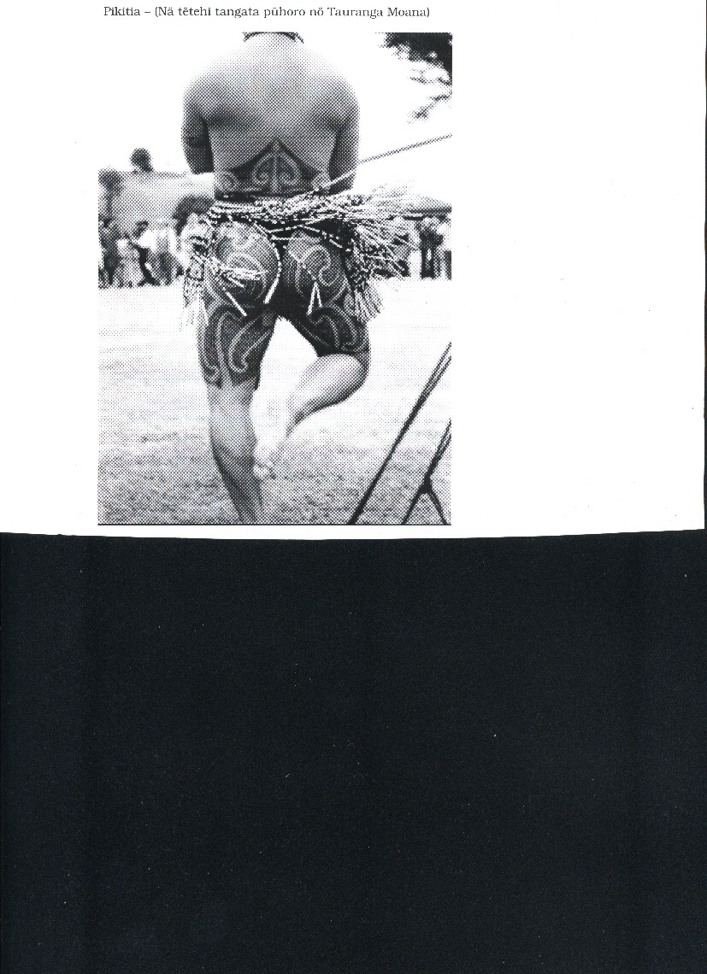

ACTIVITY 2:
Write answers to the questions in the spaces provided.

- What is this person doing?
- To your knowledge what is the purpose, the reason for this activity?
- Who are the people who are eligible to do this activity?
- In your opinion what is the real reason for this activity these days?
- What do you think of Māori body decoration? …..What do you think of this man’s body decoration?

- ACTIVITY 3
Your are a newspaper reporter at your local newspaper. You have been asked to go to a Māori gathering to do a story. Your editor wishes to place the above picture into the newspaper.
Your task is to write a story directly related to the picture….. choose whatever angle you wish to follow. (Write your story in the space provided at least 2-3 paragraphs).
A MOMENTOUS MĀORI OCCASION.

ACTIVITY 4: MINI RESEARCH TASK

- Seek out information pertaining to Māori body adornment – Tā Moko in particular.
- Look for information about PŪHORO and write in the space provided below.
- Use the following questions to help direct your thinking:-
- What is the “traditional” purpose of this activity/ritual?
- What is the history of this activity? Why is it still being done these days?
- What is the purpose of the PŪHORO?
- What are the main patterns used in PūHORO?
- Who is eligible to wear PūHORO? What entitles people to wear PūHORO?

WRITE YOUR INFORMATION HERE

ACTIVITY 5 DRAWING PRACTICE.

- identify the 3-4 main patterns used on this particular PūHORO – Copy out those patterns - write the names of the patterns beside them.

PŪHORO PATTERNS.

ACTIVITY 6:
Discuss now with your partner all the new information you have gained through your research about the WERO and PūHORO.
List 10 points in the spaces provided below,(your teacher will test you on these later).

