HE KAUPAPA PŪTAIAO

TAU 11(NCEA KAUPAE 1)

10 NGĀ AKORANGA ME NGĀ NGOHE

NGĀ PŪAHI

He Mahere Mahi mō Te Kaupapa – Tau 11 Pūtaiao – Ngā Pūahi
Tauira: | TE KATOA | Kaupapa Māori:
Te mohiotanga o te kaiako: | āhua mōhio | He iti
Ngā Wāhanga Ako: | Pūtaiao | Tāne
Te Marautanga – Te take | Pūtaiao
Whenu: | Papatūānuku, Papatūārangi | Papatūānuku,
Huarahi: | Ō Papatūānuku | Rūaumoko
Taumata: | 5/6
Ingoa: | Ngā Pūahi | Toka, pohatu
Ngā whāinga hei whakatutuki: | Ko tā ngā tauira:  - he tirotiro ki te hanga, te āhua, ngā tikanga hoki o te kahu o Papa; | Papatūānuku
 | - he tirotiro ki ngā tukanga ā-roto, ā-waho hoki e ahuahu ana i te papawhenua o Aotearoa; | Rūaumoko, Hine-i-tapeka
 | - he whakanui atu i ngā kupu, i ngā tohu, i ngā tikanga pūtaiao ka whakamahia ai;
 | - he whakaputa i ō rātau mōhiotanga pūtaiao hei whakamātau i ngā tuhinga pūtaiao o te kauwae raro, o te kauwae runga hoki (tae atu ki ngā kōrero āhua me ngā kōrero tau).
Ngā pūkenga: | Te katoa
Te titiro: | Ngā toka
Te wāhi: | Aotearoa; ngā wāhi arowhenua o te kāinga, te marae kāinga, te whare taonga ā-rohe | Aotearoa; ngā marae kāinga
Ngā akoranga: | 10
Ngā ngohe: | 1 He haerenga – whare pupuri taonga (ngā taonga tawhito), marae rānei o te kāinga.  Te Pakanga o Te Maniaroa – te whakaingoa, te hanga i ngā rākau patu. | Whakawhenua - whainga tapuwae, mihi
 | 2. Ngā kupu me ngā whakamāramatanga. Te tirotiro ki ngā momo toka me te riponga toka. | Reo Māori
 | 3. Ngā rauemi i rangahaua ake e pā ana ki ngā taputapu me ngā rākau patu. | Rangahau
Ngā ngohe: | 4. Te whakaatu i ngā kōrero i rangahaua | Whakawhenua
 | 5 & 6 Toka ngiha – tā te wānanga, tā te whakamahi | Tāhū kōrero
 | 7 & 8 Toka parataiao – tā te wānanga, tā te whakamahi | Tāhū kōrero
 | 9. Toka kāhuarau – tā te wānanga, tā te whakamahi | Tāhū kōrero
 | 10. Haerenga – he papawhenua o te kāinga(te ākau/pā pōhatu), he whare rānei o te kāinga. | Te Hao
Tikanga Māori: | Kohinga 2 – Rārangi Tikanga Māori | Whainga tapuwae, wānanga, kauhau.
Reo Māori: | Kohinga 3 – Rārangi Reo Māori | He kupu, he ingoa tohu ake; he kēmu; he panga kupu.
Ngā Rauemi:  - Kohinga 1 | A Dictionary of the Māori Language, HW Williams
 | PM Ryan: The Reed Dictionary of Modern Māori
 | http://www.teara.govt.nz/EarthSeaAndSky/MineralResources/PounamuJadeOrGreenstone/2/en
 | Nga Iwi o te Motu, M. King, Reed, 1997
 | Stone, Bone & Jade, D. Salt, Bateman, 2001
 | The Māori As He Was, E. Best, 1952
 | He Taonga Tuku Iho, R. McConnell, Reed, 1999
 | http://whakaahua.Māori.org.nz/weapons1.htm
 | http://www.minerals.co.nz/html/main_topics/resources_for_schools/introduction_to_minerals.html
 | http://www.tepapa.govt.nz/7_AwesomeForces29062005V01.7/awesomeForces.html
http://www.gns.cri.nz/store/publications/latestpubs.html#atlas – recommended purchase
http://www.gns.cri.nz/research/qmap/downloads/terrane_A3_300dpi.pdf
 | New Zealand Minerals & Rocks for Beginners, PJ Forsyth & JJ Aitken, IGNS information series 36. 1995
 | Mineral Wealth of New Zealand, B Thompson, B Braithwaite, T Christie. IGNS information series 33. 1995
 | Kiwi Integrated Science Series, 4 Science Book 3, J Sweeney, D Relph, S Haigh, L DeLacey. New House.
 | The Blue Science Workbook (NCEA Level 1), 7th edn, P Biggs, Resource Books, 2007, p82-93
 | Year 11 Science NCEA Level 1 Workbook, B Cooper, G Abbott, A Hume, ABA Books, 2007, p143-163

INGOA O TE KAUPAPA: NGĀ PŪAHI

PAETAU: TAU 11 (NCEA Taumata 1 Pūtaiao)

WHIRINGA MARAUTANGA:
NGĀ PŪKENGA AKE/NGĀ ĀHEINGA AKE:
- Te whakaaro
- Te whakawhanaunga
- Te whakauruuru, te āwhina
WHENU: Papatūānuku – Papatūārangi Taumata 5/6
NGĀ WHĀINGA HEI WHAKATUTUKI: Ko tā ngā tauira:
- he tirotiro ki te hanga, ki te āhua, ki ngā tikanga hoki o te kahu o Papa (Taumata 5);
- he tirotiro ki ngā tukanga ā-roto, ā-waho hoki e ahuahu ana i te papawhenua o Aotearoa (Taumata 6)
WHENU: Ōpūtaiao (te whare kōrero pūtaiao)
NGĀ WHĀINGA HEI WHAKATUTUKI: Ko tā ngā tauira:
- he whakanui atu i ngā kupu, i ngā tohu, i ngā tikanga pūtaiao ka whakamahia ai
- he whakaputa i ō rātau mōhiotanga pūtaiao hei whakamātau i ngā tuhinga pūtaiao o te kauwae raro, o te kauwae runga hoki (tae atu ki ngā kōrero āhua me ngā kōrero tau).

TE PĀNGA KI NGĀ AROMATAWAI NCEA:
Ka whai wāhi tēnei kaupapa ki te mahere whakaako e tautoko ana i ngā tauira e akoako ana kia whakamātautauria rātau i raro i ngā tikanga o ngā paerewa nei, i runga anō hoki i te aronga o te kaiako, o te tauira rānei me te mōhio hoki o te tauira:
- Paerewa Paetae 90190 w2 Kaupae 1 Whakamāramatia ētahi āhuatanga o te arowhenua (3 whiwhinga);
- Paerewa 6357 w5 Kaupae 1 Whakaingoatia ngā kohuke māori, toka māori hoki (3 whiwhinga);
- Paerewa 6358 w5 Kaupae 1 Whakamāramatia te hanganga mai o ngā momo toka matua, ā, whakamāramatia hoki te riponga mai (3 whiwhinga);
- Paerewa 18982 w2 Kaupae 1 Whakaaturia mai te mōhiotanga mō te Pūtaiao ā-nuku (2 whiwhinga).
NGĀ HUA AKE O TE AKO:
Ka taea e te tauira:
- te hanganga mai o ngā momo toka, ngiha atu, kāhuarau atu, parataiao atu te whakamārama;
- te momo o te toka ngiha, hei tokapuia rānei, hei tokanuku rānei te tohu;
- ngā āhuatanga ā-kiko o te toka ki te wāhi i ahu mai ai te whakakāinga;
- ngā rangi tohu toka hei whakapapa te taki.

TE MŌHIOTANGA KIA MĀTUA MŌHIOTIA:
Papatūānuku, Papatūārangi Taumata 4/5 – Ō Papatūānuku

NGĀ RAUEMI HEI TIKI:
- ētahi o ngā momo toka (tirohia te whārangi 150 te pukamahi o te Tau 11 Pūtaiao NCEA Kaupae 1, ABA Pukapuka, 2007)
- he māpihi pounamu (kia rerekē ngā momo pounamu menā e taea: pounamu rawa; pakohe, takawai māota)
- he konu paura, he huka, he pēkena houra, he peita pango temepara paura, ā, he taputapu hei ‘Hanga toka ngiha’ me ngā mahi ‘Me Hanga Matū Rawa’ i Te Akoranga 5 (tirohia ngā whārangi 147 & 149 o te Pukamahi mō te Tau 11 Pūtaiao NCEA Kaupae 1, ABA Pukapuka, 2007 mō ngā kōrero)
- he kiripōhatu, he kirikiri kaitara, rauiti hoki, he uku, he kotakota rino, he raima Parī, ā, he taputapu hoki hei ‘Tātari para’, me ngā mahi hei ‘Hanga toka parataiao’ i Te Akoranga 6 (tirohia ngā whārangi 152 – 155 o te Pukamahi mō te Tau11 Pūtaiao NCEA Kaupae 1, ABA Pukapuka, 2007, mō ngā kōrero).

NGĀ WHAKAPUAKANGA HEI TITIRO:
A Dictionary of the Māori Language, HW Williams, GP Books, 1988
The Reed Dictionary of Modern Māori, PM Ryan, Reed, 1995
http://www.teara.govt.nz/EarthSeaAndSky/MineralResources/PounamuJadeOrGreenstone/1/mi OR
http://www.teara.govt.nz/EarthSeaAndSky/MineralResources/PounamuJadeOrGreenstone/2/en
http://whakaahua.Māori.org.nz/weapons1.htm
Nga Iwi o te Motu, M. King, Reed, 1997
Stone, Bone & Jade, D. Salt, Bateman, 2001
The Māori As He Was, E. Best, 1952
He Taonga Tuku Iho, R. McConnell, Reed, 1999
http://www.tepapa.govt.nz/7_AwesomeForces29062005V01.7/awesomeForces.html
http://www.pukeariki.com/en/resources/teacherscentre/mttaranaki.htm
http://www.tki.org.nz/r/science/putaiao/pathfinder/unit24/index_e.php
New Zealand Minerals & Rocks for Beginners, PJ Forsyth & JJ Aitken, IGNS information series 36. 1995
Mineral Wealth of New Zealand, B Thompson, B Braithwaite, T Christie. IGNS information series 33. 1995
The Blue Science Workbook (NCEA Level 1), 7th edn, P Biggs, Resource Books, 2007
Year 11 Science NCEA Level 1 Workbook, B Cooper, G Abbott, A Hume, ABA Books, 2007
TE MAHERE AKORANGA 1
TE WĀ: 60 meneti (me roa ake mō te haerenga)
KAUPAPA MĀORI: Whakawhenua – whainga tapuwae; mihi
NGĀ TOHOTOHU MĀ TE KAIAKO:
- Me mātua toro atu ki te whare pupuri taonga, marae rānei ki te whakariterite.
- Whakaritea te haerenga ki te whare pupuri taonga ā-rohe, ki te marae kāinga rānei. Mō ēnei haerenga e rua, me inoi kaumātua hei ārahi, hei āwhina.
- Whakaotia ngā tikanga haerenga ā-kura, arā, pērā i ngā puka Tiaki, Ārai Whara; ngā whakaaetanga a ngā mātua, te aha, te aha.
- Me whai kape o te pūrākau ‘Te Pakanga o Te Maniaroa’ nō roto i te pukapuka He Taonga Tuku Iho, tētahi pūrākau pērā rānei o te kāinga. Ko te tikanga, māna e kitea ake ai te āhua o te kawe ā-riri kia whai whakaaro ai ki ngā rākau patu o te wā.
- Kei te putunga rauemi, te āwhinatanga rānei i te whare pupuri taonga/marae te tikanga o te whakarite whārangi kōrero mai i ngā pukapuka pērā i Nga Iwi o te Motu i tuhia e Michael King (kei ngā whārangi 16-22 ētahi kōrero), The Māori As He Was i tuhia e Elsdon Best (kei ngā whārangi 166-173 ētahi kōrero), ā, me ngā pā ipurangi pērā i http://whakaahua.Māori.org.nz/weapons1.htm.
- Whakaritea te Whārangi Mahi kia tika mō te haerenga.
- Me kī atu ki ngā tauira kia whai pukatuhi, pukatā, pene rākau hoki.
- Whiriwhiria tētahi kaikōrero hei mihi mō te rōpū.

NGĀ TOHUTOHU MĀ NGĀ TAUIRA:
- Whakaotia, whakahokia hoki ngā puka whai take mō te haerenga ki waho atu i te kura.
- Me hari pukatuhi, pukatā rānei i te haerenga.
- Me paepae ngā taringa ki te whakarongo, āta whakaarohia ngā pātai hei pātai.
- Me takirōpū iti nei te mahi hei whakatutuki i ngā ngohe o te Whārangi Mahi i roto i te wā i whakaritea ai.

HEI MAHI
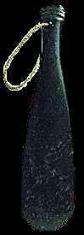
Whakarongo ki te pūrākau e pānuitia ana ki a koe.

From www.Māori.org.nz
Me toko ake te whakaaro ki te kakaritanga nei me ngā rākau patu e
whakawhiua ana i taua wā

Whakarongo, kōrero ki ngā tāngata o konei, ā, tirohia hoki ngā rauemi
e whakaaturia mai ana, kātahi ka korerotia ā-rōpūtia ngā pātai e
whai ake nei:

- He aha ngā momo rākau i whakamahia ai?
- Hei aha ngā rākau patu nei?
- I waihangatia i te aha?
- Mō ia rākau patu, he aha te take i waihangatia ai i taua
mea? (arā, he aha ngā tohu me whai taua mea?)
- I pēhea te waihanga i ngā rākau patu nei?

Tāia ngā rākau patu e whakaaturia ana, ā, tuhia hoki te ia o ngā korero a tō rōpū mō ia rākau patu.

TE MAHERE AKORANGA 2
TE WĀ: 60 meneti
KAUPAPA MĀORI: Reo Māori
NGĀ TOHUTOHU MĀ TE KAIAKO:
- Whakaritea he mahi hei whai i ngā kōrero o te haerenga o mua atu, i runga i te tono ki ngā tauira kia whakatakina mai e ngā rōpū ō rātau i manawareka ai, i manawakawa ai hoki i reira.
- Whakaaturia mai ngā tānga whakaahua a ngā rōpū.
- Whakaritea mo te Poihuka Kupu:
  - Kimihia he poi, he poi kūhi, he pēke hēke, he poi niupepa, he poi kuru rānei rite te ngohe.
  - Hei wāhi ake, pānuitia te Hei Mahi 1 – he pūrākau Māori mō ngā toka matua o Aotearoa, kātahi ka whakamārama ai i te mahi whai muri atu hei take hāngai ki ngā rauemi tino mārō hei hanga rākau patu Māori me te whakamārama hoki ka wānangatia e rātau ngā kupu e pā ana ki ēnei rauemi. Ko te kaupapa, ko NGĀ TOKA.
  - Tuhia he rārangi whānau kupu hei kupu e māia nei te kōrerotanga i te mutunga o te kaupapa. Mā tēnei e ārahi ngā whakaritenga mō Ngā Akoranga 3 ki te 9.
  - Whakaritea he taputapu tuhi kupu: whakamahia te Papa Kamakama menā e taea, te Papatuhimā rānei, te OHT rānei.
  - Tāruatia Ngā Whārangi Mahi 2 & 3.
- Me whai papakupu Reo Pākehā-Reo Māori/Reo Māori-Reo Pākehā mō Hei Mahi 3. Aratakina atu ngā tauira i runga i ō rātau mōhiohio tākupu, pūtaiao, reo Māori rānei.

NGĀ TOHUTOHU MĀ NGĀ TAUIRA:
- Ko tā Hei Mahi 1 he wāhi ake i te kaupapa toka – he pūrākau Māori poto nei me ētahi kupu whakamārama.
- Ko tā Hei Mahi 2 he wānanga i tō mōhiotanga ki ngā toka.
- Ko tā Hei Mahi 3 he whakatipu i tō mōhiotanga, i tō māramatanga e tīmata hoki ai te takitaki whakapapa kupu nei mō te Pūtaiao ā-nuku
- Whakamahia te tauira WHARE KUPU inā mutu ai ia akoranga ā muri atu nei hei whakamātau i tō mārama ki ngā kupu hou e kōrerotia ana.
HEI MAHI 1

He Whakarāpopototanga o Tētahi Pūrākau Māori
(He mea tango i The Māori As He Was i tuhia e Elsdon Best, wh. 52-53)

Tērā a Ngahue, he kaumoana o Te Moananui a Kiwa, i whanaunga ai ki a Poutini(te tohu pounamu tangata), ā, i raru ai rāua i tō rāua kāinga i Hawaiki i te riri o Hinetuahōanga(te tohu o te hōanga), nā reira rāua i heke ai ki Aotearoa.
[Ko te hōanga te pōhatu matua i tīkina atu e te Māori hei oro pounamu, nā reira i kiia ai he hoariri nō te pounamu.]
Nō te taenga atu ki Tūhua, i Te Moana a Toi, ka mea a Poutini kia noho ki reira, engari ka ohorere i te putanga o Matā(te tohu o te matā tangata), ā, ka rere ki te Tairāwhiti. I reira ka tūtaki atu ki a Waiapu(he momo waiapu), he hoariri anō hoki, nā, ka heke ki Arahura i Te Waipounamu, i reira noho whakaruru ai, ā, e tīkina atu ai e te Māori te pounamu hei hanga taputapu, hei hanga taonga, ā mohoa noa nei.
E ai ki ngā kōrero a te Māori, i whāia tonutia te iwi o Poutini e ōna hoariri, ko ētahi i patua, ko ētahi i mau. Ko te hunga i mau ko ngā taonga pounamu rongonui tuku iho.

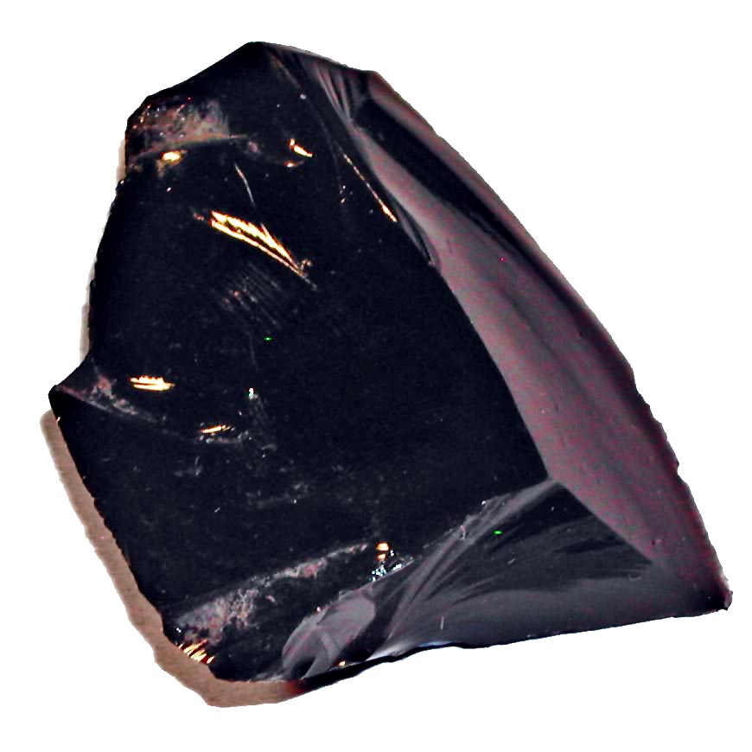
HEI MAHI 2
Ko ngā rākau patu tino māro me ētahi o ngā taputapu i whakamahia e te Māori he mea hanga i te toka whai mana, whai tikanga.
Ko ngā mahi o tēnei kaupapa he wānanga i ngā momo toka e kitea ai ngā āhuatanga o ia momo toka e rite ai mō te whakamahinga, otirā ki tā te Māori whakamahi.

TE POI HUKATOKA
Mā tō kaiako e whiriwhiri ētahi kaituhi hei tuhi i nga kupu e pā ana ki NGĀ TOKA e wānangatia ana.
- Ka kurua ana te poi ki tētahi tauira, ka kōrero ana ia i tētahi kupu mō tā tātau kaupapa(NGĀ TOKA), hei tauira, pounamu, toka ngiha rānei
- Ka tuhia te kupu e ngā kaituhi.
- Ka whakahokia atu te poi e te tauira ki te kaiako, kātahi ka kurua atu anō ki tētahi atu tauira, māna e whai kupu mai anō mō NGĀ TOKA.
- Ka pau katoa i ngā tauira ngā kupu TOKA te whakaaro, te kōrero mai, ka noho takirua.
- Mā te mahi takirua e whakarite ētahi whānau kupu 3, 4 nei, hei kāinga tuhi mō ia kupu.
- Whakatauritea atu ko ō kōrua whānau kupu ki ngā whānau kupu o tētahi atu tokorua.
HEI MAHI 3
Whakamahia te huahuatanga i raro iho nei hei hanga WHARE KUPU mō ngā kupu i tuhituhia rā.
Mā tō kaiako koe e ārahi, e tuku papakupu, rauemi hoki e rite ana.
Hei tauira:
KUPU  Te Reo Māori: pungapunga  Te Reo Pakeha: pumice | WHAKAMĀRAMATANGA  He huka rangitoto teatea kua mātao.
TAUIRA  Ka rewa ētahi pungapunga i runga i te wai, i te mea he mirumiru hau te hanga, i te wā i hū ai te rangitoto puia, rere ana, mātao ana, mau ana. | HUAHUATANGA HEI WHAKAMAHARA

RĀRANGI KUPU
- Toka | - Kahūho(kahu uho) | - Ngiha
- Pōhatu | - Rangitoto/Tokarewa | - Kāhuarau
- Kohuke | - Rangitoto | - Māpara
- Kirinuku | - Papa nekeneke | - Pākeho
- Nukuratarata | - Putanga | - Hinewaiapu
- uho | - Parataiao | - Toka hū
- Rere iakawe

TE WHAKATIPU I TŌ RĀRANGI KUPU
I a koe e mahi ana i ngā mahi o te kaupapa TOKA nei, whakairohia te WHARE KUPU mō ia kupu hou. Tirohia anō ko ia kupu hei mahi kāinga e pakari ai koe inā whakamātautauria mai ai.
NGĀ RAUEMI IPURANGI HEI WHĀWHĀ ATU MĀU http://www.galleries.com/rocks/default.htm
http://geology.com/geology-dictionary.shtml
http://www.teara.govt.nz/EarthSeaAndSky/Geology/RockAndMineralNames/en
http://www.nysm.nysed.gov/virtual/collections/splendor_in_stone/splendor_p_roc.html
NGĀ AKORANGA 3 & 4
TE WĀ: 60 meneti ia akoranga
KAUPAPA MĀORI: Whakawhenua
NGĀ TOHUTOHU MĀ TE KAIAKO:
- Tuhia mai he rārangi take iti mō Kōhatu – Tā te Māori Whakamahi Kōhatu. Me mahi takiwhā ngā tauira (kaua e neke atu i te 6 rōpū), ā, ka tohua ngā mahi hei mahi (Tirohia te Whārangi Mahi mō ngā kōrero).
- Ko ētahi take iti hei whaiwhai atu me ngā kupu ārahi hoki:
TAKE ITI | KUPU ĀRAHI | HEI RAUEMI – whāia ngā kāwai ipurangi
Ngā taputapu kōhatu | Ka whai wāhi atu ki ngā momo kōhatu i whakamahia ai; ngā āhuatanga o te kōhatu e rite ana mo te mahi; te hanga i te taputapu. | http://www.teara.govt.nz/1966/M/MāoriMaterialCulture/StoneTools/en  http://www.teara.govt.nz/EarthSeaAndSky/Geology/KohatuMāoriUseOfStone/1/en
Ngā patu kōhatu | Ka whai wāhi atu ki ngā momo kōhatu i whakamahia ai; ngā āhuatanga o te kōhatu e rite ana mo te mahi; te hanga i te taputapu. | http://www.teara.govt.nz/1966/M/MāoriMaterialCulture/Weapons/en  http://www.teara.govt.nz/EarthSeaAndSky/Geology/KohatuMāoriUseOfStone/2/en  http://whakaahua.Māori.org.nz/weapons1.htm
Ngā whakapaipai kōhatu | Ka raua mai ko ngā momo kōhatu i whakamahia ai; ngā āhuatanga o te kōhatu e rite ana mo te mahi; te hanga i te taputapu. | http://www.teara.govt.nz/1966/M/MāoriMaterialCulture/ClothingAndAdornment/en  http://www.teara.govt.nz/EarthSeaAndSky/Geology/KohatuMāoriUseOfStone/2/en
Ngā kōhatu hāngi | Ka whai wāhi atu ki ngā momo kōhatu i whakamahia ai; ngā āhuatanga o te kōhatu e rite ana mo te mahi; te hanga i te taputapu. | http://www.teara.govt.nz/1966/M/MāoriMaterialCulture/HousesAndDomesticLife/en  http://Māorifood.com/hangi.htm
Te hī, te ngaki māra, me ētahi atu mahi. | Ka whai wāhi atu ki ngā momo kōhatu i whakamahia ai; ngā āhuatanga o te kōhatu e rite ana mo te mahi; te hanga i te taputapu. | http://www.teara.govt.nz/EarthSeaAndSky/Geology/KohatuMāoriUseOfStone/3/en
Mō ngā take katoa, me whai wāhi atu ki ngā whakapapa o ngā toka me ngā kohuke: http://www.teara.govt.nz/EarthSeaAndSky/Geology/KohatuMāoriUseOfStone/1/ENZ-Resources/Standard/2/1/en#breadcrumbtop me http://www.teara.govt.nz/EarthSeaAndSky/Geology/KohatuMāoriUseOfStone/1/ENZ-Resources/Standard/2/2/en#breadcrumbtop

- Tārutia te kauwhata nei mō ia rōpū, ā, tīpakohia ngā take iti, kia rerekē mō ia kape. Pōkaitia ia kape ka rau atu ai ki roto i te pouaka whiriwhiri hei tiki noa mā te Kaihautū o ia rōpū.
- Me whakahau atu ki ngā tauira kia oti i a rātau tētahi WHARE KUPU mō ia kupu Pūtaiao ā-nuku ka kitea i ā rātau rangahautanga.
- Me hora ko ngā papakupu Reo Pākehā/Reo Māori, Reo Māori/Reo Pākehā.

NGĀ TOHUTOHU MĀ NGĀ TAUIRA:
- Ka whakaritea koutou e tō koutou kaiako kia mahi takiwhā, ā, ka tohua hoki te tūmahi mā ia tauira, ka riro rānei mā te rōpū kē tēnei e whakatau.
- Ko te mahi mā ia rōpu he rangahau i tētahi āhuatanga o Kōhatu - Tā te Māori Whakamahi Kōhatu. Mā te Kaihatū o te rōpū e whiriwhiri noa te āhuatanga hei wānanga ma te rōpū.
- Ka whakaaturia mai (hui katoa me ngā pātai a te karaehe, kaua e neke atu i te 7 meneti te roa) ā te akoranga whai muri atu, ā tētahi wā rānei ka whakataua mai e tō koutou kaiako.
- Kei te rōpū te tikanga o te whakaaturanga. Ko ētahi hei whakaaro; he whaikōrero, he whakairo, he kauhau, he haka, he waiata.

HEI MAHI
Ko tā koutou he mahi takiwhā ki te rangahau i tētahi āhuatanga o Kōhatu - Tā te Māori Whakamahi Kōhatu.
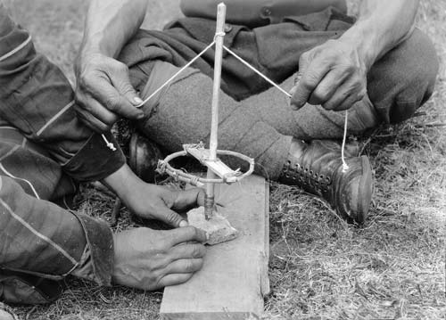
Tūwiri
E rua ngā taura o te tūwiri. Ko te matarere he pōhatu mārō, koi tonu. He kirikiri, he wai ngā hoa oro kōwiri.
Kei roto i tō rōpū he kaiārahi rawa e tutuki pai i a koutou ngā mahi katoa i roto i te wā i whakaritea ai. Ka whai wāhi katoa mai ngā tauira o te rōpū ki te rangahau, ki te whakaatu hoki, heoi ko tā te kaihautū he whakahau kia oti te mahi.
  - Tā Te Kaihautū o Te Rōpū – he whakahaere kia rere tika ai te mahi, kia mana ai te wā, kia tōtika ai te kōrero
  - Tā Te Kaipānui o Te Rōpū – he kimi i ngā tuhinga ka pānui ai ki te rōpū inā tika ai
  - Tā Te Kaituhi o Te Rōpū – he tuhi kia pupuritia ngā whakatau me ngā kōrero a te rōpū.
  - Tā Te Kaiwhakaatu o Te Rōpū – he whakarite i te whakaaturanga ki te karaehe (mā te rōpū kē te tikanga whakaatu)
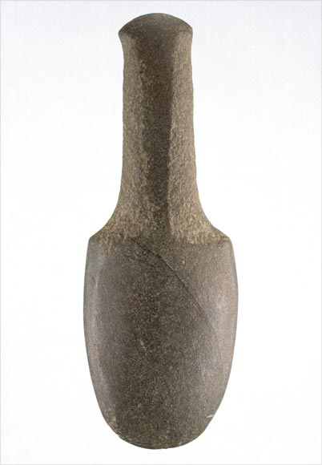
Patu Muka
Ko tā te patu muka nei he patupatu i te muka o te harakeke.

Ka whakaaturia mai (hui katoa me ngā pātai a te karaehe, kaua e neke atu i te 7 meneti te roa) ā te akoranga whai muri atu, ā tētahi wā rānei ka whakataua mai e tō koutou kaiako.
Kei te rōpū te tikanga o te whakaaturanga. Ko ētahi hei whakaaro; he whaikōrero, he whakairo, he kauhau, he haka, he waiata.
Me whakawhitiwhiti te āhua o te karawhiu.
Mō te wāhanga pātai a te karaehe, me tau utuutu: te matua ki te rōpū, te rōpū ki te matua rānei.

From www.Māori.org.nz

Kia mahara, whakairotia te WHARE KUPU mō ia kupu Pūtaiao ā-nuku hou ka rangahaua ake e koutou.
Te AKORANGA 5
TE WĀ: 60 meneti
KAUPAPA MĀORI: Tāhū kōrero
NGĀ TOHUTOHU MĀ TE KAIAKO:
- Whakamātauria te whakaaturanga NGĀ TOKA NGIHA (kōnae: NGĀ TOKA NGIHA.ppt) – Me whakarite mā te kauhau kaiako, mā te kuhu tauira rānei e kawe. Mā te whiringa tōtika e whakatau.
- Whakariteritea ngā taputapu mō ngā mahi ā-ringa nei hei whakaatu i te hanganga o te toka ngiha me ōna āhuatanga. Ka kitea ngā mokamoka kōrero mō ēnei mahi ā-ringa (‘Te Hanga Toka Ngiha’ me ‘Me Hanga Matū Rawa’) i ngā whārangi 147, 149 hoki o Te Pukamahi o ABA mō te Tau 11 Pūtaiao NCEA Kaupae 1.
  - ‘Te Hanga Toka Ngiha’ [te whakarite 10 meneti – ka mātakitakina ā te rangi muri atu]
  - ‘Me Hanga Matū Rawa’ [te whakarite 10 meneti – ka mātakitakina i te mutunga o te akoranga]
- Me whakakipakipa atu i ngā tauira kia oti i a rātau te WHARE KUPU mō ia kupu Pūtaiao ā-nuku hou ka rangahaua ake.
- Me hora he papakupu Reo Pākehā - Reo Māori/Reo Māori – Reo Pākehā.

NGĀ TOHUTOHU MĀ NGĀ TAUIRA:
- Mā tō koutou kaiako koutou e whakarōpū hei whakaoti i ngā mahi toka ngiha e rua.
- Mā tō koutou kaiako rānei te tāhū wānanga toka ngiha e whakatakoto, mā koutou rānei e kuhu kia oti.
- Whakairohia te WHARE KUPU mō ia kupu Pūtaiao ā-nuku hou ka rangahaua ake.
TE AKORANGA 6
TE WĀ: 60 meneti
KAUPAPA MĀORI: Tāhū kōrero
NGĀ TOHUTOHU MĀ TE KAIAKO:
- Whakamātauria te hua o ngā mahi ā-ringa e rua i whakaritea e ngā tauira i te akoranga o mua atu. Ka kitea ngā mokamoka kōrero mō ēnei mahi ā-ringa (‘Te Hanga Toka Ngiha’ me ‘Me Hanga Matū Rawa’) i ngā whārangi 147, 149 hoki o Te Pukamahi o ABA mō te Tau 11 Pūtaiao NCEA Kaupae 1.
- Ka whakaoti ngā tauira i ngā pātai whai muri atu kei ngā whārangi 148-151 o Te Pukamahi o ABA mō te Tau 11 Pūtaiao NCEA Kaupae 1. Me whai whatu tīwhana, toka ngiha hoki. Tērā pea ka hoki mahara atu ngā tauira ki te whakaaturanga NGĀ TOKA NGIHA (te kōnae NGĀ TOKA NGIHA ppt.) kia mārama mai anō.
- Tāruatia te PANGA KUPU NGĀ TOKA NGIHA
- Me whakakipakipa atu i ngā tauira kia oti i a rātau te WHARE KUPU mō ia kupu Pūtaiao ā-nuku hou ka rangahaua ake.
- Me hora he papakupu Reo Pākehā - Reo Māori/Reo Māori – Reo Pākehā.

NGĀ TOHUTOHU MĀ NGĀ TAUIRA:
- Me takirōpū anō kia pērā i ngā rōpū o te akoranga o mua atu ki te whakamātau, ki te tuhi hoki i ngā hua kōrero o ngā mahi ā-ringa toka ngiha e rua.
- Mā te mātaki mahi ā-ringa, mā te whakaaturanga NGĀ TOKA NGIHA (te kōnae NGĀ TOKA NGIHA ppt.) hoki koutou e āwhina ki te whakautu i ngā pātai i ngā whārangi 148-151 o Te Pukamahi o ABA mō te Tau 11 Pūtaiao NCEA Kaupae 1. Me whai whatu tīwhana, toka ngiha hoki mō te mahi i te whārangi 150.
- Whakaotia te PANGA KUPU NGĀ TOKA NGIHA. Whakamātauria āu whakautu ā-rōpū nei, ā-kaiako hoki.
- Kia mahara, whakairohia te WHARE KUPU mō ia kupu Pūtaiao ā-nuku hou ka rangahaua ake.
TE AKORANGA 7
TE WA: 60 meneti
KAUPAPA MĀORI: Tāhū kōrero
NGĀ TOHUTOHU MĀ TE KAIAKO:
- Whakamātauria te whakaaturanga NGĀ TOKA PARATAIAO (te kōnae: NGĀ TOKA PARATAIAO.ppt) – Me whakarite mā te kauhau kaiako, mā te kuhu tauira rānei e kawe. Mā te whiringa tōtika e whakatau.
- Whakariteritea ngā taputapu mō ngā mahi ā-ringa e rua nei hei whakaatu i te hanganga o te toka parataiao me ōna āhuatanga. Ka kitea ngā mokamoka kōrero mō ēnei mahi ā-ringa (‘Te Tātari Para’ me ‘Te Hanga Toka Parataiao’) i ngā whārangi 152, 154 hoki o Te Pukamahi o ABA mō te Tau 11 Pūtaiao NCEA Kaupae 1.
  - ‘Te Tātari Para’ [te whakarite 10 meneti – ka mātakitakina ā te rangi muri atu]
  - ‘Te Hanga Toka Parataiao’ [te whakarite 20 meneti – ka mātakitakina ā te rangi muri atu]
- Me whakakipakipa atu i ngā tauira kia oti i a rātau te WHARE KUPU mō ia kupu Pūtaiao ā-nuku hou ka rangahaua ake.
- Me hora he papakupu Reo Pākehā - Reo Māori/Reo Māori – Reo Pākehā.

NGĀ TOHUTOHU MĀ NGĀ TAUIRA:
- Mā tō koutou kaiako koutou e whakarōpū hei whakaoti i ngā mahi toka parataiao e rua.
- Mā tō koutou kaiako rānei te tāhū wānanga toka parataiao e whakatakoto, mā koutou rānei e kuhu kia oti.
- Whakairohia te WHARE KUPU mō ia kupu Pūtaiao ā-nuku hou ka rangahaua ake.
TE AKORANGA 8
TE WĀ: 60 meneti
KAUPAPA MĀORI: Tāhū kōrero
NGĀ TOHUTOHU MĀ TE KAIAKO:
- Whakamātauria te hua o ngā mahi ā-ringa e rua i whakaritea e ngā tauira i te akoranga o mua atu. Ka kitea ngā mokamoka kōrero mō ēnei mahi ā-ringa (‘Te Tātari Para’ me ‘Te Hanga Toka Parataiao’) i ngā whārangi 152, 154 hoki o Te Pukamahi o ABA mō te Tau 11 Pūtaiao NCEA Kaupae 1
- Ka whakaoti ngā tauira i ngā pātai whai muri atu kei ngā whārangi 153, 155 hoki o Te Pukamahi o ABA mō te Tau 11 Pūtaiao NCEA Kaupae 1. Tērā pea ka hoki mahara atu ngā tauira ki te whakaaturanga NGĀ TOKA PARATAIAO (te kōnae: NGĀ TOKA PARATAIAO ppt.) kia mārama mai anō.
- Tāruatia te PANGA KUPU NGĀ TOKA PARATAIAO.
- Me whakakipakipa atu i ngā tauira kia oti i a rātau te WHARE KUPU mō ia kupu Pūtaiao ā-nuku hou ka rangahaua ake.
- Me hora he papakupu Reo Pākehā - Reo Māori/Reo Māori – Reo Pākehā.

STUDENT INSTRUCTIONS:
- Me takirōpū anō kia pērā i ngā rōpū o te akoranga o mua atu ki te whakamātau, ki te tuhi hoki i ngā hua kōrero o ngā mahi ā-ringa toka parataiao e rua.
- Mā te mātaki mahi ā-ringa, mā te whakaaturanga NGĀ TOKA PARATAIAO (te kōnae NGĀ TOKA PARATAIAO ppt.) hoki koutou e āwhina ki te whakautu i ngā pātai i ngā whārangi 153, 155 hoki o Te Pukamahi o ABA mō te Tau 11 Pūtaiao NCEA Kaupae 1.
- Whakaotia te PANGA KUPU NGĀ TOKA PARATAIAO. Whakamātauria āu whakautu ā-rōpū nei, ā-kaiako hoki.
- Kia mahara, whakairohia te WHARE KUPU mō ia kupu Pūtaiao ā-nuku hou ka rangahaua ake.
TE AKORANGA 9
TE WĀ: 60 meneti
KAUPAPA MĀORI: Tāhū kōrero
NGĀ TOHUTOHU MĀ TE KAIAKO:
- Whakamātauria te whakaaturanga NGĀ TOKA KĀHUARAU (te kōnae: NGĀ TOKA KĀHUARAU.ppt) – Me whakarite mā te kauhau kaiako, mā te kuhu tauira rānei e kawe. Mā te whiringa tōtika e whakatau.
- Whakawehea te karaehe kia whā ngā rōpū mō ia momo toka kāhuarau (MĀKOHA, KĀHUARAU PAPANGA, KĀHUARAU KANAPA, MĀPARA), kātahi ka wehewehea anō ngā rōpū i runga i te tokomaha o ngā tauira. Ka arotahi atu ngā tauira ki ā rātau ake toka kātahi ka tahuri ki te mahi tūhonohono hei whakaako i ō rātau hoa ki ngā āhuatanga mō tā rātau toka. Kei ngā whārangi 156, 157 hoki o Te Pukamahi o ABA mō te Tau 11 Pūtaiao NCEA Kaupae 1 te roanga atu o te mahi nei.
- Tāruatia te PANGA KUPU TOKA KĀHUARAU.
- Ko ngā mahi e whai ake nei he āwhina hei whakapakari, hei whakamahara hoki i ngā mahi kura, mahi kāinga rānei menā e hiahiatia ana:
  - TE PANGA KUPU NGĀ MOMO TOKA
  - Ngā kōataata TE RIPONGA TOKA i te kōnae: TE RIPONGA TOKA.ppt – he rārangi whakaahua ēnei e taea e te tauira te tiki atu i runga i tōna anō mōhio, tōna anō mārama
  - Te mahi WHAKARITENGA O TE RIPONGA TOKA; ko ngā tohutohu kei te kōnae: WHAKARITENGA O TE RIPONGA TOKA.doc
- Me whakakipakipa atu i ngā tauira kia oti i a rātau te WHARE KUPU mō ia kupu Pūtaiao ā-nuku hou ka rangahaua ake.
- Me hora he papakupu Reo Pākehā - Reo Māori/Reo Māori – Reo Pākehā.

NGĀ TOHUTOHU MĀ NGĀ TAUIRA:
- Mā tō koutou kaiako rānei te tāhū wānanga toka kāhuarau e whakatakoto, mā koutou rānei e kuhu kia oti.
- Mā tō koutou kaiako koutou e ārahi i ngā mahi kia whai mātauranga anō mō ngā momo toka kāhuarau – e rite ai mō ngā mahi o AS 90190.
- Whakaotia te PANGA KUPU NGĀ TOKA KĀHUARAU. Whakamātauria āu whakautu ā-rōpū nei, ā-kaiako hoki.
- Kia mahara, whakairohia te WHARE KUPU mō ia kupu Pūtaiao ā-nuku hou ka rangahaua ake.
TE AKORANGA 10
TE WĀ: 60 meneti (me roa atu mō te haerenga)
KAUPAPA MĀORI: Tāhū kōrero
NGĀ TOHUTOHU MĀ TE KAIAKO:
- Me mātua toro atu ki tētahi pā toka o te kāinga hei take whakariterite māu. Ko te take ake o te haerenga he tirotiro ki te noho māori o te toka, he tohu hoki i ngā toka.
- Whakaritea te haerenga ki te/ngā wāhi – terā pea he whare hei whakaatu i ngā rauemi e whakamahia ana(pērā i ngā pōhatu o Whenuapōta), he paranga huarahi rānei e whakaatu ana i ngā papanga toka, i ngā anga pōhatu, te aha noa, he paripari rānei, he pā pōhatu rānei. Kei ngā tikanga o te kāinga te whiringa wāhi. Mō tēnei haerenga, me tono tohunga hei ārahi, hei āwhina, hei tuarā hoki.
- Whakaotia ngā tikanga haerenga ā-kura, arā, pērā i ngā puka Tiaki, Ārai Whara; ngā whakaaetanga a ngā mātua, te aha, te aha.
- Me whai whatu tīwhana harihari. Me whai kāmera hoki, tērā ngā waea pūkoro a ngā tauira te whakakāmera mai.
- Me hari pea ētahi tauira toka kua whakaingoatia me te whakapapa o te toka, pērā i Ngā Kauhau o Te Whare Pūtaiao, 4 Pukapuka Pūtaiao 3, whārangi 102-103.

NGĀ TOHUTOHU MĀ NGĀ TAUIRA:
- Whakaotia, whakahokia hoki ngā puka whai take mō te haerenga i waho atu i te kura.
- Me hari pukatuhi, puka tohu toka hoki i te haerenga hei whakaingoa toka, hei tuhi kōrero hoki.
- Me paepae ngā taringa ki te whakarongo, āta whakaarohia ngā pātai hei pātai.
- Me takirōpū iti nei te mahi hei whakatutuki i ngā ngohe o te Whārangi Mahi i roto i te wā i whakaritea ai.

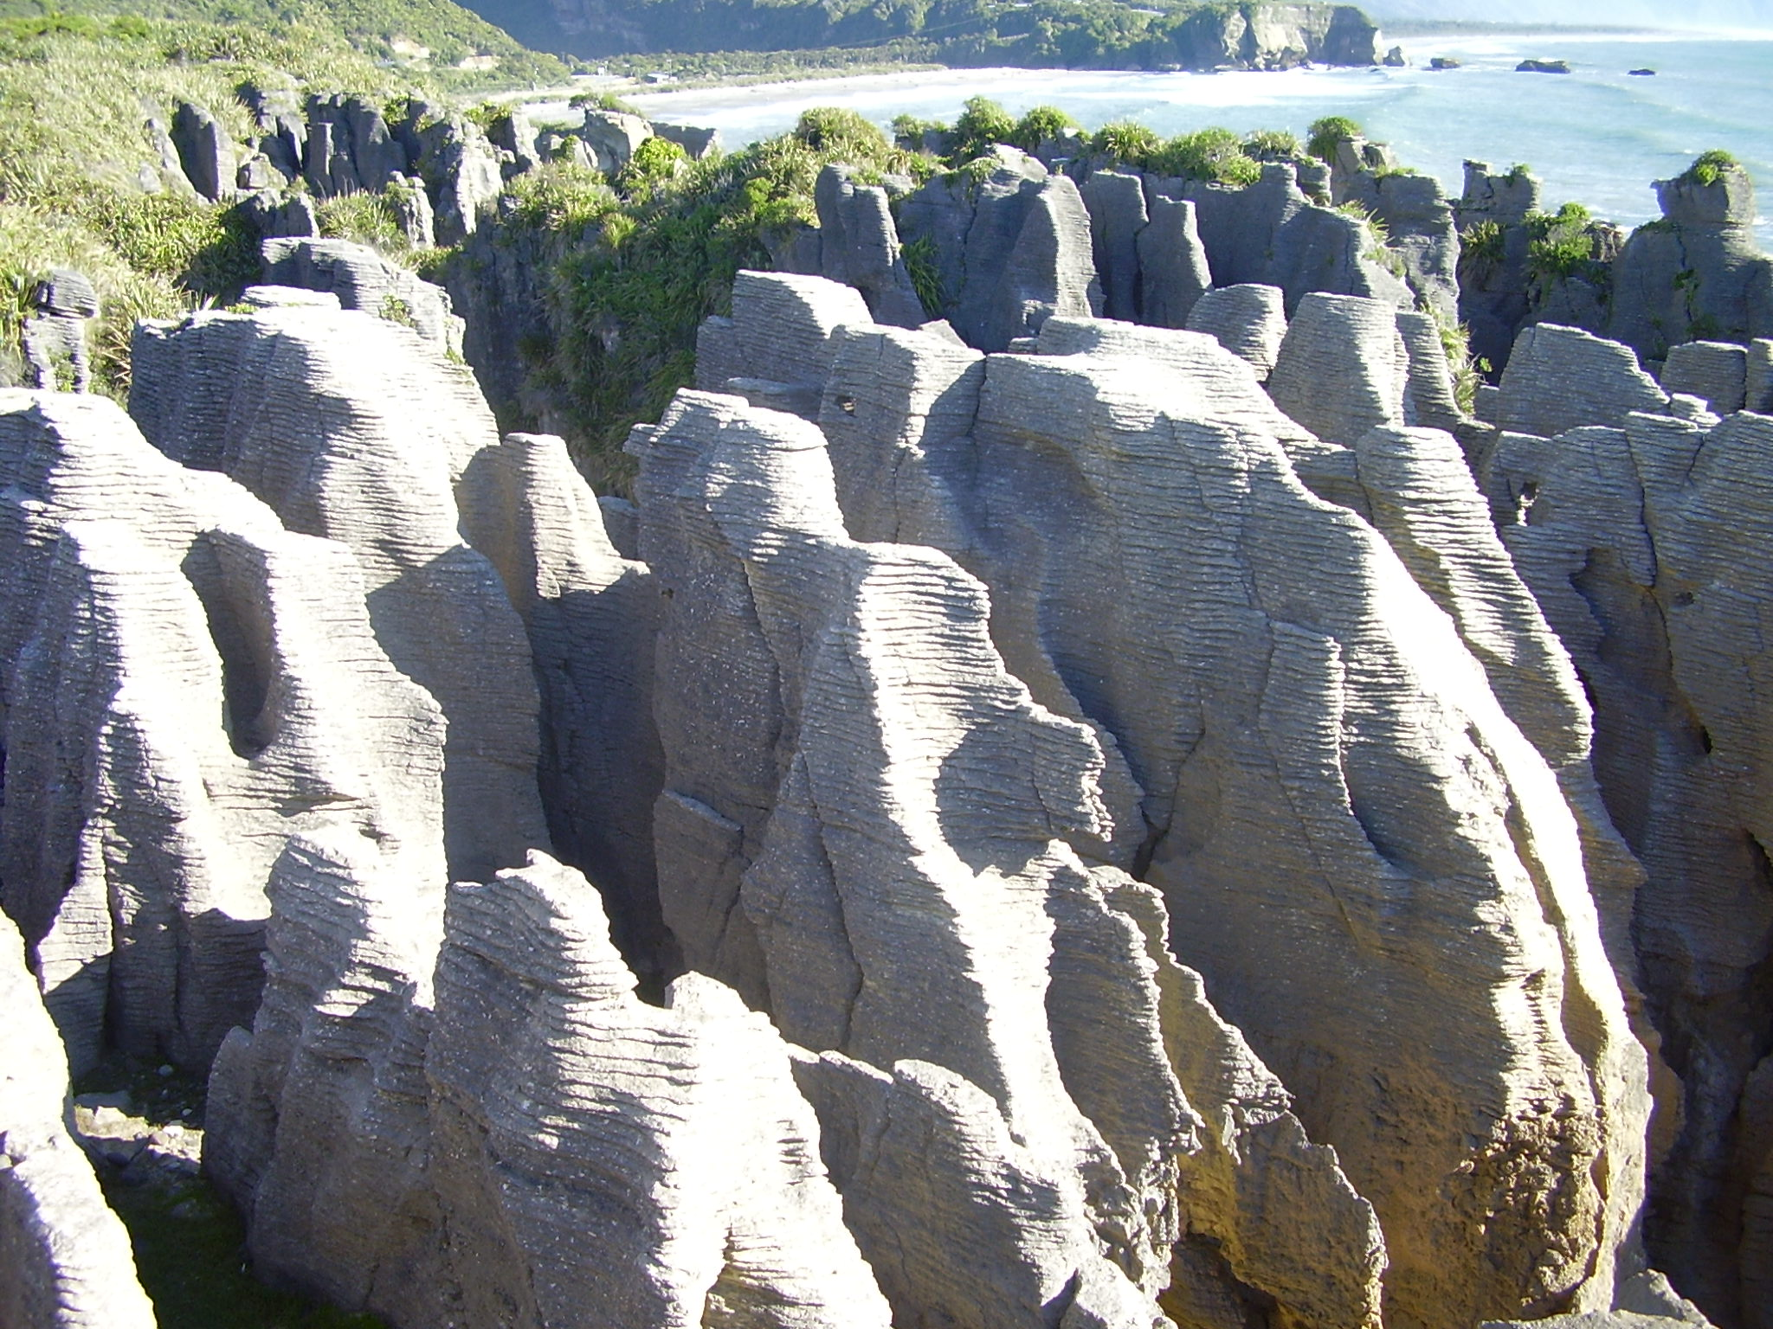
HEI MAHI
He papatūhonohono a Aotearoa nō ngā momo toka rerekē maha nei. Kua whakaaturia pea tētahi mahere arowhenua o Aotearoa e tō koutou kaiako ki a koutou.
Tērā te momo o ngā toka mai i te kāhuarau kanapa mārō tae atu ki te kōhatu hū ngohe nei, mai i te anga pōhatu tawhito rawa(te āhua 500 miriona tau te tawhito) tae atu ki ngā toka puia tamariki noa i hū mai ai i ngā tau 50 ka taha ake nei.
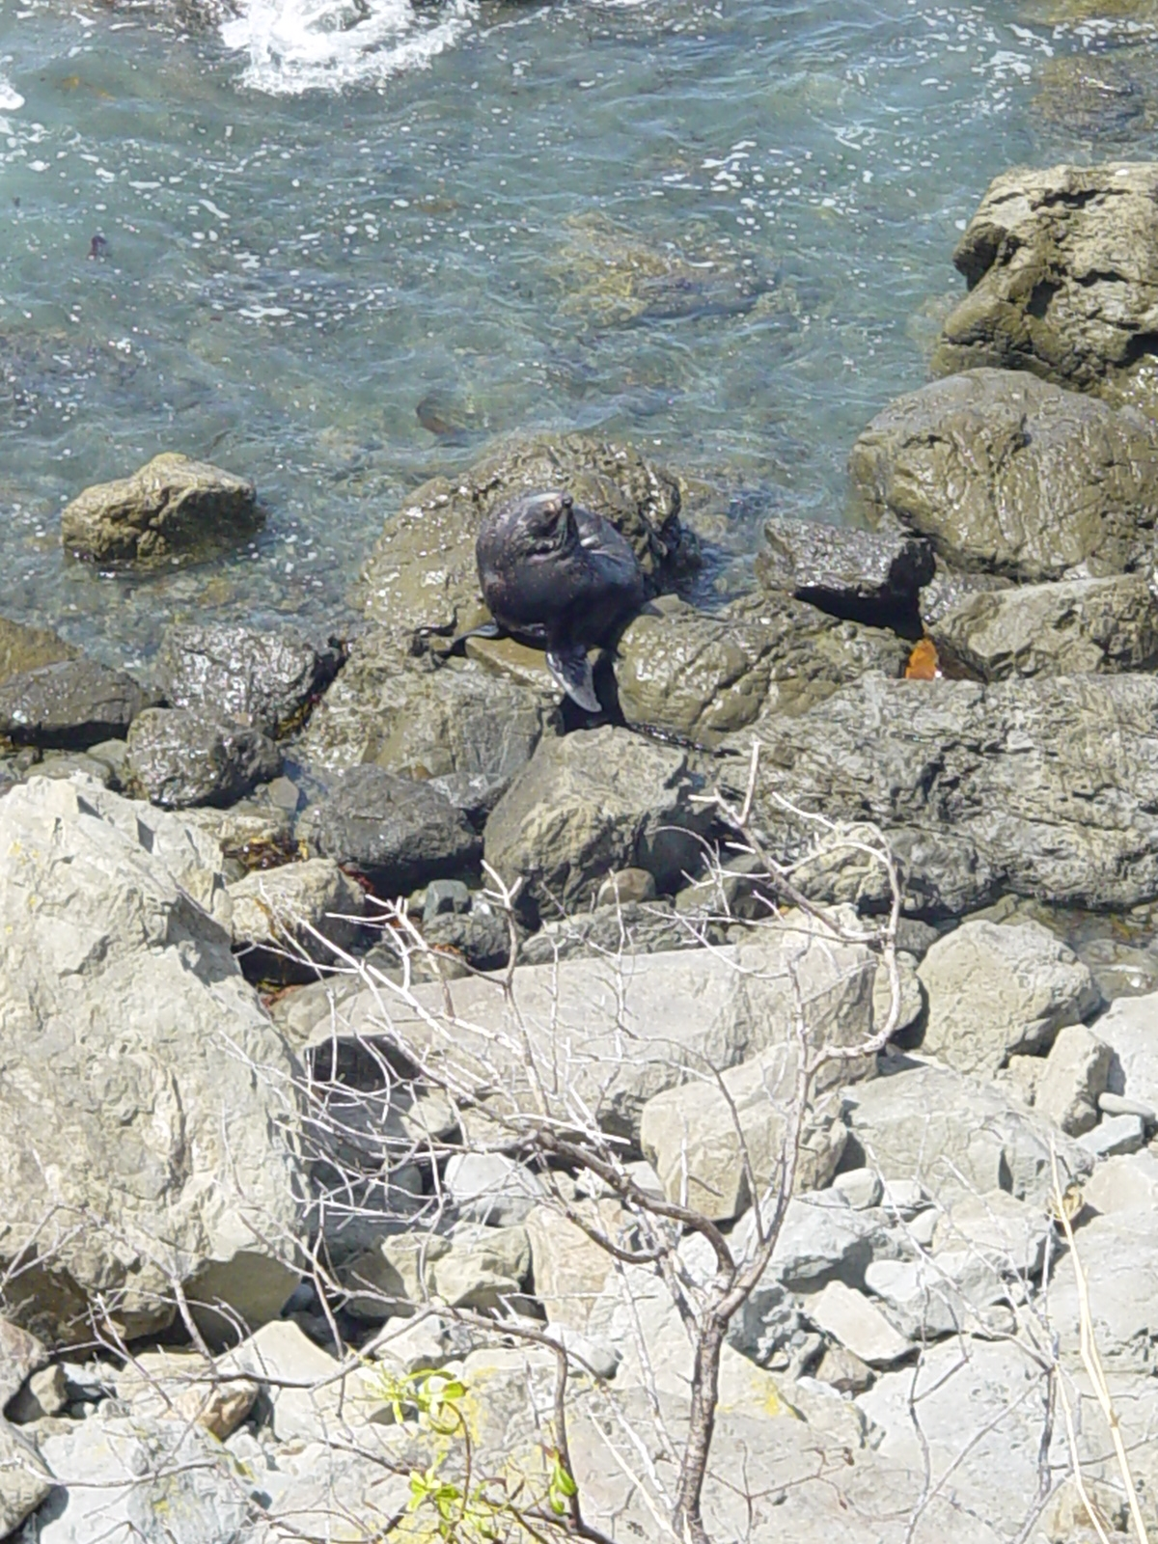
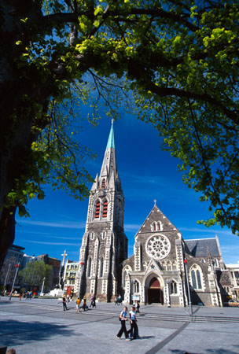
Nō te whenua rawhaki o Whenuakonowana ngā toka tawhito rawa, ā, ko ngā uri o ngā toka nei i pūtake mai i muri i te wehenga o Aotearoa hei whenua. Ko ngā tohu o ō tātau toka, ko ngā wairua o ngā papa awa, ko ngā repo rei o tūāuriuri, ko ngā papa moana hōhonu, ko ngā motu puia, ko ngā onepū kirikiri me ngā papa anga, ko ngā take pae maunga, arā atu anō, arā atu anō.
Kei te haere atu koutou ki tētahi wāhi, ētahi wāhi rānei e whakaatu ana i ngā toka o tō rohe. He wāhi māori te nuinga o ēnei wāhi kōhatu, engari kia maharatia ko ngā kōhatu i whakamahia ai hei hanga whare i haria mai i wāhi kē atu o te motu pērā i te māpara hei papa takakai ki rō kīhini, hei pōhatu whakamaharatanga rānei i ngā urupā.
Ka whakaritea pea e tō koutou kaiako kia tirotirohia ētahi wāhanga ake o te wāhi e ngā rōpū.
- Tirohia ngā momo toka. Whakamahia te whatu tīwhana menā e tika ana.
- Whakatauritea ki ngā tauira toka me te whakapapa toka.
- Whakaingoatia te momo o te toka, whakaahuatia hoki menā e taea.
- Whakamāramatia te wāhi i kitea ai te toka, whakaahutia hoki menā e taea.
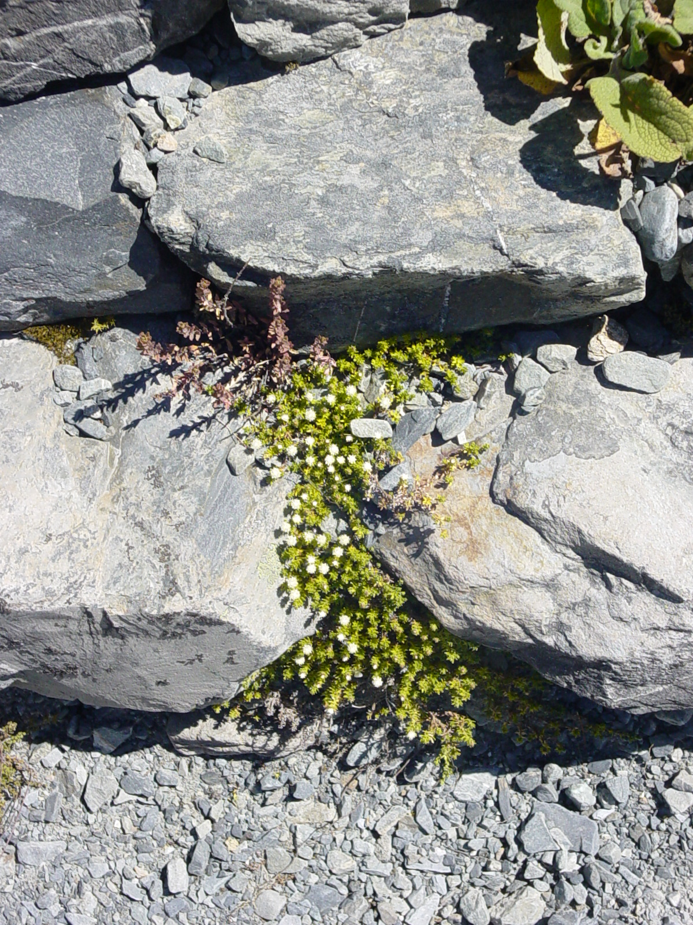
- Mutu ana, whakataurite ana i ngā hua o te mahi ki ērā o ētahi atu tauira/rōpū.

Mehemea he Maki Ārohi koe, me peka pea ki tēnei pā ipurangi kei reira ētahi kōrero whakamere māu:
http://www.minerals.co.nz/html/main_topics/mineral_moments.html

Ngā pūtakenga mai o te ahi – ngā pūahi
whakaputanga
Smart Board
literacy

