HE KAUPAPA PŪTAIAO

TAU 12/13

(NCEA KAUPAE 2/3 ŌMATAORA)

E 8 NGĀ AKORANGA ME NGĀ MAHI

NGĀ TIKANGA ŌMATAORA

Te Mahere Kaupapa Mahi – Tau 12 Ōmataora – NGĀ TIKANGA ŌMATAORA
Tauira: | TE KATOA | Kaupapa Māori:
Te mōhiotanga o te kaiako: | He āhua mōhio | He iti
Ngā wāhanga ako: | Pūtaiao | Tāne
Te Marautanga – Te take | Pūtaiao
Whenu: | Ōmataora | Tāne
Huarahi: | Te Katoa | Te katoa
Taumata: | 7
Ingoa: | Ngā Tikanga Ōmataora | Take mana tangata
Ngā whāinga hei whakatutuki: | Ko tā ngā tauira:  - He whaiwhai kōrero e tika ana kia mārama ki ngā take pūtaiao tikanga-ā-iwi e pā ana ki a rātau, ā, he tohu hoki i ngā whaiwhakaarotanga ā-waiaro nei, ā-iwi nei.
 | - He mōhio ki ngā tikanga here tohunga pūtaiao mō te whiri i ō rātau whakaaro hou ki ngā whare kōrero pūtaiao, ā, ka whakairia ki te tāhū o taua whare hei wānanga mā ngā tohunga.
 | - He āta whakaaro i ngā kōrero e tika ai te tautohe take mō te pānga, mō te takahi a te tangata i ngā kāinga rauropi (AO7.3a); | Rua; Rongomātāne
 | - He tirotiro ki ētahi tauira whakarite, whakahaere rānei mō te whakamahi i ngā āhuatanga ōmataora hei whakatutuki i ngā hiahia, i ngā tono rānei o te tangata. (AO7.3b).
Ngā pūkenga: | Te whakaaro | Rua; Rongomātāne
 | Te whakawhanaungatanga | Rua; Rongomātāne
 | Te whakauruuru, te āwhina
Te tirohanga: | Te whakatau take
Te Wāhi: | Te Ao; Aotearoa; te marae o te kāinga | Te Ao; Aotearoa; te marae o te kāinga
Ngā akoranga: | 8

Ngā ngohe: | 1 Te whakamōhio atu i ngā tikanga ōmataora mā te tauira. | Whakawhenua
 | 2. He tauira anō hei whakapakari i ngā pūkenga whakarite whakatau ā-tangata, ā-rōpū hoki – te whakaatu, te whakawhiti kōrero hoki. | Rangahau
 | 3. He tauira anō hei whakapakari i ngā pūkenga whakatau ā-tangata, ā-rōpū hoki – te whakaatu, te whakawhiti kōrero hoki. | Rangahau
 | 4. Te taki rangahau, te taki whakaatu. | Te Hao
 | 5. Te whakamōhio atu i te rangahau ā-tuakiri. | Tāhū kōrero
 | 6. Te rangahau a te tangata. | Tāhū kōrero
 | 7. Te rangahau a te tangata | Tāhū kōrero
 | 8. Te whakaatu i te rangahau a te tangata | Tāhū kōrero
Tikanga Māori: | Kohinga 2 – Rārangi Tikanga Māori | Whainga tapuwae, wānanga, kauhau, whakairo, whaikōrero
Reo Māori: | Kohinga 3 – Rārangi Reo Māori
Ngā rauemi:  - Kohinga 1 | HM Ngata: English-Maori Dictionary
 | http://www.google.co.nz

INGOA O TE KAUPAPA: NGĀ TIKANGA ŌMATAORA

PAETAU: Tau 12, 13 rānei (NCEA Kaupae 2/3 Ōmataora)

WHIRINGA MARAUTANGA:
NGĀ TINO PŪKENGA:
- Te whakaaro
- Te whakawhanaunga
- Te whakauruuru, te āwhina
WHENU: Ōmataora Taumata 7
NGĀ WHĀINGA HEI WHAKATUTUKI: Ko tā te tauira:
- He wānanga i ngā kōrero e tika ai te tautohe take mō te pānga, mō te takahi a te tangata i ngā kāinga rauropi (AO7.3a);
- He tirotiro ki ētahi tauira whakarite, whakahaere rānei mō te whakamahi i ngā āhuatanga ōmataora hei whakatutuki i ngā hiahia, i ngā tono rānei o te tangata. (AO7.3b).
WHENU: Ōpūtaiao (Te whakauruuru, te āwhina)
NGĀ WHĀINGA HEI WHAKATUTUKI: Students will:
- He whaiwhai kōrero e tika ana kia mārama ki ngā take pūtaiao tikanga-ā-iwi e pā ana ki a rātau, ā, he tohu hoki i ngā whaiwhakaarotanga ā-waiaro nei, ā-iwi nei.
- He mōhio ki ngā tikanga here tohunga pūtaiao mō te whiri i ō rātau whakaaro hou ki ngā whare kōrero pūtaiao, ā, ka whakairia ki te tāhū o taua whare hei wānanga mā ngā tohunga.
TE PĀNGA KI NGĀ AROMATAWAI NCEA:
Ka whai wāhi tēnei kaupapa ki te mahere whakaako e tautoko ana i ngā tauira e akoako ana kia whakamātautauria rātau i raro i ngā tikanga o ngā paerewa nei, i runga anō hoki i te aronga o te kaiako, o te tauira rānei me te mōhio hoki o te tauira:
- Paerewa Paetae 90769 w1 Kaupae 2 Rangahaua ngā pāhekohekonga i waenganui i te tangata me tētahi āhuatanga ōmataora. (3 whiwhinga);
- Paerewa 6352 w3 Kaupae 2 Me whai rīpoata ā-pūtaiao nei mō tētahi take e whai wāhi ana ki te taiao, he ārahi te tikanga.(4 whiwhinga);
- Paerewa Paetae 90771 w1 Kaupae 2 Rangahaua he kōrero hei whakatakoto rīpoata pūtaiao. (3 whiwhinga);
- Paerewa Paetae 90714 w2 Kaupae 3 Rangahaua he take ōmataora o nāianei. (3 whiwhinga).
NGĀ HUA AKE O TE AKO:
Ka taea e te tauira:
- ngā take e tirohia rerekētia ana i runga i te tikanga hāhi, iwi, aha atu rānei te tohu;
- ngā momo hua, ngā whara, ngā herenga o te mahi a te tangata te whakatauriterite;
- ngā take ōmataora o ēnei rā te whakatau tika;
- ngā kōrero e tika ana hei tautoko i ngā whakaaro ake o te tangata te whiriwhiri, te whakatakoto hoki.

TE MŌHIOTANGA KIA MĀTUA MŌHIOTIA:
Te Hangarau ōmataora me ngā tikanga hangarau pītau ira.

NGĀ RAUEMI HEI WHAI:
He akoranga āwhina katoa ēnei akoranga e 8 hei tautoko i te tika o te whakatau ā-tikanga nei i te ao ōmataora. Ka whakamahia motuhaketia rānei ko ia akoranga hei whakapakari i ngā tohu wānanga o te hinengaro.
He tikanga rangahau, he tauira aromatawai hoki hei āwhina.
- Ngā rauemi kua tāruatia mō ngā ngohe o te Akoranga 1.

NGĀ WHAKAPUAKANGA HEI TITIRO:
Biozone International Yr 12 Biology Student Resource & Activity Manual (new edition annually)
Link Resource – Bio-decisions by Sue Jarvis, Jon Hickford, Lindsey Conner. NZ Institute for Crop & Food Research, 1998.
Topics in Biology: Issues in Biology by Margaret Brumby. Thomas Nelson, Australia, 1984.
www.google.co.nz to find information appropriate fro your class:
- Karen Ann Quinlan http://www.ascensionhealth.org/ethics/public/cases//case21.asp
- Terri Schiavo http://news.bbc.co.uk/2/hi/americas/4358877.stm

http://www.annals.org/cgi/content/full/125/5/425-a (Chinese Eugenics)
http://www.newscientist.com/article/mg15220560.300-chinese-deal-sparks-eugenics-protests.html (New Scientist, 16 November 1996, page 4 – Chinese deal sparks eugenics protests)
Effective Literacy Strategies in Years 9 to 13 – a Guide for Teachers. Ministry of Education, Learning Media, Wellington. 2004.
TE MAHERE AKORANGA 1
TE WĀ: 60 meneti
KAUPAPA MAORI: Whakawhenua – whainga tapuwae; wānanga
NGĀ TOHOTOHU MĀ TE KAIAKO:
He mahi tuakiri te mahi nei engari he pai kē atu kia mahia ā-rōpūititia.
- Whakaritea tō wāhinga kōrero mō ngā tikanga – he mahi kaikiri tēnei, ā, me whakawhitiwhiti whakaaro ki ētahi atu, me kōrero hoki ki mua i te aroaro kaumātua.
- Whakaritea te rauemi mā te tauira mō ngā take e rua tuatahi (Hei Mahi 1 & 3) e pā ana ki ngā whakapono ake, me ngā uara ake o te tangata.
- Tāruatia te Whārangi Hei Mahi 2
- Me whai papakupu Reo Pākehā-Reo Māori/Reo Māori-Reo Pākehā.
- Me whai papakupu Ōmataora.

NGĀ TOHUTOHU MĀ NGĀ TAUIRA:
- Me tuakiri te mahi i Hei Mahi 1, whakapaparia kō ēhea ngā whakamahinga o ngā wāhanga tinana e tino whakaaetia ana, tae atu ki ērā kāore i te tino whakaaetia. Waiho mā tōu nā whakaaro, te uri a te whakapono me te uara, e whakatau. [5 meneti].
- Me hui ā-rōpū takirima nei, kaua e nui atu (kei te tokomaha o te karaehe te tikanga – me whai i ngā tohutohu a te kaiako), ki te whakawhitiwhiti kōrero mō ā koutou whakapapa i whakatakotoria e koutou, me ngā take hoki i pērā ai. [5 - 10 meneti].
- Whakatauritea ngā whakapapa o te karaehe.[5 meneti].
- Mā te rōpū tonu e tiki atu te Whārangi Hei Mahi 2 hei wānanga, hei raranga hoki i tētahi kete ariā mō ngā awe i āu whiringa whakatau. [10 meneti].
- Whakatauritea ngā kete ariā o te karaehe. [5 meneti].
- He mahi takitahi te Hei Mahi 3, whakapaparia kō ēhea ngā whakamahinga o ngā rauropi ira whakawhiti e tino whakaaetia ana, tae atu ki ērā kāore i te tino whakaaetia. Waiho mā tōu nā whakaaro, te uri a te whakapono me te uara, e whakatau [10 meneti].
- Me hui ā-rōpū takirima nei, kaua e nui atu (kei te tokomaha o te karaehe te tikanga – me whai i ngā tohutohu a te kaiako), whakatauritea ngā whakapapa o tēnā, o tēnā o ā koutou kōrero i whakatakotoria e koutou. [5 - 10 meneti].
- Whakatauritea ngā whakapapa o te karaehe [5 meneti].

HEI MAHI 1
He pānga anō o ā tātau mahi katoa ki to tātau taiao me ngā uri mataora e noho ana i reira – mai i te kai e kaingia nei e tātau, tae atu ki ā tātau mahi e mahana haere ai te ao. Ka pā ngātahi mai ā-tuakiri nei, ā-ao whānui hoki.
He wānanga i ngā whiringa whakatau mō ngā uri mataora te tikanga ōmataora. Ko tāna anō, ko ā tātau tikanga whiriwhiri whakamahinga kararehe, tangata mai, otaota mai, ā, me tā tātau whakatautika i te pai, i te kino, i ngā herenga hoki o ā tātau mahi.

TE NGOHE
Tapatapahia ngā kōrero 15 nei mō ngā whakamahinga o ngā wāhanga tinana, kātahi ka takiaho ai mai i ērā e tino whakaaetia ana e koe, tae atu ki erā kāore i te tino whakaaetia. Me whai take mō tāu i whiriwhiri ai, ā, me whakawhiti kōrero hoki ki ētahi atu o tō rōpū.

Te tuku toto | Te tuku whēkau i te wā e ora tonu ana. | Te tuku whēkau tūpāpaku | Te whakamātau whēkau tūpāpaku hei kaupapa rangahau pūtaiao | Te whakamātautau tūpāpaku kia kitea ai te take o te mate.
Te tango tautauira kiri hei whakamātau i te ira tangata o ngā whakataetae tākaro o te ao. | Ko te tango tautauira kiri, huru rānei hei whakamātautau ā-ira whakapapa (te whakamātau tohu mati ā-ira) kia kitea ai menā i taka ki te pāwhera, ki te kōhuru rānei. | Ko te tango tautaira kiri, huru rānei hei whakamātautau ā-ira whakapapa (te whakamātau tohu mati ā-ira) kia mōhiotia ai te ure tārewa | Kia hikareia te ngote toto hei whātau i te kaha waipiro o roto. | Te tango tautauira toto, kiri rānei hei tuhi atu ki te kauwhata tangata o te motu, o te ao hoki.
Ko te whakamana i te whakapākanga o te hunga e kawe iramate ana kia wharengaro. | Ka tāruatia ngā pūtau tinana tangata hei whakatipu wāhi tinana hou mō ngā whēkau e pakeke ana, e tāmate ana (hei tauira – te ate, te takihi) kia kore ai e whakahoea. | Te hanga tamaiti i ō pūtau tinana hei mahanga tino rite mōu | Te whai i ngā tikanga tiaki tinana hei whakakōpaka i te hunga mate tata – tērā ngā rongoā hangarau hou hei whakaora anō i a rātau ā tōna wā. | Tīkina atu tētahi rongo kōrero o nātata nei mō te whakamahi tinana tangata, wāhi tinana rānei korekore rawa e whakaaetia ana e koe.

Tāpirihia tō takiaho ki tētahi whārangi A4 me ngā take i whakataua e koe kia pērā ai te takitaki.
WHĀRANGI HEI MAHI 2
Wānangatia i roto i tō rōpū, ngā āhuatanga e whakaawe nei i a koe ki te whiriwhiri whakatau, kātahi ka tuhi ai i ō koutou whakaaro hei kete ariā. Tērā pea ka whakamahia ko tēnei, ka waihangatia rānei ko tāu ake.

Ki te uaua i te tīmatanga, mā ētahi o ēnei kupu pea koe e āwhina ki te whai i āu ake:
ngā whakapono hāhi ngā tikanga iwi ngā whanonga te ture te moni hei utu
HEI MAHI 3
Kei roto i te rauropi ira whakawhiti ētahi ngaku ira o tētahi atu rauropi. He tikanga tūturu tonu te mahi whakawhiti nei, heoi he mea hanga e ngā tohunga pūtaiao mai anō i ngā tau tōmua o 1970.
Nā te hanga rauropi ira whakawhiti i huaki ai te tatau o te whare hanga rongoā pērā i te taiāki huka tangata i hua mai ai i te huakita hei rongoā mate huka tangata. Kua rawekengia tētahi wāhi tonu o ētahi atu rauropi ira whakawhiti e ea ai ngā hiahia me ngā tono o te tangata, pērā i ngā huanga kai kāore e mate i te waipatutaru; ngā tōmato Flavr Savr kāore e ngohengohe ahakoa maoa; me te raihi kua tangohia tētahi pūmua o roto, nāna i mate tūtohu ai ētahi tāngata.

TE NGOHE
Tapatapahia ēnei kōrero 12 mō ngā rauropi ira whakawhiti kātahi ka takiaho ai mai i te tino o te whakaaetanga ki te paku o te whakaaetanga. Me whai take tō takitaki mai.
Hōatu ai te ira taiāki huka tangata ki te huakita kia hua mai ai te taiāki huka tangata hei rongoā mate huka. | Hōatu ai te ira huakita whakangao waipatungārara ki te parareka hei kaupare atu i te tini a Ngārara. | Hōatu ai te ira tangata māori ki ngā ira pūkahukahu o tētahi tamaiti e mate kakakīrehe whēwhē ana hei rongoā mō taua mate. | Ka whakatipuria he māpu kau e mau ira tangata ana kia hua mai ai he waiū rite ki te waiū tangata.
Whakatipuria ai te tōmato kua aro kē tētahi o ōna ira kia maoa engari kāore e tere ngohengohe. | Ka whāngaia te ira tangata ki te poaka kia tīkina atu ko ngā whēkau poaka hei huaranga ki te tangata ka kore e whakahoea e te tinana tangata. | Hōatu ai te ira kararehe ki te otaota hei whakatipu kai. | Ka whakatipuria te pīni hoea kei roto nei tētahi ira hei ātete waipatutaru me tētahi ira anō hei ātete rongoā paturopi (hei tohu) – e māharaharatia nei e ētahi mā tēnei ka horahia te huakita ātete mate.
Hōatu ai te ira poaka ki te hipi. Kātahi ka hokona te mīti hipi i ngā hupamākete kāore nei he tapanga. | Mahia ai te tīhi mā te hōatu i tētahi whākōkī kua hua mai i te huakita kua whakarerekēngia ā-iratia kia kore ai e tīkina kē atu ko ngā whākōkī o ngā whēkau kararehe. | Hōatu ai te tātai ira mō te kano ārai mate ki te ika e whakaheke ai te whakapaunga moni, me te whakahaere hoki mō te whakangao i ngā ‘kai rongoā’. | Tīkina atu tētahi rongo kōrero o nātata nei mo te whakamahi tinana tangata, wāhi tinana rānei korekore rawa e whakaaetia ana e koe.

Whakatauritea tāu takiaho kōrero ki ērā atu o ngā tauira o tō rōpū, ā, kōrerotia ngā take i pērā ai.
Tāpirihia tō takiaho ki tētahi whārangi A4 me ngā take i whakataua e koe kia pērā ai te takitaki, me ētahi whakarerekētanga hoki o muri mai i ngā whakawhitinga kōrero a te rōpū.
TE MAHERE AKORANGA 2
TE WĀ: 60 meneti
KAUPAPA MAORI: Rangahau
NGA TOHUTOHU MĀ TE KAIAKO:
Me takirōpūiti te mahi nei.
- Whakamahia a www.google.co.nz hei kimi pā ipurangi mō ngā kōrero tōtika atu mō Karen Ann Quinlan, me rite te tikanga tākupu mō te mōhio o ngā tauira. Hei āwhina, tirohia te pā ipurangi: http://www.ascensionhealth.org/ethics/public/cases//case21.asp
- Me whai papakupu Reo Pākehā-Reo Māori/Reo Māori-Reo Pākehā.
- Me whai papakupu Ōmataora.

NGĀ TOHUTOHU MĀ NGĀ TAUIRA:
- Whāia ngā tohutohu a tō kaiako mō te kimi kōrero mō Karen Ann Quinlan [10 meneti].
- Me takiwhā te mahi rōpū, me whai tūmahi katoa koutou, mō te whakautu i ngā pātai o te whārangi hei mahi. [30 meneti].
- Whakaaturia ngā whakataunga ki te karaehe. [kaua e roa atu i te 2 meneti mō ia rōpū]
HEI MAHI
Nā te take o Karen Ann Quinlan i te tau 1975, i tohetohea ai te kaupapa o te rangatiratanga o te matenga. Nāna, ka puta mai ai ētahi take uaua nei.
Tirohia ngā kōrero i tukuna mai e tō koutou kaiako kia whānui te kite i ngā take mō te hekenga o Karen ki te moe pōroa, ā, mate noa i te tau 1985.
Ko ngā take me mōhio koe. (me pēnei hoki tāu ake rangahau):

- Ngā ariā me ngā tukanga ōmataora (mō te take nei: te hanga o te roro, te mahi a te tumu, a te uho hoki o te roro; te pānga mai o te waipiro me te rongoā kino ki te roro; ngā tikanga mahi o te mihini whakahauora tangata).
- Ngā whakataunga o te ture (mō te take nei: kei te ora tonu rānei te tūroro menā he mihini kei te whakahauora i a ia? He kōhuru rānei te whakaweto i taua mihini?)
- Ngā tikanga me ngā uara(mō te take nei: he tika rānei tā ngā tākuta whakatau tuatahi kia kaua e whakawetohia ngā mihini? He tika rānei te kawe a ōna mātua i te take nei ki mua i te aroaro o te kooti? He tika koia te whakarite kia mate rawa te tangata? Menā ka whakataua kia whakawetohia ngā mihini whakahauora tangata ‘kia tukuna noatia te tangata kia mate’, kāti me mana hoki te ture kia whai tikanga tonu mō te tuku i taua tangata kia mate?)
- Ngā whakaaro (mō te take nei: he rerekē – te pāpā o Karen mō te whakahauora, mō te whāngai iaia toto)

NGOHE
Kei roto i tō rōpū takiwhā, whirwhiria mā wai ngā mahi nei:
- Tā Te Kaihautū o Te Rōpū – he whakahaere kia rere tika ai te mahi, kia mana ai te wā, kia tōtika ai te kōrero
- Tā Te Kaipānui o Te Rōpū – he kimi i ngā tuhinga ka pānui ai ki te rōpū inā tika ai
      - Tā Te Kaituhi o Te Rōpū – he tuhi kia pupuritia ngā whakatau me ngā kōrero a te rōpū.
- Tā Te Kairīpoata o Te Rōpū – he whakahoki i ngā kōrero ki te karaehe.

Wānangatia, kōrerotia ngā whakautu mō ngā take e whā.
Tuhia, whakaaturia hoki ngā whakataunga ki tā te rōpū whakatika ai. Kaua e roa atu i te 2 meneti te whakaaturanga.
TE MAHERE AKORANGA 3
TE WĀ: 60 meneti
KAUPAPA MAORI: Rangahau

NGĀ TOHUTOHU MĀ TE KAIAKO:
Me takirōpūiti te mahi nei.
- Whakamahia a www.google.co.nz hei kimi pā ipurangi mō ngā kōrero tōtika atu mō Terri Schiavo, me rite te tikanga tākupu mō te mōhio o ngā tauira. Hei āwhina, tirohia te pā ipurangi: http://www.cnn.com/interactive/us/0503/timeline.schiavo.case/frameset.exclude.html, http://news.bbc.co.uk/2/hi/americas/4358877.stm rānei
- Me whai papakupu Reo Pākehā-Reo Māori/Reo Māori-Reo Pākehā.
- Me whai papakupu Ōmataora.

NGĀ TOHUTOHU MĀ NGĀ TAUIRA:
- Whāia ngā tohutohu a tō kaiako mō te kimi kōrero mō Terri Schiavo [10 meneti].
- Me takiwhā te mahi rōpū, me whai tūmahi katoa koutou, mō te whakautu i ngā pātai o te whārangi hei mahi. [30 meneti].
- Whakaaturia ngā whakataunga ki te karaehe. [kaua e roa atu i te 2 meneti mō ia rōpū]
HEI MAHI
Ki tōu ake whakaaro, he rerekē rawa te tango kapu whakahāora i te tango kōrere whāngai iaia e tuku kai ana ki te tinana? Koia rānei ko te whakamate korekai i te tangata?
Tirohia ngā kōrero takiwā i tukuna mai e tō koutou kaiako kia whānui te kite i ngā take mō te hinganga o Terri Schiavo i tino whara ai tōna roro i te tau 1990 tae atu ki tōna matenga i te tau 2005.
He pērā anō ki a Karen Ann Quinlan, ka puta mai ngā take mō Terri Schiavo, ā, tērā pea kua takahi whakamua atu ngā whāwhātanga atu ōmataora i ngā uara, i te māramatanga, i ngā ture hoki o tō tātau iwi. He tere rawa ngā tupunga hangarau ōmataora, rongoā hoki i roto i ngā tau tekau kua hori ake nei, ā, e tupu tonu nei. Mā te mārama ki ngā whakaritenga me ngā take e whai wāhi ai te iwi whānui ki te paepae kōrero o Mōhio. Mā tō āro mai ki te ako kaupapa ōmataora e whai wāhi hoki ai koe hei tangata mātau ki roto i ēnei kōrero take ā-iwi.
TE NGOHE
Kei roto i tō rōpū takiwhā, whirwhiria mā wai ngā mahi nei:
- Tā Te Kaihautū o Te Rōpū – he whakahaere kia rere tika ai te mahi, kia mana ai te wā, kia tōtika ai te kōrero
- Tā Te Kaipānui o Te Rōpū – he kimi i ngā tuhinga ka pānui ai ki te rōpū inā tika ai
      - Tā Te Kaituhi o Te Rōpū – he tuhi kia pupuritia ngā whakatau me ngā kōrero a te rōpū.
- Tā Te Kairīpoata o Te Rōpū – he whakahoki i ngā kōrero ki te karaehe.

Wānangatia, kōrerotia ngā whakautu mō ngā take e whā.
Ngā ariā, ngā tukanga ōmataora:
Ngā pātai matua, ki tāu nā titiro, kia mārama rawa. Me rau atu pea ko ēnei:
- Take ōmataora
- Te ture
- Te tikanga
- Ngā āhuatanga ā-iwi
Tērā te wā ka whakaarohia hoki ko ngā āhuatanga o taiao. Ehara i te mea ka rau katoa atu ngā āhuatanga ki roto i ēnei take.
- Wānangatia ngā kōrero tāutuutu a ngā paepae.
- Māu anō tāu e whakatau; me whai kiko hoki hei tautoko
Tuhia, whakaaturia hoki ngā whakataunga ki tā te rōpū whakatika ai. Kaua e roa atu i te 2 meneti te whakaaturanga.

TE MAHERE AKORANGA 4
TE WĀ: 60 meneti
KAUPAPA MAORI: Te Hao
NGĀ TOHUTOHU MĀ TE KAIAKO:
Me takirōpūiti te mahi nei.
- Whakaritea te rauemi tauira mō te take tikanga whakamutunga e pā ana ki te whakamātautau ira tangata me te ture Ahuahu Whakapapa o Haina.
- Tirohia te URL http://www.annals.org/cgi/content/full/125/5/425-a me http://www.newscientist.com/article/mg15220560.300-chinese-deal-sparks-eugenics-protests.html menā e mahi ana (menā kāore, tirohia www.google.co.nz kia kitea ngā pā ipurangi pai rawa atu mō ngā kōrero mō ngā mahi ahuahu tangata, me rite te tikanga tākupu mō te mōhio o ngā tauira.
- Menā e hiahia ana, tāruatia ngā tuhinga e rua nei mō ia tokowhā hei tikanga Whare Pānui mā rātau (tirohia te whārangi 121 o ‘Ngā Tikanga Tākupu Whainiho’ mō ngā kōrero).
- Whakaritea ētahi whangaono takirua (pai atu ngā mea rākau, he kaha, ka rite tonu te makamaka, heoi tērā pea ka waihangatia i te kāri māmā mā te whai i te tauira i raro iho nei); me tuku whangaono takirua ki ia rōpū.
  - He pātai māmā noa iho kei ngā taha o tētahi o ngā whangaono hei tīmata, hei tauira - “he aha?”, “ko wai?”, “āhea/inahea?”, “kei hea/ki hea/i hea?”, “he aha ai?”, and “pēhea?” i te reo Māori, reo Pākehā rānei.
  - He tūmahi kei ngā taha o tērā atu o ngā whangaono, hei tauira “kei te/e…ana”, “ka”, “e taea”, “ka”, “pea”, and “me” i te reo Māori, reo Pākehā rānei.
Te tauira whangaono kāri:

- Me whai papakupu Ōmataora.

NGĀ TOHUTOHU MĀ NGĀ TAUIRA:
- Me takiwhā te mahi nei, whāia ngā tohutohu a tō kaiako mō te rōpū, mo ia tangata hoki; kei te whārangi mahi e whakarāpopotohia ana.
- Tirohia te URL i tohua mai e tō kaiako mō ngā mahi ahuahu tangata a te iwi Haina (ka tuhia rānei tēnei māu). Mutu ana te pānui, whakaotia i runga i te tikanga takahi whā kia mārama ai ngā tuhinga. [15 meneti].
- Tuaruatia te mahi nei mō te kōrero o Tohunga Pūtaiao Hou e whaitake ana ki ngā tātaritanga o te iwi Haina mō ngā ira mate e tētahi umanga ake.[15 meneti].
- Hei mahi mā te katoa, tirohia ngā tauira kōrero o ia rōpū hei whakautu i ngā pātai o te whārangi hei mahi. Ka whakarāpopotohia ēnei whakautu hei pānui ā-rōpū nei ka whakairia hei kitenga mā te karaehe [25 meneti].
HEI MAHI 1
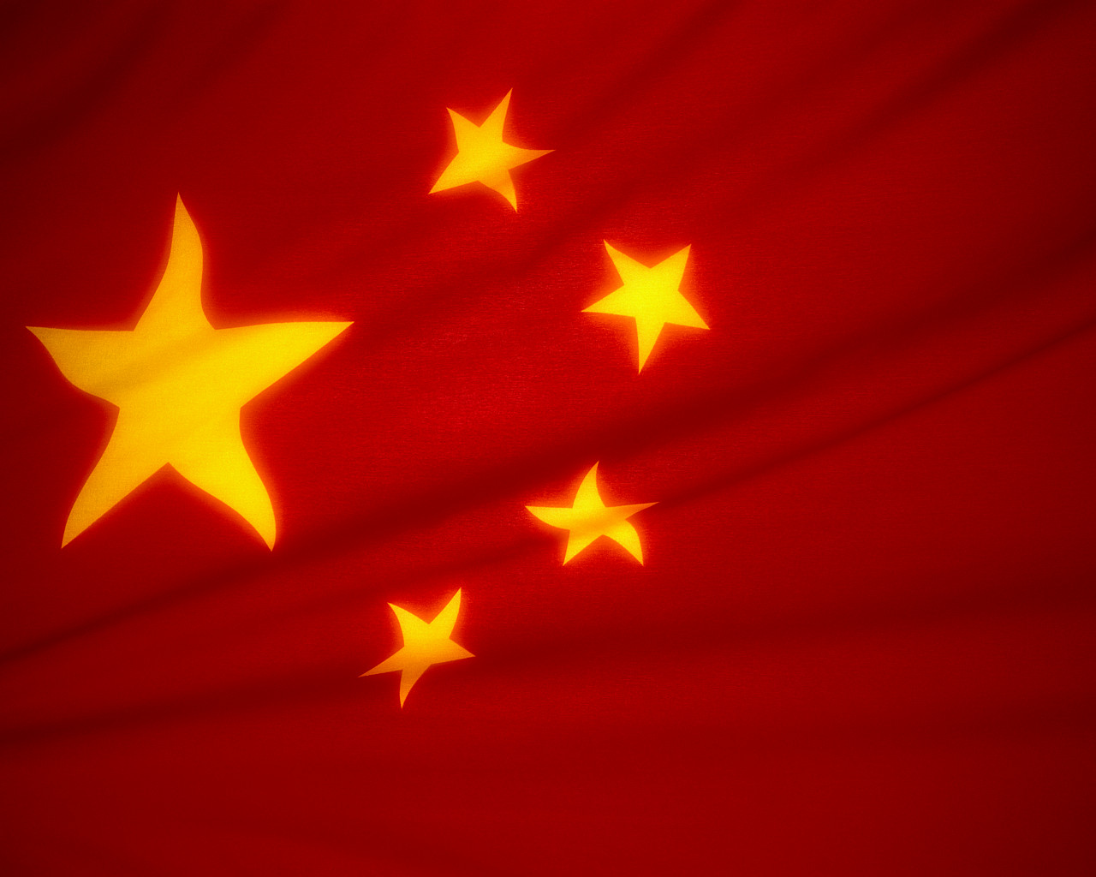
Te Ture Ahuahu Tangata o Haina mō te Tiaki Whare Tangata, Tamariki hoki.
Ka tukuna tētahi tuhinga ki a koe hei pānui māu ake, hei pānui ā-waha rānei mā tētahi o te rōpū.
Mā ia tauira o te rōpū te rōpū e arahi i roto i tētahi o ngā mahi e whai ake nei:
- Te Uiuinga – Mā te maka i te whangaono pātai me te whangaono tūmahi e tohu atu i te pātai hei whiu atu māu ki te rōpū hei whakautu mā rātau, hei tauira “He aha pea e…ai?” Ka whakautua e ētahi atu o te rōpū, kātahi ka riro mā tētahi anō hoki e maka whangaono hei whakarite pātai māna ki te rōpū hei whakautu hoki mā rātau.
- Te Tohu i Ngā Kupu Matua – tohua, whakamāramatia tētahi kupu matua, ka pērā anō ko ia tauira o te rōpū hei tuku kupu matua anō. Kia 6 -8 ngā kupu ka kōrerotia, ka whakataua hoki e te rōpū.
- Te Whakarāpopoto – Tāruatia, whakarāpopotohia rānei te ngako o te kōrero i ōu ake kupu, ka whaiwhai pērā ko ia tauira o te rōpū me tāna ake kōrero. Ka kōrerotia, ka whakataua e te rōpū tetahi whakarāpopototanga i runga anō i ngā kupu matua kua tohua mai.
- Te Whakaata i Ngā Whakaaro – Whakaatahia te ngako o te tuhinga, i runga anō i ngā kōrero kua wānangatia e te rōpū, te whakaaro o tēnā, te kī a tēnā.

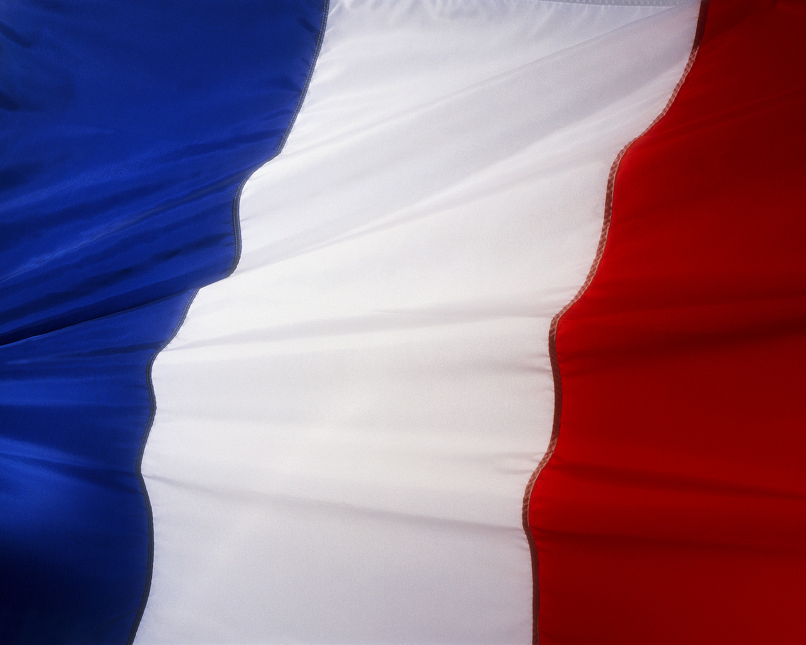
HEI MAHI 2

Tutū Ana Te Whakahē i Te Whakataunga Kirimana a Te Umanga Hangarau Ōmataora WīWī me Haina Mō Te Ahuahu Tangata

Ka tukuna tētahi tuhinga anō hei pānui māu ake, hei pānui ā-waha rānei mā tētahi tauira o te rōpū.
Kia pērā anō ki ō mua mahi, Mā ia tauira o te rōpū te rōpū e arahi i roto i tētahi o ngā mahi e whai ake nei:
- Te Uiuinga
- Te Tohu i Ngā Kupu Matua
- Te Whakarāpopoto
- Te Whakaata i Ngā Whakaaro
Mena e hiahia ana, me whakawhiti i ngā tūmahi.
HEI MAHI 3
Kua tino mārama ināianei ia rōpū ki ngā āhuatanga o tēnei kaupapa i ngā tau waenga o te 1990, ā, ka whai wāhi hoki ki te whakautu i ngā pātai i raro iho nei.
- He aha e māharaharatia ai e ngā tohunga pūtaiao te tātaritanga o te iwi Haina e tētahi umanga ake mō ngā ira mate?
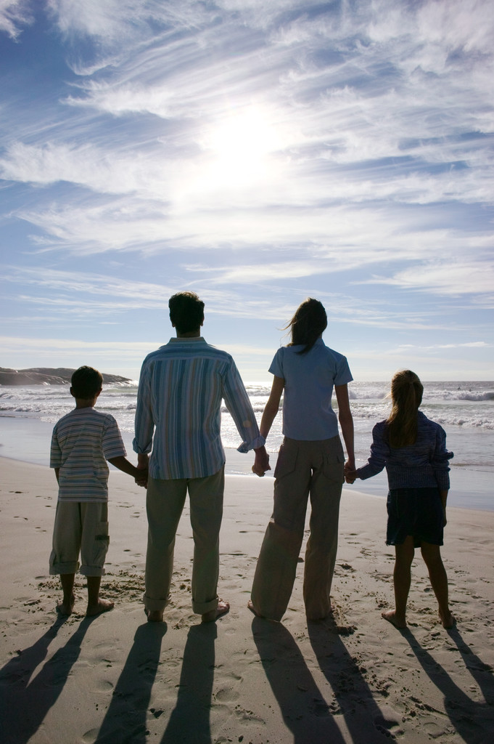
- Me pēhea e whaihua ai te iwi Haina i te ture Ahuahu Tangata?
- Me pēhea hoki koe mehemea ka kitea tētahi ira mate i roto i a koe, ā, kāore e whakaaetia kia whai tamariki koe?
- Menā ka kitea tētahi ira mate i roto i a koe, pērā i ērā mō te ikura, mō te kakakīrehe whēwhē rānei, ka whai tamariki rānei koe?
- Nō ngā tau 1960, i whakataua e ētahi o ngā rohe o te Huinga Rohe o Amerika kia whakamātautauria katoatia ngā tamariki mangumangu, āhia hoki i te mea tērā e mate nui ai ngā iwi nei i te mate pūtau toronaihi. Ka whakamōhiotia te hunga pakari nei te ora e kawe ana i tēnei mate mō ngā heipūtanga mate i mua i te wā e rite ana mō te whai tamariki. I tīmata hoki ētahi kaitukumahi ki te pare atu i ngā tonomahi a te hunga mangumangu e kawe ana i taua ira, heoi ka taka te wā ka whakakorengia aua ture. Ki ōu whakaaro, e tika ana kia mōhio te tamaiti, iwa ki te tekau pea te pakeke, he whare anō ia nō te mate? Whakamāramatia ō whakaaro.
- He nui ngā tāngata e whakaaro ana ko te tātaritanga ira mate te tīmatanga o te whakamana kāwanatanga kia riro māna ake e tohu mā wai e whakawhānau tamariki, ā, me te whakarāwekeweke i ngā tātai heke tangata.
  - Me pēhea te kāwanatanga e tātari ā-tōpū pēnei?
  - He aha ngā hua mo te whanaketanga tangata?
  - He aha ngā here hei mau ki te iwi Haina, ki ētahi kāwanatanga anō hoki e whakarite ana i te tātari ā-tōpū, kia kore e rawekengia pēneitia te iwi?

Menā ka whai tāima i muri i te kōrero, me hanga pānui e whakarāpopoto ana i te whakatau a tō rōpū.
TE MAHERE AKORANGA 5, 6, 7 & 8
TE WĀ: 60 meneti mō ia akoranga + te wā mahi kāinga
KAUPAPA MAORI: Tāhū kōrero
NGĀ TOHUTOHU MĀ TE KAIAKO:
He mahi tuakiri te mahi nei engari he pai kē atu kia mahia ā-rōpūititia. Ka taea hoki te rangahau tahi engari ko te aromatawai he tikanga tuakiri.
- Whakaritea te ngohe hei mahi mā te tauira me te whārangi tohutohu mō te aromatawai Paerewa Paetae, Paerewa rānei.
- Mehemea kāore i te nui ngā kaupapa, me paku whakamōhio atu rātau ki ētahi whakapuakanga hei tirotiro, hei tauira:
Tau 12 Ōmataora 2007 Tā Te Tauira Pukapuka Rauemi, Mahi Hoki – te tirohanga whānui whārangi 10-11
Tau 13 Ōmataora 2007 Tā Te Tauira Pukapuka Rauemi, Mahi Hoki – te tirohanga whānui whārangi 54-55
- Whakamahia te whārangi KWLH (whārangi 16) hei whakamohio atu i ia take, hei te wā rānei e whiriwhiri kaupapa ana ngā tauira hei rangahau, hei āwhina i a rātau ki te tohu i ō rātau whare kōrero ake kua mau kē i a rātau, e āro nei rātau, ā, me te whakataki hoki i ā rātau akoakonga. Tirohia te whārangi 161 of ‘Ngā Tikanga Tākupu Whaikiko’ mō ngā kōrero.
- Ko ētahi take hei tirotiro:
  - Huarangawhēkau
  - Te Rangahau Pūtau Tātā
Ētahi tauira mō
AS 90714
(Ōmataora 3.2)
  - Te Whakawhiti Ira
  - Te Rāhui Mataora
  - Te Tātai Ira
  - Te Tārua Ira
  - Te whai inanga i te awa o Aparima
  - Te ahuwhenua i te rohe o MacKenzie
  - Te Rāhui ā-ōmataora i ngā kīrehe orotā me ngā tahumaero
Ētahi tauira mō
AS 90769
(Ōmataora 2.2)
  - Ngā whakaritenga ōmataora tiaki para
  - Ngā tikanga hangarau whākōkī
  - Ngā hangarau rongoā
  - Ngā hangarau kai
  - Te rāhui kīrehe orotā
Ētahi tauira mō
AS 90771 (Pūtaiao 2.2)
  - Te Whakaora ā-ira
  - He take taiao o te kāinga, o te motu, o te ao rānei US 6352 Kaupae 2
- Tīkina atu te Tauira Rangahau (whārangi 17) hei whakahauhau i ngā tauira ki te whaiwhai haere i ā rātau puna kōrero – tāruatia ētahi mō ia tauira. Kua whakairohia te tauira nei hei āwhina i ngā mahi mō AS90714 engari he māmā noa iho te tīni hei tohu i ngā tūmahi ake o ērā atu o ngā paerewa i runga ake nei.

NGĀ TOHUTOHU MĀ NGĀ TAUIRA:
Whāia ngā tohutohu a tō kaiako, a te whārangi aromatawai mahi hoki hei whakaoti atu i tāu rangahau i runga i ngā kupu ārahi o ngā akoranga o mua atu. Mā te whakaoti whārangi KWLH e mōhio ai he aha tāu e mōhio nei mō ētahi kaupapa hei rangahau māu, e āwhina hoki i a kōrua ko tō kaiako kia tika ai te mahi i raro i ngā whakaritenga ariā, e whaihaere hoki i tāu nā akoako.
Ko tā te Tauira Rangahau he āwhina i a koe ki te whakariterite i āu kōrero rangahau. Ka whakatakotoria ngā mokamoka kōrero inā whakaritea ai, tuhia ai tāu rīpoata.
E mōhiotia ana | E hiahia ana kia mōhiotia | Kua ākona, e mau kē ana | E mōhitotia pēheatia ana

Te Tauira Rangahau Ōmataora

Whakamahia te tauira i raro iho nei hei āwhina i a koe ki te whakariterite i āu kōrero e rangahaua ana e koe. Puritia ēnei kōrero hei whakamātau i ō rauemi i mua i te tuhinga i tāu rīpoata, hei tiki kīnga a ētahi, hei tuhi whakapuakanga i roto tonu i te rīpoata, hei whakarārangi hoki i ngā whakapuakanga.

Ingoa:
Kaituhi:
Kaitā:
Tau i tāia ai:
Wāhi i tāia ai:
URL:
Te take e tohea ināianei ana tēnei kaupapa. | Ngā Ariā me Ngā Tukanga Ōmataora
Ngā whakataunga ā-ōmataora, ā-iwi, ā-tikanga, ā-ōhanga, ā-taiao hoki | Ngā momo whakaaro rerekē

TE MAHI AROMATAWAI & TE RĀRANGI MĀKA (hei tauira):

<TE INGOA O TE KURA>

2008

Ōmataora 3.2

“Kei tēhea taha koe?”

Paerewa Paetae AS90714 whakaputanga 2
Te rangahau i tētahi take koiora o nāianei ake
Whiwhinga: 3

He Kupu Ārahi Kaiako:
Kua tuhia ngā kupu ārahi e whai ake nei hei āwhina i ngā kaiako ki te whakamahi i tēnei rauemi aromatawai ā-roto kia whaimana ai, kia taurite ai te aromatawaitanga.

Te horopaki/te āhua:
I takea mai te mahi i ngā hangarau ōmataora o nāianei, ōna whakataunga, ngā momo whakaaro o ngā tāngata mō te take nei me ngā whakaritenga hoki hei whakatinana atu. Ko tā ngā tauira he rangahau, he tuhi rīpoata. Ka whiriwhiria e ngā tauira tētahi take o tētahi rārangi take, kātahi ka kohikohi ai i ngā momo rauemi e pā ana ki taua take, mō ngā mōhiotanga ōmataora, mō ngā whakataunga, me ngā momo whakaaro hoki. Ka taea e ngā tauira ngā kōrero taketake tonu te kohi mai, heoi anō, ko ngā raraunga matua ko ērā kua kohia kētia, ngā kōrero, me ngā whakaaro.

Ka wherawherahia e ngā tauira ngā raraunga kua rangahaua e rātau, ka whakaritea kia tohua ko ngā āhuatanga e tika ana hei rīpoata mā rātau. Ka whakawhāititia mai ā rātau raraunga kua rangahaua nei me ā rātau kupu akoako kua tuhia e rātau, kātahi ka tuhi ai i tētahi rīpoata mō ngā take i whiriwhiria ai. Hei whakamana i ā rātau mahi, ka whakariteritea, ka tukuna mai hoki ā rātau kupu akoako me ā rātau kōrero rangahau. Ka tīkina atu ko ngā kōrero rangahau hei whakatau menā nō reira anō te kai o te rīpoata kia tutuki i te tauira te paerewa, kua tuituia anō ngā kōrero o ngā momo puna kōrero kia eke Panuku, kia eke Tangaroa hoki. Hei whakaatu i te tikanga tuitui, ka tirohia menā kua tīkina atu ko ngā kōrero kua whakapuakina mai hei tuhi ki roto tonu i te rīpoata(hei kupu wae, hei kīnga).

Ngā Tikanga:
He mahi takitahi, takirōpū rānei tēnei, heoi me whai kape rauemi rangahau katoa ngā tauira, inā tuhia ai ā rātau rīpoata. Kua raua atu he kōrero ki roto i ngā mahi e whakamārama ana i te āhua o te whakariterite i ngā rauemi rangahau. He mahi takitahi te tuhi rīpoata, he ōkawa hoki, ka wherawherahia ngā rauemi rangahau me ngā kupu akoako. Mā te kotahi wiki anō ki rō karaehe e oti ai i ngā tauira te tuhinga matarere, whakamutunga hoki. Me whai wāhi ki te rorohiko.

Ngā rauemi hei tiki:
Me whai wāhi ngā tauira ki ngā momo puna kōrero mō ā rātau take.
Me whai wāhi ngā tauira ki te rorohiko.

Hei kōrero tāpiri:
Me rangahau ‘ngā take o nāianei’. Te tikanga kei te rahi ngā momo kōrero o nāianei kua tāia, ā, me te rerekē hoki o ngā whakaaro.

Te Whārangi Tohutohu Mā Te Tauira

He kupu whakatau
Ko te mahi nei he rangahau kōrero, he tuhi rīpoata hoki mō tētahi take ōmataora o nāianei. Ka aromatawaitia i raro i te Paerewa Paetae 90714 whakaputanga 2.

Ngohe 1 – Te whiriwhiri take
Tirohia te takiwā <rā ki rā> 2008 hei whakaoti i ngā Ngohe 1, 2 hoki, kei roto i tēnei te wā ki rō karaehe hei wāhi ake i te kaupapa nei.

Whiriwhiria tētahi take mai i te rārangi take i raro iho nei; he tukanga ēnei o te hangarau ōmataora, ā, he take ōmataora tonu o nāianei.
- Huarangawhēkau
- Te Rangahau Pūtau Tātā
- Te Whakawhiti Ira
- Te Wete Huingaira
- Te Tātai Ira
- Te Tārua Ira

Ko te hua o tō rangahau he rīpoata, kia noho māu hoki ō whakaaro e whakakikokiko mō te whanaketanga, mō te whakamahinga rānei o tētahi o ēnei hangarau hou.

Ngohe 2 – Rangahau
Rangahaua tō take. Me whānui te kohikohi i ngā momo kōrero, ā, me kohi kōrero mō:
- Te take e tohea ināianei ana taua kaupapa;
- Ngā ariā ōmataora me ngā tukanga e pā ana ki taua take;
- Ngā whakataunga ā-ōmataora, ā-iwi, ā-tikanga, ā-ōhanga, ā-taiao hoki mō taua take;;
- Ngā momo whakaaro rerekē mō taua take;
- Ngā hiahia, ngā tono rānei o te hunga tangata ki te tukanga hangarau ōmataora nei;

Whakariteritea āu kōrero rangahau me āu rauemi rangahau ki roto i tētahi pūkohi (he pai te raukōnae wherawhera pūata nei).
Mō te rārangi pukapuka, me mārama te tuhi i ngā puna kōrero ka kohia nei e koe.

Tirohia ngā rauemi rangahau, tīpakohia ngā whakaaro matua (hei tauira, te tīpako ā-tae, ngā tapanga whakapiri, ngā kupu whakamārama, te aha, te aha). Mā tēnei e wawe ai te tiki i ō whakaaro matua i āu rauemi rangahau i a koe e tuhi ana i tāu rīpoata.
Ngohe 3 - Rīpoata

Me tuku atu āu rauemi rangahau katoa, tae atu ki ngā kupu whakamārama me ngā kupu akoako, ki tō kaiako i te rangi i mua mai i te tuhinga rīpoata, arā <te rā>; ka whakahoki ēnei ki a koe i ia rā e tuhia ana te rīpoata. E 3 rawa ngā akoranga i te Wiki <#> o te Wāhanga <#> hei whakaoti i ngā tuhinga mātārere me te whakamutunga hoki o tāu rīpoata.

Tuhia tētahi rīpoata, kei reira e tuituia ana ngā kōrero o ngā momo puna kōrero kua tohua mai hei:
- Wānanga i ngā ariā me ngā tukanga ōmataora nāna i ara ai te take nei.
- Wānanga i ngā whakataunga nui ā-ōmataora, ā-iwi, ā-tikanga, ā-ōhanga, ā-taiao rānei mō taua take.
- Wānanga i ngā whakaaro rerekē o ngā tāngata me ngā take hoki i pērā ai aua whakaaro.
- Whakamātauria, kōrerotia hoki te mana tika o ngā puna kōrero, me te ngākau aro i roto i ngā kōrero.

Me rau atu hoki ō whakaaro mō te take nei. Me whakakikokiko hoki mā te mārama ki ngā āhuatanga ōmataora me ngā kōrero i kohia ai hei tautoko.

Whakamahi ngā tohu kōrero, ngā kupu wae, ngā whakapuakanga hoki hei tohu rawa i te takenga mai o ngā kōrero me ngā whakaaro.

Tukuna tētahi rārangi whakapuakanga mō ngā kōrero i whai wāhi ki te rīpoata. Tirohia ngā tohutohu i raro iho nei mō te whakatakoto rārangi whakapuakanga.

Te Rārangi Whakapuakanga
Kia whakamātauria atu, kia whakamanahia hoki ngā raraunga/ngā kīnga/ngā whakaahua/ngā huahua/ngā mahere katoa i whāwhātia e koe; me whai wāhi ngā whakapuakanga i tīkina atu ai hei kōrero mō te tuhinga, te kōrero whakamutunga rānei ki roto i tētahi rārangi whakapuakanga. E tūtohu ana kia whāia te whakaritenga whakapuakanga o te Rōpū Wānanga Hinengaro o (APA).
E whakamāramatia ana i raro iho nei.

Mō te pukapuka:
Kia tuhia pēneitia: kaituhi, te rā i tāia ai, te ingoa, ngā kōrero tānga

- Te Kaituhi (Ngā) Tuhia te ingoa whānau, kātahi ka tuhi ai ko ngā pū mō te katoa o ngā kaituhi. Waiho mā te piko e wehe ai ngā kaituhi. Mā te ira kati anō e whakakapi. Hei tauira, Selinger, B.

- Te rā i tāia ai. Taiepatia te tau i tāia ai te pukapuka, hei tauira -.(1989).

- Te ingoa. Me tuhi tītaha, me taiepa ētahi atu kōrero hei tohu, hei tauira - Chemistry in the Marketplace (4th ed.).

- Ngā kōrero tānga. Tuhia te ingoa o te taone, ka kopirua, whai uri ko te ingoa o te kaitā kia poto, hei tauira – whakarērea atu ngā kupu pēnei ngā kaitā, Kamu. Hei tauira - Sydney: Heinemann.

Kia pēnei te katoa:
Selinger, B. (1989). Chemistry in the Marketplace (4th wh.). Poihākena: Hainamene

Mō ngā pukapitokōrero:
Ka tuhia pēneitia: kaituhi, te rā i tāia ai, te ingoa o te tuhinga, te ingoa o te pukapitokōrero, me ngā kōrero tānga.

- Te Kaituhi(Ngā) me te rā i tāia. He rite tonu ki te pukapuka, hei tauira - Becker, L.J. & Seligman, C. (1981).

- Te ingoa o te tuhinga. Me tuhi noa, hei tauira - Welcome to the Energy Crisis.

- Te ingoa o te pukapitokōrero me ngā kōrero tānga. Tuhia te katoa o te ingoa ki rō taiepa. Whai muri, tuhia te nama o te pukapuka engari kaua e tuhi “Vol.” i mua i te nama. Hei whakakapi tuhia ngā nama whārangi. Tuhia ko te “pp” i mua i ngā nama whārangi o ngā niupepa me ngā moheni engari kaua mō ngā tuhinga pukapitokōrero, hei tauira - Journal of Social Issues, 37, 1-7.

Kia pēnei te katoa:
Becker, L.J. & Seligman, C. (1981). Welcome to the Energy Crisis. Journal of Social Issues. 37, 1-7

Mō te ipurangi:
Mehemea kua tīkina atu he kōrero i te ipurangi, hei tauira – he tuhinga, he whakaahua, he mahere, he aha atu rānei, e toru ngā kōrero hei tuhi māu. Ko ēnei:
- te kāinga ipurangi
- te rōpū, tangata rānei e tiaki ana i taua pā ipurangi. Mā tēnei e tohu mai te mana o taua pā ipurangi
- te rā i uru atu ai koe ki taua whārangi ipurangi

Kia tuhia pēneitia:
www.usgs.com/catastrophism/asaro (United States Geological Society, 12.02.02)

Te mana o ngā kīnga/kōrero:
Kia whakamātauria atu, kia whakamanahia hoki ngā kīnga, me tohu katoa ngā kōrero kua tāruatia i roto i tō tuhinga. Me pēnei te tuhi:

- Te ingoa whānau o te kaituhi, te rā i tāia ai, ngā nama whārangi, me taiepa.
Hei tauira - (Smith, 1998, p293)

Kia mahara, ka noho tēnei ki roto i tō tuhinga i muri tonu i ngā kīnga. Mā te kupu wae hoki e tohu. Ka raua atu ko tētahi nama ki roto i te tuhinga ki te taha o te kīnga e tohu ana i te kaituhi, te rā i tāia ai, me ngā nama whārangi (pā ipurangi rānei), ā, ka tuhia ēnei ki raro i te whārangi.

Hei tauira.……Asaro stated that ……….

NGĀ WHAKARITENGA AROMATAWAI:

Paerewa Paetae 90714
Paetae | Kaiaka | Kairangi
- Te rangahau mōhiohio hei whakaahua i tētahi take koiora o nāianei ake. | - Te kōtuitui mōhiohio kua rangahaua hei whakamārama i tētahi take koiora o nāianei ake. | - Te kōtuitui me te arotake mōhiohio kua rangahaua hei matapaki i tētahi take koiora o nāianei ake.

- Mō te aromatawai, e tika ana kia whakaputaina e ngā ākonga he mōhiohio whakatara e pā ana ki:
  - ngā ariā koiora me ngā tukanga e pā ana ki te take
  - ngā pānga o te take, ka āhei ngā āhuatanga koiora, āhuatanga matatika, āhuatanga ohaoha, āhuatanga taiao rānei
- ngā whakaaro, ngā tirohanga rerekē, tae noa hoki ki ō rātou ake whakaaro.
- Me whakakikokiko ngā tauira ā rātau whakaaturanga, ā rātau whakamāramatanga, ā rātau wānanga rānei ki ngā kōrero whakapuakanga. Heoi me rau atu ngā whakapuakanga ki roto tonu i te tuhinga rīpoata, ka whakamōmonahia atu i te rārangi whakapuakanga.
- Ngā Kupu
  - Ko te whakaatu he tautuhi, he whakamahere kōrero, he whakapuaki āhuatanga, he taki kōrero rānei.
  - Ko te tuitui he whakawhāiti, he whakariterite i ngā kōrero whaipānga mai, i ngā momo whakaaro hoki.
  - Ko te whakamārama he whakatakoto mā te tauira i te take i pērā ai tētahi āhuatanga.
  - Ko te whakamātautau he whakahau i te tauira kia:
    - homai kōrero mō ngā matatiki me ngā mōhiohio, ā, kua whakaarotia ngā whakaaro pēnei i te hāngaitanga (ki te rā, te tirohanga a te hoa, te whakaaea pūtaiao), te whakahāwea (ngā waiaro, ngā uara me ngā mātāpono), te āta whakaaro mō te āhua whakamahi whakaaro pūtaiao a ētahi rōpū, ōna anō whakaaro, ōna anō waiaro me ōna anō mātāpono.
    - me uru mai he whakawā, ka kitea atu te whai whakaaro ki ngā pānga o te take. Ko te whakawā, he kōrero mō ngā whakaaro e tautoko ana, e whakahē ana rānei i tētahi āhuatanga o te take, o tētahi pānga rānei o te take.
  - Ko te wānanga he whakaputanga mā te tauira i tōna māramatanga mā te raranga haere i ngā kaupapa ōmataora. Ka noho te tauira ki te whakatika, ki te whakawhanaunga, ki te whakamātautau, ki te whakataurite, ki te wetewete hoki.

Te Rārangi Aromatawai mō AS 90714 Rangahaua he Take Ōmataora o Nāianei TE INGOA O TE TAUIRA:_______________
Mā te whakaeke ki te paetauākī i runga ake o te pou kōrero e whiwhi tohu ai te tauira (Paetae, Kaiaka, Kairangi)
Ngā whakaaturanga kia eke Paetae | Ngā whakaaturanga kia eke Kaiaka | Ngā whakaaturanga kia eke Kairangi
He kōrero tautoko kua rangahaua, kua wherawherahia kia puta mai ai he rīpoata, kei roto ko ngā whakaaturanga whaitohu whakapuakanga e pā ana ki ngā ariā ōmataora, ngā whakataunga, me ngā momo whakaaro rerekē. | Kua rangahaua ngā kōrero, kua tuituia ki roto i tētahi rīpoata e whakaatu ana i ngā whakamāramatanga whaitohu whakapuakanga e pā ana ki ngā ariā ōmataora, ngā whakataunga, me ngā momo whakaaro rerekē | Kua rangahaua ngā kōrero, kua whakamātautauria, kua tuituia hoki ki roto i tētahi rīpoata e whakaatu ana i ngā wānangatanga o te take, ngā whakataunga me ngā momo whakaaro rerekē. Kua whakatakotoria, kua whakamanahia hoki tōna ake whakaaro.
Ko tā te rīpoata he whakaatu, mā te tautuhi, mā te whakamahere kōrero, mā te whakapuaki āhuatanga, mā te taki kōrero hoki mō;  - Ngā ariā me ngā tukanga ōmataora e pā ana ki te take.  - Ngā whakataunga o te take(ā-ōmataora, ā-iwi, ā-tikanga, ā-ōhanga, ā-taiao rānei).  Ngā momo whakaaro, tirohanga rereke mō te take.  Me rau atu ki roto i te rīpoata ko:  - Ngā whakapuakanga mō ngā puna kōrero i tohua ai i roto i te tuhinga.  - He rārangi pukapuka kī mokamoka nei. | Ko tā te rīpoata he whakamārama, mā te whakatakoto i te take i pērā ai, te pēheatanga rānei:  - Ngā ariā me ngā tukanga ōmataora e pā ana ki te take.  - Ngā whakataunga o te take(ā-ōmataora, ā-iwi, ā-tikanga, ā-ōhanga, ā-taiao rānei).  Ngā momo whakaaro, tirohanga rereke mō te take.  Me rau atu ki roto i te rīpoata ko:  - Ngā whakapuakanga mō ngā puna kōrero i tohua ai i roto i te tuhinga.  - He rārangi pukapuka kī mokamoka nei.  - He tuituinga kōrero (ngā kōrero e rite ana me ngā whakaaro mai i ngā momo puna kōrero kua whakawhāitihia, kua whakariteritea). | Ko tā te rīpoata he wānanga, mā te whakaputanga māramatanga mā te raranga haere i ngā kaupapa ōmataora. Ma te whakatika, mā te whakawhanaunga, mā te whakamātautau, mā te whakataurite, mā te wetewete hoki tēnei e tutuki atu ai:  - Ngā ariā me ngā tukanga ōmataora e pā ana ki te take.  - Ngā whakataunga o te take(ā-ōmataora, ā-iwi, ā-tikanga, ā-ōhanga, ā-taiao rānei).  Ngā momo whakaaro, tirohanga rereke mō te take.  Me rau atu ki roto i te rīpoata ko:  - Ngā whakapuakanga mō ngā puna kōrero i tohua ai i roto i te tuhinga.  - He rārangi pukapuka kī mokamoka nei.  - He tuituinga kōrero (ngā kōrero e rite ana me ngā whakaaro mai i ngā momo puna kōrero kua whakawhāitihia, kua whakariteritea).  - He whakamātautau i ngā kōrero mō ngā matatiki me ngā mōhiohio, ā, kua whakaarotia ngā whakaaro pēnei i te hāngaitanga (ki te rā, te tirohanga a te hoa, te whakaaea pūtaiao), te whakahāwea (ngā waiaro, ngā uara me ngā mātāpono), te āta whakaaro mō te āhua whakamahi whakaaro pūtaiao a ētahi rōpū, ōna anō whakaaro, ōna anō waiaro me ōna anō mātāpono, ā…  - Me uru mai he whakawā, ka kitea atu te whai whakaaro ki ngā pānga o te take. Ko te whakawā, he kōrero mō ngā whakaaro e tautoko ana, e whakahē ana rānei i tētahi āhuatanga o te take, o tētahi pānga rānei o te take.

He kupu mō te ‘Literacy’, tā – tuhi, kupu - kōrero
Mō te hanga tangata tonu te ahuahu, heoi koirā te tikanga o te Eugenics – he ahuahu tangata mā te whiriwhiri i ngā ira ora.
Pukapuka pitopito kōrero
Smith, 1998, p293

