SCIENCE UNIT PLAN

YEAR 11

(NCEA LEVEL 1 SCIENCE)

10 LESSONS & ACTIVITIES

TOOLS OF FIRE

Plan for Unit of Work – Year 11 Science – Tools of Fire
Model: | ALL | Kaupapa Māori:
Teacher knowledge: | Moderate | Low
Essential Learning Area: | Science | Tāne
Curriculum – Subject | Science
Strand: | Planet Earth and Beyond | Papatūānuku,
Process: | Earth Systems | Rūaumoko
Level: | 5/6
Title: | Tools of Fire | Toka
Achievement Aims & Objective(s): | Students will:  - investigate the composition, structure, and features of the geosphere; | Papatūānuku
 | - investigate the external and internal processes that shape and change the surface features of New Zealand; | Rūaumoko, Hine-i-tāpeka
 | - use a wider range of science vocabulary, symbols and conventions.
 | - apply their understandings of science to evaluate both popular and scientific texts (including visual and numerical literacy).
Key Competencies: | All
Perspective: | Rocks
Setting: | Aotearoa; local geological site; local marae/museum | Aotearoa; local marae
Lessons: | 10
Activities: | 1 Field trip – museum (artefacts) or local marae.  The Battle of Maniaroa – weapon ID and making | Whakawhenua - whāinga tapuwae, mihi
 | 2. Vocabulary and definitions. Review types of rock and rock cycle. | Reo Māori
 | 3. Research specified materials related to tools and weapons. | Rangahau

Activities: | 4. Presentation of research | Whakawhenua
 | 5 & 6 Igneous rocks – theory & practical | Tāhū kōrero
 | 7 & 8 Sedimentary rocks – theory & practical | Tāhū kōrero
 | 9. Metamorphic rocks – theory & practical | Tāhū kōrero
 | 10. Field trip – local geological site (rocky shore/quarry) and/or local buildings | Te Hao
Māori Practice: | Kohinga 2 - Māori practice checklist | Whāinga tapuwae, wānanga, kauhau.
Reo Māori: | Kohinga 3 - Reo Māori checklist | Single words & labels; games; word puzzles.
Resources:  - Kohinga 1 | A Dictionary of the Māori Language, HW Williams
 | PM Ryan: The Reed Dictionary of Modern Māori
 | http://www.teara.govt.nz/EarthSeaAndSky/MineralResources/PounamuJadeOrGreenstone/2/en
 | Nga Iwi o te Motu, M. King, Reed, 1997
 | Stone, Bone & Jade, D. Salt, Bateman, 2001
 | The Māori As He Was, E. Best, 1952
 | He Taonga Tuku Iho, R. McConnell, Reed, 1999
 | http://whakaahua.māori.org.nz/weapons1.htm
 | http://www.minerals.co.nz/html/main_topics/resources_for_schools/introduction_to_minerals.html
 | http://www.tepapa.govt.nz/7_AwesomeForces29062005V01.7/awesomeForces.html
http://www.gns.cri.nz/store/publications/latestpubs.html#atlas – recommended purchase
http://www.gns.cri.nz/research/qmap/downloads/terrane_A3_300dpi.pdf
 | New Zealand Minerals & Rocks for Beginners, PJ Forsyth & JJ Aitken, IGNS information series 36. 1995
 | Mineral Wealth of New Zealand, B Thompson, B Braithwaite, T Christie. IGNS information series 33. 1995
 | Kiwi Integrated Science Series, 4 Science Book 3, J Sweeney, D Relph, S Haigh, L DeLacey. New House.
 | The Blue Science Workbook (NCEA Level 1), 7th edn, P Biggs, Resource Books, 2007, p82-93
 | Year 11 Science NCEA Level 1 Workbook, B Cooper, G Abbott, A Hume, ABA Books, 2007, p143-163

UNIT TITLE: TOOLS OF FIRE

YEAR LEVEL: Year 11 (NCEA Level 1 Science)

CURRICULUM DETAILS:
KEY COMPETENCIES:
- Thinking
- Relating to others
- Participating & contributing
STRAND: Planet Earth & Beyond Level 5/6
ACHIEVEMENT OBJECTIVES: Students will:
- investigate the composition, structure, and features of the geosphere (Level 5);
- investigate the external and internal processes that shape and change the surface features of New Zealand (Level 6).
STRAND: Nature of Science (communicating in science)
ACHIEVEMENT OBJECTIVES: Students will:
- use a wider range of science vocabulary, symbols and conventions.
- apply their understandings of science to evaluate both popular and scientific texts (including visual and numerical literacy).

RELATIONSHIP TO NCEA ASSESSMENT:
This unit may be used as part of the teaching programme that supports preparation of students for assessment against any of the following, depending upon teacher and/or student interest and student ability:
- Achievement Standard 90190 v2 Level 1 Describe aspects of geology (3 credits);
- Unit Standard 6357 v5 Level 1 Identify common minerals and rocks (3 credits);
- Unit Standard 6358 v5 Level 1 Describe the formation of major rock types and describe the rock cycle (3 credits);
- Unit Standard 18982 v2 Level 1 Demonstrate knowledge of Earth science (2 credits).
SPECIFIC LEARNING OUTCOMES:
The students should be able to:
- describe how a range of igneous, metamorphic and sedimentary rocks are formed;
- classify igneous rocks as volcanic or plutonic;
- relate physical properties of rocks to the environment in which they were formed;
- use rock keys to classify rocks.

EXPECTED PRIOR KNOWLEDGE:
Planet Earth & Beyond Level 4/5 – Earth Systems

RESOURCE REQUIREMENTS:
- a range of different rocks of each type (see page 150 of Year 11 Science NCEA Level 1 Workbook, ABA Books, 2007)
- samples of pounamu (different species if possible: nephrite; argillite, serpentine)
- powdered alum (potassium aluminium sulphate), sugar, sodium bicarbonate (baking soda), black tempera powder paint, and apparatus for ‘Making an igneous rock’ and ‘Chemical composition is crucial’ practicals in Lesson 5 (see pages 147 & 149 in Year 11 Science NCEA Level 1 Workbook, ABA Books, 2007, for detail)
- gravel, coarse sand, fine sand, clay, iron filings, plaster of Paris (calcium sulphate) and apparatus for ‘Sorting sediments’ and Making a sedimentary rock’ practicals in Lesson 6 (see pages 152 – 155 in Year 11 Science NCEA Level 1 Workbook, ABA Books, 2007, for detail).

REFERENCE MATERIAL:
A Dictionary of the Māori Language, HW Williams, GP Books, 1988
The Reed Dictionary of Modern Māori, PM Ryan, Reed, 1995
http://www.teara.govt.nz/EarthSeaAndSky/MineralResources/PounamuJadeOrGreenstone/1/mi OR
http://www.teara.govt.nz/EarthSeaAndSky/MineralResources/PounamuJadeOrGreenstone/2/en
http://whakaahua.māori.org.nz/weapons1.htm
Nga Iwi o te Motu, M. King, Reed, 1997
Stone, Bone & Jade, D. Salt, Bateman, 2001
The Māori As He Was, E. Best, 1952
He Taonga Tuku Iho, R. McConnell, Reed, 1999
http://www.tepapa.govt.nz/7_AwesomeForces29062005V01.7/awesomeForces.html
http://www.pukeariki.com/en/resources/teacherscentre/mttaranaki.htm
New Zealand Minerals & Rocks for Beginners, PJ Forsyth & JJ Aitken, IGNS information series 36. 1995
Mineral Wealth of New Zealand, B Thompson, B Braithwaite, T Christie. IGNS information series 33. 1995
The Blue Science Workbook (NCEA Level 1), 7th edn, P Biggs, Resource Books, 2007
Year 11 Science NCEA Level 1 Workbook, B Cooper, G Abbott, A Hume, ABA Books, 2007
LESSON PLAN 1
TIME: 60 minutes (extra time for travel may be required)
KAUPAPA MĀORI: Whakawhenua – whāinga tapuwae; mihi
TEACHER INSTRUCTIONS:
- Make at least one preliminary trip to museum or marae for planning purposes.
- Organise trip to the local museum or marae to see and hear about different implements/weapons – what they were made from; what they were used for; how they were made. In either case, the advice, guidance and preferably the presence of a kaumātua would be ideal for local knowledge, traditions, history associated with particular pieces, etc.
- Complete school trip requirements, e.g. Risk Analysis & Management documentation; parental consent, etc.
- Have a copy of the short story ‘The Battle of Maniaroa’ in He Taonga Tuku Iho, or similar appropriate to the local area. Its use is to create an image of warring factions to stimulate thought about weaponry of the time.
- Depending on available resources and assistance at museum/marae, prepare resource sheets from books such as Nga Iwi o te Motu by Michael King (selections from pages 16-22), The Māori As He Was by Elsdon Best (selections from pages 166-173), and websites such as http://whakaahua.māori.org.nz/weapons1.htm.
- Adapt Activity Sheet as appropriate for the organised visit.
- Instruct students to have notebooks/sketchbooks and pencils with them.
- Delegate role of kaikōrero for mihi on behalf of the group.

STUDENT INSTRUCTIONS:
- Complete and return documentation for trip out of school.
- Have a notebook or sketchbook with you on the trip.
- Be prepared to listen well and ask thoughtful questions.
- Work in small groups to complete the tasks on the Activity sheet in the time available.

ACTIVITY
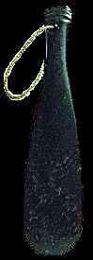
Listen to the story that will be read to you.

From www.māori.org.nz
Imagine the encounter and the weapons that would have been used
at this time.
Listen to and talk with the people here, and look at the resources
available, then discuss in groups, the following questions:

- What range of weapons would be used?
- What were they used for?
- What were they made from?
- For each weapon, why would it have been made
from this material (i.e. what characteristics would
the material need to have for its purpose?
- How would they have been made?

Sketch the weapons on display and make notes on each from your group discussions.

LESSON PLAN 2
TIME: 60 minutes
KAUPAPA MĀORI: Reo Māori
TEACHER INSTRUCTIONS:
- Prepare follow-up to previous lesson’s field trip by asking for offerings from groups of the ‘highs’ and ‘lows’ they experienced.
- Display group sketches.
- Prepare for Vocabulary Snowball:
  - Locate a poi, Koosh ball, hacky sack, rolled-up ball of newspaper or similar soft throwing item.
  - After introducing the activity by reading out Activity 1 – a Māori legend about important rocks of Aotearoa, describe the next activity (2) as a focus on the hardest materials used in Māori weapons and explain that they will be brainstorming words associated with these materials. The topic will be ROCKS.
  - Make up a list of related words that you want to be used with confidence by the unit of the unit. This will give guidance for the requirements of Lessons 3 to 9.
  - Prepare word-recording materials: use a SmartBoard if available, or whiteboard, OHT.
  - Photocopy Activity sheets 2 & 3.
- Have English-Māori/Māori-English dictionaries available for Activity 3. Guide students according to their literacy, science, and te reo ability.

STUDENT INSTRUCTIONS:
- Activity 1 introduces the topic of rocks – a short version of a Māori legend with some explanations.
- Activity 2 is a way of brainstorming what you already know about rocks.
- Activity 3 develops your knowledge and understanding and starts a useful literacy glossary of terms for Earth Science.
- Use the VOCAB SQUARE template after each following lesson to check your understanding of the new terminology that you have used.
ACTIVITY 1

A Short Version of a Māori Legend
(adapted from The Māori As He Was by Elsdon Best, p 52-53)

Ngahue, a Polynesian voyager, was in some way connected with Poutini, (the personified form of greenstone [nephrite]), and in their home in Hawaiki they incurred the hostility of Hine-tua-hoanga, (the personified form of sandstone); hence they fled to New Zealand.
[Sandstone was the principal agent employed by the Māori in fashioning greenstone implements, so it is spoken of as the enemy of greenstone.]
On reaching Tūhua, or Mayor Island, Bay of Plenty, Poutini (greenstone) proposed to remain at that place, but was alarmed by the presence of Matā (personified form of obsidian), and so fled to the East Cape district. Here, he encountered Waiapu (a form of chert), another enemy, and so fled onward to Arahura, South Island, where he found refuge, and whence the Māori has ever obtained greenstone for the manufacture of implements and ornaments.
The various enemies of “the greenstone folk” as the Māori quaintly puts it, are said to have pursued them and attacked them, slaying some and capturing others. The names of the captives are those of famous greenstone heirlooms, implements, and ornaments.

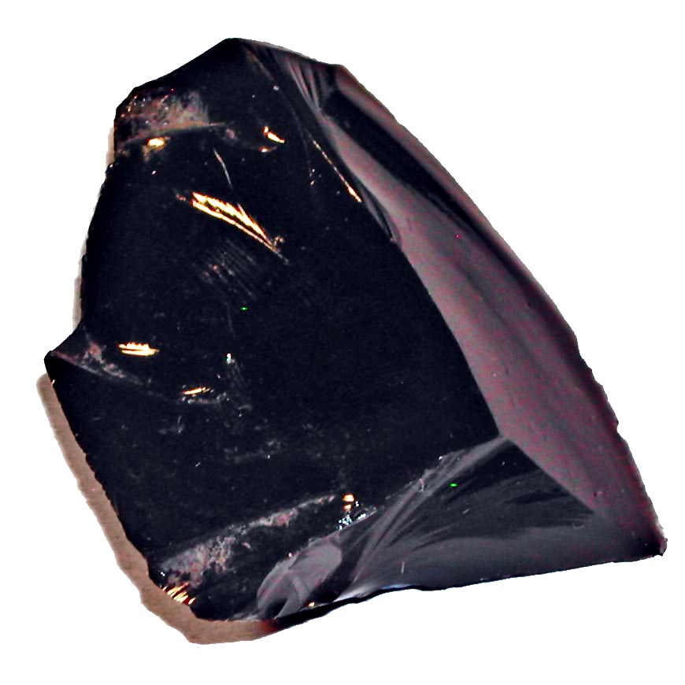
ACTIVITY 2
The hardest of the weapons and other tools used by the Māori were made from rock with special qualities.
In this unit of work we are going to focus on different types of rock to recognise their characteristics and properties and relate these to their uses especially as used by Māori.

ROCK SNOWBALL
Your teacher will appoint a couple of recorders to note the words that you brainstorm related to ROCKS.
- When the ball is thrown to a student, they will say a word that is associated with our topic (ROCKS), e.g. pounamu or igneous.
- The recorders write down the word.
- The student with the ball throws it back to the teacher who then throws it to another student who gives another word associated with ROCKS.
- When everyone has contributed and the class has exhausted the ROCK words they can think of, move into pairs.
- In pairs, work out at least 3 or 4 categories for the word list and record each word into the most appropriate category.
- Compare your categories with another pair of students.
ACTIVITY 3
Use the diagram below to create VOCAB SQUARES for the words listed.
Your teacher will guide you in this and provide dictionaries and resources as required.
Example:
WORD  Te Reo Māori: pungapunga  Te Reo Pākehā: pumice | DEFINITION  He huka rangitoto teatea kua matao  Light-coloured lava froth that has cooled.
EXAMPLE  Some pieces of pumice can float on water because of the air bubbles trapped when the lava cooled and hardened after it was blasted out of a volcano. | DIAGRAM TO HELP REMEMBER

WORD LIST
- Rock | - Outer core | - Igneous
- Stone | - Magma | - Metamorphic
- Mineral | - Lava | - Marble
- Crust | - Tectonic plates | - Limestone
- Mantle | - Vent | - Granite
- Inner core | - Sedimentary | - Mudstone
- Convection currents

GROWING YOUR WORD LIST
At you progress through this unit of work on ROCKS, create a VOCAB SQUARE for each new word. Revise each one for homework in preparation for your assessment.

WEB RESOURCES THAT YOU COULD USE
http://www.galleries.com/rocks/default.htm
http://geology.com/geology-dictionary.shtml
http://www.teara.govt.nz/EarthSeaAndSky/Geology/RockAndMineralNames/en
http://www.nysm.nysed.gov/virtual/collections/splendor_in_stone/splendor_p_roc.html
LESSON PLAN 3 & 4
TIME: 60 minutes per period
KAUPAPA MĀORI: Whakawhenua
TEACHER INSTRUCTIONS:
- Draw up list of sub-topics for Kōhatu – Māori use of stone. Students work in groups of 4 (maximum of 6 groups) with designated roles (see Activity Sheet for detail).
- Suggested sub-topics with additional guidelines:
SUB-TOPIC | GUIDELINES | SUGGESTED RESOURCES – try following links from each webpage
Stone tools | Include type of stones used; characteristic of the stone for this use; how item was made. | http://www.teara.govt.nz/1966/M/MāoriMaterialCulture/StoneTools/en  http://www.teara.govt.nz/EarthSeaAndSky/Geology/KōhatuMāoriUseOfStone/1/en
Stone weapons | Include type of stones used; characteristic of the stone for this use; how item was made. | http://www.teara.govt.nz/1966/M/MāoriMaterialCulture/Weapons/en  http://www.teara.govt.nz/EarthSeaAndSky/Geology/KōhatuMāoriUseOfStone/2/en  http://whakaahua.māori.org.nz/weapons1.htm
Stone ornaments | Include type of stones used; characteristic of the stone for this use; how item was made. | http://www.teara.govt.nz/1966/M/MāoriMaterialCulture/ClothingAndAdornment/en  http://www.teara.govt.nz/EarthSeaAndSky/Geology/KōhatuMāoriUseOfStone/2/en
Hāngi stones | Include type of stones used; characteristic of the stone for this use; how item was made. | http://www.teara.govt.nz/1966/M/MāoriMaterialCulture/HousesAndDomesticLife/en  http://māorifood.com/hāngi.htm
Fishing, Gardening & other uses | Include type of stones used; characteristic of the stone for this use; how item was made. | http://www.teara.govt.nz/EarthSeaAndSky/Geology/KōhatuMāoriUseOfStone/3/en
For all topics, include whakapapa of rocks and minerals:
http://www.teara.govt.nz/EarthSeaAndSky/Geology/KōhatuMāoriUseOfStone/1/ENZ-Resources/Standard/2/1/en#breadcrumbtop and http://www.teara.govt.nz/EarthSeaAndSky/Geology/KōhatuMāoriUseOfStone/1/ENZ-Resources/Standard/2/2/en#breadcrumbtop

- Print a copy of this table for each group and highlight a different sub-topic on each one. Fold each separately and place in selection box for each Group Chairperson to randomly select from.
- Encourage students to complete a VOCAB SQUARE for each new Earth Science term they come across in their research.
- Have English-Māori/Māori-English dictionaries available.

STUDENT INSTRUCTIONS:
- Your teacher will organise you into groups of 4 and either designate a role to each student or direct the group members to make this decision.
- Each group will be researching an aspect of Kōhatu – Māori Use of Stone. The Group Chairperson will randomly select the aspect for the group..
- Presentation (maximum 7 minutes, including class question time) will be in the next class period, or the date determined by your teacher.
- The format of presentation is a group decision. Some suggestions are: whaikōrero; whakairo; kauhau; haka and waiata.

ACTIVITY
You will be working in groups of 4 to research an aspect of Kōhatu – Māori Use of Stone.
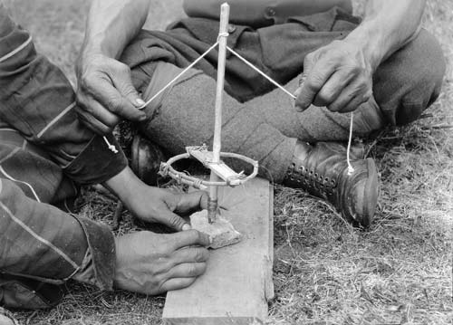
Stone drills
Tūwiri (drills) had two cords. The tip was a hard, sharp stone. Sand and water were used as an abrasive during drilling.
Within your group you will each have a specific leadership role to ensure that all tasks are completed in a timely fashion. All members of the group help in all parts of the research and presentation; the task leader has the responsibility of making sure the task is completed.
  - Group chairperson – keeps order, time and discussion on track
  - Group reader – finds and reads text to group as required
  - Group recorder – records group decisions and information
  - Group presenter – leads presentation back to class (group decision on format)
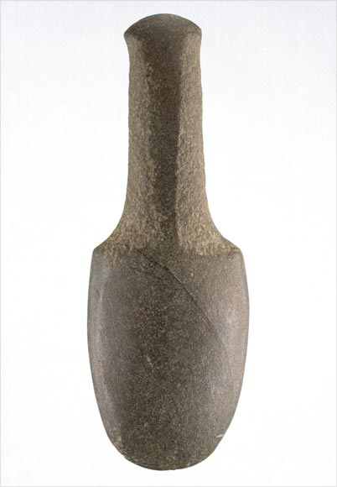
Flax pounder
The patu muka (flax pounder) was used to pound the inner fibres of the harakeke (flax).

Presentation (maximum 7 minutes, including class question time) will be in the next class period, or the date determined by your teacher.

The format of presentation is a group decision. Some suggestions are: whaikōrero; whakairo; kauhau; haka and waiata. Interactive activities are encouraged.

The class question time can be two-way: class to group or group to class.

From www.māori.org.nz

Remember to complete a VOCAB SQUARE for each new Earth Science term that you come across in your research.
LESSON PLAN 5
TIME: 60 minutes
KAUPAPA MĀORI: Tahu kōrero
TEACHER INSTRUCTIONS:
- Check through presentation IGNEOUS ROCKS (file: IGNEOUS ROCKS.ppt) – make decision re teacher-presented or students work at their own pace through it. This will be dependent on professional judgement.
- Prepare the gear for the 2 practical activities that demonstrate formation of igneous rocks and their characteristics. Detail of these practicals (‘Making an Igneous Rock’ and ‘Chemical Composition is Crucial’) can be found on pages 147 and 149 of the ABA Year 11 Science NCEA Level 1 Workbook.
  - ‘Making an Igneous Rock’ [set up 10mins – to be viewed following day]
  - ‘Chemical Composition is Crucial’ [set up 10mins – to be viewed at end of period]
- Encourage students to complete a VOCAB SQUARE for each new Earth Science term they come across.
- Have English-Māori/Māori-English dictionaries available.

STUDENT INSTRUCTIONS:
- Your teacher will organise you into groups to complete the two igneous rock practical activities.
- The theory content for igneous rocks will either be led by your teacher or you will work through it at your own pace.
- Complete a VOCAB SQUARE for each new Earth Science term that you come across.
LESSON PLAN 6
TIME: 60 minutes
KAUPAPA MĀORI: Tahu kōrero
TEACHER INSTRUCTIONS:
- Check through results of the 2 practical activities set up by students in previous period. Detail of these practicals (‘Making an Igneous Rock’ and ‘Chemical Composition is Crucial’) can be found on pages 147 and 149 of the ABA Year 11 Science NCEA Level 1 Workbook.
- Students will complete follow-up questions on pages 148-151 of the ABA Year 11 Science NCEA Level 1 Workbook. A supply of hand lenses and igneous rocks will be required. Students may need to refer back to the presentation IGNEOUS ROCKS (file: IGNEOUS ROCKS.ppt) for clarification.
- Prepare copies of the IGNEOUS ROCKS CROSSWORD.
- Encourage students to complete a VOCAB SQUARE for each new Earth Science term they come across.
- Have English-Māori/Māori-English dictionaries available.

STUDENT INSTRUCTIONS:
- Form back into the previous period’s group to check and record the results of the two igneous rock practical activities.
- Using your observations from the practical activities and the presentation IGNEOUS ROCKS (file: IGNEOUS ROCKS.ppt), answer the questions on pages 148-151 of the ABA Year 11 Science NCEA Level 1 Workbook. You will need to use a hand lens and samples of igneous rocks for the exercise on page 150.
- Complete the IGNEOUS ROCKS CROSSWORD. Check your answers with your group and your teacher.
- Remember to complete a VOCAB SQUARE for each new Earth Science term that you come across.
LESSON PLAN 7
TIME: 60 minutes
KAUPAPA MĀORI: Tahu kōrero
TEACHER INSTRUCTIONS:
- Check through presentation SEDIMENTARY ROCKS (file: SEDIMENTARY ROCKS.ppt) – make decision re teacher-presented or students work at their own pace through it. This will be dependent on professional judgement.
- Prepare the gear for the 2 practical activities that demonstrate formation of sedimentary rocks and their characteristics. Detail of these practicals (‘Sorting Sediments’ and ‘Making a Sedimentary Rock’) can be found on pages 152 and 154 of the ABA Year 11 Science NCEA Level 1 Workbook.
  - ‘Sorting Sediments’ [set up 10mins – to be viewed following day]
  - ‘Making a Sedimentary Rock’ [set up 20mins – to be viewed at following day]
- Encourage students to complete a VOCAB SQUARE for each new Earth Science term they come across.
- Have English-Māori/Māori-English dictionaries available.

STUDENT INSTRUCTIONS:
- Your teacher will organise you into groups to complete the two sedimentary rock practical activities.
- The theory content for sedimentary rocks will either be led by your teacher or you will work through it at your own pace.
- Complete a VOCAB SQUARE for each new Earth Science term that you come across.
LESSON PLAN 8
TIME: 60 minutes
KAUPAPA MĀORI: Tahu kōrero
TEACHER INSTRUCTIONS:
- Check through results of the 2 practical activities set up by students in previous period. Detail of these practicals (‘Sorting Sediments’ and ‘Making a Sedimentary Rock’) can be found on pages 152 and 154 of the ABA Year 11 Science NCEA Level 1 Workbook.
- Students will complete follow-up questions on pages 153 & 155 of the ABA Year 11 Science NCEA Level 1 Workbook. Students may need to refer back to the presentation SEDIMENTARY ROCKS (file: SEDIMENTARY ROCKS.ppt) for clarification.
- Prepare copies of the SEDIMENTARY ROCKS CROSSWORD.
- Encourage students to complete a VOCAB SQUARE for each new Earth Science term they come across.
- Have English-Māori/Māori-English dictionaries available.

STUDENT INSTRUCTIONS:
- Form back into the previous period’s group to check and record the results of the two sedimentary rock practical activities.
- Using your observations from the practical activities and the presentation SEDIMENTARY ROCKS (file: SEDIMENTARY ROCKS.ppt), answer the questions on pages 153 & 155 of the ABA Year 11 Science NCEA Level 1 Workbook.
- Complete the SEDIMENTARY ROCKS CROSSWORD. Check your answers with your group and your teacher.
- Remember to complete a VOCAB SQUARE for each new Earth Science term that you come across.
LESSON PLAN 9
TIME: 60 minutes
KAUPAPA MĀORI: Tahu kōrero
TEACHER INSTRUCTIONS:
- Check through presentation METAMORPHIC ROCKS (file: METAMORPHIC ROCKS.ppt) – make decision re teacher-presented or students work at their own pace through it. This will be dependent on professional judgement.
- Divide class into 4 groups for each metamorphic rock (SLATE, SCHIST, GNEISS & MARBLE), then further divide into groups depending on numbers. Students focus on their rock and move into a Jigsaw activity to up-skill their peers on their rock. This activity is detailed on pages 156 & 157 of the ABA Year 11 Science NCEA Level 1 Workbook.
- Prepare copies of the METAMORPHIC ROCKS CROSSWORD.
- The following activities are optional for reinforcement/revision in class or homework:
  - KINDS OF ROCKS CROSSWORD
  - ROCK CYCLE slides in file: ROCK CYCLE.ppt – these are a selection of images that can be used by individual students depending on their level of understanding of the process
  - ROCK CYCLE SIMULATION activity; instructions in file: ROCK CYCLE SIMULATION.doc
- Encourage students to complete a VOCAB SQUARE for each new Earth Science term they come across.
- Have English-Māori/Māori-English dictionaries available.

STUDENT INSTRUCTIONS:
- The theory content for metamorphic rocks will either be led by your teacher or you will work through it at your own pace.
- Your teacher will direct you on the activity to ensure expertise on all of these metamorphic rock types – they are all required for AS 90190.
- Complete the METAMORPHIC ROCKS CROSSWORD. Check your answers with your group and your teacher.
- Remember to complete a VOCAB SQUARE for each new Earth Science term that you come across.
LESSON PLAN 10
TIME: 60 minutes (extra time for travel may be required)
KAUPAPA MĀORI: Tahu kōrero
TEACHER INSTRUCTIONS:
- Make at least one preliminary trip to local geological site(s) for planning purposes. The trip is for viewing rocks in situ and identification only.
- Organise trip to the site(s) – these may be buildings to show materials used (e.g. Portland stone), road cuttings to show strata, fossils, etc., cliffs, or a quarry. The site(s) chosen will depend on your local area. The advice, guidance and preferably the presence of an expert would be ideal.
- Complete school trip requirements, e.g. Risk Analysis & Management documentation; parental consent, etc. for the trip.
- Hand lenses will be required. A camera would be useful; students may wish to use camera phones.
- Named samples of rocks may be taken on the trip and a classification key, e.g. in Kiwi Integrated Science Series, 4 Science Book 3, pages 102-103.

STUDENT INSTRUCTIONS:
- Complete and return documentation for trip out of school.
- Have a notebook and rock ID book with you on the trip for identifying rocks and recording.
- Work in small groups to complete the tasks on the Activity sheet in the time available.

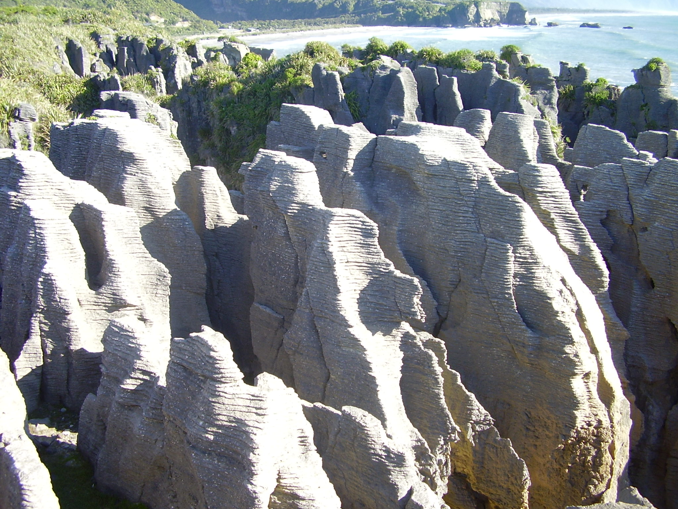
ACTIVITY
New Zealand is a jigsaw of many different rock types. Your teacher may have shown you a poster of a geological map of New Zealand.
The rock types range from hard gneiss to soft mudstone, from the oldest fossils (about 500 million years old) to volcanic rocks erupted in the last 50 years. The oldest rocks were part of the ancient continent of Gondwanaland, while later rocks were formed after the New Zealand continent drifted away from its parent. Our rocks represent vanished river plains, ancient peat swamps, deep sea floors, volcanic islands, beach sands and shell beds, the roots of mountain ranges, and much more.
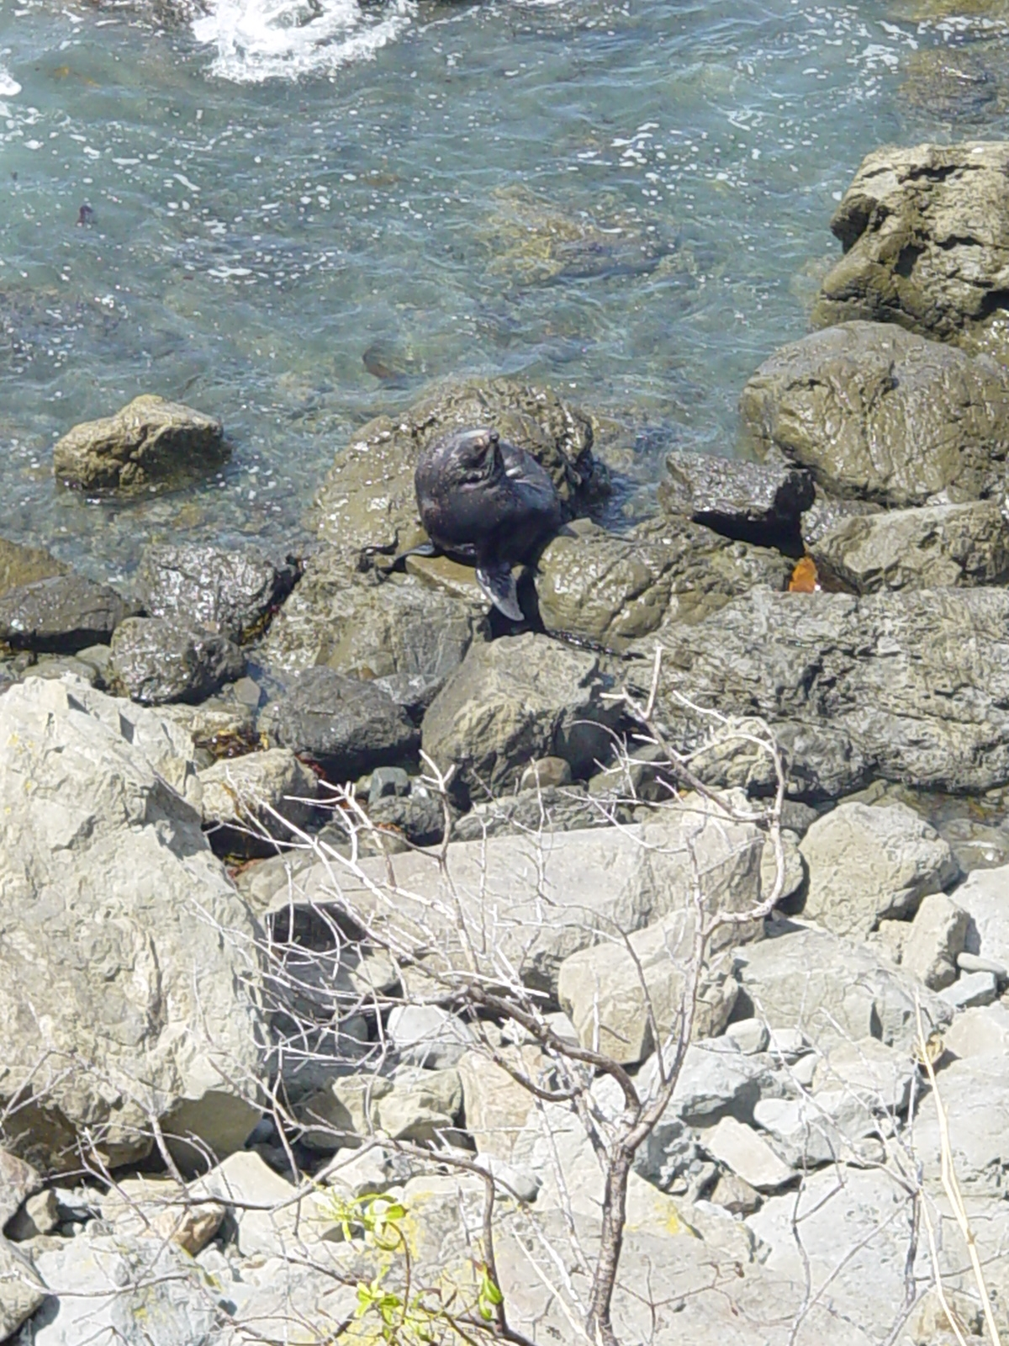

You are going to visit one or more sites which show the rocks in your local area. In most cases these will be natural rock sites but remember that stone used for buildings was probably imported from another part of the country as would marble used for kitchen bench tops or headstones in a cemetery.

Your teacher may direct groups to investigate specific areas of the site.
- Observe rock types. Use hand lenses if required.
- Compare to rock samples and classification key.
- Name rock type and take a photograph if possible.
- Describe location and take a photograph if possible.
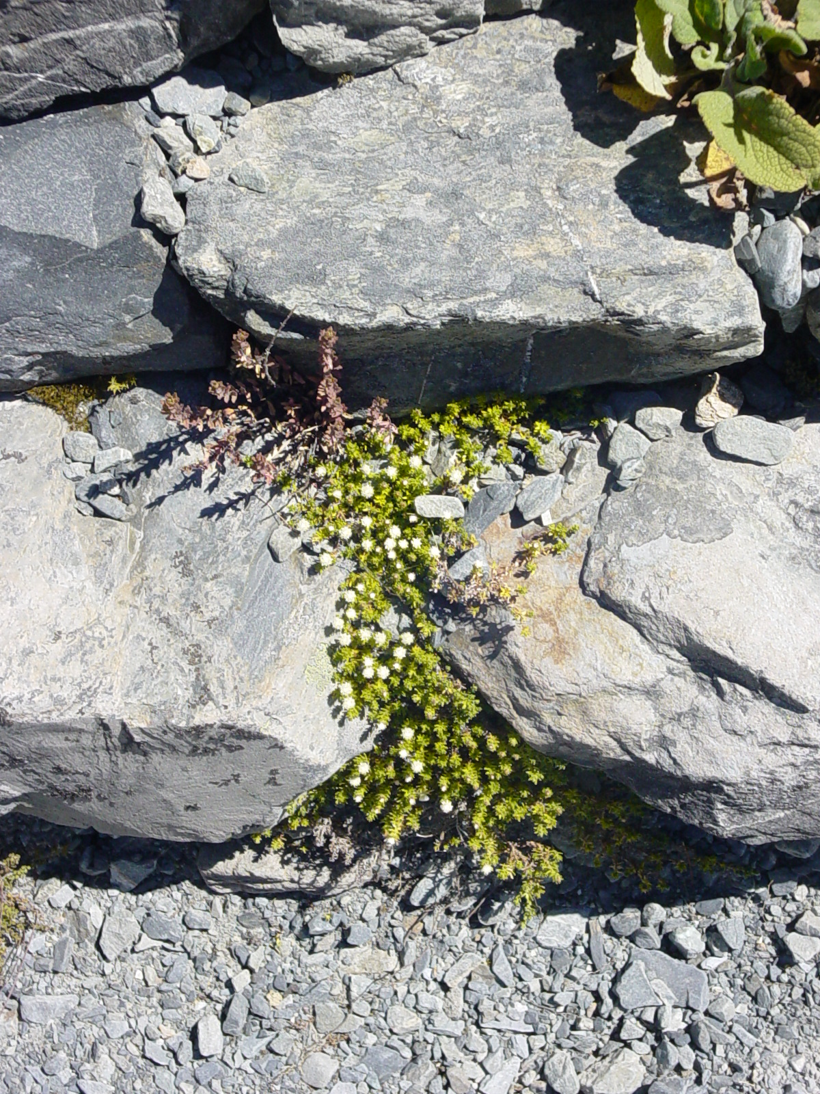
- When complete, compare findings with other students/groups.

If you are a Fact Fiend, you may like to visit this webpage for some interesting information:
http://www.minerals.co.nz/html/main_topics/mineral_moments.html

