HE KAUPAPA PŪTAIAO

TAU 10

TE MARAUTANGA O AOTEAROA KAUPAE 5 PŪTAIAO

TE AO AHUPŪNGAO

E 6 NGĀ AKORANGA ME NGĀ MAHI

TE KŌHAUHAU

He Mahere Kaupapa Mahi – Tau 10 Pūtaiao – Kōhauhau
Tauira: | Katoa | Kaupapa Māori:
Mōhiotanga o te kaiako: | He āhua mōhio | He iti
Wāhanga ako: | Pūtaiao | Tāne
Marautanga - take | Pūtaiao
Whenu: | Papatūānuku, Papatūārangi | Ranginui
Kawa: | Ō Papatūānuku  Ō ngā poukōrero | Papatūānuku; Ranginui  Papatūānuku
Kaupae: | 5
Ingoa: | Kōhauhau | Tāwhirimatea
Ngā whāinga hei whakatutuki(s): | Ko ā ngā tauira:  - He tirotiro ki te hanga, te āhua me ngā āhuatanga o te papa ōnuku, te wai ōnuku, me te kōhauhau. (ŌPapatūānuku); | Tāwhirimatea
 | - He tirotiro ki te reretītaringa o te wera o Te Rā, o Papa, o te mahi hoki a te tangata ki te ao mā te papa ōnuku, mā te wai ōnuku, mā te kōhauhau anō hoki (Ōngā poukōrero); | Tāwhirimatea
 | - He āta whakarite, he āta kawe i ngā tirohanga, me te whakatauira mai (te pou wānanga o Pūtaiao);
 | - He whakapiki mōhiotanga ki ngā take tikanga pūtaiao ā-iwi mā te kohikohi kōrero pūtaiao hei tāhū whakatau, ā, hei take whakatikatika hoki ki ngā wāhi e tika ana (ko ā mua, ko ā muri);
 | - Me mārama ki te tikanga o ngā tirotirohanga a te hunga pūtaiao, i takea mai i ngā kaupapa whakaaro o te wā, ā, ka kimi kōrero hei tautoko, kia wetewetekia hoki e te whakaaro o te kawa arotau (te pou mārama o Pūtaiao);
Ngā pūkenga matua: | Te katoa
Tirohanga: | Te kōhauhau hei kaitītaritari i te wera.
Wāhi: | Aotearoa, te ao | Aotearoa, te ao
Ngā akoranga: | 6

Hei mahi: | 1. Te hanga me te āhua o te kōhauhau. | Tāhū kōrero
 | 2. Te whakawera i a Papa – he mahi whakatautika. | Whakawhenua
 | 3. He tirotiro ki ngā āhuatanga ka pā mai ki te pāmahana o Papa. | Rangahau
 | 4. Te tītaritari i te wera  Te whakapakari kupu | Reo Māori
 | 5. & 6. Te Mahanatanga o Te Ao – ngā korero tika me ngā whakaaro. | Tāhū kōrero
Tikanga Māori: | Kohinga 2 – He Rārangi Māori | Whakairo, reo Māori, whaikōrero, wānanga, waiata
Reo Māori: | Kohinga 3 – He Rārangi Reo Māori | He kupu
Rauemi:  - Kohinga 1 | PM Ryan: The Reed Dictionary of Modern Māori
 | He Taonga Tuku Iho – Ngāti Porou stories from the East Cape, R McConnell, Reed, 1999.
 | http://209.85.173.104/search?q=cache:LbNJiMI2EAYJ:www.gisborneherald.co.nz/features/te_ao_Māori_apr04.pdf+Rerekohu+%22flying+mist%22+-school&hl=en&ct=clnk&cd=1&gl=nz
 | http://www.teachersdomain.org/resources/ess05/sci/ess/watcyc/vertical/index.html
 | http://wings.avkids.com/Book/Atmosphere/instructor/heat-01.html
 | http://www.teachersdomain.org/resources/phy03/sci/phys/matter/greenhouse2/index.html
 | http://www.pbs.org/now/classroom/globalwarming.html
 | http://www.pbs.org/now/classroom/globalvenn.pdf
 | http://www.pbs.org/now/classroom/globalproject.pdf
 | http://www.cnn.com/SPECIALS/2005/changing.earth/
 | http://www.weatherquestions.com/What_is_the_greenhouse_effect.htm
 | http://www.weatherquestions.com/What_is_infrared_radiation.htm
INGOA KAUPAPA: KŌHAUHAU

PAETAU: Tau 10

WHIRINGA MARAUTANGA:
PŪKENGA MATUA: Te katoa
WHENU: Papatūānuku, Papatūārangi Kaupae 5
NGĀ WHĀINGA HEI WHAKATUTUKI: Ko ā ngā tauira:
- He tirotiro ki te hanga, te āhua me ngā āhuatanga o te papa ōnuku, te wai ōnuku, me te kōhauhau. (ŌPapatūānuku);
- He tirotiro ki te reretītaringa o te wera o Te Rā, o Papa, o te mahi hoki a te tangata ki te ao mā te papa ōnuku, mā te wai ōnuku, mā te kōhauhau anō hoki (Ōngā poukōrero);

WHENU: Ōpūtaiao
NGĀ WHĀINGA HEI WHAKATUTUKI: Ko ā ngā tauira:
- He āta whakarite, he āta kawe i ngā tirohanga, me te whakatauira mai (te pou wānanga o Pūtaiao);
- He whakapiki mōhiotanga ki ngā take tikanga pūtaiao ā-iwi mā te kohikohi kōrero pūtaiao hei tāhū whakatau, ā, hei take whakatikatika hoki ki ngā wāhi e tika ana (ko ā mua, ko ā muri);
- Me mārama ki te tikanga o ngā tirotirohanga a te hunga pūtaiao, i takea mai i ngā kaupapa whakaaro o te wā, ā, ka kimi kōrero hei tautoko, kia wetewetekia hoki e te whakaaro o te kawa arotau (te pou mārama o Pūtaiao);

NGĀ HUA AKE O TE AKO:
Kia taea e ngā tauira:
- ngā wāhanga o te kōhauhau te whakaahua, te kōrerorero hoki;
- te weranga me te mātaotanga o te kōhauhau te whakamārama;
- te kawenga a ngā aumoana i te wera o te kōhauhau ki te ao te kōrerorero;
- te rerenga o te hau hei hua nō te weranga me te mātaotanga te whakaahua;
- ngā āhuatanga pai, kino hoki o te kati kōtuhi te whakamārama;
- ngā momo whakaaro mō te mahanatanga o te ao te whakatauriterite.

TE MŌHIOTANGA KIA MŌHIOTIA:
Papatūānuku, Papatūārangi Kaupae 3/4

NGĀ RAUEMI HEI WHAI:
- Akoranga 2 (kia kotahi te kete taputapu mō te whakaatu ki te karaehe, mā ia rōpū rānei):
- Kia 2 ngā inepāmahana
- Kia 2 ngā pēke kirihou – he nui tētahi, he paku tētahi
- Kia 2 ngā here hei whiri
  - Akoranga 3 (mā ia rōpū tauira)
- Kia 6 ngā paepae whakamātautau PET (tirohia te mahere akoranga mō ngā kōrero hangahanga)
- Kia 3 ngā kapu onemata
- Kia 3 ngā kapu onetea
- Kia 3 ngā kapu wai
- Kia 6 ngā inepāmahana
- He teipa kōataata
- Kia 1 te rama 150-wata te kaha
- He rama whakaata kawe
- He tūranga mō ngā rama

Me whai te kaitiaki taiwhanga, te kaiako rānei ko ēnei hei whakatū i ngā paepae whakamātautau – kei te tokomaha o ngā rōpū te maha o ngā taputapu:
- Peita mā
- Onemata
- Onetea
- Wai

- Akoranga 4
- He kete puka mahere whenua mā te karaehe
- He ao mahere, he huarahi rānei ki te ao mahere ipurangi: http://oceanworld.tamu.edu/resources/atlas.htm
- Ka whai wāhi ki te pouaka kōpaka me te wai
- He tae uriuri kai
- He terei moka haupapa
- He paepae karāhe mā ia rōpū

- Me whai papakupu Reo Pākehā-Reo Māori/Reo Māori-Reo Pākehā.

NGĀ WHAKAPUAKANGA:
The Reed Dictionary of Modern Māori, PM Ryan, Reed, 1995
http://209.85.173.104/search?q=cache:LbNJiMI2EAYJ:www.gisborneherald.co.nz/features/te_ao_Māori_apr04.pdf+Rerekohu+%22flying+mist%22+-school&hl=en&ct=clnk&cd=1&gl=nz
He Taonga Tuku Iho – Ngati Porou stories from the East Cape, R McConnell, Reed, 1999.
http://www.teachersdomain.org/resources/ess05/sci/ess/watcyc/vertical/index.html
http://wings.avkids.com/Book/Atmosphere/instructor/heat-01.html
http://www.teachersdomain.org/resources/phy03/sci/phys/matter/greenhouse2/index.html
http://www.pbs.org/now/classroom/globalwarming.html
http://www.pbs.org/now/classroom/globalvenn.pdf
http://www.pbs.org/now/classroom/globalproject.pdf
http://www.cnn.com/SPECIALS/2005/changing.earth/
http://www.weatherquestions.com/What_is_the_greenhouse_effect.htm
http://www.weatherquestions.com/What_is_infrared_radiation.htm
MAHERE AKORANGA 1
TE WĀ: 60 meneti
KAUPAPA MĀORI: Tāhū kōrero
NGĀ TOHUTOHU MĀ TE KAIAKO:
- Hei tīmata i tēnei kaupapa mahi me tēnei akoranga me pānui te kōrero poto mō Rerekohu i Hei Mahi 1, kātahi ka wānanga ai i te take pūtaiao o tōna ingoa. Menā e rite ana, tohua ngā kīnga matua o te rerenga: “…….ngā ata makariri o te takurua, ka kitea te kohutea e rere ana i te moana i te ngutuawa, te wāhi e tutaki ai te wai mātao o te whenua ki te wai mahana o te moana.”
Me mātua mārama ngā tauira ki te kaupapa riponga wai o te Kaupae 3/4 – te whakaetonga me te tōtātanga; me te rōrahi wera o te whenua me te wai pea (ka wānangatia ā-ringatia tēnei take i Akoranga 2).
Kōrerotia pēneitia te wānanga kaupapa nei kia whai wāhi ki te kaupapa kōhauhau me āna takohanga mai.
- Ko tā Hei Mahi 2 he āta titiro ki te kōhauhau, ōna wāhanga(ngā hau me ngā papa), tona hiranga hoki ki oranga o te ao. Ko te mahi mā ngā tauira he whakatū kauwhata e mārama ai rātau ki ngā wehenga o te kōhauhau hei whakapapa ā-pāmahana, ka rerekē te pāmahana i ia papa. Me pānui ngā tauira ngā kōrero hei tāhū, me whakairi ngā tohu kōrero, me whiriwhiri hoki ki hea tīmata ai, ki hea hoki mutu ai ia papa i runga i te hau o ngā kōrero i pānuitia ai. [35 - 45 men]
Me mātua mōhio ngā tauira ki te whakairi kōrero ki te kauwhata ki ngā tau tōraro.
Āta kōrerotia ngā tohutohu, pānuitia ā-wahatia ngā kōrero i roto i ngā pouaka. Tērā pea ka hia āwhina ngā tauira kia mōhio ai rātau mā te pānui i ngā kōrero o te tuhinga e mārama ai rātau ki ngā wehenga papa.

Tērā e aromatawaitia tēnei mahi: Kia whakamātautauria ngā tauira mō te tika o te whakairi i ngā kōrero o te mahere ki te kauwhata. Kia oti hoki i a rātau ngā ingoa e 8 te tapa ki te kauwhata: kōhauhuri, kahuhuri, kōhaupapa, kahupapa, kōhauwaenga, kahuwaenga, kōhauāhuru, pekerangi.
- He whakatōpūtanga a Hei Mahi 3 i ngā mahi katoa i runga ake nei, kia tino mārama, kia ita pāhekoheko te karawhiu: http://www.teachersdomain.org/resources/ess05/sci/ess/watcyc/vertical/index.html
[3 men]

NGĀ TOHUTOHU MĀ NGĀ TAUIRA:
- Ko tāu mahi he tirotiro ki te kōhauhau o Papa me tōna pānga tata ki te wai, mā reira e ora ai ko tātau me ngā koiora katoa e noho ana i te mata o te whenua.
- Mō Hei Mahi 1, ka wānangatia te pānga o te ingoa o tētahi rangatira nui o Ngāti Porou me te riponga wai.
- Ko te kaupapa o Hei Mahi 2 ko te hanga o te kōhauhau, ko tāu he whakamārama i ngā kōrero o te whare kauwhata, ā, ka whakatau ā-rōpū i ngā pātai e wānangatia ana.
- Ka whakaaturia e tō kaiako tētahi mahi pāhekoheko poto e mārama ai koutou ki ngā kōrero i ākona ai.
HEI MAHI 1
Mō Rerekohu te kōrero nei, he rangatira nō Te Kawakawa Mai Tawhiti(Te Araroa). Ko te wāhi tuatahi tēnei o te kōrero mō te karonga whawhai a Rerekohu, e kitea nei kāore i matenui ngā rangatira nui ki te whawhai anake.
Nā Bob McConnell o Te Araroa te pūrākau nei, nō roto i te pukapuka, He Taonga Tuku Iho — Ngā Pūrākau o Ngāti Porou.

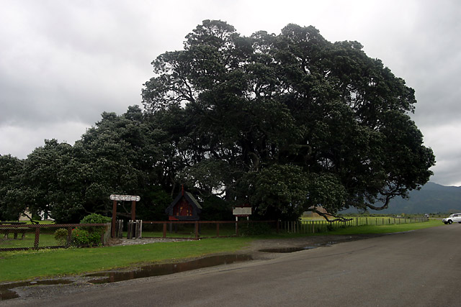
Ko Te Waha o Rerekohu tēnei rākau. He āhua rerekē te tapa ingoa pēnei ki te rākau, engari inā te take. E ai ki ngā kōrero a ngā pakeke i konei anō tētahi pātaka kai he whakaputunga kai mā te waha o tētahi tamaiti rangatira nei ko Rerekohu tōna ingoa. Nō te moana, nō te whenua hoki ngā kai.
He aha i rangatira ai tēnei tamaiti? Kāti, koia te mātāmua a Hukarereiti, te tama mātāmua a Tūterangiwhiu, te mātāmua hoki a Tūwhakairiora nui. Ko te tipuna wahine o Rerekohu ko Hinerupe tonu. Atu i ēnei tīpuna nui ōna, ko tōna kōkā he wahine rangatira nō roto o Te Whānau a Apanui, na, ka noho rangatira a Rerekohu ki ngā iwi e rua nei. Ka rangatira tonu atu ia i te hariharinga kai a te tangata ki a ia, i a ia e tamariki tonu ana.
He aha i tapaina ai ia ko Rerekohu? Kāore au i te tino mōhio engari, i ngā ata makariri o te takurua, ka kitea atu te kohu e rere ana i te moana i te ngutuawa, te wāhi e tūtaki ai te wai mātao o te awa ki te wai mahana o te moana. Ki tōku whakaaro i whānau pea a Rerekohu i tētahi ata pērā, ā, ka tapaina iho te ingoa ko Rerekohu.

Wānangatia i roto i ō koutou rōpū ngā tikanga pūtaiao o te ingoa o Rerekohu.

HEI MAHI 2
TE KŌHAUHAU

Kōhautia ai a Papa i te kahuhau, māna e mahana ai a Papa.

He ranunga te hau nō ngā momo hau anō. (He mahere pāe e whakaatu ana i te ranunga hau i te takiwā)
Nā te tō a papa ka mau ki te whenua engari ka toro rau kiromita noa atu ki te rangi.
He whakaapi, he mātotoru kē atu ngā hau e tata ana ki te whenua. Ko te haurua o te hau i te kōhauhau kei raro i te 5 kiromita i te mata o Papa.
Ka piki haere, ka rauangi haere te kōhauhau. Kāore he paerohe i waenganui i te kōhauhau me te rangiāteanui. Ka rauangi haere te hau, ā ātea noa.

ME WHAI KŌHAUHAU TĀTAU I TE MEA ...

- Mā te kōhauhau tonu e kai ngā hihi katinga o te rā, kia kore ai tātau e mate i tōna iraruke kino.
- Māna anō e whakaheke te piki, te heke rānei o te pāmahana, ao ki te pō, pō ki te ao.
- Ki te kore he kōhauhau, ka kore he kauhau ora i te ao – me whai hāora ngā kararehe me ngā tipu hei whakangāora, me whai hāorarua waro hoki ngā tipu hei ahotakakame.
- He wāhi nui anō o te kōhauhau mō te kawe wai, te kawe pūngao hoki i te ao.

TE WHAKAPAPA KŌHAUHAU

Ki te piki i te rangi kōhauhau, ka rerekē haere. E whā ngā papa ā-pāmahana rerekē. Ko te take i rerekē ai te pāmahana, he kainga nō te kōhauhau i ngā hihi o te rā e heke haere ana i te rangi.

Kei raro nei ētahi pouaka kōrero mō te kōhauhau o Papa. Tīkina atu ēnei kōrero hei ingoa mō ngā kauwhata ka tuhia e koe i te whārangi 12 hei whakaatu i ngā momo papa rerekē me ngā rohe i waenganui. Ko ngā moka kōrero hei āwhina i a koe kei te whārangi e whai muri atu nei.

Ko ngā rohe ō-runga i waenganui i ngā papa; ko te kahuhuri, ko te kahupapa, me te kahuwaenga.
Ko te papa tata ki a Papa, ko te kōhauhuri. Kei konei te rahinga o te tākohuwai. Piki haere ai, makariri haere ai i tēnei o ngā papa. 7 km te teitei o te kōhauhuri i ngā pou o Papa, 17km i te paeweherua. Koinei te papa e mātua karawhiuwhiua ana e te mahi a Tāwhirimatea. Ko te pāmahana rite ā-tau i te mata o Papa ko te 15ºC, āhuru ana.
Ko te papa o runga ake i te kōhauhuri ko te kōhaupapa. Piki haere ai, wera haere ai i tēnei papa. Ko te take kei konei te hāora toru e noho ana. He ārai te mahi a te pekerangi i ngā hihi kino o te rā ka hurihia hei wera noa. 50km mai i te mata o Papa te rohe ōrunga o te kōhaupapa. Koinei te wāhi e rere ai ngā wakarere kawe pāhihi, kāore e raru i ngā huarere o te takiwā, ā, e totika ana te pupuhi a te hau.
Kei runga ake i te kōhaupapa ko te kōhauwaenga. Koinei te papa makariri ake o te kōhauhau. Piki haere ai, makariri haere ai te hau - tōna, -90ºC tonu te makariri.
Kei tua atu i te kōhauwaenga ko te kōhauāhuru. Ka piki haere, ka wera haere hoki. Neke atu i te 1370ºC te pikinga o te wera i tēnei papa. Rauangi ana ngā hau o tēnei papa. Kei roto i te kōhauāhuru ko te kōhautuakatote. He wahi tapu tēnei i te mea, māna, ka taea e tātau te tuku reo ki tawhiti mā te wāhi nei e kawe whakaata ki a Papa anō. Ka kitea hoki i konei Ngā Tahunui a Rangi, ki te raki, ki te tonga anō hoki. Hua mai ai ēnei ramatae āwhiowhio nei i te toronga mai o ngā matimati o Tamanuiterā ki te kahu o Papa. Huriāmio ai te wakaātea i te rohe ōrunga o te kōhauāhuru.
Ko te kahupekerangi ehara tonu i te papa i te mea ka rauangi haere, ka memeha ki te rangiāteanui. Kāore he pae weherua i ēnei kōhau: ka marara kē atu ngā ngota o te hau – he hauwai, he haumāmā te hau i konei. Ka hoki mai ana ngā kaitoroātea i tuarangi ki a Papa, ko te wāhi e rongo ai te pānga o te kōhauhau i te hokinga mai, 75km i runga i a Papa.

Tiketike (km) | Pāmahana (ºC) | Tiketike (km) | Pāmahana  (ºC)
0 | 15 | 52 | -2
5 | -18 | 55 | -7
10 | -49 | 60 | -17
12 | -56 | 65 | -33
20 | -56 | 70 | -54
25 | -51 | 75 | -65
30 | -46 | 80 | -79
35 | -37 | 84 | -86
40 | -22 | 92 | -86
45 | -8 | 95 | -81
48 | -2 | 100 | -72
Kei te mahere i te taha matau nei ngā ine pāmahana toharite i ngā tiketike rerekē o te kōhauhau o Papa. Tuhia ngā kōrero nei ki te kauwhata o te whārangi e whaimuri ana, ā, tīwhanatia ōna tohu kia hono. Me tika te tuhi i ngā tau tōraro.

Mā konei e whakaatu mai ai te āhua o te pāmahana ahakoa te wā, te wāhi rānei; engari, terā pea e rerekē ai te pāmahana i ngā tautoharite, otirā ki ngā papa kōhauhau ōraro.

Whakaingoatia ngā momo papa kōhauhau me ngā rohe i waenganui. Tohua te rohe o te pekerangi.

Kia oti i a koe tō kauwhata te whakatū, kōrerotia i tō rōpū ēnei pātai:
- He aha i wehe ai ngā papa matua e whā o te kōhauhau ki ngā wāhi e noho nei ināianei?
- He aha te mea whakapiki i te pāmahana i te kōhaupapa?
- Ka taea te whakarere wakarere i te kōhauwaenga? He aha ai? He aha i kore ai?
- Whai tikanga ai te pāmahana o te kōhauāhuru ki te aha?

KAUWHATA PĀMAHANA I NGĀ TIKETIKE REREKĒ
Tiketike(km i runga ake i te kārewa o te moana) | 100
Tiketike(km i runga ake i te kārewa o te moana) | 95
Tiketike(km i runga ake i te kārewa o te moana) | 90
Tiketike(km i runga ake i te kārewa o te moana) | 85
Tiketike(km i runga ake i te kārewa o te moana) | 80
Tiketike(km i runga ake i te kārewa o te moana) | 75
Tiketike(km i runga ake i te kārewa o te moana) | 70
Tiketike(km i runga ake i te kārewa o te moana) | 65
Tiketike(km i runga ake i te kārewa o te moana) | 60
Tiketike(km i runga ake i te kārewa o te moana) | 55
Tiketike(km i runga ake i te kārewa o te moana) | 50
Tiketike(km i runga ake i te kārewa o te moana) | 45
Tiketike(km i runga ake i te kārewa o te moana) | 40
Tiketike(km i runga ake i te kārewa o te moana) | 35
Tiketike(km i runga ake i te kārewa o te moana) | 30
Tiketike(km i runga ake i te kārewa o te moana) | 25
Tiketike(km i runga ake i te kārewa o te moana) | 20
Tiketike(km i runga ake i te kārewa o te moana) | 15
Tiketike(km i runga ake i te kārewa o te moana) | 10
Tiketike(km i runga ake i te kārewa o te moana) | 5
Tiketike(km i runga ake i te kārewa o te moana) | 0
 |  | -100 | -90 | -80 | -70 | -60 | -50 | -40 | -30 | -20 | -10 | 0 | 10 | 20
 | Pāmahana(ºC)

Kia waru ngā kupu ka tuhia e koe ki ngā wāhi tika o te kauwhata: kōhauhuri, kahuhuri, kōhaupapa, kahupapa, kōhauwaenga, kahuwaenga, kōhauāhuru, pekerangi.
MAHERE AKORANGA 2
TE WĀ: 60 meneti
KAUPAPA MĀORI: Whakawhenua
NGĀ TOHUTOHU MĀ TE KAIAKO:
- Ko te weranga o Papa me te kōhauhau te kaupapa matua o tēnei akoranga. Hei tīmatanga, me kōrero rānei, me whakamahara rānei i ngā tauira ko Papa anake te aorangi whai kōhauhau, whai wai hoki hei kaupapa oranga.
Ka whai wāhi ngā mahi ki te maungawera o te kōhauhau e whai oranga ai te ao.
- Me tere ruku i Hei Mahi 1 i te mea ka tata pau te akoranga i te mahi nei – me whakaatu, me mahi ā-rōpū rānei.
Ka tirohia e ngā tauira a Papa e mahana haere ana i te awatea, e mātao haere ana i te pō. Mā tēnei e mārama ai rātau ki te kati kōtuhi.
E rua ngā wāhanga o te tirohanga nei, ko tā ngā tauira, ko te whakatūranga, ko waenganui, me te whakamutunga, kāti me whai i Hei Mahi 2 & 3 i ngā wā e wātea ana. Ko te mahi kāinga he tuhi i tētahi kōwae e whakamārama ana i ā rātau tirohanga; ā, waiho mā te kauwhata aromatawai i raro nei tērā e whakamātautau.
He rite te papataurua hau i roto i te pēke ki te whare whakatipu huawhenua, pērā i te kōhauhau o Papa. He maungawera te tikanga o te pēke me te papa anō hoki, ka rere mai ngā hihi o te rā, ka mau.
Ine aromatawai | Tikanga aromatawai
Kairangi  4 | Mārama ana te kōrerotanga mai a te tauira mō te maungawera o Papa ki te kōhauhau, nā reira i kati kōtuhi ai.
Kaiaka  3 | Ka taea e te tauira te kōrero mai te weranga o Papa i te rā, te mātaohaeretanga i te pō.
Paetae  2 | Ka taea e te tauira te kōrero mō te weranga o Papa i te rā, arā, te wāhi e aro atu ana ki te rā.
Kāore i eke  1 | Ka taea e te tauira te kōrero mō te weranga o Papa i te rā.

- Mō Hei Mahi 2, whakaaturia te whakaata poto (2 men 15 hek) ki ngā tauira mō te kati kōtuhi hei whakataukī atu i te hiranga o tēnei āhuatanga mō te whakatau i te pāmahana toharite o Papa e āhuru ai te noho kia 15ºC, kaua kē e -18 ºC. Whakaaturia te whakaata i muri i te uiuitanga poto o te tohunga pūtaiao, waiho te toenga whakaata mō Akoranga 4 ki reira whakahāngai kē ai ngā whakaaro ki ngā raru tautuutunga wera i te pānga o te mahi a te tangata. http://www.teachersdomain.org/resources/phy03/sci/phys/matter/greenhouse2/index.html
- Mō te whakamōhio atu i Hei Mahi 2, tērā pea me nui atu te whakamāramatanga mō ngā rerekētanga o te maungawera i te paerohe kōhauhau, mā te wāhi, mā te kaupeka hoki e tohu mai.
Ki te rere tūtika (kia 90 putu te kokinga) mai ngā hihi o te rā ki tētahi wāhi o te paerohe kōhauhau, ka nui rawa ake te iraruke ka mau ki taua wāhi anō. Meingatia te hana o te rama kia hāngai pū ki tētahi wāhi o te pakitara kia kitea ai te porohita mārama nei. Me neke whakatemaui, whakatematau rānei, ā, ka hoki anō ki tōna wāhi tuatahi. Ka kitea e koe inā hōtiu ai te rere koki o te hana ka whānui kē atu te wāhi e rama mai ana, engari kāore e kaha te hana mai. E pēnei ana te pānga mai o ngā hihi o te rā ki te kōhauhau o Papa, ā, nā te tīwhana o Papa ka nui atu te pānga mai o te pūngao kōmaru ki te paeweherua o te ao i tērā ka pā atu ki ōna pou. Mā te noho hoki o Papa ki tērā o te rā (te noho titaha o Papa i tōna pou tāwhirowhiro) e tohu te nui o te maungairaruke. Ki te raumati i te kōpae tonga, e anga tītaha atu ana ki te rā, ka roa ngā rā, ka rere tūtika mai ngā hihi o te rā. Ahakoa oti tawhiti atu a Papa i tōna huringa āmiotanga i te rā, ka pai tonu, i te nui o te pūngao hihi, i te roa hoki o ngā rā. Ki te tata rawa a Papa ki te rā, ka noho tītaha atu Te Pou Tonga, ka makariri kē te kōpae tonga: he poto ngā rā, he hōtiu te rere mai o ngā hihi o te rā.
Kātahi ka whakaaritia mai e ngā tauira te rerenga, te rironga hoki o te iraruke i te rā.
Whakaritea he kāri whakatūnga, kōwhiria hoki te nui o ngā tauira mō ia tūranga, mā te tokomaha o te karaehe e tohu mai. E whai ake nei ngā kāri whakatūnga me ngā kōrero:
Te rerenga iraruke mai i te rā ki te kōhauhau.
Ko te rerenga iraruke te rironga mai o te pūngao i te rā ki te kōhauhau o Papa. Ka rere mai te pūngao me he taingaru. Ngarungaru mai ana i te rangiāteanui i te mea kāore he tukitukinga ki muingota kē.
Tā te kaiako pānui: Ka nui te paunga o te pūngao e rere mai ana i te kōhauhau i mua i te taenga mai ki te mata o Papa. Ka whakawhenumitia atu, ka whakaataria, ka rere tītaritari noa hoki.
2.Te whakawhenumi pūngao
Inā whakawhenumitia ai te pūngao, ka mau ki roto i tētahi mea, matū rānei, ā, nā tēnei ka wera haere taua matū, ka whakaataria anō.
3Te whakaata pūngao
Inā kauparea ai te pūngao kōmaru e rere ngaru mai ana e ngā matūriki me ngā matanui kia hoki atu, ka kīa ai he whakaata. He kaiwhakaata ngā kapua, te hukarere, me te onetea.
4.Te rere tītaritari pūngao
Inā rite ai te rahi o ngā matūriki i te roa o ngā ngaru iraruke ka rere tītaritari noa. Marara ana te rere pūngao ki wīwī, ki wāwā, ki te rangiāteanui anō hoki.

Tā te kaiako pānui:
Nā ēnei tūmahi e toru, ka iti iho i te haurua o te pūngao kōmaru ka hou mai ki te kōhauhau e tatū iho ki te mata o Papa, ā, ko tōna haurima noa iho ka pau ki te whakamahana i te kōhauhau ake.
5.Te kawenga
I ahu mai te nuinga o te wera e whakamahana ana i te kōhauhau, i a Papamura. Ka puta ake hoki te paku wera i a Papa hei whakamahana i te kōhauhau, ā, ka kīa ai ko tēnei he kawenga. Ko te kawenga wera te whakanekenga o te wera i roto tonu i tētahi mea. Ehara te hau me te wai i te kaikawe pai, nā reira ka mahana anake ko te hau e miri ana i te mata o Papa, i te kawenga wera nei.

6.Te kawenga ake
Ka rere hoki he wera anō i te mata o Papa ki te kōhauhau mā te mahi e kīa nei he kawenga ake. Ko te kawenga ake he rerenga ake o te wera mā te nekehanga tonu o te mea e mura ana. Hei tauira, ka wera ana te hau i te pākaiahi, ka rere ake i te tūmere, ā, ka māmā kē atu i te hau o te takiwā.

Tā te kaiako pānui:
Kāore e aukatia e te kōhauhau te rerenga o te iraruke kōmaru e tae mai ana ki a Papa, engari ko te pūngao wera e kawea ake ana i te mata o Papa ka tata mau katoa ki te kōhauhau. He aha ai? Ka whakarerekēhia te roa o ngā ngaru kawe e te rerekētanga o te wera o te rā me Papa – he iti te wera, ka roa te ngaru.
Ngarupoto iho – Ngaruroa ake
Ka hoki ake hei hana ngaruroa ko ngā hihi e rere ngarupoto noa iho ana i te tākohu wai me te hāorarua waro, ā, ka rere whenumi ake ki ōna kapua anō. Ka wera haere ngā kapua nei, ā, ka whakaata anō te wera ki a Papa – he whakahokinga tonu i te wera ki a Papa.
Tā te kaiako pānui:
Ko tēnei mahi whakamau i te wera ngaruroa ka kīa ai he kati kōtuhi, ā, he mea hira anō e āhuru ai te pāmahana o te kōhauhau mō te hunga ora.

Tērā pea ka whakaaritia tēnei ā tētahi wā anō, ki mua rānei i te whakaminenga tāngata. Me ngahau te ako mā te whakakākahu, mā te hanga, mā te pueru anō hoki.

NGĀ TOHUTOHU MĀ NGĀ TAUIRA:
- Ko tāu mahi i Hei Mahi 1, he tirotiro ki ngā āhuatanga hei whakaatu i te kati kōtuhi. Ka tīmata i te tīmatanga o te akoranga, ka tirohia, ka tuhia ngā ine pāmahana i te weheruatanga o te karaehe me te mutunga anō. Ka kohikohia ēnei kōrero hei tuhi kōwae mō te pānga o ēnei whakamātautau ki te tikanga mahi o te kati kōtuhi.
- Ka whakaataria e tō koutou kaiako tētahi whakaatanga i Hei Mahi 2 e whakamārama ana i te hiranga o te kati kōtuhi hei kauhau ora mō tātau i te ao.
- Mō Hei Mahi 3, ka tū koe hei kaiwhakatū i tētahi whakaaritanga mō te rerenga o te waiora a Tāne.
- HEI MAHI 1
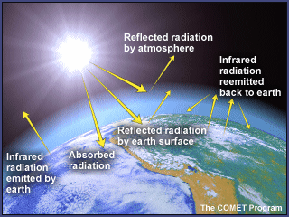
Ko tāu mahi he whakamātautau e tāwhai ana i te kati kōtuhi. Ko ngā taputapu hei whai, ko te rā tonu(te rama wera rānei), kia 2 ngā ine pāmahana, kia 2 ngā here whiri, kia rua hoki ngā pēke kirihou.
Mā tēnei e taea e koe te mātaki kia mārama ki te weranga o Papa i te awatea, ki te mātaotanga i te pō. Hei mahi kāinga, māu anō e whiri whakatau mō ngā kōrero kua tuhia e koe.

Whakaritenga
- Hoatu tētahi o ngā ine pāmahana ki roto i te pēke paku.
- Puhia ki roto i te pēke kia pupuhi, kātahi ka here ai ki te here whiri.
- Hoatu tēnei pēke paku kua pupuhia ki roto i te pēke kirihou nui.
- Pupuhia te pēke nui ki te hau, herea ki te here whiri kia mau.
- Waiho te pēke i te hana o te rā, ā, whakatakotoria te ine pāmahana tuarua ki te taha. Me he marumaru te rā, whakaritea ki raro i tētahi rama wera.
- Tuhia ngā pāmahana o ia ine pāmahana i te tīmatanga o te whakamātautau.
- Kia pau te 25 meneti, me tuhi anō.
- Nekehia te hanga whakamātautau(waiho te rama) ki roto i tētahi kāpata, torōa pōuri rānei.
- Kia pau te 25 meneti me titiro ki ngā tau ine pāmahana.

Kōrero
wā (men) | pāmahana (ºC)
wā (men) | Ine pāmahana ō-roto | Ine pāmahana ō-waho
Tīmatanga
I muri i te 25 men i te rā
I muri i te 25 men i te pōuri

Ngā whakataunga

_________________________________________________________________________

_________________________________________________________________________

_________________________________________________________________________

_________________________________________________________________________

HEI MAHI 3
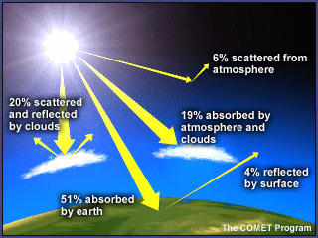
Ka nui rawa te hana mai o te rā, ko tōna nui hoki ka pau atu i mua i te taenga mai ki te kahu o Papa.
Inā heke ai te hana o te rā i te kōhauhau, ka whakawhenumitia e ngā papa kōhauhau e whā, nō reira hoki te rerekētanga o te pāmahana o tēnā papa, o tēnā papa. Heoi, ko te nuinga atu o te hana nei ka mau i te mata tonu o Papa. Ka whakaataria atu i a Papa tētahi wāhi anō o tēnei hei whakamahana i te kōhauhuri.

Ka whakaaritia te karaehe tētahi pakiwaitara mō te rerenga o te whakaatanga o te waiora a Tāne.
Mā tō kaiako e tuku kāri whakatūnga, māna anō e pānui te kōrero pakiwaitara.
Āta whakarongo ki te pānuitanga tuatahi, kia mārama ai koe ki tōu nā tūranga i te whakaaritanga i tō kari whakatūnga.
Āta whakarongo anō ki te pānuitanga tuarua, kia tae atu ki te kōrero mōu, whakatūria tō ringa ki runga, ā, tirohia te karaehe kia kite ai koe i ō hoa whakaari mō taua tūranga anō.

Mutu kau ana te pānuitanga, ka whakaritea e tō kaiako:
- kia noho ā-tūranga whakaari koutou;
- te roa o te wā hei akoako mā koutou ā koutou ake kōrero;
- te wāhi ki a koutou mō te whakawaiwai i te whakaaro i tōu nā tūranga.

MAHERE AKORANGA 3
TE WĀ: 60 meneti
KAUPAPA MĀORI: Rangahau
NGĀ TOHUTOHU MĀ TE KAIAKO:
- Ko tā ngā tauira i tēnei akoranga, he tirotiro, he whakatau hoki mā te tikanga tauira pātara, te pānga o ngā momo kahu, kōhau rānei ki te wera. Mā tēnei e mōhio ai rātau ki ngā tikanga maungawera o te kati kōtuhi, kia toru ake, arā, te pūata o te uhi wharemāota, ngā tae o ngā papa i roto i te wharemāota, me ngā momo papa. Nā, ka whakanoho ko ēnei tikanga ki te kōhauhau o Papa me te whakamārama anō hoki i te hiranga o ēnei hei tikanga maungawera. Hei whakapiki mōhiotanga mā rātau, me whai tauira ake hei whakatinana i ngā hua o te akoako.
- Ngā taputapu hei whai mā ia rōpū:
  - Kia 6 ngā paepae whakamātautau PET (tirohia te mahere akoranga mō ngā kōrero hangahanga)
  - Kia 3 ngā kapu onemata
  - Kia 3 ngā kapu onetea
  - Kia 3 ngā kapu wai
  - Kia 6 ngā inepāmahana
  - He teipa kōataata
  - Kia 1 te rama 150-wata te kaha
  - He rama whakaata kawe *pānuitia te kōrero whiore o ngā tohutohu a te kaiako.
  - He tūranga mō ngā rama

Me whai te kaitiaki taiwhanga, te kaiako rānei ko ēnei hei whakatū i ngā paepae whakamātautau – kei te tokomaha o ngā rōpū te maha o ngā taputapu:
  - Peita mā
  - Onemata
  - Onetea
  - Wai

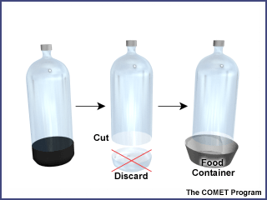
Te hanga paepae whakamātautau:
- Me whai pātara PET 2R (mau pōtae) mō ia paepae, me tētahi paepae kirihou 2 Kapu/½R hei tūranga – me 12hm te whitianga ō-runga(pai ana ngā paepae kirīmi kawa, tīhi wei, paepae teri rānei)
- Me whakawaiwai ki rō wai mahana kia makere ai te tapanga.
- Poroa te tou o te pātara kia 5hm mai i raro, ā, me makere atu te tou.
- Whakatūria te pātara mau potae ki roto i te tūranga kirihou, nā, kua rite te paepae whakamātautau.
Kia mahara: Ki te kore e nui atu ngā rama, ka kore pea e noho tahi ngā paepae e ono i raro i te wā kotahi. Ka kore e rite te kaha o te rama ki ia paepae, ko tata ka kaha ake, ko tawhiti ka kaha kore, heoi ka hē pea te whakamātautau. Tērā pea kia ruarua ngā pātara i te wā kotahi ka tika.

HEI MAHI
Ahakoa e noho here ana te pāmahana o Papa ki te kati kotuhi o te kōhauhau, tērā ētahi āhuatanga ano e pākaha nei ki te wera, ki te mātao hoki o Papa:
Ko te āhuatanga nui atu, ko te momo o te papa ka whitia e te hana o te rā:
- Ka kaha whakaataria te hana o te rā i te papa awakeo kia hoki atu ki te rangiāteanui, nā, kāore e nui atu te wera ki taua papa, ka āhua mātao kē.
- Ka kaha whenumitia te hana o te rā i te onemata o te kōraha, nā, māna e kaha wera ai taua papa me te kōhauhau o-raro.
- He pānga anō o te papa kapua ki te kati kōtuhi, arā, he aukati i te hana o te rā kia kore e tae iho ki a Papa, he aukati hoki i te whakaatanga o Papa ki te rangiāteanui.
- He nui te pānga o te wai ki te wera, ki te mātao rānei o Papa. 70% o te mata o Papa e uhia ana i te wai. Ko tāna, he mau, he kawe hoki i te wera.

Mā tēnei whakamātautau e mārama ai koe ki te pānga o ngā momo papa, uhi rānei ki te tikanga whakawera, mā te ritenga tauira pātara. Ka tukuna ki a koutou e tō kaiako ngā taputapu nei:
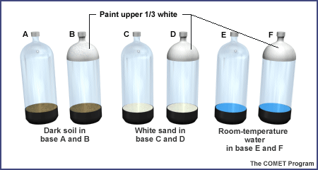
  - Kia 6 ngā paepae whakamātautau PET (tirohia te whakaahua i te taha maui)
  - Kia 6 ngā inepāmahana
  - He teipa kōataata
  - He rama 150-wata te kaha ki roto tūranga kawe.
  - He tūranga rama

- Āta tirohia ngā tapanga pātara A, B, C, D, E, me F, me whai peita mā ngā pātara B, D, me F.
- Whakamātauria ngā kai o ia paepae pātara kia whai onemata ngā pātara A me B, kia whai onetea ngā pātara C me D, he wai kei roto i E me F kia ‘rūma’ noa te pāmahana.
- Whakapiria he ine pāmahana (mā te teipa kōataata) ki roto tonu i ia pātara (kia anga whakawaho.
- Hoatu ngā pātara ki roto i ngā paepae. Me whai pōtae ngā pātara.
- Kia noho ngā tou ine pāmahana ki runga tata ake i ngā ngutu paepae. Ki te noho ngā tou i raro i ngā paepae, ka rongo kē i te wera o te one, o te wai rānei, kātahi kā hē kē.

- Me matapae ake ka wera kē atu ko tēhea o ngā pātara. Tuhia āu matapaenga me ngā take i pērā ai: _____________________________________________________________________
_____________________________________________________________________
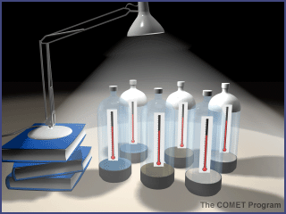
- Whakaritea i roto i tō rōpū ngā tūmahi ake a ia tangata mō te whakamātautau, hei tauira, te tiaki i te wā, te pānui ine pāmahana o ia pātara, te tuhi ine, te aha, te aha….
- Whakatūria ngā pātara kia 15hm te tawhiti atu i te rama, kia anga whakawaho atu te ine pāmahana i te rama(pērā i te whakaahua).
- Tuhia ngā pāmahana kaupapa i te mahere i raro iho nei.
- Whakakāngia te rama, ā, me tuhi ngā ine i ia rua meneti. Kia pēnei nā te mahi mō te 20 meneti.
- Whakakauwhatatia ngā kōrero. Tuhia hoki he tohu hei whakamārama i te tae o ia pātara.

TE WĀ  (men) | Pāmahana pātara (ºC)
TE WĀ  (men) | A | B | C | D | E | F
0 (kaupapa)
2
4
6
8
10
12
14
16
18
20

KAUWHATA RERENGA KĒTANGA O TE PĀMAHANA O IA PĀTARA.
Pāmahana (ºC) | 60
Pāmahana (ºC) | 58
Pāmahana (ºC) | 56
Pāmahana (ºC) | 54
Pāmahana (ºC) | 52
Pāmahana (ºC) | 50
Pāmahana (ºC) | 48
Pāmahana (ºC) | 46
Pāmahana (ºC) | 44
Pāmahana (ºC) | 42
Pāmahana (ºC) | 40
Pāmahana (ºC) | 38
Pāmahana (ºC) | 36
Pāmahana (ºC) | 34
Pāmahana (ºC) | 32
Pāmahana (ºC) | 30
Pāmahana (ºC) | 28
Pāmahana (ºC) | 26
Pāmahana (ºC) | 24
Pāmahana (ºC) | 22
Pāmahana (ºC) | 20
 |  | 0 | 2 | 4 | 6 | 8 | 10 | 12 | 14 | 16 | 18 | 20
 | TE WĀ (men)
TOHU:
Ngā Kitenga me Ngā Pātai
- Whakatauritea ngā korero kauwhata o tēnā pātara, o tēnā pātara.
- Kōrerotia ngā whakataunga me te whakamārama anō hoki.
- Kōrerotia te pānga o ngā āhuatanga tauira whare māota ki ērā o te ‘whare māota o te ao’. He aha ngā āhuatanga ōrite, rerekē hoki?
Whakamahia te hinengaro
- Tuhia, whakamāramatia hoki me pēhea te whakatū tauira whare māota(me te rama kā) ki te wāhi mātao tonu atu o te pāmahana. Kei hea kē tēnei tū wāhi i te ao?
- Tuhia, whakamāramatia hoki te whare māota e puta mai ai te wera nui atu. Kei hea hoki ko tēnei o ngā tū wāhi i te ao?
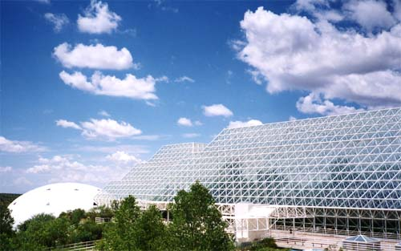

Ko Kōhaumataora 2 tēnei i te koraha o Arizona. He whare māota tōna āhua, engari he whare tiaki koiora kē.
Kimihia he kōrero anō mō tēnei whare, he aha i huaina ai ko te Kōhaumataora 2 – he aha hoki te Kōhaumataora 1?

MAHERE AKORANGA 4
TE WĀ: 60 meneti mō ia akoranga
KAUPAPA MĀORI: Reo Māori
NGĀ TOHUTOHU MĀ TE KAIAKO:
- Ko tā Hei mahi 1 he whakapakari kupu, me whakarite kia hāngai ki te matatau o ngā tauira ki te reo Māori. Kua tuhia tēnei mō te hunga tauira paku nei te matatau nā reira kua reo rua mai ngā kupu e rite ana.
Me whai papakupu Pākehā-Māori/Māori-Pākehā. Ārahina ngā tauira i runga i ō rātau matatau tākupu, pūtaiao, reo Māori anō hoki.
Me whakahauhau i ngā tauira kia oti i a rātau tētahi WHARE KUPU te whakairo mō ia kupu KŌHAUHAU ka kitea i roto i ēnei mahi.

- He whakarāpopoto te mahi o Hei Mahi 2 i ngā tirohanga o te akoranga o mua atu, kātahi ka tahuri ki ngā hau (Kia mahara: he kaupapa mahi kē atu anō ngā huarere o Tāwhirimatea). Me tuhi kōwae kōrero ngā tauira hei whakaatu i ō rātau mōhiotanga. Ngā rauemi hei whai mō tēnei mahi:
- He kete puka mahere whenua mā te karaehe

- Kei ngā au o te hau, o te moana hoki te tikanga kawe i te wera o te kōhauhau. Ko tā Hei Mahi 3 he wānanga i te mahi a te aumoana. Ngā rauemi hei whai mō tēnei mahi:
  - He ao mahere, he huarahi rānei ki te ao mahere ipurangi: http://oceanworld.tamu.edu/resources/atlas.htm
  - Ka whai wāhi ki te pouaka kōpaka me te wai
  - He tae uriuri kai
  - He terei moka haupapa
  - He paepae karāhe mā ia rōpū

Me mahi moka haupapa whai tae uriuri. Kia 2 o ēnei mā ia rōpū.
Ka kitea e ngā tauira te hekenga o te wai mātao(whai tae) me te nekenga hoki i te papararo o te paepae kia tata ki te wai mahana i waenganui; ka rere te wai mahana ki ngā taha o te paepae; ka mahana haere te wai mātao, ka rewa ake.

- Kei roto i te kōpae kōrero, Te Rahinga Wera Moana, ngā ariā matua mō te rahinga wera moana hei tirotiro mā te kaiako.
NGĀ TOHUTOHU MĀ NGĀ TAUIRA:
- Ko tā Hei Mahi 1 he whakapakari i tō mōhiotanga, i tō māramatanga hoki, he whakatū tāhū kupu mōu mō te ao kōhauhau.
Tīkina atu te tauira WHARE KUPU i muri i ia akoranga e whai ake nei hei whakamātautau i tō mōhio ki ngā kupu hou e kōrerotia ana.
- Mō Hei Mahi 2 ka tirohia anō āu whakataunga i Akoranga 3, ka tīkina atu hei mahi māu mō te takenga mai o ngā aurerenga hau.
- Mō Hei Mahi 3, ka tirotirohia e ia rōpū ngā aumoana me te kawenga o te wera o te kōhauhau.
HEI MAHI 1
He nui ngā kupu kōhauhau kua kitea e koe mai i te tīmatanga o tēnei kaupapa mahi. Tīkina atu hei whakairo WHARE KUPU mō ngā kupu o tēnei kaupapa mahi.
Kei raro iho nei tētahi tauira WHARE KUPU. Tīkina atu ngā kupu kua whakarārangitia hei whakairo WHARE KUPU mōu.
Mā tō kaiako koe e ārahi, e tuku papakupu, rauemi mai..
Hei tauira:
KUPU  Te Reo Māori: huinga hau  Te Reo Pākehā: air | WHAKAMĀRAMATANGA  He ranunga hau te huinga hau  Air is a mixture of gases
HEI TAUIRA  Piki ake ana i te kōhauhau, rauangi ana te hau. Ka kīa ai kua heke haere te pēhanga hau. | MAHERE HEI WHAKAMAHARA  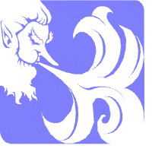

RĀRANGI KUPU
Reo Pākehā | Reo Māori | Reo Pākehā | Reo Māori
carbon dioxide | hauhā | greenhouse | whare māota
oxygen | hā ora | temperature | te wera/pāmahana
nitrogen | hauota | heat energy | pūngao wera
atmosphere | kōhauhau | heat | wera
gas | hau | radiation | tokowhiti
ozone | hau ārai | aircraft | wakarererangi
cloud | kapua

TE WHAKAMŌMONA I TŌ RĀRANGI KUPU
I a koe e kai ana i tēnei kaupapa mahi mō te KŌHAUHAU, whakairohia he WHARE KUPU mō ia kupu hou.
HEI MAHI 2
I kitea e koe i te akoranga o mua atu:
Kai ai te wai i te wera ōrite, engari kāore e pēra rawa te tere wera, arā, ka pōturi kē te wera i te wai i te wera i te whenua.
- Nui kē atu te ngaruhana ka kaingia e te taeuri i tērā o te taetea, nā reira ka wera kē atu te onemata(ka tere mātao hoki).

E ai ki ngā tohu nei ka wera karawhiti haere te mata o Papa, i te nui o ōna wai, o ōna whenua hoki. Ka wera kē atu ō-roto o ngā whenua rawhaki i ngā whenua iti.

Nā te karawhiti o te wera o te mata o Papa i hua mai ai te huarere rangi:
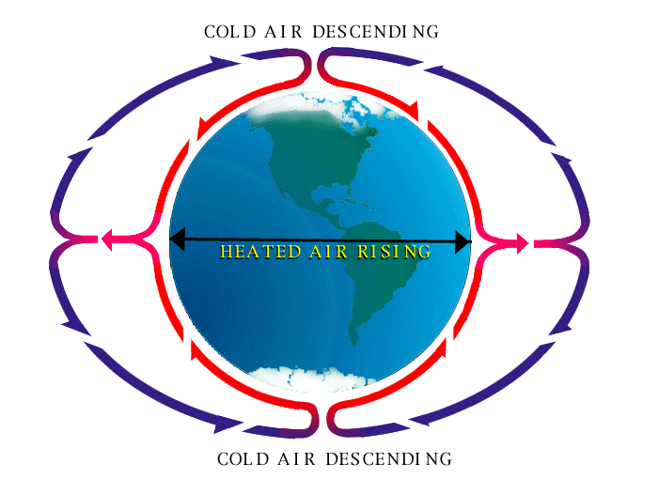
- Ki te rerekē ngā wera o te hau, ka rewa ake te hau wera i te mea kāore i te tino apiapi, ka heke kē te hau mātao i te kaha apiapi.
- Nā ēnei ritenga ka rere mai ai te hau(na te huringa hoki o Papa).
- Kāore i te taumaha te pēhanga hau o te hau wera i te mea nakawhiti ana ngā matūriki hau, marara ana te noho – kāore i te noho apiapi.
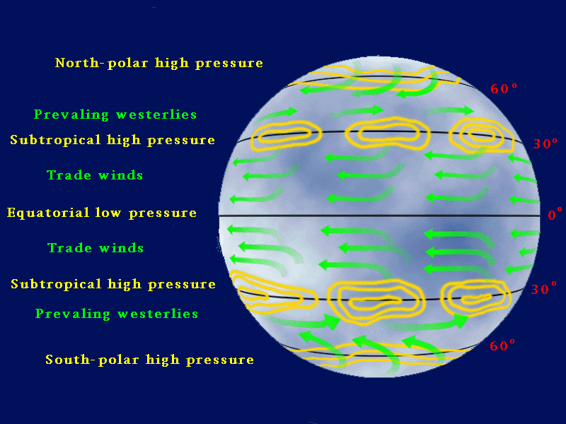
- Ka rere te pēhanga hau nui atu ki ngā wāhi iti nei te pēhanga hau, he hau rere te hua mai.
- Nā te tikanga maungawera o te wai ka pai te pāmahana o Papa i tērā menā ka nui kē atu tōna mata whenua, nā reira e whai wāhi āhuru ai hei oranga mō te tangata, mō ngā mea ora katoa.
- Heoi, ka mahana ake ngā whenua rawhaki, me te hau anō i runga i ēnei whenua, nā reira ka puta mai ngā momo huarere, hau anō hoki i ēnei pāmahana, pēhanga hau rerekē.

Titiro ki te whakaahua i runga ake nei e whakaatu ana i ngā tikanga rerenga hau o te ao. Tikina atu he puka mahere whenua hei whakautu i ēnei pātai:
- Ko te ahopae o te tāone nui tata ki a koe: ________________
- Ko ngā hau matua o taua tāone nui: __________________
Nā ēnei akoranga ōu ka āhei koe ki te whakamārama i ngā hau o te moana, o te whenua hoki, me te take i āhuru kē ai te pāmahana o te takutai moana.
He wāhi āhuru ngā tāone nui o tai,he mātao pai i te raumati(pērā i Tamaki). Ko ngā wāhi o tuawhenua (pērā i Te Puku o Ōtākou) ka wera ki te 30 i te raumati, ke heke ki raro i te 0 i te takurua.

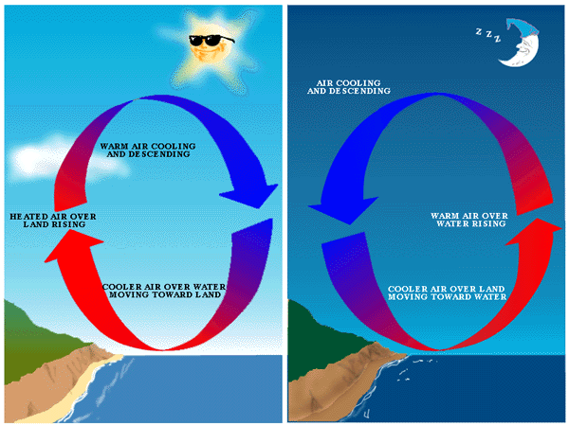
Ko tēhea te whakaahua e tohu ana i te hau moana, i te hau whenua?
Whakamōhiotia mai, kātahi ka tuhi ai i tētahi kōwae kōrero i raro i ia whakaahua hei whakamārama i te mahi a te hau. (tirohia anō te whārangi o mua atu kia rau mai ko ngā kupu: nui; iti; pēhanga hau; apiapi.

He hau ________ tēnei. He hau________ tēnei.
__________________________
__________________________
__________________________
__________________________
__________________________
__________________________
__________________________
__________________________
__________________________
__________________________
__________________________
__________________________
__________________________
__________________________
__________________________
__________________________
__________________________
__________________________
__________________________
__________________________
__________________________
__________________________
__________________________
__________________________

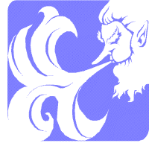

HEI MAHI 3
Āta tirohia te ao mahere i tō rūma, te ao mahere moana rānei i te ipurangi http://oceanworld.tamu.edu/resources/atlas.htm.

Tohua ko Te Moananui a Kiwa, ko Te Moana Ranatiki, ko Te Moana Inia anō hoki.

Ka tīmata, ka mutu hoki ia moana ki hea?

Ka rere honohono katoa ngā moana o Papa hei ‘moana ao’ kotahi.

Ki tō whakaaro, ka mahana kē atu te wai i hea — tata ki te paeweherua, ki ngā pou rānei?

Ka whakaatu koe i roto i tēnei whakamātautau, te rerehuinga o te waimātao o ngā pou ki te wai mahana o te paeweherua, hei aumoana.
- Me takirōpū te mahi nei. Tīkina tētahi paepae pūata, whakakīa ki te wai mahana o te kōrere, koinei te wai mahana i te rohe moana o te pae weherua.
- Hoatu tētahi moka haupapa ki ia pito o te paepae. Koinei te waimātao ki ngā rohe pou. Ka ahatia inā rewa ai nga moka haupapa?
- Tāia, tuhia tōu kitenga ki konei:

- Tuhia tētahi whakamāramatanga mō te huanga mai o ngā aumoana i te rerekē o ngā pāmahana wai i ngā rohe rerekē o te ‘ao moana’.
___________________________________________________________________
___________________________________________________________________
___________________________________________________________________
___________________________________________________________________
___________________________________________________________________
MAHERE AKORANGA 5 & 6
TE WĀ: 60 meneti mō ia akoranga
KAUPAPA MĀORI: Tāhū kōrero
NGĀ TOHUTOHU MĀ TE KAIAKO:
- He rangahau te mahi o ngā akoranga e rua nei, i te pānga o te kati kōtuhi ki te mahanatanga o te ao; me whai wāhi ki te ipurangi. Mā te rangahau nei e whai take ai ngā tauira ki te wānanga i ō rātau nā whakaaro mō te kaupapa o te mahanatanga o te ao.
- Kei te ipurangi te āhua o tēnei mahere akoranga: http://www.pbs.org/now/classroom/globalwarming.html - mā te wā me te āhei o ngā tauira ki te mahi wehe kē e tohu te kōwhiringa mahi. Pānuitia ‘Hei Papakōrero mō Ngā kaiako’ kātahi ka kōwhiria ngā wāhi hei whai.
- Anei ētahi atu pā ipurangi mau kōrero āwhina: http://www.weatherquestions.com/What_is_the_greenhouse_effect.htm
http://www.weatherquestions.com/What_is_infrared_radiation.htm
- Whakamahia te mahere Venn: http://www.pbs.org/now/classroom/globalvenn.pdf
- Mehemea ka whai tāima, koinei tētahi mahi hei whakapakari ake i te mōhio: http://www.pbs.org/now/classroom/globalproject.pdf
- Me whai papakupu Pākehā-Māori/Māori-Pākehā. Arahina ngā tauira i runga i ō rātau mōhio ki te tākupu, ki te pūtaiao, ki te reo Māori anō hoki.
- Me whakahau atu i ngā tauira kia oti i a rātau tētahi WHARE KUPU te whakairo mō ia kupu KŌHAUHAU hou ka kitea e rātau i roto i ngā mahi rangahau.

